NIP Project — Movie Ticket Booking Submission
Pega Platform project · This document is your complete submission
Read this before you start:
1. Fill in Section 1 completely. The Pega application name must follow the format NIP-[Project]-[YourName].
2. Create a new Operator in Pega with your full name and log in as that operator before taking any screenshot.
3. When you create your test case, enter YOUR FULL NAME in the Issue Description (Vehicle) or Movie Name (Movie) field.
4. Complete only the section for your chosen project. Delete the other project section.
5. Paste one screenshot per user story (10 total). Follow the screenshot rules in your selected project section.
6. Answer every question in Sections 3 and 4 in your own words.
7. Save the file using this format: ProjectName_FirstName_LastName.docx. Use VehicleService or MovieTicket as the ProjectName. Examples: VehicleService_Ravi_Kumar.docx or MovieTicket_Ravi_Kumar.docx.

Section 1 — Your Details
Full Name | Thirakala Ramya Sree
Email ID (registered on NIP) | thirakalaramyasree@gmail.com
Phone Number | 9703981461
College Name | Narayana Engineering College Gudur
Course (e.g. IT, CS) | CSE
State | Andhra Pradesh
Project Chosen (Vehicle Service OR Movie Ticket Booking) | Movie Ticket Booking
Pega Application Name (e.g. NIP-VehicleService-YourName) | NIP-MovieTicketBooking-RamyaSree
Case Type Name (exact) | Movie Ticket Request
Pega Instance URL | https://rvajqnv8.pegaacademy.net/prweb/app/movie-ticket-booking/1O3kfChUoyqPj2zmFwqFq7C8uA6oWcaK*/!STANDARD?pzuiactionzzz=CXtycX1mNzQ5NWNlMmNiY2VmYWVmYTVmZmUxMDA0NTkxYmViNWQyNjJiZjQ1NWUzZmFhMmY2OTc5MzljYWYxM2NlNDgyMWE4ZDVmMjExNzMwNTVkZmQ3YTU2Nzc4MmI4Mzg2Y2MyNzAzMTk3YjIwZTMzZDI5ZGJlYTY2ODhkMjk0NWJmNQ%3D%3D*&AccessGroupName=MovieTic%3AAuthors&Location=pzuiactionzzz%3DCXtycX0wN2UzM2MzMzE5MjA5ZmI1YTNjYjc2YWQ2NTYyM2NjMTdhZTczYjQxZDQ1NDI1NjI5M2UxNjE2M2U1MGY4ODk3MDllODFhNjA3MzljMzY3NDZkYzgxODAzZDBmNjU4MWE%3D*
Operator Name (created in Pega with your full name) | author@uplus

Section 2B — Movie Ticket Booking Management Application
Complete this section only if you selected this project. Delete the other project section before submitting.

Screenshot rules — IMPORTANT before you start:
1. Name your Pega application as: NIP-VehicleService-YourName OR NIP-MovieTicket-YourName
2. Create a new Operator in Pega with your full name (Security → Operators) and log in as that operator.
3. When you create your test case, enter YOUR FULL NAME in the Issue Description (Vehicle) or Movie Name (Movie) field.
4. The logged-in operator name must be visible in every screenshot wherever the Pega interface displays it.
5. The student's full name must be visible in all running-case screenshots.
6. Configuration screenshots must clearly show the relevant application or rule name.
Screenshots that do not show these will not be accepted.

US-001 — Submit Movie Ticket Request
What is expected:
Case created, customer submits Movie Name, Show Date, Show Time, Number of Tickets. Validation applied.
Screenshot — paste your screenshot below this line:
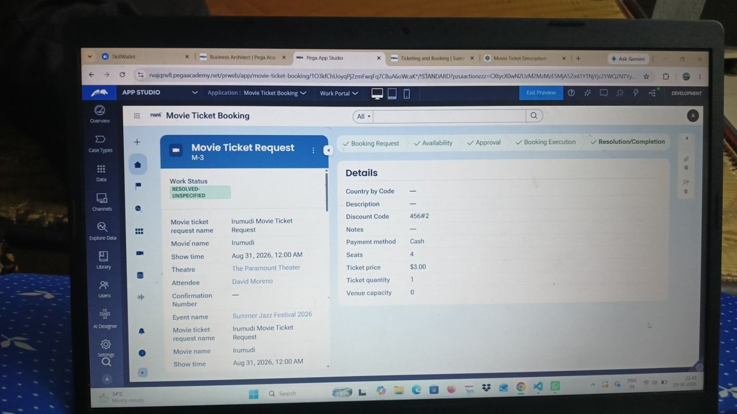

What I built for this (1–2 lines in your own words):
I created the Movie Ticket Request case with Movie Name, Show Date, Show Time, and Number of Tickets, with the required validation on the booking request.

US-002 — Check Show Availability
What is expected:
Availability stage. Seat Availability Status and Available Seats Count captured. Booking proceeds only if available.
Screenshot — paste your screenshot below this line:


What I built for this (1–2 lines in your own words):
I added an Availability stage to check the show and ticket inventory before the booking continues to the approval stage.

US-003 — Calculate Booking Cost
What is expected:
Total Cost calculated automatically from Ticket Price and Number of Tickets using a business rule.
Screenshot — paste your screenshot below this line:


What I built for this (1–2 lines in your own words):
I configured the booking cost calculation so the Total Cost is derived automatically from the ticket price and ticket quantity.

US-004 — Confirm Booking Request
What is expected:
Approval stage assigned to Customer. Booking Status captured. Flow branches on confirm/cancel.
Screenshot — paste your screenshot below this line:
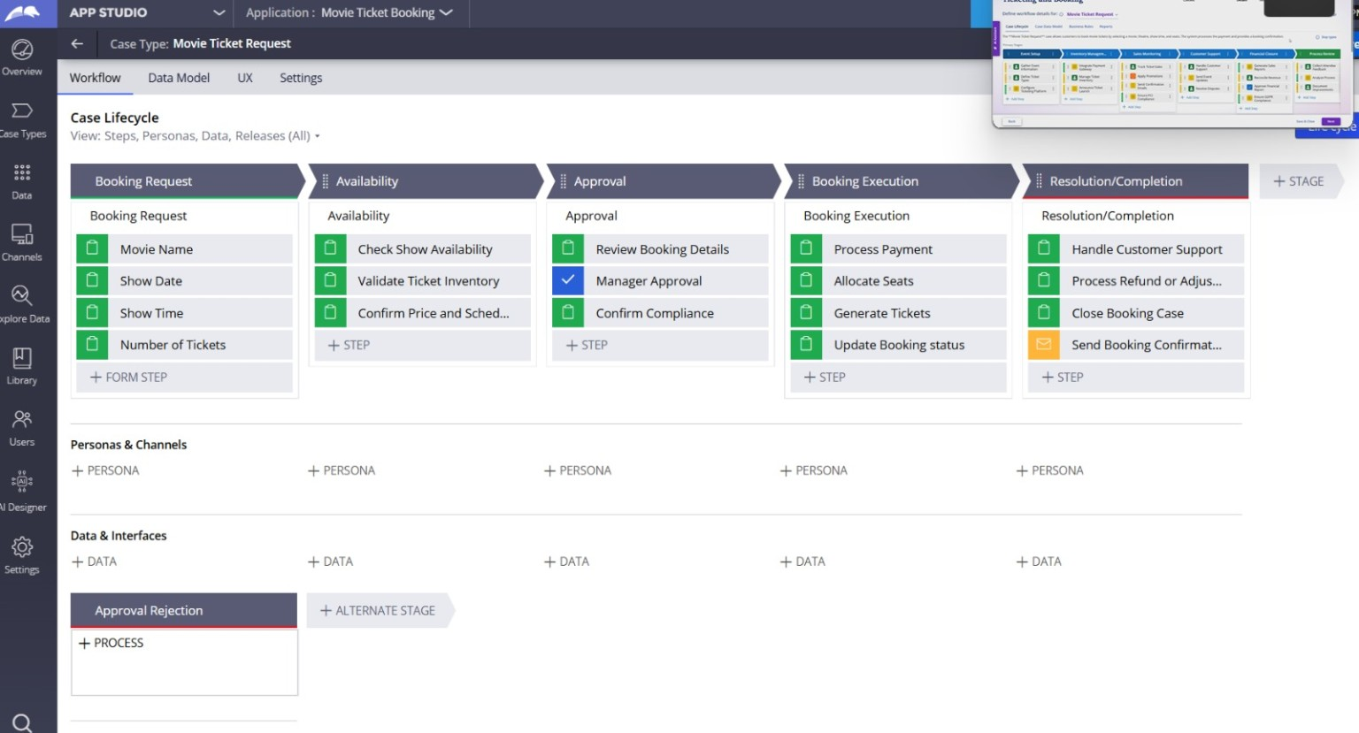

What I built for this (1–2 lines in your own words):
I added an Approval stage for the booking request so the booking can be confirmed or cancelled before execution.

US-005 — Maintain Movie and Show Data
What is expected:
Reusable Movie and Show data objects created with Movie Name, Genre, Show Date, Show Time, Seat Capacity — linked to case.
Screenshot — paste your screenshot below this line:


What I built for this (1–2 lines in your own words):
I used reusable movie/show information in the case and linked the movie and show details to the booking request.

US-006 — Review Booking Details
What is expected:
Confirmation screen shows Movie Name, Show Timing, Number of Tickets and Total Cost clearly.
Screenshot — paste your screenshot below this line:


What I built for this (1–2 lines in your own words):
I provided a review/confirmation view that presents the movie, show timing, ticket quantity, and booking cost before execution.

US-007 — Process Ticket Booking
What is expected:
Booking Execution stage. Seat Numbers, Ticket ID and Booking Confirmation Status maintained.
Screenshot — paste your screenshot below this line:


What I built for this (1–2 lines in your own words):
I configured the Booking Execution stage to process payment, allocate seats, generate tickets, and update booking status.

US-008 — Notify Booking Confirmation
What is expected:
Correspondence rule triggered on case resolution. Email includes movie, show, seat and cost details.
Screenshot — paste your screenshot below this line:


What I built for this (1–2 lines in your own words):
I configured the Resolution/Completion flow to close the booking and send the booking confirmation after resolution.

US-009 — Define Booking SLA
What is expected:
SLA configured on the case type. Goal: 1 day. Deadline: 2 days. Priority increases on breach.
Screenshot — paste your screenshot below this line:


What I built for this (1–2 lines in your own words):
I configured the booking SLA on the case type with the required goal and deadline and priority escalation on breach.

US-010 — Route by Show Type
What is expected:
Routing rule or Decision Table routes to PremiumShowQueue or StandardShowQueue based on Show Type property.
Screenshot — paste your screenshot below this line:


What I built for this (1–2 lines in your own words):
I configured routing based on Show Type so premium and standard shows can be directed to their respective work queues.

Section 3 — About Your Application
These answers are checked against your screenshots. Write exactly what is in your application.

Q1. List your stages in the order they appear in your case lifecycle.
Stage names in order, separated by commas.
Booking Request, Availability, Approval, Booking Execution, Resolution/Completion.

Q2. Name the data object(s) you created and the properties inside them.
Data object name and its properties.
Movie and Show data: Movie Name, Genre, Show Date, Show Time, and Seat Capacity. The case also contains booking fields such as Number of Tickets and show details.

Q3. What is the exact name and type of the rule you used to calculate Total Cost?
Provide:
• Rule Name
• Rule Type
• Properties used in the calculation
• Formula used
Rule name: CalculateTotalCost (verify the exact rule name in App Studio before submission). Rule type: Declare Expression/business rule used for the automatic calculation. Properties used: Ticket Price and Ticket Quantity/Number of Tickets. Formula: Ticket Price × Number of Tickets.

Section 4 — Your Understanding
Short, honest and specific answers score well.

Q4. What did Blueprint generate for you, and what did you add or change yourself afterwards?
Be specific about what was already there and what you built or modified on top.
Blueprint provided the initial Ticketing and Booking application context, workflow structure, and personas. I then configured and refined the Pega application, case flow, data, routing, calculations, and completion behavior needed for the project.

Q5. Was there anything Blueprint created that you had to correct or configure further? Describe one example.
A real example from your own work.
One area that required further configuration was the case workflow after the initial Blueprint structure. I refined the stages and steps so the flow matched the Movie Ticket Request process, including Availability, Approval, Booking Execution, and Resolution/Completion.

Q6. Explain your case flow from creation to resolution, in order.
What happens first, who does what, when the case closes.
The customer starts a Movie Ticket Request by entering the movie and show details and number of tickets. The case moves to Availability to validate the show and inventory, then to Approval for confirmation. After approval, Booking Execution processes payment, allocates seats, generates tickets, and updates the booking status. Finally, Resolution/Completion handles completion and the booking confirmation before the case closes.

Q7. Pick two design choices you made in your application and explain why you made them.
For each design choice, provide:
• What you implemented
• Why you chose that approach
• What benefit it provides to the application
Design choice 1: I separated the case into clear lifecycle stages—Booking Request, Availability, Approval, Booking Execution, and Resolution/Completion. I chose this to make each part of the booking process easy to manage and understand.
Design choice 2: I used show-type-based routing/work queues. I chose this so different categories of shows can be handled by the appropriate queue and the workflow remains scalable.

Q8. What was the hardest part, and how exactly did you fix it?
Specific and honest. A real challenge scores much better than a generic answer.
The hardest part was aligning the generated workflow with the required user stories and making sure the stages and steps followed the expected booking sequence. I fixed this by reviewing the case lifecycle in App Studio, checking each stage and step, and refining the flow before testing the case.

Q9. If the approval step was only needed when Total Cost is above a certain amount, what would you change in your application?
Explain what you would change and where. You do not need to build this.
I would add a condition before the Approval stage that checks Total Cost against the chosen threshold. If Total Cost is above the threshold, the case would enter the Approval stage; otherwise it would bypass approval and continue directly to Booking Execution. The condition would be configured in the case workflow/decision point before Approval.

Q10. List three exact rule names from your application that you personally created or modified.
Include the rule name and rule type for each one (for example: CalculateTotalCost - Declare Expression).
CalculateTotalCost — Declare Expression (verify exact rule name/type in App Studio).
ShowTypeRouting — Decision Table/route rule (verify exact rule name/type in App Studio).
BookingConfirmation — Correspondence rule (verify exact rule name/type in App Studio).
Q11. List all personas used in your application.
List the persona names exactly as they appear in your application.
Administrator/Self, Booking Agent, Customer.
Q12. List all work queues used in your application and explain when each one is used.
For each work queue, provide its exact name and the condition or type of work routed to it.
PremiumShowQueue — used for bookings routed for Premium Show types.
StandardShowQueue — used for bookings routed for Standard Show types.
Before You Submit — Check These
Read through once before uploading.
1. Section 1 filled in. Application named as NIP-[Project]-[YourName]. Names match the actual application.
2. New Operator created in Pega with my full name. I logged in as that operator for all screenshots.
3. Only my chosen project section remains — the other project section is deleted.
4. All 10 user story screenshots are pasted and follow the operator, running-case, application, and rule-name evidence requirements.
5. Every question in Sections 3 and 4, including Q10, Q11, and Q12, is answered in my own words.
6. This file is named using the required format: ProjectName_FirstName_LastName.docx (for example, VehicleService_Ravi_Kumar.docx or MovieTicket_Ravi_Kumar.docx) and uploaded as required.

