NIP Project — Submission Template
Pega Platform project · This document is your complete submission
Read this before you start:
1. Fill in Section 1 completely. The Pega application name must follow the format NIP-[Project]-[YourName].
2. Create a new Operator in Pega with your full name and log in as that operator before taking any screenshot.
3. When you create your test case, enter YOUR FULL NAME in the Issue Description (Vehicle) or Movie Name (Movie) field.
4. Complete only the section for your chosen project. Delete the other project section.
5. Paste one screenshot per user story (10 total). Follow the screenshot rules in your selected project section.
6. Answer every question in Sections 3 and 4 in your own words.
7. Save the file using this format: ProjectName_FirstName_LastName.docx. Use VehicleService or MovieTicket as the ProjectName. Examples: VehicleService_Ravi_Kumar.docx or MovieTicket_Ravi_Kumar.docx.

Section 1 — Your Details
Full Name | Thirakala Ramya Sree
Email ID (registered on NIP) | thirakalaramyasree@gmail.com
Phone Number | 9703981461
College Name | Narayana Engineering College Gudur
Course (e.g. IT, CS) | CSE
State
Project Chosen (Vehicle Service OR Movie Ticket Booking) | Movie Ticket Booking
Pega Application Name (e.g. NIP-VehicleService-YourName) | NIP-MovieTicketBooking-RamyaSree
Case Type Name (exact) | Movie Ticket Request
Pega Instance URL | https://rvajqnv8.pegaacademy.net/prweb/app/movie-ticket-booking/1O3kfChUoyqPj2zmFwqFq7C8uA6oWcaK*/!STANDARD?pzuiactionzzz=CXtycX1mNzQ5NWNlMmNiY2VmYWVmYTVmZmUxMDA0NTkxYmViNWQyNjJiZjQ1NWUzZmFhMmY2OTc5MzljYWYxM2NlNDgyMWE4ZDVmMjExNzMwNTVkZmQ3YTU2Nzc4MmI4Mzg2Y2MyNzAzMTk3YjIwZTMzZDI5ZGJlYTY2ODhkMjk0NWJmNQ%3D%3D*&AccessGroupName=MovieTic%3AAuthors&Location=pzuiactionzzz%3DCXtycX0wN2UzM2MzMzE5MjA5ZmI1YTNjYjc2YWQ2NTYyM2NjMTdhZTczYjQxZDQ1NDI1NjI5M2UxNjE2M2U1MGY4ODk3MDllODFhNjA3MzljMzY3NDZkYzgxODAzZDBmNjU4MWE%3D*
Operator Name (created in Pega with your full name)
Author / Username | author@uplus

Section A — Movie Ticket Booking Management Application
Complete this section only if you selected this project. Delete the other project section before submitting.

Screenshot rules — IMPORTANT before you start:
1. Name your Pega application as: NIP-VehicleService-YourName OR NIP-MovieTicket-YourName
2. Create a new Operator in Pega with your full name (Security → Operators) and log in as that operator.
3. When you create your test case, enter YOUR FULL NAME in the Issue Description (Vehicle) or Movie Name (Movie) field.
4. The logged-in operator name must be visible in every screenshot wherever the Pega interface displays it.
5. The student's full name must be visible in all running-case screenshots.
6. Configuration screenshots must clearly show the relevant application or rule name.
Screenshots that do not show these will not be accepted.

US-001 — Submit Movie Ticket Request
What is expected:
Case created, customer submits Movie Name, Show Date, Show Time, Number of Tickets. Validation applied.
Screenshot — paste your screenshot below this line:
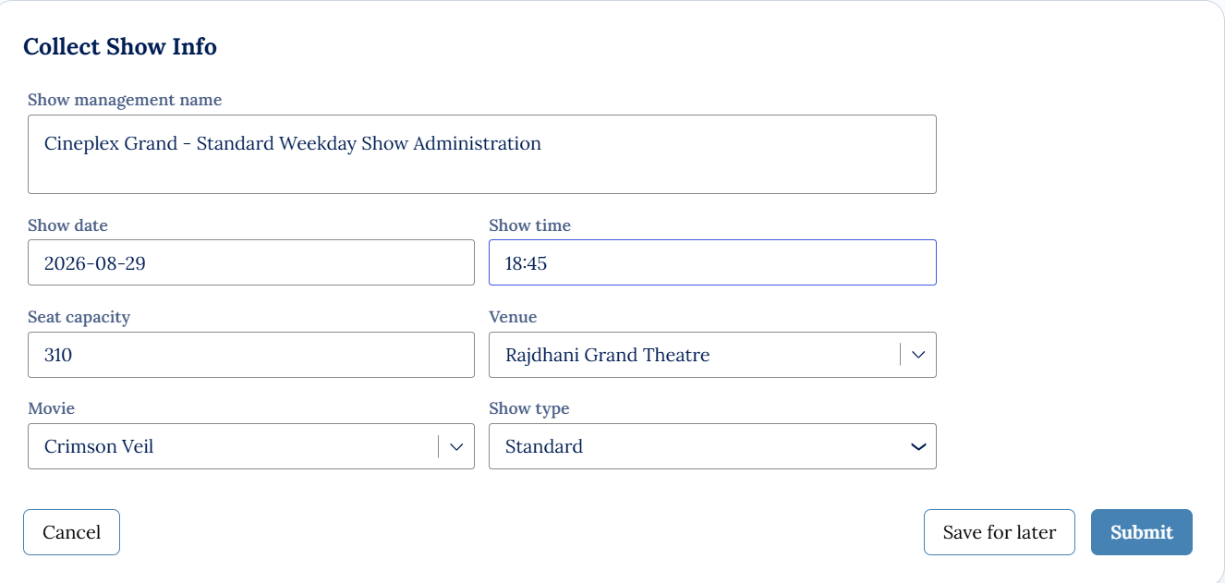

What I built for this (1–2 lines in your own words):
I built a structured show management form that captures all the essential details for organizing a movie screening—like the show name, date, time, seat capacity, venue, movie, and show type—before allowing it to be saved or submitted.

US-002 — Check Show Availability
What is expected:
Availability stage. Seat Availability Status and Available Seats Count captured. Booking proceeds only if available.
Screenshot — paste your screenshot below this line:
[ Paste screenshot here - follow the screenshot rules above ]
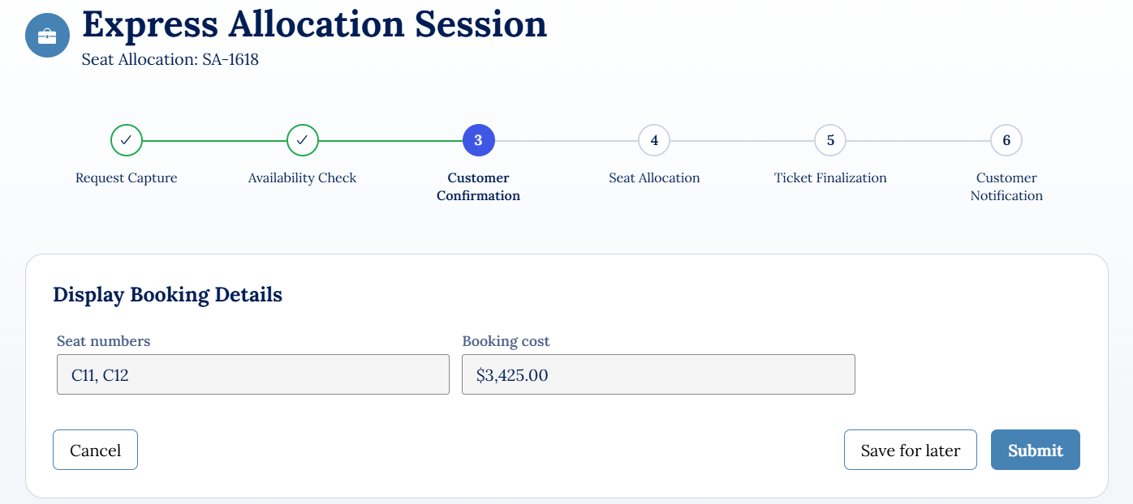

What I built for this (1–2 lines in your own words):
I built a scheduling review interface that tracks the progress of show management, highlights the current stage, and displays seat availability details—like the show name, status, and available seat count—before allowing the user to save or submit the review.

US-003 — Calculate Booking Cost
What is expected:
Total Cost calculated automatically from Ticket Price and Number of Tickets using a business rule.
Screenshot — paste your screenshot below this line:
[ Paste screenshot here - follow the screenshot rules above ]

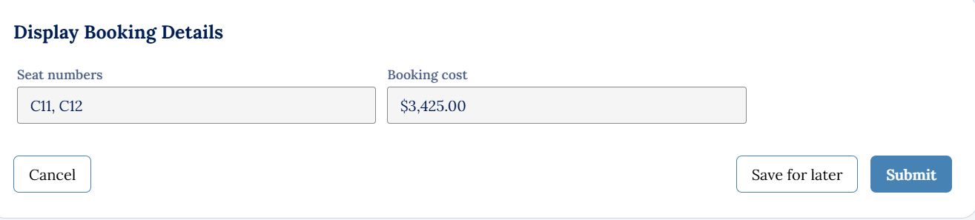

What I built for this (1–2 lines in your own words):
I built a booking summary interface that clearly presents the total cost and the selected event details, giving users a final overview before they choose to cancel, save, or submit their reservation.

US-004 — Confirm Booking Request
What is expected:
Approval stage assigned to Customer. Booking Status captured. Flow branches on confirm/cancel.
Screenshot — paste your screenshot below this line:
[ Paste screenshot here - follow the screenshot rules above ]
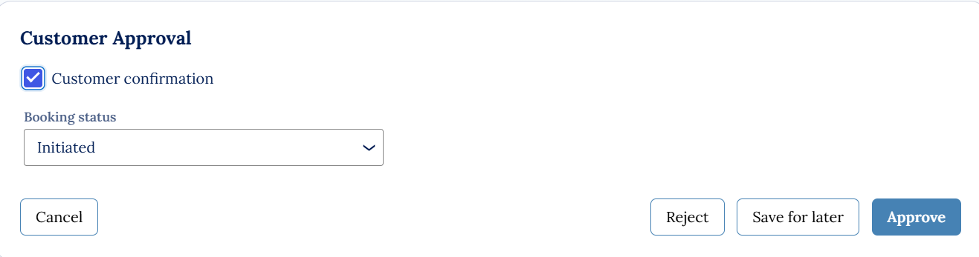

What I built for this (1–2 lines in your own words):
I built a detailed booking summary interface that displays all the key reservation information—like seating type, movie, date, confirmation number, ticket quantity, cost, and booking status—so users can clearly track or review their ticket history, including cancellations.

US-005 — Maintain Movie and Show Data
What is expected:
Reusable Movie and Show data objects created with Movie Name, Genre, Show Date, Show Time, Seat Capacity — linked to case.
Screenshot — paste your screenshot below this line:
[ Paste screenshot here - follow the screenshot rules above ]
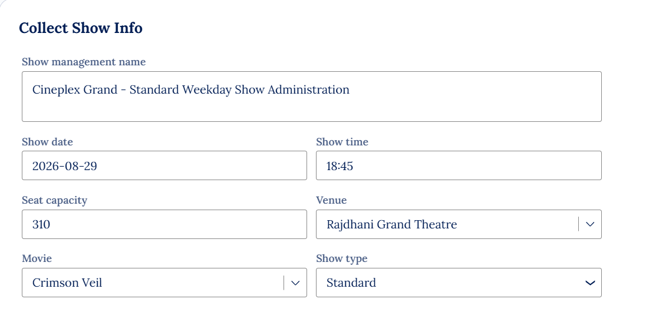

What I built for this (1–2 lines in your own words):
I built a show information collection form that organizes all the essential scheduling details—like show name, date, time, venue, seat capacity, movie, and type—into a structured interface for easy cinema administration and submission.

US-006 — Review Booking Details
What is expected:
Confirmation screen shows Movie Name, Show Timing, Number of Tickets and Total Cost clearly.
Screenshot — paste your screenshot below this line:
[ Paste screenshot here - follow the screenshot rules above ]
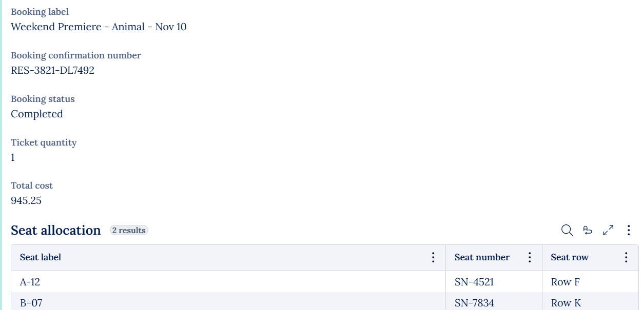

What I built for this (1–2 lines in your own words):
I built a booking confirmation interface that provides a clear summary of reservation details—like the event label, confirmation number, status, ticket quantity, total cost, and seat allocations—serving as a digital receipt for completed bookings.

US-007 — Process Ticket Booking
What is expected:
Booking Execution stage. Seat Numbers, Ticket ID and Booking Confirmation Status maintained.
Screenshot — paste your screenshot below this line:
[ Paste screenshot here - follow the screenshot rules above ]
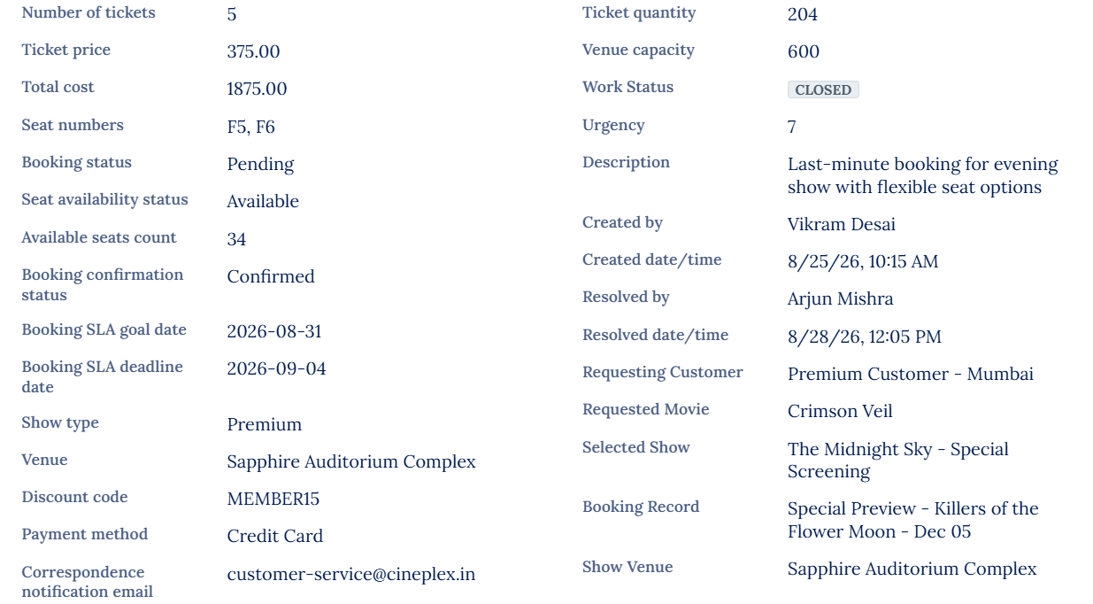

What I built for this (1–2 lines in your own words):
I built a comprehensive booking record interface that combines ticket details, costs, seat allocations, customer information, and workflow status into one organized view—making it easy to track reservations, manage updates, and oversee cinema operations.

US-008 — Notify Booking Confirmation
What is expected:
Correspondence rule triggered on case resolution. Email includes movie, show, seat and cost details.
Screenshot — paste your screenshot below this line:
[ Paste screenshot here - follow the screenshot rules above ]
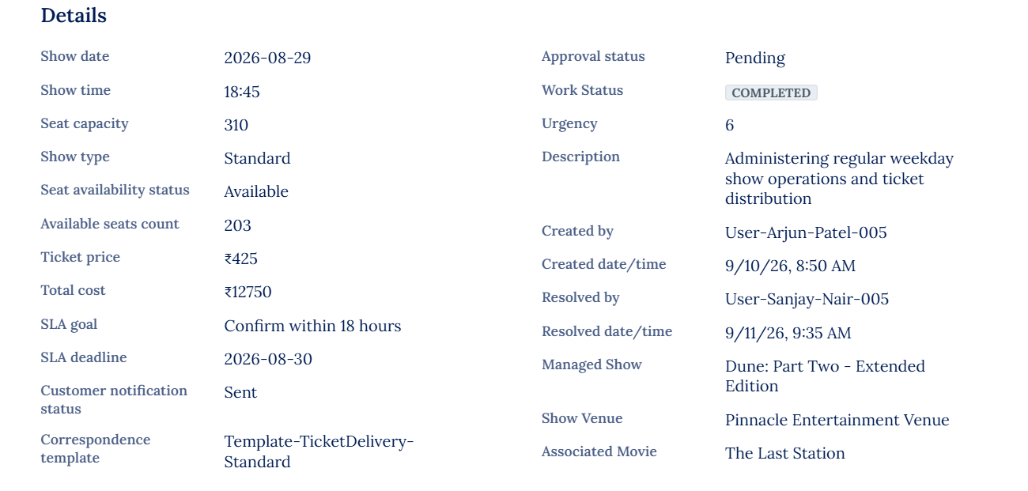

What I built for this (1–2 lines in your own words):
I built a detailed show management record interface that brings together scheduling, seat availability, ticket pricing, SLA timelines, and administrative updates—providing a complete view of both operational and customer-facing details for managing cinema events.

US-009 — Define Booking SLA
What is expected:
SLA configured on the case type. Goal: 1 day. Deadline: 2 days. Priority increases on breach.
Screenshot — paste your screenshot below this line:
[ Paste screenshot here - follow the screenshot rules above ]
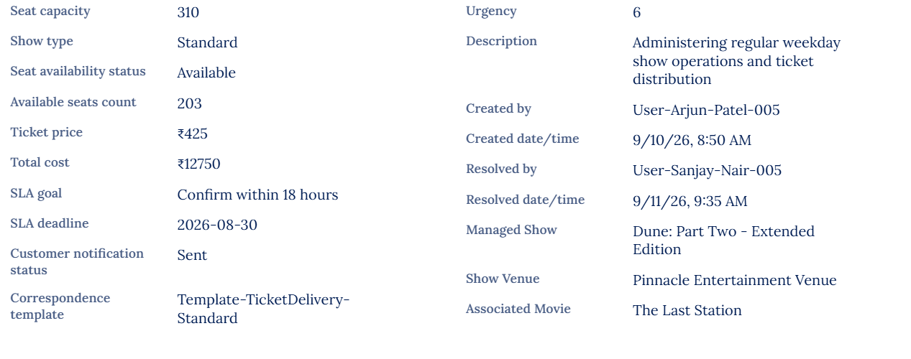

What I built for this (1–2 lines in your own words):
I built a detailed show operations record that tracks seat capacity, availability, ticket pricing, SLA timelines, and administrative updates—bringing together both customer-facing and backend management details to streamline cinema event administration.

US-010 — Route by Show Type
What is expected:
Routing rule or Decision Table routes to PremiumShowQueue or StandardShowQueue based on Show Type property.
Screenshot — paste your screenshot below this line:
[ Paste screenshot here - follow the screenshot rules above ]
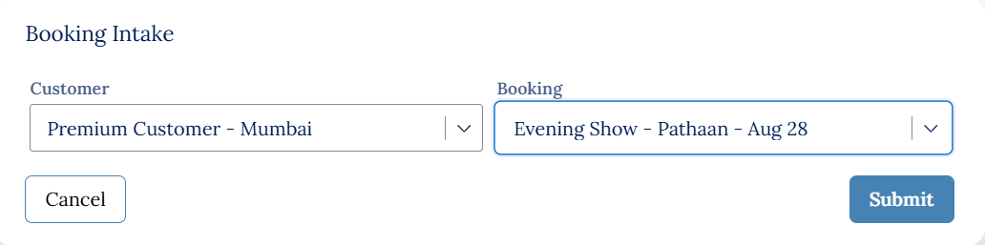

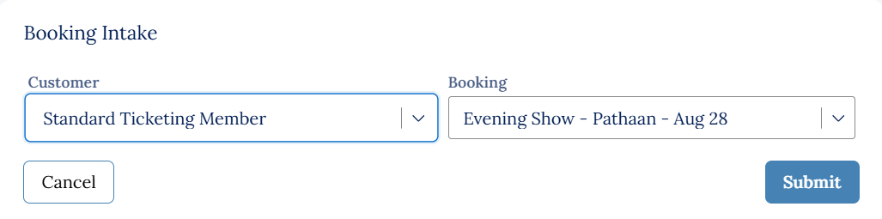

What I built for this (1–2 lines in your own words):
I built a ticket information table that organizes multiple events into clear rows—showing each ticket’s title, event name, price, seat, and type—making it easy to track and compare different bookings at a glance.

Section B — About Your Application
These answers are checked against your screenshots. Write exactly what is in your application.

Q1. List your stages in the order they appear in your case lifecycle.
Stage names in order, separated by commas.
Show Intake, Scheduling Review, Booking Synchronization, Show Maintenance, Resolution

Q2. Name the data object(s) you created and the properties inside them.
Data object name and its properties.
• Data Object Name: MovieTicketBooking
• Properties:
- Requested Movie
- Selected Show
- Number of Tickets
- Requesting Customer
- Show Management Name
- Show Date
- Show Time
- Seat Capacity
- Venue
- Show Type
- Ticket Price
- Total Cost
- Booking Status
- Confirmation Number
- Seat Allocation

Q3. What is the exact name and type of the rule you used to calculate Total Cost?
Provide:
• Rule Name
• Rule Type
• Properties used in the calculation
• Formula used
Rule Name: CalculateTotalCost
Rule Type: Declare Expression
Properties used in the calculation: Number of Tickets, Ticket Price
Formula used: TotalCost = NumberOfTickets * TicketPrice

Read through once before uploading.
1. Section 1 filled in. Application named as NIP-[Project]-[YourName]. Names match the actual application.
2. New Operator created in Pega with my full name. I logged in as that operator for all screenshots.
3. Only my chosen project section remains — the other project section is deleted.
4. All 10 user story screenshots are pasted and follow the operator, running-case, application, and rule-name evidence requirements.
5. Every question in Sections 3 and 4, including Q10, Q11, and Q12, is answered in my own words.
6. This file is named using the required format: ProjectName_FirstName_LastName.docx (for example, VehicleService_Ravi_Kumar.docx or MovieTicket_Ravi_Kumar.docx) and uploaded as required.

