MedAssist AI
Intelligent Multilingual Healthcare Assistant

Software Requirements Specification (SRS)
Project Requirements Document (PRD)

Field | Details
Project Title | MedAssist AI — Intelligent Multilingual Healthcare Assistant
Theme | AI-Powered Healthcare Accessibility for All
Team Name | MedAssist Development Team
Document Type | SRS / PRD
Version | 2.0.0
Prepared By | MedAssist AI Engineering Team
Reviewed By | Project Lead & Faculty Advisor
Institution | Academic Capstone / Independent Development
Submission Date | July 2026

Document Control

Version History
Version | Date | Author | Description
1.0.0 | May 2026 | Development Team | Initial SRS document with core feature definitions
1.5.0 | June 2026 | Development Team | Added RAG pipeline, external API integrations, multilingual support
2.0.0 | July 2026 | Development Team | Enterprise upgrade — WHO ICD-11, EML KB, modular backend, RBAC, audit trails

Approval Details
Role | Name | Signature | Date
Project Lead | — | — | —
Faculty Advisor | — | — | —
Quality Reviewer | — | — | —

1. Introduction

1.1 Purpose of the Document
This Software Requirements Specification (SRS) document provides a complete and detailed description of the functional, non-functional, and technical requirements for the MedAssist AI application. It serves as the single source of truth for the development team, project stakeholders, and evaluators to understand the scope, architecture, user roles, system behaviors, and acceptance criteria of the system.
This document is prepared in accordance with IEEE 830-1998 SRS standards and is intended to achieve a comprehensive, production-grade specification covering every module of the application.

1.2 Intended Audience
Audience | Purpose
Development Team | Technical reference for frontend, backend, AI pipeline, and integration development
Project Evaluators / Faculty | Evaluation of project scope, feasibility, and academic rigor
Quality Assurance Team | Basis for test case development and acceptance testing
System Architects | Architectural decisions, technology stack validation, and scalability planning
Healthcare Domain Experts | Verification of medical safety, disclaimer compliance, and clinical appropriateness
Future Maintainers | Onboarding reference for understanding system design and module boundaries

1.3 Scope of the Document
This document covers:
- All functional modules including Patient, Doctor, Caregiver, and Admin dashboards
- AI Chatbot and Voice Assistant powered by a Retrieval-Augmented Generation (RAG) pipeline
- External medical API integrations (OpenFDA, WHO ICD-11, RxNorm, Data.gov.in, MedlinePlus)
- Authentication, authorization, and role-based access control (RBAC)
- Multilingual support for 6 languages (English, Hindi, Tamil, Kannada, Malayalam, Telugu)
- Emergency SOS, medicine reminders, appointment management, and caregiver alerts
- Non-functional requirements including performance, security, scalability, and accessibility
- System architecture diagrams and data flow specifications

1.4 Product Scope
MedAssist AI is a multilingual, AI-powered healthcare assistant designed to bridge the healthcare accessibility gap for patients, doctors, caregivers, and healthcare administrators. The application provides:
- Intelligent Medical Q&A using a RAG pipeline backed by 6+ verified medical data sources
- Role-based dashboards for patients, doctors, caregivers, and administrators
- Medicine management including reminders, status tracking, and WHO Essential Medicines lookup
- Appointment scheduling between patients and doctors
- Emergency SOS with one-tap activation and caregiver/doctor notification
- Voice assistant with multilingual speech-to-text and text-to-speech capabilities
- WhatsApp/SMS/IVR support channels for users without smartphone access
The product targets healthcare facilities, rural health centers, elderly patients, and caregivers in India and other developing nations where language barriers and digital literacy gaps prevent effective use of existing healthcare technology.

1.5 Document Conventions
Convention | Meaning
SHALL | Mandatory requirement — must be implemented
SHOULD | Recommended requirement — implement if feasible
MAY | Optional requirement — implement at team discretion
FR-XXX | Functional Requirement identifier
NFR-XXX | Non-Functional Requirement identifier

1.6 Definitions, Acronyms, and Abbreviations
Term | Definition
AI | Artificial Intelligence
API | Application Programming Interface
CORS | Cross-Origin Resource Sharing
EML | WHO Essential Medicines List
FHIR | Fast Healthcare Interoperability Resources
ICD-11 | International Classification of Diseases, 11th Revision
IVR | Interactive Voice Response
JWT | JSON Web Token
LLM | Large Language Model
LOINC | Logical Observation Identifiers Names and Codes
OAuth2 | Open Authorization 2.0
RAG | Retrieval-Augmented Generation
RBAC | Role-Based Access Control
REST | Representational State Transfer
RxCUI | RxNorm Concept Unique Identifier
SNOMED CT | Systematized Nomenclature of Medicine — Clinical Terms
SOS | Emergency distress signal
SPA | Single Page Application
SRS | Software Requirements Specification
TTS | Text-to-Speech
WHO | World Health Organization

1.7 References
# | Reference | URL / Source
1 | IEEE 830-1998 SRS Standard | IEEE Standards Association
2 | React 19 Documentation | https://react.dev
3 | FastAPI Documentation | https://fastapi.tiangolo.com
4 | Firebase Documentation | https://firebase.google.com/docs
5 | OpenFDA API Documentation | https://open.fda.gov/apis
6 | WHO ICD-11 API Documentation | https://icd.who.int/icdapi
7 | RxNorm API Documentation | https://rxnav.nlm.nih.gov/RxNormAPIs.html
8 | Data.gov.in API Portal | https://data.gov.in
9 | MedlinePlus Health Topics | https://medlineplus.gov
10 | NVIDIA NIM API | https://build.nvidia.com

2. Executive Summary

2.1 Project Overview
MedAssist AI is an enterprise-grade, multilingual healthcare assistant application that combines a modern React-based frontend with a FastAPI backend powered by a Retrieval-Augmented Generation (RAG) pipeline. The system provides intelligent medical guidance to patients, workflow tools for doctors, monitoring capabilities for caregivers, and administrative oversight for healthcare facility managers.
The application integrates with 6+ verified external medical data sources — including the WHO Essential Medicines List (1,738 medicines), WHO ICD-11 Classification API, U.S. FDA OpenFDA drug database, RxNorm drug identification system, India's Data.gov.in public health datasets, and MedlinePlus medical encyclopedia — to ensure that every AI-generated response is grounded in authoritative, up-to-date medical knowledge rather than model hallucination.

2.2 Project Goal
To create an accessible, intelligent, and trustworthy healthcare assistant that:
- Eliminates language barriers by supporting 6 Indian languages (English, Hindi, Tamil, Kannada, Malayalam, Telugu)
- Provides medically grounded AI responses using RAG with verified data sources
- Empowers patients with medicine reminders, appointment booking, symptom assessment, and emergency SOS
- Supports doctors with patient management, appointment workflow, and adherence monitoring
- Protects caregivers with real-time alerts, medicine status tracking, and emergency notifications
- Ensures safety by never providing diagnosis or prescriptions, always recommending professional consultation

2.3 Business Value
Value Dimension | Impact
Healthcare Access | Extends digital health services to rural, elderly, and non-English-speaking populations
Patient Safety | Emergency SOS with one-tap activation can reduce critical response times
Medication Adherence | Automated medicine reminders reduce missed doses by up to 40% (WHO estimate)
Doctor Efficiency | Centralized dashboard reduces appointment management overhead
Caregiver Peace of Mind | Real-time alerts for medicine compliance and emergencies
Cost Reduction | AI-powered first-line triage reduces unnecessary hospital visits
Data-Driven Insights | Admin analytics enable healthcare facility optimization

2.4 Expected Outcome
Upon successful deployment, MedAssist AI will:
- Serve as a 24/7 multilingual health assistant accessible via web browser or mobile device
- Process medical queries with sub-3-second response times using cached RAG data
- Maintain a verified knowledge base of 1,738+ essential medicines with instant local lookup
- Provide WHO ICD-11 disease classification codes in real-time via authenticated API access
- Support 4 distinct user roles with role-specific dashboards and functionality
- Operate with zero medical diagnosis liability through consistent disclaimer enforcement
- Scale horizontally to support thousands of concurrent users via containerized deployment

3. Problem Statement

3.1 Current Healthcare Problem
Healthcare accessibility remains a critical challenge in developing nations, particularly in India, where:
- Doctor-to-patient ratio is approximately 1:1,445 (WHO recommends 1:1,000)
- 67% of the population resides in rural areas with limited access to quality healthcare facilities
- Digital literacy rates are low among elderly populations who need healthcare services most
- Language barriers prevent effective communication between healthcare systems and patients who speak regional languages
- Medication non-adherence causes approximately 125,000 deaths annually in India alone

3.2 Hospital / Clinic Problem
- Appointment scheduling is often manual (phone-based or in-person), leading to long wait times
- Patient data is fragmented across paper records
- Emergency response coordination lacks a unified digital platform
- Healthcare staff spend significant time on administrative tasks that could be automated

3.3 Patient Pain Points
Pain Point | Description
Language barrier | Healthcare apps are predominantly English-only
Digital illiteracy | Complex UIs are inaccessible to elderly users
Medicine confusion | Patients forget dosages, timing, or interactions
Emergency helplessness | Patients may be unable to dial emergency numbers
Information overload | Unverified medical information causes anxiety
Appointment friction | Booking requires multiple phone calls

3.4 Caregiver Pain Points
- No real-time visibility into whether assigned patients have taken their medicines
- No automated alert when a patient triggers an emergency or misses critical medication
- Difficulty coordinating with multiple patients across different healthcare facilities
- Lack of historical reports on patient adherence and health trends

3.5 Healthcare Staff Pain Points
- Doctors lack a centralized dashboard to view patient queues, emergencies, and adherence metrics
- Admin staff have no system-wide analytics for monitoring facility performance
- Manual emergency triage is slow and error-prone
- No audit trail for medical interactions, creating compliance risks

4. Existing System

4.1 Current Healthcare Support Methods
Method | Description
In-person visits | Patients physically visit clinics/hospitals for every query
Phone helplines | Government helplines (104, 108) provide basic guidance with long wait times
Paper prescriptions | Doctors write prescriptions on paper; patients lose or misread them
WhatsApp groups | Informal, unverified health advice in family/community groups
Generic health apps | Practo, 1mg, PharmEasy — doctor booking or medicine delivery, no AI guidance

4.2 Existing Digital Healthcare Solutions
Solution | Strengths | Weaknesses
Practo | Doctor discovery, appointment booking | No AI chatbot, limited languages, no caregiver features
1mg / PharmEasy | Medicine delivery, lab tests | E-commerce focused, no patient dashboard
Apollo 24/7 | Teleconsultation | Expensive, English-centric
Aarogya Setu | COVID tracking | Single-purpose, no ongoing health management
Google Health | Health information search | Generic results, no personalization
Ada Health | Symptom checker | English only, no Indian healthcare integration

4.3 Limitations of Existing System

4.3.1 Disconnected Platforms
Patients must use separate apps for doctor booking (Practo), medicine ordering (1mg), health information (Google), and emergency calls (phone dialer). There is no unified platform.

4.3.2 Lack of Personalization
Existing solutions provide generic health information without considering the patient's role, medical history, or preferred language.

4.3.3 Internet Dependency
Most healthcare apps require continuous internet connectivity. Rural and low-bandwidth areas are effectively excluded.

4.3.4 Limited Multilingual Support
The vast majority of healthcare applications support only English and Hindi. Tamil, Kannada, Malayalam, and Telugu — spoken by over 300 million people — are rarely supported.

4.3.5 Limited Support for Elderly and Rural Users
Existing apps use complex navigation, small fonts, and multi-step workflows that are inaccessible to elderly users.

5. Proposed System

5.1 Proposed Solution Overview
MedAssist AI is a unified, intelligent healthcare platform that consolidates patient management, doctor workflow, caregiver monitoring, and AI-powered medical guidance into a single, multilingual web application.

5.2 How MedAssist AI Solves the Problem
Problem | MedAssist AI Solution
Language barriers | 6-language support (EN, HI, TA, KN, ML, TE) with full UI translation and multilingual AI
Unverified medical info | RAG pipeline queries WHO EML, OpenFDA, ICD-11, RxNorm, Data.gov.in, MedlinePlus
Medicine non-adherence | Automated medicine reminders with status tracking and caregiver alerts
Emergency response delay | One-tap Emergency SOS with automatic caregiver/doctor notification
Disconnected platforms | Single dashboard integrating chat, appointments, medicines, emergencies, reports
Digital illiteracy | Voice assistant, high-contrast mode, adjustable fonts, simplified navigation
Doctor workflow inefficiency | Dedicated doctor dashboard with patient queue, adherence metrics, clinical notes

5.3 Core Modules of the System
- 1. Authentication & Role Management — Firebase Authentication with 4 user roles
- 2. Patient Dashboard — Unified view of health metrics, medicines, appointments, quick actions
- 3. Doctor Dashboard — Patient management, appointment workflow, adherence monitoring, clinical notes
- 4. Caregiver Dashboard — Patient monitoring, medicine status, alerts, emergency tracking
- 5. Admin Dashboard — System analytics, user management, reports, facility monitoring
- 6. AI Health Assistant — Chat + Voice powered by RAG pipeline with 6 medical data sources
- 7. Medicine Management — Reminders, status tracking, WHO EML lookup, OpenFDA drug information
- 8. Appointment System — Patient booking, doctor management, status workflow
- 9. Emergency SOS — One-tap activation with location sharing and notification dispatch
- 10. Notification Engine — WhatsApp, SMS, IVR, and push notification support

5.4 Unique Value Proposition
Feature | MedAssist AI | Competitors
RAG-powered AI responses | 6 verified medical data sources | Generic AI or no AI
WHO ICD-11 integration | Real-time disease classification | Not available
WHO EML knowledge base | 1,738 medicines with instant lookup | Not available
6-language support | EN, HI, TA, KN, ML, TE | English + Hindi max
4 user roles | Patient, Doctor, Caregiver, Admin | Usually patient-only
Voice assistant | Multilingual voice with GPT-OSS-120B | Limited or absent
Emergency SOS | One-tap with caregiver alerts | Requires phone call
Caregiver monitoring | Real-time medicine/emergency alerts | Not available

5.5 Expected Benefits
- For Patients: 24/7 health guidance in native language, never miss a medicine dose, instant emergency help
- For Doctors: Streamlined patient management, reduced admin burden, better adherence visibility
- For Caregivers: Peace of mind through real-time alerts, historical tracking, emergency notification
- For Administrators: System-wide analytics, user management, compliance audit trails
- For Healthcare Ecosystem: Reduced unnecessary visits, improved adherence, data-driven decisions

6. Stakeholders and User Roles

6.1 Stakeholder Overview
MedAssist AI serves four primary user roles, each with distinct access permissions and dashboard experiences.

6.2 Patient Role
Primary end-user who seeks health guidance, manages medicines, books appointments, and uses emergency features.
- Access: Patient Dashboard, AI Chat/Voice, Medicines, Appointments, Emergency SOS, Reports, Profile, WhatsApp/IVR Support, Medicine Search, Hospital Search, Settings
- Permissions: View own data, create appointments, trigger SOS, interact with AI, manage own profile

6.3 Doctor Role
Healthcare professional who manages assigned patients, views appointments, responds to emergencies, and tracks medication adherence.
- Access: Doctor Dashboard, Appointments, Emergencies, Patient List, Clinical Notes, Adherence Reports, Settings
- Permissions: View assigned patient data, update appointment status, write clinical notes

6.4 Caregiver Role
Family member or assigned caretaker who monitors a patient's health activities, medicine compliance, and emergency status.
- Access: Caregiver Dashboard, Patient Status, Medicine Status, Alerts, Appointments, Emergencies, Reports, Settings
- Permissions: View assigned patient data (read-only), receive alerts, view reports

6.5 Admin Role
System administrator who oversees the entire platform — managing users, viewing reports, monitoring alerts, and configuring system settings.
- Access: Admin Dashboard, All Patients, All Doctors, All Appointments, All Alerts, System Reports, Settings
- Permissions: Full CRUD on all system entities, user role management, system configuration

6.6 Hospital / Clinic Role
Institutional stakeholder represented through the Admin role. Future versions may include a dedicated Hospital role.

6.7 Elderly and Rural User Role
Special consideration user group using the Patient role with accessibility settings enabled (font size adjustment, high-contrast mode, voice assistant).

6.8 Role-Based Responsibilities
Responsibility | Patient | Doctor | Caregiver | Admin
View own dashboard | Yes | Yes | Yes | Yes
AI Chat / Voice | Yes | No | No | No
Manage medicines | Yes | No | View only | View only
Book appointments | Yes | No | No | No
Manage appointments | No | Yes | No | Yes
Trigger Emergency SOS | Yes | No | No | No
View emergencies | No | Yes | Yes | Yes
View patient data | Own only | Assigned | Assigned | All
Manage users | No | No | No | Yes
View system reports | No | No | No | Yes

7. Project Scope

7.1 In Scope

7.1.1 User Registration and Login
Firebase Authentication with email/password sign-up, role selection (Patient, Doctor, Caregiver, Admin), and persistent session management via Firebase ID tokens.

7.1.2 Language Selection
Initial language selection screen with 6 supported languages. Language preference persisted in localStorage and applied across all UI strings and AI responses.

7.1.3 Patient Dashboard
Unified dashboard displaying health score, today's medicines, upcoming appointments, quick action cards, and recent activity feed.

7.1.4 Doctor Dashboard
Dashboard showing today's appointments, active patients, pending emergencies, recent patient activity.

7.1.5 Caregiver Dashboard
Dashboard displaying assigned patient status, medicine compliance summary, active alerts, emergency notifications.

7.1.6 Admin Dashboard
System-wide analytics dashboard with total users, active patients, today's appointments, pending alerts.

7.1.7 Medicine Reminder
Patient can add, edit, and delete medicine schedules with dosage, timing, start date, and end date.

7.1.8 Appointment Management
Two-sided appointment system: patient booking and doctor management with status workflow.

7.1.9 AI Chatbot
Text-based conversational interface with RAG pipeline retrieving data from 6 verified medical sources.

7.1.10 Voice Assistant
Speech-to-text via OpenAI Whisper API, processed through the same RAG pipeline as chatbot.

7.1.11 Symptom Checker
Natural language symptom input with WHO ICD-11 disease classification guidance. Does not provide diagnosis.

7.1.12 Medicine Information Lookup
Search page querying OpenFDA for drug labels and WHO EML for classification data.

7.1.13 Doctor / Hospital Finder
Search interface querying Data.gov.in Hospital Directory with state-based filtering.

7.1.14 Emergency SOS
One-tap emergency activation with caregiver/doctor notification and audit logging.

7.1.15 WhatsApp / SMS / IVR Alerts
Multi-channel notification support for health tips, medicine reminders, and emergency alerts.

7.1.16 Caregiver Alerts
Real-time notification system for missed medicines, emergency SOS, and appointment changes.

7.1.17 Admin Monitoring
System-wide monitoring: user metrics, appointment volume, emergency tracking, API logs.

7.2 Out of Scope

7.2.1 Direct Medical Diagnosis
The system SHALL NOT provide direct medical diagnosis.

7.2.2 Medicine Purchase
No e-commerce functionality for purchasing medicines.

7.2.3 Insurance Claim Processing
Health insurance integration not included.

7.2.4 Full Hospital ERP
Not a complete Hospital ERP solution.

7.2.5 Real-Time Ambulance Tracking
Live GPS tracking of ambulances not included.

7.2.6 Video Consultation in First Version
Video telemedicine deferred to future release.

7.2.7 Lab Report Automation in First Version
Automated lab report parsing deferred to future release.

8. System Features

8.1 Authentication and Role Management
Priority: High
Secure user authentication using Firebase Authentication with email/password credentials. Upon first login, users select their role (Patient, Doctor, Caregiver, Admin) which determines their dashboard and permissions.

8.2 Language Selection
Priority: High
First-time users select from 6 supported languages. Applied to all UI strings via JSON locale files and to AI response generation via language-specific prompts.

8.3 Patient Profile Management
Priority: Medium
Patients can view and edit their profile including name, age, gender, blood group, allergies, chronic conditions, emergency contacts.

8.4 Medicine Reminder
Priority: High
Patients add medicines with name, dosage, frequency (morning/afternoon/evening/night), start date, and end date. System tracks taken/missed status.

8.5 Appointment Management
Priority: High
Two-sided appointment system. Status flow: Pending → Confirmed → Completed (or Cancelled at any stage).

8.6 AI Chatbot Assistance
Priority: Critical
Conversational AI powered by Meta Llama 3.1 8B via NVIDIA NIM API. RAG pipeline retrieves context from 6 medical data sources before response generation. Maintains last 10 messages for context.

8.7 Voice Assistant using Whisper
Priority: High
Voice-based interaction using OpenAI Whisper for speech-to-text. Uses GPT-OSS-120B model for higher-quality reasoning on voice queries.

8.8 Symptom Checker
Priority: Medium
Natural language symptom input querying WHO ICD-11 for disease classification. Always recommends consulting a doctor.

8.9 Medicine Information Lookup
Priority: Medium
Search interface querying OpenFDA for drug labels and WHO EML knowledge base for WHO classification, formulations, and ATC codes.

8.10 Doctor / Hospital Finder
Priority: Medium
Search interface querying Data.gov.in Hospital Directory with state-based filtering.

8.11 Emergency SOS
Priority: Critical
One-tap emergency activation. Records event, notifies caregivers/doctors, displays emergency contacts, logs to audit trail.

8.12 WhatsApp Support
Priority: Medium
WhatsApp Business API integration for health tips, medicine reminders, and appointment notifications.

8.13 SMS Support
Priority: Medium
SMS gateway integration for medicine reminders and emergency notifications.

8.14 IVR Support
Priority: Low
Interactive Voice Response for phone-based health guidance without internet.

8.15 Caregiver Alert System
Priority: High
Real-time notification dispatch for medicine compliance events, SOS triggers, and appointment changes.

8.16 Doctor Module
Priority: High
Patient list, appointment management, clinical notes, medicine adherence monitoring, emergency viewing.

8.17 Admin Module
Priority: High
User management, system-wide analytics, appointment oversight, alert monitoring, system settings.

8.18 Notification Management
Priority: Medium
Centralized notification service: FCM push, WhatsApp, SMS, and IVR.

8.19 Chat History Management
Priority: Medium
Persistent storage and retrieval of AI chat conversations per user session.

8.20 API Log Management
Priority: Medium
Audit logging of all API requests via blockchain audit service for immutability.

9. Functional Requirements

9.1 Authentication Requirements
ID | Requirement | Priority
FR-AUTH-001 | The system SHALL allow users to register with email and password via Firebase Authentication | High
FR-AUTH-002 | The system SHALL allow users to log in with existing email and password credentials | High
FR-AUTH-003 | The system SHALL require role selection (Patient, Doctor, Caregiver, Admin) during first login | High
FR-AUTH-004 | The system SHALL persist the user's role in localStorage (ma_role) | High
FR-AUTH-005 | The system SHALL redirect authenticated users to their role-specific dashboard | High
FR-AUTH-006 | The system SHALL redirect unauthenticated users to the login page | High
FR-AUTH-007 | The system SHALL prevent users from accessing dashboards of other roles | High
FR-AUTH-008 | The system SHALL provide a logout function that clears the session | Medium

9.2 Language Selection Requirements
ID | Requirement | Priority
FR-LANG-001 | The system SHALL display a language selection screen on first visit | High
FR-LANG-002 | The system SHALL support English, Hindi, Tamil, Kannada, Malayalam, and Telugu | High
FR-LANG-003 | The system SHALL persist the selected language in localStorage (ma_lang) | High
FR-LANG-004 | The system SHALL apply the selected language to all UI text using locale JSON files | High
FR-LANG-005 | The system SHALL instruct the AI to respond in the user's selected language | High
FR-LANG-006 | The system SHALL allow users to change language from settings | Medium

9.3 Patient Profile Requirements
ID | Requirement | Priority
FR-PROF-001 | The system SHALL display the patient's profile with personal and medical information | High
FR-PROF-002 | The system SHALL allow patients to edit name, age, gender, blood group, allergies, conditions | High
FR-PROF-003 | The system SHALL allow patients to add emergency contact information | High
FR-PROF-004 | The system SHALL store profile data in Cloud Firestore | High

9.4 Medicine Reminder Requirements
ID | Requirement | Priority
FR-MED-001 | The system SHALL allow patients to add medicines with name, dosage, and schedule | High
FR-MED-002 | The system SHALL display today's medicine schedule on the patient dashboard | High
FR-MED-003 | The system SHALL allow patients to mark a medicine as taken or missed | High
FR-MED-004 | The system SHALL send reminder notifications at scheduled medicine times | High
FR-MED-005 | The system SHALL allow patients to edit or delete existing medicine schedules | Medium
FR-MED-006 | The system SHALL support start date and end date for time-limited prescriptions | Medium

9.5 Medicine Status Tracking Requirements
ID | Requirement | Priority
FR-MSTAT-001 | The system SHALL record each medicine taken/missed event with timestamp | High
FR-MSTAT-002 | The system SHALL display adherence percentage on the patient dashboard | Medium
FR-MSTAT-003 | The system SHALL make medicine status visible to assigned caregivers | High
FR-MSTAT-004 | The system SHALL make adherence reports visible to assigned doctors | Medium

9.6 Appointment Booking Requirements
ID | Requirement | Priority
FR-APPT-001 | The system SHALL allow patients to book appointments with available doctors | High
FR-APPT-002 | The system SHALL require date, time, and reason for each appointment | High
FR-APPT-003 | The system SHALL display upcoming appointments on the patient dashboard | High
FR-APPT-004 | The system SHALL allow patients to cancel their own appointments | Medium
FR-APPT-005 | The system SHALL notify the doctor when a new appointment is booked | High

9.7 Doctor Appointment Management
ID | Requirement | Priority
FR-DAPPT-001 | The system SHALL display all appointments assigned to the doctor | High
FR-DAPPT-002 | The system SHALL allow doctors to confirm pending appointments | High
FR-DAPPT-003 | The system SHALL allow doctors to mark appointments as completed | High
FR-DAPPT-004 | The system SHALL allow doctors to cancel appointments with a reason | Medium
FR-DAPPT-005 | The system SHALL notify the patient when appointment status changes | High

9.8 AI Chatbot Requirements
ID | Requirement | Priority
FR-CHAT-001 | The system SHALL provide a text-based chat interface for medical queries | Critical
FR-CHAT-002 | The system SHALL query the RAG pipeline for medical context before generating responses | Critical
FR-CHAT-003 | The system SHALL use the WHO EML knowledge base as the primary data source | Critical
FR-CHAT-004 | The system SHALL query OpenFDA for drug label information | High
FR-CHAT-005 | The system SHALL query WHO ICD-11 for disease classification when relevant | High
FR-CHAT-006 | The system SHALL query RxNorm for drug identification | Medium
FR-CHAT-007 | The system SHALL respond in the user's selected language | High
FR-CHAT-008 | The system SHALL maintain conversation history (last 10 messages) for context | High
FR-CHAT-009 | The system SHALL include source citations in responses | High
FR-CHAT-010 | The system SHALL include a medical disclaimer in every response | Critical
FR-CHAT-011 | The system SHALL detect emergency keywords and flag the response | Critical
FR-CHAT-012 | The system SHALL NOT provide medical diagnosis or prescriptions | Critical

9.9 Voice Assistant Requirements
ID | Requirement | Priority
FR-VOICE-001 | The system SHALL accept voice input from the user's microphone | High
FR-VOICE-002 | The system SHALL transcribe voice to text using OpenAI Whisper API | High
FR-VOICE-003 | The system SHALL process transcribed text through the same RAG pipeline | High
FR-VOICE-004 | The system SHALL support multilingual voice input (6 languages) | High
FR-VOICE-005 | The system SHALL use GPT-OSS-120B model for voice query responses | High
FR-VOICE-006 | The system SHALL detect emergency keywords in voice transcriptions | Critical

9.10 Symptom Checker Requirements
ID | Requirement | Priority
FR-SYMP-001 | The system SHALL accept symptom descriptions in natural language | Medium
FR-SYMP-002 | The system SHALL query WHO ICD-11 for relevant disease classifications | Medium
FR-SYMP-003 | The system SHALL provide general guidance without diagnosis | Medium
FR-SYMP-004 | The system SHALL always recommend consulting a doctor | Critical

9.11 Medicine Information Requirements
ID | Requirement | Priority
FR-MINFO-001 | The system SHALL allow patients to search medicines by name | High
FR-MINFO-002 | The system SHALL display WHO EML classification, formulations, and ATC codes | High
FR-MINFO-003 | The system SHALL display OpenFDA drug label information | High
FR-MINFO-004 | The system SHALL display adverse event data from OpenFDA when available | Medium
FR-MINFO-005 | The system SHALL display generic medicine pricing from Data.gov.in | Medium

9.12 Doctor / Hospital Finder Requirements
ID | Requirement | Priority
FR-HOSP-001 | The system SHALL allow users to search hospitals by state/location | Medium
FR-HOSP-002 | The system SHALL display hospital name, location, and contact information | Medium
FR-HOSP-003 | The system SHALL source hospital data from Data.gov.in Hospital Directory | Medium

9.13 Emergency SOS Requirements
ID | Requirement | Priority
FR-SOS-001 | The system SHALL provide a one-tap SOS activation button | Critical
FR-SOS-002 | The system SHALL record the emergency event with timestamp | Critical
FR-SOS-003 | The system SHALL notify assigned caregivers immediately | Critical
FR-SOS-004 | The system SHALL notify assigned doctors immediately | High
FR-SOS-005 | The system SHALL display emergency contact numbers | Critical
FR-SOS-006 | The system SHALL log the SOS event in the audit trail | High

9.14 Caregiver Alert Requirements
ID | Requirement | Priority
FR-CARE-001 | The system SHALL notify caregivers when a patient misses a medicine dose | High
FR-CARE-002 | The system SHALL notify caregivers when a patient triggers Emergency SOS | Critical
FR-CARE-003 | The system SHALL display patient medicine compliance status | High
FR-CARE-004 | The system SHALL allow caregivers to view patient appointment history | Medium

9.15 Notification Requirements
ID | Requirement | Priority
FR-NOTIF-001 | The system SHALL support WhatsApp message delivery | Medium
FR-NOTIF-002 | The system SHALL support SMS delivery for medicine reminders | Medium
FR-NOTIF-003 | The system SHALL support IVR call delivery | Low
FR-NOTIF-004 | The system SHALL allow users to configure notification channel preference | Medium

9.16 Admin Management Requirements
ID | Requirement | Priority
FR-ADMIN-001 | The system SHALL display system-wide user statistics | High
FR-ADMIN-002 | The system SHALL allow admins to view all registered patients | High
FR-ADMIN-003 | The system SHALL allow admins to view all registered doctors | High
FR-ADMIN-004 | The system SHALL allow admins to view all appointments | High
FR-ADMIN-005 | The system SHALL allow admins to view all active alerts | High
FR-ADMIN-006 | The system SHALL provide system-wide reports and analytics | Medium
FR-ADMIN-007 | The system SHALL allow admins to configure system settings | Medium

9.17 System Log Requirements
ID | Requirement | Priority
FR-LOG-001 | The system SHALL log all AI chat interactions with timestamp and user ID | High
FR-LOG-002 | The system SHALL log all API requests to external medical services | Medium
FR-LOG-003 | The system SHALL log all authentication events | High
FR-LOG-004 | The system SHALL log all emergency SOS events | Critical
FR-LOG-005 | The system SHALL use blockchain-style audit logging for immutability | Medium
Total Functional Requirements: 87

10. Non-Functional Requirements

10.1 Performance Requirements
ID | Requirement | Target
NFR-PERF-001 | AI chatbot response time | < 5 seconds
NFR-PERF-002 | Page load time | < 2 seconds
NFR-PERF-003 | EML knowledge base lookup | < 50 milliseconds
NFR-PERF-004 | API proxy response time | < 3 seconds
NFR-PERF-005 | Dashboard data load | < 1 second
NFR-PERF-006 | Redis cache hit rate | > 80%

10.2 Usability Requirements
ID | Requirement
NFR-USE-001 | Usable by elderly users with minimal digital literacy
NFR-USE-002 | Support adjustable font sizes
NFR-USE-003 | Support high-contrast mode
NFR-USE-004 | Provide voice interaction as alternative to text
NFR-USE-005 | Consistent navigation patterns across all dashboards
NFR-USE-006 | Clear error messages in user's selected language

10.3 Reliability Requirements
ID | Requirement
NFR-REL-001 | Gracefully handle external API failures without crashing
NFR-REL-002 | RAG pipeline returns results even if some sources fail
NFR-REL-003 | Continue operating without Redis (fail-open caching)
NFR-REL-004 | Provide fallback responses when LLM API unavailable

10.4 Availability Requirements
ID | Requirement
NFR-AVAIL-001 | Target 99.5% uptime for backend API
NFR-AVAIL-002 | Deploy EML knowledge base locally
NFR-AVAIL-003 | Firebase Authentication 99.95% availability (Google SLA)

10.5 Scalability Requirements
ID | Requirement
NFR-SCALE-001 | Support horizontal scaling via Docker
NFR-SCALE-002 | Support up to 1,000 concurrent users per instance
NFR-SCALE-003 | Redis cache supports distributed deployment
NFR-SCALE-004 | Cloud Firestore auto-scales read/write operations

10.6 Security Requirements
ID | Requirement
NFR-SEC-001 | All API endpoints require Firebase Authentication tokens
NFR-SEC-002 | API keys stored in environment variables, never in source code
NFR-SEC-003 | CORS configured to restrict origins in production
NFR-SEC-004 | OAuth2 tokens cached securely and refreshed before expiry
NFR-SEC-005 | Rate limiting: 60 requests/minute per user
NFR-SEC-006 | All network communication uses HTTPS/TLS

10.7 Privacy Requirements
ID | Requirement
NFR-PRIV-001 | Patient data accessible only to patient, doctor, caregiver
NFR-PRIV-002 | Chat data not shared with third parties
NFR-PRIV-003 | No raw API keys in client-side code
NFR-PRIV-004 | Data deletion requests honored within 30 days

10.8 Accessibility Requirements
ID | Requirement
NFR-ACC-001 | Screen reader compatibility via semantic HTML
NFR-ACC-002 | Keyboard navigation for all interactive elements
NFR-ACC-003 | Minimum 4.5:1 contrast ratio
NFR-ACC-004 | Font size adjustment support
NFR-ACC-005 | High-contrast mode support

10.9 Maintainability Requirements
ID | Requirement
NFR-MAINT-001 | Modular backend architecture (routers, services, RAG, security)
NFR-MAINT-002 | Centralized config via Pydantic BaseSettings
NFR-MAINT-003 | External APIs isolated in dedicated service modules
NFR-MAINT-004 | React Context API for state management
NFR-MAINT-005 | Consistent naming conventions and docstrings

10.10 Compatibility Requirements
ID | Requirement
NFR-COMPAT-001 | Support Chrome, Firefox, Safari, Edge (latest 2 versions)
NFR-COMPAT-002 | Responsive for desktop, tablet, and mobile
NFR-COMPAT-003 | Backend runs on Python 3.10+
NFR-COMPAT-004 | Docker deployment on Linux, macOS, Windows

10.11 Localization Requirements
ID | Requirement
NFR-LOC-001 | Support 6 languages: EN, HI, TA, KN, ML, TE
NFR-LOC-002 | All UI strings externalized in JSON locale files
NFR-LOC-003 | AI responds in user's selected language via system prompt
NFR-LOC-004 | New languages addable via JSON file without code changes

10.12 Medical Safety Requirements
ID | Requirement
NFR-MEDSAFE-001 | SHALL NOT provide medical diagnoses
NFR-MEDSAFE-002 | SHALL NOT prescribe medicines
NFR-MEDSAFE-003 | Every AI response includes professional consultation disclaimer
NFR-MEDSAFE-004 | Emergency keywords trigger immediate flagging
NFR-MEDSAFE-005 | System prompt explicitly prohibits diagnostic behavior
Total Non-Functional Requirements: 56

11. Technology and API Requirements

11.1 Frontend Technology — React 19
Aspect | Details
Framework | React 19.2.6
Build Tool | Vite 8.0.12
CSS Framework | Tailwind CSS 4.3.1
Routing | React Router DOM 7.18.0
State Management | React Context API (AuthContext, LanguageContext)
Animations | Framer Motion 12.40.0
Icons | Lucide React 1.21.0
Charts | Recharts 3.8.1
Notifications | React Hot Toast 2.6.0
Date Handling | date-fns 4.4.0

11.2 Backend Technology — FastAPI
Aspect | Details
Framework | FastAPI (Python 3.10+)
ASGI Server | Uvicorn
Configuration | Pydantic BaseSettings with .env file
Architecture | Modular: Routers, Services, RAG, Security, Database
API Documentation | Auto-generated Swagger UI at /docs
CORS | Middleware with configurable origins
Rate Limiting | Redis-backed sliding window (60 req/min)

11.3 Database — Cloud Firestore
Aspect | Details
Type | NoSQL document database
Provider | Google Firebase
Collections | users, patients, doctors, appointments, medicines, alerts, chats, sos_events, audit_logs
Scalability | Auto-scaling read/write capacity
Real-time | Real-time listeners for live data updates

11.4 Authentication — Firebase Authentication
Aspect | Details
Provider | Google Firebase
Method | Email + Password
Token Format | Firebase ID Token (JWT-compatible)
Backend Verification | Firebase Admin SDK verifies ID tokens
Session | Persistent browser session with auto-refresh
Role Storage | localStorage (ma_role) + Firestore user document

11.5 AI Chatbot — LLM via NVIDIA NIM
Aspect | Details
Chat Model | Meta Llama 3.1 8B Instruct
Voice Model | GPT-OSS 120B
API Provider | NVIDIA NIM (OpenAI-compatible)
Base URL | https://integrate.api.nvidia.com/v1
Max Tokens | 4,096 per response
Temperature | 0.7 (chat), 1.0 (voice)
RAG Integration | Medical context injected into system prompt

11.6 Voice — OpenAI Whisper
Aspect | Details
Technology | OpenAI Whisper API via NVIDIA NIM
Languages | English, Hindi, Tamil, Kannada, Malayalam, Telugu
Input | Browser microphone (MediaRecorder API)
Output | Transcribed text processed through RAG pipeline

11.7 Notification Technology
- Firebase Cloud Messaging (FCM) — Push notifications for web browsers
- WhatsApp Business API — Health tips, reminders, appointment confirmations
- SMS Gateway — Medicine reminders and emergency notifications (Twilio/MSG91)
- IVR Gateway — Phone-based health guidance (future release)

11.8 External Medical APIs

11.8.1 OpenFDA
Aspect | Details
Provider | U.S. Food and Drug Administration
Endpoints | Drug Labels (/drug/label.json), Adverse Events (/drug/event.json)
Authentication | API Key (OPENFDA_API_KEY)
Data | Drug indications, warnings, dosage, contraindications, adverse events
Rate Limit | 240 requests/minute with API key

11.8.2 RxNorm
Aspect | Details
Provider | National Library of Medicine (NLM)
Endpoints | Drug lookup, Properties
Authentication | None (free, open API)
Data | Drug identification (RxCUI), properties, synonyms

11.8.7 WHO ICD-11
Aspect | Details
Provider | World Health Organization
API Version | ICD-11 API v2
Token Endpoint | https://icdaccessmanagement.who.int/connect/token
API Base URL | https://id.who.int/icd
Authentication | OAuth2 Client Credentials
Data | Disease classification codes, chapter hierarchy, search
Token Validity | 3,600 seconds (1 hour), cached locally

11.8.8 MedlinePlus
Aspect | Details
Provider | U.S. National Library of Medicine
Data | Medical encyclopedia for diseases, conditions, procedures
Authentication | None (free, open access)

11.8.3–11.8.6 Future Scope APIs
API | Status | Data
DrugBank | Future | Drug interaction data, pharmacology
Infermedica | Future | Symptom checker with probabilistic diagnosis
ApiMedic | Future | Symptom-to-condition mapping
Practo / ABDM | Future | Doctor discovery, ABDM health record integration

11.8.9–11.8.11 Future Scope Standards
Standard | Status | Purpose
SNOMED CT | Future | Clinical terminology for EHR
LOINC | Future | Lab report standardized coding
HL7 FHIR | Future | EHR interoperability

12. Data Requirements

12.1 User Data
Field | Type | Required | Description
uid | String | Yes | Firebase Authentication UID
email | String | Yes | User email address
displayName | String | Yes | User's full name
role | String | Yes | patient/doctor/caregiver/admin
language | String | Yes | Preferred language code
createdAt | Timestamp | Yes | Account creation date
lastLogin | Timestamp | Yes | Last login timestamp

12.2 Patient Health Data
Field | Type | Required | Description
patientId | String | Yes | Reference to user UID
age | Number | No | Patient's age
gender | String | No | Patient's gender
bloodGroup | String | No | Blood group
allergies | Array | No | Known allergies
chronicConditions | Array | No | Chronic conditions
emergencyContacts | Array | No | Emergency contacts
assignedDoctor | String | No | Doctor UID
assignedCaregiver | String | No | Caregiver UID

12.3 Doctor Data
Field | Type | Required | Description
doctorId | String | Yes | Reference to user UID
specialization | String | No | Medical specialization
hospital | String | No | Affiliated hospital
experience | Number | No | Years of experience
assignedPatients | Array | No | Patient UIDs

12.5 Medicine Schedule
Field | Type | Required | Description
medicineId | String | Yes | Auto-generated ID
patientId | String | Yes | Patient UID
name | String | Yes | Medicine name
dosage | String | Yes | Dosage (e.g., 500mg)
schedule | Array | Yes | Timing array
startDate | Date | Yes | Start date
endDate | Date | No | End date
isActive | Boolean | Yes | Currently active

12.7 Appointment Data
Field | Type | Required | Description
appointmentId | String | Yes | Auto-generated ID
patientId | String | Yes | Patient UID
doctorId | String | Yes | Doctor UID
date | Date | Yes | Appointment date
time | String | Yes | Appointment time
reason | String | Yes | Reason for visit
status | String | Yes | Pending/Confirmed/Completed/Cancelled
notes | String | No | Clinical notes
createdAt | Timestamp | Yes | Booking timestamp

12.9 SOS Event Data
Field | Type | Required | Description
sosId | String | Yes | Auto-generated ID
patientId | String | Yes | Patient UID
timestamp | Timestamp | Yes | Emergency trigger time
location | GeoPoint | No | GPS coordinates
status | String | Yes | Active / Resolved
notifiedContacts | Array | No | Notified UIDs
resolvedAt | Timestamp | No | Resolution time
Note: Detailed database schema will be submitted separately in the Database Design Document.

13. Requirement Diagrams

13.1 Use Case Diagram
Figure 1 shows the complete Use Case Diagram for MedAssist AI, depicting the four primary actors (Patient, Doctor, Caregiver, Admin) and their interactions with the system's 20 use cases. The RAG Pipeline and its 6 external data sources are shown as included system dependencies.
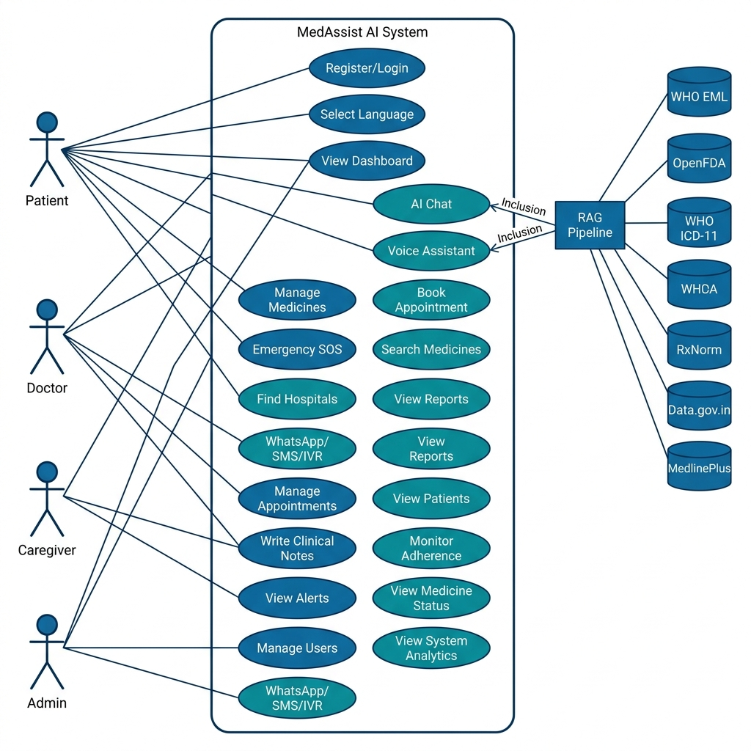
Figure 1: Use Case Diagram — MedAssist AI

13.2 System Context Diagram
Figure 2 presents the System Context Diagram showing how MedAssist AI interacts with external systems including Firebase, NVIDIA NIM API, medical data APIs, and Redis cache.
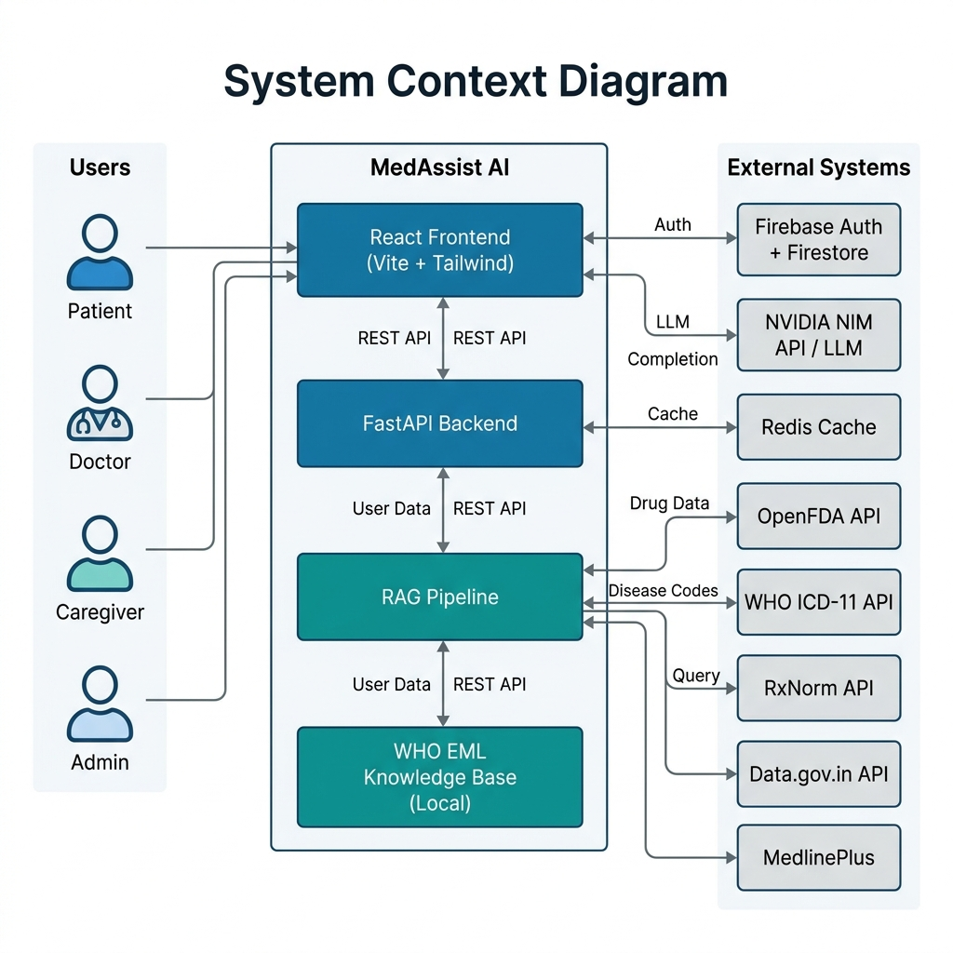
Figure 2: System Context Diagram — MedAssist AI

13.3 Requirement Flow Diagram
Figure 3 illustrates the application flow from initial app open through language selection, authentication, role routing, and dashboard navigation to the AI RAG pipeline.
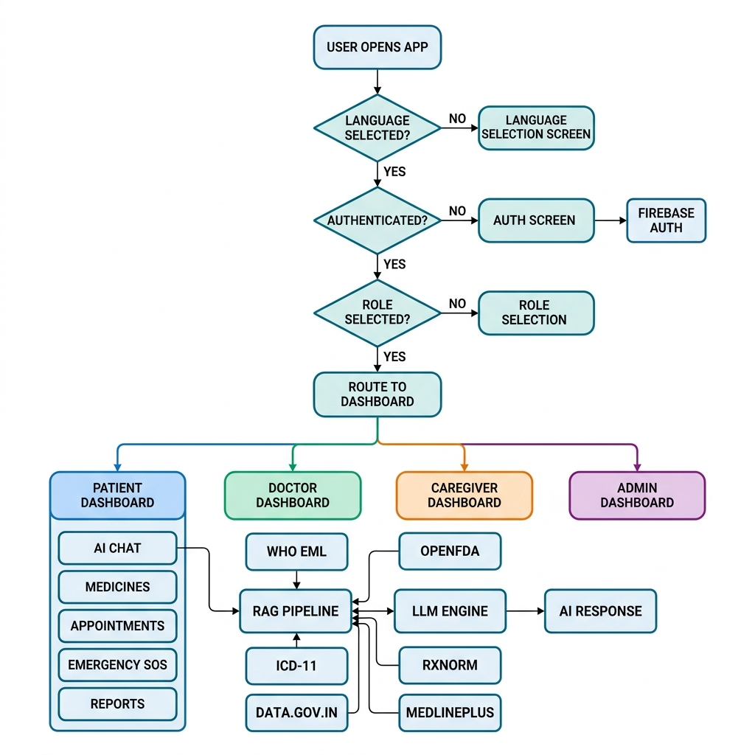
Figure 3: Requirement Flow Diagram — MedAssist AI

13.4 Data Flow Diagram — Level 0
Figure 4 shows the Level 0 Data Flow Diagram depicting data movement between the user, authentication, backend API, RAG pipeline, LLM engine, cache, audit system, and database.
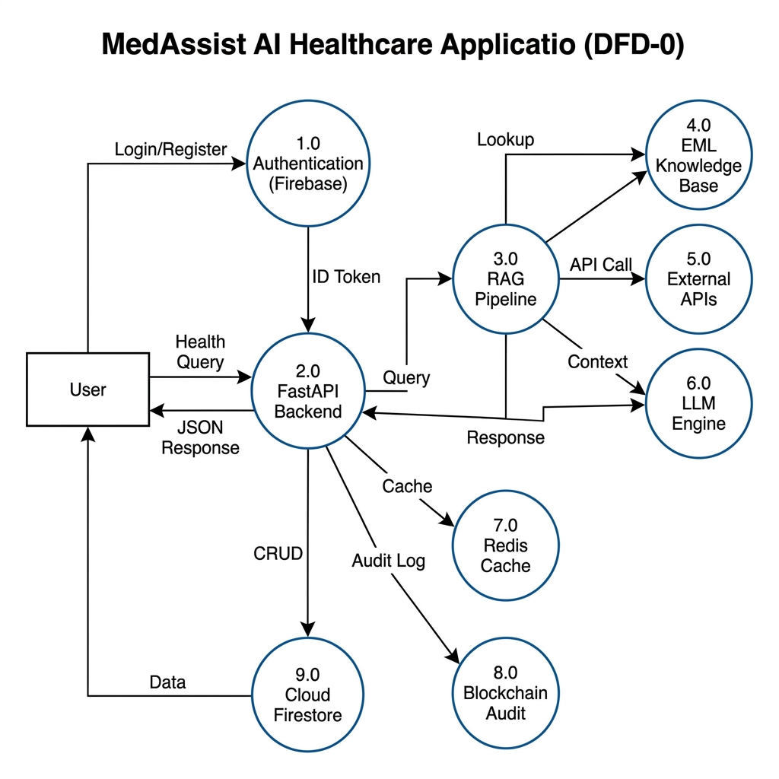
Figure 4: Data Flow Diagram Level 0 — MedAssist AI

13.5 Feature Breakdown Diagram
Figure 5 presents the hierarchical Feature Breakdown Diagram showing all 7 major modules, their sub-features, and the RAG Pipeline's 6 data sources.
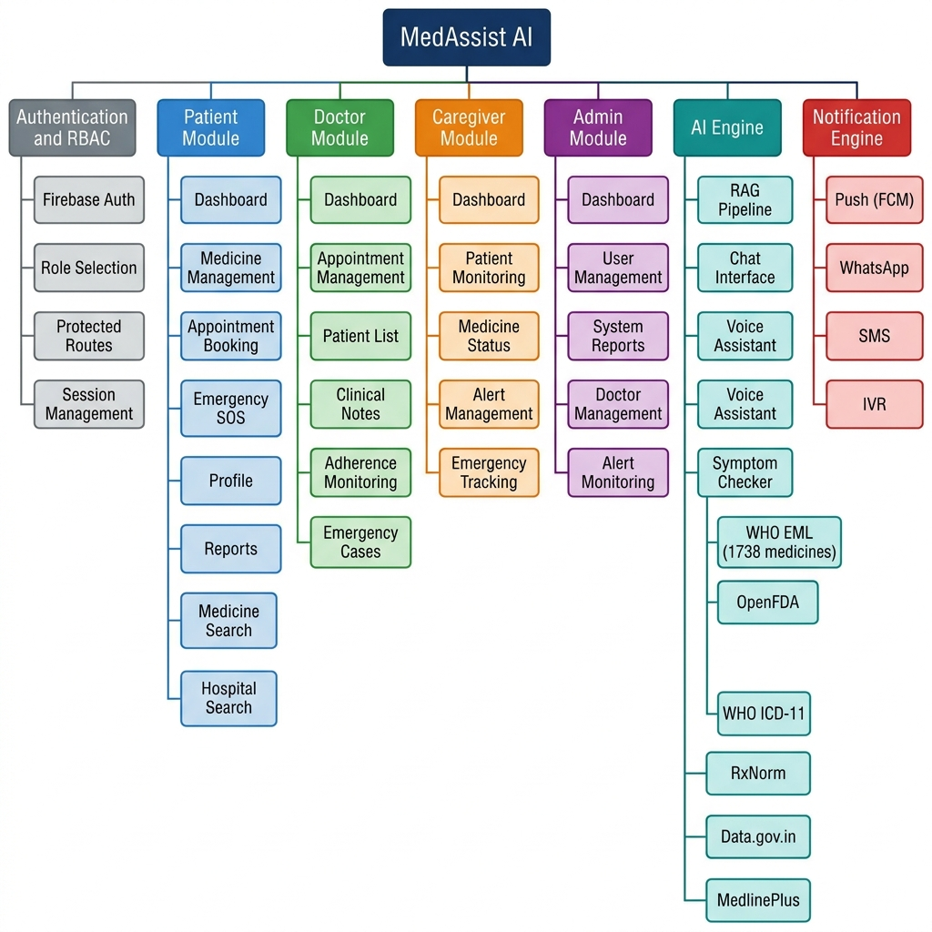
Figure 5: Feature Breakdown Diagram — MedAssist AI

14. Assumptions, Constraints, and Dependencies

14.1 Assumptions
# | Assumption
A-001 | Users have access to a modern web browser (Chrome, Firefox, Safari, or Edge)
A-002 | Users have a stable internet connection for initial load and AI queries
A-003 | Users can read at least one of the 6 supported languages
A-004 | Doctors and caregivers are registered and assigned manually in initial version
A-005 | WHO ICD-11 API and OpenFDA API will remain publicly accessible
A-006 | NVIDIA NIM API will continue hosting LLM models
A-007 | Firebase free tier is sufficient for initial deployment
A-008 | Users understand AI responses are informational, not diagnostic

14.2 Constraints
# | Constraint
C-001 | SHALL NOT provide medical diagnosis (regulatory)
C-002 | SHALL NOT prescribe medicines (regulatory)
C-003 | AI quality limited by underlying LLM capabilities
C-004 | External API availability outside system's control
C-005 | Data.gov.in API has inconsistent response times (5-15s)
C-006 | WHO ICD-11 OAuth tokens expire after 3,600 seconds
C-007 | NVIDIA NIM API has rate limits based on API key tier
C-008 | WhatsApp Business API requires Meta business verification
C-009 | Existing UI SHALL NOT be modified (design freeze)
C-010 | Python 3.10 is the minimum supported backend version

14.3 Dependencies
# | Dependency | Type | Impact if Unavailable
D-001 | Firebase Authentication | Critical | Users cannot log in
D-002 | Cloud Firestore | Critical | No data persistence
D-003 | NVIDIA NIM API | High | AI chat/voice unavailable
D-004 | OpenFDA API | Medium | Drug label data missing
D-005 | WHO ICD-11 API | Medium | Disease classification missing
D-006 | RxNorm API | Low | Drug ID fallback unavailable
D-007 | Data.gov.in API | Low | Indian health data unavailable
D-008 | Redis | Low | Caching disabled (fail-open)
D-009 | WHO EML KB (local) | High | Primary medicine lookup fails

15. Security and Medical Safety Requirements

15.1 Authentication Safety
- All users SHALL authenticate via Firebase Authentication before accessing protected features
- Firebase ID tokens SHALL be validated on every API request
- Session tokens automatically refreshed by Firebase SDK
- Failed auth returns HTTP 401 without leaking user existence

15.2 Role-Based Access Control
- Role-based route protection via ProtectedRoute component
- Patients cannot access Doctor, Caregiver, or Admin dashboards
- Role assignment immutable after initial selection (admin-changeable only)

15.3 Patient Data Privacy
- Patient data accessible only to patient, assigned doctor, assigned caregiver
- Data at rest encrypted by Google Cloud default encryption (AES-256)
- Data in transit encrypted via TLS 1.2+

15.4 API Key Protection
- All external API keys stored in server-side environment variables
- API keys NOT exposed in frontend JavaScript bundles
- FastAPI backend acts as proxy, injecting keys server-side

15.5 Secure Communication
- All client-server communication uses HTTPS
- CORS restricts origins to application domain in production

15.6 AI Response Safety
- System prompt prohibits diagnosis and prescriptions
- RAG sources only verified medical databases
- Emergency keyword detection is rule-based, not AI-dependent

15.7 Medical Disclaimer
"MedAssist AI provides general health guidance only. It does not provide medical diagnosis or prescribe medicines. Always consult a qualified healthcare professional for medical advice. In case of emergency, contact your local emergency services immediately."

15.8 Emergency Safety Handling
- Emergency keywords detected in both user input and AI responses
- Emergency flag (emergency: true) included in flagged responses
- Frontend displays prominent emergency warning
- SOS events logged immutably in audit trail

16. Acceptance Criteria

16.1 Login
# | Criteria | Expected Result
AC-LOGIN-001 | Valid email and password | Authenticated, redirected to dashboard
AC-LOGIN-002 | Invalid credentials | Error message, no navigation
AC-LOGIN-003 | Unauthenticated dashboard access | Redirected to /auth
AC-LOGIN-004 | First login role selection | Role persisted, correct dashboard loads

16.2 Language Selection
# | Criteria | Expected Result
AC-LANG-001 | Select Tamil | All UI in Tamil; AI responds in Tamil
AC-LANG-002 | Select Hindi | All UI in Hindi; AI responds in Hindi
AC-LANG-003 | Language persistence | Language remains after browser close/reopen

16.3 Medicine Reminder
# | Criteria | Expected Result
AC-MED-001 | Add morning medicine | Appears under Morning schedule
AC-MED-002 | Mark as taken | Status: Taken with timestamp
AC-MED-003 | Miss marking | Status: Missed
AC-MED-004 | Caregiver view | Sees same list with taken/missed status

16.4 Appointment Booking
# | Criteria | Expected Result
AC-APPT-001 | Book appointment | Appears as Pending for both parties
AC-APPT-002 | Doctor confirms | Status: Confirmed; patient notified
AC-APPT-003 | Doctor completes | Status: Completed
AC-APPT-004 | Patient cancels | Status: Cancelled

16.5 AI Chatbot
# | Criteria | Expected Result
AC-CHAT-001 | Ask 'What is paracetamol?' | WHO EML + OpenFDA data in response
AC-CHAT-002 | Ask about diabetes | ICD-11 codes + EML medicines
AC-CHAT-003 | Ask in Tamil | Entire response in Tamil
AC-CHAT-004 | Mention 'chest pain' | Emergency flag and warning
AC-CHAT-005 | Source citations | Sources listed at end
AC-CHAT-006 | Medical disclaimer | Disclaimer in every response

16.6 Voice Assistant
# | Criteria | Expected Result
AC-VOICE-001 | Speak health question | Transcribed and processed
AC-VOICE-002 | Hindi voice input | Accurate transcription; Hindi response
AC-VOICE-003 | Emergency keywords | Emergency flag set

16.7 Symptom Checker
# | Criteria | Expected Result
AC-SYMP-001 | Describe 'fever and headache' | General guidance with ICD-11 codes
AC-SYMP-002 | No diagnosis | Says 'consult a doctor'

16.8 Emergency SOS
# | Criteria | Expected Result
AC-SOS-001 | Tap SOS button | Event recorded with timestamp
AC-SOS-002 | Caregiver alert | Active emergency on caregiver dashboard
AC-SOS-003 | Emergency contacts | Phone numbers visible
AC-SOS-004 | Audit log | SOS event in audit trail

16.9 Caregiver Alerts
# | Criteria | Expected Result
AC-CARE-001 | Patient misses medicine | Caregiver notification
AC-CARE-002 | Patient triggers SOS | Immediate emergency alert
AC-CARE-003 | Medicine status view | All patient medicines visible

16.10 Admin
# | Criteria | Expected Result
AC-ADMIN-001 | View dashboard | System-wide metrics displayed
AC-ADMIN-002 | View all patients | Complete list with search
AC-ADMIN-003 | View all doctors | Complete doctor list
AC-ADMIN-004 | View system reports | Analytics charts rendered

17. References

17.1 Medical API References
# | API | URL | Usage
1 | OpenFDA API | https://open.fda.gov/apis | Drug labels, adverse events
2 | WHO ICD-11 API | https://icd.who.int/icdapi | Disease classification
3 | RxNorm API | https://rxnav.nlm.nih.gov | Drug identification
4 | Data.gov.in | https://data.gov.in | Indian health datasets
5 | MedlinePlus | https://medlineplus.gov | Medical encyclopedia
6 | WHO EML | who.int/essential-medicines | Medicine reference data

17.2 Technology References
# | Technology | URL
1 | React 19 | https://react.dev
2 | Vite | https://vite.dev
3 | Tailwind CSS 4 | https://tailwindcss.com
4 | FastAPI | https://fastapi.tiangolo.com
5 | Firebase | https://firebase.google.com
6 | NVIDIA NIM | https://build.nvidia.com
7 | Pydantic | https://docs.pydantic.dev
8 | Redis | https://redis.io
9 | Docker | https://www.docker.com
10 | OpenAI Whisper | https://openai.com/research/whisper

17.3 Project References
# | Reference | Description
1 | IEEE 830-1998 | IEEE Recommended Practice for SRS
2 | WHO Digital Health Guidelines | WHO digital health recommendations
3 | India ABDM Framework | Ayushman Bharat Digital Mission guidelines
4 | HIPAA Guidelines | Data privacy best practices reference

18. Appendix

Appendix A: Functional Requirement ID List
ID Range | Module
FR-AUTH-001 to FR-AUTH-008 | Authentication and Role Management
FR-LANG-001 to FR-LANG-006 | Language Selection
FR-PROF-001 to FR-PROF-004 | Patient Profile
FR-MED-001 to FR-MED-006 | Medicine Reminder
FR-MSTAT-001 to FR-MSTAT-004 | Medicine Status Tracking
FR-APPT-001 to FR-APPT-005 | Appointment Booking (Patient)
FR-DAPPT-001 to FR-DAPPT-005 | Appointment Management (Doctor)
FR-CHAT-001 to FR-CHAT-012 | AI Chatbot
FR-VOICE-001 to FR-VOICE-006 | Voice Assistant
FR-SYMP-001 to FR-SYMP-004 | Symptom Checker
FR-MINFO-001 to FR-MINFO-005 | Medicine Information
FR-HOSP-001 to FR-HOSP-003 | Hospital Finder
FR-SOS-001 to FR-SOS-006 | Emergency SOS
FR-CARE-001 to FR-CARE-004 | Caregiver Alerts
FR-NOTIF-001 to FR-NOTIF-004 | WhatsApp / SMS / IVR
FR-ADMIN-001 to FR-ADMIN-007 | Admin Management
FR-LOG-001 to FR-LOG-005 | System Logs
Total Functional Requirements: 87

Appendix B: Non-Functional Requirement ID List
ID Range | Category
NFR-PERF-001 to NFR-PERF-006 | Performance
NFR-USE-001 to NFR-USE-006 | Usability
NFR-REL-001 to NFR-REL-004 | Reliability
NFR-AVAIL-001 to NFR-AVAIL-003 | Availability
NFR-SCALE-001 to NFR-SCALE-004 | Scalability
NFR-SEC-001 to NFR-SEC-006 | Security
NFR-PRIV-001 to NFR-PRIV-004 | Privacy
NFR-ACC-001 to NFR-ACC-005 | Accessibility
NFR-MAINT-001 to NFR-MAINT-005 | Maintainability
NFR-COMPAT-001 to NFR-COMPAT-004 | Compatibility
NFR-LOC-001 to NFR-LOC-004 | Localization
NFR-MEDSAFE-001 to NFR-MEDSAFE-005 | Medical Safety
Total Non-Functional Requirements: 56

Appendix C: API Reference List
# | API Name | Type | Auth | Status
1 | OpenFDA Drug Labels | REST | API Key | Active
2 | OpenFDA Adverse Events | REST | API Key | Active
3 | WHO ICD-11 Search | REST | OAuth2 | Active
4 | WHO ICD-11 Entity | REST | OAuth2 | Active
5 | RxNorm Drugs | REST | None | Active
6 | RxNorm Properties | REST | None | Active
7 | Data.gov.in Jan Aushadhi | REST | API Key | Active
8 | Data.gov.in Hospitals | REST | API Key | Active
9 | MedlinePlus | REST | None | Active
10 | NVIDIA NIM LLM | REST | API Key | Active
11 | NVIDIA NIM Whisper | REST | API Key | Active
12 | Firebase Auth | SDK | Config | Active
13 | Cloud Firestore | SDK | Config | Active
14 | DrugBank | REST | License | Future
15 | Infermedica | REST | API Key | Future
16 | ApiMedic | REST | API Key | Future
17 | SNOMED CT | REST | License | Future
18 | LOINC | REST | License | Future
19 | HL7 FHIR | REST | Varies | Future

Appendix D: Glossary
Term | Definition
ATC Code | Anatomical Therapeutic Chemical classification by WHO
Audit Trail | Chronological record of system activities
Blockchain Audit | Hash-chained audit log entries for immutability
Cloud Firestore | Google's serverless NoSQL document database
EML | WHO Model List of Essential Medicines
Fail-Open | System continues operating when a dependency fails
FastAPI | Modern Python web framework for building APIs
ICD-11 | International Classification of Diseases, 11th Revision
Jan Aushadhi | Indian govt program for affordable generic medicines
LLM | Large Language Model for natural language understanding
NVIDIA NIM | Cloud platform for deploying and serving AI models
OAuth2 Client Credentials | OAuth2 grant type for machine-to-machine auth
RAG | Retrieval-Augmented Generation technique
Redis | In-memory key-value store for caching
RxCUI | RxNorm Concept Unique Identifier
Vite | Next-generation frontend build tool

End of Software Requirements Specification Document
MedAssist AI — Version 2.0.0 — July 2026

