MedAssist AI
Intelligent Multilingual Healthcare Assistant

━━━━━━━━━━━━━━━━━━━━━━━━━━━━━━━━━━━━━━━━━━━━━━━━━━━━━━━━━━━━

DATABASE DESIGN DOCUMENT

Field | Details
Project Title | MedAssist AI — Intelligent Multilingual Healthcare Assistant
Document Type | Database Design Document
Database Platform | Google Cloud Firestore (NoSQL Document Database)
Backend Framework | FastAPI (Python 3.10+)
Authentication | Firebase Authentication (Email / Password)
Version | 2.0.0
Prepared By | MedAssist AI Engineering Team
Date | July 2026

Table of Contents
1. List of Entities
2. List of Attributes
3. Entity-Relationship Diagrams
4. Relationships Between Entities
5. Database Design — Collection Schemas
5.1. User Management Collections
5.2. Patient Health Profile Collections
5.3. Doctor Professional Collections
5.4. Caregiver Monitoring Collections
5.5. Medicine Management Collections
5.6. Appointment Booking Collections
5.7. Emergency SOS Collections
5.8. AI Chat and Voice Collections
5.9. Notification Engine Collections
5.10. Alert Management Collections
5.11. Reports and Analytics Collections
5.12. Audit and Compliance Collections
5.13. System Configuration Collections
6. Firestore Security Rules
7. Composite Index Requirements
8. Data Integrity and Business Rules
9. Complete Collection Summary

1. List of Entities

1. User Management Module
- User
- UserRole
- UserPreference
- SecurityCredential
- SessionLog
- AccountStatus

2. Patient Health Profile Module
- PatientProfile
- EmergencyContact
- Allergy
- ChronicCondition
- BloodGroup
- PatientStatus

3. Doctor Professional Module
- DoctorProfile
- Specialization
- HospitalAffiliation
- DoctorAvailability
- ClinicalNote

4. Caregiver Monitoring Module
- CaregiverProfile
- CaregiverPatientMapping
- AlertPreference
- CaregiverRelationshipType

5. Medicine Management Module
- MedicineSchedule
- MedicineLog
- MedicineSlot
- ReminderConfiguration
- WHOEssentialMedicine
- MedicineCategory

6. Appointment Booking Module
- Appointment
- AppointmentStatus
- AppointmentSlot
- AppointmentReason
- AppointmentPolicy

7. Emergency SOS Module
- SOSEvent
- SOSNotification
- EmergencyService
- SOSStatus

8. AI Chat and Voice Module
- ChatSession
- ChatMessage
- VoiceSession
- RAGQueryLog
- ChatLanguageSetting

9. Notification Engine Module
- Notification
- NotificationChannel
- NotificationTemplate
- NotificationPreference
- DeliveryLog

10. Alert Management Module
- Alert
- AlertType
- AlertSeverity
- AlertStatus

11. Reports and Analytics Module
- HealthReport
- AdherenceReport
- SystemReport
- ReportType
- ReportSchedule

12. Audit and Compliance Module
- AuditLog
- ConsentRecord
- BlockchainBlock
- DataAccessLog

13. System Configuration Module
- SystemSetting
- LanguageLocale
- APIConfiguration
- RateLimitPolicy
- FeatureFlag

2. List of Attributes

1. User Management Module

User
Attribute | Description
user_id | Firebase UID — unique identifier for each user
email | Registered email address of the user
display_name | Full name of the user as displayed in the interface
role | User role: patient / doctor / caregiver / admin
phone | Contact phone number with country code
language_preference | Preferred language code: en / hi / ta / kn / ml / te
profile_photo_url | URL of the user's profile picture
is_active | Whether the user account is currently active
email_verified | Whether the email has been verified via Firebase
created_at | Timestamp of account creation
updated_at | Timestamp of last profile update
last_login | Timestamp of last successful login
deleted | Soft delete flag

2. Patient Health Profile Module

PatientProfile
Attribute | Description
patient_id | Reference to user_id — one-to-one relationship
age | Patient's age in years
gender | Patient's gender: Male / Female / Other
blood_group | Blood group: A+ / A- / B+ / B- / AB+ / AB- / O+ / O-
condition | Primary medical condition description
allergies | Array of known allergies
chronic_conditions | Array of chronic conditions (diabetes, hypertension)
assigned_doctor_id | Reference to the assigned doctor user_id
assigned_caregiver_id | Reference to the assigned caregiver user_id
health_score | Calculated health score 0–100
adherence | Medicine adherence percentage 0–100
status | Patient status: Active / Stable / Needs Attention / Critical

3. Doctor Professional Module

DoctorProfile
Attribute | Description
doctor_id | Reference to user_id — one-to-one relationship
specialization | Medical specialization of the doctor
hospital | Name of the affiliated hospital or clinic
experience_years | Number of years of professional experience
qualification | Medical qualifications and degrees
license_number | Medical license or registration number
rating | Average patient rating 0.0–5.0
is_accepting_patients | Whether the doctor is accepting new patients

5. Medicine Management Module

MedicineSchedule
Attribute | Description
medicine_id | Unique identifier for the medicine schedule entry
patient_id | Reference to the patient this medicine belongs to
name | Name of the medicine
dosage | Dosage amount and unit: 500mg / 10ml
frequency | Administration frequency: Once daily / Twice daily
schedule_slots | Array of time slots: morning / afternoon / evening / night
reminder_times | Array of specific reminder times: 08:00 / 20:00
is_active | Whether the medicine schedule is currently active

6. Appointment Booking Module

Appointment
Attribute | Description
appointment_id | Unique identifier for the appointment
patient_id | Reference to the patient user_id
doctor_id | Reference to the doctor user_id
date | Appointment date in ISO format YYYY-MM-DD
time | Appointment time e.g. 10:00 AM
reason | Reason for the appointment provided by the patient
status | Scheduled / Confirmed / Completed / Missed / Cancelled

7. Emergency SOS Module

SOSEvent
Attribute | Description
sos_id | Unique identifier for the SOS event
patient_id | Reference to the patient who triggered the SOS
timestamp | Date and time the SOS was triggered
location_latitude | GPS latitude coordinate if available
location_longitude | GPS longitude coordinate if available
status | SOS status: Active / Acknowledged / Resolved / False Alarm
severity | Severity level: Low / Medium / High / Critical
notified_contacts | Array of user_ids who were notified

12. Audit and Compliance Module

AuditLog
Attribute | Description
audit_id | Unique identifier for the audit log entry
record_type | Type: medical_record / consent / prescription / access_log
actor_id | User_id of the user who performed the audited action
action | Action: create / read / update / delete / verify
data_hash | SHA-256 hash of the record data for integrity
previous_hash | Hash of the previous audit log — blockchain chaining
block_hash | Combined hash for immutability verification
block_index | Sequential index of this block in the audit chain

3. Entity-Relationship Diagrams
The following Entity-Relationship (ER) diagrams visually represent the database structure of MedAssist AI across all 13 modules. Each diagram shows entities (collections), their key attributes, and the relationships between them including cardinality (1:1, 1:M, M:M).

3.0 Complete ER Overview
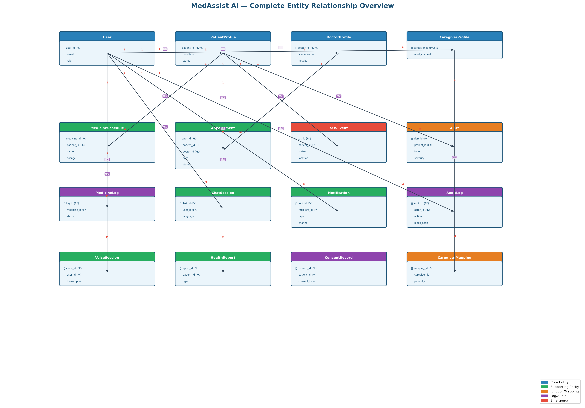

3.1 Module 1: User Management
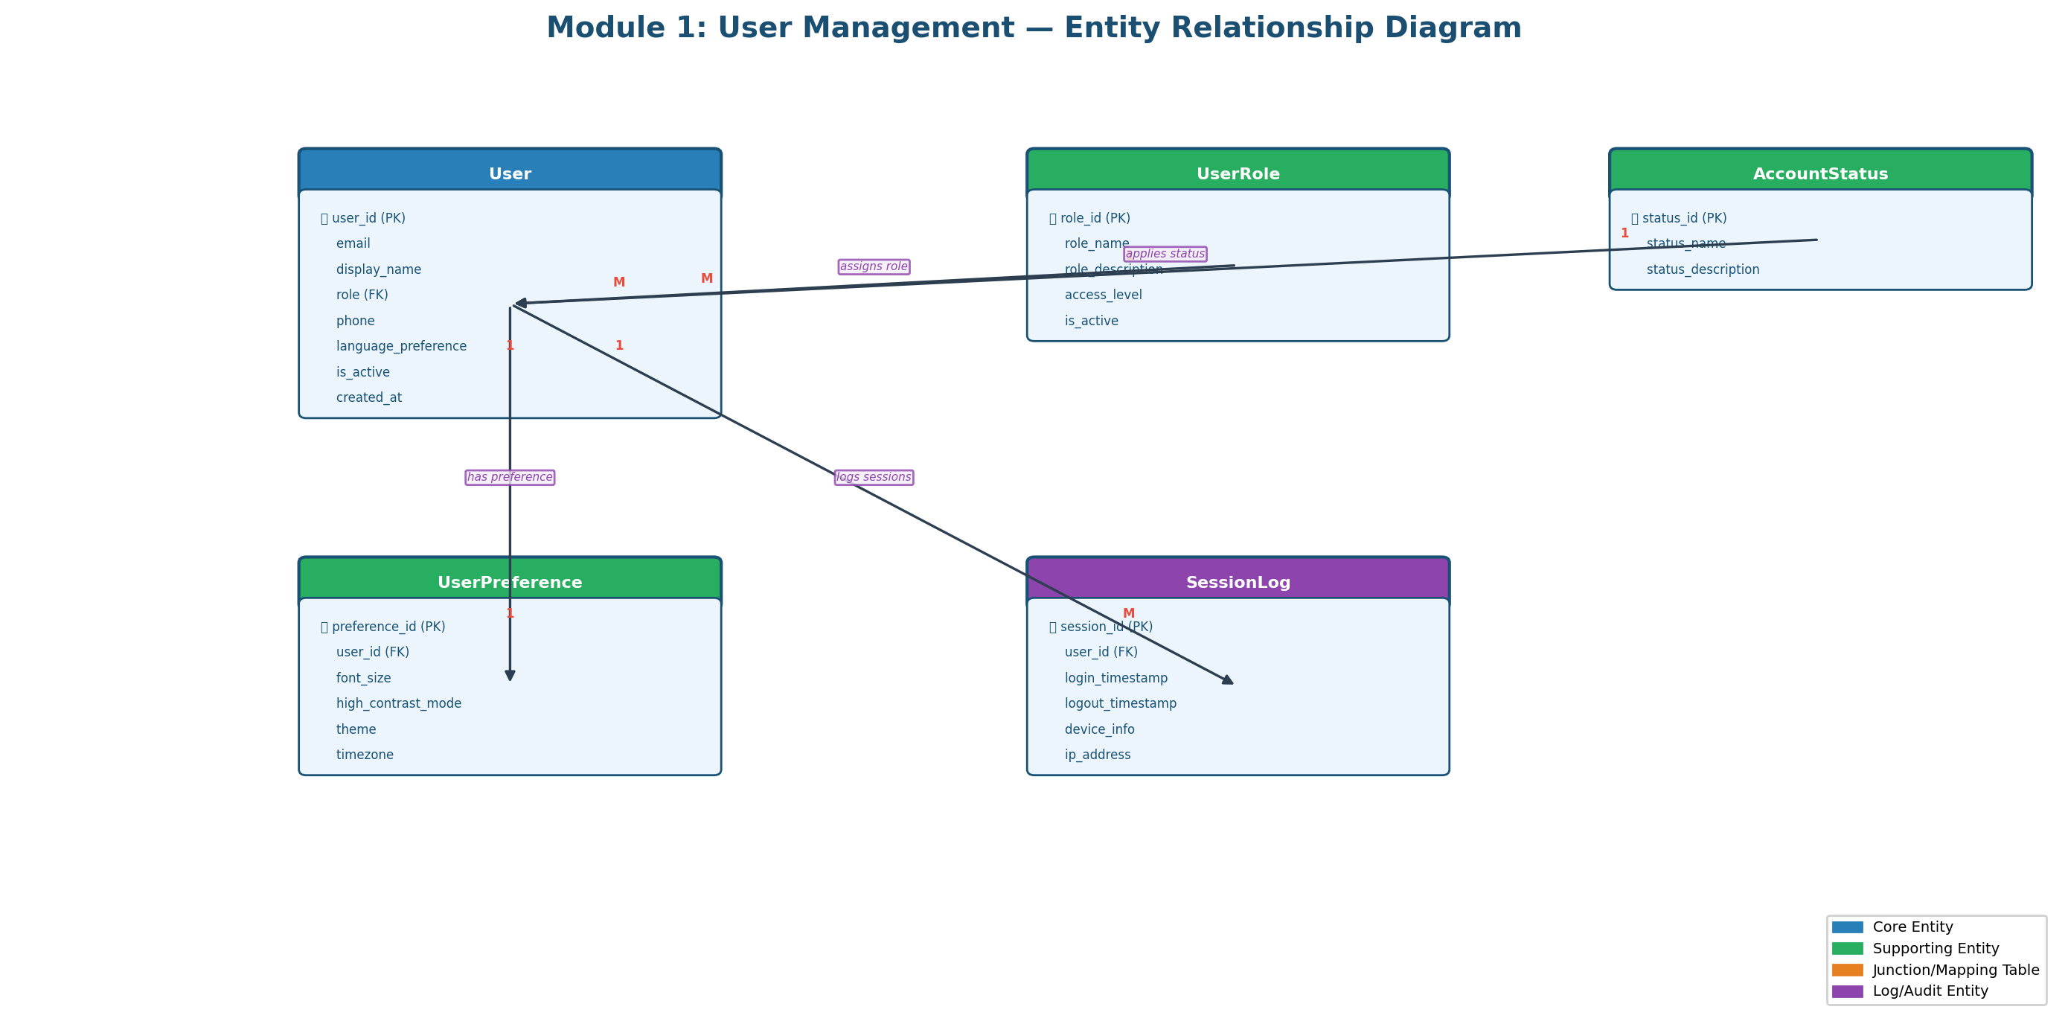

3.2 Module 2: Patient Health Profile
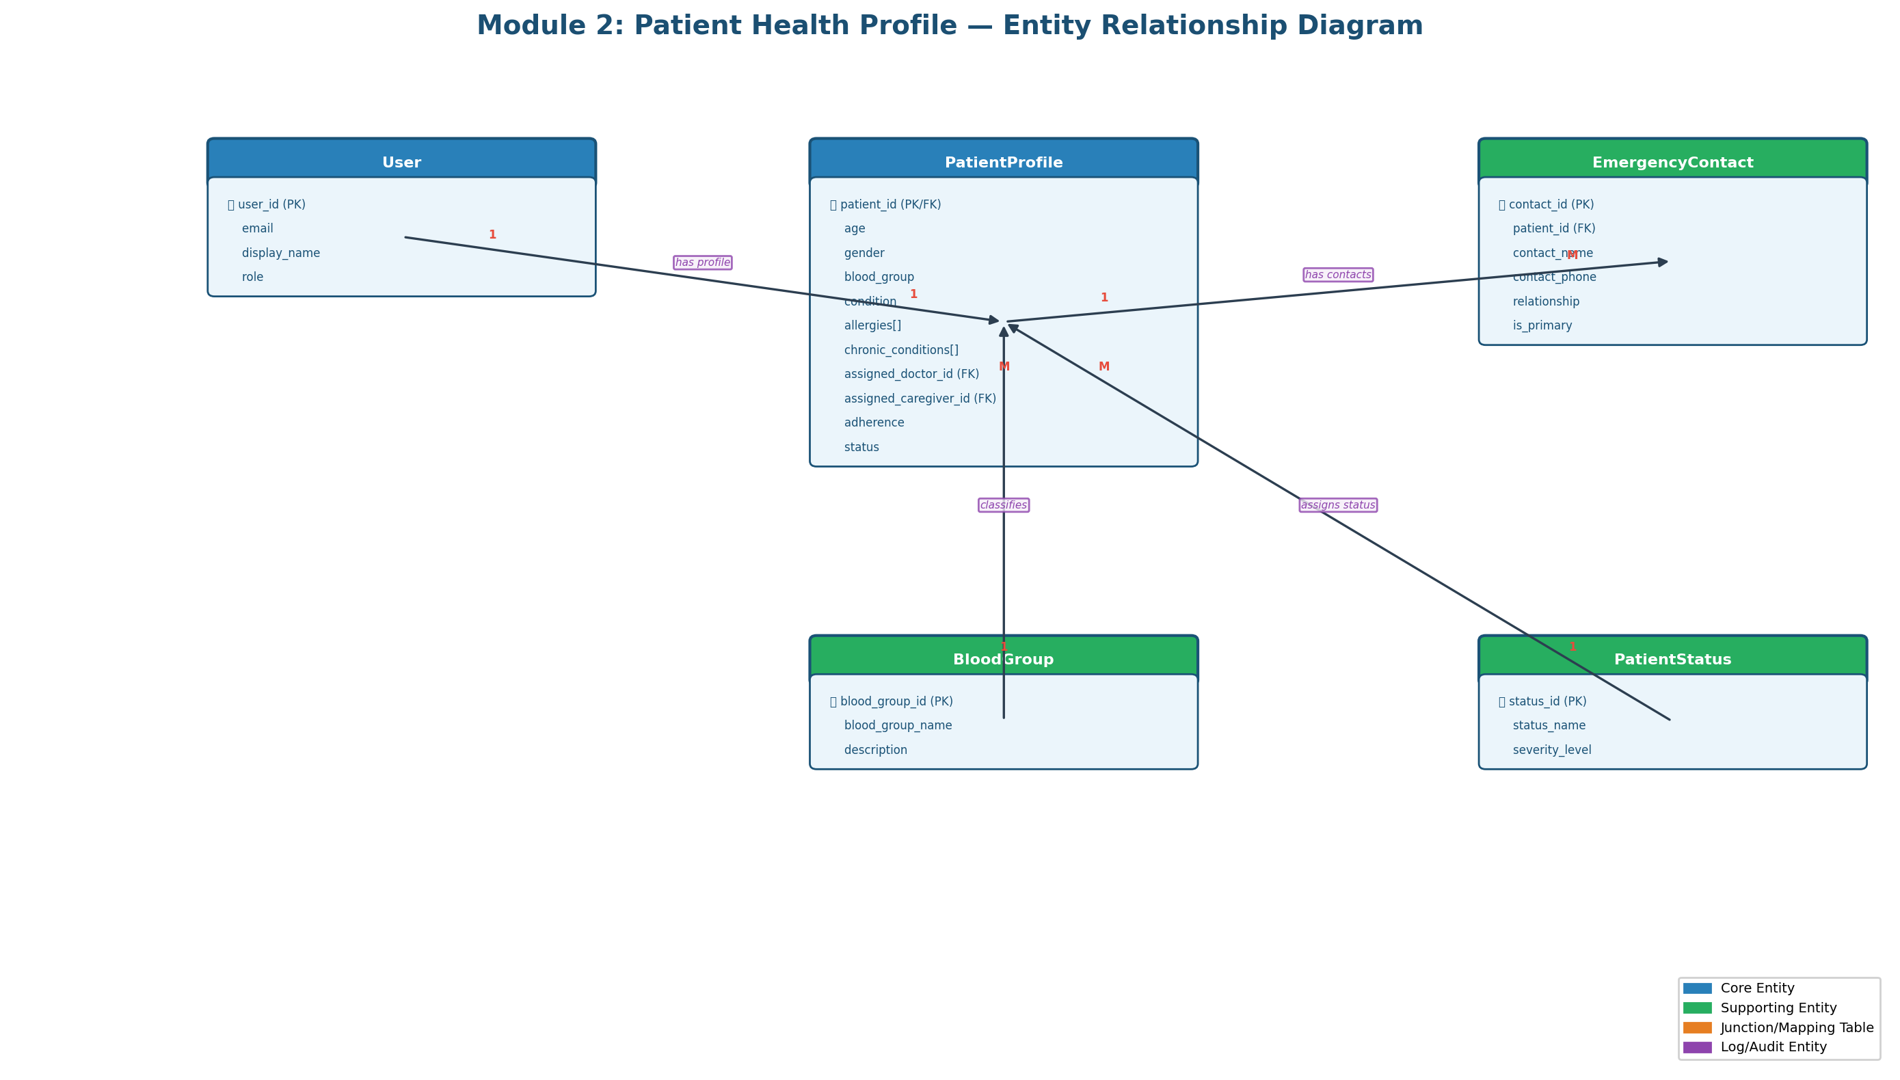

3.3 Module 3: Doctor Professional
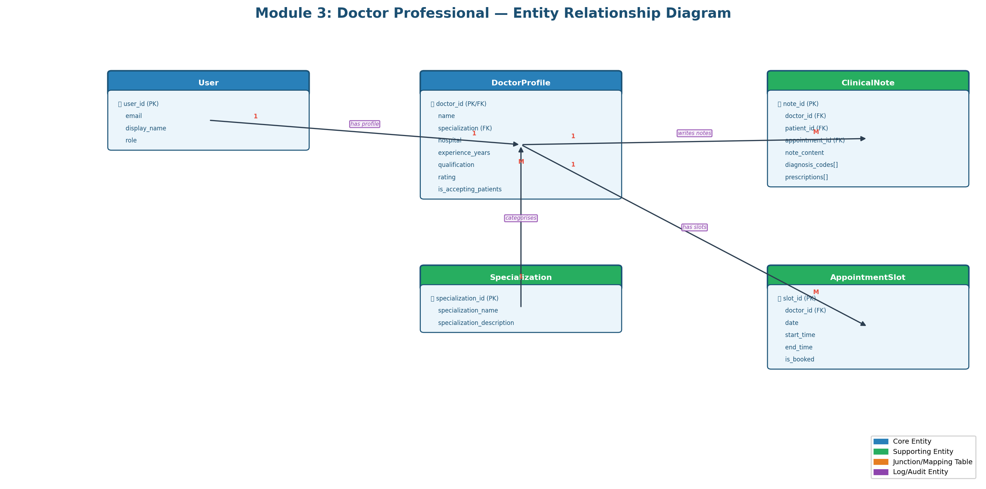

3.4 Module 4: Caregiver Monitoring
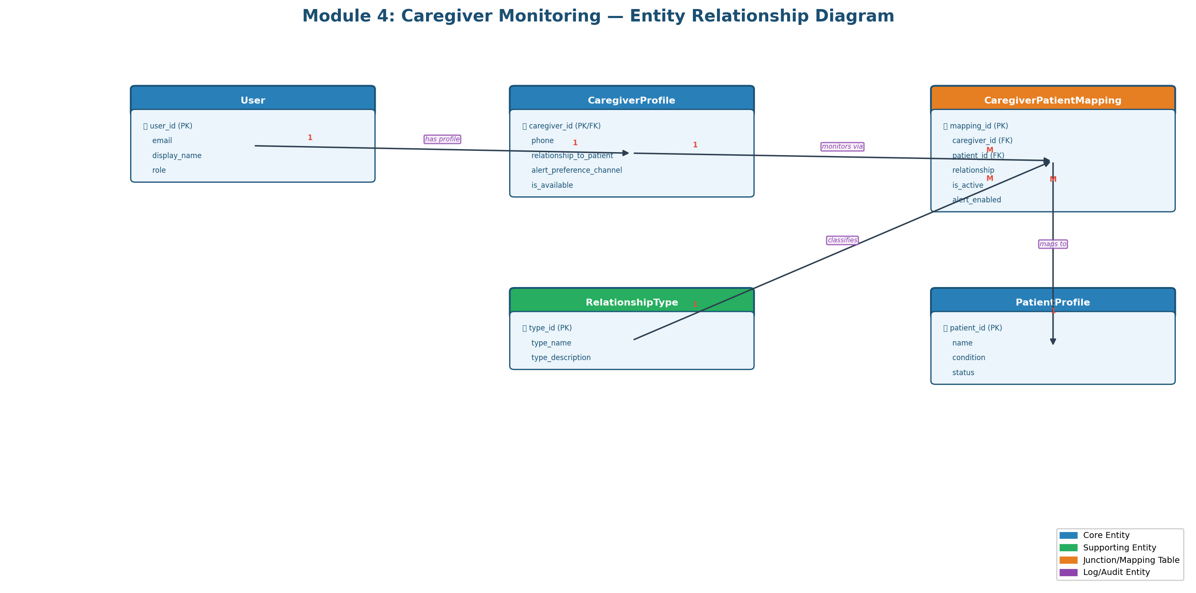

3.5 Module 5: Medicine Management
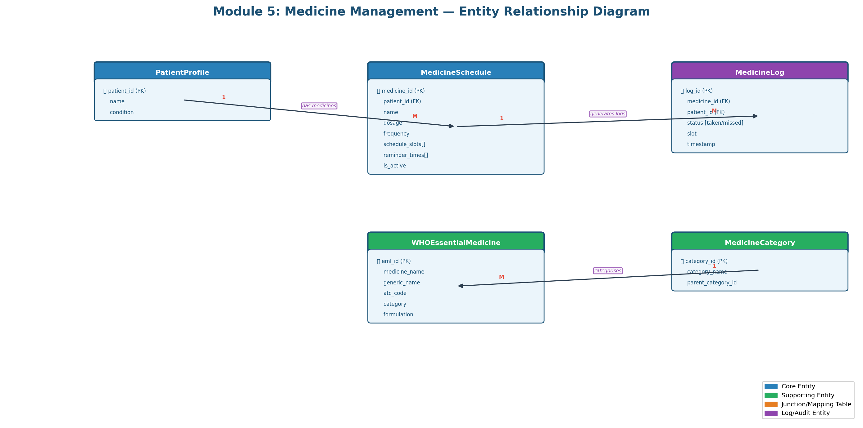

3.6 Module 6: Appointment Booking
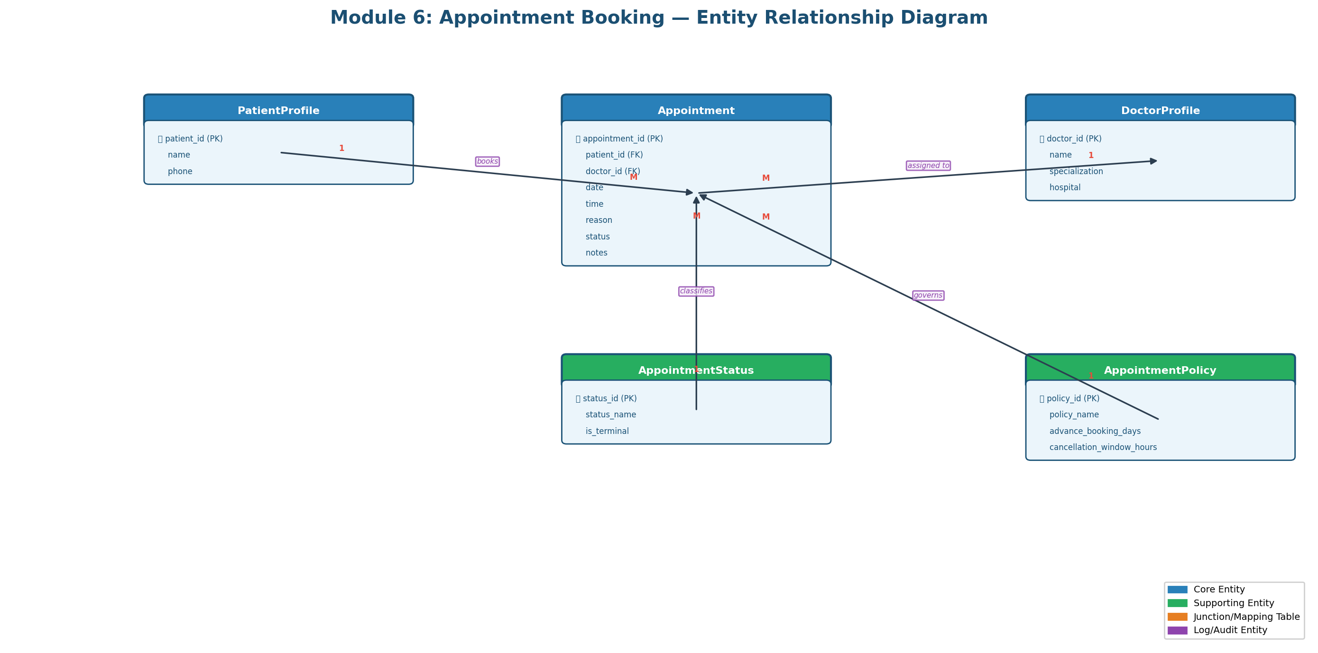

3.7 Module 7: Emergency SOS
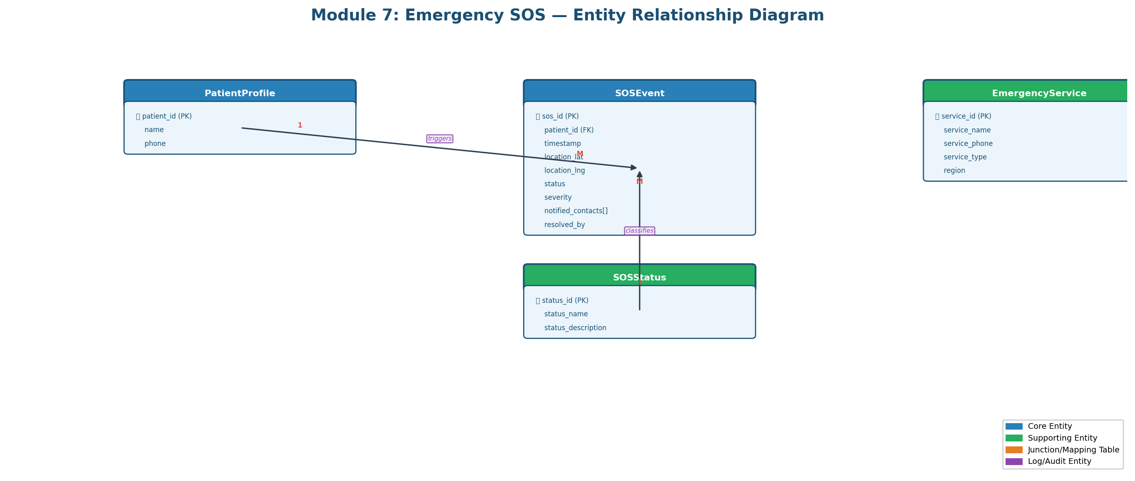

3.8 Module 8: AI Chat and Voice
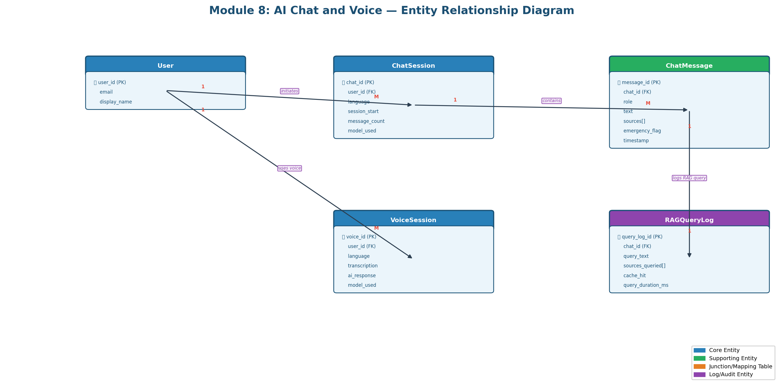

3.9 Module 9: Notification Engine
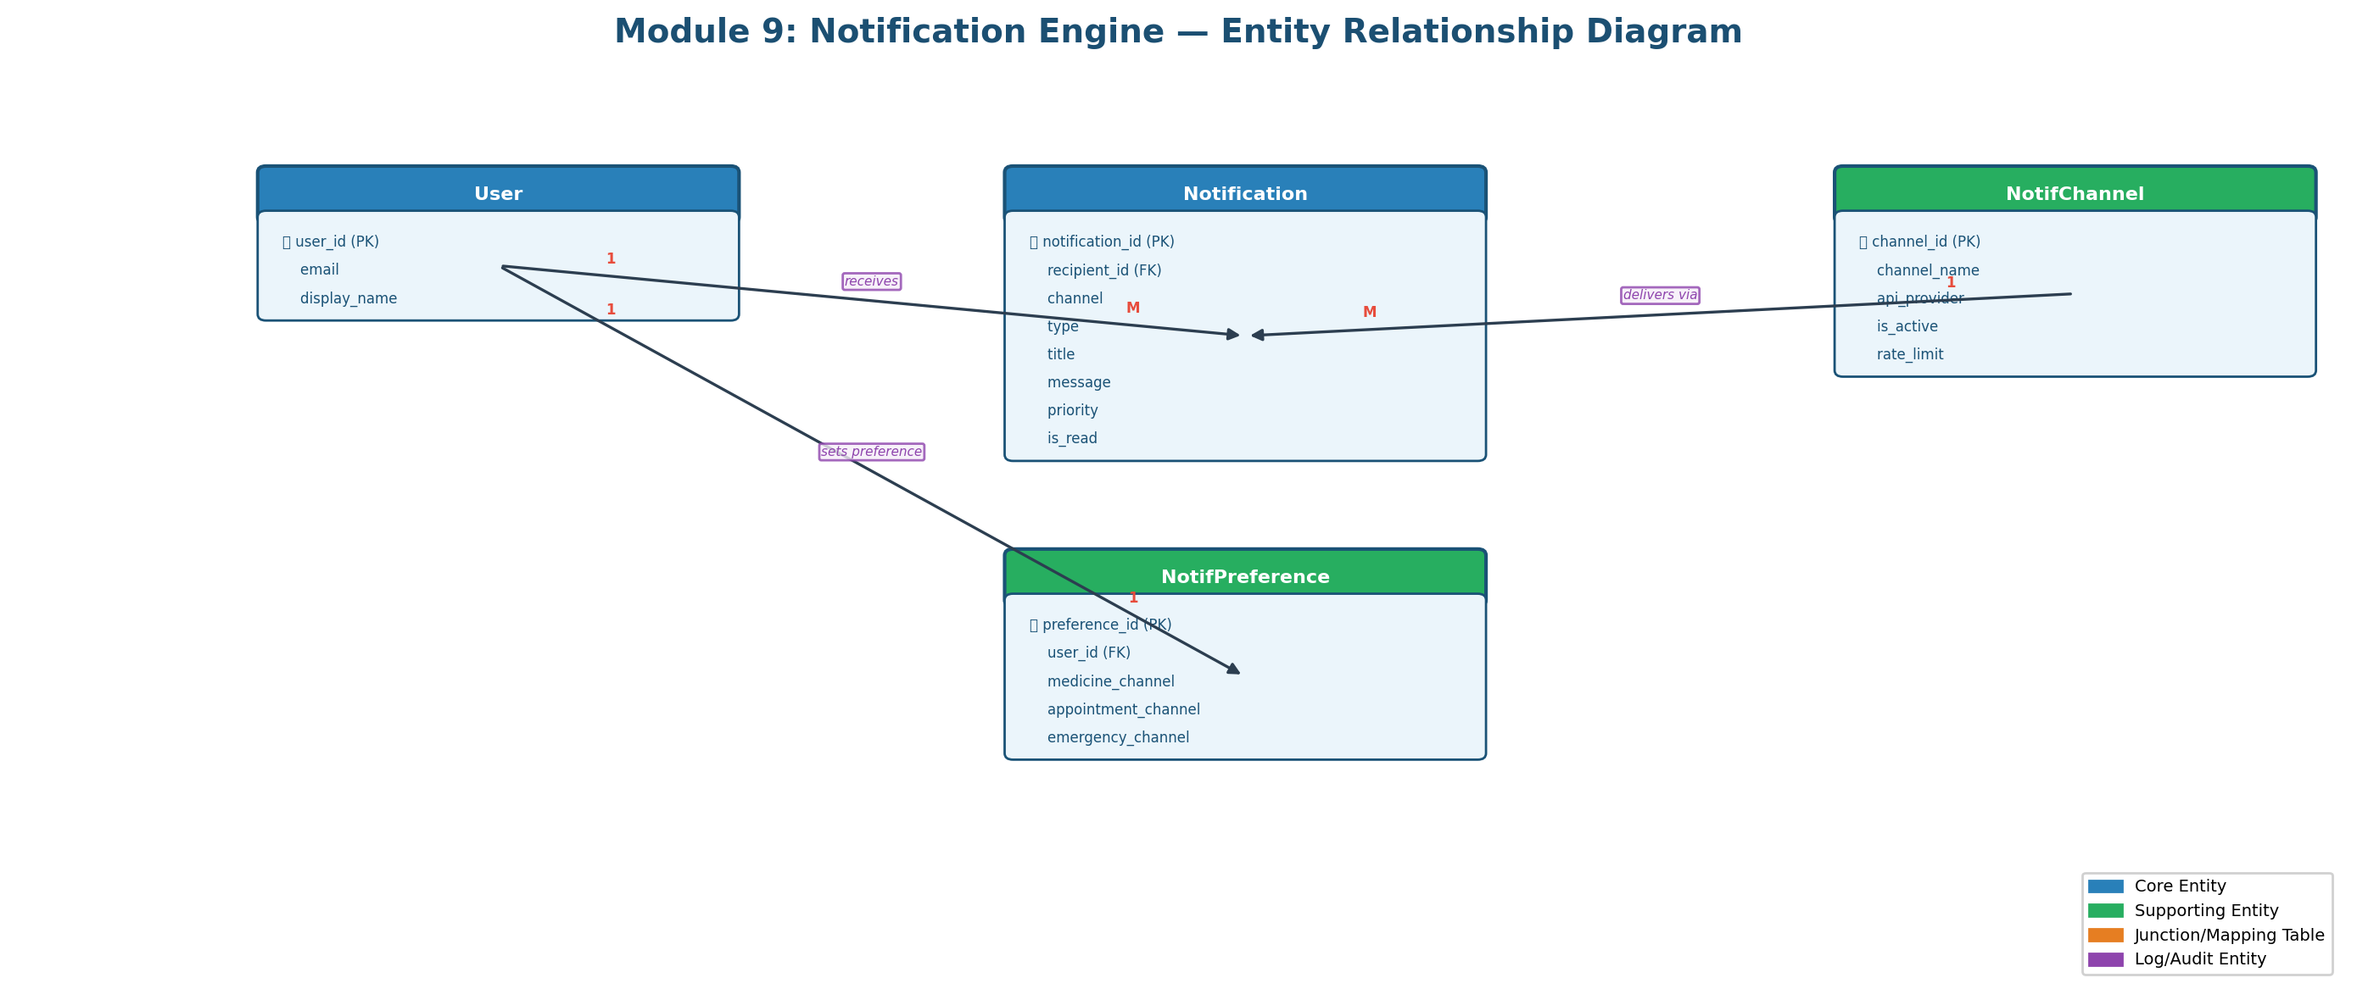

3.10 Module 10: Alert Management
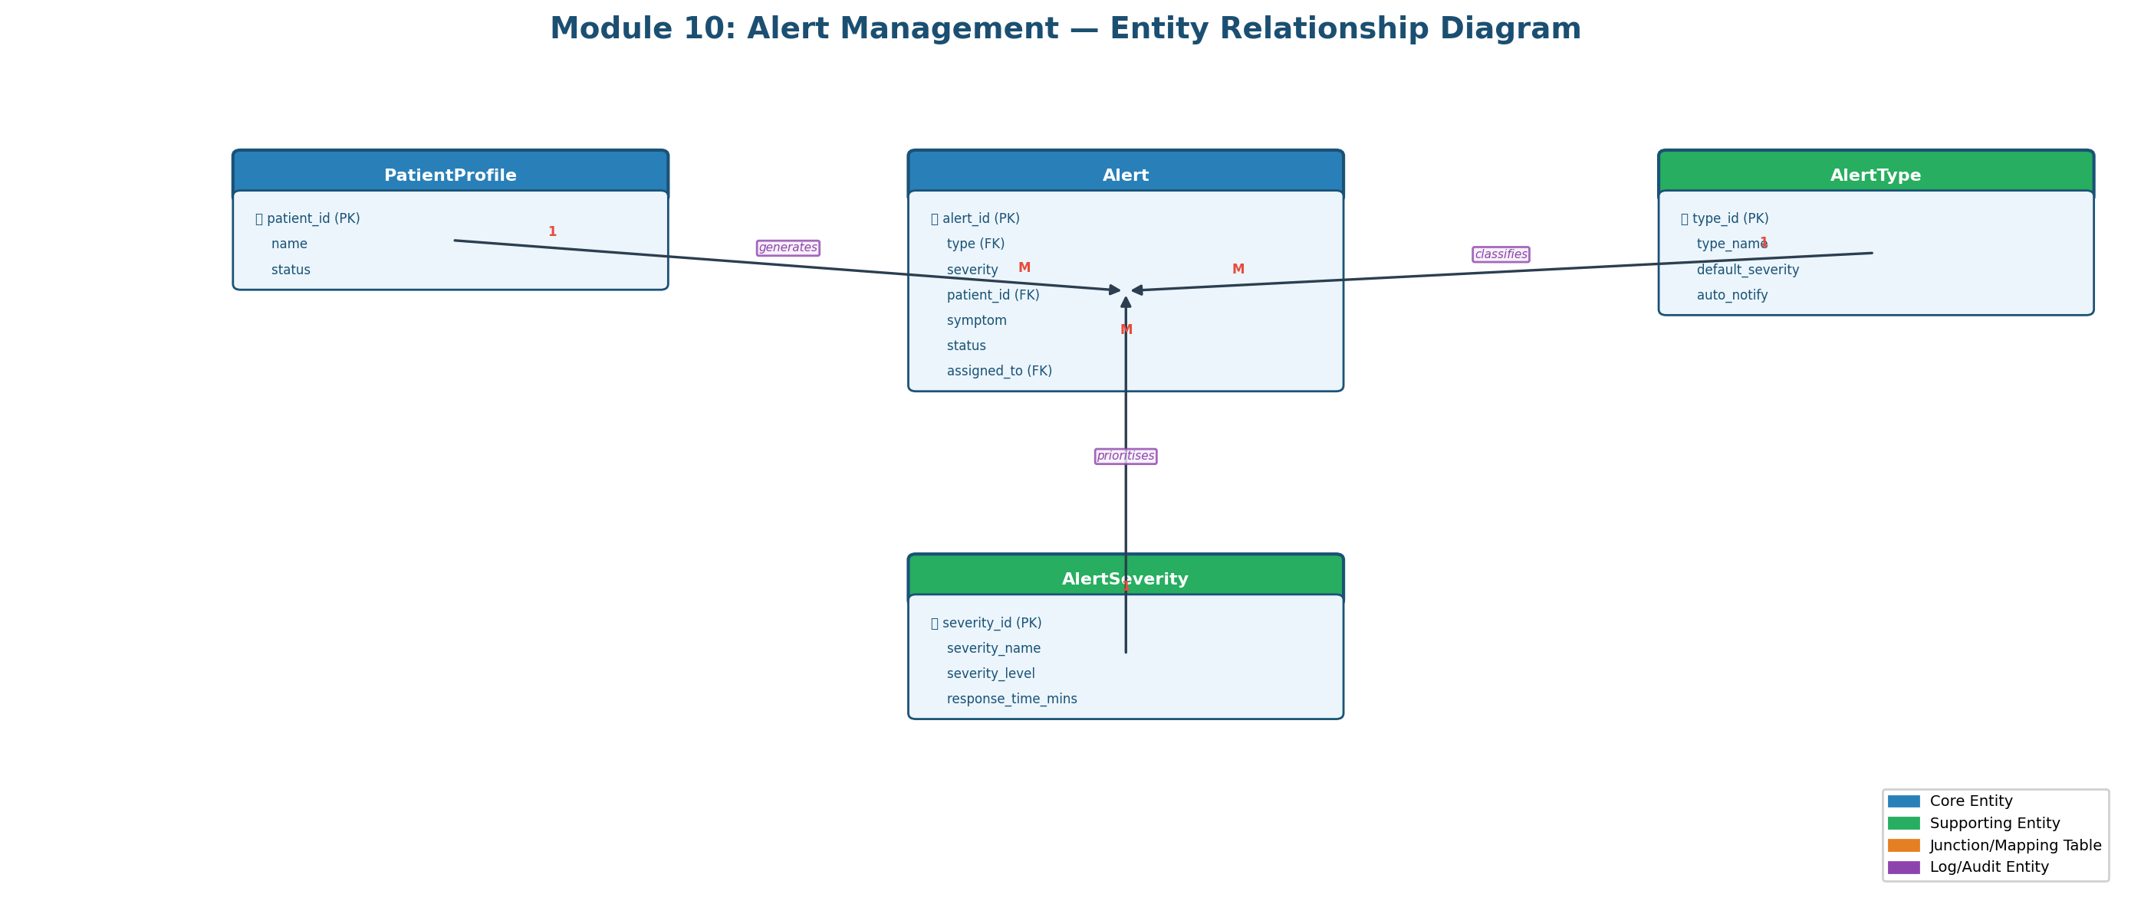

3.11 Module 11: Reports and Analytics
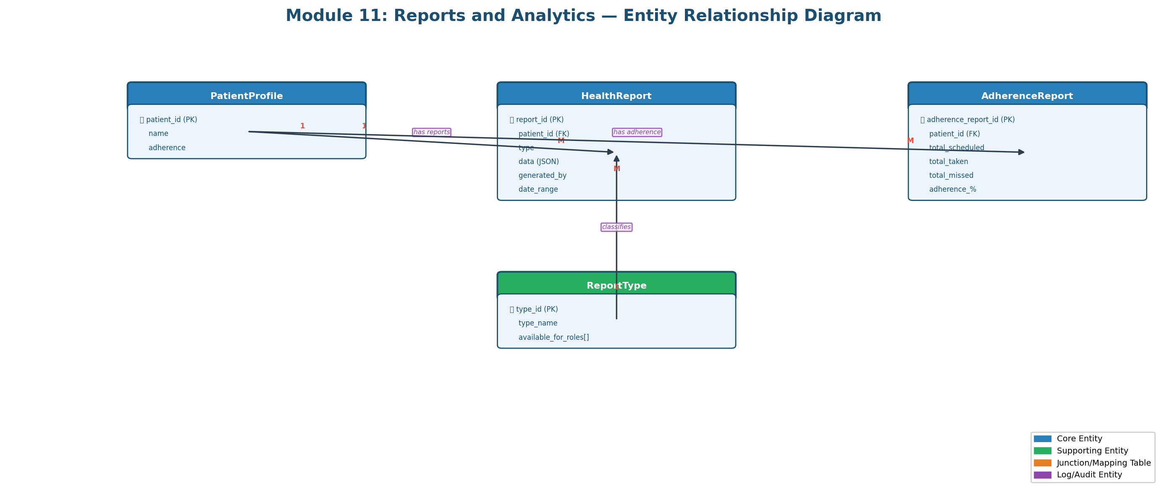

3.12 Module 12: Audit and Compliance
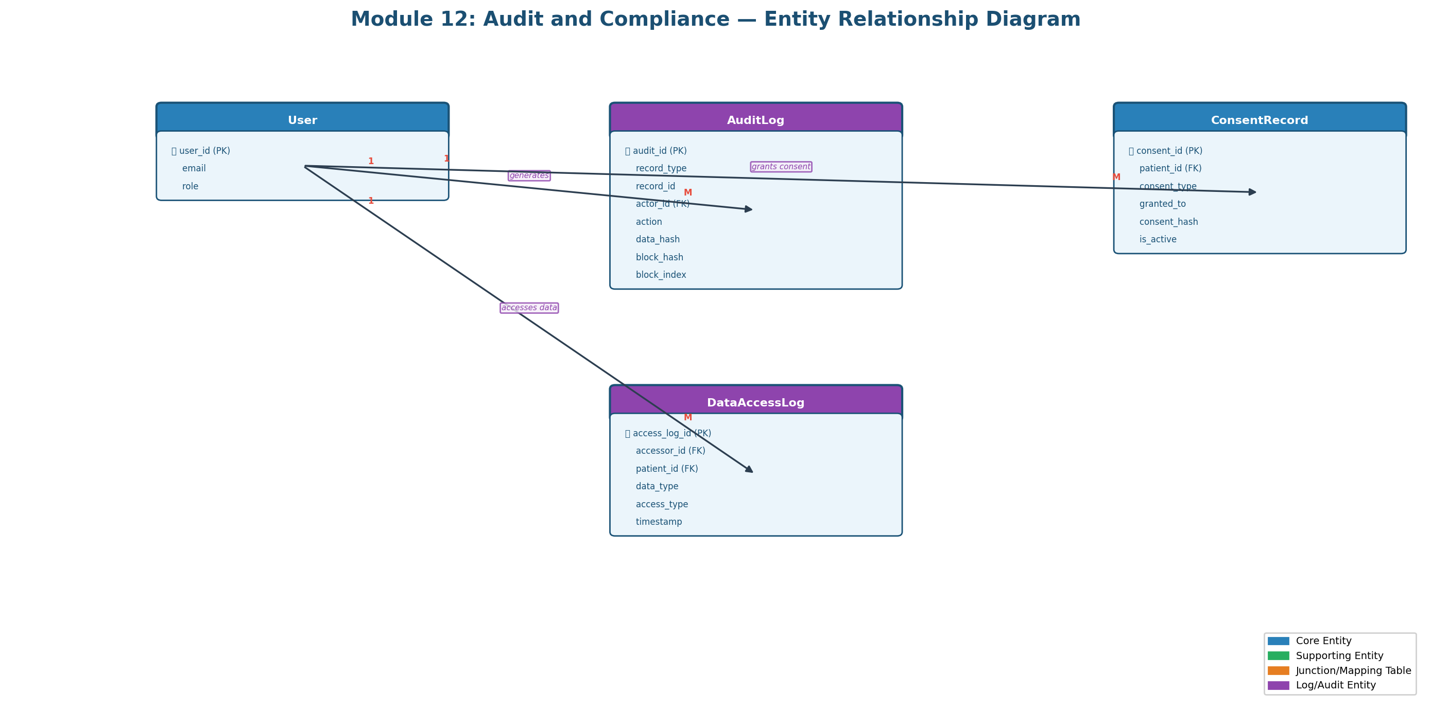

4. Relationships Between Entities

User Management
Entity A | Entity B | Cardinality | Description
UserRole | User | 1 to M | One role assigned to many users
User | UserPreference | 1 to 1 | Each user has one preference record
User | SessionLog | 1 to M | One user has many login sessions
AccountStatus | User | 1 to M | One status applies to many accounts

Patient Health Profile
Entity A | Entity B | Cardinality | Description
User | PatientProfile | 1 to 1 | Each patient user has one profile
PatientProfile | EmergencyContact | 1 to M | One patient has many emergency contacts
BloodGroup | PatientProfile | 1 to M | One blood group applies to many patients
PatientProfile | DoctorProfile | M to 1 | Many patients assigned to one doctor

Doctor Professional
Entity A | Entity B | Cardinality | Description
User | DoctorProfile | 1 to 1 | Each doctor user has one profile
Specialization | DoctorProfile | 1 to M | One specialization for many doctors
DoctorProfile | ClinicalNote | 1 to M | One doctor writes many notes

Caregiver Monitoring
Entity A | Entity B | Cardinality | Description
User | CaregiverProfile | 1 to 1 | Each caregiver has one profile
CaregiverProfile | PatientProfile | M to M | Many-to-many via CaregiverPatientMapping

Medicine Management
Entity A | Entity B | Cardinality | Description
PatientProfile | MedicineSchedule | 1 to M | One patient has many schedules
MedicineSchedule | MedicineLog | 1 to M | One schedule generates many logs
DoctorProfile | MedicineSchedule | 1 to M | One doctor prescribes many schedules

Appointment Booking
Entity A | Entity B | Cardinality | Description
PatientProfile | Appointment | 1 to M | One patient books many appointments
DoctorProfile | Appointment | 1 to M | One doctor has many appointments
Appointment | ClinicalNote | 1 to 1 | Each appointment may have one note

Emergency SOS
Entity A | Entity B | Cardinality | Description
PatientProfile | SOSEvent | 1 to M | One patient triggers many SOS events
SOSEvent | Notification | 1 to M | One SOS sends many notifications

AI Chat and Voice
Entity A | Entity B | Cardinality | Description
User | ChatSession | 1 to M | One user has many chat sessions
ChatSession | ChatMessage | 1 to M | One session has many messages
User | VoiceSession | 1 to M | One user has many voice sessions
ChatMessage | RAGQueryLog | 1 to 1 | Each response has one RAG log

Alert and Notification
Entity A | Entity B | Cardinality | Description
PatientProfile | Alert | 1 to M | One patient has many alerts
User | Notification | 1 to M | One user receives many notifications
SOSEvent | Alert | 1 to 1 | Each SOS generates one critical alert

Audit and Compliance
Entity A | Entity B | Cardinality | Description
User | AuditLog | 1 to M | One user generates many audit entries
PatientProfile | ConsentRecord | 1 to M | One patient grants many consents
AuditLog | AuditLog | 1 to 1 | Blockchain-style hash chaining

5. Database Design — Firestore Collection Schemas
Firestore organises data into collections (equivalent to tables) and documents (equivalent to rows). Each document contains fields (equivalent to columns).

5.1 User Management

Collection: users
Field | Data Type | Constraints | Description
user_id (doc ID) | String | PK, Firebase UID | Unique user identifier
email | String | Required, Unique, Indexed | Email address
display_name | String | Required | Full name
role | String | Required, Enum | patient/doctor/caregiver/admin
phone | String | Optional | Phone with country code
language_preference | String | Default: 'en' | en/hi/ta/kn/ml/te
is_active | Boolean | Default: true | Account active flag
created_at | Timestamp | Auto-set | Creation timestamp
updated_at | Timestamp | Auto-set | Update timestamp
deleted | Boolean | Default: false | Soft delete flag

5.2 Patient Health Profile

Collection: patients
Field | Data Type | Constraints | Description
patient_id (doc ID) | String | PK, FK → users | Same as user_id
age | Number | Range [0-150] | Patient's age
gender | String | Enum | Male/Female/Other
blood_group | String | Enum | A+/A-/B+/B-/AB+/AB-/O+/O-
condition | String | Required | Primary condition
allergies | Array<String> | Optional | Known allergies
chronic_conditions | Array<String> | Optional | Chronic conditions
assigned_doctor_id | String | FK → doctors | Assigned doctor
assigned_caregiver_id | String | FK → caregivers | Assigned caregiver
adherence | Number | Range [0-100] | Medicine adherence %
status | String | Enum | Active/Stable/Needs Attention/Critical
deleted | Boolean | Default: false | Soft delete flag

5.3 Doctor Professional

Collection: doctors
Field | Data Type | Constraints | Description
doctor_id (doc ID) | String | PK, FK → users | Same as user_id
name | String | Required | Doctor's full name
specialization | String | Required | Specialization
hospital | String | Required | Affiliated hospital
experience_years | Number | Range [0-60] | Years of experience
rating | Number | Range [0.0-5.0] | Average rating
is_accepting_patients | Boolean | Default: true | Accepting patients
deleted | Boolean | Default: false | Soft delete flag

Collection: clinical_notes
Field | Data Type | Constraints | Description
note_id (doc ID) | String | PK, Auto-gen | Note identifier
doctor_id | String | FK → doctors, Indexed | Author doctor
patient_id | String | FK → patients, Indexed | Subject patient
note_content | String | Required | Clinical note text
diagnosis_codes | Array<String> | Optional | ICD-11 codes
prescriptions | Array<Map> | Optional | Prescribed medicines

5.4 Caregiver Monitoring

Collection: caregivers
Field | Data Type | Constraints | Description
caregiver_id (doc ID) | String | PK, FK → users | Same as user_id
phone | String | Optional | Contact phone
alert_preference_channel | String | Enum | push/sms/whatsapp
is_available | Boolean | Default: true | Availability
deleted | Boolean | Default: false | Soft delete flag

Collection: caregiver_patient_mappings
Field | Data Type | Constraints | Description
mapping_id (doc ID) | String | PK, Auto-gen | Mapping identifier
caregiver_id | String | FK → caregivers, Indexed | Caregiver ref
patient_id | String | FK → patients, Indexed | Patient ref
relationship | String | Required | Relationship type
is_active | Boolean | Default: true | Active flag

5.5 Medicine Management

Collection: medicines
Field | Data Type | Constraints | Description
medicine_id (doc ID) | String | PK, Auto-gen | Medicine identifier
patient_id | String | FK → patients, Indexed | Patient reference
name | String | Required | Medicine name
dosage | String | Required | Dosage: 500mg
frequency | String | Required | Frequency description
reminder_times | Array<String> | Default: [] | Reminder times
is_active | Boolean | Default: true | Active flag
deleted | Boolean | Default: false | Soft delete flag

Collection: medicine_logs
Field | Data Type | Constraints | Description
log_id (doc ID) | String | PK, Auto-gen | Log identifier
medicine_id | String | FK → medicines, Indexed | Medicine ref
patient_id | String | FK → patients, Indexed | Patient ref
status | String | Enum [taken, missed] | Dose status
slot | String | Enum | morning/afternoon/evening/night
timestamp | Timestamp | Required | Event timestamp

5.6 Appointment Booking

Collection: appointments
Field | Data Type | Constraints | Description
appointment_id (doc ID) | String | PK, Auto-gen | Appointment ID
patient_id | String | FK → patients, Indexed | Patient reference
patient_name | String | Required | Patient display name
doctor_id | String | FK → doctors, Indexed | Doctor reference
doctor_name | String | Required | Doctor display name
date | String | Format: YYYY-MM-DD | Appointment date
time | String | Required | Appointment time
status | String | Enum | Scheduled/Confirmed/Completed/Cancelled
deleted | Boolean | Default: false | Soft delete flag

5.7 Emergency SOS

Collection: sos_events
Field | Data Type | Constraints | Description
sos_id (doc ID) | String | PK, Auto-gen | SOS identifier
patient_id | String | FK → patients, Indexed | Patient reference
timestamp | Timestamp | Required | SOS trigger time
location_latitude | Number | Optional | GPS latitude
location_longitude | Number | Optional | GPS longitude
status | String | Enum | Active/Acknowledged/Resolved
severity | String | Enum | Low/Medium/High/Critical
notified_contacts | Array<String> | Default: [] | Notified IDs

5.8 AI Chat and Voice

Collection: chats
Field | Data Type | Constraints | Description
chat_id (doc ID) | String | PK, Auto-gen | Chat session ID
user_id | String | FK → users, Indexed | User reference
language | String | Enum | en/hi/ta/kn/ml/te
session_start | Timestamp | Required | Session start
message_count | Number | Default: 0 | Message count
model_used | String | Default | AI model identifier

Collection: voice_sessions
Field | Data Type | Constraints | Description
voice_id (doc ID) | String | PK, Auto-gen | Voice session ID
user_id | String | FK → users, Indexed | User reference
language | String | Enum | en/hi/ta/kn/ml/te
transcription | String | Required | Whisper transcription
ai_response | String | Required | AI response text

5.9 Notification Engine

Collection: notifications
Field | Data Type | Constraints | Description
notification_id (doc ID) | String | PK, Auto-gen | Notification ID
recipient_id | String | FK → users, Indexed | Recipient
channel | String | Enum | push/sms/whatsapp/ivr/email
type | String | Enum | medicine_reminder/appointment/sos/alert
message | String | Required | Content text
is_read | Boolean | Default: false | Read status

5.10 Alert Management

Collection: alerts
Field | Data Type | Constraints | Description
alert_id (doc ID) | String | PK, Auto-gen | Alert identifier
type | String | Enum | Emergency/Missed Medicine/Warning
severity | String | Enum | Low/Medium/High/Critical
patient_name | String | Required | Patient display name
symptom | String | Required | Alert description
status | String | Enum | unread/read/Resolved/Dismissed
deleted | Boolean | Default: false | Soft delete flag

5.11 Reports and Analytics

Collection: reports
Field | Data Type | Constraints | Description
report_id (doc ID) | String | PK, Auto-gen | Report identifier
patient_id | String | FK → patients, Indexed | Patient reference
type | String | Enum | Health Summary/Lab Results/Adherence
data | Map (JSON) | Optional | Report payload
generated_at | Timestamp | Optional | Generation time

5.12 Audit and Compliance

Collection: audit_logs
Field | Data Type | Constraints | Description
audit_id (doc ID) | String | PK, Auto-gen | Audit identifier
record_type | String | Enum | medical_record/consent/prescription
actor_id | String | FK → users, Indexed | Acting user
action | String | Enum | create/read/update/delete/verify
data_hash | String | Optional | SHA-256 hash
block_hash | String | Required | Block hash
block_index | Number | Required | Sequential index
verified | Boolean | Default: true | Integrity flag

Collection: consent_records
Field | Data Type | Constraints | Description
consent_id (doc ID) | String | PK, Auto-gen | Consent ID
patient_id | String | FK → patients, Indexed | Patient ref
consent_type | String | Enum | data_sharing/treatment/research
granted_to | String | Required | Entity receiving consent
consent_hash | String | Required | SHA-256 hash
is_active | Boolean | Default: true | Active flag

5.13 System Configuration

Collection: system_settings
Field | Data Type | Constraints | Description
setting_id (doc ID) | String | PK, Key name | Setting identifier
setting_key | String | Required, Unique | Setting key
setting_value | Dynamic | Required | Setting value
category | String | Required | Setting category

Collection: language_locales
Field | Data Type | Constraints | Description
locale_id (doc ID) | String | PK, Lang code | Locale ID
language_code | String | Unique | ISO code
language_name | String | Required | English name
native_name | String | Required | Native script name
is_active | Boolean | Default: true | Enabled flag

6. Firestore Security Rules (RBAC)
Role-Based Access Control (RBAC) is enforced through Firestore Security Rules. Only authenticated users can access data, and operations are restricted by user role.

Collection | Read | Create | Update | Delete
users | Owner or Admin | Owner | Owner or Admin | Admin only
patients | Owner / Doctor / Caregiver / Admin | Patient or Admin | Owner / Doctor / Admin | Admin only
doctors | All authenticated | Doctor or Admin | Owner or Admin | Admin only
medicines | All authenticated | Patient / Doctor / Admin | Patient / Doctor / Admin | Patient or Admin
appointments | All authenticated | Patient or Admin | Patient / Doctor / Admin | Admin only
sos_events | All authenticated | Patient only | Doctor / Caregiver / Admin | Not allowed
alerts | All authenticated | All authenticated | Doctor / Caregiver / Admin | Admin only
audit_logs | Admin only | All authenticated | Not allowed (immutable) | Not allowed
chats | All authenticated | All authenticated | All authenticated | Not allowed
reports | All authenticated | Doctor or Admin | Doctor or Admin | Admin only
system_settings | All authenticated | Admin only | Admin only | Admin only

7. Composite Index Requirements
Collection | Index Fields | Query Purpose
patients | assigned_doctor_id ASC, status ASC | Doctor's patients by status
patients | assigned_caregiver_id ASC, status ASC | Caregiver's patients by status
medicines | patient_id ASC, is_active ASC | Active medicines for a patient
medicine_logs | patient_id ASC, timestamp DESC | Recent logs for a patient
appointments | patient_id ASC, date DESC | Patient's appointments by date
appointments | doctor_id ASC, date ASC, status ASC | Doctor's appointments
sos_events | patient_id ASC, timestamp DESC | SOS history for a patient
sos_events | status ASC, timestamp DESC | Active SOS events
chats | user_id ASC, session_start DESC | User's chat sessions
alerts | patient_id ASC, status ASC, created_at DESC | Patient alerts
notifications | recipient_id ASC, is_read ASC, created_at DESC | Unread notifications
audit_logs | actor_id ASC, timestamp DESC | Audit trail by user
audit_logs | record_type ASC, timestamp DESC | Audit trail by type

8. Data Integrity and Business Rules

Referential Integrity Rules
- Every patient_id MUST reference a valid user with role = 'patient'
- Every doctor_id MUST reference a valid user with role = 'doctor'
- Every caregiver_id MUST reference a valid user with role = 'caregiver'
- Appointment patient_id and doctor_id MUST reference existing documents

Soft Delete Rules
- All primary collections implement soft delete via 'deleted' Boolean field
- Soft-deleted documents are excluded from all list queries
- Hard delete is restricted to admin users (GDPR compliance)

Timestamp Rules
- created_at is auto-set on creation and MUST NOT be modified
- updated_at is auto-set on every document update
- All timestamps use ISO 8601 format in UTC timezone

Status Transition Rules
- Appointment: Scheduled → Confirmed → Completed (terminal) OR Cancelled (terminal)
- SOS: Active → Acknowledged → Resolved (terminal) OR False Alarm (terminal)
- Alert: unread → read → Resolved (terminal) OR Dismissed (terminal)
- Terminal statuses MUST NOT transition to any other status

Data Validation Rules
- Email addresses MUST conform to RFC 5322 format
- Phone numbers MUST include country code prefix
- Age MUST be in range 0–150
- Adherence percentage MUST be in range 0–100
- Health score MUST be in range 0–100
- Doctor rating MUST be in range 0.0–5.0

9. Complete Collection Summary
# | Collection Name | Module | Est. Documents
1 | users | User Management | Thousands
2 | user_roles | User Management | 4 (static)
3 | user_preferences | User Management | Thousands
4 | session_logs | User Management | Tens of thousands
5 | patients | Patient Profile | Hundreds–Thousands
6 | doctors | Doctor Profile | Tens–Hundreds
7 | caregivers | Caregiver Profile | Tens–Hundreds
8 | caregiver_patient_mappings | Caregiver Monitoring | Hundreds
9 | clinical_notes | Doctor Module | Thousands
10 | medicines | Medicine Management | Thousands
11 | medicine_logs | Medicine Management | Tens of thousands
12 | who_essential_medicines | Medicine Management | 1,738 (WHO EML)
13 | appointments | Appointment Booking | Thousands
14 | appointment_slots | Appointment Booking | Thousands
15 | sos_events | Emergency SOS | Hundreds
16 | chats | AI Chat | Thousands
17 | voice_sessions | AI Voice | Thousands
18 | rag_query_logs | AI Pipeline | Tens of thousands
19 | notifications | Notifications | Tens of thousands
20 | alerts | Alerts | Thousands
21 | reports | Reports | Thousands
22 | adherence_reports | Reports | Thousands
23 | audit_logs | Audit | Tens of thousands
24 | consent_records | Audit | Hundreds
25 | data_access_logs | Audit | Tens of thousands
26 | system_settings | System Config | Tens (static)
27 | language_locales | System Config | 6 (static)
28 | api_configurations | System Config | 6–10 (static)

━━━━━━━━━━━━━━━━━━━━━━━━━━━━━━━━━━━━━━━━━━━━━━━━━━━━━━━━━━━━
End of Database Design Document — MedAssist AI v2.0.0

