Online Bus Reservation
Modern Software Requirements Specification

Version <1.0>

Revision History
Date | Version | Description | Author
26/08/2015 | <1.0> | Online Bus Reservation System | Boppana Ramya Sree

Table of Contents
1. Introduction 3
1.1 Purpose 3
1.2 Scope 3
1.3 Definitions, Acronyms and Abbreviations 3
1.4 References 3
1.5 Overview 3
2. Overall Description 3
2.1 Use-Case Model Survey 3
2.1.1 Introduction 3
2.1.2 Survey Description 3
2.1.3 Use-Case Model Hierarchy 3
2.1.4 Diagrams of the Use-Case Model 3
2.2 Assumptions and Dependencies 3
3. Requirements 3
3.1 Use-Case Specifications 3
3.2 Functionality 3
3.2.1 <Functional Requirement One> 3
3.3 Usability 3
3.3.1 <Usability Requirement One> 3
3.4 Reliability 3
3.5 Performance 3
3.5.1 <Performance Requirement One> 3
3.6 Supportability 3
3.6.1 <Supportability Requirement One> 3
3.7 Design Constraints 3
3.7.1 <Design Constraint One> 3
3.8 Online User Documentation and Help System Requirements 3
3.9 Purchased Components 3
3.10 Interfaces 3
3.10.1 User Interfaces 3
3.10.2 Hardware Interfaces 3
3.10.3 Software Interfaces 3
3.10.4 Communications Interfaces 3
3.11 Licensing Requirements 3
3.12 Legal, Copyright and Other Notices 3
3.13 Applicable Standards 3

Modern Software Requirements Specification

Introduction

Purpose
The purpose of the Software Requirements Specification document is to maintain all the functions and the specifications of the Online Bus Reservation System. Besides, it contains the detailed descriptions of all the requirements specified before.

Scope
The scope of the OBRS is:

- A person should be able to

  - Login to the system through the first page of the application

  - Change the password after logging into the system

  - Should be able to create a new login for the accessing the reservation facility

  - Query the buses for two weeks (Only two weeks advance reservation is available).

  - No reservation before two days can be done.

  - See his/her current reservations on different buses along with the details.

  - Able to choose the seats which can are available for a certain class.

    - Give details about the details about the credit card details.

  - A mail should be send to the concerned person about the confirmation of the ticket to the specified email address.

  - The login Id and password should be sent to the mentioned email address if a new account is created.

  - A calendar should be there which helps the person to select dates. It should also show the public and nation holidays.

  - The system should automatically show the fare for the corresponding seat and amount of money needs to be pay for selected seats.

Definitions, Acronyms and Abbreviations
Acquirer: specifies requirements for and accepts delivery of a new or modified software product and its documentation.

Administrator: The one who manages and maintains computer systems and software.

Calendar: it is a tool which user enters monthly program

ONLINE BUS RESERVATION SYSTEM (OBRS): The project name.

FAQ: Frequently Asked Questions.

IEEE: Institute of Electrics & Electronics Engineering

IS: Information Systems

IT: Information Technology

Marquee: A piece of text that scrolls across a browser document window.

SDD: Software Design Document

Server: The main computer on a network.

SPMP: Software Project Management Plan

SRS: Software Requirements Specification

Staff: The people who works for Book My Ticket Company.

Team: The name of the developer group.

User: People who open the OBRS web site and the administrator of the OBRS website.

Web: the network of computers that forms the Internet

FERSOFT: Fast Efficient Reliable Software Company

References
    - IEEE STD 1058-1998, IEEE Standard for Software Project Management Plans

    - IEEE STD 830-1998, IEEE Recommended Practice for Software Requirements Specifications

    - IEEE STD 1016-1998, Recommended Practice for Software Design Descriptions

    - Pressman, Roger S., Software Engineering “A Practitioner’s Approach”, Fifth Edition, McGraw-Hill, 2000.

    - http://httpd.apache.org/

    - http://www.macromedia.com

    - http://www.mysql.com/

http://www.mozilla.org/

    - http://libresoft.urjc.es/debiancounting/sarge/index.php?menu=Package&package=sloccount we will use PHP in our project.

    - http://www.microsoft.com

Overview
After giving a brief introduction about the project, the body of the report is divided into two parts. They are;

- The 2nd chapter contains the details of all the use cases.

- The last chapter consists a full description of the functions, their properties, their aims, the constraints and the requirements of the project.

Overall Description
This document contains the problem statement that the current system is facing which is hampering the growth opportunities of the company. It further contains a list of the stakeholders and users of the proposed solution. It also illustrates the needs and wants of the stakeholders that were identified in the brainstorming exercise as part of the requirements workshop. It further lists and briefly describes the major features and a brief description of each of the proposed system.
The following SRS contains the detail product perspective from different stakeholders. It provides the detail product functions of the OTBS with user characteristics permitted constraints, assumptions and dependencies and requirements subsets

Use-Case Model Survey

Introduction
This section gives the details of all the use cases and the references to their specifications, their hierarchy and the different use case diagrams.

Survey Description
The scope of this effort is to provide an online reservation system for booking bus tickets..

Use-Case Model Hierarchy

The major concepts involved in use case model are:

- Actor: an actor represents anything that interacts with the system.
- Use case: a use case is a sequence of action a system perform that yields a result to the actor.
- Relation: it defines the relationship between actor and a user.

The actors involved in the use case diagram are:

- Passenger
- Train details DB(database)
- Reservation DB
- Admin

The use cases involved are:

- Login
- Check availability
- Date
- Train name
- Reservation type
- Fill and Submit form
- Make reservation
- Make cancellation
- Issue ticket

Diagrams of the Use-Case Model
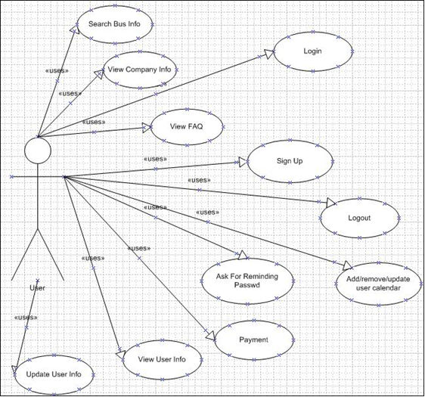 of the entire use-case model are included here.]

Figure: Use Case of User

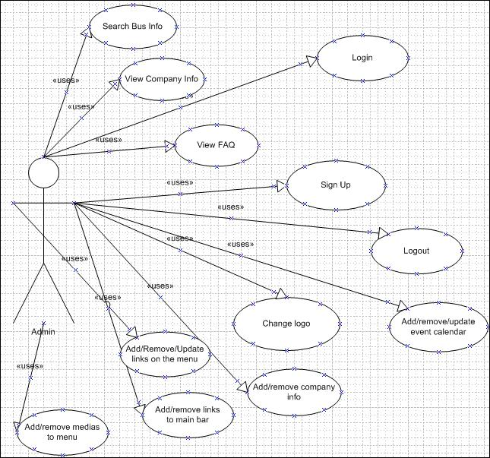

Figure: Use Case of Admin

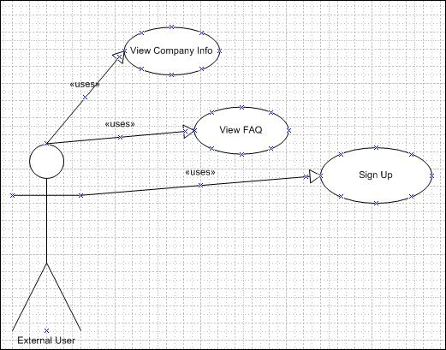

Figure: Use Case of External User

Assumptions and Dependencies
The user must have the ability to use the internet.

The user must have connected to the internet to use the system.

The user’s computer must be Windows 95 or later version platforms and Microsoft Internet Explorer version 5.5 or later

TCP/IP protocol must be installed to communicate through HTTP messages. The accuracy of the information of users is the responsibility of all users.

Requirements
This subsection contains the requirements for the e-store. These requirements are organized by the features discussed in the vision document. Features from vision documents are then refined into use case diagrams and to sequence diagram to best capture the functional requirements of the system. All these functional requirements can be traced using tractability matrix.

Use-Case Specifications
All the use cases and their specifications are documented in separate use case documents for each of the use case.

Functionality

Login

Use Case No | 1
Use Case Name | Login
Defined By | Boppana Ramya Sree |  |  |  |  |  | Last Updated By |  | Boppana Ramya Sree
Defined On | 26/08/2015 |  |  |  |  |  | Last Updated On |  | 2/09/2015
Actors: | User and Admin
Descriptions | User Login.
Pre-conditions | The user must be a member of the system.
Post-conditions
Priority | High
Normal Course |  | 1 | Users enter their user names.
Events |  | 2 | Users enter their passwords.
 |  | 3 | Users click login button.
 |  | 4 | System connects to database.
 |  | 5 | Homepage displayed.
Alternative |  | A 3.1 Users can enter their user names and password wrongly.
Courses
 |  | A 3.2 |  | Error message appears.
 |  | A 3.3 |  | Continue with Step 1 in the normal Course Events.
 |  | A 4.1 |  | An error may occur during the database operation.
 |  | A 4.2 |  | System shows error messages.
Exceptions
Assumptions
Notes:
 |  |  |  | Table 1. Use Case of Login Function

Logout

Use Case No | 2
Use Case Name | Logout
Defined By | Boppana Ramya Sree |  |  |  |  | Last Updated By |  | Boppana Ramya Sree
Defined On | 26/08/2015 |  |  |  |  | Last Updated On |  | 2/09/2015
Actors: | User and Admin
Descriptions | User Logout.
Pre-conditions |  | The user must be Log on to the system.
Post-conditions
Priority |  | Middle
Normal Course |  | 1. | The system users click to logout button.
Events |  | 2. | DB connection terminated.
 |  | 3. | The system logout the user successfully.
 |  | 4. | The system redirect to the homepage.
Alternative
Courses
Exceptions
Assumptions
Notes:
 |  |  | Table 2. Use Case of Logout Function

Signup

Use Case No | 3
Use Case Name | Sign up
Defined By | Boppana Ramya Sree |  |  |  |  | Last Updated By |  | Boppana Ramya Sree
Defined On | 26/08/2015 |  |  |  |  | Last Updated On |  | 2/09/2015
Actors: | User
Descriptions | User Sign up.
Pre-conditions | New user with new mail address is required
Post-conditions
Priority |  | Medium
Normal Course |  | 1. | Users enter their e-mail address.
Events |  | 1.1 | Users enter their passwords.
 |  | 1.2 | Users enter other required information.
 |  | 2. | Users click sign up button.
 |  | 3. | System connects to database.
 |  | 4. | A message appears which shows the membership applied.
 |  | 5. | Activation mail is sent.
Alternative |  | A 4.1 Same e-mail address is existed in database
Courses
 |  | A 4.2 Error message appears.
 |  | A 4.3 Continue with Step 1 in the normal course events.
 |  | A 3.1 An error may occur during the database operation.
 |  | A 3.2 System shows error messages.
Exceptions
Assumptions
Notes:
 |  |  | Table 3. Use Case of Sign Up Function

Remind Password

Use Case No | 4
Use Case Name | Remind Password
Defined By |  | Boppana Ramya Sree |  |  |  | Last Updated By |  | Boppana Ramya Sree
Defined On |  | 26/08/2015 |  |  |  | Last Updated On |  | 2/09/2015
Actors: |  | User
Descriptions |  | Reminding forgotten passwords.
Pre-conditions |  | The user must be a member of the system.
Post-conditions
Priority |  | Medium
Normal Course |  | 1. Users enter their e-mail address.
Events |  | 2. Users click on Remind Password Button.
 |  | 3. Password is sent to e-mail address.
Alternative |  | A 2.1 Wrong e-mail should be entered.
Courses
 |  | A 2.2 Error message appears.
 |  | A 2.3 Continue with Step 1 in the normal course events
Exceptions
Assumptions
Notes:
 |  | Table 4. Use Case of Remind Password Function

View User Info

Use Case No | 5
Use Case Name | View user Info
Defined By |  | Boppana Ramya Sree |  |  | Last Updated By |  | Boppana Ramya Sree
Defined On |  | 26/08/2015 |  |  | Last Updated On |  | 2/09/2015
Actors: |  | User
Descriptions |  | Viewing the user info.
Pre-conditions |  | The user must be logged on to the system.
Post-conditions
Priority |  | High
Normal Course |  | 1. The user must be logged on to the system which is defined on
Events |  | use case 1.
 |  | 2. The user clicks on desired person or themselves.
 |  | 3. The system retrieves the desired person’s information from DB.
 |  | The system shows the person’s information in new page.
Alternative |  | A 3.1. The system cannot access to the DB.
Courses
 |  | A 3.2. The system puts a message on the top of the window about the
 |  | problem.
 |  | A 3.3. Continue with Step 2 in the normal course events.
Exceptions
Assumptions
Notes: |  | Referenced Use Case 1.

Table 5. Use Case of View User Info Function

Update User Info

Use Case No | 6
Use Case Name | Update User Info
Defined By | Boppana Ramya Sree |  |  |  |  |  | Last Updated By |  |  | Boppana Ramya Sree
Defined On | 26.08.2015 |  |  |  |  |  | Last Updated On |  |  | 2/09/2015
Actors: | User
Descriptions | Updating the user info.
Pre-conditions | The user must be logged on to the system.
Post-conditions
Priority | High
Normal Course | 1. |  | The user must be logged on to the system which is defined on
Events |  |  | use case 1.
 | 2. |  | The user clicks on themselves.
 | 3. |  | The system retrieves the desired person’s information from DB.
 |  |  | The system shows the person’s information in new page.
 | 4. |  | The user clicks on Update Profile Link.
 | 5. |  | The user can update his/her profile in desired information field.
 | 6. |  | The user clicks on Save Button.
 | 7. |  | The user profile is updated.
Alternative | A 3.1. The system cannot access to the DB.
Courses
 | A 3.2. The system redirect to the home page.
 | A 3.3. The system puts a message on the top of the window about the
 | problem.
 | A 3.4. Continue with Step 2 in the normal course events.
 | A 6.1. The system cannot access to the DB.
 | A 6.2. The system puts a message on the top of the window about the
 | problem.
 | A 6.3. Continue with Step 5 in the normal course events.
Exceptions
Assumptions
Notes: |  | Referenced Use Case 1.

Table 6. Use Case of Update User Info Function

View Buses Info

Use Case No | 7
Use Case Name | View buses Info
Defined By | Boppana Ramya Sree |  |  |  |  |  | Last Updated By |  | Boppana Ramya Sree
Defined On | 26/08/2015 |  |  |  |  |  | Last Updated On |  | 02/09/2015
Actors: | User
Descriptions | Viewing the buses info.
Pre-conditions | The user must be logged on to the system.
Post-conditions
Priority | High
Normal Course | 1. The user must be logged on to the system which is defined on
Events | use case 1.
 | 2. The user clicks on desired time and destination.
 | 3. The system retrieves the desired buses information from DB.
 | 4. The system shows the buses information in new page.
 | 5. The system shows the available seats from the selected bus.
Alternative | A 3.1. The system cannot access to the DB.
Courses
 | A 3.2. The system puts a message on the top of the window about the
 | problem.
Exceptions
Assumptions
Notes: |  | Referenced Use Case 1.

Table 7. Use Case of View Buses Info Function

Payment

Use Case No | 8
Use Case Name | Payment
Defined By | Boppana Ramya Sree |  |  |  |  |  | Last Updated By |  | Boppana Ramya Sree
Defined On | 26/08/2015 |  |  |  |  |  | Last Updated On |  | 2/09/2015
Actors: | User
Descriptions | Paying money for the available (selected) seat(s).
Pre-conditions | The user must be logged on to the system.
Post-conditions
Priority | High
Normal Course | 1. |  | The user must be logged on to the system which is defined on
Events |  |  | use case 1.
 | 2. |  | The user clicks on desired time and destination.
 | 3. |  | The system retrieves the desired buses information from DB.
 | 4. |  | The system shows the buses information in new page.
 | 5. |  | The system shows the available seats from the selected bus.
 | 6. |  | The system shows the details of the payment.
 | 7. |  | The system sent an email to the customer for informing.
Alternative |  | A 3.1. The system cannot access to the DB.
Courses
 |  | A 3.2. The system puts a message on the top of the window about the
 |  | problem.
 |  | A 3.3. Continue with Step 2 in the normal course events.
Exceptions
Assumptions
Notes: |  | Referenced Use Case 1
 |  | Table 8 . Use Case of Payment Function

Admin Tool

Use Case No | 9
Use Case Name | Admin Tool
Defined By | Boppana Ramya Sree |  |  |  |  | Last Updated By |  | Boppana Ramya Sree
Defined On | 26/08/2015 |  |  |  |  | Last Updated On |  | 2/09/2015
Actors: | Admin
Descriptions | Paying money for the available (selected) seat(s).
Pre-conditions | The admin must be logged on to the system.
Post-conditions
Priority | High
Normal Course | 1. The admin must be logged on to the system which is defined on
Events | use case 1.
 | 2. The admin must be clicked on the admin operations. The
 | system gives opportunity the admin doing the following:
 |  | If the change logo is clicked, the admin can change the
 |  | logo of the company.
 |  | If the add/remove/update links is clicked, the admin can
 |  | change the links.
 |  | If the give option is clicked, the admin can change the
 |  | search options.
 |  | If the add/remove/update event is clicked, the admin
 |  | can change the events on the calendar.
 |  | If the add/remove content is clicked, the admin can
 |  | change the content of the web site.
Alternative |  | A 3.1. The system cannot access to the DB.
Courses
 |  | A 3.2. The system puts a message on the top of the window about the
 |  | problem.
 |  | A 3.3. Continue with Step 2 in the normal course events.
Exceptions
Assumptions
Notes: |  | Referenced Use Case 2

Table 9 . Use Case of Admin Tool Function

Usability

Graphical User Interface
- The system shall provide a uniform look and feel between all the web pages.

- The system shall provide use of buttons, icons and toolbars.

Accessibility

- The system shall provide handicap access.

- The system shall provide multi language support.

Reliability

3.4.1 Availability
The system shall operate 95% of the time. The number of defect should not exceed 10 per function. In addition, before the submission of the final release the calendar must be tested in case of the defects over 10 per function.

Back-end Internal Computers
- The system shall provide storage of all databases on redundant computers with automatic switchover.

- The system shall provide for replication of databases to off-site storage locations.

- The system shall provide RAID V Disk Stripping on all database storage disks

Internet Service Provider
- The system shall provide a contractual agreement with an internet service provider for T3 access with 99.9999% availability.

- The system shall provide a contractual agreement with an internet service provider who can provide 99.999% availability through their network facilities onto the internet.

Performance
- The product shall be based on web and has to be run from a web server.

- The product shall take initial load time depending on internet connection strength which also depends on the media from which the product is run.

- The performance shall depend upon hardware components of the client/customer.

Supportability

Configuration Management Tool
The source code developed for this system shall be maintained in configuration management tool.

Design Constraints

Standard Development Tools

The system shall be built using a standard web page development tool that conforms to either IBM’s CUA standards or Microsoft’s GUI standards.

Web Based Product

- There are no memory requirements
- The computers must be equipped with web browsers such as Internet explorer.
- The product must be stored in such a way that allows the client easy access to it.
- Response time for loading the product should take no longer than five minutes.
- A general knowledge of basic computer skills is required to use the product

Online User Documentation and Help System Requirements

- The system shall provide an online hierarchical and cross-linked help system in HTML that describes and illustrates all system functions.
- The first time a new user accesses the system and on user demand thereafter, the system shall provide an online tutorial to allow users to practice booking tickets using a static tutorial menu. The system shall not store tickets booked using this template in the database or confirm tickets for such bookings.

Purchased Components
Not applicable.

Interfaces

User Interfaces
The OBRS shall be designed as a web based that has a main user interface. Format of main screen shall be standard and flexible. The system shall be user friendly designed. Pages shall be connected each other in a consistent way. Operations can be done with the system shall be repeatable. The design of the pages should allow users to do this.
Main (Login) Page

Main interface includes a Logo, Background, Username and Password Fields, Login button and Sign Up link, if the user click on Sign Up link it retrieves the Sign Up Page. If the user click Login Button after he/she enters username and password, the system retrieve Main Page of the user.

Sign Up Page

Sign Up Page contains 4 fields which are labeled as E-Mail Address, Confirm E-Mail Address, Password, Confirm Password. User can sign up the system by entering these required fields and then pressing the Sign Up Button.

There shall be other pages who has functionality related with the customer operations and admin tool operations. The example figures of the pages will be added to the document.

Hardware Interfaces
There is no need any hardware interface for Online Bus Reservation System.

Software Interfaces
- There are 2 product options for viewing:

A. Name: Microsoft Internet Explorer

Mnemonic: -

Specification number: -

Version number: 5.5

Source: Microsoft Corporation, the interface of the OBRS is well-documented and can be found at [10].

Purpose: The web browser specified above is required as the container of the client software at the client site in order to execute the client site of OBRS.

Definition of the Interface: The Microsoft Internet Explorer is the software, provides a flexible and reliable browsing experience with enhanced Web privacy features for all users.

OR

B. Name: Mozilla Firefox

Mnemonic: -

Specification number: -

Version number: 2.0

Source: Mozilla Foundation, the interface of the OBRS is well-documented and can be found at [8].

Purpose: The web browser specified above is required as the container of the client software at the client site in order to execute the client site of OBRS.

Definition of the Interface: The Mozilla Firefox Browser is the software, provides a flexible and reliable browsing experience with enhanced Web privacy features for all users.

- Name: Apache HTTP Server

Mnemonic: -

Specification number: -

Version number: 2.0.5.5

Source: The Apache Software Foundation, the interface of the OBRS with the application system is well-documented and can be found at [5].

Purpose: In order to execute the client site of OBRS, the web server specified above is required as the provider of the client software at the server site.

Definition of the Interface: The Apache HTTP Server Project is an effort to develop and maintain an open-source HTTP server for modern operating systems including UNIX and Windows NT. The goal of this project is to provide a secure, efficient and extensible server that provides HTTP services in sync with the current HTTP standards.
3. Name: PHP

Mnemonic: -

Specification number: -

Version number: 4.0

Source: PHP Group, the interface of the OBRS is well-documented and can be found at [9].

Purpose: In order to build web pages which work with MySQL database and Apache server?

Definition of the Interface: PHP is a widely-used general-purpose scripting language that is especially suited for Web development and can be embedded into HTML.

- Name: Macromedia Dreamweaver

Mnemonic: -

Specification number: -

Version number: 8

Source: Macromedia Inc., the interface of the OBRS is well-documented and can be found at [6].

Purpose: The web development tool specified above is required for designing and coding the project.

Definition of the Interface: Macromedia Dreamweaver is the industry-leading web development tool, enabling users to efficiently design, develop and maintain standards-based websites and applications.

5. Name: MySQL

Mnemonic: - Specification number: - Version number: 5.0

Source: MySQL document defining the interface can be found at [7].

Purpose: Required as database server.

Definition of the Interface: MySQL is the world's most popular open source database software, with over 100 million copies of its software downloaded or distributed throughout its history. With superior speed, reliability, and ease of use, MySQL has become the preferred choice of corporate IT Managers because it eliminates the major problems associated with downtime, maintenance, administration and support.

Communications Interfaces
The default communication protocol for data transmission between server and the client is Transmission Control Protocol/ Internet Protocol (TCP/IP). At the upper level Hyper Text Transfer Protocol (HTTP, default port=80, default of apache port=8080) will be used for communication between the web server and client

Licensing Requirements
Not applicable.

Legal, Copyright and Other Notices
OBRS should display the disclaimers, copyright, word mark, trademark and product warranties of the Marvel electronics and home entertainment.

Applicable Standards
It shall be as per the industry standard.

