Big Data Analytics and Apps

Lab 2-1 Assignment

**Subgroup:16**

Shivani Gaddala

Ramya Sri Gangula

REST APIs used:

* Weather API
* Text to Speech
* Mashup

<https://github.com/ramyasrigangula/Subgroup16/tree/master/Assignment2/Assignment2>

**How it helps in our project:**

This Mashup application can be used by blind people to know weather of a location by announcing the location and country names. Here we are trying to mashup Openweather API with Text-to-Speech API, that is weather for input locations is fetched from Openweather API and is sent to the Text to Speech api. Finally we will be listening weather details in speech form.

**Note:** We are yet to create Speech-to-Text API and mashup it with the existing one, which we can show it in our next sessions.

**Screenshots-**

**Text-to-Speech:**

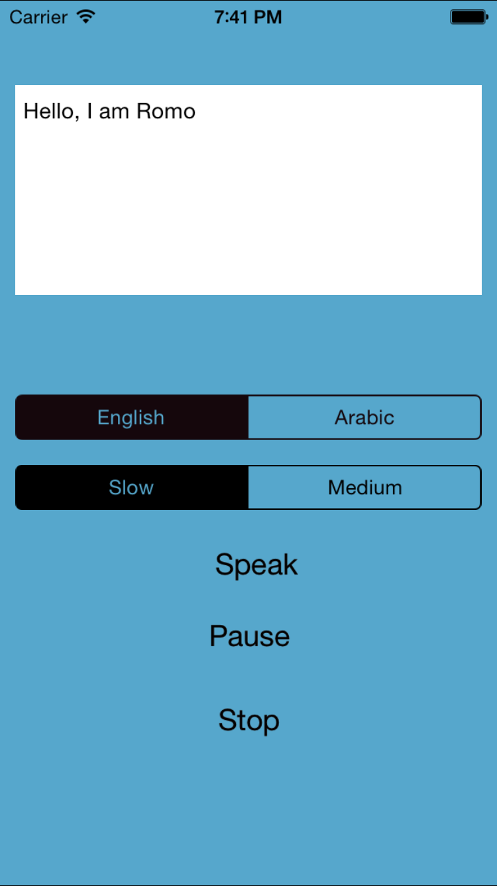

**Open Weather API:**

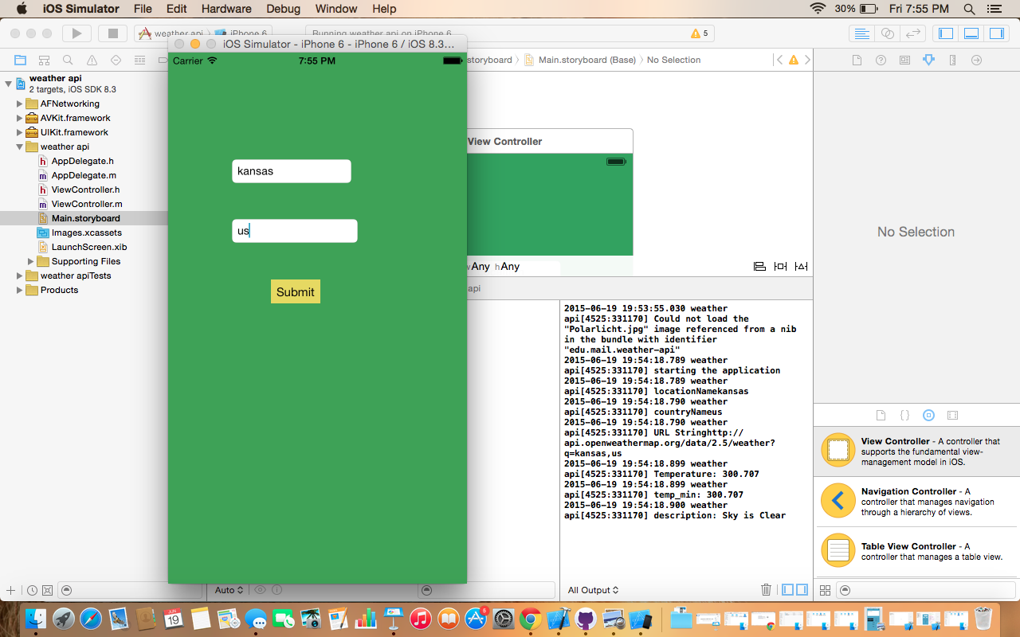

**Mashup Application:**

