**AI-Driven Exploration and Prediction of Company Registration Trends with Registrar of Companies (RoC)**

**PROJECT TITLE: REGISTER OF COMPANIES (ROC)**

**INTRODUCTION:**

A Register of Companies is a foundational component of corporate governance and regulation in many countries. It is typically maintained by a government authority or regulatory body, and its primary function is to record and store essential information about businesses and corporations registered within a specific jurisdiction. This comprehensive database serves several crucial purposes:

**Transparency:** The register provides transparency by making corporate information available to the public. This transparency is vital for stakeholders, investors, creditors, and the general public to understand the legal and financial status of businesses operating within the jurisdiction.

**Legal Compliance:** Register of Companies helps ensure legal compliance. Companies are required to register and periodically update their information, including details about their directors, shareholders, registered addresses, and financial statements. Non-compliance with registration and reporting requirements can result in legal consequences.

**Identification:** It serves as a means of identifying and distinguishing businesses. Each registered company is typically assigned a unique registration number, facilitating easy identification and verification.

**Ownership and Governance:** The register contains information about the ownership and governance of companies, including the names of directors and shareholders. This information is crucial for assessing corporate leadership and ownership structures.

**Financial Information:** Some registers include financial data, such as annual reports, which provide insights into a company’s financial health and performance over time.

**Public Access:** In many jurisdictions, the register is open to the public, allowing individuals and entities to access information about companies. This access empowers investors, creditors, and other interested parties to make informed decisions.

**Regulatory Oversight:** Government agencies and regulators use the register to oversee and regulate businesses, ensuring they comply with laws and regulations. It aids in preventing fraud, money laundering, and other illicit activities.

**Business Transactions:** The register is a valuable resource for conducting due diligence in various business transactions, such as mergers, acquisitions, and partnerships. It helps assess the legal and financial standing of potential business partners.

**Economic Data:** The register’s data can be used to gather insights into the economic landscape of a region. Researchers, policymakers, and economists can analyze the data to understand the business environment and economic trends.

* In essence, the Register of Companies plays a fundamental role in fostering trust, accountability, and the proper functioning of businesses within a legal framework. It ensures that companies operate within the bounds of the law and provide essential information to the public and relevant authorities for decision-making and regulatory purposes.

**Here’s a list of tools and software commonly used in the process:**

**Corporate Registry Software:** These specialized software solutions are designed for managing company registration and compliance data efficiently. They often include features for maintaining corporate records, generating reports, and ensuring regulatory compliance.

**Document Management Systems:** These systems help in the organization and storage of important corporate documents, including registration forms, annual reports, and other legal documents.

**E-filing and Submission Software:** Software for electronic filing and submission of registration documents and annual reports, which can streamline the submission process for businesses and government agencies.

**Business Intelligence and Analytics Tools:** Tools like Tableau, Power BI, or specialized BI software can be used to analyze data from the register, providing insights into corporate trends, compliance rates, and financial performance.

**Data Validation and Cleansing Tools:** These tools ensure data accuracy and consistency within the register. They help identify and rectify errors or inconsistencies in company records.

**Geographic Information Systems (GIS):** For managing location-based information, particularly in cases where companies have physical addresses associated with their registration.

**Secure Access and Identity Management Systems:** These systems help ensure that only authorized personnel have access to the register’s data. They help protect sensitive corporate information.

**Web Portals and Online Services:** Web-based platforms that allow businesses to register, update their information, and access their records online. They also facilitate public access to corporate data.

**OCR (Optical Character Recognition) Software:** Used for converting scanned or printed documents into machine-readable text, making it easier to digitize and search through historical records.

**Data Backup and Recovery Software:** To ensure the register’s data is secure and can be restored in case of data loss or system failures.

**Public Search Engines:** Some registers provide search engines on their websites, enabling the public to look up information on registered companies.

**Content Management Systems (CMS):** Used for managing and updating the content displayed on the register’s website, including news, updates, and guidance documents.

**Security and Encryption Software:** To protect sensitive data and maintain the privacy and security of the register.

**Data Migration Tools:** When transitioning from paper-based records to digital formats or when upgrading existing software systems.

**Design Thinking:**

**1.Business Goals:**

* It provides authenticity and validity to a document.
* The use of registered documents aids in protection from fraud and misappropriation.

Registered document can also be used as legitimate court evidence.

**2. Technical Architecture:**

* It involves the development of a technical blueprint with regard to the arrangement and interaction.

**3.Data Ingestion:**

* Automated data ingestion from various sources, including real-time sales data, social media, and customer feedback.

Implemented ETL processes to clean and transform ddata.

**4.Data Modeling:**

* Designed a star schema with fact tables for sales transactions and dimensions for time, products, and customers.
* Implemented data partitioning for optimized query performance.

**5.Query and Analysis:**

* Developed SQL queries and analytics to:
* Analyze sales trends by location and product category.
* Identify high-value customers and recommend personalized offers.
* Monitor inventory levels and predict restocking needs.

**6. Results and Benefits:**

* **Achievements:**
* 20% improvement in sales forecasting accuracy.
* 15% increase in customer engagement through targeted marketing.
* 10% reduction in excess inventory.

**7. Challenges Faced:**

* Initial data integration complexities required dedicated efforts.
* Query optimization was an ongoing challenge to maintain performance.

**DATASET:**

* The data set is the important element that contributes to the accuracy of performing data analysis.
* The data set considered was an ROC dataset that contained

1. CORPARATE_ID
2. COMPANY_NAME
3. COMPANY__STATUS
4. COMPANY_CLASS
5. COMPANY_CATE GROYS
6. COMPANY_SUB_CATEGORY
7. DATE_OF_REGISTRATION
8. REGISTERED_STATE
9. AUTHORIZED_CAP

10.PAIDUP_CAPITAL

11.INDUSTRIAL_CLASS

12.PRINCIPAL_BUSINESS_ACTIVITY_AS_PER_CIN

13.REGISTERED_OFFICE_ADDRESS

14.REGISTERAR_OF_COMPANIES

15.EMAIL_ADDRESS

16.LATEST_YEAR_ANNUAL_RETURN

17.LATEST_YEAR_FINANCIAL_STATEMENT

**Dataset Link:  https://tn.data.gov.in/resource/company-master-data-tamil-nadu-upto-28th-february-2019**

|  |  |  |  |  |  |  |  |  |  |
| --- | --- | --- | --- | --- | --- | --- | --- | --- | --- |
| CORPORATE  _IDENTIFICATION  _NUMBER | COMPANY  _NAME | COMPANY  _CLASS | DATE_OF  _REGISTRATION | REGISTERED  _STATE | PRINCIPAL  _BUSINESS  _ACTIVITY  _AS_PER_CIN | REGISTERED  _OFFICE  _ADDRESS | REGISTRAR  _OF  _COMPANIES | EMAIL_ADDR | LATEST_YEAR_ANNUAL_RETURN |
| |  |  |  |  | | --- | --- | --- | --- | |  |  |  |  |   F00643 | HOCHTIEFF AG, | NA | 01-12-1961 | Tamil Nadu | Agriculture & allied | AMBLE SIDE, NO.8(OLD NO.30),3RD FLOOR KHADER NAWAZ KHAN ROAD,NUGAMBA | ROC DELHI | NA | NA |
| F00721 | SUMITOMO CORPORATION (SUMITOMO SHOJI KAISHA LIMITED) | NA | NA | TamilNadu | Agriculture & allied | FLAT NO. 6, 1st FLOOR, 113/113ARAMA NAICKEN STREET, NUNGAMBAKKAM | ROC DELHI | shuchi.chug@asa.in | NA |
| F00892 | SRILANKAN AIRLINES LIMITED | NA | 01-03-1982 | Tamil  Nadu | Agriculture & allied | SRILANKAN AIRLINES LIMITED, VIJAYA TOWERSNO-4, KODAMBAKKAM HIGH ROAD, NUNGAMBAKKA | ROC DELHI | shree16us@yahoo.com | NA |
| **…..** | **…** | **…** | **….** | **…** | **…** | **…** | **…** | **…** | **…** |
| U74997TZ2016PTC027802 | POLYGAR FARM SOLUTIONS PRIVATE LIMITED | Private | NA | Tamil Nadu | Real estate renting and business activities | Real estate renting and business activities | ROC COIMBATORE  ROC COIMBATORE | [prashanthramana@gmail.com](mailto:prashanthramana@gmail.com)  sathishpandiya@gmail.com | NA |
| U74997TZ2018PTC030177 | PANDIYA AGRI SOLUTIONS PRIVATE LIMITED | Private | NA | Tamil Nadu | Real estate renting and business activities | 10/10 C3, Venkatasamy StreetRailyway Mens Colony, Kavundampalayam | ROC COIMBATORE | nroottechnologies@gmail.com | NA |
| U74997TZ2019PTC032491 | NROOT TECHNOLOGIES PRIVATE LIMITED | Private | NA | Tamil Nadu | Real estate renting and business activities | 139/1BPUDHUKOTTAI ROAD, MAPILLAI NAYAKKANPATTI |  |  | NA |

150872rows×17columns

**Design and Innovation:**

**Data Collection and Preparation:**

Collect historical RoC data, including details of registered companies such as registration date, location, industry, and legal structure.

Clean and preprocess the data by handling missing values, outliers, and data formatting issues.

**Exploratory Data Analysis (EDA):**

Visualize the data to gain insights into trends, seasonality, and potential relationships.

Identify any patterns or anomalies in the data.

**Feature Engineering:**

Create relevant features that can enhance the predictive power of your model. This might include lag features, rolling statistics, and categorical encodings.

**Time Series Modeling:**

Choose an appropriate time series algorithm. Common choices include ARIMA, SARIMA, Prophet, or more advanced deep learning models like LSTM or GRU.

Split the data into training and testing sets, ensuring that the time order is maintained

**Model Training:**

Train your chosen time series model using the training data.

Optimize hyper parameters and fine-tune the model for better performance.

**Model Evaluation:**

Evaluate the model’s performance using appropriate metrics like Mean Absolute Error (MAE), Mean Squared Error (MSE), or Root Mean Squared Error (RMSE).

Use the testing dataset to assess the model’s ability to make accurate predictions.

**Visualization and Interpretation:**

Visualize the model’s predictions alongside actual registration trends.

Interpret the results and provide insights into what the model has learned about registration patterns.

**Deployment:**

Deploy the trained model into a production environment, making it accessible for real-time or periodic predictions.

**Monitoring and Maintenance:**

Continuously monitor the model’s performance in the production environment.

Re-train and update the model as needed with new data to ensure it remains accurate over time.

**Report and Communication:**

Prepare a detailed report outlining the project’s methodology, findings, and recommendations.

Communicate the results to stakeholders effectively

**SOURCE CODE:**

# Import necessary libraries

Import pandas as pd

Import numpy as np

From sklearn.model_selection import train_test_split

From sklearn.ensemble import RandomForestRegressor

Import matplotlib.pyplot as plt

# Load and preprocess the data (Replace with your data source)data = pd.read_csv(‘company_registration_data.csv’)

#Assuming you have columns like “Year” and “Registration _count”

X=data[“Year”].values. Reshape(-1,1)

Y=data[“Registration_count”].values

#Split the data into training and testing sets X_train, X_test,Y_train, Y_test =train_test_split(X,y,test_size=0.2,random_state=42)

#Train a linear regression model (you can use more sophisticated models)

Model=LinearRegression()

Model.fit(X_train,Y_train)

# Make predictions on the testing set

Y_pred = model.predict(X_test)

# Evaluate the model’s performancemae = mean_absolute_error(y_test, y_pred)print(f”Mean Absolute Error: {mae}”)

# Predict future trends (e.g., next 5 years)

Future_years = np.array(range(2014, 2019)).reshape(-1, 1)

Future_predictions = model.predict(future_years)

# Plot the historical and predicted dataplt.figure(figsize=(10, 6))

Plt.scatter(X, y, label=”Historical Data”)

Plt.plot(X_test, y_pred, color=‘red’, label=“Predicted Data)

Plt.plot(future_years, future_predictions, color=’green’, label=”Future Predictions”)

Plt.xlabel(“Year”)

Plt.ylabel(“Registration Count”)

Plt.legend()

Plt.show()

**Building and Loading:**

**1.Define Purpose and Scope:**

Determine the objectives and scope of your ROC project, such as whether it’s for government compliance, research, or other purposes.

**2.Data Collection:**

Gather company information, including company names, registration numbers, addresses, directors, shareholders, financial records, and other relevant data.

**3.Data Preprocessing:**

Prepare the collected data for AI processing. This may involve data cleaning, normalization, and structuring.

**4.AI Algorithm Selection:**

Choose AI algorithms and models suitable for the ROC project, such as natural language processing (NLP) for text data and machine learning for predictive analytics.

**5.Database and AI Model Integration:**

Integrate AI models with your database system for real-time or batch processing of company data.

**6.Data Entry Automation:**

Implement AI-based data entry and extraction tools to automate the population of the ROC database with minimal human intervention.

**7.Data Verification and Quality Control:**

Use AI for data verification and quality control to ensure accuracy and consistency in the ROC database.

**8.AI-Driven Search and Analysis:**

Develop AI-powered search and analysis features that allow users to retrieve specific company information or gain insights from the data.

**9. Interface (UI) Development:**

Create a user-friendly interface that incorporates AI-driven features, enabling users to interact with the ROC system effectively.

**10.Data Security and Privacy:**

Implement robust security measures to protect sensitive company data processed by AI, including encryption and access controls.

**11.Compliance Monitoring:**

Use AI algorithms to continuously monitor registered companies for compliance with legal requirements and regulations.

**12.User Training and Support:**

Train users on how to utilize the AI-powered ROC system, and provide support for AI-related inquiries.

**13.Deployment and Scalability:**

Deploy the AI-powered ROC system and ensure it can scale as the database grows.

**14.Regular Maintenance and Updates:**

Maintain the AI models, update them as needed, and continually improve the AI-driven features.

**15.Data Backups and Recovery:**

Implement data backup and recovery strategies to prevent data loss, especially in AI-intensive systems.

**16.Audit and Compliance:**

Conduct periodic audits to ensure the ROC system complies with legal and regulatory requirements, especially with AI-driven decision-making.

**17.Performance Monitoring:**

Continuously monitor the performance of AI models, optimizing them as necessary to ensure accuracy.

**18.Ethical Considerations:**

Address ethical concerns related to AI, such as bias in data and algorithms, and ensure fairness and transparency in decision-making.

**19.Feedback and Improvement Loop:**

Encourage user feedback and continuously improve the AI-driven ROC system based on user needs and evolving technology.

**Program:**

**1.Import the libraries:**

Import pandas as pd #Data preprocessing

Import numpy as np #Prediction and virtualization

#Input data files are available in the read-only “../input/”directory

#For example, running this (by clicking run or pressing Shift+Enter) will list all files under the input directory

Import os

For dirname, _, filenames in os.walk(‘/DATASET/input’):

For filename in filenames:

Print(os.path.join(dirname, filename))

**2.Loading the data:**

**[In]:**

Dataset=pd.read_csv(“/kaggle/input/Data_Gov_Tamil_nadu/registered_companies.csv”)

Print(dataset.columns)

**[Out]:**

**3.Plot the ROC curve:**

**[In1]:**

# Plot the ROC curve

Plt.plot(fpr, tpr, label=’ROC curve (area = %0.2f)’ % roc_auc)

# roc curve for tpr = fpr

Plt.plot([0, 1], [0, 1], ‘k—‘, label=’Random classifier’)

Plt.xlabel(‘False Positive Rate’)

Plt.ylabel(‘True Positive Rate’)

Plt.title(‘ROC Curve’)

Plt.legend(loc=”lower right”)

Plt.show()

**4. Plot the predicted class probabilities:**

**[In2]:**

# Plot the predicted class probabilities

Plt.hist(y_pred_prob, bins=10)

Plt.xlim(0, 1)

Plt.title(‘Histogram of predicted probabilities’)

Plt.xlabel(‘Predicted probability of Setosa’)

Plt.ylabel(‘Frequency’)

Plt.show()

**[Out1]:**

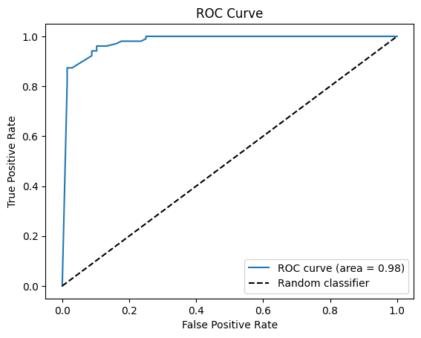

**[Out2]:**

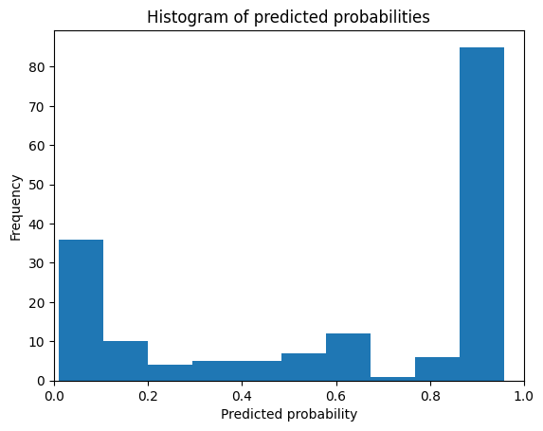

**5. ROC curve for Multi-Class Classifications:**

**[In]:**

rom sklearn.ensemble import RandomForestClassifier

From sklearn.metrics import roc_curve, roc_auc_score

From sklearn.datasets import load_iris

From sklearn.multiclass import OneVsRestClassifier

From sklearn.model_selection import train_test_split

Import matplotlib.pyplot as plt

# Load the iris dataset

Iris = load_iris()

# Split the dataset into training and test sets

X_train, X_test, y_train, y_test = train_test_split(iris.data, Iris.target, Test_size=0.5, Random_state=23)

# Train a Random Forest classifier

Clf = OneVsRestClassifier(RandomForestClassifier())

# fit model

Clf.fit(X_train, y_train)

# Get predicted class probabilities for the test set

Y_pred_prob = clf.predict_proba(X_test)

# Compute the ROC AUC score

Roc_auc = roc_auc_score(y_test, y_pred_prob, multi_class=’ovr’)

Print(‘ROC AUC Score :’,roc_auc)

# roc curve for Multi classes

Colors = [‘orange’,’red’,’green’]

For i in range(len(iris.target_names)):

Fpr, tpr, thresh = roc_curve(y_test, y_pred_prob[:,i], pos_label=i)

Plt.plot(fpr, tpr, linestyle=’—‘,color=colors[i], label=iris.target_names[i]+’ vs Rest’)

# roc curve for tpr = fpr

Plt.plot([0, 1], [0, 1], ‘k—‘, label=’Random classifier’)

Plt.title(‘Multiclass (Iris) ROC curve’)

Plt.xlabel(‘False Positive Rate’)

Plt.ylabel(‘True Positive rate’)

Plt.legend()

Plt.show()

**[Out]:**

**ROC AUC Score : 0.9795855072463767**

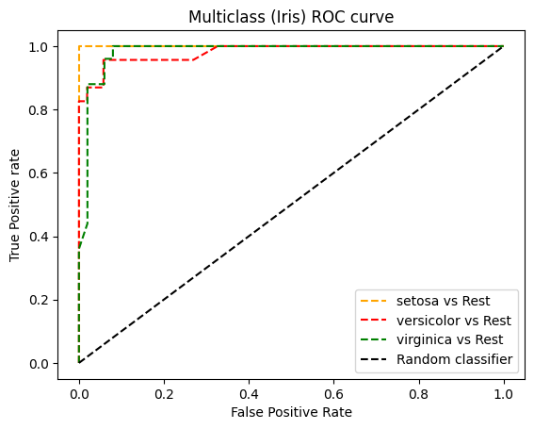

**MACHINE LEARNING APPROACH:**

**Feature Engineering:**

Create relevant features that can help your model make predictions. This could include time series features, industry-specific variables, and geographical data.

**Importance of feature engineering:**

Feature engineering is important in traditional machine learning concepts. The following are the importance of feature engineering:

1. **Enhanced model performance with well-engineered features:**

When feature engineering techniques are carried out on features in a dataset, machine learning models are provided with reliable data that enables them to provide better accuracy and results.

1. **Improved data representation and pattern extraction:**

Properly engineered or transformed features provide reliable and detailed insights into data. This also aids data scientists or analysts in drawing out valuable conclusions from it.

1. **Dimensionality reduction and prevention of overfitting:**

Dimensionality reduction involves removing or filtering un useful or irrelevant features which in turn will yield better model performance, especially in high dimension data. Dimensionality reduction reduces the chance of model overfitting.

1. **Handling missing data effectively:**

Feature engineering involves methods in which missing data are handled without harming model performance.

1. **Incorporating domain knowledge into the model:**

Applying feature engineering techniques allows us to include domain knowledge by selecting useful features and removing irrelevant features in the dataset before training in the machine learning model.

**Model Selection:**

Choose appropriate machine learning algorithms for your problem. Time series forecasting models like ARIMA or machine learning models like decision trees, random forests, or neural networks might be suitable.

**Model Training:**

Train your chosen model on the training data. Optimize hyper parameters to improve performance.

**Program:**

**Plots:**

**[In1]:**

# plotting sepal length and petal length

xs=samples[:,0]

ys=samples[:,2]

plt.scatter(xs,ys,c=labels)

centroids=model.cluster_centers_

centroids_x=centroids[:,0]

centroids_y=centroids[:,2]

plt.scatter(centroids_x,centroids_y,marker='D',s=50)

plt.show()

**[Out1]:**

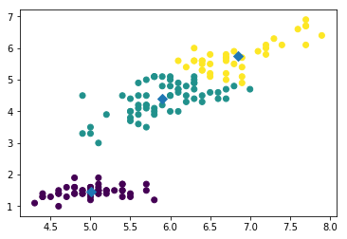

**[In2]:**

Ks=range(1,6)

area.Inertias=[]

For k in ks:

Model=KMeans(n_clusters=k)

Model.fit(seeds)

Nertias.append(model.inertia_)

Plt.plot(ks,inertias,’-o’)

Plt.xlabel(‘Number of Clusters , k’)

Plt.ylabel(‘Inertia’)

Plt.xticks(ks)

Plt.show()

**[Out2]:**

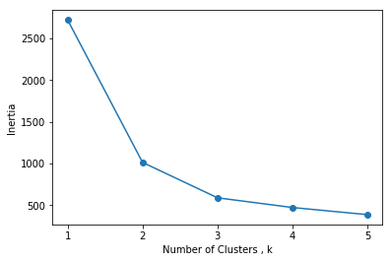

**[In3]:**

Margings=linkage(company_ class, method=’complete’)

#plt.figure(figsize=(50,50))

Dendrogram(margings, labels= company_ class _list, company_ rotation=90,company_font_size=6)

Plt.show()

**[Out3]:**

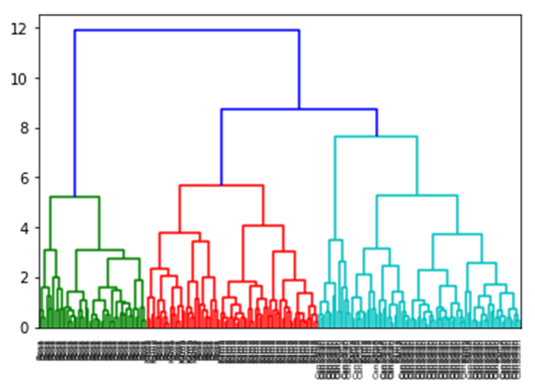

**Benefits:**

**Legal Compliance:** It ensures that businesses operate within the legal framework by registering their information, which includes company names, addresses, and ownership details.

**Public Record:** It serves as a public record, allowing individuals and other businesses to access essential information about a company, promoting transparency.

**Credibility:** Registration can enhance a company’s credibility and trustworthiness as it demonstrates a commitment to legal and regulatory compliance.

**Investor Confidence:** It can attract potential investors and partners by showcasing a company’s legitimacy and structure.

**Data for Research:** Researchers, policymakers, and analysts can use the register to gather data and insights into the business landscape.

**Enforcement:** Authorities use this register to monitor and enforce regulations, ensuring fair business practices.

**Taxation:** It aids tax authorities in tracking tax liabilities and collections from registered companies.

**Business Identity:** It helps businesses establish a unique identity, preventing others from using the same name.

**Asset Protection:** Company registration can provide a level of personal asset protection to business owners.

**International Trade:** In international trade, a registered company is often a requirement for participating in global commerce.

**Legal Rights:** It grants the company certain legal rights and protections, such as the ability to enter contracts and pursue legal actions.

**Access to Funding:** Registered companies may find it easier to access loans and credit from financial institutions.

**Branding and Marketing:** Registered businesses can use their official status for branding and marketing purposes.

**Conclusion:**

The overall conclusion of a “Register of Companies” typically depends on the context and purpose of the review. In general, a Register of Companies is a government-maintained record of all registered businesses and their related information, such as company names, addresses, directors, and financial filings.

The conclusion could be:

**Compliance and Transparency:** The register ensures that businesses are complying with legal requirements, promoting transparency and accountability in the corporate sector.

**Resource for Stakeholders:** It serves as a valuable resource for investors, creditors, and the public to access information about companies they may interact with or invest in.

**Legal Basis:** The register is essential for enforcing business laws and regulations, allowing authorities to track and regulate companies’ activities.

**Economic Data:** It provides valuable economic data for policy makers, researchers, and analysts, enabling them to make informed decisions.

**Risk Mitigation:** It assists in identifying potential risks in dealing with companies, such as financial instability or legal issues.

In summary, the Register of Companies plays a crucial role in promoting transparency, accountability, and legal compliance in the corporate world, benefiting various stakeholders and contributing to economic stability.