A **list box** represents the list of all the values of a specific field. Selecting a value in list box highlights the related values in other sheet objects. This helps in faster visual analysis. It is also very useful to follow a drill down path among various sheet objects. It also has a search feature which allows to search for specific values in the list box which is very helpful for a very long list of values.

Creating List Box

Creation of **List Box** involves navigating through menu **Layout -> New Sheet Object -> List Box**. The below screen shows these steps.

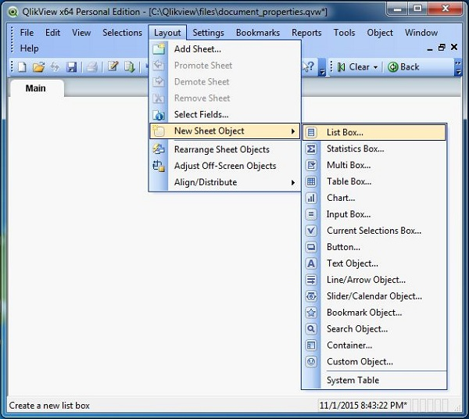

Next we choose Product category as the field on which we build the list box.

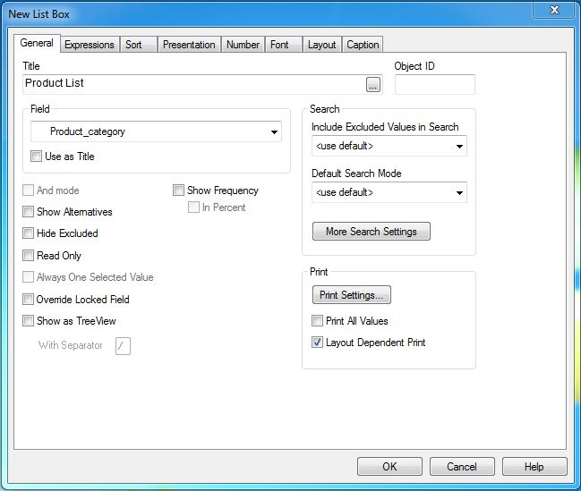

List Box Data

Finishing the above steps brings the following screen which shows the values of Product category as a list box.

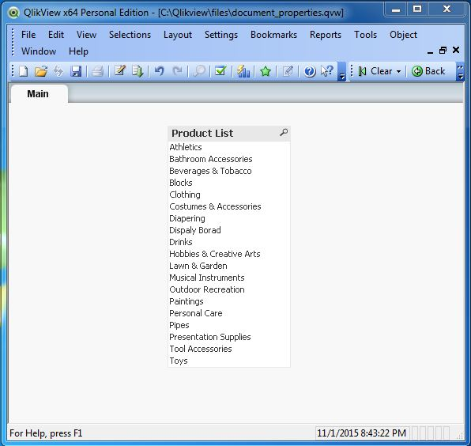

Search Option in List Box

When the List Box contains very large number of values it is difficult to scroll down and look for it. So the search box at the top of the list box can be used to type the search string. The relevant values appear as soon as the first letter is typed.

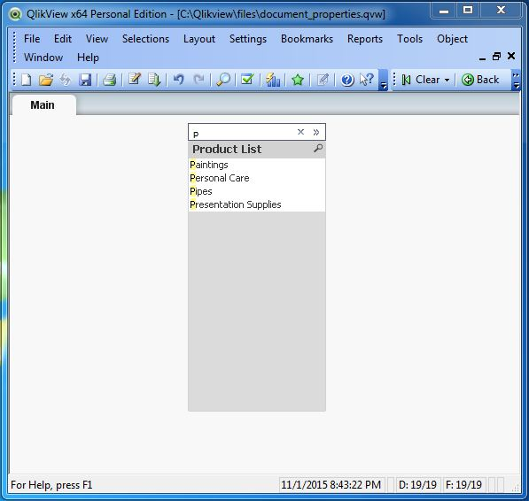

List Box and Association

Other Sheet Objects automatically get associated with the List Box and the association is easily observed by selecting values form the list box.

🡪Listbox click on show frequency

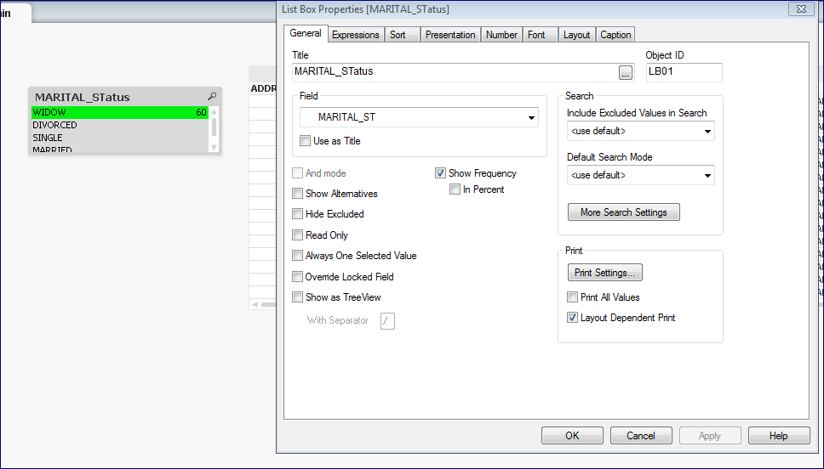

**Sorting by state by default means when u select a value from list box it appers first in listbox**

**If u change it to descending then selected value it appear last**

**U can say sort by frequency in ascending or descending order by just clicking on only frequency to**

**Got to caption tab here give label to list box..here u can check on allow minimize and maximize options**

**Goto presentation tab and uncheck single column…. Single column means only one column in listbox, when u uncheck this fixed number of columns get selected give number of columns those many column appear in list box**

A **Multi Box** represents the list of all the values from multiple fields as drop down values. Similar to list box, the selection of a value in Multi Box highlights the related values in other sheet objects. This helps in faster visual analysis. It is also very useful to follow a drill down path among various sheet objects.

**Multiple listbox frequency is in presentation tab**

