1. Place a forloop container on the package
2. Drag a Execute SQL task inside the Forloop Container
3. Goto View Menu >Other Windows>Variables
4. Count Int32 10
5. Incrementby Int32 0
6. Double click on ForLoop Container
7. 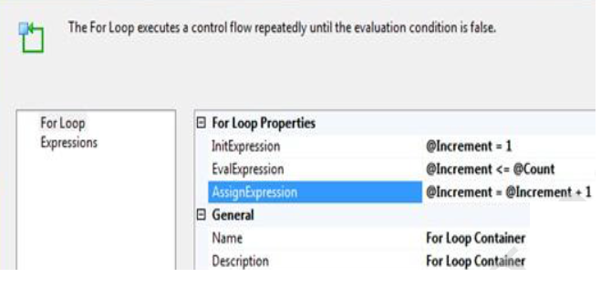
8. Goto SQL server
9. Create table TforLoop (AppName varchar(50),AppType varchar (30) )
10. Insert into tforloop values ('app1','app1')
11. Select * from tforloop
12. Execute the package
13. See the result in SQL Server
14. Specify the connection manager
15. ExecuteSQL Task Properties show Editor set the connection to PKPLaptop_2273\pkplaptop_2273
16. SQL statement specify Insert into tforloop values ('app1','app1')
17. Execute the package
18. Goto SQL Server and see the records inserted

For FTP Task

Drag and Drop an FTP Task

Double Click FTP Task > Properties

Set the FtpCOnnection and send the files

Specify the operation property

ExecutePackageTask

Drag a ExecutePackageTask

Double Click Goto Package properties and specify the packagenamefromprojectreference

Execute the package

Incase of any parameters those can also be specified