Data Flow Components

Character Map

create table emp_ssis

(empid int,

empfirstname varchar(50),

emplastname varchar(50)

)

insert into emp_ssis values (1,'vaishali','kasture')

create table emp_ssis_destination

(empid int,

empfirstname varchar(50),

emplastname varchar(50)

)

1. Create a new Integration Project
2. Drag a Oledb Source from DataFlow Sources
3. Double click on it connect to database and select emp_ssis table
4. 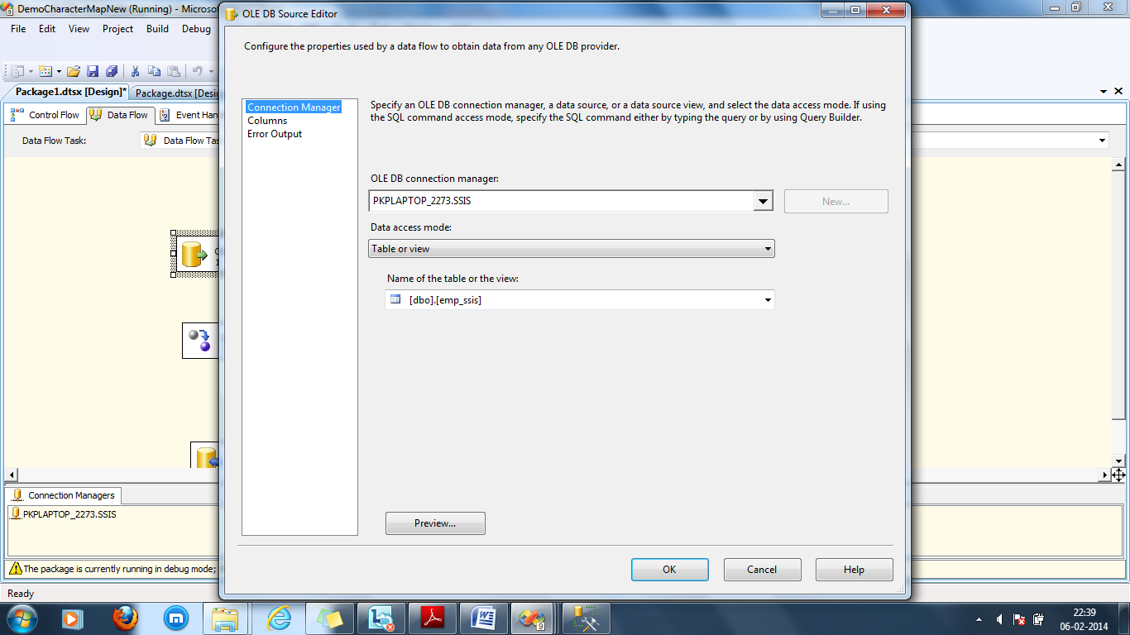
5. Select the character Map
6. Configure the same
7. 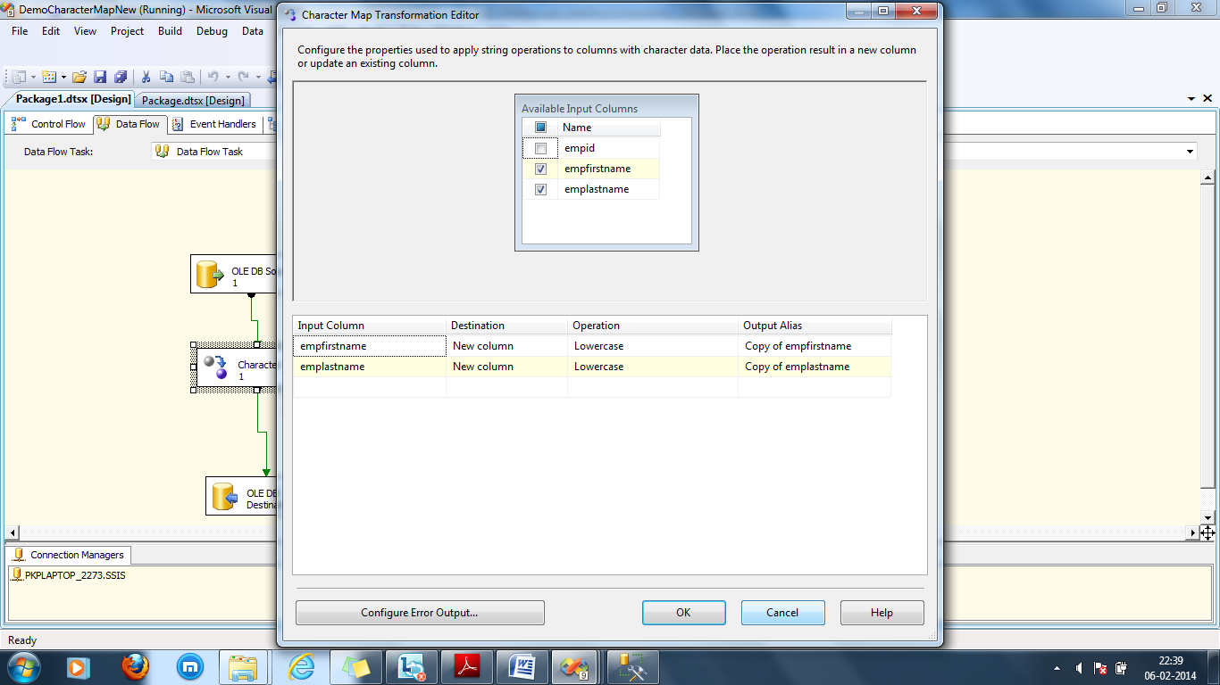
8. Select the Oldedb destination
9. Configure to emp_ssis_destination
10. 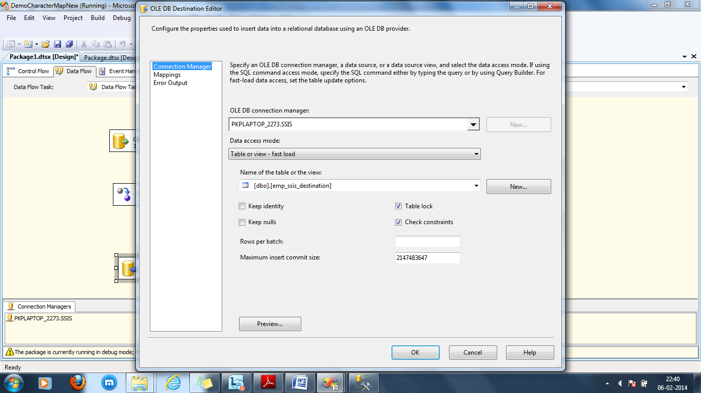
11. Column Mapping

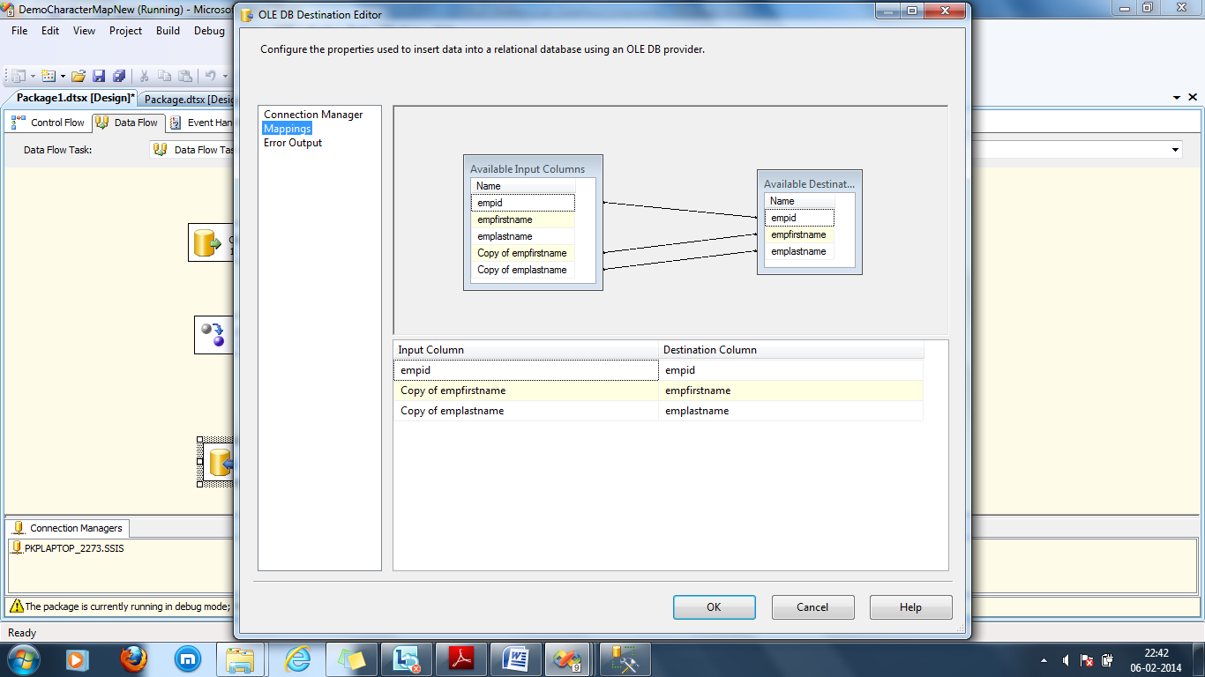

Build the package

Execute the package

Goto Sql server 2008

Use ssis

select * from emp_ssis_destination

using character map transformed text of column from upper case to lower case