**SSIS and Web Service**

Now, expose a method call in the Web Service:

http://www.codeproject.com/images/minus.gifCollapse | [Copy Code](http://www.codeproject.com/Articles/24999/Calling-a-Web-Service-from-a-SQL-Integration-Servi)

public class SSISService : System.Web.Services.WebService

{

[WebMethod]

public string HelloMoon()

{

return "Hello Moon";

}

[WebMethod]

public int Multiply(int nParam1, int nParam2)

{

return nParam1 * nParam2;

}

}

Create an SSIS package:

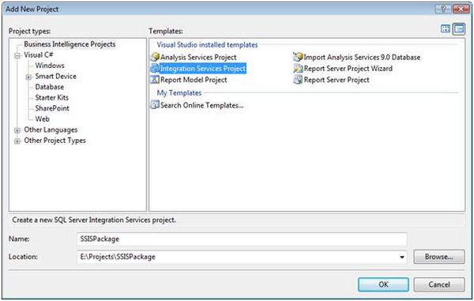

***Figure 3 - Create an SSIS Package***

Add a web service task:

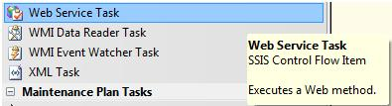

***Figure 4 - SSIS Toolbox***

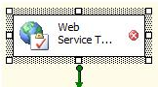

***Figure 5 - Web Service Task***

Next, modify the Web Service task:

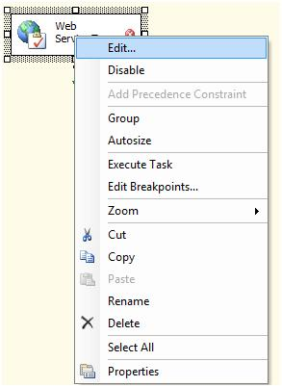

***Figure 6 - Edit Web Service Task***

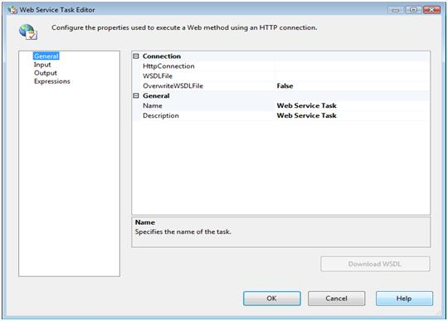

***Figure 7 - Web Service Task Editor***

Now, define the HTTP connection:

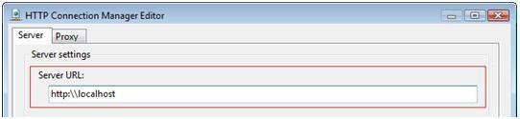

***Figure 8 - HTTP Connection Manager Editor***

The next step is to define the WSDL file:

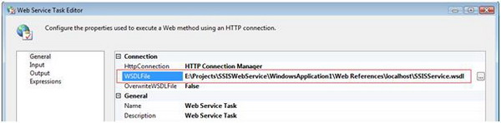

***Figure 9 - Web Service Task Edit (Definition of the WSDL file)***

Define the Web Service Task inputs:

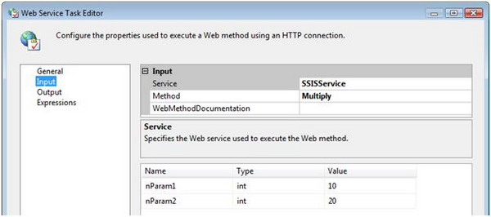

***Figure 10 - Web Service Task Editor (Definition of web service input properties)***

Now, define the Web Service output. The output of the Web Service can be written to variables or to an output file. This sample outputs the results from the Web Service to a file system file that is defined using the File Connection Manager Editor (Figure 11).

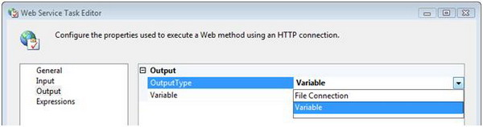

***Figure 11 - Web Service Task Editor (Definition of Web Service output properties)***

***Figure 11 - Web Service Task Editor (Definition of Web Service output properties)***

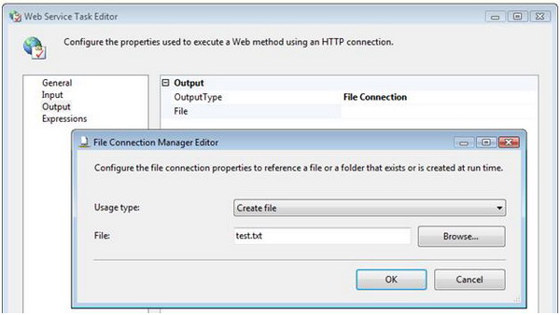

***Figure 12 - File Connection Manger***

See the test.txt file it will have the output of the webmethod.