# Introduction

# BreatheClean.AI is a smart environmental health assistant built using Streamlit, OpenWeatherMap, and GBIF APIs. This app provides real-time air quality updates, weather forecasts, native plant listings, and AI-driven health advice. It is designed to help users—especially allergy-sensitive individuals—make informed decisions about their environment.

# This document showcases the app’s key features through annotated screenshots and provides a visual walkthrough of its functionality.

# BreatheClean.AI Project Screenshots

## Weather and Air Quality Forecast for New York

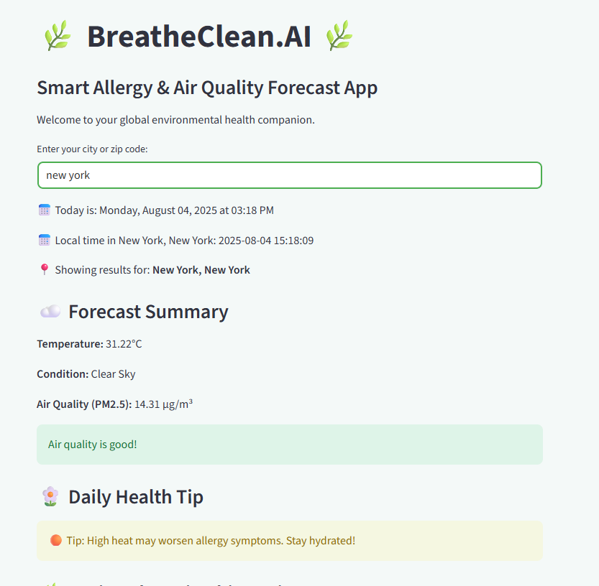

## List of Native Plants Retrieved from GBIF

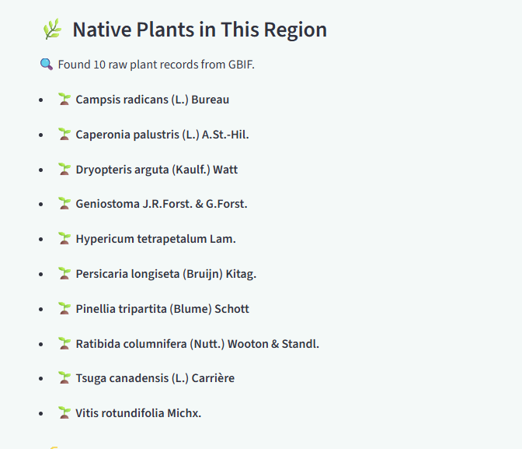

## Pollen Spread Risk Meter Visualization

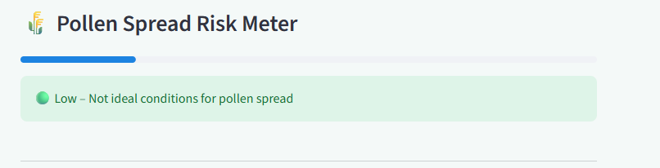

## AI Health Assistant Query Input Interface

