PROJECT DOCUMENTATION
EduGenie
Google Gemini Powered Learning Assistant
An AI-powered educational assistant that answers questions, explains concepts, generates quizzes, summarizes passages and builds personalized learning paths - built with FastAPI, Google Gemini and a lightweight HTML/CSS frontend.

Detail | Information
Project Title | EduGenie: Google Gemini Powered Learning Assistant
Submitted by | Tella Divya Sree
Mentor | Siri
Date | 11/04/2025
Technology | Python, FastAPI, Google Gemini 1.5 Pro, LaMini-Flan-T5, HTML, CSS

Table of Contents

1. Introduction

1.1 Project Overview
EduGenie is a lightweight, AI-powered educational assistant that simplifies learning through generative AI. It is designed for students of all academic levels and brings five learning tools into one simple web page: question answering, concept explanation, quiz generation, passage summarization and personalized learning recommendations.
The application is built with FastAPI for the backend and a simple HTML + CSS frontend. It combines the strengths of a cloud-based model (Google Gemini 1.5 Pro) for advanced reasoning with a small local model (LaMini-Flan-T5-783M) for simple, CPU-friendly explanations. This hybrid design lets EduGenie run comfortably on modest hardware such as a Mac M1 while still benefiting from cloud intelligence.

1.2 Problem Statement
Many learners struggle with dense textbooks, scattered online resources and a lack of personalised guidance. Traditional study material is static: it cannot answer follow-up questions, test understanding, or adapt to the learner's level. Learners with little technical background are often overwhelmed by complex explanations.

1.3 Objectives
- Provide instant, accurate answers to academic and general-knowledge questions.
- Explain complex concepts in simple, beginner-friendly language.
- Generate multiple-choice quizzes from a topic or passage to test understanding.
- Summarize long educational passages for quick revision.
- Create structured, personalized learning paths from beginner to advanced level.
- Keep the system modular, lightweight and easy to run locally.

1.4 Target Users
User Group | How EduGenie helps
School students | Simple explanations and quick answers for homework and revision.
College students | Summaries of long reading material and quizzes for self-assessment.
Self-learners | Structured learning paths for new skills such as SQL or programming.
Educators & content platforms | A modular base that can be embedded into learning platforms.

1.5 Key Features
Ask Questions (Gemini) | Explain Concepts (LaMini-Flan-T5) | Generate Quizzes (3 MCQs, JSON) | Summarize long passages | Recommend Learning Path from beginner to advanced.

2. Usage Scenarios
The following scenarios show how different learners use EduGenie in practice.
Scenario | Learner Goal | EduGenie Task | Outcome
1 - Quick knowledge | A student exploring oceans and rivers asks "Which is the largest ocean?" | Ask a Question (QnA) | A short, accurate answer generated by Gemini 1.5 Pro.
2 - Self-assessment | A student wants to check her understanding of the Pythagoras Theorem. | Generate Quiz | Three MCQs with four options each; wrong answers are corrected.
3 - Structured learning | A learner exploring SQL wants a plan from basics to advanced topics. | Recommend Path | A step-by-step path with timelines, topics and resource suggestions.

Why it matters
Each scenario maps to exactly one module and one API endpoint, which keeps the user experience simple: choose a task, type the input, press submit and read the result directly below the form.

3. System Architecture

3.1 Architecture Overview
EduGenie follows a clean three-layer architecture. The presentation layer collects user input, the application layer exposes REST endpoints through FastAPI, and the logic layer contains one Python module per learning feature. The modules call either Google Gemini 1.5 Pro (cloud) or LaMini-Flan-T5-783M (local).
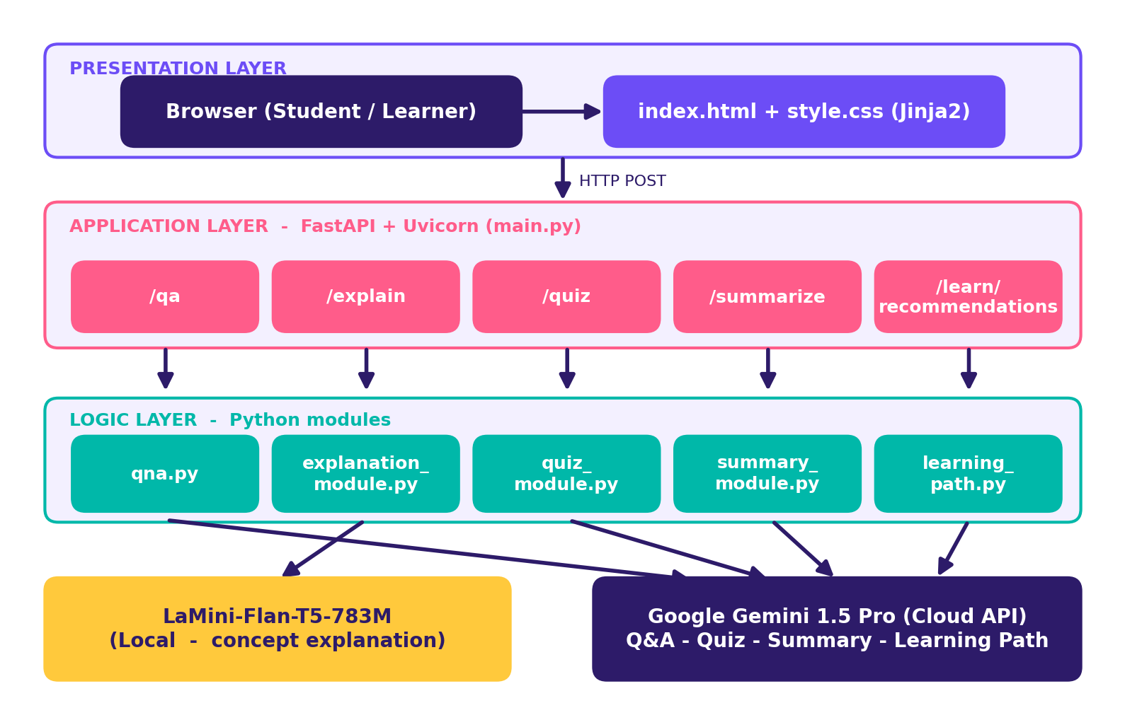
Figure 1: EduGenie layered architecture

3.2 Request Flow
A single request travels through the system in six steps:
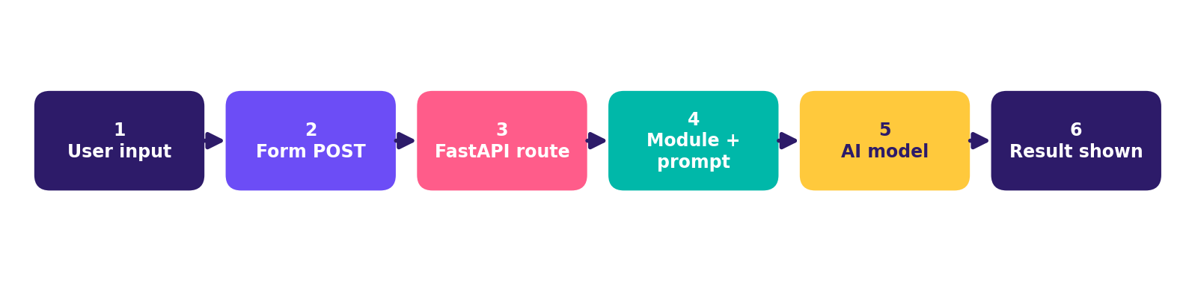
Figure 2: End-to-end request flow
- The user selects a task from the dropdown and types text into the input area.
- The HTML form sends a POST request to the FastAPI backend.
- FastAPI routes the request to the matching endpoint (/qa, /explain, /quiz, /summarize or /learn/recommendations).
- The endpoint calls the matching module, which builds a structured prompt.
- The module sends the prompt to Gemini 1.5 Pro (cloud) or LaMini-Flan-T5 (local) and receives the response.
- The response is cleaned or parsed and rendered below the input box in real time.

3.3 Component Responsibilities
Component | Responsibility
Browser / HTML form | Collects the task type and the learner's text; displays results.
FastAPI (main.py) | Defines REST endpoints, validates input and routes to modules.
Uvicorn | ASGI server that runs the FastAPI application.
Jinja2 | Renders templates/index.html.
Feature modules | Prompt construction, model invocation, response cleanup and error handling.
Gemini 1.5 Pro | Cloud model for Q&A, summarization, quizzes and learning paths.
LaMini-Flan-T5-783M | Local, CPU-compatible model for concept explanations.

4. Technology Stack and Prerequisites

4.1 Technology Stack
Layer | Technology | Purpose
Language | Python 3.10+ | Core programming language for backend and AI modules.
Web framework | FastAPI | High-performance REST API framework.
Server | Uvicorn (ASGI) | Runs the FastAPI app with hot reload.
Templating | Jinja2 | Serves the HTML page.
Frontend | HTML5 + CSS3 | Responsive, minimal user interface.
Cloud AI | Google Gemini 1.5 Pro | Advanced reasoning and structured output.
Local AI | LaMini-Flan-T5-783M | Lightweight instruction-tuned explanation model.

4.2 Python 3.10+
- Download the latest Python 3.10+ installer for your operating system from the official website.
- Run the installer and tick "Add Python to PATH".
- Follow the installation prompts to complete the setup.
- Verify the installation by running the command below in a terminal.
python --version

4.3 Google Gemini API Key
- Visit Google AI Studio and sign in with your Google account.
- Create a new project and enable the Gemini API.
- Generate an API key and store it securely (for example in an environment variable, never in source control).

4.4 Python Libraries
pip install fastapi uvicorn jinja2
pip install google-generativeai transformers torch
Note
The library names beyond FastAPI, Uvicorn and Jinja2 (google-generativeai, transformers, torch) are the standard packages needed to call Gemini and to run LaMini-Flan-T5 locally. Pin exact versions in requirements.txt for your environment.

4.5 Reference Links
- Google AI for Developers - https://ai.google.dev/gemini-api/docs/api-key
- FastAPI documentation - https://fastapi.tiangolo.com/
- FastAPI tutorial - https://fastapi.tiangolo.com/tutorial/
- Uvicorn on PyPI - https://pypi.org/project/uvicorn/

5. Model Selection (Milestone 1)
Milestone 1 focused on choosing the AI models and defining the project architecture. EduGenie deliberately uses two models so that each task is handled by the model best suited to it.

5.1 Gemini 1.5 Pro (via API)
- Used for: Q&A, summarization, quiz generation and learning paths.
- Benefits: advanced reasoning, structured outputs and cloud inference (no heavy local hardware needed).

5.2 LaMini-Flan-T5-783M (local)
- Used for: concept explanation.
- Benefits: instruction-tuned, lightweight and CPU-compatible, so it runs on laptops such as the Mac M1.

5.3 Model Comparison
Aspect | Gemini 1.5 Pro | LaMini-Flan-T5-783M
Deployment | Cloud (API) | Local
Strength | Advanced reasoning, structured JSON output | Short, simple, readable explanations
Hardware need | None locally (internet required) | CPU-compatible; modest RAM
Used in modules | QnA, Quiz, Summary, Learning Path | Explanation
Cost/limits | API key and usage quotas apply | Free after download

5.4 Folder Architecture
EduGenie/
main.py # FastAPI app
explanation_module.py # Concept explanation logic
qna.py # Question answering
quiz_module.py # Quiz generation
summary_module.py # Summarization
learning_path.py # Learning recommendations
templates/
index.html # HTML frontend
static/
style.css # Styling
requirements.txt # Python dependencies
Figure 3: Project folder structure
The one-file-per-feature layout keeps each responsibility isolated. A new feature can be added by creating a new module and registering a new endpoint in main.py without touching existing modules.

6. Core Module Design (Milestone 2)
Milestone 2 implemented the five functional modules and exposed them through a FastAPI backend. Each module receives text input, builds a task-specific prompt, calls a model and returns clean output or a readable error message.
About the code samples
The Python snippets in this section are illustrative reference implementations that follow the behaviour described in the project report. Function names such as clean_json_block and get_learning_recommendations come from the project; other names are suggestions and may differ from your source files.

6.1 Explanation Module (explanation_module.py)
This module uses the LaMini-Flan-T5 model, a lightweight generative model fine-tuned to give concise, context-aware responses that break complex topics into easily understandable language. By focusing on clarity and brevity it helps beginners, school students and self-learners grasp essential concepts without feeling overwhelmed.
Attribute | Detail
Model | LaMini-Flan-T5-783M (local, CPU-compatible)
Input | A topic or concept typed by the learner
Output | A short, simplified explanation in plain text
Endpoint | /explain

from transformers import pipeline

generator = pipeline("text2text-generation",
model="MBZUAI/LaMini-Flan-T5-783M")

def explain_concept(topic: str) -> str:
prompt = f"Explain '{topic}' in simple words for a beginner."
result = generator(prompt, max_length=256, do_sample=False)
return result[0]["generated_text"]

6.2 Question Answering Module (qna.py)
Powered by Gemini 1.5 Pro, this module handles a wide range of general-knowledge and academic questions with precision. Its contextual understanding makes it an effective tool for learners seeking accurate, AI-driven assistance across diverse subjects.
import google.generativeai as genai

model = genai.GenerativeModel("gemini-1.5-pro")

def answer_question(question: str) -> str:
try:
response = model.generate_content(question)
return response.text
except Exception as e:
return f"Error: {e}"

6.3 Quiz Module (quiz_module.py)
The quiz module generates three multiple-choice questions from a given passage, each with four carefully crafted options. Gemini analyses the context and meaning of the passage so that questions are relevant and distractors are plausible. The final output is structured JSON for easy integration with the frontend.
The module sends a structured prompt to the model and expects valid JSON, where each question contains four options and a correct answer. To ensure reliable parsing it removes any Markdown code fences using the clean_json_block function, then parses the cleaned text into a Python list. If generation or parsing fails, a detailed error message is returned for debugging.
Step | Action
1 | Build a structured prompt asking for 3 MCQs in strict JSON.
2 | Call Gemini 1.5 Pro with the passage/topic.
3 | Clean the response with clean_json_block (strip ```json fences).
4 | Parse the cleaned text with json.loads into a Python list.
5 | Return the list, or a detailed error message if parsing fails.

import json, re

def clean_json_block(text: str) -> str:
return re.sub(r"```(?:json)?|```", "", text).strip()

def generate_quiz(passage: str):
prompt = ("Create 3 multiple-choice questions from the text below. "
"Return ONLY valid JSON: a list of objects with keys "
"'question', 'options' (4 items) and 'answer'.\n\n" + passage)
try:
raw = model.generate_content(prompt).text
return json.loads(clean_json_block(raw))
except Exception as e:
return {"error": f"Quiz generation failed: {e}"}

6.4 Summary Module (summary_module.py)
This feature uses Gemini to compress long paragraphs into concise, easy-to-understand versions, ideal for quick revision. It preserves the core information while removing redundancy, helping learners absorb key points without losing clarity or context.
def summarize_text(text: str) -> str:
prompt = ("Summarize the following passage in a concise, "
"easy-to-understand way, keeping key points:\n\n" + text)
return model.generate_content(prompt).text

6.5 Learning Path Module (learning_path.py)
The get_learning_recommendations function uses Google Gemini to generate a personalized, structured learning path for any topic. A detailed prompt instructs the AI to suggest concepts from beginner to advanced, organised by difficulty and supported with resources such as videos, articles and books. The function safely handles API responses and errors, returning either the generated plan or a helpful error message if the response is invalid or incomplete.
def get_learning_recommendations(topic: str) -> str:
prompt = (f"Create a structured learning path for '{topic}' from "
"beginner to advanced. Include topics by difficulty, "
"timelines, and resources (videos, articles, books).")
try:
response = model.generate_content(prompt)
return response.text if response and response.text else "No response."
except Exception as e:
return f"Error: {e}"

6.6 Module Summary
Module | File | Model | Endpoint
Explanation | explanation_module.py | LaMini-Flan-T5 | /explain
Q&A | qna.py | Gemini 1.5 Pro | /qa
Quiz | quiz_module.py | Gemini 1.5 Pro | /quiz
Summary | summary_module.py | Gemini 1.5 Pro | /summarize
Learning Path | learning_path.py | Gemini 1.5 Pro | /learn/recommendations

7. Backend API with FastAPI
Activity 2.2 defined RESTful endpoints for each module and connected every endpoint to its module logic. FastAPI also provides automatic interactive documentation (Swagger UI) at /docs, which is useful for testing each endpoint.

7.1 Endpoint Reference
Endpoint | Method | Module called | Purpose
/qa | POST | qna.py | Answer a question
/explain | POST | explanation_module.py | Simplified concept explanation
/quiz | POST | quiz_module.py | Generate 3 MCQs from text or topic
/summarize | POST | summary_module.py | Summarize a long passage
/learn/recommendations | POST | learning_path.py | Personalized learning path

7.2 Application Skeleton (main.py)
from fastapi import FastAPI, Request, Form
from fastapi.templating import Jinja2Templates
from fastapi.staticfiles import StaticFiles

app = FastAPI(title="EduGenie")
app.mount("/static", StaticFiles(directory="static"), name="static")
templates = Jinja2Templates(directory="templates")

@app.get("/")
def home(request: Request):
return templates.TemplateResponse("index.html", {"request": request})

@app.post("/qa")
def qa(text: str = Form(...)):
return {"result": answer_question(text)}

# /quiz, /summarize and /learn/recommendations follow the same pattern

7.3 Error Handling
- Every module wraps model calls in try/except and returns a readable error message instead of crashing.
- The quiz module reports parsing errors with detail so prompt problems can be debugged quickly.
- The learning-path module checks for empty or invalid responses before returning them.

8. Frontend Development (Milestone 3)

8.1 Web Interface (Activity 3.1)
The frontend is intentionally simple so it loads fast and works on any device.

index.html
- Task dropdown with five options: Explain, QnA, Quiz, Summary and Recommend Path.
- Text area for the learner's question, topic or passage.
- Submit button that triggers the request.
- Result container that displays the response below the input box.

style.css
- Responsive design that adapts to desktop, tablet and mobile screens.
- Styled buttons, input areas and result container for a clean look.

8.2 Live Integration (Activity 3.2)
- Form submission sends a POST request to the FastAPI backend.
- The result appears below the input box in real time, without leaving the page.
- Quiz responses are rendered as questions with four options; a wrong choice is corrected by showing the right answer.

8.3 User Interface Flow
Step | User action | System response
1 | Open http://127.0.0.1:8000 | Home page with task dropdown and input area.
2 | Choose a task and enter text | Input is prepared for submission.
3 | Click Submit | POST request is sent to the matching endpoint.
4 | Wait a moment | AI response is generated and returned.
5 | Read the result | Answer, explanation, summary, quiz or learning path appears below.

9. Deployment and Testing (Milestone 4)

9.1 Run Locally (Activity 4.1)
- Open a terminal in the EduGenie project folder.
- Install dependencies from requirements.txt.
- Set the Gemini API key as an environment variable.
- Start the server with Uvicorn.
- Open the application in a browser.
pip install -r requirements.txt
export GOOGLE_API_KEY="your-api-key" # Windows: set GOOGLE_API_KEY=...
uvicorn main:app --reload

# Then open: http://127.0.0.1:8000

9.2 Functional Testing (Activity 4.2)
Test case | Input | Expected result | Status
Ask a question | Which is the largest ocean? | Correct, concise answer (Pacific Ocean). | Pass
Get an explanation | A concept such as Photosynthesis | Simple, beginner-level explanation. | Pass
Generate a quiz | Pythagoras Theorem | 3 MCQs with 4 options each; wrong answers corrected. | Pass
Summarize content | A long paragraph | Shorter version retaining key points. | Pass
Learning plan | SQL | Beginner-to-advanced path with resources. | Pass

9.3 Exploring EduGenie - Results
- Asking questions: direct, accurate answers to general-knowledge and academic queries.
- Explaining topics: complex ideas broken into simple language.
- Summarizing long paragraphs: concise versions suitable for quick revision.
- Generating quizzes: three questions with four options each; the app corrects the answer if a wrong option is chosen.
- Learning recommendations: beginner-to-advanced guidance with details of resources to learn from and step-by-step direction throughout.
Tip
Add your own screenshots here (home page, each task result and the quiz screen) before submission.

10. Challenges and Solutions
Challenge | How it was addressed
Accuracy of AI-generated responses | Continuous testing and refinement of prompt structures.
Consistent performance across devices | Lightweight local model plus cloud inference for heavy tasks.
Balancing personalization with general usability | Simple single-page UI with task selection and level-aware prompts.
Reliable JSON from the quiz model | Strict prompt format and the clean_json_block parser with error reporting.
Data privacy concerns | Secure storage of API keys and minimal data handling.
Clarity of user interface | Iterative UI optimisation for readability and responsiveness.

10.1 Key Learning Outcomes
- Prompt engineering for structured outputs.
- Cloud AI integration with the Gemini API.
- User-centric design for beginner learners.
- Modular, scalable architecture with FastAPI.

10.2 Security and Privacy Considerations
- Never hard-code the API key; use environment variables or a secrets manager.
- Do not commit .env files to version control.
- Validate and limit input length to protect the API quota.
- Avoid storing personal learner data unless a clear privacy policy is in place.
- Treat AI output as guidance and verify important facts against trusted sources.

11. Future Enhancements
Area | Planned enhancement | Benefit
Interaction | Voice-based input and output | Hands-free learning and accessibility.
Reach | Multilingual support | Breaks language barriers for a global audience.
Access | Mobile application with offline features | Learn anytime, anywhere.
Insight | Progress-tracking dashboards | Visualise the learning journey with metrics.
Engagement | Badges, streaks and challenge-based assessments | Higher motivation through gamification.
Adaptivity | Analytics-driven adaptive learning paths | Content tuned to strengths and weaknesses.
Collaboration | Group study, teacher and parent dashboards | Shared and supervised learning.
Integration | LMS integration (Moodle, Google Classroom) | Fits into existing school workflows.
Input types | Image and PDF recognition | Snapshot-based doubt solving and document summaries.
Engagement | Real-time sync and smart notifications | Continuity across devices and sessions.

12. Conclusion
EduGenie is a robust and accessible AI-powered educational assistant that combines cloud-based intelligence with an intuitive, low-footprint web interface. It supports self-learners, educational institutions and content platforms by simplifying complex concepts, providing instant question-and-answer interactions, generating personalised quizzes, offering concise summaries and tailoring learning paths to individual needs.
The project achieved key milestones in AI integration, user experience design and content adaptability. Its modular structure allows easy upgrades, and its cloud-based backend ensures scalability. The challenges encountered - response accuracy, cross-device performance, personalization and privacy - were resolved through prompt refinement, UI optimisation and careful testing, and gave valuable experience in prompt engineering, cloud integration and scalable design.
EduGenie is more than a tool: it is a foundation for personalised, inclusive and intelligent education. By bridging gaps in access, comprehension and adaptability, it has the potential to become a comprehensive, learner-first companion for the modern era.

Appendix A: Glossary
Term | Meaning
FastAPI | A modern Python web framework for building APIs quickly.
Uvicorn | An ASGI web server used to run FastAPI applications.
Jinja2 | A Python templating engine for generating HTML.
Gemini | Google's family of generative AI models, accessed via API.
LaMini-Flan-T5 | A small, instruction-tuned text-to-text model that runs locally.
MCQ | Multiple-choice question.
Prompt engineering | Designing instructions so an AI model returns useful, well-formatted output.
REST API | A web interface where clients use HTTP requests to call server functions.

Appendix B: Project Sign-off
Field | Value
Submitted by | Tella Divya Sree
Mentor | Siri
Date | 11/04/2025

