Contents

HP Fortify Jenkins Plugin 2

Installing the Jenkins Plugin 2

Verifying Plugin Installation 2

Create a new job in Jenkins 3

Configuration: 3

Builds for Non-Source Control Projects 4

Using the Jenkins Plugin with Continuous Builds 4

Issues faced in fortify job on Jenkins 5

# HP Fortify Jenkins Plugin

The HP Fortify Jenkins Plugin is used in conjunction with HP Fortify Software Security Center (SSC), a collaborative system for reviewing and auditing security analysis results. If you use a Fortify plugin such as maven to scan your source code after each build, the Jenkins plugin automatically uploads the Fortify project results (in an FPR file) to an SSC server and enables you to view the details within SSC Server. It also provides metrics for each build and an overview of the results, without having to connect to SSC.

# Installing the Jenkins Plugin

To install the Jenkins plugin, you must have Jenkins installed on your system.

1. Open a browser window and navigate to <http://mo-543f0fc82.mo.sap.corp:8080/jenkins/>

2. From the Jenkins user interface, select Manage Jenkins, and then select Manage Plugins.

3. On the Plugin Manager page, click the Advanced tab.

4. In the Upload Plugin section, click Browse, and then locate and select the fortifyJenkins.hpi file. Path:

“\\dwdf213.wdf.sap.corp\sec_scan\Public\Fortify\Installation\v4.30 - recommended\HP_Fortify_SCA_and_Apps_4.30_Windows_TF302-15214.zip-HP_Fortify_jenkins_plugin1.4.0.zip\fortify-jenkins.hpi”

5. Click Upload.

6. Restart Jenkins.

# Verifying Plugin Installation

To verify that the Jenkins plugin is installed:

1. Open a browser window and navigate to <http://mo-543f0fc82.mo.sap.corp:8080/jenkins/>

2. From the Jenkins user interface, select Manage Jenkins, and then select Manage Plugins.

3. On the Plugin Manager page, click the Installed tab.

4. Make sure that HP Fortify Jenkins Plugin version 1.4.30 is listed in the table of installed plugins.

# Create a new job in Jenkins

**Step1:** Go to Jenkins top page, **select ->Translation service->New Job**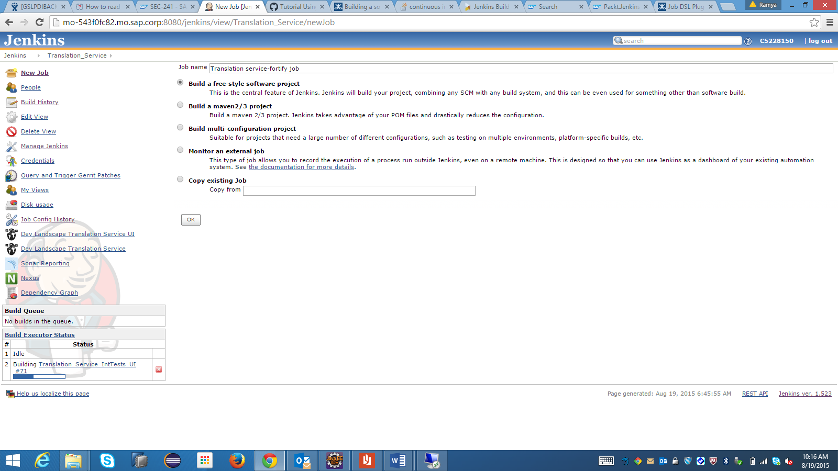

**Step 2:** Fill in the name field, e.g. "Translation service-fortify"

**Step 3**: Select the "Build a free-style software project" radio button.

**Step 4**: Click the OK button

# Configuration:

**Step1:** select your job **->click on configuration**

1. **In Source code Management select-> Git**

|  |  |
| --- | --- |
|  | * Repository URL: ssh://hudsonvoter@git.wdf.sap.corp:29418/com.sap.translationservice.git * Click on dropdownlist Repository browser:   Select Gitweb:  Enter below link in URL  URL: <https://git.wdf.sap.corp:50000/git/?p=com.sap.translationservice.git> |

**2. Build Area:**

* Select Add timestamps to console

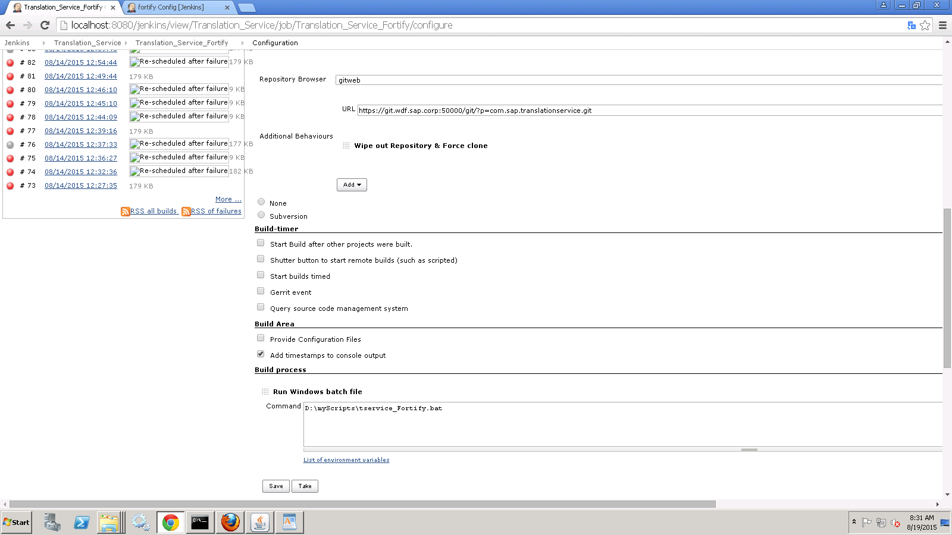

**3. Build Process:**

* Click on dropdownlist ->Add Build setup, select **“Execute windows batch file”**
* Here you should give batch file path
* Click on Save button.

Batch file contains maven commands. Maven commands will clean, compile, scan and upload results to an SSC [Software Security Center] server.

# Builds for Non-Source Control Projects

Sometimes there is a need to build a project simply for demonstration purposes or access to a SVN/CVS repository is unavailable. By choosing to configure the project  as "None" under "Source Code Management" you will have to:

1. Build the Project at least once, (it will fail), but Jenkins will create the structure jenkins/workspace/PROJECTNAME/

# Using the Jenkins Plugin with Continuous Builds

To use the Jenkins plugin with continuous builds:

1. Place the FPR resulting from a source code scan into the workspace directory for the job. (On Windows systems, the default directory is C:\Users\<username>\.jenkins\jobs\<project_name>\workspace.)

Note: Configure your build procedure to do this automatically. You can specify the path to your FPR file with the FPR Filename setting on the Job Configuration page, see configuring the Build Step to Use for the Jenkins Plugin

2. From the Jenkins user interface, select Build Now.

3. To read progress messages from the Jenkins plugin, in the Build History box, select the build link, and then, on the <build_number> page, select Console Output.

4. After the build is completed (after you see the “Finished: SUCCESS” message), return to the project page.

# Issues faced in fortify job on Jenkins

1. **Server could not be contacted**

I got this error because authentication token has expired

1. **Keytool.exe is not a valid Win 32 application?**

Whenever I try to import the certificate, I got "keytool.exe is not a valid win32 application" error because keytool.exe file has ‘0’ bytes.

|  |  |  |  |  |  |  |  |  |  |  |  |  |  |  |  |  |  |  |  |  |  |  |  |  |  |  |
| --- | --- | --- | --- | --- | --- | --- | --- | --- | --- | --- | --- | --- | --- | --- | --- | --- | --- | --- | --- | --- | --- | --- | --- | --- | --- | --- |
|  |  |  |  |  |  |  |  |  |  |  |  |  |  |  |  |  |  |  |  |  |  |  |  |  |  | **Solution:** I have installed fortify 4.10 in my system and replaced keytool.exe on the machine throwing this error and that worked for me. |

1. **Access Denied. Please ensure the requested project exists and the supplied user has appropriate permissions.**

I figured out my issue was related to my token. I had generated my token using AnalysisUploadToken for my gettoken argument and that only allows uploading. I had to create another token using **AnalysisUpload** Token in order to upload it.

1. **Updating the Rulepacks**

* Run <Fortify install dir>\bin\fortifyupdate.cmd.

**Error:** Certificate is not imported

Issue was related to certificate, before I was trying to import **“SAPNetCA.der”** certificate but this certificate was expired”. Then I tried with **SAPGlobalRootCA.cer.**

D:\Fortify\app\jre\bin>keytool -import –trustcacerts -alias rootCA –file "D:\certificate\**SAPGlobalRootCA.cer**" -keystore "D:\Fortify\app\jre\lib\security\cacerts"

D:\Fortify\app\bin>Fortifyclient token -gettoken AnalysisUploadToken -url https://fortify1.wdf.sap.corp/ssc -user C5228150