Steps to be followed once you have downloaded the code from GIT to run in local environment

1. Downloading the code from GIT is same as usual
2. Once you download the code and have the packages in eclipse. Resolve the errors, mainly the errors will be packages not formed properly and compiler version different
3. Now in package “com.sap.translationservice.parent” go Run configuration by right clicking and clicking on run as
4. Select Maven Build and click on “New” button on top and update configuration as shown:

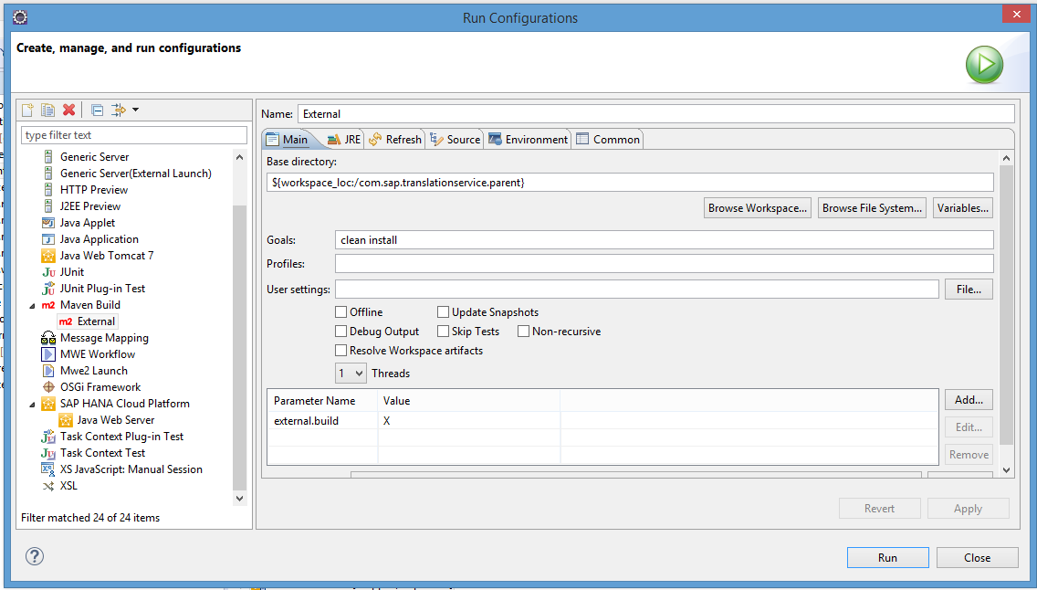

1. Once updated click Apply and Run to build the project
2. On Successful build you have to update “Deployment Assembly” by right clicking on package “com.sap.translationservice.service.web.extern” -> properties and “Deployment Assembly” as shown

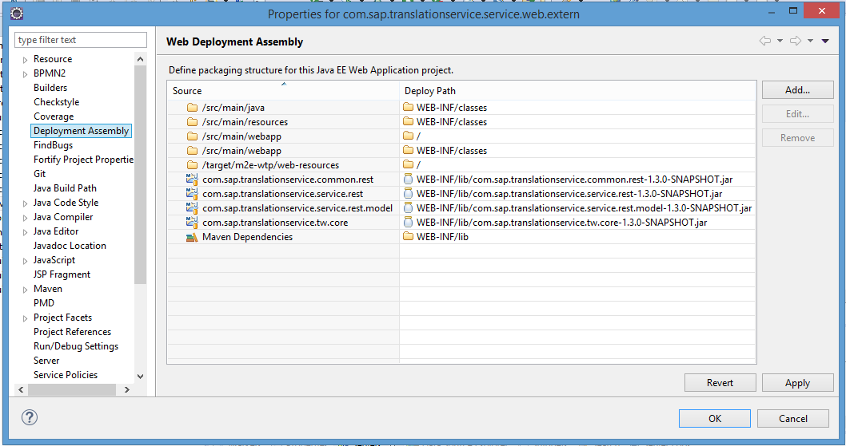

1. Now the server has to be configured with a username and password, chose any and add role, User for this user created. This will be the credentials that will be used while launching the app locally on browser. Create appropriate xsbackend connections in server.
2. Also you have to update the connection.properties file with credentials for HANA system

Connection.properties can be found in config_master->connection_data.

1. Now add the project,” com.sap.translationservice.service.web.extern” to the server. Restart or publish as suitable and launch it in the browser to have your application running locally