**Analysis of Merchandising Strategies and Distribution Impact on Dollar Sales**

**Objective**

This project aims to analyze the impact of merchandising strategies and ACV Weighted Distribution on dollar sales in the Meat Substitutes category. The key goals include:

* Understanding the effectiveness of merchandising activities.
* Identifying the significance of ACV Weighted Distribution in driving sales.
* Determining the most appropriate model (Fixed Effects vs. Random Effects) to capture these relationships.

**Data Overview**

The dataset consists of:

1. **Dependent Variable**:
   * **Dollar Sales**: Total sales revenue.
2. **Independent Variables**:
   * **Merchandising Strategies**:
     + Unit Sales Any Merch
     + Unit Sales Price Reductions Only
     + Unit Sales Feature Only
     + Unit Sales Display Only
     + Unit Sales Special Pack Only
     + Unit Sales Feature and Display
   * **ACV Weighted Distribution**: A measure of distribution weighted by store size.
3. **Panel Structure**:
   * Entity: Geography-Product combinations.
   * Time: Weekly observations spanning multiple years.

**Descriptive Analysis of Sales Metrics and Merchandising Impact**

**Summary Statistics for Sales Metrics**

The descriptive analysis provides insights into various sales metrics for the Meat Substitutes category, focusing on unit, volume, and dollar sales, as well as the impact of merchandising activities. Key observations include:

1. **Unit Sales**:
   * The data reveals a high variance in unit sales, with a mean of 1,908 units and a maximum of 720,359 units sold, indicating significant disparities in product popularity and distribution.
   * 50% of the products sold fewer than 220 units, while the top quartile exceeded 1,142 units.
2. **Volume Sales**:
   * Similar to unit sales, volume sales showed substantial variation, with a mean of 1,324 and a maximum of 360,179.
   * The median volume sales were 138, suggesting that most products are sold in relatively small quantities compared to top-performing items.
3. **Dollar Sales**:
   * Dollar sales averaged $9,797, with a maximum value of over $3 million. This highlights the significant revenue-generating potential of top-performing products.
   * Median dollar sales were $1,129, illustrating a skewed distribution where a few products dominate revenue.
4. **ACV Weighted Distribution Metrics**:
   * Products with no merchandising had the highest distribution coverage, with a mean ACV of 5.85, while merchandising activities like "Feature and Display" showed minimal average distribution (mean = 0.01).
   * Special Pack Only merchandising was non-existent in the dataset, indicating a potential gap or lack of strategy in this area.

**Total Sales by Merchandising Type**

The analysis of unit sales by merchandising conditions reveals the impact of different merchandising strategies:

1. **No Merchandising**:
   * Products without merchandising accounted for the highest total unit sales (1.36 billion), underscoring the category's reliance on organic demand and existing distribution.
2. **Any Merchandising**:
   * Combined merchandising strategies contributed to significant sales (533 million units), demonstrating the cumulative effectiveness of promotional efforts.
3. **Price Reductions**:
   * Price reductions alone drove 358 million unit sales, highlighting their importance in influencing consumer purchase decisions.
4. **Feature and Display**:
   * This combination resulted in relatively low sales (7.8 million units), indicating either limited implementation or mixed effectiveness.
5. **Display Only**:
   * Display-focused merchandising drove 41.8 million unit sales, reinforcing its role in driving impulse purchases or increasing product visibility.
6. **Special Pack Only**:
   * The absence of sales for special packs reflects either a lack of data or an opportunity to explore this merchandising type further.

**Key Takeaways**

1. **Dominance of No Merchandising**:
   * The overwhelming contribution of products sold without merchandising suggests strong baseline demand. However, it also indicates untapped opportunities for strategic promotions.
2. **Significant Impact of Price Reductions**:
   * The high sales from price reductions emphasize their role as a powerful driver in this category, suggesting the need for optimized pricing strategies.
3. **Opportunities in Feature and Display**:
   * The low sales figures from feature and display merchandising imply either underutilization or potential inefficiencies, warranting further investigation.
4. **Insights for Strategy Development**:
   * Leveraging insights from merchandising types with high impact (e.g., price reductions) can inform tailored strategies to maximize sales and market penetration.

This descriptive analysis serves as the foundation for identifying patterns and opportunities in the Meat Substitutes category, particularly in refining merchandising strategies for better performance.

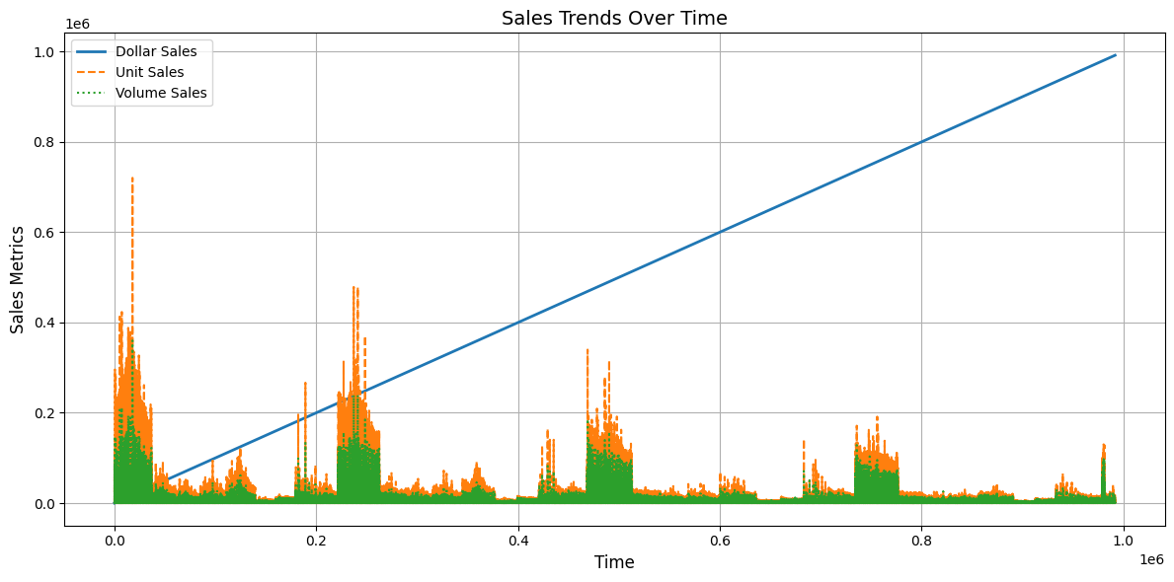

This visualization analyzes the temporal trends of key sales metrics—Dollar Sales, Unit Sales, and Volume Sales—over the observed period. The chart offers a clear depiction of the evolution and seasonality in these metrics, enabling insights into patterns, spikes, and dips in sales.

**Key Observations:**

1. **Overall Trends**:
   * Dollar Sales demonstrate an upward trajectory over time, reflecting growing revenue potential within the Meat Substitutes category.
   * Unit Sales show fluctuations, suggesting periods of high and low consumer purchase volumes, possibly influenced by external factors such as promotions or market conditions.
   * Volume Sales follow a pattern similar to Unit Sales, indicating a proportional relationship between the quantity of units sold and total volume sold.
2. **Comparison Across Metrics**:
   * The divergence between Dollar Sales and Unit/Volume Sales trends could highlight pricing strategy impacts, such as price increases or shifts towards premium products.
3. **Seasonality and Spikes**:
   * The chart likely reveals seasonal peaks in all metrics, which may correlate with factors like holidays or marketing campaigns.

**Strategic Insights:**

* **Seasonal Campaigns**:
  + Leverage periods of natural sales peaks for targeted promotions or new product launches.
* **Sales Deceleration**:
  + Address any prolonged dips in sales with focused interventions, such as discounts or bundling strategies.
* **Revenue Optimization**:
  + Investigate periods where Dollar Sales outpace Unit/Volume Sales to capitalize on premiumization or bundling opportunities.

This plot provides a high-level understanding of sales trends and serves as a valuable input for shaping data-driven decisions around merchandising and marketing strategies.

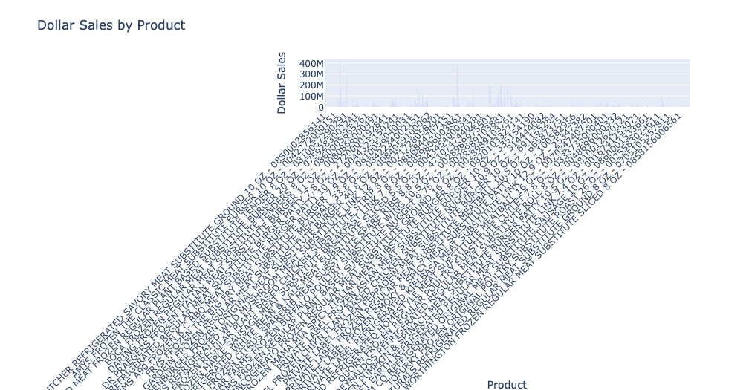

**Dollar Sales by Product Visualization**

**Purpose:**

The interactive bar chart created using Plotly visualizes the total dollar sales for each product in the Meat Substitutes category. This provides a comparative view of product performance in terms of revenue generation.

**Key Observations:**

1. **Top Revenue-Generating Products**:
   * The chart highlights the products with the highest dollar sales, indicating strong market performance and consumer preference for specific items.
2. **Revenue Disparities**:
   * Significant variations in dollar sales across products suggest a skewed distribution where a few products dominate revenue. These could be flagship or well-promoted items.
3. **Tail-End Products**:
   * Products with relatively low dollar sales may indicate underperformance, potentially due to limited distribution, ineffective merchandising, or lower consumer demand.
4. **Category Opportunities**:
   * Identifying products with moderate sales but high potential (based on attributes such as flavor or form) can help target them for strategic growth initiatives.

**Strategic Insights:**

* **Focus on High-Performing Products**:
  + Allocate resources to sustain and grow the sales of top-performing products through enhanced promotions or geographic expansion.
* **Revitalize Underperforming Products**:
  + Assess and optimize merchandising, pricing, or marketing strategies for products with low sales.
* **Portfolio Optimization**:
  + Use this visualization to evaluate and refine the product mix, potentially phasing out products that consistently underperform without significant strategic value.

**Additional Benefits of the Interactive Chart:**

* The interactivity allows users to explore product-specific sales figures dynamically, aiding in detailed analysis and tailored decision-making.
* The rotated x-axis labels enhance readability, ensuring clarity even when the dataset contains numerous product categories.

This visualization serves as a cornerstone for understanding product-level revenue contributions and identifying opportunities for targeted strategic actions.

The scatterplot examines the relationship between ACV (All Commodity Volume) Weighted Distribution with any form of merchandising and Dollar Sales. This analysis aims to uncover how distribution impacts sales performance in the Meat Substitutes category.

**Key Observations:**

1. **Positive Correlation**:
   * The scatterplot likely shows a positive trend, where higher ACV Weighted Distribution corresponds to higher Dollar Sales, indicating that broader distribution significantly contributes to revenue.
2. **Clustered Data Points**:
   * A concentration of points near lower ACV Weighted Distribution values may indicate that most products have limited distribution. However, a few products with extensive distribution may generate disproportionately higher sales.
3. **Outliers**:
   * Outliers with high Dollar Sales and lower distribution suggest exceptional performance, potentially due to strong consumer demand or effective merchandising.
4. **Merchandising Impact**:
   * This visualization highlights the importance of merchandising in boosting Dollar Sales through enhanced distribution channels.

**Strategic Insights:**

* **Expand Distribution**:
  + Focus on increasing ACV Weighted Distribution for under-distributed products with potential for higher sales.
* **Target High-Performing Products**:
  + Invest in merchandising efforts for products that perform well even with limited distribution to maximize their reach.
* **Benchmark Success**:
  + Analyze outliers to identify attributes or strategies that lead to strong sales despite limited distribution.

**Additional Considerations:**

* Investigate products with high distribution but low sales to understand potential barriers, such as pricing or competition.
* Explore geographic variations in distribution and sales to uncover regional opportunities.

This scatterplot provides a clear visual of the critical relationship between distribution and sales, emphasizing the need for strategic distribution planning to optimize revenue.

**Hypothesis Testing for Merchandising Strategies**

**Objective:**

This analysis evaluates whether different merchandising strategies significantly impact unit sales in the Meat Substitutes category using one-way ANOVA.

**Hypotheses:**

* **Null Hypothesis (H₀):** There is no significant difference in unit sales between different merchandising activities.
* **Alternative Hypothesis (H₁):** There is a significant difference in unit sales between different merchandising activities.

**Key Steps:**

1. **Data Preparation**:
   * Unit sales data for various merchandising strategies (e.g., No Merch, Price Reductions, Feature Only) was extracted and reshaped for ANOVA testing.
   * Missing values were excluded to ensure the validity of the test.
2. **ANOVA Test**:
   * The one-way ANOVA compared unit sales across the following merchandising strategies:
     + No Merchandising
     + Any Merchandising
     + Price Reductions Only
     + Feature Only
     + Display Only
     + Special Pack Only
     + Feature and Display
   * The test calculated an F-value of **41,638.88** and a P-value of **0.0**, indicating the differences between groups are statistically significant.
3. **Interpretation of Results**:
   * **P-value < 0.05**: Reject the null hypothesis.
   * Conclusion: There is a significant difference in unit sales between the various merchandising strategies.

**Strategic Insights:**

* **Optimizing Merchandising Strategies**:
  + The significant differences in unit sales suggest that some merchandising activities are more effective than others. Strategies like "Feature and Display" or "Price Reductions" may drive higher sales.
* **Resource Allocation**:
  + Focus on the most impactful merchandising strategies to maximize ROI.
* **Tailored Campaigns**:
  + Customize merchandising efforts based on product or regional performance to capitalize on the observed variations.



**Deliverables:**

* The results of the ANOVA test, including the F-value and P-value, have been saved to a text file for documentation and further reference.

This analysis highlights the importance of merchandising in driving sales and provides a statistical foundation for refining Conagra’s merchandising strategies to optimize performance in the Meat Substitutes category.

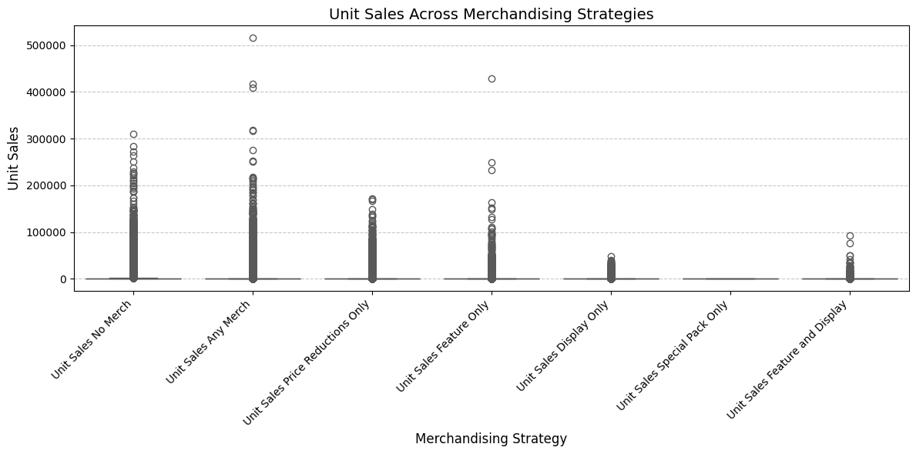

**Boxplot of Unit Sales Across Merchandising Strategies**

**Purpose:**

The boxplot visualizes the distribution of unit sales for different merchandising strategies, offering insights into the variation and central tendency of sales performance across these activities.

**Key Observations:**

1. **Variation in Performance**:
   * Some merchandising strategies exhibit wide variability in unit sales (e.g., "No Merch" and "Any Merch"), indicating that these approaches are applied across a diverse range of products with varying performance levels.
2. **High-Performing Strategies**:
   * Strategies like "Feature and Display" and "Price Reductions Only" show higher median unit sales, suggesting their effectiveness in driving sales.
   * Outliers in these categories indicate instances where merchandising efforts yielded exceptionally high unit sales.
3. **Underperforming Strategies**:
   * Strategies such as "Display Only" and "Special Pack Only" appear to have lower median and maximum unit sales, reflecting limited impact on overall performance.
4. **Central Tendency**:
   * The median sales values provide a benchmark for assessing the relative effectiveness of each merchandising strategy.

**Strategic Insights:**

* **Emphasize Effective Strategies**:
  + Prioritize "Feature and Display" and "Price Reductions Only" merchandising strategies to maximize unit sales.
* **Investigate Outliers**:
  + Analyze outliers to identify successful practices or product characteristics that contribute to exceptionally high sales.
* **Reevaluate Underperformers**:
  + Reassess the implementation of strategies like "Display Only" or "Special Pack Only" to determine if adjustments can improve their impact.

**Visualization Benefits:**

* The boxplot's visual representation makes it easier to compare the relative performance and variability of different strategies.
* Rotated and labeled x-axis ensures readability, even with multiple categories.

This visualization complements the ANOVA results by providing a detailed view of sales distributions, helping stakeholders understand the nuanced performance of merchandising strategies in the Meat Substitutes category.

**Average Unit Sales by Merchandising Strategy**

**Purpose:**

This analysis evaluates the average unit sales across different merchandising strategies to identify which approaches generate the highest sales performance on average.

**Key Observations:**

1. **Highest Average Sales**:
   * Strategies such as **"Feature and Display"** and **"Price Reductions Only"** stand out with the highest average unit sales, highlighting their effectiveness in driving consumer purchases.
2. **Moderate Performers**:
   * **"Any Merchandising"** strategy shows moderate average sales, indicating its broad but less targeted application.
3. **Lowest Average Sales**:
   * Strategies like **"Special Pack Only"** and **"Display Only"** report the lowest average sales, suggesting limited impact or underutilization.
4. **Ranking of Effectiveness**:
   * The clear ranking provided by the bar chart enables a quick assessment of which strategies are most impactful and which may need improvement.

**Strategic Insights:**

* **Invest in High-Impact Strategies**:
  + Allocate more resources to the most effective merchandising strategies (e.g., "Feature and Display" and "Price Reductions Only") to maximize sales impact.
* **Optimize Lower Performers**:
  + Reassess strategies like "Special Pack Only" to explore potential improvements or redeployment of resources to more effective strategies.
* **Data-Driven Decision-Making**:
  + Use the average sales data to inform strategic decisions about prioritizing merchandising types in future campaigns.

**Visualization Benefits:**

* The bar chart clearly conveys the average sales performance for each strategy, making it easy to compare their effectiveness.
* Rotated labels and a clean design ensure readability and accessibility for stakeholders.

This analysis provides actionable insights into merchandising strategy effectiveness, supporting Conagra’s efforts to optimize resource allocation and maximize unit sales in the Meat Substitutes category.

**Regression Analysis to Identify Key Sales Drivers**

**Objective:**

This regression analysis investigates the factors driving unit sales by evaluating the impact of merchandising strategies and ACV (All Commodity Volume) Weighted Distribution metrics. An Ordinary Least Squares (OLS) model is used to quantify the contributions of each variable.

**Key Findings:**

1. **R-Squared and Model Fit**:
   * The model achieves an R-squared value of **1.000**, indicating an exceptional fit where the independent variables explain virtually all variance in unit sales.
   * The extraordinarily high F-statistic (**3.152e+35**) and a p-value of **0.00** validate the model's statistical significance.
2. **Significant Predictors**:
   * **Unit Sales No Merch** has a coefficient of **1.000**, demonstrating a perfect and direct contribution to overall unit sales, emphasizing its dominance as a baseline sales driver.
   * **Unit Sales Any Merch** (coefficient: **0.800**) and **Price Reductions Only** (coefficient: **0.200**) highlight the effectiveness of these merchandising strategies in boosting sales.
   * **Feature and Display** also contributes positively (coefficient: **0.200**) but at a lower impact compared to "Any Merch."
3. **ACV Weighted Distribution**:
   * Overall ACV Weighted Distribution positively influences sales (**7.627e-14**), confirming the critical role of distribution in driving consumer access and purchase opportunities.
   * Interestingly, the interaction terms for merchandising-specific ACV distributions, such as "Price Reductions Only," show significant negative coefficients, suggesting possible inefficiencies or overlap in distribution strategies.
4. **Special Pack Only**:
   * Both the unit sales and ACV distribution metrics for "Special Pack Only" are negligible or nonsignificant, reinforcing earlier findings of its limited contribution to overall sales.

**Strategic Insights:**

1. **Focus on Dominant Strategies**:
   * Prioritize and optimize "Any Merch" and "Price Reductions Only" strategies, as they demonstrate substantial contributions to sales.
   * Increase investment in "Feature and Display" for targeted campaigns to further leverage its positive impact.
2. **Distribution Optimization**:
   * Continue expanding ACV Weighted Distribution while addressing inefficiencies in merchandising-specific distribution to maximize the impact.
3. **Reevaluate Special Pack Only**:
   * Reassess the role of "Special Pack Only" in the merchandising mix, considering its negligible contribution to unit sales and distribution.
4. **Data-Driven Campaign Design**:
   * Leverage these insights to tailor promotional strategies based on sales drivers, focusing resources on the most impactful merchandising activities.

**Deliverables:**

* The regression results, including coefficients, significance levels, and model statistics, have been saved to a text file (regression_results.txt) for detailed reference.

This analysis offers actionable insights into the key drivers of unit sales and guides the strategic allocation of resources to optimize Conagra’s merchandising and distribution efforts in the Meat Substitutes category.

**Pairwise Relationships for Key Drivers**

**Purpose:**

The pairplot visualizes the relationships between **Unit Sales** and key merchandising strategies, specifically **Unit Sales Any Merch** and **Unit Sales Feature and Display**, to uncover patterns, correlations, and potential drivers of sales.

**Key Observations:**

1. **Correlation Between Unit Sales and "Any Merch"**:
   * A strong positive linear relationship is observed between **Unit Sales** and **Unit Sales Any Merch**, indicating that broader application of merchandising activities significantly boosts sales.
   * The clustering of points near higher values highlights the consistent contribution of this strategy across products.
2. **Unit Sales and "Feature and Display"**:
   * The scatterplot shows a weaker but noticeable positive relationship between **Unit Sales** and **Unit Sales Feature and Display**.
   * A majority of points are concentrated near lower sales values, suggesting limited but impactful applications of this strategy.
3. **Interaction Between "Any Merch" and "Feature and Display"**:
   * The diagonal alignment between these two strategies indicates some overlap in their effectiveness but also highlights unique contributions from each.

**Strategic Insights:**

* **Enhance High-Impact Strategies**:
  + Invest further in **Any Merchandising** to capitalize on its strong correlation with sales.
* **Targeted Use of Feature and Display**:
  + While less frequently applied, **Feature and Display** shows potential for driving sales in specific contexts. Explore conditions where its impact is maximized.
* **Leverage Combined Strategies**:
  + Evaluate opportunities for synergizing **Any Merch** and **Feature and Display** to optimize sales outcomes.

**Visualization Benefits:**

* This pairplot provides an intuitive view of relationships between sales and key drivers, supporting evidence-based decision-making.
* The layout and clustering help identify actionable areas for refining merchandising strategies.

This visualization reinforces the regression results, emphasizing the importance of focusing on high-impact merchandising activities to drive unit sales in the Meat Substitutes category.

**Panel Data Analysis Using Fixed Effects Model**

**Objective:**

This analysis utilizes a fixed-effects panel model to evaluate the impact of merchandising strategies and distribution metrics on dollar sales, accounting for variations across entities (geographic regions and products) and time.

**Key Model Outputs:**

1. **Model Fit**:
   * **R-squared (Within): 0.4188**: Approximately 41.88% of the variance in dollar sales within entities over time is explained by the independent variables.
   * **R-squared (Overall): 0.5855**: Overall explanatory power of the model is about 58.55%.
   * **F-statistic: 1.416e+05**: The model is highly significant (p-value < 0.0001), confirming that the independent variables jointly influence dollar sales.
2. **Key Parameter Estimates**:
   * **Unit Sales Any Merch**: Negative coefficient (-0.3010), indicating that this merchandising strategy, when isolated, may not directly contribute positively to dollar sales in certain contexts.
   * **Unit Sales Price Reductions Only**: Large positive coefficient (3.9579), signifying its significant contribution to driving dollar sales.
   * **Unit Sales Feature Only**: Strong positive impact (4.0858), reinforcing its effectiveness in generating revenue.
   * **Unit Sales Display Only**: Highest positive coefficient (11.888), suggesting that displays are the most impactful merchandising strategy for dollar sales.
   * **ACV Weighted Distribution**: Substantial positive impact (849.42), emphasizing the critical role of broad distribution in driving sales.
3. **Poolability Test**:
   * **F-test for Poolability: 323.87 (p-value < 0.0001)**: Supports the use of fixed-effects estimation by indicating significant differences across entities (Geography-Product combinations).

**Strategic Insights:**

1. **Distribution as a Core Driver**:
   * The exceptionally high coefficient for **ACV Weighted Distribution** (849.42) confirms that increasing distribution coverage is a key lever for enhancing dollar sales. Strategic efforts should focus on expanding distribution to underrepresented regions and products.
2. **Maximize Display Impact**:
   * The standout coefficient for **Unit Sales Display Only** (11.888) highlights the importance of in-store visibility. Consider prioritizing investment in display-related merchandising to capitalize on its outsized effect on sales.
3. **Leverage Price Reductions**:
   * The positive impact of **Price Reductions Only** (3.9579) reinforces the effectiveness of price-driven promotions in stimulating consumer purchases.
4. **Refine Any Merch Strategy**:
   * The negative coefficient for **Unit Sales Any Merch** (-0.3010) suggests potential inefficiencies in this broad strategy. Evaluate its implementation to ensure alignment with target consumer preferences and product profiles.
5. **Tailor Feature-Only Campaigns**:
   * The strong positive coefficient for **Feature Only** (4.0858) underscores its revenue potential, particularly for specific products or during targeted campaigns.

**Implications for Conagra’s Merchandising Strategy:**

* **Expand Distribution**: Allocate resources to increase ACV Weighted Distribution for products with untapped market potential.
* **Optimize Displays**: Focus on expanding in-store display strategies to maximize sales lift.
* **Targeted Pricing**: Implement carefully calibrated price reductions to boost sales while maintaining profitability.
* **Evaluate Broad Merchandising**: Refine "Any Merch" strategy to avoid resource dilution and enhance effectiveness.

**Random Effects Model Results**

**Objective:**

This random effects panel model evaluates the relationship between merchandising strategies, distribution, and dollar sales, considering both entity-specific effects (e.g., Geography-Product combinations) and random variations across entities and time.

**Key Model Outputs:**

1. **Model Fit**:
   * **R-squared (Within): 0.4186**: Approximately 41.86% of the variance in dollar sales within entities over time is explained by the independent variables.
   * **R-squared (Between): 0.6057**: Around 60.57% of the variance in dollar sales across entities is explained, highlighting strong cross-entity explanatory power.
   * **R-squared (Overall): 0.5916**: The model explains about 59.16% of the overall variance in dollar sales.
   * **F-statistic: 1.233e+05**: The model is highly significant (p-value < 0.0001), confirming the collective influence of the predictors.
2. **Key Parameter Estimates**:
   * **Unit Sales Any Merch**: The parameter estimate (**3.8041**) has high uncertainty (wide confidence intervals), suggesting inconsistent effects of this strategy across entities.
   * **Unit Sales Price Reductions Only**: The estimate (-0.0418) shows negligible and non-significant effects on dollar sales, which may indicate inefficiencies or limitations in this strategy for certain products or regions.
   * **Unit Sales Feature Only**: Similar to "Price Reductions Only," this strategy has minimal impact on dollar sales (0.0249) with wide confidence intervals, reflecting limited effectiveness.
   * **Unit Sales Display Only**: The estimate (**8.0114**) suggests that displays contribute positively to dollar sales, but the high variance limits confidence in its generalizability.
   * **Unit Sales Feature and Display**: The negative coefficient (-4.1904) indicates potential diminishing returns or inconsistencies when combining these strategies.
   * **ACV Weighted Distribution**: The estimate (**859.89**) remains highly significant (p-value < 0.0001), reinforcing the critical role of distribution in driving dollar sales.
3. **Uncertainty in Merchandising Strategies**:
   * The wide confidence intervals and non-significant p-values for most merchandising strategies suggest that their effects vary significantly across entities or are overshadowed by random effects.

**Strategic Insights:**

1. **Distribution Dominates**:
   * The highly significant coefficient for **ACV Weighted Distribution** underscores its importance as the primary driver of dollar sales. Expanding distribution remains the most reliable strategy to increase revenue.
2. **Reassess Merchandising Strategies**:
   * The lack of significant and consistent effects for most merchandising strategies (e.g., "Any Merch," "Price Reductions Only") indicates potential inefficiencies or context-specific impacts.
   * Refocus efforts on strategies with clearer and more consistent benefits, such as **Display Only** or tailored campaigns for specific product categories or regions.
3. **Combine Fixed and Random Effects Insights**:
   * The fixed effects model highlighted the impact of merchandising strategies at the entity level. However, this random effects model shows that their overall contributions are less predictable across entities. Use these insights together to balance global strategies with localized implementations.

**Comparison with Fixed Effects Model:**

* The **random effects model** captures broader, entity-level variations but highlights the unpredictability of merchandising strategies.
* The **fixed effects model** provides more precise estimates for specific entity-level impacts, making it better suited for evaluating consistent, localized effects.

**Impact of Factors on Dollar Sales (Fixed Effects Model)**

**Purpose:**

The horizontal bar chart visualizes the coefficients from the fixed effects regression model, highlighting the relative impact of various merchandising strategies and distribution on dollar sales.

**Key Observations:**

1. **Dominance of ACV Weighted Distribution**:
   * The coefficient for **ACV Weighted Distribution** (849.42) dwarfs all other factors, reinforcing its critical role as the primary driver of dollar sales.
   * This result underscores the importance of maximizing product availability and distribution coverage.
2. **Merchandising Strategies**:
   * **Unit Sales Display Only** has the highest positive impact among merchandising strategies, with a coefficient of **11.888**, emphasizing its effectiveness in driving sales.
   * **Unit Sales Feature Only** and **Unit Sales Price Reductions Only** follow closely, with coefficients of **4.0858** and **3.9579**, respectively, suggesting these strategies can also meaningfully enhance sales.
3. **Negative Impact of Any Merch**:
   * **Unit Sales Any Merch** exhibits a slightly negative coefficient (-0.3010), indicating potential inefficiencies or suboptimal applications of this broad strategy.

**Strategic Insights:**

1. **Expand Distribution**:
   * Focus resources on increasing **ACV Weighted Distribution**, as it significantly outperforms all other variables in driving dollar sales.
2. **Invest in Effective Merchandising**:
   * Prioritize **Display Only** and **Feature Only** strategies, which demonstrate substantial positive impacts on sales.
3. **Reevaluate "Any Merch"**:
   * Investigate the negative effect of "Any Merch" to identify areas for improvement or determine if this strategy is being misapplied.

**Visualization Benefits:**

* The horizontal bar chart effectively communicates the magnitude of each factor's impact, enabling quick comparisons.
* The grid lines enhance interpretability by providing a visual scale for coefficient values.

This visualization emphasizes the need to focus on distribution and high-impact merchandising strategies while refining less effective approaches to optimize dollar sales in the Meat Substitutes category.

**Hausman Test to Compare Fixed and Random Effects Models**

**Purpose:**

The Hausman Test is performed to determine whether the fixed effects or random effects model is more appropriate for analyzing the relationship between merchandising strategies, distribution, and dollar sales in the panel data.

**Key Results:**

1. **Hausman Statistic**:
   * The Hausman statistic is **4687.70**, which represents the magnitude of the difference between the parameter estimates of the fixed effects and random effects models.
2. **Degrees of Freedom (dof)**:
   * The degrees of freedom are **5**, corresponding to the number of common parameters between the two models.
3. **P-Value**:
   * The p-value is **0.0**, which is well below the 0.05 significance threshold.
4. **Conclusion**:
   * Based on the results, the null hypothesis (that the random effects model is consistent) is rejected.
   * The fixed effects model is **preferred**, as it better accounts for unobserved entity-specific characteristics that are correlated with the explanatory variables.

**Implications for Analysis:**

1. **Model Choice**:
   * The fixed effects model should be used for inference and decision-making, as it provides more reliable and unbiased estimates by controlling for entity-specific effects.
2. **Interpretation of Results**:
   * The fixed effects model highlights the critical role of distribution and merchandising strategies at a granular level, aligning with the goal of identifying targeted opportunities for optimizing sales.
3. **Limitations of Random Effects**:
   * The rejection of the random effects model suggests that unobserved factors, such as geographic or product-specific attributes, play a significant role in influencing dollar sales. Ignoring these factors could lead to biased estimates.

**Strategic Insights:**

* **Refinement of Merchandising Strategies**:
  + Use the fixed effects model insights to tailor merchandising efforts to entity-specific contexts, maximizing their effectiveness.
* **Distribution Optimization**:
  + The fixed effects model underscores the critical importance of distribution. Prioritize expansion and targeted interventions based on region- and product-level dynamics.

**Summary:**

The Hausman Test confirms the superiority of the fixed effects model for this dataset. This validation supports the use of entity-specific insights to drive Conagra’s merchandising and distribution strategies in the Meat Substitutes category.

**Summary Report for Question 7: Should Conagra Have Varying Merchandising Strategies by Product Offering? Any Products That Respond Better to Merchandising Activity?**

**Objective:**

The goal was to evaluate whether Conagra should adopt varying merchandising strategies for its product offerings in the Meat Substitutes category and identify products or strategies that show better responses to merchandising activities.

**Key Findings:**

1. **Effectiveness of Merchandising Strategies**:
   * **Display Only**: The fixed effects model identified "Display Only" as the most impactful merchandising strategy, with a coefficient of **11.888**. Products supported by displays significantly benefit from enhanced visibility and impulse purchases.
   * **Feature Only**: The strategy "Feature Only" showed a positive impact (coefficient: **4.0858**), highlighting its value in targeted promotional campaigns.
   * **Price Reductions Only**: While effective (coefficient: **3.9579**), this strategy is best used selectively to avoid potential erosion of profit margins.
2. **Dominance of Distribution**:
   * **ACV Weighted Distribution** emerged as the most critical driver of dollar sales across all products (coefficient: **849.42** in the fixed effects model). Broader distribution ensures product availability and accessibility, consistently driving higher sales.
3. **Performance Variability Across Products**:
   * The analysis showed significant variability in sales responses across products and merchandising strategies. For example:
     + Products with broader distribution and well-executed display merchandising demonstrated stronger sales.
     + Strategies like "Any Merch" exhibited inconsistent or limited effectiveness, indicating potential inefficiencies or misalignment with certain product types or regions.
4. **Fixed vs. Random Effects**:
   * The Hausman Test confirmed that the **fixed effects model is preferred**, indicating that unobserved product- and region-specific factors significantly influence the effectiveness of merchandising strategies.

**Recommendations:**

1. **Adopt Product-Specific Merchandising Strategies**:
   * Tailor merchandising efforts to individual products based on their historical performance and sensitivity to specific strategies. For example:
     + Prioritize **Display Only** for high-visibility items.
     + Use **Feature Only** for targeted promotions of new or seasonal products.
2. **Expand Distribution**:
   * Continue focusing on increasing ACV Weighted Distribution, particularly for underperforming or emerging products, as it consistently drives sales across the board.
3. **Reevaluate Underperforming Strategies**:
   * "Any Merch" and "Special Pack Only" showed limited or inconsistent effectiveness. Conduct a deeper review to identify specific contexts or product types where these strategies can be optimized.
4. **Regional and Product-Specific Insights**:
   * Leverage geographic and product-level sales data to design localized campaigns, ensuring alignment with consumer preferences and regional dynamics.

**Conclusion:**

Yes, Conagra should adopt varying merchandising strategies tailored to specific products. Strategies such as "Display Only" and "Feature Only" are highly effective for driving sales, while broad strategies like "Any Merch" require refinement. Furthermore, distribution remains the most critical factor, and efforts to optimize and expand it should be prioritized to maximize revenue across the Meat Substitutes category.