Programming Technology
Assignment 3rd



Labyrinth

Ramzan Muhammad (PN8UOM)

Description:
Create the Labyrinth game, where objective of the player is to escape from this labyrinth.
The player starts at the bottom left corner of the labyrinth. He has to get to the top right
corner of the labyrinth as fast he can, avoiding a meeting with the evil dragon. The player
can move only in four directions: left, right, up or down.
There are several escape paths in all labyrinths. The dragon starts off from a randomly
chosen position, and moves randomly in the labyrinth so that it choose a direction and
goes in that direction until it reaches a wall. Then it chooses randomly a different
direction. If the dragon gets to a neighboring field of the player, then the player dies.
Because it is dark in the labyrinth, the player can see only the neighboring fields at a
distance of 3 units. Record the number of how many labyrinths did the player solve, and
if he loses his life, then save this number together with his name into the database. Create
a menu item, which displays a high score table of the players for the 10 best scores. Also,
create a menu item which restarts the game.
Take care that the player and the dragon cannot start off on walls.

Characters of our game:
Player Dragon Walls




Background



UML Diagram

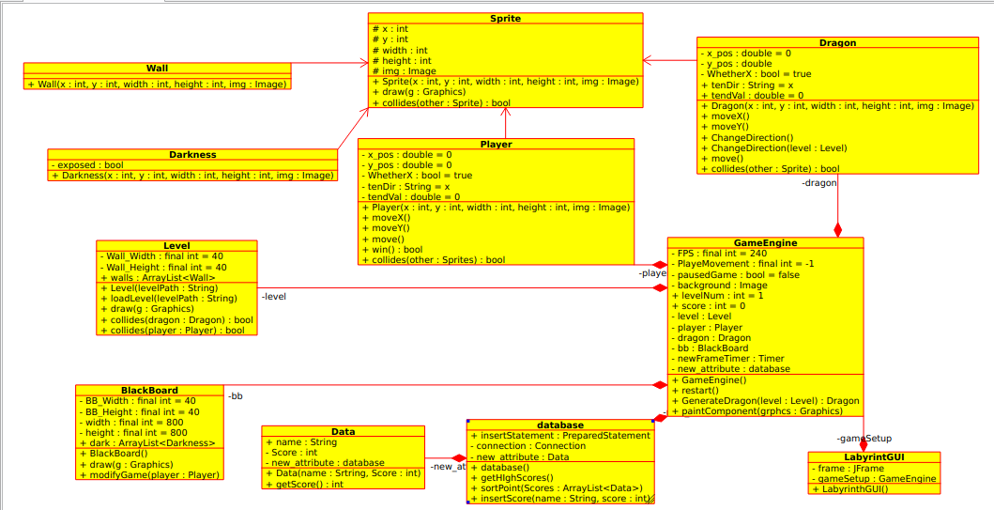

Testing
1. How our main screen looks like When we are running the game:

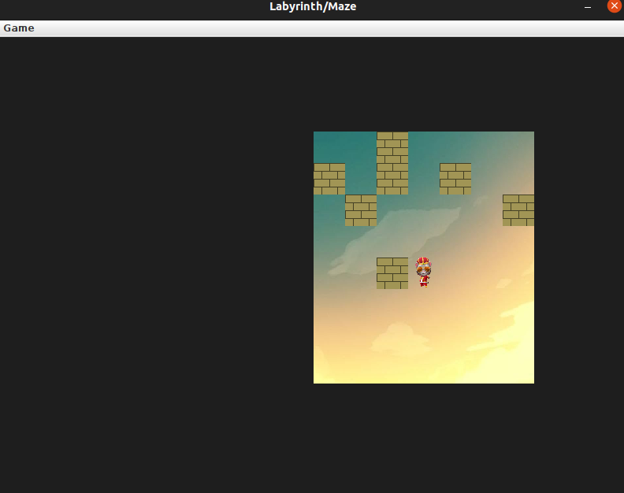

Test No 2:
Check weather our player cross the walls or not:
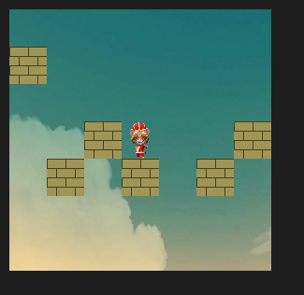

Test NO 3
Check if player touch the top right corner of the main window
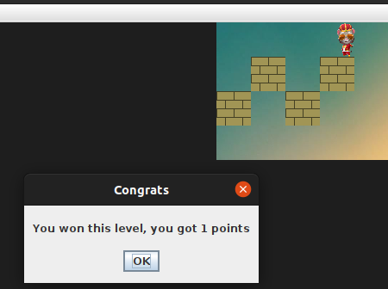

Test No 4
To check the movement of the dragon:

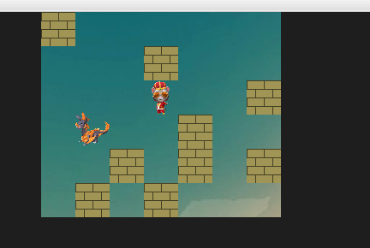

Test 5.
To check when dragon touch the Players
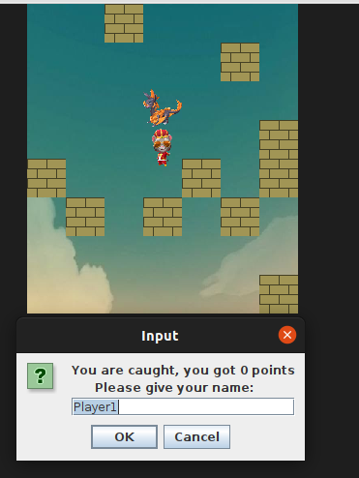

Test NO 6
To check new game button is working or not:
