Combine two strings character wise like this First String : “abcdefg” Second String : “1234” Output String : “a1b2c3d4efg
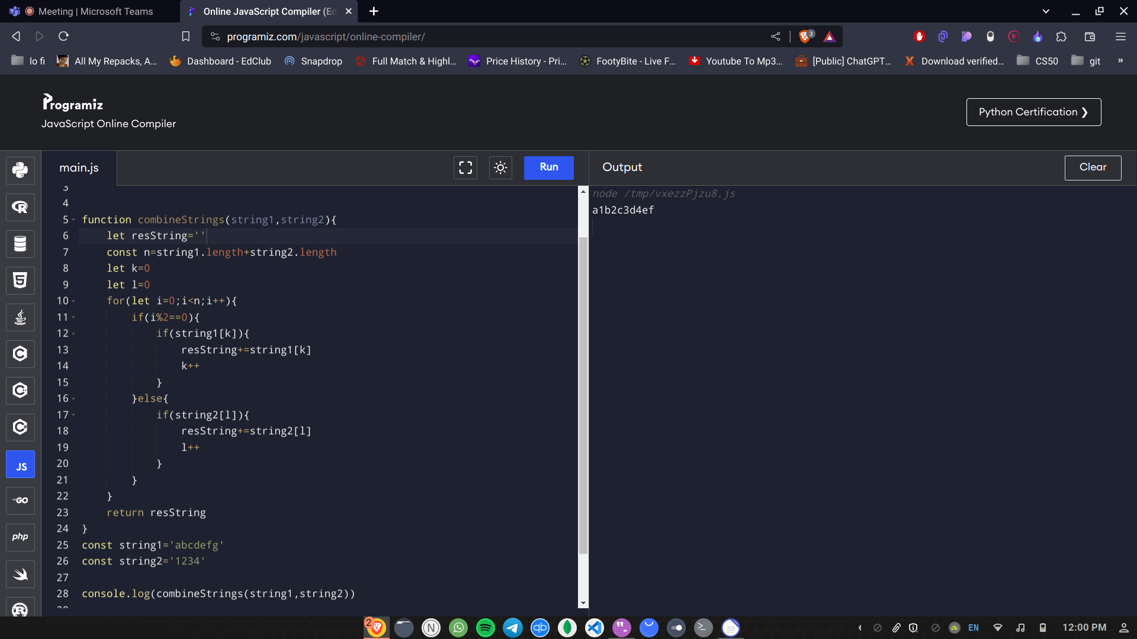
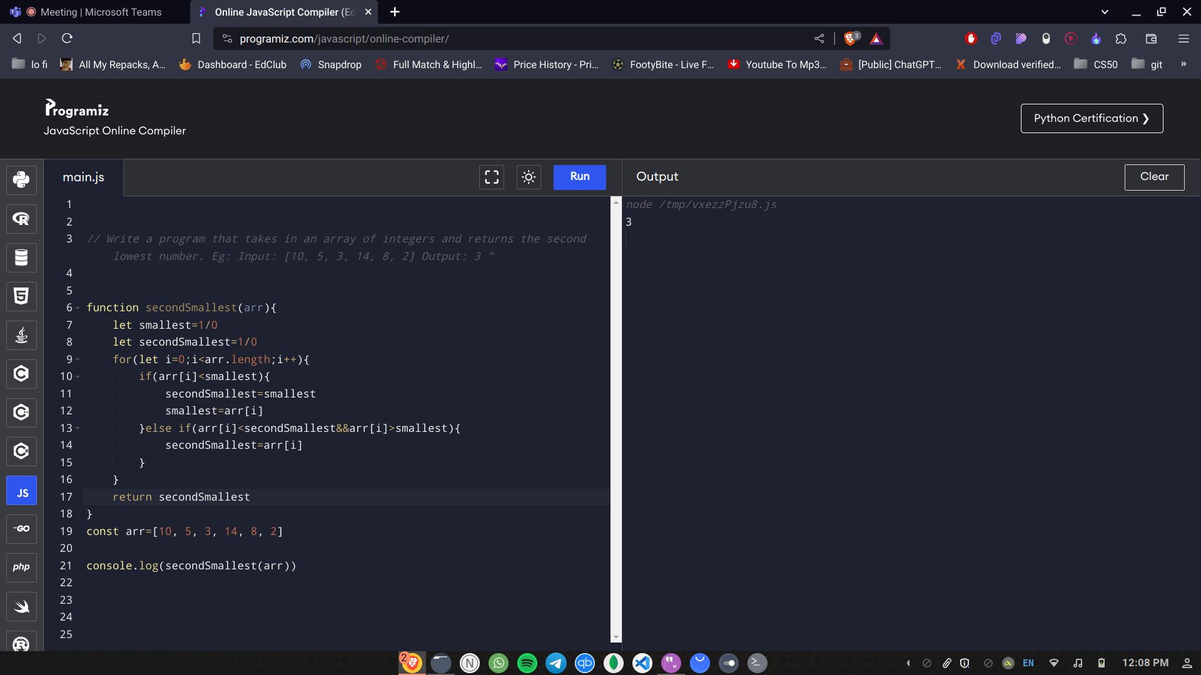
Write a program that takes in an array of integers and returns the second lowest number. Eg: Input: [10, 5, 3, 14, 8, 2] Output: 3
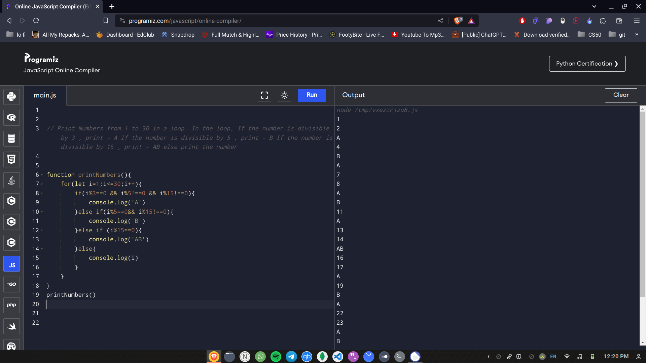
Print Numbers from 1 to 30 in a loop. In the loop, If the number is divisible by 3 , print - A If the number is divisible by 5 , print - B If the number is divisible by 15 , print - AB else print the number

