Medicare Internal Audit – Module Pipeline Run Guide
Purpose: Provide a clear execution order and operating model for the preprocessing pipeline.

1. Repository Structure
Root folder: medicareinternalaudit
medicareinternalaudit/
├─ config/ # Shared preprocessing utilities (used by Structure + Results)
├─ structurecode/ # Structure-sheet processing (one module per column)
│ └─ 202101_run_structure_universal.py # Structure runner (execution order)
└─ results_pipeline/ # Results-sheet processing (aligned with structure rules)
└─ 202_run_results_multi_sheets.py # Results runner (multi-sheet execution)
2. What Each Folder Does
Component | Location | Role | Typical Outputs
Shared config | config/ | Common cleaning + normalization rules to keep Structure and Results consistent. | Derived columns, normalized labels, UVL-safe tokens.
Structure pipeline | structurecode/ | Processes the Structure sheet(s). Each column has a dedicated processor to ensure traceability. | Processed Structure Excel sheets; UVL-ready fields.
Results pipeline | results_pipeline/ | Processes Results sheet(s) using the same shared rules, ensuring alignment with the Structure pipeline. | Processed Results Excel sheets; aligned coding/cleaning.
Structure runner | structurecode/202101_run_structure_universal.py | Defines the ordered execution of all Structure processors (single controlled entry point). | End-to-end structured processing logs + outputs.
Results runner | results_pipeline/202_run_results_multi_sheets.py | Detects and processes multiple Results sheets in a single run. | End-to-end results processing logs + outputs.

3. Execution Order (Recommended)
1. Prepare input Excel file(s). Naming convention: files begin with 'ISO_DATA' (e.g., ISO_DATA_2025.xlsx).
2. Run the Structure pipeline runner (202101_run_structure_universal.py) to process all Structure sheets in a controlled order.
3. Run the Results pipeline runner (202_run_results_multi_sheets.py) to process all Results sheets using the same shared rules.
4. Optional: Generate a random sample report across sheets to support manual verification on a smaller dataset.

4. Sheet Discovery and Scaling Strategy
The runners are designed for workbooks that contain multiple sheets. They detect target sheets by name prefixes configured in the code (Structure prefixes and Results prefixes). This makes the pipeline scalable as the dataset grows (1 month → 3 months → 6 months → 9 months → full year 2025).
Verification approach: run the pipeline on progressively larger data windows, then cross-check a random sample report to validate that derived columns and computed fields match the original source values (traceability).
5. Pipeline Flow (High-Level)
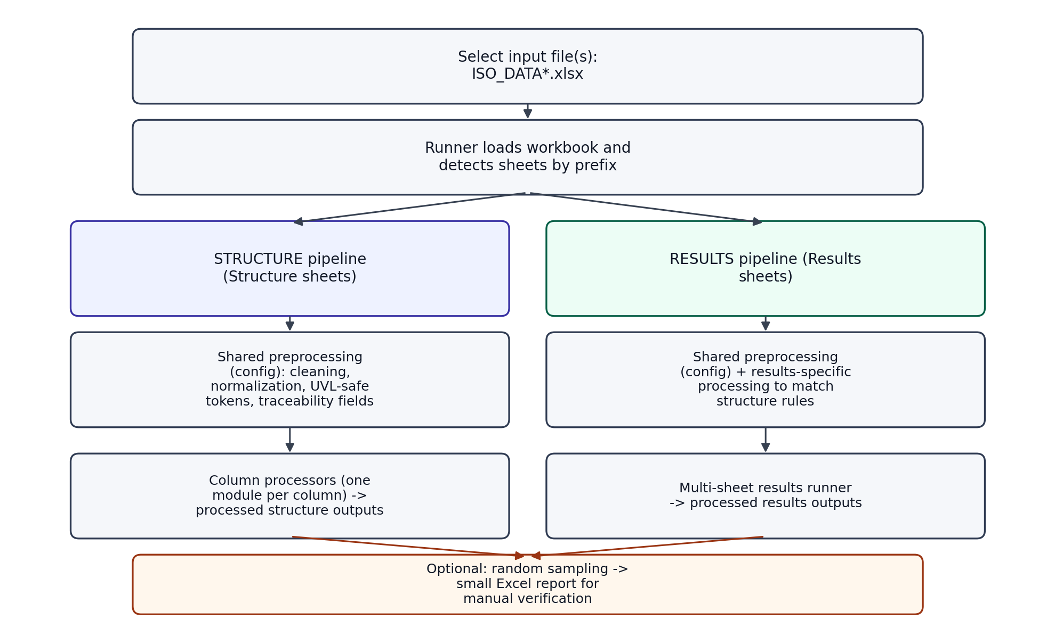
Figure 1. End-to-end execution flow for Structure + Results pipelines with optional sampling.

6. Typical Run Commands (Illustrative)
Note: exact arguments depend on your local environment and configuration constants. The key requirement is to run the two entry points in the order shown above.
# From the project root (medicareinternalaudit)
python structurecode/202101_run_structure_universal.py
# Then run results processing
python results_pipeline/202_run_results_multi_sheets.py

