Data Sources and Initial Extraction
The internal audit data used in this study originates from an Oracle-based internal audit system (ISO system). Using SQL Navigator, we executed a unified extraction query and exported the data into a single Excel workbook (ISO_DATA.xlsx) that consolidates both the audit structure (configuration) and the visit-level audit results. This design choice supported end-to-end traceability between the configured audit framework and the recorded operational outcomes within one artifact.
Within ISO_DATA.xlsx, the structural configuration is represented through six structure sheets: ISO_Check_category1 to ISO_Check_category5, and ISO_Check_category2025. The ISO_Check_category2025 sheet contains the full structural snapshot for the year 2025, while the remaining structure sheets partition the same structural data into grouped month ranges to facilitate incremental manual verification. These structure sheets define the internal audit framework, including audit types, audit plan behavior, laboratory categories, checklist items, and predefined answer options. They also include scoring-related fields such as item weights, answer option values, minimum acceptable scores at both item and category levels, and the overall category score. Furthermore, each category, item, and answer option is linked to unique identifiers, and categories are versioned using an issue number to distinguish checklist releases over time.
The visit-level results are captured in five results sheets for 2025 (VISIT_RESULT1 to VISIT_RESULT5). These sheets record the actual audit visits and the responses selected for checklist items during each visit, linked back to the corresponding categories, items, and versions defined in the structure sheets. This combined workbook enabled us to validate that the generated feature model faithfully represents the configurable audit structure, while also supporting complementary analyses based on historical outcomes (e.g., quantifying “Not Applicable” usage and assessing system-policy compliance such as missing audit plans in planned visits).
For verification and validation of the transformation pipeline, the multi-sheet organization was intentionally designed to support stepwise inspection: we first validated smaller partitions and then expanded to the complete 2025 snapshot, ensuring alignment and enabling manageable manual cross-checking of the Python-based Excel-to-UVL transformation
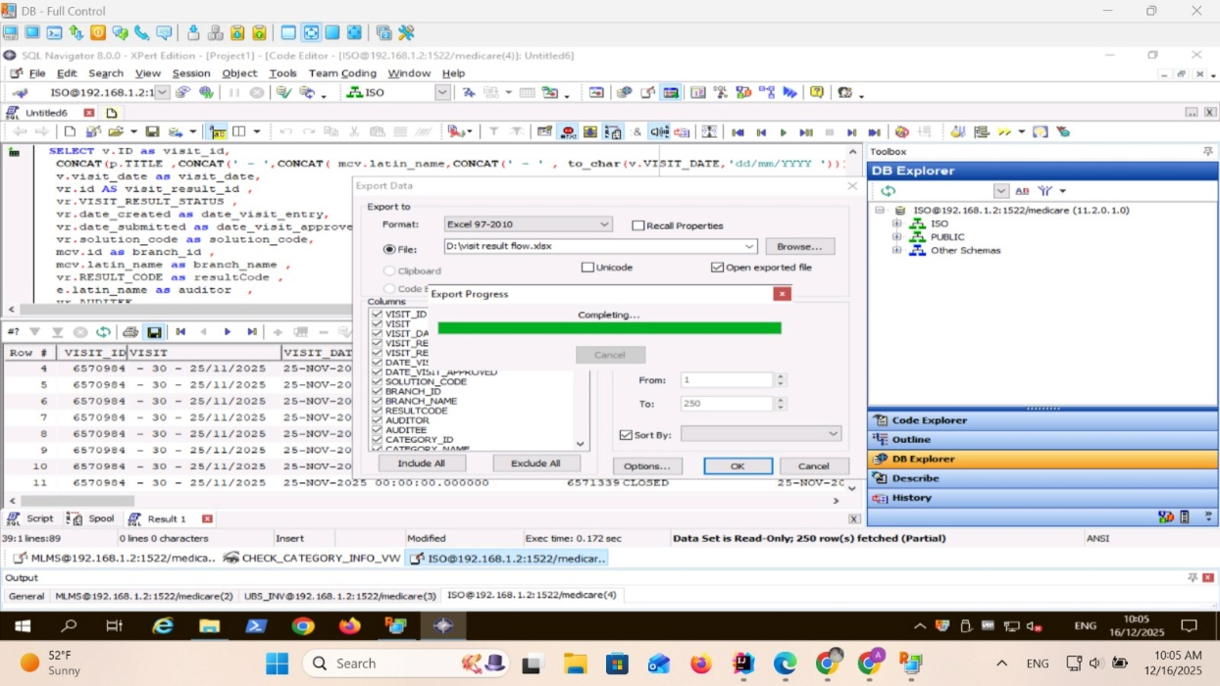
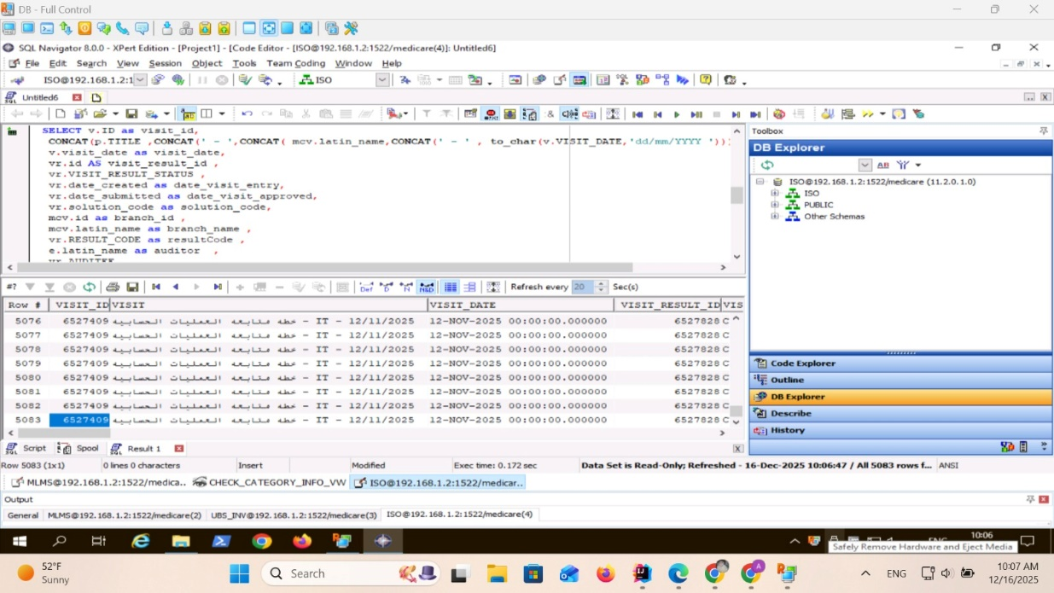
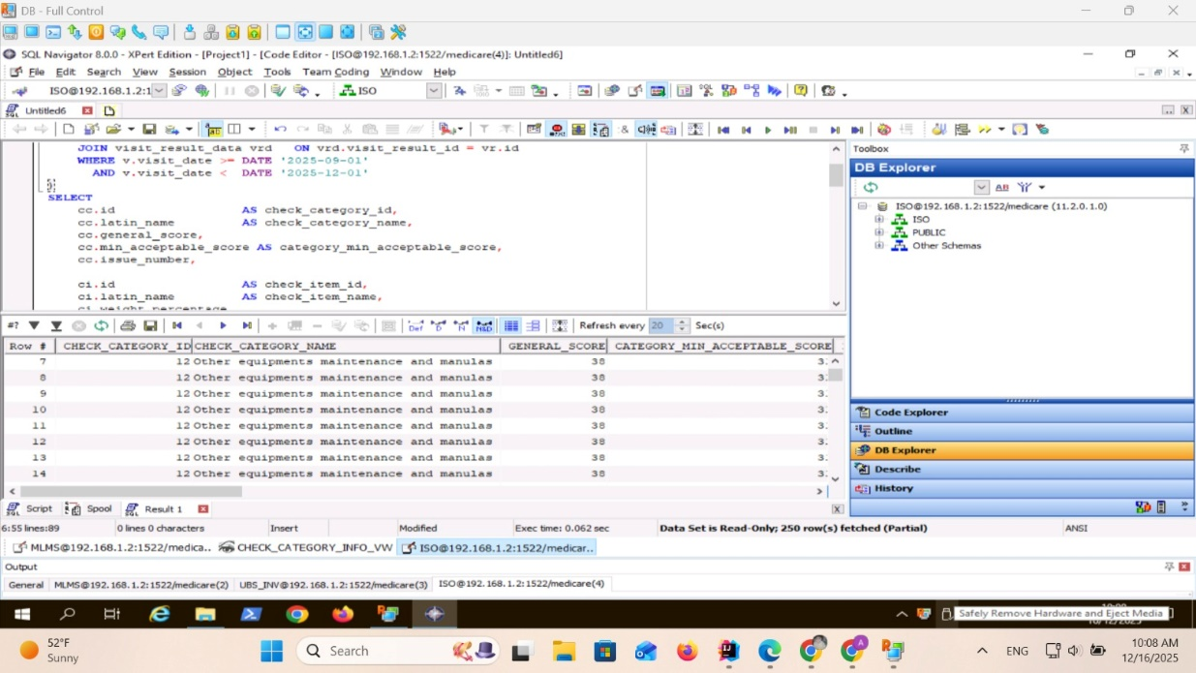

Methods – Category preprocessing"
In the structural sheet (ISO_Check_category), CHECK_CATEGORY_NAME represents audit section labels (categorical/structural data). To preserve traceability, the raw column was retained unchanged and two derived columns were created. First, CATEGORY_NAME_CLEAN was produced via string normalization (e.g., trimming leading/trailing whitespace and collapsing repeated spaces) using pandas string operations. Pandas+1 Second, because operational datasets may contain typographical inconsistencies that fragment categories and undermine model consistency, we applied controlled label harmonization through a curated dictionary-based replacement (e.g., “manulas” → “manuals”), stored in CATEGORY_NAME_HARMONIZED. Pandas Finally, a UVL-safe category identifier (CATEGORY_CODE) was generated from the harmonized label by lowercasing, replacing spaces with underscores, and removing non-alphanumeric characters to ensure parser compatibility and stable referencing in the feature tree. This step is consistent with UVL’s requirement that features use unique, well-formed identifiers. ScienceDirect
Concrete example (before → after):
- Raw: Other equipments maintenance and manulas
- Harmonized: Other equipments maintenance and manuals
- UVL-safe code: other_equipments_maintenance_and_manuals
Not applied (explicitly): mean, median, mode, min–max normalization, and z-normalization were not used because category names are non-numerical labels (categorical identifiers), and applying numerical normalization would be methodologically inappropriate at this preprocessing stage.

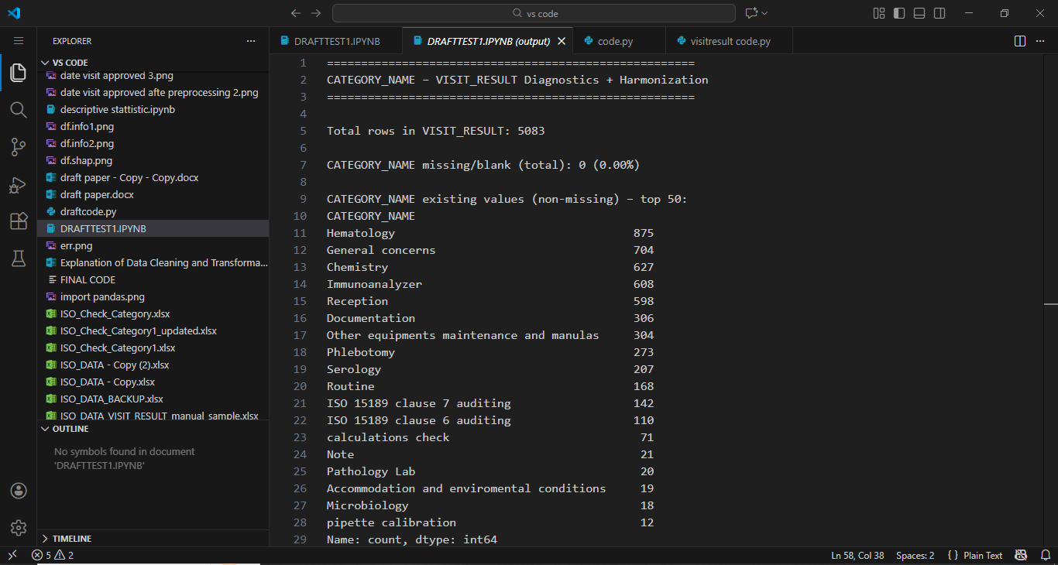
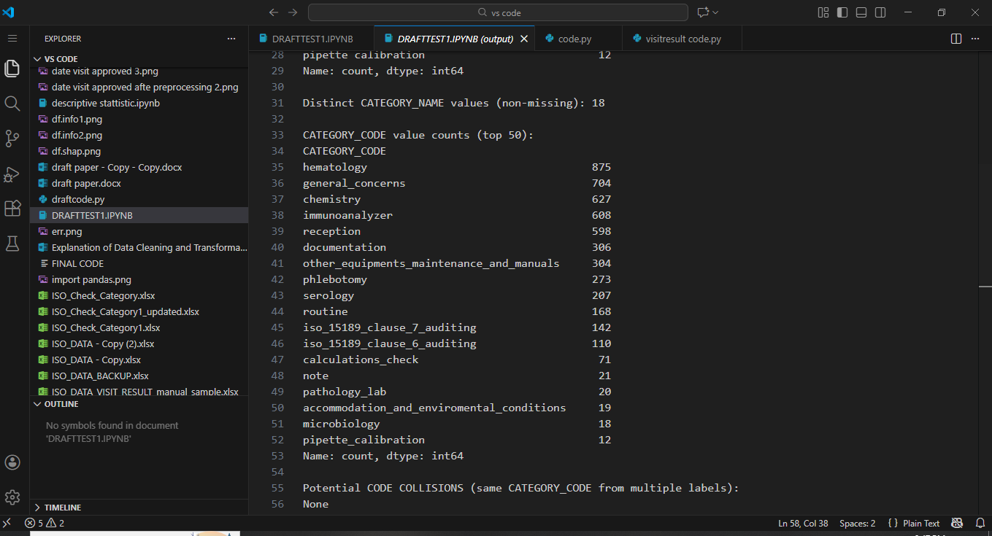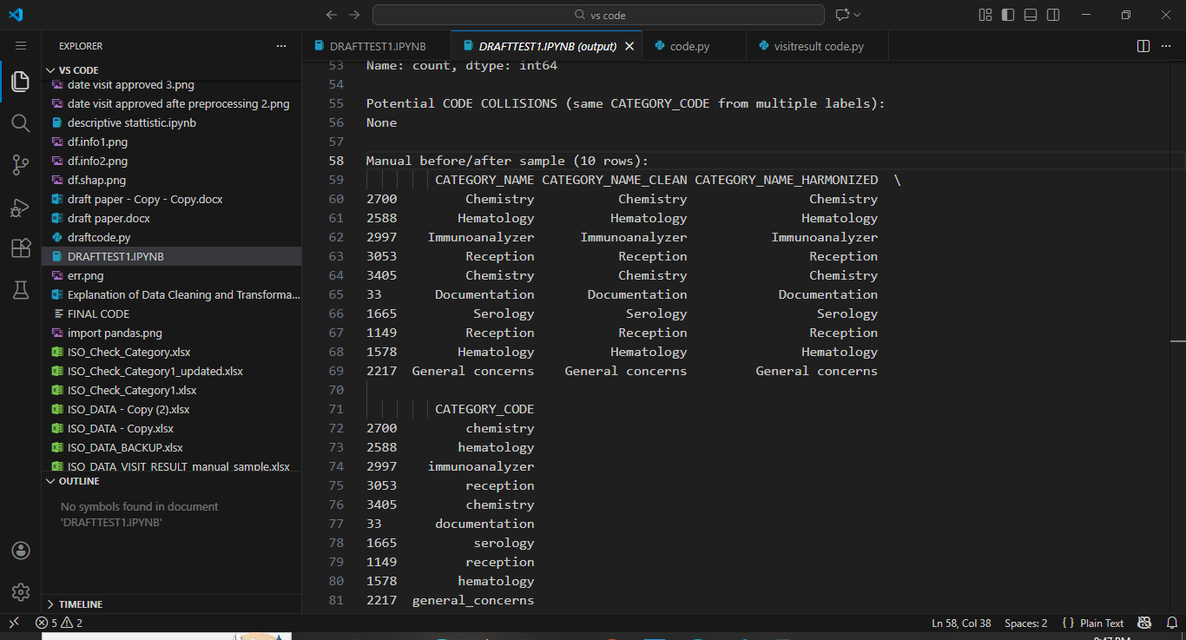
Category Preprocessing Validation (Manual and Automated Cross-Check)
To further validate the category preprocessing pipeline, a manual cross-verification step was conducted in parallel with the automated Python-based checks. Specifically, the researcher manually inspected the structural Excel sheet and identified distinct audit categories based on the original operational data.
In parallel, the preprocessing and validation scripts were executed to extract the set of unique harmonized categories (CATEGORY_NAME_HARMONIZED) and their corresponding UVL-safe identifiers (CATEGORY_CODE). The automated results consistently yielded the same number of categories.
This one-to-one correspondence between manually identified categories and automatically generated categories confirms the correctness of the preprocessing logic and the reliability of the category harmonization and encoding steps. Moreover, this cross-check demonstrates that no categories were unintentionally removed, merged, or duplicated during preprocessing, thereby ensuring semantic consistency between the raw data and the generated feature model representation.
Such combined manual and automated validation is recommended when transforming operational quality management data into formal models, as it increases confidence in the soundness of the data preparation pipeline and supports the reproducibility of the transformation process.
Handling of System-Generated Identifiers (CHECK_CATEGORY_ID)
The CHECK_CATEGORY_ID attribute represents a system-generated unique identifier assigned internally by the ISO-based audit management system. This identifier is not exposed to users during audit planning or execution and does not represent a selectable or configurable option.
Consequently, CHECK_CATEGORY_ID was not modeled as a feature within the UVL feature model. Instead, it was retained solely for internal traceability and relational consistency between audit categories and their associated checklist items. This design decision ensures a clear separation between semantic configuration dimensions, which are explicitly modeled as features, and technical identifiers, which serve only as internal system references.
Excluding system-generated identifiers from the feature model avoids unnecessary model complexity and aligns with established feature modeling principles, where only user-relevant and decision-oriented attributes are represented.
Audit Type Preprocessing (AUDIT_TYPE)
In the structural Excel sheet (ISO_Check_category1-5/2025), the AUDIT_TYPE field represents a nominal categorical attribute describing the audit visit type. To ensure full traceability, the raw column (AUDIT_TYPE) was preserved unchanged and two derived columns were created: AUDIT_TYPE_CLEAN and AUDIT_TYPE_CODE. First, AUDIT_TYPE_CLEAN was generated using string normalization (trimming whitespace, standardizing case, and removing internal spaces if present) to eliminate formatting noise that can arise in operational exports and lead to inconsistent categorical levels during modeling. Second, AUDIT_TYPE_CODE was produced using rule-based identifier encoding (UVL-safe sanitization) to obtain stable, tool-compatible tokens for downstream feature modeling and constraint referencing. These steps ensure that semantically identical audit types are represented consistently and can be reliably used in the UVL feature model.
Concrete example (before → after):
- Raw (AUDIT_TYPE): PLANNED, UNPLANNED, RE-EVALUATE
- Cleaned (AUDIT_TYPE_CLEAN): PLANNED, UNPLANNED, RE-EVALUATE (canonical representation; formatting normalized where needed)
- UVL-safe code (AUDIT_TYPE_CODE): planned, unplanned, re_evaluate
It is worth noting that in the current dataset, the normalized audit type values remained identical to the original entries, indicating that the preprocessing step is idempotent and does not alter already consistent categorical data.
Techniques explicitly not applied (and rationale):
Numerical preprocessing methods such as z-normalization, min–max normalization, and summary-statistic imputation strategies based on mean/median/mode were not applied because AUDIT_TYPE is non-numeric (nominal categorical data). Applying numerical scaling or central-tendency transformations would be methodologically inappropriate and would not preserve the semantics of audit type categories.
Audit Type Validation (Automated and Manual Cross-Check)
To validate the audit type preprocessing, a post-processing verification step was performed by extracting the set of unique values from the raw column (AUDIT_TYPE) and the derived columns (AUDIT_TYPE_CLEAN, AUDIT_TYPE_CODE). The automated uniqueness inspection confirmed the presence of exactly three distinct audit types (n = 3), matching the operational definitions used in the internal audit system: planned, unplanned, and re-evaluate. This outcome was independently confirmed via manual review of the Excel sheet, which also yielded three categories (n = 3). The agreement between the manual inspection and the automated extraction provides evidence that preprocessing did not introduce spurious categories, collapse distinct categories, or omit any valid audit types, supporting semantic consistency prior to UVL model integration.
Handling of Category Scoring and Acceptance Thresholds
(GENERAL_SCORE and CATEGORY_MIN_ACCEPTABLE_SCORE)
The structural dataset includes two closely related numeric attributes, GENERAL_SCORE and CATEGORY_MIN_ACCEPTABLE_SCORE, which together define the scoring policy at the audit category level. GENERAL_SCORE represents the total possible score allocated to a category, computed as the sum of item-level weights, while CATEGORY_MIN_ACCEPTABLE_SCORE specifies the minimum acceptable score required for a category to be considered successful. In the studied system, this threshold corresponds to 80% of the category’s total score.
These attributes are system-defined evaluation parameters and do not represent user-selectable or configurable options. Accordingly, neither GENERAL_SCORE nor CATEGORY_MIN_ACCEPTABLE_SCORE was modeled as a UVL feature. Instead, they were retained as scoring metadata to preserve traceability and to support subsequent performance evaluation. During preprocessing of the audit results dataset, these parameters will be used to compute normalized category performance measures (percentage scores) and to derive categorical outcome variables (PASS/FAIL), which are more suitable for analytical and reporting purposes than representing raw numeric scoring parameters within the configuration model.
Numerical scaling techniques such as z-normalization, min–max normalization, or central-tendency–based transformations (mean, median, mode) were not applied at the structural preprocessing stage, as the primary role of these attributes is deterministic rule-based evaluation rather than statistical comparison across heterogeneous numeric variables.
Audit Plan Preprocessing (AUDIT_PLAN)
In the structural Excel sheets (ISO_Check_category1–5 and ISO_Check_category2025), AUDIT_PLAN is a nominal text attribute describing the audit plan associated with an audit visit. To preserve traceability while enabling consistent feature modeling, the raw column AUDIT_PLAN was kept unchanged and two derived columns were generated: AUDIT_PLAN_CLEAN and AUDIT_PLAN_CODE.
First, AUDIT_PLAN_CLEAN was created through text normalization (e.g., trimming extra whitespace, case harmonization, and Arabic/English text normalization) to eliminate formatting noise that may introduce artificial categorical levels. Second, AUDIT_PLAN_CODE was produced using a hybrid strategy combining rule-based mapping and a robust fallback representation. Specifically, a curated set of regex rules was applied to map known plan patterns into stable canonical codes (e.g., Q1–Q4 plans, ISO 15189 clause-compliance plans, or calibration/renewal plans). When no predefined rule matched, the normalized text was converted into a UVL-safe token using to_uvl_code, ensuring that no unseen or newly introduced plan descriptions are dropped from downstream modeling.
This design provides (1) semantic harmonization for recurrent plans and (2) completeness via lossless representation for previously unknown plan phrases.
Concrete example (before → after):
- Raw (AUDIT_PLAN): ISO 15189 clause audit, Quarter 1 plan, Balance certificate renewal
- Cleaned (AUDIT_PLAN_CLEAN): same values after normalization
- Encoded (AUDIT_PLAN_CODE):
  - iso15189_clause_compliance_audit
  - quarter_1
  - mass_balance_calibration_renewal
System-aware note:
Operationally, an audit plan is functionally expected only when the visit type is planned, whereas it may be naturally absent for unplanned visits. Therefore, missingness in AUDIT_PLAN was interpreted conditionally in relation to AUDIT_TYPE, rather than being treated as a universal data-quality defect.
Techniques explicitly not applied (and rationale):
Numerical preprocessing techniques (z-normalization, min–max scaling) and central-tendency imputation (mean/median/mode) were not applied because AUDIT_PLAN is categorical text data; numeric scaling or statistical imputation would be methodologically inappropriate and would not preserve plan semantics.
Audit Plan Validation (Automated + Manual Cross-Check)
Validation was performed through post-processing verification by comparing the unique values of AUDIT_PLAN against the derived AUDIT_PLAN_CLEAN and AUDIT_PLAN_CODE columns. Automated inspection confirmed that rule-based mappings produced consistent canonical codes, while unmatched plans were still represented through the fallback UVL-safe encoding without loss. In addition, a manual review on sampled records verified that the assigned codes remained semantically aligned with their original plan descriptions and that distinct plans were not incorrectly collapsed into a single code. The agreement between automated inspection and manual sampling provides evidence that preprocessing preserves semantics and generates stable tokens suitable for UVL constraint reasoning.
From a feature modeling perspective, this relationship is expressed as a constraint stating that the selection of an audit plan is permitted only if the audit type corresponds to a planned visit. Conversely, when an audit plan is selected, the audit type must be planned. Encoding this dependency as an explicit constraint prevents semantically invalid configurations (e.g., assigning a quarterly audit plan to an unplanned visit) and ensures alignment between the feature model and the real-world audit workflow.
This constraint-based representation enhances the semantic correctness of the configuration model and supports automated validation of audit visit configurations.

Processing and Validation of Audit Check Items
The audit check items constitute the core semantic units of the internal audit system, as each category comprises a structured set of items representing specific compliance requirements derived from ISO 15189 clauses and internal quality procedures. In the raw Excel data, each check item is stored in a human-readable textual format under the column CHECK_ITEM_NAME. Due to the structure of the audit system, the same textual item may appear multiple times within the dataset, not as a result of data duplication, but because each item is associated with multiple predefined answer options (e.g., Yes, No, Not Applicable), resulting in multiple rows per logical item.

Initial Data Characteristics (Before Processing)
An example of the raw check item representation is shown below, where the same item text appears repeatedly across rows:
CHECK_ITEM_NAME (raw):
“An approved file for the Centrifuge device is available, containing all required information such as maintenance logs, calibration records, operating instructions, and performance verification documents, and it is regularly updated in accordance with the quality management system.”
This identical text may appear multiple times, each occurrence corresponding to a different answer option. At this stage, the data are not suitable for direct modeling, as:
- Textual identifiers contain spaces, punctuation, and mixed casing.
- The same item text appears multiple times, potentially causing ambiguity in feature-based representations such as UVL.
- There is no explicit linkage between the item, its category, its issuing version, and its answer options in a machine-readable form.
When the raw check item texts were initially used directly as feature identifiers, multiple identical feature names were generated across different rows and categories. This resulted in duplicated feature definitions, which are not permitted in UVL-based feature models and caused model generation and parsing errors. In particular, items associated with multiple answer options or reused across categories led to non-unique feature identifiers. To resolve this issue, a composite feature-naming strategy was introduced, ensuring that each audit item is represented by a globally unique feature while preserving its semantic meaning and structural context.

Cleaning and Canonicalization of Item Names
To address these issues, a multi-step preprocessing strategy was applied. First, the raw item text was normalized to produce a clean, canonical representation stored in ITEM_NAME_CLEAN. This step removes non-semantic variability (e.g., extra spaces or formatting artifacts) while preserving the full semantic meaning of the item. Importantly, in many cases—including the example above—the cleaned text remains identical to the original, indicating that the preprocessing step is idempotent, i.e., it does not alter already well-formed data but guarantees consistency when inconsistencies are present.

Generation of UVL-Safe Item Codes
Next, each cleaned item text was transformed into a UVL-safe identifier (ITEM_TEXT_CODE) by:
- Converting all characters to lowercase,
- Replacing spaces with underscores,
- Removing punctuation and non-alphanumeric symbols.
For the example item, the resulting code is:
ITEM_TEXT_CODE:
an_approved_file_for_the_centrifuge_device_is_available_containing_all_required_information_such_as_maintenance_logs_calibration_records_operating_instructions_and_performance_verification_documents_and_it_is_regularly_updated_in_accordance_with_the_quality_management_system
This transformation ensures compliance with the syntactic constraints of feature modeling languages such as UVL and enables deterministic reuse of item identifiers across datasets and system components.

Disambiguation of Reused Items Across Categories
A critical design challenge arises from the fact that the same audit item text may legitimately appear in more than one category (e.g., equipment management, quality control, or safety). To prevent feature name collisions in the UVL model, item-level identifiers were further contextualized by embedding structural metadata into a composite feature name (ITEM_FEATURE_NAME). This composite identifier integrates:
- The category identifier,
- The issuing/version number,
- The internal item ID,
- The canonical item text code.
For example:
ITEM_FEATURE_NAME:
item_cat12__iss1__item303__an_approved_file_for_the_centrifuge_device_is_available_containing_all_required_information_such_as_maintenance_logs_calibration_records_operating_instructions_and_performance_verification_documents_and_it_is_regularly_updated_in_accordance_with_the_quality_management_system
This strategy guarantees global uniqueness of item features while preserving traceability to their original category and version, which is essential for longitudinal audits and historical analyses.

Representation of Answer Options
Each check item is associated with a fixed set of answer options. These were modeled as subordinate features using the ANSWER_FEATURE_NAME, where each answer is explicitly bound to its parent item feature. For instance:
- ...__no
- ...__yes
- ...__not_applicable
This hierarchical encoding aligns with feature-based modeling best practices, where a parent feature (the audit item) governs the selection of mutually exclusive child features (the possible answers).

Validation and Consistency Checks
To validate the correctness of this preprocessing pipeline, both manual inspection and programmatic checks were conducted. For selected categories (e.g., Chemistry and Serology), the total number of rows and the number of unique CHECK_ITEM_ID values were independently verified. In all tested cases, the number of unique items matched the expected manual counts, confirming that:
- No items were lost during preprocessing,
- No artificial duplication was introduced,
- Repetition at the row level correctly reflects answer-level multiplicity rather than item-level redundancy.

Methodological Rationale
Notably, no statistical normalization techniques (e.g., z-score normalization or scaling) were applied at this stage. This decision is methodologically justified, as check items represent structural and categorical entities, not numerical measurements. Normalization techniques are therefore reserved for the analysis of audit results and performance metrics, which are addressed separately in the results-processing phase.
Overall, this structured preprocessing of audit check items establishes a robust and semantically faithful foundation for subsequent UVL-based modeling, constraint definition, and AI-assisted reasoning within the proposed internal audit digital twin.
Audit Item Answer Preprocessing and Encoding
1. Nature of the Answer Data
Each audit item in the internal audit structure is associated with a predefined set of answer options representing the auditor’s response during the visit. These answers are categorical and discrete by nature (e.g., Yes, No, Not Applicable), and are reused across a large number of audit items and categories. Therefore, while the textual answer values are semantically identical across items, their representation within a feature-based variability model must be context-aware and uniquely identifiable.
Example of raw answer data (before preprocessing):
CHOICE_VALUE_OPTION_NAME
No
Yes
NOT applicable

2. Identified Data Issues and Modeling Constraints
When answer options were initially considered as standalone features (e.g., yes, no, not_applicable), this resulted in extensive feature duplication across multiple audit items. Since UVL-based feature models require globally unique feature identifiers, reusing the same answer feature names across different items caused feature redefinition conflicts and model parsing failures.
In addition, answer values are dependent on the corresponding audit item, meaning that their interpretation is only valid within the context of a specific item. Treating answers as global features would therefore lead to semantic ambiguity and structural inconsistency in the generated feature model.

3. Preprocessing Strategy and Transformation Steps
To resolve these issues, a hierarchical and context-aware encoding strategy was applied:
- Text normalization
The raw answer text was standardized to produce a clean categorical representation (ANSWER_TEXT_CLEAN) by:
  - trimming whitespace,
  - enforcing consistent capitalization,
  - harmonizing equivalent labels (e.g., NOT applicable → not applicable).
- UVL-safe categorical encoding
Each cleaned answer was transformed into a machine-readable code (ANSWER_CODE) using lowercase normalization and underscore separation:
  - No → no
  - Yes → yes
  - Not applicable → not_applicable
- Contextual feature construction
To ensure global uniqueness and preserve semantic context, each answer feature was encoded as a composite identifier combining:
  - the audit item identifier,
  - the category context,
  - the item textual code,
  - the answer code.

4. Before and After Transformation Example
Before preprocessing:
CHOICE_VALUE_OPTION_NAME
No
Yes
NOT applicable
After preprocessing:
ANSWER_TEXT_CLEAN | ANSWER_CODE | ANSWER_FEATURE_NAME
No | no | item_303__other_equipments_maintenance_and_manuals__…__no
Yes | yes | item_303__other_equipments_maintenance_and_manuals__…__yes
Not applicable | not_applicable | item_303__other_equipments_maintenance_and_manuals__…__not_applicable
This approach guarantees that each answer option is uniquely bound to its corresponding audit item while remaining compatible with UVL’s strict feature uniqueness constraints.

5. Rationale for Excluding Numerical Normalization Techniques
Numerical preprocessing techniques such as Z-normalization, min–max scaling, or mean/median imputation were deliberately not applied at this stage. The answer data are nominal categorical variables without inherent numeric ordering or magnitude. Applying numerical normalization would be methodologically incorrect and could introduce artificial semantics not supported by the original audit process.
This decision aligns with established best practices in categorical data preprocessing and feature modeling.

6. Validation and Consistency Checks
To validate the correctness of the transformation, a manual and programmatic verification was performed:
- For selected audit items, the number of answer rows in the original Excel file was manually counted.
- The same counts were reproduced programmatically after preprocessing.
- Each audit item was confirmed to have a consistent and complete set of answer features, with no duplication or loss of information.
The validation confirmed that the preprocessing pipeline is idempotent, meaning that clean input data remain unchanged while problematic structures are systematically corrected when encountered.

7. Methodological Justification
By encoding answers as item-scoped features rather than global entities, the preprocessing pipeline ensures:
- semantic correctness,
- structural validity of the UVL model,
- scalability across evolving audit structures and future extensions.
This design choice is particularly suitable for feature-based representations of complex audit systems where reuse of categorical responses is common.

Handling of Internal Identifier Columns (Technical Keys)
Nature of the Identifier Columns
The columns CHECK_ITEM_ID, CHOICE_ID, and CHOICE_VALUE_OPTION_ID represent system-generated internal identifiers used exclusively for relational linkage within the audit management system. These identifiers are automatically assigned by the underlying database and are not selected, modified, or directly observed by auditors or quality managers during audit planning or execution.
Their primary function is to ensure referential integrity across different structural entities, such as:
- linking audit items to their category,
- associating answer options with their corresponding items,
- maintaining stable internal references across database tables and system operations.

Identified Modeling Considerations
From a methodological perspective, these identifier columns present several important characteristics:
- Lack of semantic meaning
The identifier values do not convey domain-specific or interpretative information related to audit quality, compliance status, or operational performance.
- System-dependent representation
The numerical values are specific to the internal implementation of the audit system and may vary across system versions, deployments, or database migrations.
- Invisibility to audit stakeholders
These identifiers are not exposed to auditors during data entry, nor do they influence audit decisions or outcomes.
- Non-configurational nature
The identifiers do not represent selectable options, conditions, or states and therefore do not constitute variability dimensions suitable for feature-based modeling.

Data Processing and Usage Strategy
Given these characteristics, a clear separation was maintained between structural linkage keys and modeling variables:
- The identifier columns were preserved unchanged in the preprocessed Excel file to maintain full traceability and internal consistency.
- They were utilized programmatically during preprocessing to:
  - disambiguate audit items reused across categories,
  - ensure correct association between items and their answer options,
  - support the generation of composite, globally unique feature identifiers.
- The identifiers were explicitly excluded from direct representation in the UVL feature model, as they do not reflect configurable or analytical aspects of the audit process.

Methodological Rationale for Exclusion from Feature Modeling
Including system-generated identifiers as features would introduce artificial variability unrelated to the audit domain and could distort the semantic interpretation of the feature model. Feature-based modeling aims to represent meaningful choices, conditions, and structural relationships, rather than internal database mechanics.
Accordingly, the identifiers were treated as technical enablers rather than conceptual entities, aligning with established best practices in data modeling and software product line engineering.

Validation and Consistency Assurance
Throughout the preprocessing pipeline, the identifier columns were leveraged to verify consistency and detect unintended duplication, particularly in cases where identical audit item texts appeared across multiple categories. Their use ensured that:
- each audit item was uniquely tracked,
- answer options were correctly bound to their corresponding items,
- no collisions occurred during feature name generation.
At the same time, their exclusion from the final feature model ensured that the UVL representation remained stable, interpretable, and independent of system-specific implementation details.
Methods – Audited Entity (Branch / Department / Organization) Preprocessing
In the structural sheet (ISO_Check_category), audited entities were represented using two source columns: BRANCH_ID (a system-generated internal identifier) and BRANCH_NAME (a human-readable label). These fields encode structural categorical information describing the organizational unit under audit, including physical branches, departments, and organization-level entities. To preserve full traceability and avoid destructive transformations, both raw columns were retained unchanged, and a set of derived columns was generated for preprocessing and feature-model construction.
First, BRANCH_LABEL_CLEAN was created through string normalization, including trimming leading and trailing whitespace and collapsing repeated spaces, ensuring consistent textual representation of entity labels. Second, because operational datasets may contain heterogeneous naming conventions—such as numeric branch codes stored as strings, Arabic branch names, short department labels, and long English organizational names—controlled label harmonization was applied using a curated override dictionary. This step mapped known labels into canonical representations (e.g., حلحول --- 34; Ein Sara --- 33; “جنين - البيادر - 35” ---- 35; “Purchase Department” ---- PD; and “Elite Medical Consultancy Services Co. – MediCare” ----- headoffice), thereby reducing label fragmentation while preserving semantic intent.
Third, the harmonized label was transformed into a UVL-safe token (BRANCH_LABEL_SLUG) by lowercasing, replacing whitespace with underscores, and removing non-alphanumeric characters. In parallel, an explicit ENTITY_TYPE (branch, dep, or org) was inferred using rule-based classification to distinguish operational branches from departments and organization-level entities. Fourth, BRANCH_ID_NUM was derived as a numeric representation of the authoritative BRANCH_ID to ensure consistency and to support traceable feature construction.
Finally, to guarantee global uniqueness and direct traceability between the source system and the feature model, a composite audited-entity identifier (BRANCH_FEATURE_CODE) was constructed by combining BRANCH_ID_NUM, ENTITY_TYPE, and BRANCH_LABEL_SLUG, following the pattern:
BRANCH_FEATURE_CODE = “medicare_{BRANCH_ID_NUM}{ENTITY_TYPE}{BRANCH_LABEL_SLUG}”.
This composite encoding ensures syntactic compatibility with Universal Variability Language (UVL), prevents feature-name collisions, and maintains a transparent linkage to the original operational identifiers.
Concrete examples (before → after)
Branch-level entities (numeric branch labels):
• Raw BRANCH_NAME: 27
• BRANCH_LABEL_CLEAN: 27
• ENTITY_TYPE: branch
• BRANCH_LABEL_SLUG: 27
• BRANCH_ID_NUM: 51
• BRANCH_FEATURE_CODE: medicare_51_branch_27
Department-level entity (textual label with controlled harmonization):
• Raw BRANCH_NAME: Purchase Department
• BRANCH_LABEL_CLEAN: PD
• ENTITY_TYPE: dep
• BRANCH_LABEL_SLUG: pd
• BRANCH_ID_NUM: 801
• BRANCH_FEATURE_CODE: medicare_801_dep_pd
These examples illustrate that when BRANCH_NAME is already a numeric identifier, the preprocessing pipeline preserves its semantic content while enforcing UVL-safe syntax. Conversely, when BRANCH_NAME is a textual organizational label, controlled harmonization ensures consistent canonical representation prior to feature construction. In both cases, heterogeneous entity representations are uniformly integrated into the feature model without semantic loss or identifier collisions.
Records with missing entity information (i.e., BRANCH_ID and BRANCH_NAME both absent) were not forced into entity encoding. Instead of deleting such rows—which could lead to unintended data loss—BRANCH_FEATURE_CODE was generated only when completeness criteria were satisfied (BRANCH_LABEL_CLEAN, ENTITY_TYPE, BRANCH_LABEL_SLUG, and BRANCH_ID_NUM available), while incomplete records were retained with null values. This non-destructive preprocessing strategy preserves structural integrity and aligns with ISO 15189 principles emphasizing unambiguous identification, controlled documentation, and traceability within laboratory quality management systems.
Audited Entity Preprocessing Validation (Manual and Automated Cross-Check)
To validate the audited-entity preprocessing pipeline, verification was conducted at two complementary levels. First, a manual inspection of the structural Excel sheet was performed to identify the distinct audited entities represented in the operational data, accounting for branches, departments, and organization-level units despite heterogeneous naming conventions.
Second, automated validation scripts were executed to extract the set of generated BRANCH_FEATURE_CODE values and assess their properties. The automated checks confirmed that all entities meeting completeness criteria (presence of BRANCH_ID, inferred ENTITY_TYPE, and valid BRANCH_LABEL_SLUG) were encoded into unique feature identifiers, with no unintended duplications. Records lacking sufficient information were intentionally left unencoded (NA), rather than removed, to preserve structural integrity and prevent accidental data loss.
Manual spot-checking was then performed across representative cases (numeric-only labels, Arabic branch names, short department codes, and long English organizational labels) to confirm that each generated feature code accurately reflected the intended canonical entity and entity type. This combined manual–automated validation strategy ensures both syntactic correctness (UVL-safe identifiers) and semantic fidelity (faithful representation of audited entities), and aligns with recommended practices for transforming operational quality-management data into formal variability models.

For each variable in the visit results dataset, a standardized preprocessing protocol was applied to ensure consistency, traceability, and methodological rigor. The protocol consisted of four sequential steps. First, a completeness assessment was performed by computing the total number of records and the absolute and relative frequency of missing or blank values. Second, the effective data type of each variable was inspected to identify potential inconsistencies between the stored and intended semantic type (e.g., numeric values stored as strings or malformed date fields). Third, data preprocessing and error handling were conducted using deterministic, non-destructive transformations, with explicit documentation of encountered issues and illustrative before–after examples. Finally, verification was performed through a combination of automated code-based checks and manual validation using randomly sampled records. This systematic approach ensures that each variable is methodologically justified, reproducible, and suitable for subsequent modeling and analysis.

System Data Quality Limitations
As with most real-world operational datasets, the audit data used in this study were subject to certain system-level limitations originating from the source information systems. Specifically, a small subset of audit records contained missing responses for a single audit item within the Reception category. Manual inspection confirmed that this issue was caused by a data-entry or data-export defect in the audit system, rather than by analyst decisions or preprocessing logic.
To prevent analytical bias, these system-induced limitations were explicitly handled through a non-imputation policy, ensuring that missing responses were preserved as null values and excluded from feature generation. The affected cases were limited in scope, consistently associated with the same audit item across multiple branches, and did not propagate into the structural variability model. Consequently, these limitations do not compromise the validity or interpretability of the analytical results.

No. | Data Quality Issue | Source / Cause | Potential Impact | Mitigation Strategy (Implemented in Code)
1 | Inconsistent category naming | Manual data entry and spelling variations across audits | Same category represented as multiple nodes in the UVL model | Category names were normalized and harmonized using a predefined spelling map, followed by deterministic code generation (CATEGORY_NAME_HARMONIZED, CATEGORY_CODE).
2 | Unsafe characters and whitespace in text fields | Free-text fields containing spaces, symbols, or inconsistent formatting | Invalid or non-parsable feature identifiers in the UVL model | All textual fields were normalized and encoded using a unified UVL-safe transformation function to remove unsafe characters and enforce consistent naming.
3 | Duplicate item labels across categories or issues | Reuse of identical item names in different audit contexts | Feature name collisions and ambiguous traceability between STRUCTURE and RESULTS | A composite item key was constructed using category ID, issue number, and item ID, ensuring globally unique item feature names.
4 | Missing or empty answer options | Structural rows without defined answer values | Generation of phantom answer features and invalid UVL branches | Missing-like answers were explicitly detected and excluded from encoding, ensuring that no answer code or feature is generated for empty values.
5 | Answer value collisions across different items | Common answers such as “Yes/No” reused in multiple items | Incorrect merging of answer options across unrelated items | Answer features were namespaced by their parent item feature, preserving contextual uniqueness.
6 | Status value collisions (e.g., “CLOSED”) | Identical labels used in visit status and visit result status | Logical ambiguity and feature collisions in the configuration model | Distinct namespaces (vs_ and vrs_) were enforced for visit status and visit result status codes.
7 | Unknown or unexpected status values | Introduction of new status values not predefined in mappings | Pipeline failure or loss of information | A fallback encoding mechanism was applied, allowing unknown values to be safely encoded without interrupting processing.
8 | Inconsistent branch naming and identifiers | Variations in branch names and non-numeric branch IDs | Multiple representations of the same audited entity | Branch names were normalized, overridden where necessary, classified by entity type, and combined with numeric IDs to generate stable audited-entity features.
9 | Non-numeric branch identifiers | Branch IDs stored as text or mixed numeric formats | Runtime errors during feature generation | Safe numeric parsing with exception handling was applied; invalid values were set to null rather than causing execution failure.
10 | Noisy or unsupported item classification values | Classification values beyond the intended Major/Minor scheme | Inconsistent severity modeling and invalid classification features | Only supported classifications (Major/Minor) were encoded; all other values were intentionally ignored.
11 | Implicit execution dependencies between transformations | Manual execution of scripts in arbitrary order | Incomplete or inconsistent derived columns | A centralized execution orchestrator was introduced to enforce a deterministic and reproducible transformation order.

APA-style references
- Benavides, D. (2025). Feature modelling with the Universal Variability Language (UVL). Information and Software Technology. ScienceDirect
- pandas development team. (n.d.). pandas.Series.replace. pandas documentation. Pandas
- pandas development team. (n.d.). Working with text data. pandas user guide. Pandas
- pandas development team. (n.d.). pandas.Series.str.strip. pandas documentation. Pandas
Van der Aalst, W. (2016). Data quality and preprocessing. In Process Mining. Springer.
Knaflic, S. N. (2020). Storytelling with data: Let’s practice! Wiley.
Benavides, D., Trinidad, P., & Ruiz-Cortés, A. (2010). Automated reasoning on feature models. Computer Networks, 54(6), 951–970.
Van der Aalst, W. (2016). Data quality and validation in process-oriented data. Springer.
Kitchenham, B., et al. (2009). Systematic validation in empirical software engineering. Information and Software Technology.
Benavides, D., Trinidad, P., & Ruiz-Cortés, A. (2010). Automated reasoning on feature models. Computer Networks, 54(6), 951–970.
Van der Aalst, W. M. P. (2016). Process mining: Data science in action (2nd ed.). Springer.
Knaflic, S. N. (2020). Storytelling with data: Let’s practice! Wiley.
Han, J., Kamber, M., & Pei, J. (2012). Data mining: Concepts and techniques (3rd ed.). Morgan Kaufmann.
Batory, D. (2005). Feature models, grammars, and propositional formulas. Software Product Lines Conference, 7–20.
Benavides, D., Segura, S., & Ruiz-Cortés, A. (2010). Automated analysis of feature models 20 years later: A literature review. Information Systems, 35(6), 615–636.
Han, J., Kamber, M., & Pei, J. (2012). Data mining: Concepts and techniques (3rd ed.). Morgan Kaufmann.

