

Ramziddin Khusanov

|  |
| --- |
| Business Template  **Subject areas**  **Auction House** |
| **Logo / Image** |

Contents

1 Business Description 3

1.1 Business background 3

1.2 Problems. Current Situation 3

1.3 The benefits of implementing a database. Project Vision 3

2 Model description 3

2.1 Definitions & Acronyms 3

2.2 Logical Scheme 3

2.3 Objects 3

# 

# Business Description

## Business background

The business operates as an **auction house**, where sellers bring their items to be displayed and sold to the highest bidder. Before each auction, the company carefully reviews every item, determines its estimated value, and decides in which upcoming event it will attract the most interest. Each piece is then given a **lot number** — a unique code that helps track it throughout the auction process.

During every auction, detailed records are kept: the **date**, **time**, and **location** of the event, the **seller’s information**, the **starting price**, and the **final sale amount** once the bidding ends. This ensures full transparency and builds trust between all participants. Sellers can offer as many items as they want, and buyers are free to purchase any number of lots. Interestingly, the same person or company can act as both a **seller** and a **buyer**, depending on their interests.

## Problems. Current Situation

One of the main problems is the **lack of a centralized system** for managing auction data. Each auction involves many details: items, sellers, buyers, prices, and payments. Without an organized digital database, keeping track of these relationships becomes time-consuming and prone to human error. For example, it may be hard to confirm whether a specific item has already been sold, or to find the total number of items a particular seller has listed.

Another issue is **data duplication and inconsistency**. Since multiple employees may record similar information separately, discrepancies often appear between auction logs, payment sheets, and item catalogs. This leads to confusion when generating financial reports or when customers request transaction verification.

The **payment process** also suffers from inefficiency. After each auction, payments are recorded manually, which increases the risk of mistakes, delays, or even loss of important financial data. Additionally, the absence of an integrated buyer-seller history makes it difficult to analyze customer behavior or identify loyal clients who regularly participate in auctions.

## the Benefits of implementing a database. Project Vision

With this database in place, employees will be able to **instantly search for and retrieve accurate information**, whether it’s about a specific artwork, a seller’s history, or a buyer’s past purchases. This will significantly reduce time spent on administrative tasks and minimize human errors that often occur when working with manual records.

A well-designed database will also improve **data consistency and security**. Since every item, auction, and transaction will be recorded systematically, it will become easier to prevent duplicate entries and ensure that all data remains up-to-date. Access controls and permissions can be set so that only authorized staff can modify sensitive information, protecting both the company and its clients.

In the long term, the database will serve as the foundation for **data-driven decision-making**. Management will be able to generate reports on sales trends, customer activity, and overall auction performance. This insight will help the company plan better events, attract more clients, and adjust pricing or commission strategies based on real data.

# Model description

At the heart of this model is the **User** table. It represents everyone who takes part in the company’s activities — whether they are selling items, buying them, or both. Instead of keeping separate records for each role, one unified table keeps all user information organized, helping to reduce duplication and confusion.

The **Item** table stores details about every antique or artwork that will be sold. Each item has a unique **product code**, which also serves as its lot number during the auction. The table includes key details such as the title, year of creation, description, and starting price, as well as the seller who owns it. This makes it easy to see who offered what, and for how much.

The **Auction** table holds information about each auction event — including when and where it takes place. To link items to their specific auction, the **Auction Item** table acts as a bridge. It connects each item’s product code with the auction it belongs to and stores information such as the buyer’s ID, the final sale price, and the sale status.

Finally, the **Payment** table ensures that the financial side of the business is tracked with accuracy. It records who paid, who received the payment, the amount, the method of payment, and whether the payment has been completed or is still pending. This makes it possible to monitor transactions clearly and maintain trust between buyers, sellers, and the company.

## Definitions & Acronyms

* **Definitions**
* **Auction:**  
  A public event where items such as antiques or artworks are sold to the highest bidder. Each auction has its own date, time, and location.
* **Item:**  
  A product, usually an artwork or antique, that is listed by a seller to be sold at an auction. Every item has a unique product code and description.
* **Lot Number (Product Code):**  
  A special identification code assigned to each item. It helps track the item throughout the auction process and ensures that no two items have the same code in a single event.
* **Seller:**  
  A person or organization that offers an item for sale during an auction.
* **Buyer:**  
  A person or organization that purchases an item at an auction by placing the highest bid.
* **User:**  
  A general term for anyone registered in the system. A user can act as both a seller and a buyer.
* **Auction Item:**  
  The connection between an item and the auction it appears in. It stores details such as the buyer, sold price, and auction ID.
* **Payment:**  
  The financial transaction that occurs after an item is sold. It includes details such as the amount, payment method, status, and commission.
* **Database:**  
  A structured system that stores and organizes all data related to the auction — including users, items, events, and payments — for easy access and management.
* **🔹 Acronyms**

| **Acronym** | **Meaning** |
| --- | --- |
| **DBMS** | Database Management System |
| **ERD** | Entity–Relationship Diagram |
| **PK** | Primary Key (a unique identifier for each record) |
| **FK** | Foreign Key (a field that links one table to another) |
| **ID** | Identifier or Identification Number |
| **SQL** | Structured Query Language (used to manage and query databases) |

## Logical Scheme

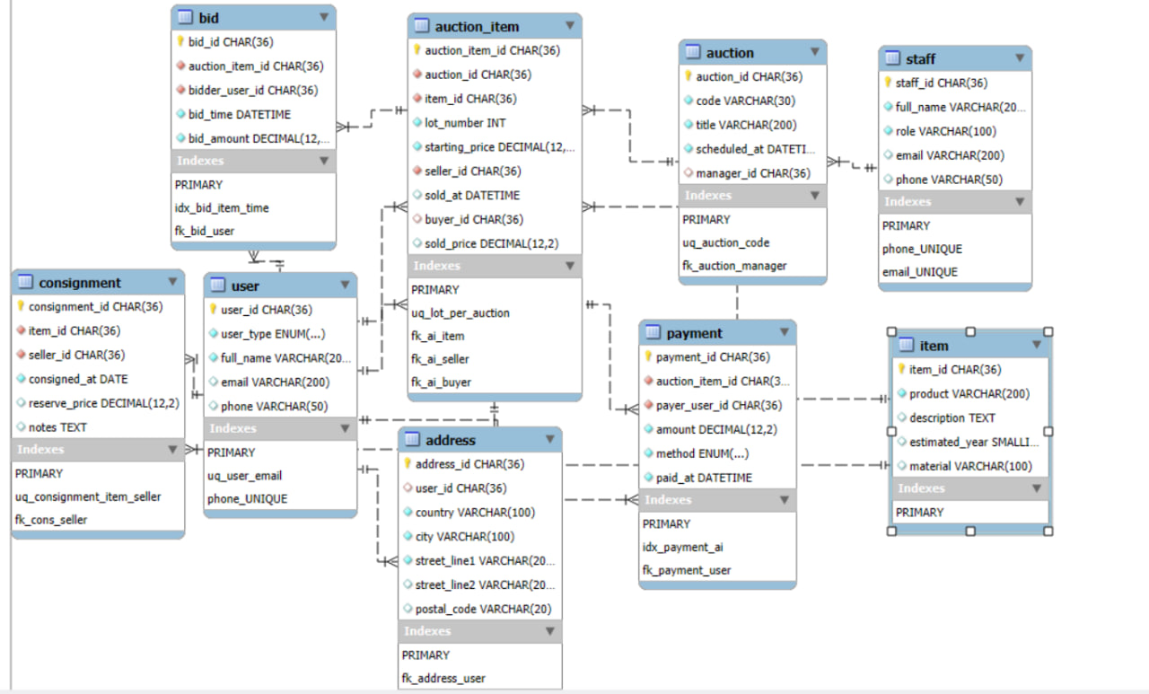

## Objects

|  |  |  |  |
| --- | --- | --- | --- |
| Table Name | Field name | Field Description | Data Type |
| USER | user_id | Unique identifier for each user (Primary Key) | CHAR(36) |
| user_type | Type of user — either individual person or organization | ENUM('PERSON','ORGANIZATION') |
| full_name | Full legal or company name of the user | VARCHAR(200) |
| email | Email address of the user (**unique**) | VARCHAR(200) |
| phone | Contact phone number | VARCHAR(50) |
|  |  |  |

|  |  |  |  |
| --- | --- | --- | --- |
| Table Name | Field name | Field Description | Data Type |
| ADDRESS | address_id | Unique identifier for each address (Primary Key) | CHAR(36) |
| user_id | Owner of this address (Foreign Key → user.user_id, nullable) | CHAR(36) |
| country | Country name | VARCHAR(100) |
| city | City name | VARCHAR(100) |
| street_line1 | Primary street address | VARCHAR(200) |
| street_line2 | Additional address line (optional) | VARCHAR(200) |
|  |  |  |  |

|  |  |  |  |
| --- | --- | --- | --- |
| Table Name | Field name | Field Description | Data Type |
| STAFF | staff_id | Unique identifier for each staff member (Primary Key) | CHAR(36) |
| full_name | Full name of the staff member | VARCHAR(200) |
| role | Job role/position | VARCHAR(100) |
| email | Staff email (**unique**) | VARCHAR(200) |
| phone | Staff phone number | VARCHAR(50) |
|  |  |  |
|  |  |  |  |
|  |  |  |  |

|  |  |  |  |
| --- | --- | --- | --- |
| Table Name | Field name | Field Description | Data Type |
| ITEM | item_id | Unique identifier for each item (Primary Key) | VARCHAR (36) |
| product | Product name/title | VARCHAR(200) |
| description | Detailed description of the item | TEXT |
| estimated_year | Approximate production year | SMALLINT |
| material | Material or composition | VARCHAR(100) |
|  |  |  |
|  |  |  |  |

|  |  |  |  |
| --- | --- | --- | --- |
| Table Name | Field name | Field Description | Data Type |
| AUCTION | auction_id | Unique identifier for each auction (Primary Key) | VARCHAR (36) |
| code | Auction code (**unique**) | VARCHAR(30) |
| title | Auction event title | VARCHAR(200) |
| scheduled_at | Scheduled date and time of the auction | DATETIME |
| manager_id | Staff responsible for the auction (Foreign Key → staff.staff_id, nullable) | VARCHAR (36) |
|  |  |  |
|  |  |  |  |

|  |  |  |  |
| --- | --- | --- | --- |
| Table Name | Field name | Field Description | Data Type |
| AUCTION_ITEM | auction_item_id | Unique identifier for the auction lot (Primary Key) | VARCHAR (36) |
| auction_id | Auction where the lot appears (Foreign Key → auction.auction_id) | VARCHAR (36) |
| item_id | Item being auctioned (Foreign Key → item.item_id) | VARCHAR (36) |
| lot_number | Lot number **unique within the same auction** | INT |
| starting_price | Starting/minimum bid price (must be ≥ 0) | DECIMAL(12,2) |
| seller_id | Seller (owner) of the item (Foreign Key → user.user_id) | VARCHAR (36) |
|  | sold_at | Date and time when the lot was sold (nullable until sold) | DATETIME |
|  | buyer_id | Buyer who won the lot (Foreign Key → user.user_id, nullable) | VARCHAR (36) |
|  | sold_price | Final sold price (nullable; must be ≥ 0 when sold) | DECIMAL(12,2) |

|  |  |  |  |
| --- | --- | --- | --- |
| Table Name | Field name | Field Description | Data Type |
| **CONSIGNMENT** | consignment_id | Unique identifier for the consignment record (Primary Key) | VARCHAR (36) |
| item_id | Consigned item (Foreign Key → item.item_id) | VARCHAR (36) |
| seller_id | User who consigned the item (Foreign Key → user.user_id) | VARCHAR (36) |
| consigned_at | Date the item was consigned | DATE |
| reserve_price | Minimum acceptable price (nullable; ≥ 0 if set) | DECIMAL(12,2) |
| notes | Additional consignment information | TEXT |

|  |  |  |  |
| --- | --- | --- | --- |
| Table Name | Field name | Field Description | Data Type |
| **BID** | bid_id | Unique identifier for the bid (Primary Key) | VARCHAR (36) |
| auction_item_id | Lot that is being bid on (Foreign Key → auction_item.auction_item_id) | VARCHAR (36) |
| bidder_user_id | User who placed the bid (Foreign Key → user.user_id) | VARCHAR(36) |
| bid_time | Timestamp when the bid was placed | DATETIME |
| bid_amount | Amount offered (must be > 0) | DECIMAL(12,2) |
|  |  |  |

|  |  |  |  |
| --- | --- | --- | --- |
| Table Name | Field name | Field Description | Data Type |
| **PAYMENT** | payment_id | Unique identifier for the payment (Primary Key) | VARCHAR(36) |
| auction_item_id | Lot the payment relates to (Foreign Key → auction_item.auction_item_id) | VARCHAR (36) |
| payer_user_id | User making the payment (Foreign Key → user.user_id) | VARCHAR (36) |
| amount | Amount paid (must be > 0) | DECIMAL(12,2) |
| method | Payment method (cash/card/bank transfer/other) | ENUM('CASH','CARD','BANK_TRANSFER','OTHER') |
| paid_at | Date/time of payment (defaults to current timestamp) | DATETIME |
|  |  |  |  |

|  |  |  |  |
| --- | --- | --- | --- |
| Table Name | Field name | Field Description | Data Type |
| **DELIVERY** | delivery_id | Unique identifier for the delivery (Primary Key) | VARCHAR(36) |
| auction_item_id | Sold lot being delivered (**unique**, Foreign Key → auction_item.auction_item_id) | VARCHAR(36) |
| ship_from_address_id | Origin address (Foreign Key → address.address_id, nullable) | VARCHAR(36) |
| ship_to_address_id | Destination address (Foreign Key → address.address_id, nullable) | VARCHAR(36) |
| carrier_name | Delivery company/courier name | VARCHAR(100) |
| tracking_number | Shipment tracking number | VARCHAR(100) |
|  | shipped_at | Date/time item was shipped (nullable) | DATETIME |

| **Relationship** | **Type** | **Description** |
| --- | --- | --- |
| Users → Items | 1 : N | One seller can register many items |
| Auctions → Auction_Items | 1 : N | One auction includes many items |
| Items → Auction_Items | 1 : N | One item is listed in one auction |
| Users → Auction_Items | 1 : N | One buyer can buy multiple items |
| Auction_Items ↔ Payments | 1 : 1 | Each sold item has one payment |
| Users → Payments | 1 : N | One user can make or receive many payments |

**Example with data:**

|  |  |  |  |  |
| --- | --- | --- | --- | --- |
| user_id | user_type | full_name | email | phone |
| u001 | PERSON | Alice Johnson | [alice@mail.com](mailto:alice@mail.com) | +998900001111 |
| u002 | PERSON | Bob Karimov | [bob@mail.com](mailto:bob@mail.com) | +998900002222 |
| u003 | ORGANIZATION | Antique Asia Traders | [contact@aat.com](mailto:contact@aat.com) | +998900003333 |

|  |  |  |  |  |  |  |
| --- | --- | --- | --- | --- | --- | --- |
| address_id | user_id | country | city | street_line1 | street_line2 | postal_code |
| a001 | u001 | Uzbekistan | Tashkent | Amir Temur Ave 10 | — | 100000 |
| a002 | u002 | Uzbekistan | Samarkand | Registon St 5 | — | 140100 |
| a003 | NULL | Uzbekistan | Bukhara | Old Market 77 | — | 200200 |

|  |  |  |  |  |
| --- | --- | --- | --- | --- |
| staff_id | full_name | role | email | phone |
| s001 | John Smith | Auction Manager | [john@auction.com](mailto:john@auction.com) | +998900005555 |
| s002 | Emma Davis | Logistics Coordinator | [emma@auction.com](mailto:emma@auction.com) | +998900006666 |

|  |  |  |  |  |
| --- | --- | --- | --- | --- |
| item_id | product | description | estimated_year | material |
| it001 | Vintage Persian Vase | Handcrafted, 19th century | 1890 | Ceramic |
| it002 | Samarkand Silk Rug | Traditional Uzbek silk carpet | 1950 | Silk |
| it003 | Bronze Warrior Statue | Ancient warrior figure | 1700 | Bronze |

|  |  |  |  |  |
| --- | --- | --- | --- | --- |
| auction_id | code | title | scheduled_at | manager_id |
| au001 | AUC2025-01 | Spring Luxury Auction | 2025-04-10 18:00 | s001 |
| au002 | AUC2025-02 | Silk Road Treasures Event | 2025-05-22 17:00 | s001 |

|  |  |  |  |  |  |  |  |  |
| --- | --- | --- | --- | --- | --- | --- | --- | --- |
| auction_item_id | auction_id | item_id | lot_number | starting_price | seller_id | sold_at | buyer_id | sold_price |
| ai001 | au001 | it001 | 1 | 5000.00 | u001 | 2025-04-10 18:30 | u003 | 5500.00 |
| ai002 | au001 | it002 | 2 | 7000.00 | u002 | NULL | NULL | NULL |
| ai003 | au002 | it003 | 1 | 10000.00 | u003 | NULL | NULL | NULL |

|  |  |  |  |  |  |
| --- | --- | --- | --- | --- | --- |
| consignment_id | item_id | seller_id | consigned_at | reserve_price | notes |
| c001 | it001 | u001 | 2025-03-01 | 4500.00 | Excellent condition |
| c002 | it002 | u002 | 2025-03-05 | 6500.00 | Rare Uzbek silk work |

|  |  |  |  |  |
| --- | --- | --- | --- | --- |
| bid_id | auction_item_id | bidder_user_id | bid_time | bid_amount |
| b001 | ai001 | u002 | 2025-04-10 18:10 | 5200.00 |
| b002 | ai001 | u003 | 2025-04-10 18:12 | 5500.00 |
| b003 | ai002 | u001 | 2025-04-10 18:20 | 7300.00 |

|  |  |  |  |  |  |
| --- | --- | --- | --- | --- | --- |
| payment_id | auction_item_id | payer_user_id | amount | method | paid_at |
| p001 | ai001 | u003 | 5500.00 | BANK_TRANSFER | 2025-04-10 18:35 |

|  |  |  |  |  |  |  |  |
| --- | --- | --- | --- | --- | --- | --- | --- |
| delivery_id | auction_item_id | ship_from_address_id | ship_to_address_id | carrier_name | tracking_number | shipped_at | delivered_at |
| d001 | ai001 | a003 | a001 | DHL Express | DHL12345UZ | 2025-04-11 10:00 | — |