Business Template

Subject areas
Logo / Image

Contents
Business Description 3
1.1 the Benefits of implementing a database. Project Vision 3
2 Model description 3
2.1 Definitions & Acronyms 3
2.2 Logical Scheme 3
2.3 Objects 3

Business Description

the Benefits of implementing a database. Project Vision
The Hotel Booking System database helps manage hotel operations in a structured and reliable way. It stores information about rooms, guests, reservations, services, payments, and employees in one centralized system. This makes it easier for the hotel to track room availability, manage bookings for specific dates, and record additional services such as breakfast or parking.
Data integrity and consistency are ensured using primary keys, foreign keys, and constraints. These rules guarantee that each record is unique and that relationships between tables remain valid. For example, a reservation must be linked to an existing guest and hotel, and services can only be added if they exist in the system.
The model also keeps historical information instead of overwriting previous data. Tables such as reservation_room, payment, and room_status_history store past records so the hotel can track previous reservations, payments, and room status changes.
The structure is scalable because it separates different entities into normalized tables. This allows the system to easily support multiple hotels, new services, or additional features without major redesign.
To keep the data accurate as the system grows, several constraints are used, such as NOT NULL, UNIQUE, and CHECK conditions. These ensure valid dates, positive prices, and correct relationships between tables.

Model description

Definitions & Acronyms
Definitions & Acronyms
Several key entities and roles in the system require clear definitions to correctly understand the database model.
Hotel refers to the physical location where rooms are available for guests to stay.
Room represents an individual accommodation unit within a hotel that can be reserved.
Room Type defines the category of a room, such as single, double, or suite, including its capacity and base price.
Guest is the person who makes a reservation and stays at the hotel.
Reservation is the booking made by a guest for one or more rooms for a specific period.
Service refers to additional options offered by the hotel, such as breakfast, parking, or spa access.
Employee is a staff member responsible for managing reservations, rooms, and services.
Some terms may be misunderstood without clarification. For example, reservation refers to the overall booking record, while reservation_room represents the assignment of specific rooms to that reservation. Similarly, stay_record represents the actual check-in and check-out information during a guest’s stay.
Several abbreviations appear repeatedly in the database structure. PK (Primary Key) identifies a unique record in a table, while FK (Foreign Key) links one table to another to maintain relationships between entities. 3NF (Third Normal Form) refers to the normalization level used in the database design to eliminate redundancy and ensure that each attribute depends only on the primary key.
These definitions help ensure that the database model is interpreted correctly and consistently.

Logical Scheme
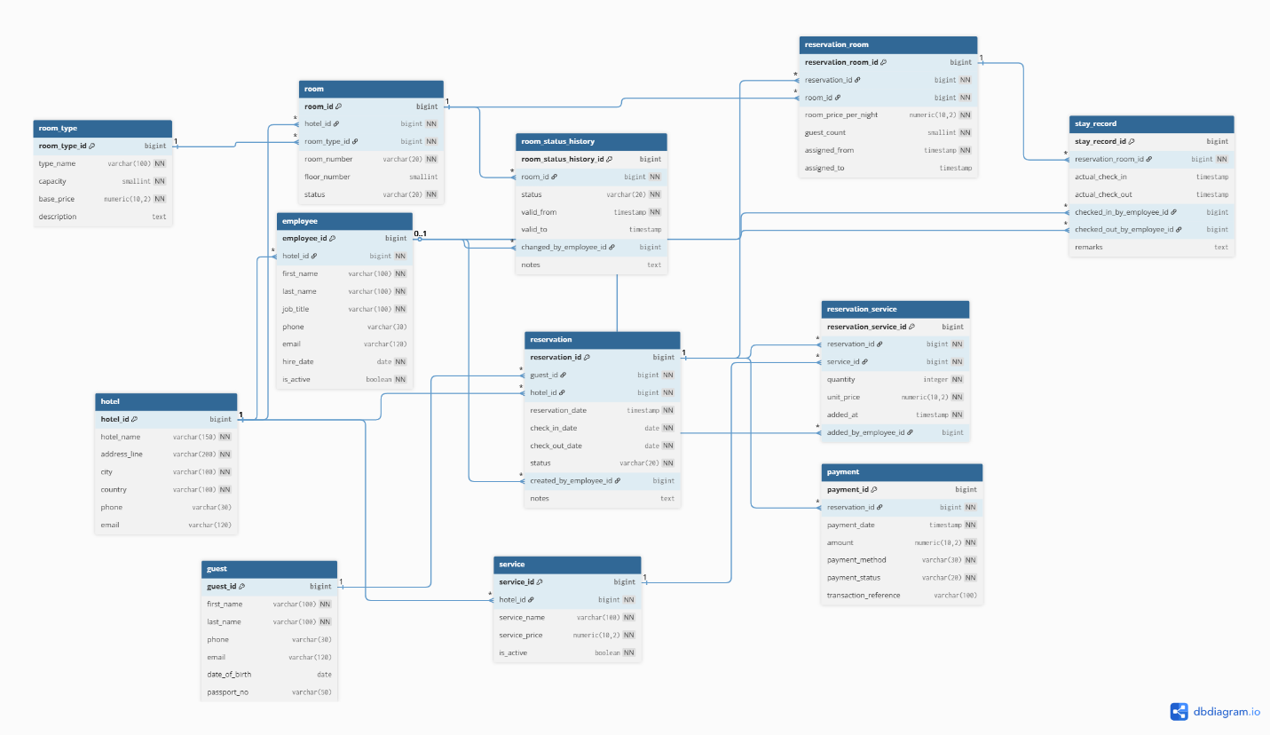

Logical Scheme
The most difficult modeling decision was designing the relationship between reservations and rooms. A reservation can include multiple rooms, and a room can appear in many reservations over time. To solve this, a many-to-many relationship was implemented using the reservation_room table. This table also allows the system to store additional information such as price per night and assignment time.
The design prevents several possible data anomalies. For example, duplicate room numbers in the same hotel are prevented by a UNIQUE constraint on (hotel_id, room_number). Incorrect reservation data is avoided using CHECK constraints, such as ensuring that the check-out date is later than the check-in date. Foreign keys also prevent invalid references, ensuring that reservations cannot exist without a valid guest or hotel.
The model is scalable because it separates data into normalized tables following Third Normal Form (3NF). New attributes or participants can be added without changing the existing structure. For example, new services, room types, or additional guest details can be added easily without affecting other tables.
If the system requirements expand, the part of the model most likely to change would be pricing and availability management. For example, the hotel might introduce seasonal pricing, discounts, or dynamic pricing based on demand, which could require additional tables or attributes related to room pricing and reservation management.

Objects
What real-world concept or event does this table represent?
This table represents a hotel booking made by a guest. It stores information about when the reservation was created, the planned check-in and check-out dates, and the reservation status.
Why must this information be stored separately instead of inside another table?
Reservations must be stored separately because one guest can create multiple reservations, and each reservation may include multiple rooms and services. Keeping reservations in a separate table allows the system to manage bookings independently from guest or room information.
What is the normalization level of the table?
The table is in Third Normal Form (3NF). All attributes depend only on the primary key (reservation_id), and there are no repeating groups or redundant data.
Are there partial or transitive dependencies?
There are no partial dependencies because the primary key is a single attribute. There are also no transitive dependencies because attributes such as check_in_date, check_out_date, and status depend directly on the reservation_id and not on other attributes.
Why did you choose this primary key (PK)? Could a composite key work instead?
The primary key reservation_id was chosen because it uniquely identifies each reservation and simplifies relationships with other tables such as payments or room assignments. A composite key based on guest_id and dates could exist, but it would be less flexible and harder to manage.
Which foreign keys (FK) were added and why?
The table includes foreign keys such as guest_id and hotel_id. These link the reservation to the guest who made the booking and the hotel where the reservation will occur. This ensures referential integrity and prevents reservations from existing without valid related records.

Table: hotel
Field Name | Field Description | Data Type
hotel_id | Unique identifier of the hotel, PK | BIGINT
hotel_name | Name of the hotel | VARCHAR
address_line | Hotel address | VARCHAR
city | City where the hotel is located | VARCHAR
country | Country location | VARCHAR
phone | Contact phone number | VARCHAR
email | Hotel contact email | VARCHAR

Table: room_type
Field Name | Field Description | Data Type
room_type_id | Unique identifier of room type, PK | BIGINT
type_name | Name of the room category | VARCHAR
capacity | Maximum number of guests allowed | SMALLINT
base_price | Standard price for this room type | NUMERIC
description | Additional details about the room type | TEXT

Table: room
Field Name | Field Description | Data Type
room_id | Unique identifier of the room, PK | BIGINT
hotel_id | Reference to hotel where the room is located, FK | BIGINT
room_type_id | Reference to the room type, FK | BIGINT
room_number | Room number within the hotel | VARCHAR
floor_number | Floor where the room is located | SMALLINT
status | Current room status | VARCHAR

Table: guest
Field Name | Field Description | Data Type
guest_id | Unique identifier of the guest, PK | BIGINT
first_name | Guest first name | VARCHAR
last_name | Guest last name | VARCHAR
phone | Guest contact number | VARCHAR
email | Guest email address | VARCHAR
date_of_birth | Guest birth date | DATE
passport_no | Guest passport number | VARCHAR

Table: employee
Field Name | Field Description | Data Type
employee_id | Unique identifier of employee, PK | BIGINT
hotel_id | Reference to hotel where employee works, FK | BIGINT
first_name | Employee first name | VARCHAR
last_name | Employee last name | VARCHAR
job_title | Employee position or role | VARCHAR
phone | Employee contact number | VARCHAR
email | Employee email address | VARCHAR
hire_date | Date when employee was hired | DATE
is_active | Indicates if employee is active | BOOLEAN

Table: reservation
Field Name | Field Description | Data Type
reservation_id | Unique identifier of reservation, PK | BIGINT
guest_id | Reference to guest making reservation, FK | BIGINT
hotel_id | Reference to hotel where reservation is made, FK | BIGINT
reservation_date | Date when reservation was created | TIMESTAMP
check_in_date | Planned guest check-in date | DATE
check_out_date | Planned guest check-out date | DATE
status | Reservation status | VARCHAR
created_by_employee_id | Employee who created reservation, FK | BIGINT
notes | Additional reservation notes | TEXT

Table: reservation_room
Field Name | Field Description | Data Type
reservation_room_id | Unique identifier of room assignment, PK | BIGINT
reservation_id | Reference to reservation, FK | BIGINT
room_id | Reference to reserved room, FK | BIGINT
room_price_per_night | Price per night for the assigned room | NUMERIC
guest_count | Number of guests in the room | SMALLINT
assigned_from | Date/time when room was assigned | TIMESTAMP
assigned_to | Date/time when assignment ended | TIMESTAMP

Table: service
Field Name | Field Description | Data Type
service_id | Unique identifier of service, PK | BIGINT
hotel_id | Reference to hotel offering service, FK | BIGINT
service_name | Name of service | VARCHAR
service_price | Price of the service | NUMERIC
is_active | Indicates if service is available | BOOLEAN

Table: reservation_service
Field Name | Field Description | Data Type
reservation_service_id | Unique identifier of service assignment, PK | BIGINT
reservation_id | Reference to reservation, FK | BIGINT
service_id | Reference to service provided, FK | BIGINT
quantity | Number of service units | INTEGER
unit_price | Price of the service at booking time | NUMERIC
added_at | Date/time when service was added | TIMESTAMP
added_by_employee_id | Employee who added service, FK | BIGINT

Table: payment
Field Name | Field Description | Data Type
payment_id | Unique identifier of payment, PK | BIGINT
reservation_id | Reference to reservation, FK | BIGINT
payment_date | Date/time of payment | TIMESTAMP
amount | Payment amount | NUMERIC
payment_method | Method of payment | VARCHAR
payment_status | Status of payment | VARCHAR
transaction_reference | External transaction identifier | VARCHAR

Table: stay_record
Field Name | Field Description | Data Type
stay_record_id | Unique identifier of stay record, PK | BIGINT
reservation_room_id | Reference to assigned reservation room, FK | BIGINT
actual_check_in | Actual guest check-in time | TIMESTAMP
actual_check_out | Actual guest check-out time | TIMESTAMP
checked_in_by_employee_id | Employee who performed check-in, FK | BIGINT
checked_out_by_employee_id | Employee who performed check-out, FK | BIGINT
remarks | Additional stay notes | TEXT

Table: room_status_history
Field Name | Field Description | Data Type
room_status_history_id | Unique identifier of status record, PK | BIGINT
room_id | Reference to room, FK | BIGINT
status | Room status at given time | VARCHAR
valid_from | Date/time when status started | TIMESTAMP
valid_to | Date/time when status ended | TIMESTAMP
changed_by_employee_id | Employee who changed the status, FK | BIGINT
notes | Additional status information | TEXT

Example with data:

hotel_id | hotel_name | city | country
1 | Grand Plaza | Tashkent | Uzbekistan
2 | City Hotel | Samarkand | Uzbekistan
3 | Silk Road Inn | Bukhara | Uzbekistan

Table: room_type
room_type_id | type_name | capacity | base_price
1 | Single | 1 | 80.00
2 | Double | 2 | 120.00
3 | Suite | 4 | 300.00

Table: room
room_id | hotel_id | room_type_id | room_number | status
1 | 1 | 1 | 101 | available
2 | 1 | 2 | 102 | available
3 | 2 | 3 | 201 | maintenance

Table: guest
guest_id | first_name | last_name | phone
1 | Ali | Karimov | +998901234567
2 | John | Smith | +447000000000
3 | Maria | Ivanova | +79990000000

Table: employee
employee_id | hotel_id | first_name | job_title | is_active
1 | 1 | Aziza | Receptionist | true
2 | 1 | Bekzod | Manager | true
3 | 2 | Dilshod | Technician | true

Table: reservation
reservation_id | guest_id | hotel_id | check_in_date | check_out_date
1 | 1 | 1 | 2026-03-10 | 2026-03-15
2 | 2 | 1 | 2026-04-01 | 2026-04-05
3 | 3 | 2 | 2026-05-02 | 2026-05-04

Table: reservation_room
reservation_room_id | reservation_id | room_id | guest_count
1 | 1 | 1 | 1
2 | 1 | 2 | 2
3 | 2 | 3 | 2

Table: service
service_id | hotel_id | service_name | service_price
1 | 1 | Breakfast | 15.00
2 | 1 | Parking | 10.00
3 | 2 | Spa | 50.00

Table: reservation_service
reservation_service_id | reservation_id | service_id | quantity
1 | 1 | 1 | 2
2 | 1 | 2 | 1
3 | 2 | 3 | 1

Table: payment
payment_id | reservation_id | amount | payment_method
1 | 1 | 300.00 | card
2 | 2 | 500.00 | cash
3 | 3 | 200.00 | online

Table: stay_record
stay_record_id | reservation_room_id | actual_check_in | actual_check_out
1 | 1 | 2026-03-10 14:00 | 2026-03-15 12:00
2 | 2 | 2026-03-10 14:15 | 2026-03-15 11:50
3 | 3 | 2026-04-01 13:30 | 2026-04-05 12:05

Table: room_status_history
room_status_history_id | room_id | status | valid_from
1 | 1 | available | 2026-03-01 08:00
2 | 2 | occupied | 2026-03-10 14:00
3 | 3 | maintenance | 2026-04-01 09:00

