Developing a Backend Admin for Learner’s Academy.

# Developer name: Ramzi Wasel

Core concepts that were used in the project are:

* Database
* Collections
* Exception Handling

# Technologies that were used in the project are:

* + Data structures such as arrays.
  + Handling exceptions.
  + Servlets
  + Html
  + CSS
  + Tomcat Apache 8.5
  + Java classes
  + MySQL

# Application features:

* + Login page for a single signing to the website.
  + Navigation bar to navigate through the website and list all the classes, subjects, teachers, and students.
  + Close the application at any time.

The application was done in three sprints, the first sprint for sprint planning and preparing. Next, two sprint for developing and testing the application. Moving on to the first sprint we planned the flow of the development and how we are approaching the project. Furthermore, we developed the database tables and entered data. Then, we created java classes for each table in the database. Moving on, to the developing the servlets to link the classes and the implementation of the code. Then we created a view in the database so we can print the data we want from each table. Later we created a java class for that view. Then we implemented the navigation bar to make it easier for the admin when he/she use the Backoffice. Next, we created the homepage before logging in, the main page after logging in and the login form. We also created a servlet for login implementation. Furthermore, we created the option to logout from the website if desired. Finally, we tested the website and added a bit of CSS so that it presented better.

Below you will find screenshots of the application:

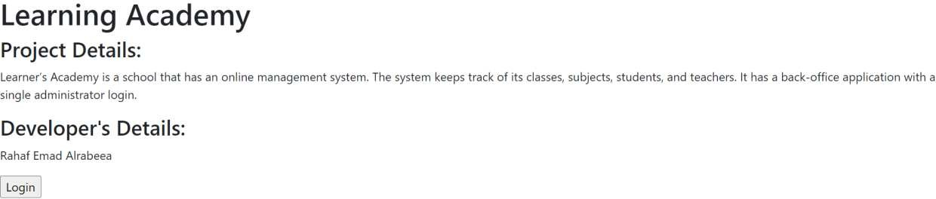

The above screenshot displays the welcome menu and the option to login in the website.

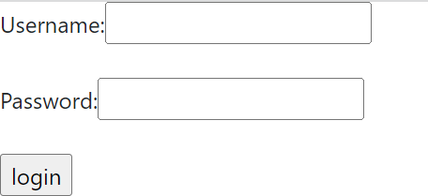

The admin will enter his/her credentials to log in which are “admin” and “admin”.



The navigation bar after login.

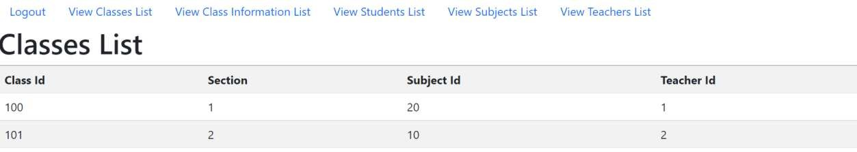

This is the classes list where it shows all the classes.

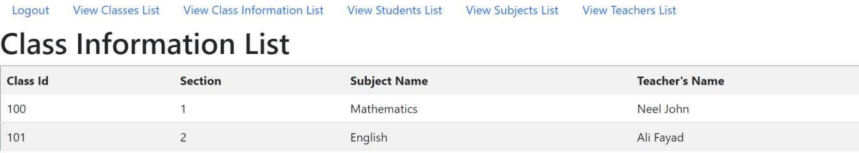

This the class information list page where it shows the information of each class.

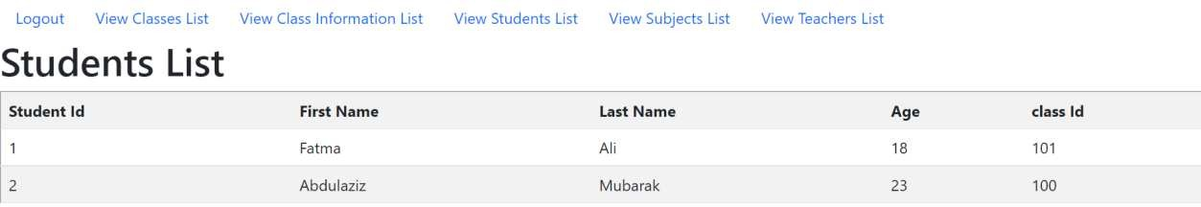

This is the students list page where it shows all the student information.

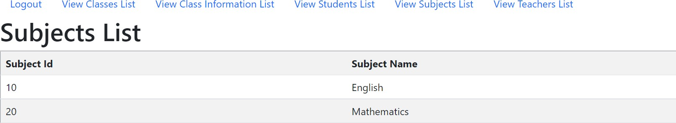

This is the subjects list which shows the subject name and id.

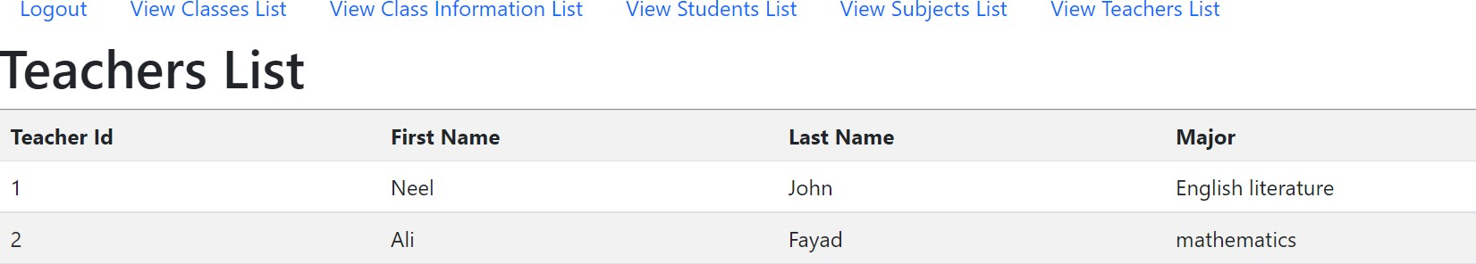

This is the teachers list with all the information of the teachers.

There is also the option to log out from the website.

To conclude, this project will help the admin a lot in his/her everyday use. It is developed in a way to make their life easier as it is user-friendly and easy to learn. In the future, we would like to add enhancements such as creating, updating and deleting data as it would also enhance the admin a lot more. This project aims to design and develop a backend administrative portal for the Learner’s Academy using Java EE technologies. The goal of this project is to apply servlet, jsp and JDBC concepts.

This is the link to github: <https://github.com/moayadalsaleh/LearningAcademyProject>

you will also find the code of the database below.

create database administrativeManagmentSystem;

CREATE TABLE `subjects` (

`subject_id` int NOT NULL,

`subject_name` varchar(55) NOT NULL, primary key (`subject_id`)

) ENGINE=InnoDB DEFAULT CHARSET=utf8mb4;

INSERT INTO `subjects` (`subject_id`, `subject_name`) VALUES (10, 'English'),

(20, 'Mathematics');

CREATE TABLE `teachers` (

`teacher_id` int NOT NULL,

`fname` varchar(55) NOT NULL,

`lname` varchar(55) NOT NULL,

`major` varchar(55) DEFAULT NULL, primary key (`teacher_id`)

) ENGINE=InnoDB DEFAULT CHARSET=utf8mb4;

INSERT INTO `teachers` (`teacher_id`, `fname`, `lname`, `major`) VALUES (1, 'Neel', 'John', 'English literature'),

(2, 'Ali', 'Fayad', 'mathematics');

CREATE TABLE `classes` (

`class_id` int NOT NULL,

`section` int NOT NULL,

`teacher_id` int NOT NULL,

`subject_id` int NOT NULL,

`time` varchar(44) NOT NULL, primary key (`class_id`),

foreign key (`subject_id`) references `subjects`(`subject_id`), foreign key (`teacher_id`) references `teachers`(`teacher_id`)

) ENGINE=InnoDB DEFAULT CHARSET=utf8mb4;

INSERT INTO `classes` (`class_id`, `section`, `teacher_id`, `subject_id`, `time`) VALUES (100, 1, 1, 20, '18:00'),

(101, 2, 2, 10, '14:30');

CREATE TABLE `students` (

`student_id` int NOT NULL,

`fname` varchar(55) NOT NULL,

`lname` varchar(55) NOT NULL,

`age` int DEFAULT NULL,

`class_id` int NOT NULL, primary key (`student_id`),

foreign key (`class_id`) references `classes`(`class_id`)

) ENGINE=InnoDB DEFAULT CHARSET=utf8mb4;

INSERT INTO `students` (`student_id`, `fname`, `lname`, `age`, `class_id`) VALUES (1, 'Fatma', 'Ali', 18, 101),

(2, 'Abdulaziz', 'Mubarak', 23, 100),

CREATE VIEW `class_info` AS

select classes.class_id, classes.section, classes.time , teachers.fname, teachers.lname, subjects.subject_name from classes, teachers, subjects

where classes.teacher_id = teachers.teacher_id and classes.subject_id = subjects.subject_id;

CREATE TABLE `Admin_login` (

`admin_id` int NOT NULL,

`username` varchar(55) NOT NULL,

`password` varchar(55) NOT NULL, primary key (`admin_id`)

) ENGINE=InnoDB DEFAULT CHARSET=utf8mb4;

INSERT INTO `Admin_login` (`admin_id`, `username`, `password`) VALUES (1, 'admin', 'admin');