ML Homework 7 Report
- Code with detail explanations
- Kernel Eigenfaces
- Read data
Load training and testing faces. Resize the images to reduce the complexity of matrix operations and convert the image into a one-dimensional vector
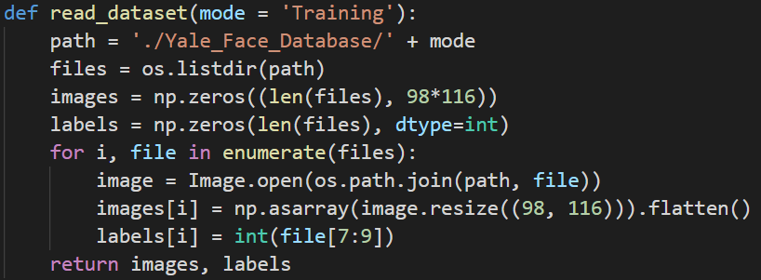
- PCA
- Calculate the average face. (avg_face)
- Move data to the center by reduce each face by average face. (diff_train_face)
- Calculate the covariance matrix S=AA^{T}. (A = diff_train_face.T)
- Calculate the eigenvalues and eigenvectors of the covariance matrix S.
- Sort the eigenvalues to pick the first 25 eigenvectors and visualize eigenfaces by transpose and resize the eigenvectors.
- Compute weight of test faces for every eigenvector by doing dot product of test faces and eigenvectors. Reconstructing faces by multiply the weight to eigenfaces and added to average face. Random choose 10 numbers as indexes and visualize reconstruction faces of these indexes
- Compute weight of training faces and test faces. Use 5-nearest neighbor to do face recognition.
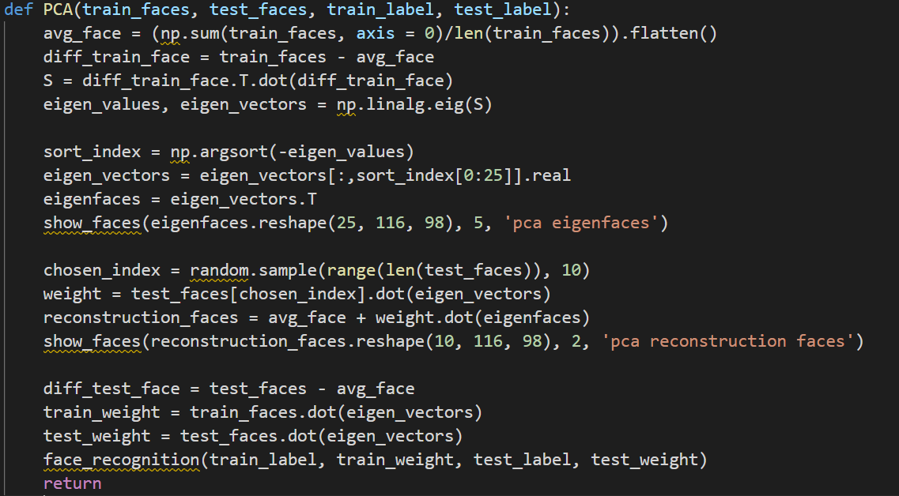
- LDA
- Calculate the average face. (avg_face)
- Calculate the class means of each class. (mean_class_i)
- Use the function below to calculate S_{W} and S_{B}:
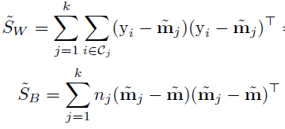
(y_{i} – m_{j} = faces_i – mean_class_i = diff_class_i,
m_{i} – m = mean_class_i – avg_face = diff_class)
- Calculate the covariance matrix S= S_{W}⁻¹S_{B}.
- Calculate the eigenvalues and eigenvectors of the covariance matrix S.
- Sort the eigenvalues to pick the first 25 eigenvectors and get fisherfaces by multiply the eigenvectors from PCA with selected eigenvectors. Visualize fisherfaces by transpose and resize the eigenvectors.
- Compute weight of test faces for every eigenvector by doing dot product of test faces and eigenvectors. Reconstructing faces by multiply the weight to eigenfaces and added to average face. Random choose 10 numbers as indexes and visualize reconstruction faces of these indexes
- Compute weight of training faces and test faces. Use 5-nearest neighbor to do face recognition.
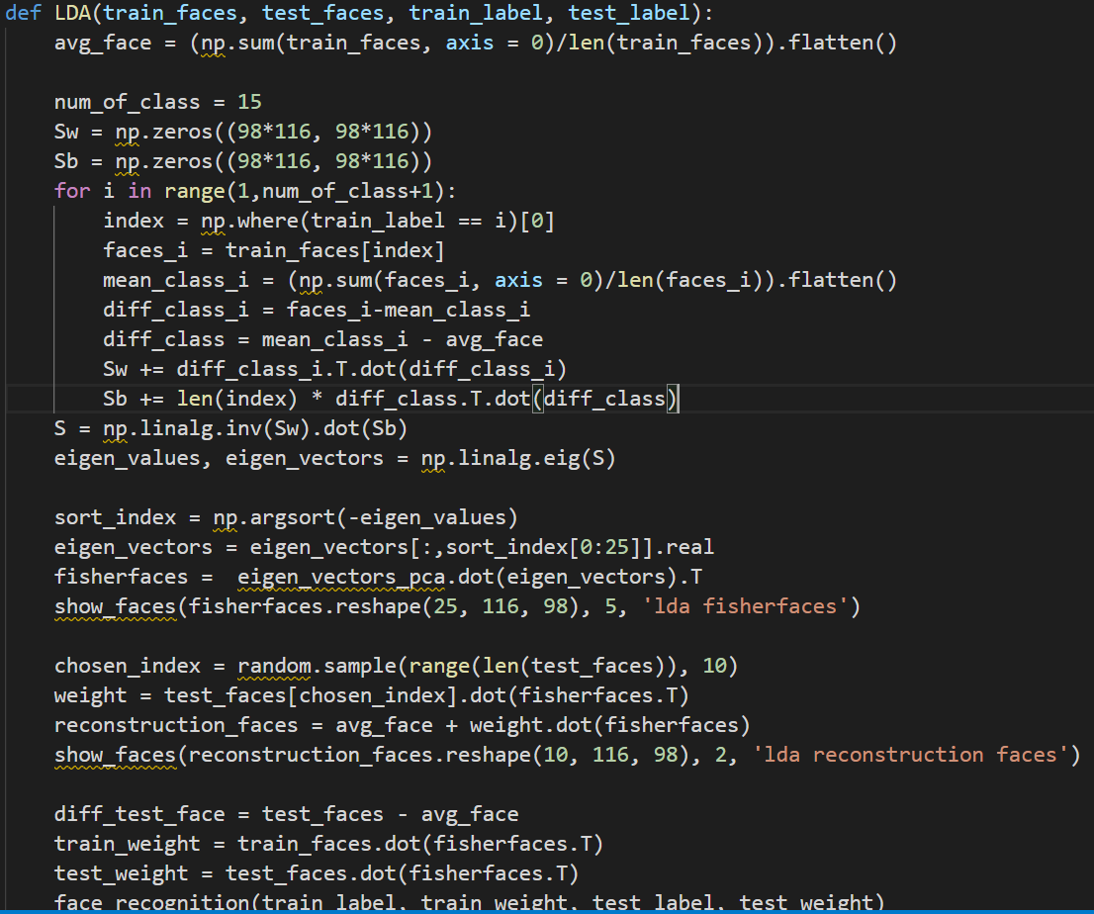
- Kernel PCA
- Calculate the average face. (avg_face)
- Calculate the RBF kernel. (K)
- Center the kernel by the function below:
(k_prime)
- Calculate the eigenvalues and eigenvectors of the kernel matrix.
- Sort the eigenvalues to pick the first 25 eigenvectors and visualize eigenfaces by transpose and resize the eigenvectors.
- Compute weight of test faces for every eigenvector by doing dot product of test faces and eigenvectors. Reconstructing faces by multiply the weight to eigenfaces and added to average face. Random choose 10 numbers as indexes and visualize reconstruction faces of these indexes
- Compute weight of training faces and test faces. Use 5-nearest neighbor to do face recognition.
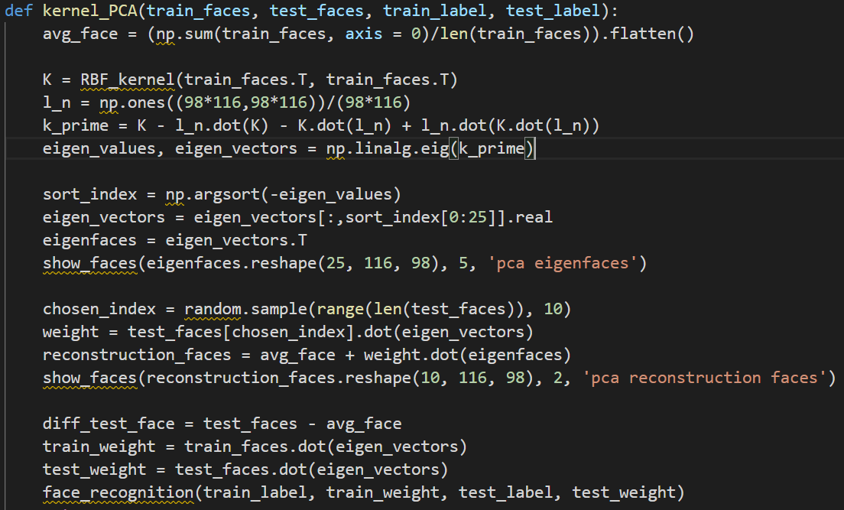
- Kernel LDA
- Calculate the average face. (avg_face)
- Calculate the RBF kernel. (K)
- Use the function below to calculate M and N:
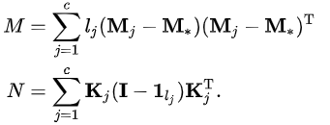
(M_{j} – M* = Mj – M_star = diff_class)
- Calculate the covariance matrix S= N⁻¹M.
- Calculate the eigenvalues and eigenvectors of the covariance matrix S.
- Sort the eigenvalues to pick the first 25 eigenvectors and get fisherfaces by multiply the eigenvectors from PCA with selected eigenvectors. Visualize fisherfaces by transpose and resize the eigenvectors.
- Compute weight of test faces for every eigenvector by doing dot product of test faces and eigenvectors. Reconstructing faces by multiply the weight to eigenfaces and added to average face. Random choose 10 numbers as indexes and visualize reconstruction faces of these indexes
- Compute weight of training faces and test faces. Use 5-nearest neighbor to do face recognition.
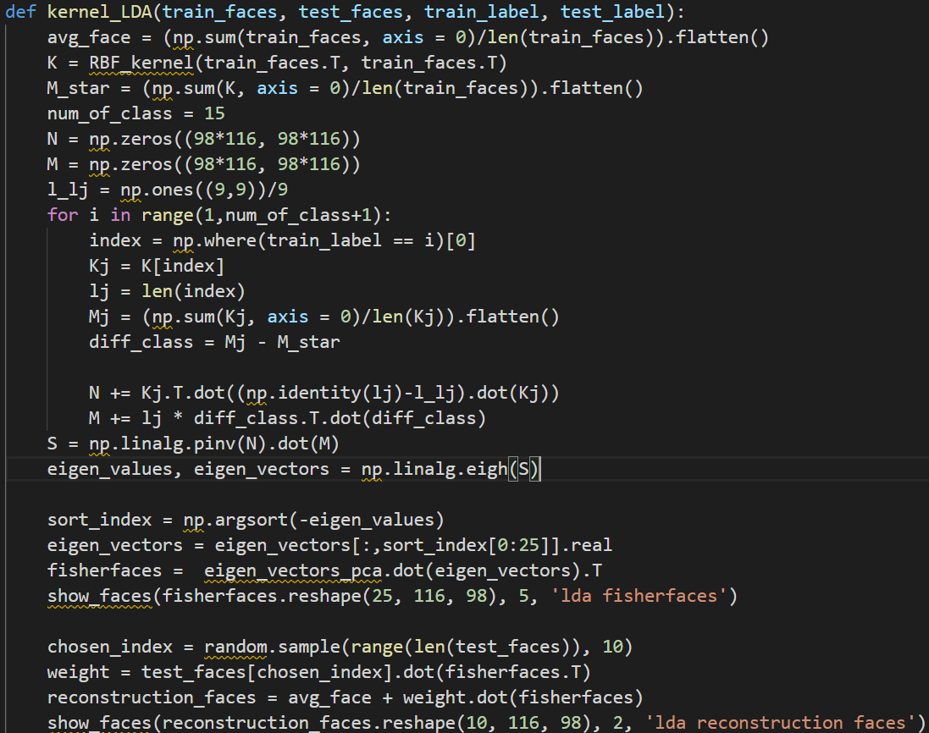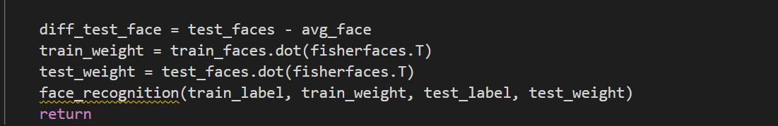
- Visualize face
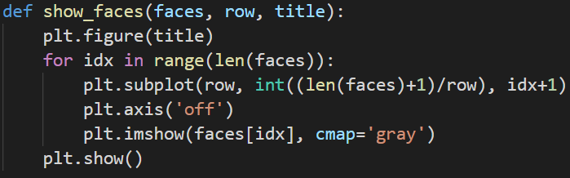
- Face recognition
Calculate the square of Euclidean distance between each pair of test weight and weight, predict by select the most index occurrence from 5 nearest.
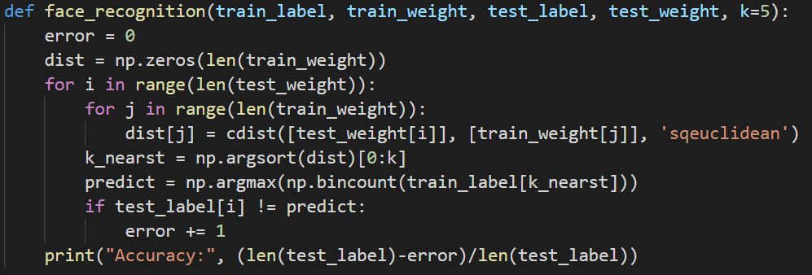
- t-SNE
Modify q_{ij} by:
Modify the gradient by:
- Experiments settings and results
- Kernel Eigenfaces
- PCA
Eigenfaces:
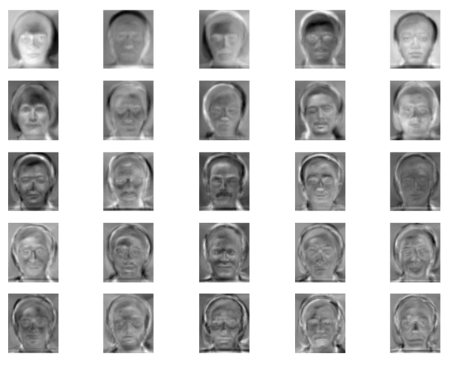
Reconstruction faces:
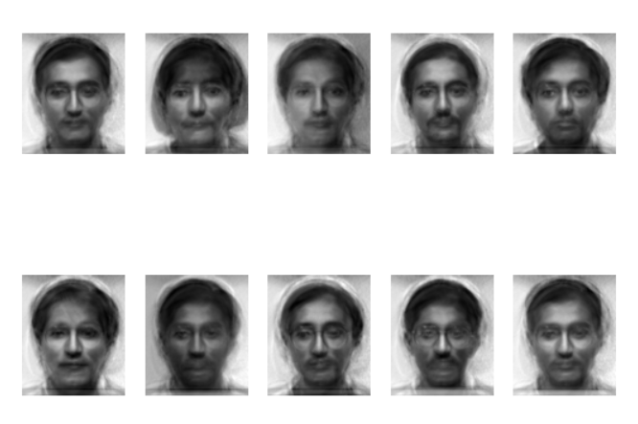
Accuracy: 0.9
- LDA
Fisherfaces:
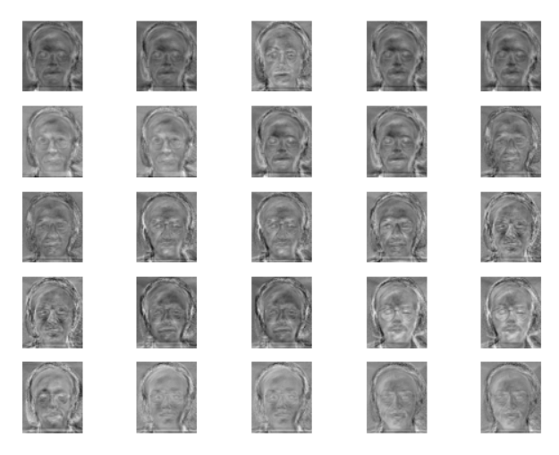
Reconstruction faces:
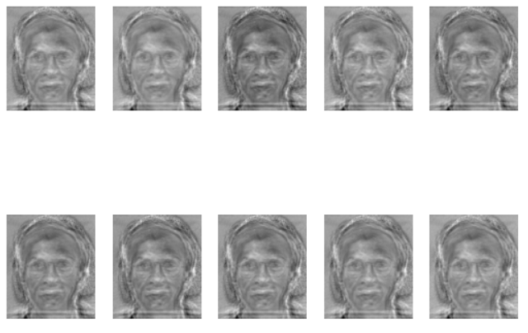
Accuracy: 0.87
- Kernel PCA
Eigenfaces:
Reconstruction faces:
Accuracy: 0.87
- Kernel LDA
Eigenfaces:
Reconstruction faces:
Accuracy: 0.9
- t-SNE
- t-SNE
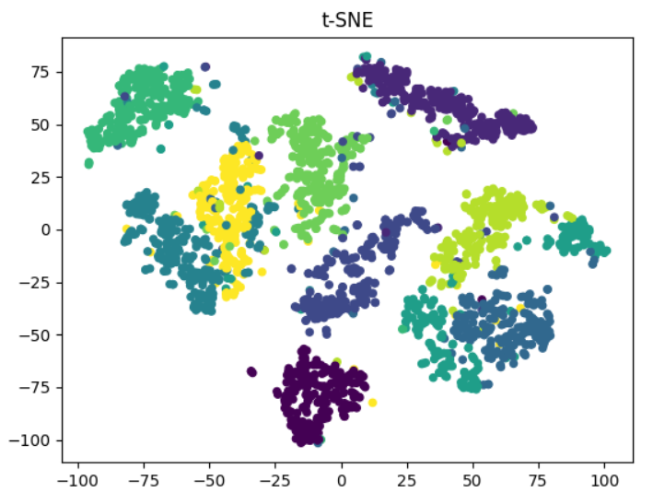
Perplexity = 10
Perplexity = 50
Perplexity = 100
- s-SNE
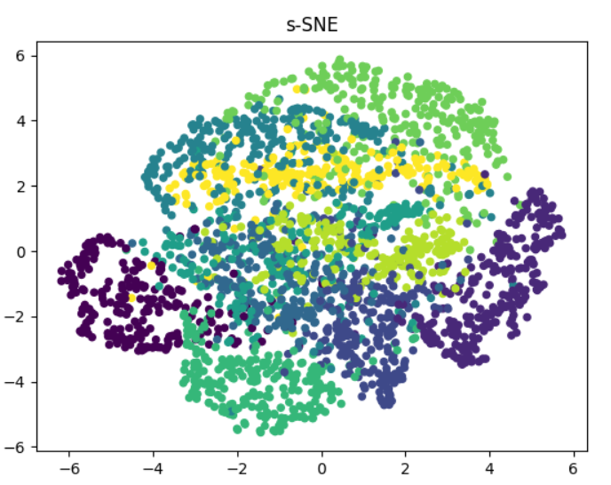
- Observations and Discussions
- Kernel Eigenfaces
- Dimensionality reduction makes our machine learning model learn faster and more efficient in terms of computational cost. Moreover, this method is to prevent our model suffers from overfitting problem due to its feature selection properties.
- Due to the insufficient amount of test data, we cannot conclude which face recognition method is better. But from the results of this experiment, PCA performs better than LDA.
- The main difference between LDA and PCA is that PCA completely processes data for principal component analysis, while LDA handles the difference between categories.
- Kernel’s result is better than non-kernel’s just at expected. The standard always finds linear principal components to represent the data in lower dimension. Sometime, we need non-linear principal components. If we apply standard for the below data, it will fail to find good representative direction. Kernel rectifies this limitation.
- The computational complexity for Kernel to extract principal components take more time compared to Standard.
- t-SNE
- The clusters of t-SNE are scattered that Symmetric SNE bounds into crowded problem.
- t-SNE can quickly separate different classes into different positions, and then modify the distribution in a more general way. Symmetric SNE only moves data slightly in low-dimensional space.
- When the perplexity increases, points will be more compact in every class.

