1. Put the vacuum_interference.m in the same folder as DS2.exe and DS2V.exe

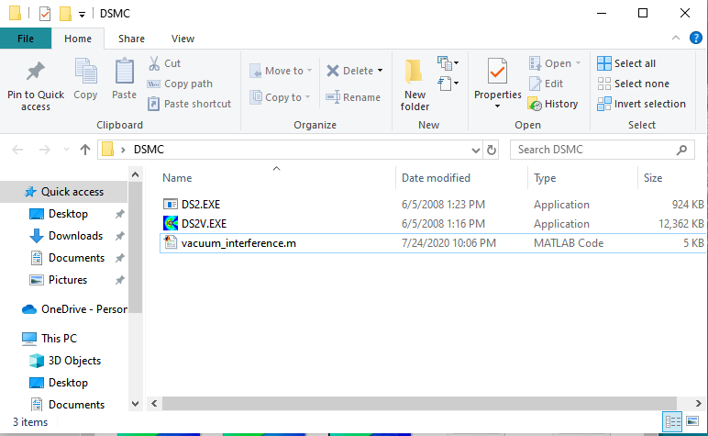

1. Run vaccum_interference.m with correctly input data for full skimmer simulation (if the skimmer is not an arc, the user needs to input his own vertices of the polygon, etc.) If you wish to focus on skimmer tip, you can use Bird.m instead.

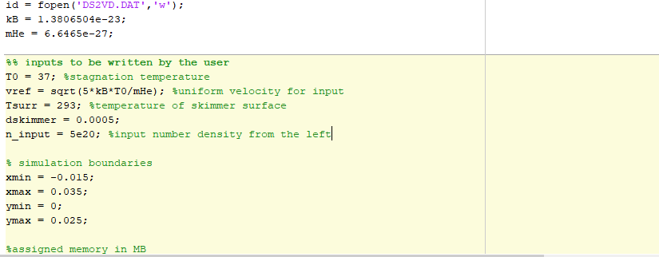

1. Run DS2V.exe, press start in bottom left corner and send 3. Check that the program is running OK, if not press stop and review the data file by pressing the button on top right.

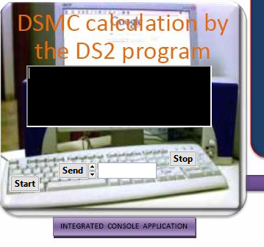

1. Move into interactive display and update files

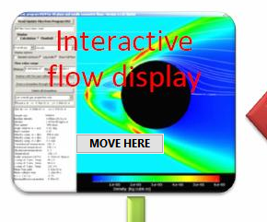 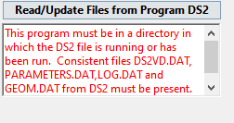

1. Check for warning messages in the mini-console. There may be some warning of m.c.s./m.f.p. ratio being marginal or too few molecules in a region of the simulation, but this is OK in the beginning provided that the error does not persist into steady state.

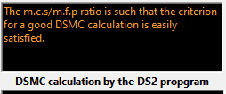

Or, if you are experienced enough, you can check the plot of m.c.s./m.f.p. in flowfield part. Usually, high ratios at the front of the stream is fine, since the program has yet to adapt to the number density there (e.g. region circled in black), but high ratios in mainstream is usually not fine (e.g. region circled in red).

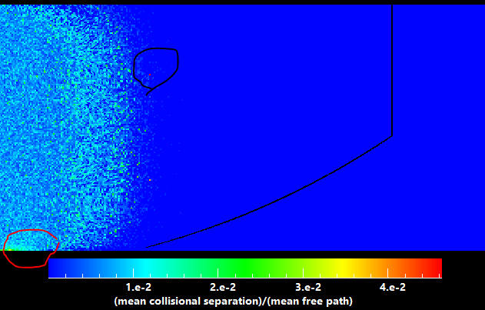

1. Look at the molecule number history. When the number of simulated molecules stops increasing and starts to oscillate somewhat around a fixed value, then you’ve at least started to reach steady state and could try to begin collecting data. You should also ignore any messages that says ‘Too many samples were taken yet the cells are not yet adapted to the flow.’ As long as m.c.s./m.f.p ratio is ok, the program should be behaving well. Restarting and adapt the cells is not ideal since you will lose some accuracy.

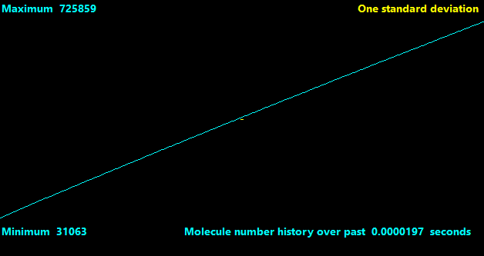

1. If the program is running too slowly, e.g. less than 1e-3 computational speed, it is probably best if you consider changing input parameters.

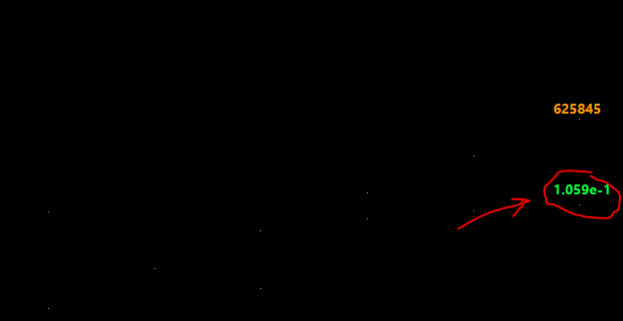

1. To collect data, go into the Flowfield part of the display.

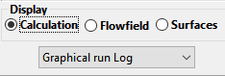

You can then choose to either click on a point in the flow or give x,y coordinates to check the physical properties at that point.

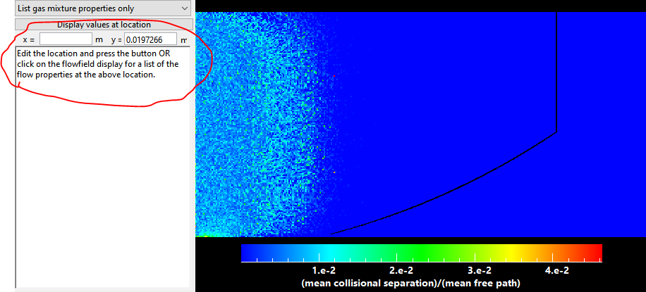

1. You can also choose to plot selected property values between the last two locations you chose to display (the program displays says that it plots against fractional distance from the penultimate point you were at to the last point you were at, but in fact at 0.0 you are at the last point and at 1.0 you are at the penultimate point) and then write that as a text file.

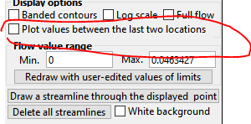



1. To get a feel for whether you are recording steady state behavior, it is best that you take multiple data points (~3-5) at different times and then see if the property you are looking at fluctuates by a lot. You can write out several text files this way and do post-processing in matlab. Usually if the centerline number density curve is smooth then the simulation is near steady state.
2. After you recorded all data, go back to the calculations part of the display and stop the program at the mini-console.
3. Alternatively, if you want to process the simulation data directly, copy the DS2FF.DAT file in your folder and give it another name, e.g. fileID.DAT, and then use function prepare_data defined in prepare_data.m, e.g. record = prepare_data(‘fileID.DAT’) to transfer all data into the ‘record’ array in matlab. For simulations of the skimmer tip, you can also refer to the template in skimmer_interference_plot.m to analyze the steady state on-axis flux of the simulation.
4. If the simulation has not reached steady state when you stopped the program, you can press ‘START’ again in the mini-console and then send ‘1’ first and then ‘0’ to continue the previous sample.