Contents
Part 1: Reddit API Integration (4 Marks) 3
Python code for API access 3
Print/log at least 20 posts per subreddit 4
Export raw data to CSV (raw_reddit_data.csv) 6
Figure 1 Raw Reddit data preview 7
Part 2: Text Cleaning & Preprocessing (3 Marks) 7
Python function for preprocessing 7
Before/after comparison table for at least 5 samples 8
Figure 2 Preprocessed Text Samples 8
Part 3: Post Classification (5 Marks) 8
Classification code 8
Confusion matrix or accuracy score 9
Final classified dataset (CSV) 9
Figure 3 Classification results 10
Part 4: Power BI Dashboard Integration (6 Marks) 11
Screenshots of the dashboard 11
Explanation of each visual 11
Figure 4 Reddit Post Classification Dashboard 12
Part 5: Report & Reflection 12
Tools and Libraries Used: 12
Challenges Faced During Integration: 13
Future Improvements: 13
Figure 5 Pipeline overview diagram 14

Part 1: Reddit API Integration (4 Marks)

Python code for API access
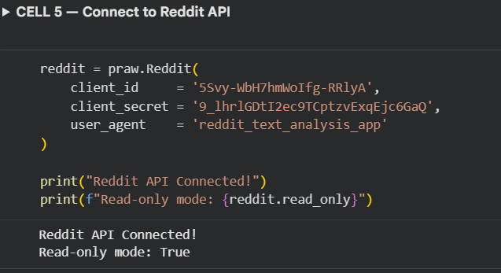

Print/log at least 20 posts per subreddit
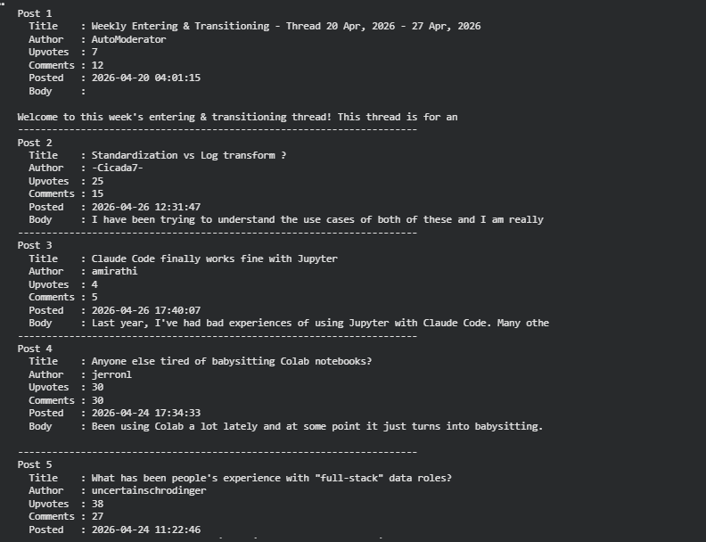
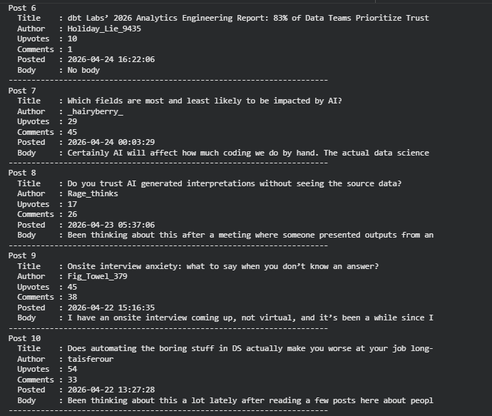
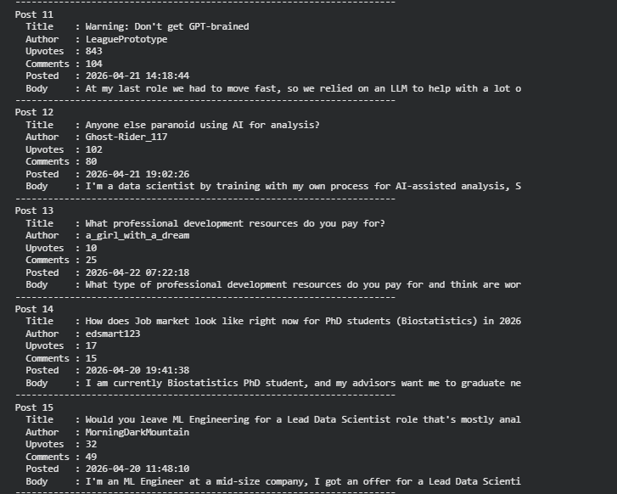
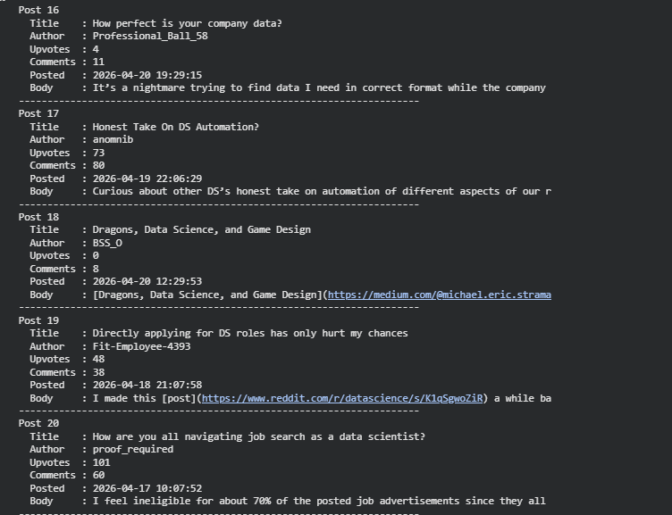

Export raw data to CSV (raw_reddit_data.csv)
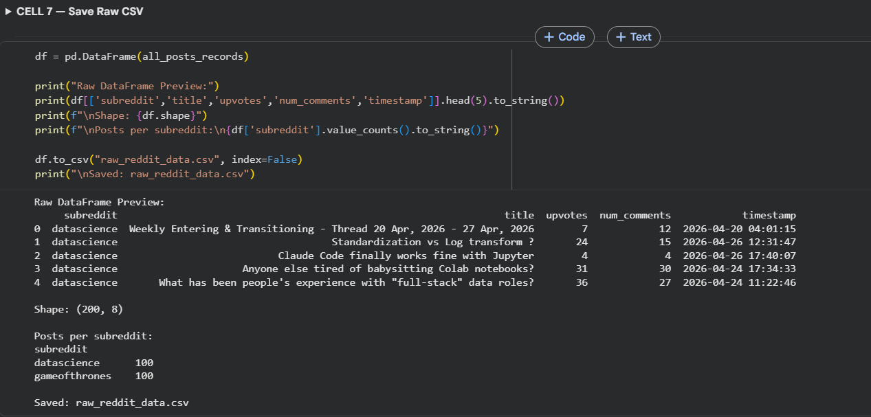
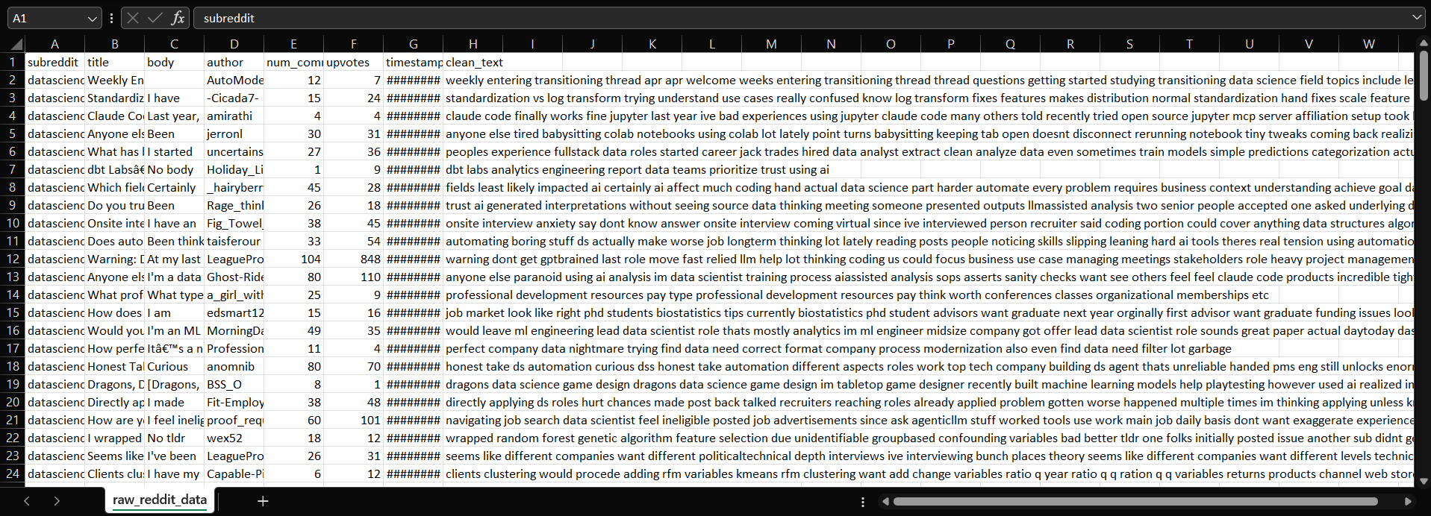

Figure 1 Raw Reddit data preview

Part 2: Text Cleaning & Preprocessing (3 Marks)

Python function for preprocessing
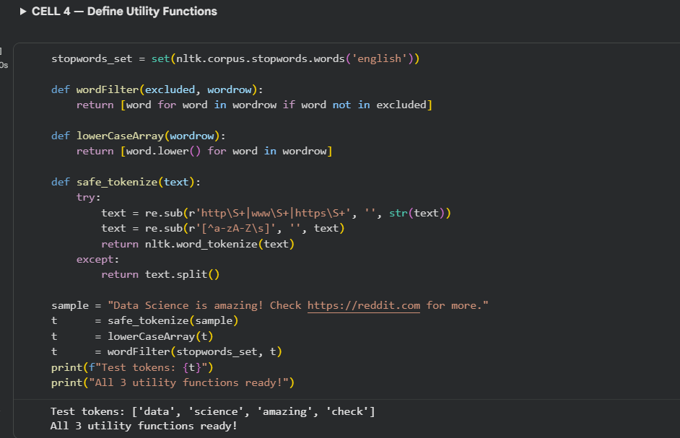

Before/after comparison table for at least 5 samples
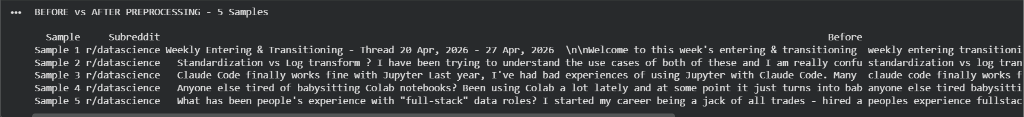

Figure 2 Preprocessed Text Samples

Part 3: Post Classification (5 Marks)

Classification code
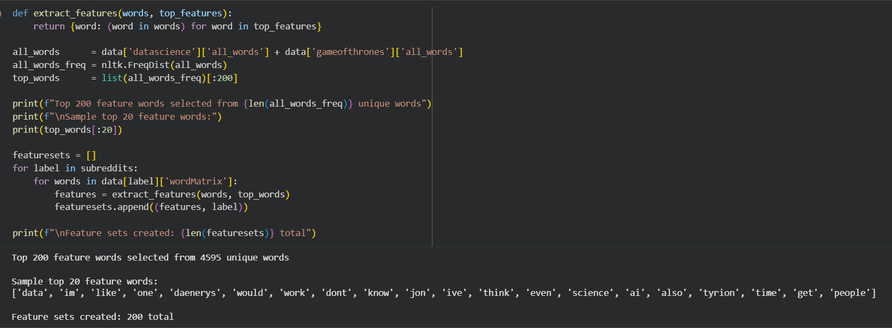

Confusion matrix or accuracy score
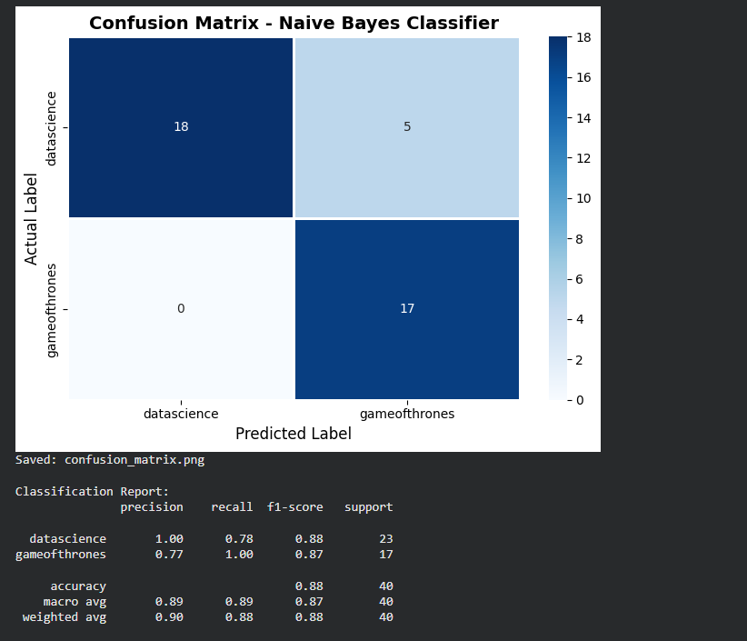

Final classified dataset (CSV)
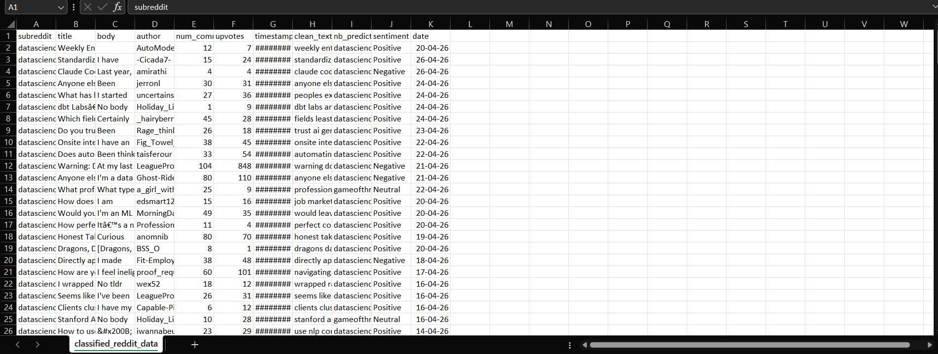
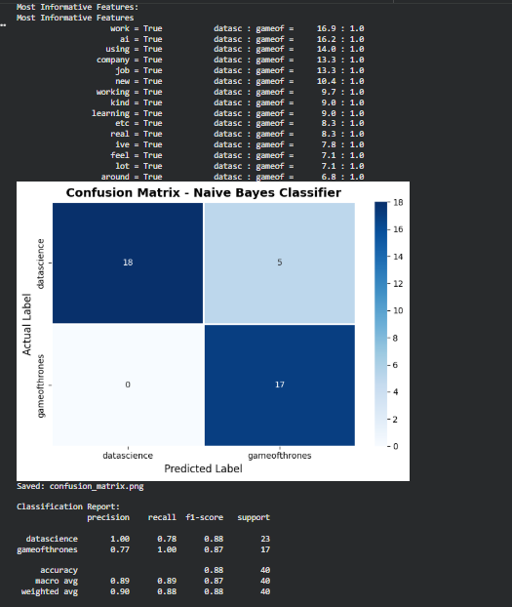

Figure 3 Classification results

Part 4: Power BI Dashboard Integration (6 Marks)

Screenshots of the dashboard
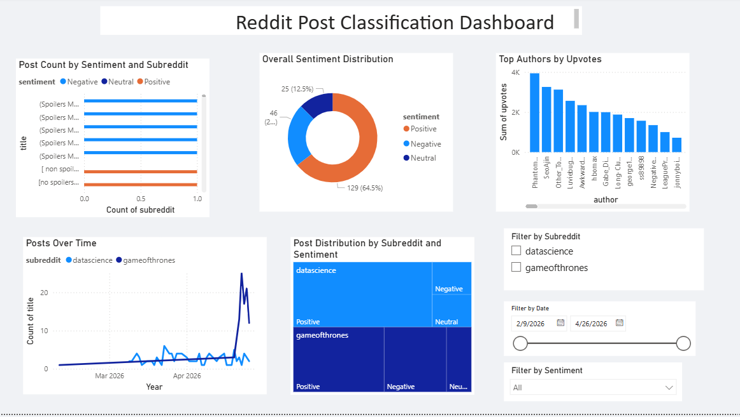

Explanation of each visual
- Bar Chart (Post Count by Sentiment and Subreddit):
- This shows how many posts are happy, sad or neutral in each subreddit.
- Line Chart (Posts Over Time):
- This shows on which dates more or less posts were made.
- Donut Chart (Overall Sentiment Distribution):
- This shows out of all posts how many percent are positive negative or neutral.
- Treemap (Post Distribution by Subreddit and Sentiment):
- This shows both subreddits in boxes where the bigger the box the more posts it has.
SLICERS:
- Column Chart (Top Authors by Upvotes):
- This shows which users got the most likes on their posts.
- Filter by Subreddit:
- Click this to see data of only one subreddit at a time.
- Filter by Date:
- Click this to see posts from a specific time period only.
- Filter by Sentiment:
- Click this to see only positive or only negative or only neutral posts.

Figure 4 Reddit Post Classification Dashboard

Part 5: Report & Reflection

Steps taken from API to Cleaning to Classification to Visualization:
I first connected to Reddit using the PRAW library and fetched 100 posts from two subreddits named datascience and gameofthrones. Each post had a title, body, author, upvotes, comments and time-stamp. Then I cleaned the text, removing links, punctuation and common words like “the” and “is.” I split each post into individual words after cleaning and converted all of them to lower case. Then I used VADER to check if each post is positive, negative or neutral. I also trained a Naive Bayes model on the most common 200 words to predict what subreddit a post would belong to. Finally I loaded the data into Power BI and built charts to show the outcomes

Tools and Libraries Used:
All the code was written in Python. Used PRAW to scrape the posts and connect to reddit. The text was cleaned and stopwords were removed using NLTK. The sentiment of each post was determined using VADER from NLTK . Classifying posts into subreddits using Naive Bayes from NLTK. Pandas was used to save and handle data in tables. Charts were generated in Python using MatplotLib and Seaborn. Finally, the dashboard was developed in Power BI Desktop with interactive visuals and filters.

Challenges Faced During Integration:
The first challenge was setting up the Reddit API as I had to create an app on the Reddit website and get the client id and secret which was confusing at first. The second difficulty was that some posts had empty body text so I had to deal with that by replacing it with No body. Another problem was that VADER did not always produce accurate results for short Reddit titles, as they lack the necessary words to correctly detect sentiment. The fourth challenge was importing the word cloud visual into Power BI as it was not available by default and needed to be installed separately. The fifth challenge was that the majority of the posts were collected on the same date, therefore the time series line chart did not show much variation.

Future Improvements:
I would like to collect posts automatically every hour in the future so the data is always fresh and up to date. I would also like to use a better model like HuggingFace transformers for sentiment which gives more accurate results than VADER. I would also gather data from more subreddits to make the analysis more useful. Another improvement would be creating a live website using Streamlit where anyone can type a subreddit name and see the results immediately. Lastly I would like to be able to publish the Power BI dashboard online so it can be shared with others easily without them having to install Power BI.

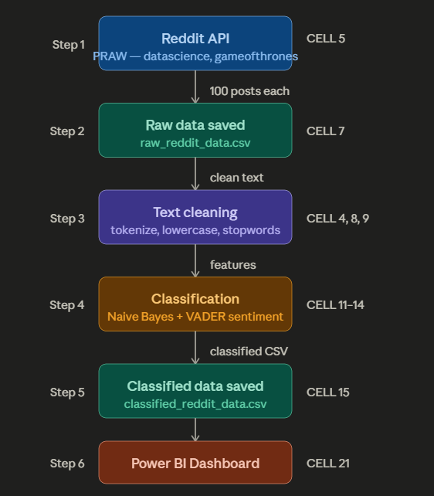

Figure 5 Pipeline overview diagram

