Markov chain and stochastic model

Why This Approach?
- System Complexity
  - The Big-Little architecture has multiple execution phases (I/O → Computation → Storage → Network).
  - Each phase has a different processing rate depending on whether tasks are assigned to the optimal or non-optimal core.
- Need for a Probabilistic Model
  - Tasks can be correctly assigned or misassigned probabilistically (pc = misassignment probability).
  - Markov Chain (CTMC) models how tasks move between different execution states.
- Goal
  - Analyze how misassignment (pc) affects throughput.
  - Find an optimal scheduling strategy that minimizes misassignment and maximizes system performance.
you can estimate the task arrival rate (λ\lambdaλ) using state transitions and steady-state probabilities.
lambda_tasks = (NB + NL) / total_cores
This assumes that tasks arrive at a steady rate (λ) per core.

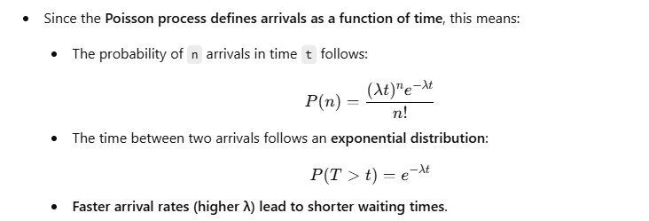
using the Uniform Load Balancing Approach, assuming that tasks arrive randomly and are evenly distributed across all cores.
What Does This Formula Mean?
- NB + NL gives the total number of tasks arriving in the system.
- Dividing by total_cores evenly distributes tasks across all cores.
- The result (lambda_tasks) represents the number of tasks arriving per second per core
The approach used to calculate the task arrival rate (λ) is a combination of both:
- Uniform Load Balancing → Distributes tasks evenly across CPU cores.
- Poisson Arrival Process → Models how tasks arrive over time (randomly distributed).
Uniform Load Balancing (Used to Assign Tasks to Cores)
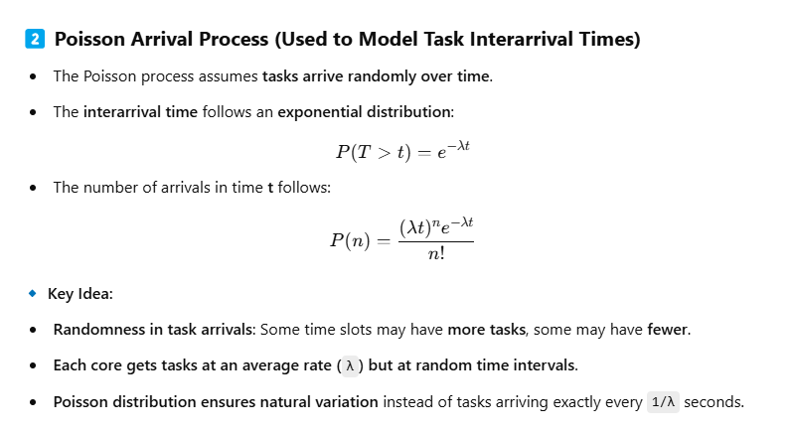 Service time (mean_time) represents how long it takes to process a task.
The service rate (λ) is how many tasks can be processed per second:
Since different core types handle tasks at different speeds, we need to compute separate service rates for correctly assigned and misassigned tasks.
By finding the bottleneck (min() in our code), we determine the true system performance limit.

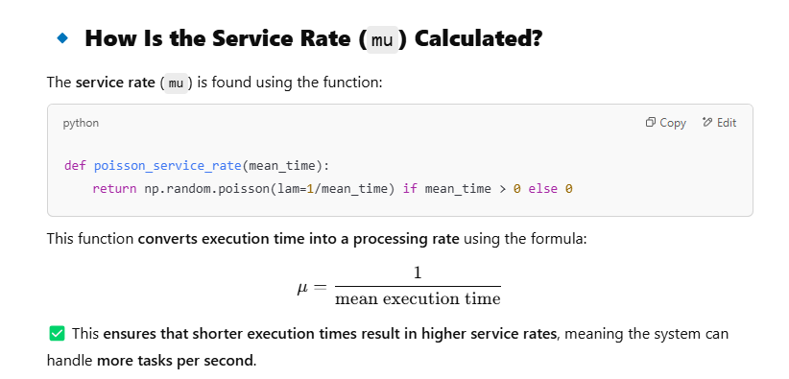

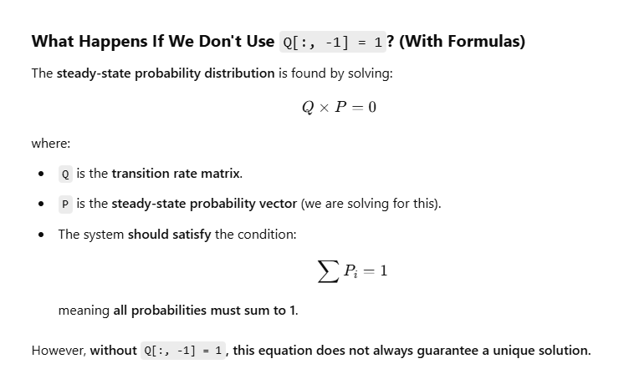

Mmk
The simulation uses two main event types: arrival events (customers entering the queue) and departure events (customers leaving after service).
1. Number of Servers
M/M/1 Queue
- Only one server is available.
M/M/K Queue
- Multiple servers (k servers) available.
In the provided code:
python
CopyEdit
mu_rates = [6, 6, 7] # Different service rates for each server
num_servers = len(mu_rates)

2. Initialization of Departure Times
M/M/1 Queue
- Single departure time initialized to infinity.
python
CopyEdit
departure_time = float('inf')
M/M/K Queue
- List of departure times for each server:
python
CopyEdit
departure_times = [float('inf')] * num_servers

3. Handling of Arrivals
M/M/1 Queue
- If server is idle (queue == 1), service starts immediately.
M/M/K Queue
- Checks for idle servers and picks one server randomly:
python
CopyEdit
idle_servers = [i for i, t in enumerate(departure_times) if t == float('inf')]
if idle_servers:
chosen_server = np.random.choice(idle_servers)
# serve immediately

4. Service Rates
M/M/1 Queue
- Single service rate:
python
CopyEdit
service_time = np.random.exponential(1 / mu_rate)
M/M/K Queue
- Different servers can have different service rates (mu_rates is a list):
python
CopyEdit
service_time = np.random.exponential(1 / mu_rates[chosen_server])

5. Departure Events
M/M/1 Queue
- Single departure event updates one server state only.
M/M/K Queue
- Finds which server finishes first:
python
CopyEdit
next_departure_time = min(departure_times)
departing_server = departure_times.index(next_departure_time)

5. Metrics Calculations
M/M/1 Queue
- Single server utilization calculation:
python
CopyEdit
utilization = server_busy_time / simulation_time
M/M/K Queue
- Calculates utilization for each server separately:
python
CopyEdit
mean_server_utilizations = [busy_time / simulation_time for busy_time in server_busy_times]

6. Throughput Calculation
M/M/1 Queue
- No explicit throughput calculation.
M/M/K Queue
- Explicitly tracks throughput (number of customers served per unit time):
python
CopyEdit
throughput += 1
mean_system_throughput = throughput / simulation_time

6. Complexity of Code
M/M/1 Queue
- Simpler code as it deals with one customer and one server at a time.
M/M/K Queue
- Slightly more complex logic to handle multiple servers simultaneously.
- Checks for the availability of multiple servers and picks an idle one randomly.

Why the Differences Exist?
- In an M/M/1 queue, the scenario is simpler—only one service channel, simplifying arrival/departure handling.
- In an M/M/K queue, multiple servers make things more complex—you must manage multiple independent servers, each potentially idle or busy, with different possible service rates and completion times.

Summary (Key Differences):
Aspect | M/M/1 Queue | M/M/K Queue
Servers | 1 | K (multiple servers)
Departure time | Single value | List of values (one per server)
Idle-server handling | Single check (queue == 1) | Check a list for idle servers
Service rate | Single value for all customers | Can vary per server
Utilization | Single calculation | Per-server calculation
Throughput | Not explicitly calculated | Explicitly calculated

