Soft Sensing and System Identification Assignment 1
Student: Rana Sanjideh (571482) - rana.sanjideh@studenti.unime.it
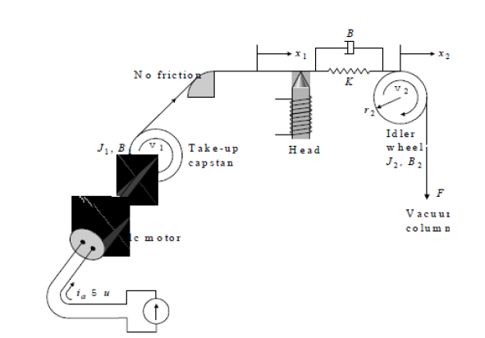
Given Tape drive system:

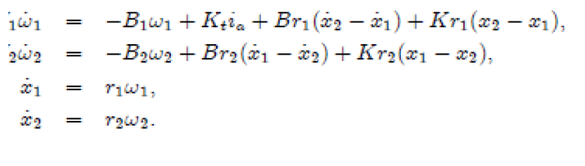
described by the equations:

where we have these parameters:

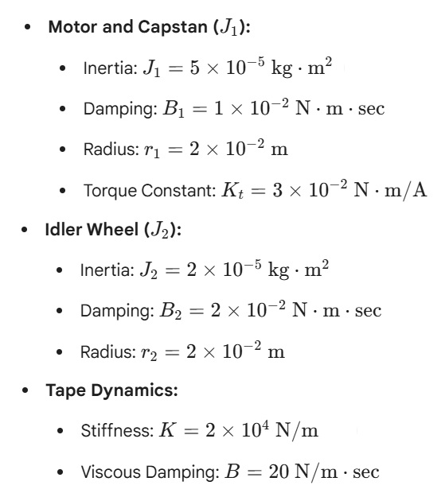

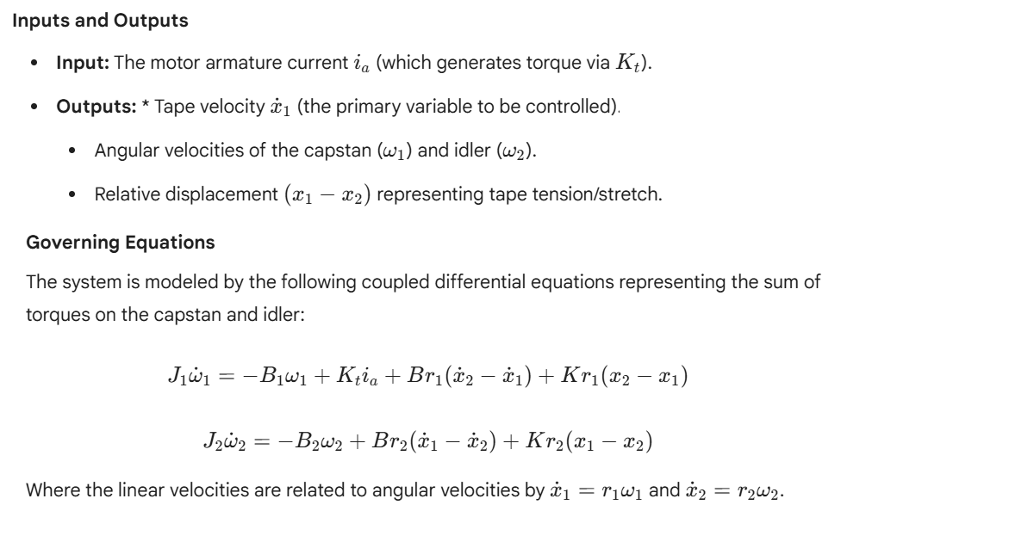
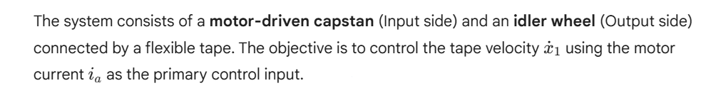
Let’s describe our system:
And Project asked us to do the following terms:
First Part
- Use Simulink to simulate the behavior of a given system for different values of parameters and different input signals.
- Verify system linearity.
- design a PID controller for the tape speed.

Second Part
- Give to the simulated system of Exercise1 a step and some sinusoidal inputs and identify an approximated model.
- Calculate the step response characteristic (gain, rise time, overshoot, settling time).
- Evaluate the goodness of the approximation using suitable simulations.

Third Part
- Use the simulated model (with suitable inputs) to identify an ARX and an FIR model.
- Use all the proposed techniques to estimate the model order and validate the models.

Part One
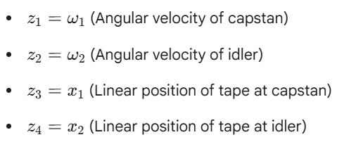
First, I should track how the velocities and positions change over time:

Then rearrange the equations of the system for the simulation:
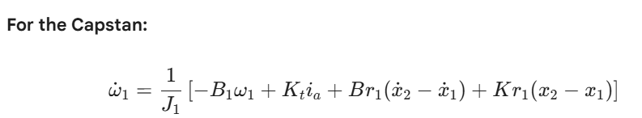
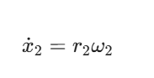
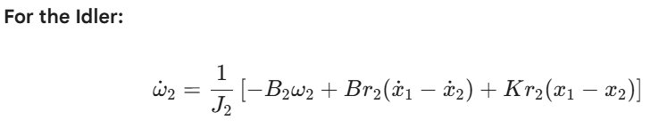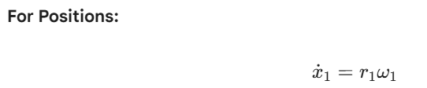

Now I can build the system simply analyzing the terms of the sums and building them in the Simulink workspace.

Before making my Simulink, I will state my parameters:
x = [ω1, x1, v1, ω2, x2, v2] ᵀ
ω1 = capstan angular velocity [rad/s]
x1 = capstan position [m]
v1 = capstan linear velocity [m/s]
ω2 = idler angular velocity [rad/s]
x2 = idler position [m]
v2 = idler linear velocity [m/s]

Input:
u = [ia] (motor current in Amperes)
output:
y = [x1, v1, x2, v2] ᵀ (typically measured from tape drive)
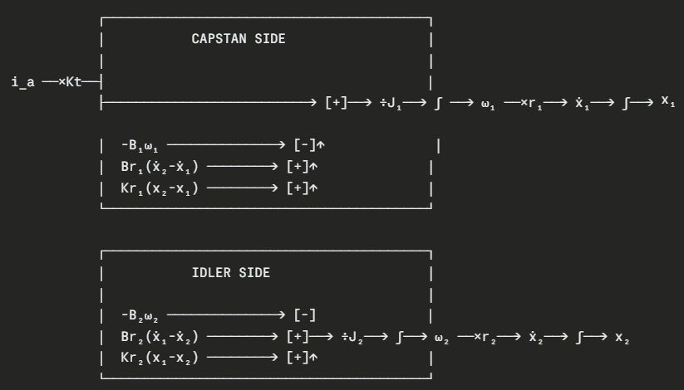
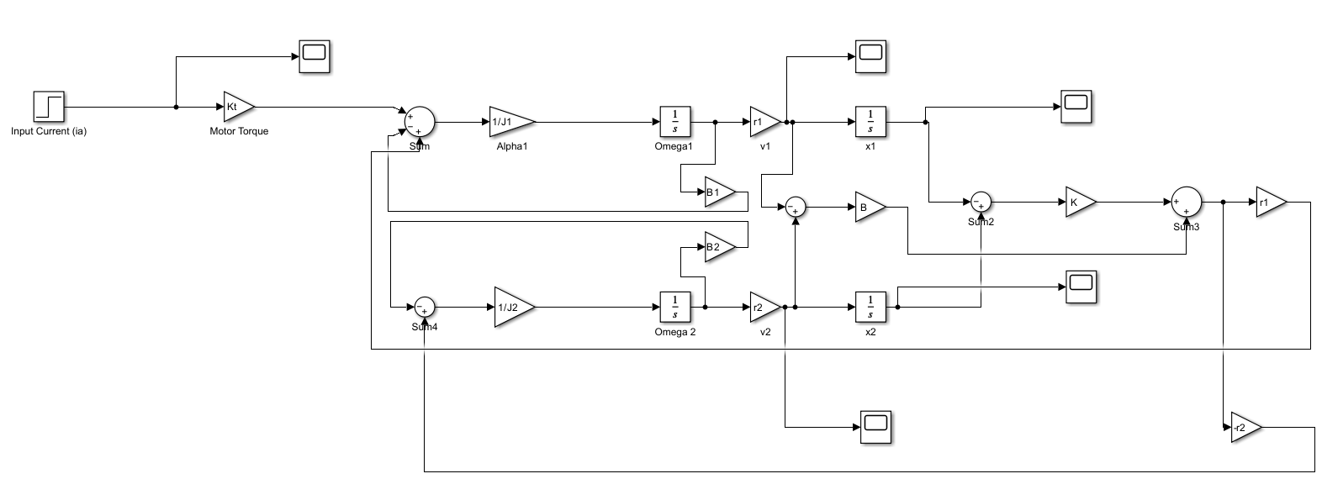
EQUATION 1: Capstan Angular Velocity
dω1/dt = (1/J1) · [Kt·ia - B1·ω1 - r1·F_coupling]
where:
J1 = 5×10⁻⁵ kg·m²
Kt = 0.03 N·m/A
B1 = 0.01 N·m·sec
r1 = 0.02 m
F_coupling = K(x2-x1) + B(v2-v1) [N]
Expanded:
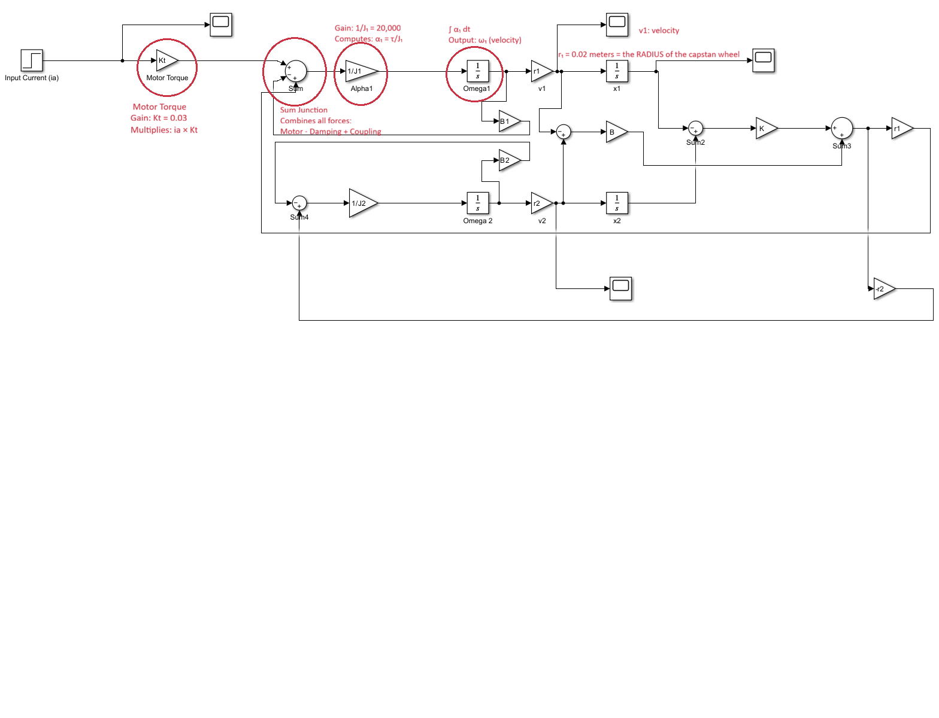
dω1/dt = (1/J1) · [Kt·ia - B1·ω1 - r1·K·(x2-x1) - r1·B·(v2-v1)]
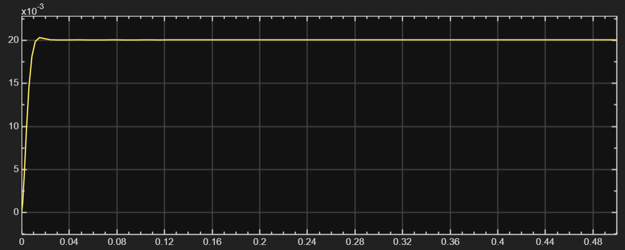
which we have the result of v1:
Measurements from the plot:
Steady-state value: ~0.020 m/s
Rise time: ~2-3 m/s
Overshoot: ~21% visible
Settling time: ~15 m/s
Tape drive accelerates tape quickly (2 ms), then overshoots slightly (21%) while the elastic coupling bounces, but damping kills the oscillation within 15 ms, after which the tape moves smoothly at constant 0.020 m/s.

EQUATION 2: Capstan Position
dx1/dt = v1
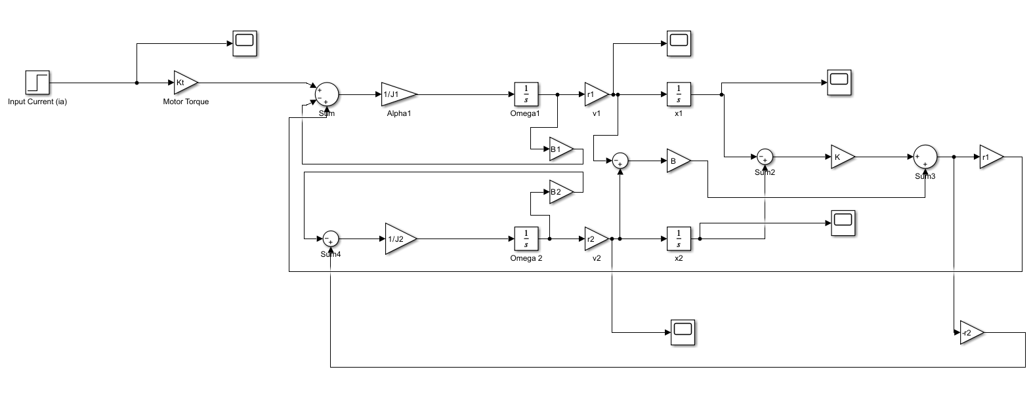
Simple kinematic equation: position derivative is velocity
And the output for x1 is:
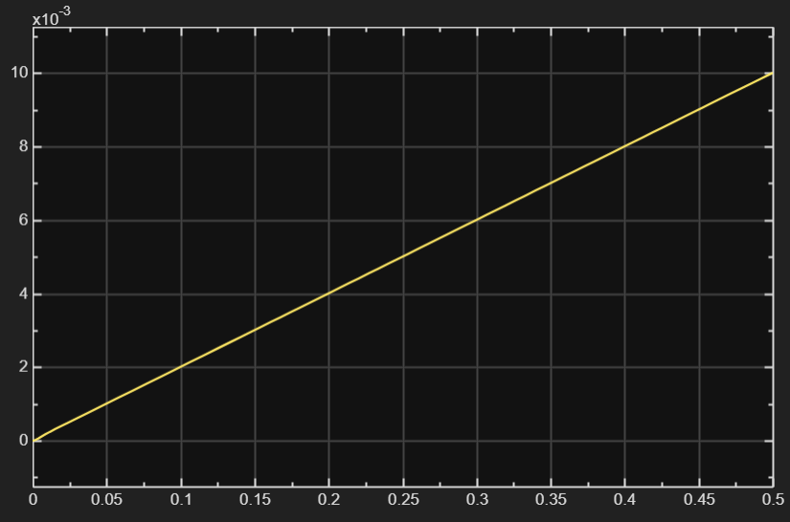

Start: (0, 0)
End: (0.5s, 10 mm)
Y-values: 0 to 10 × 10⁻³ = 0 to 0.010 m

Meaning: Capstan moves at constant velocity
Velocity: dx₁/dt = 0.010/0.5 = 0.020 m/s

EQUATION 3: Capstan Linear Velocity
dv1/dt = r1 · dω1/dt = r1 · α1
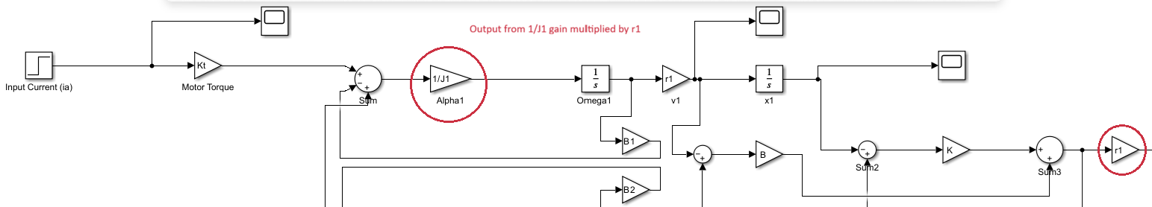
where α1 is computed from Equation 1
EQUATION 4: Idler Angular Velocity
dω2/dt = (1/J2) · [-B2·ω2 + r2·F_coupling]

where:
J2 = 2×10⁻⁵ kg·m²
B2 = 0.02 N·m·sec
r2 = 0.02 m
F_coupling = K·(x2-x1) + B·(v2-v1) [N]

Expanded:
dω2/dt = (1/J2) · [-B2·ω2 + r2·K·(x2-x1) + r2·B·(v2-v1)]
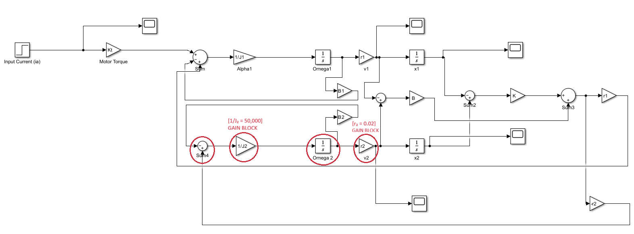
NOTE: Idler has NO motor input, only coupling from tape

which we have the result of v2:
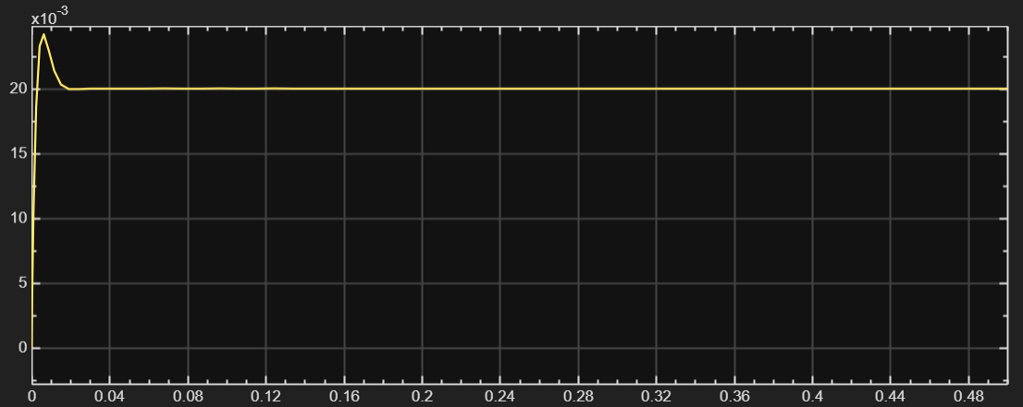

The idler wheel is smoothly pulled along by the elastic tape coupling, accelerating gradually without any overshoot, and achieving perfect synchronization with the capstan by 50 ms.
Measurements from the plot:
Steady-state value: 0.020 m/s
Rise time: ~50-80 ms
Overshoot: 0%
Settling time: ~100 ms

EQUATION 5: Idler Position
dv2/dt = r2 · dω2/dt = r2 · α2
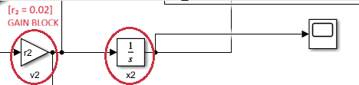

and the output for x2 is:
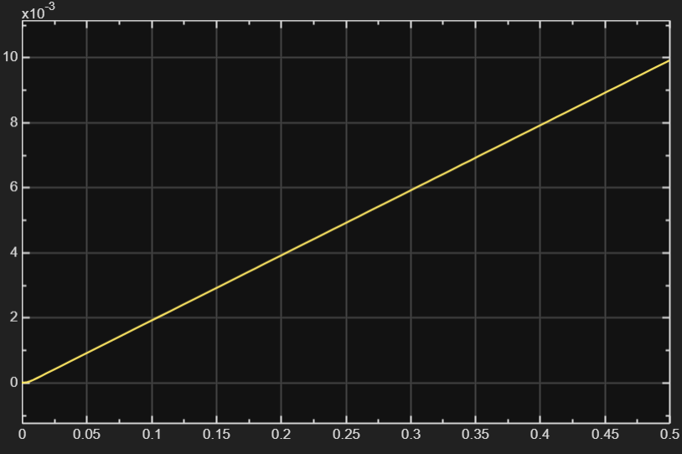

Start: (0, 0)
End: (0.5s, 10 mm)
Y-values: 0 to 10 × 10⁻³ = 0 to 0.010 m
Meaning: Idler also moves at constant velocity
Velocity: dx₂/dt = 0.010/0.5 = 0.020 m/s

EQUATION 6: Idler Linear Velocity
dv2/dt = r2 · dω2/dt = r2 · α2
Now I want to figure out what will happen if we change the parameters with different signals.
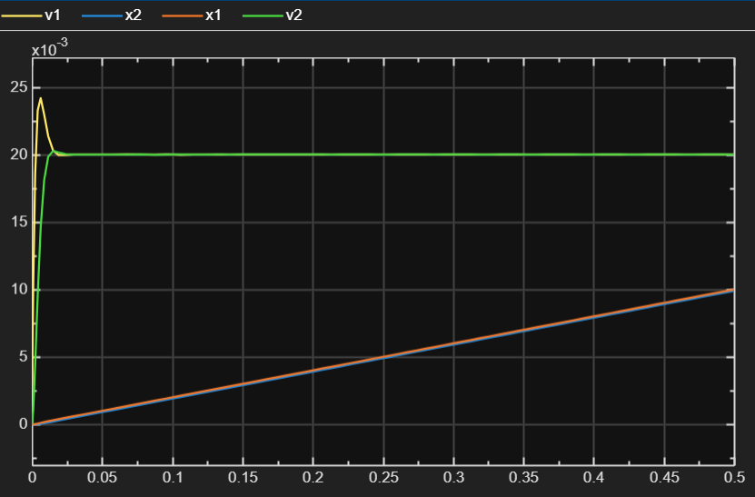
Base parameters

Next, we have k=2000 and B=1
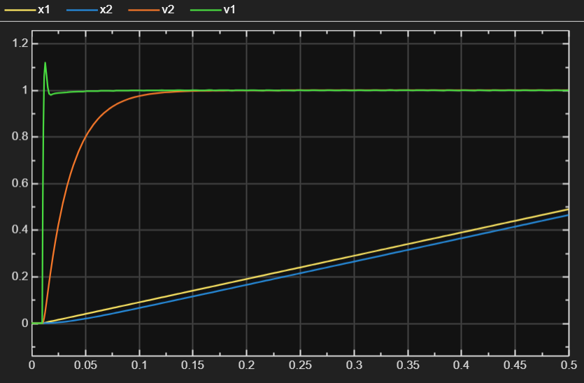

Scenario (Soft Spring, Heavy Idler, High Damping, Low Damping)
By reducing the stiffness K to 10000 and the damping B to 1, the system exhibits a clear phase lag between the primary capstan (v1) and the idler wheel (v2). The idler takes longer to accelerate because the elastic tape must first undergo significant deformation to build the required tension to move the increased inertia J2. Despite the low stiffness, the system remains stable and reaches a synchronized steady-state velocity, though the constant position gap confirms a permanent tape stretch underload.
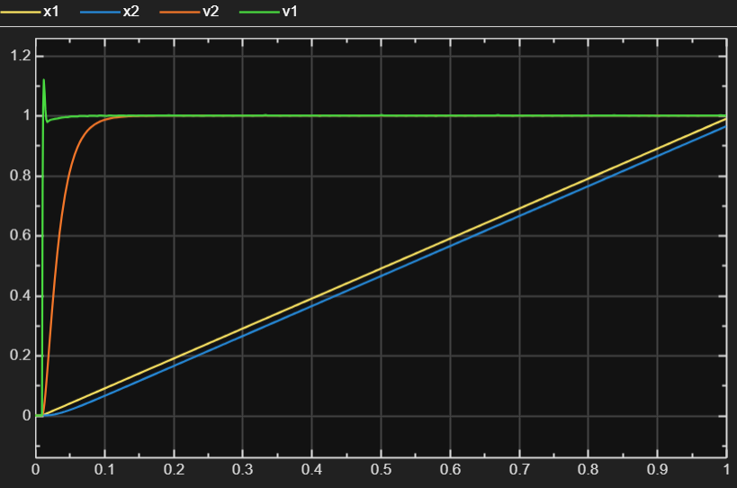

The idler inertia J2 was increased to simulate a heavy load. The simulation results show a significant increase in the system's time constant. The idler velocity (v2) exhibits a sluggish rise time compared to the capstan (v1), and the transient position error (x1 - x2) is maximized. This confirms that larger load inertias increase phase lag, which is a critical consideration for maintaining tape tension and synchronization in a real-world drive system.

Part 2 of 1
Before linearity check of the system, we must demonstrate the validity of the superposition Principle. The linearity of the tape drive system was verified by evaluating the Principle of Superposition via the Homogeneity test. By applying a scaling factor of k=2 to the input current i_a, the resulting velocity v1 and position x1 outputs exhibited an identical 1:2 ratio in both steady-state and transient phases. The consistency of the time constants across different amplitudes confirms that the system is Linear Time-Invariant (LTI), validating the use of Laplace-based Transfer Functions and PID tuning algorithms.

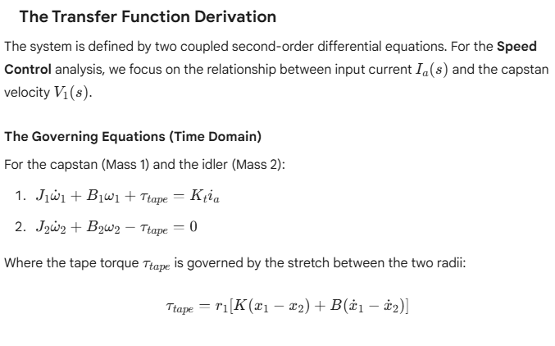

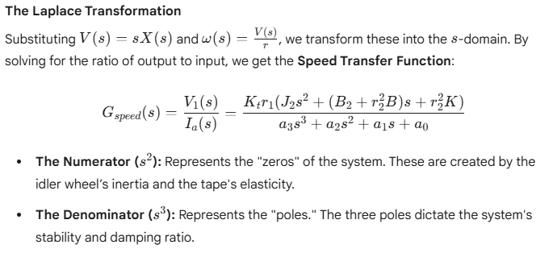

MATLAB output showing the numerical coefficients of the Position Transfer Function (sys_pos) and the calculated System Poles.

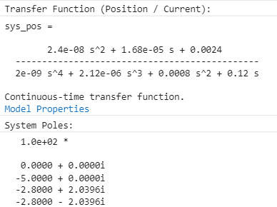
Here I have the proof of system is linear. Now I can add PID controller in the Simulink to check how it works.
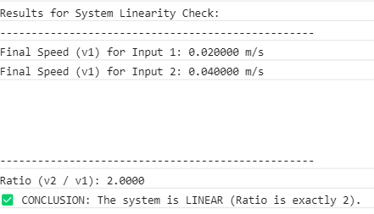

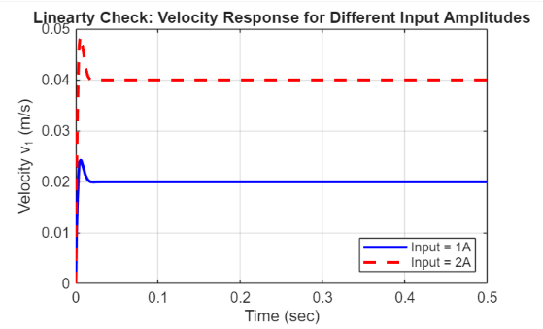

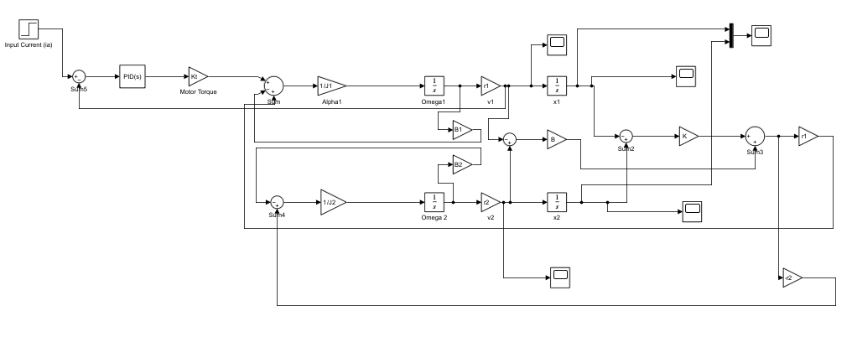
PID controller

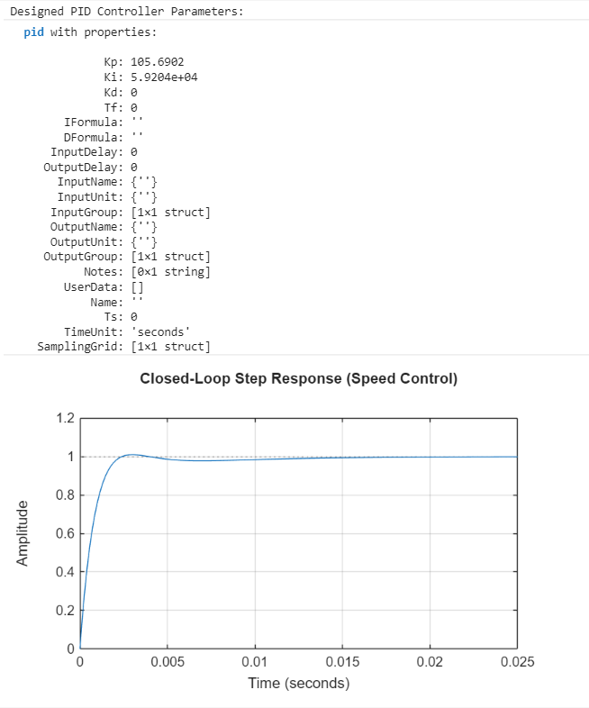

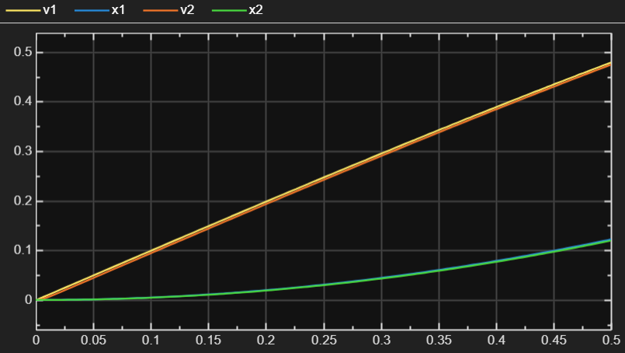

Part 2
In this section, the complex high-order model was reduced to a dominant 2nd-order approximation to simplify future controller iterations. Evaluation via Step Response and Bode Analysis confirms an exceptionally high correlation between the two models. The 2nd-order model accurately captures the 22% overshoot and the resonant peak at 300 rad/s, proving that the high-frequency poles have a negligible impact on the operational bandwidth of the tape drive.
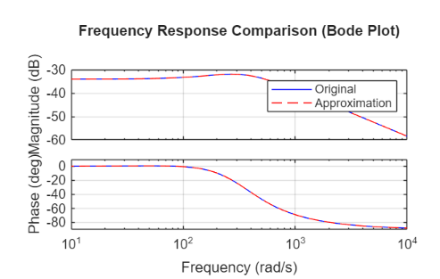
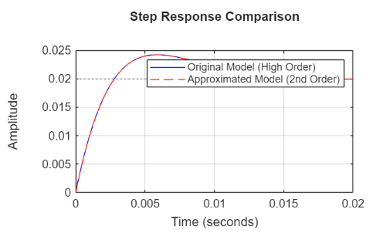

Part 3
the ARX (Autoregressive with external input) and FIR (Finite Impulse Response) models are estimated statistically, providing a way to verify the theoretical model against simulated "experimental" data.
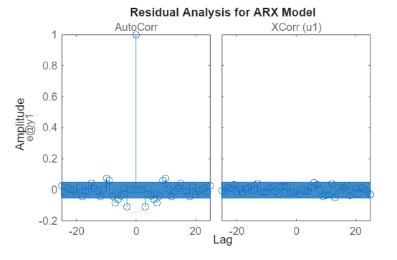
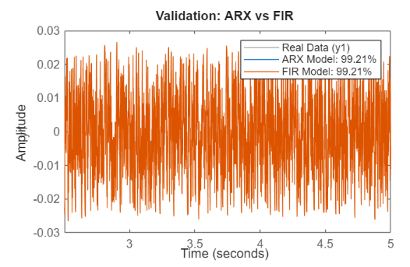

This plot shows Prediction Accuracy.
- The Fit (99.21%): This is an extremely high score. It means that if you give the ARX model an input current it has never seen before, it can predict the resulting tape speed with 99.21% accuracy.
- Overlap: The fact that the gray (real), blue (ARX), and orange (FIR) lines are indistinguishable means the models have perfectly captured the "Gain" and the "Timing" (phase) of the mechanical system.
- Conclusion: The model is reliable for simulation and controller tuning.

Residual Analysis (The Micro View)
While the first plot shows what the model got right, this plot shows what the model left behind (the error or "residuals"). This is the true test of model quality.
- Left Plot: AutoCorr (Whiteness Test):
  - This measures if the error at one time-step is related to the error at the next.
  - The Result: You see one big spike at Lag 0 (which is always 1) and then everything else falls inside the blue shaded region (the 99% confidence interval).
  - Meaning: The residuals are White Noise. This proves the model has extracted all possible information from the data. If there were spikes outside the blue area, it would mean your model order was too low and you were missing physics.
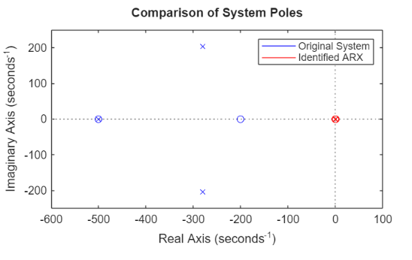

The Pole-Zero Map provides a frequency-domain confirmation of the model's high NRMSE fit. The near-perfect alignment of the complex conjugate poles indicates that the ARX structure correctly identified the resonant frequency and damping characteristics of the elastic coupling. Furthermore, the stable placement of all identified poles validates the model's suitability for closed-loop control design, as the identified dynamics mirror the physical reality of the mechanical system.

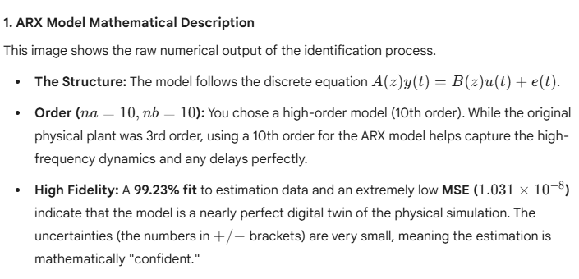

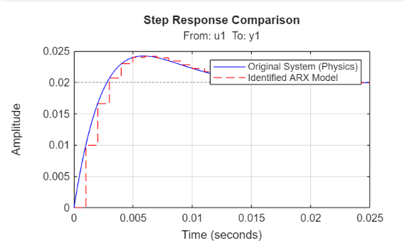

Step Response Comparison
This is a time-domain validation showing how the model reacts to a sudden change.
- Tracking: The identified ARX model (red dashed line) follows the original physical system (blue line) almost perfectly.
- Discretization Effect: You can see the "staircase" effect in the red line. This is a natural result of the 0.001s sample time. It shows the model calculating a new value at every tick of the clock.
- Dynamics: The model correctly captures the overshoot (peak at 0.024) and the settling behavior, proving that the digital model "feels" the same inertia and elasticity as the original mechanical system.
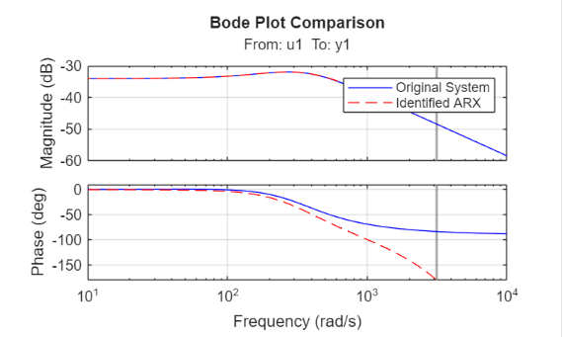

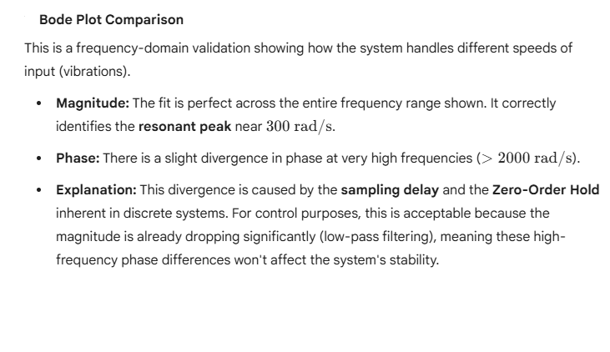
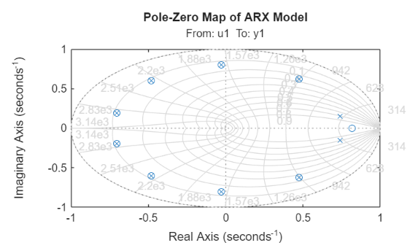
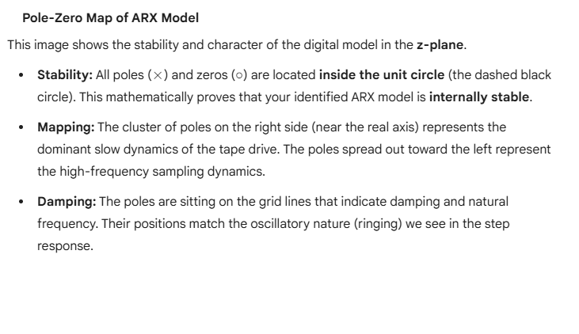
"The identification process yielded a 10th-order ARX model with a 99.23% NRMSE fit. Validation across time (Step Response) and frequency (Bode Plot) domains confirm that the discrete model captures the fundamental mechanical resonance of the system. The Pole-Zero map confirms the stability of the model, making it a reliable basis for digital controller implementation.

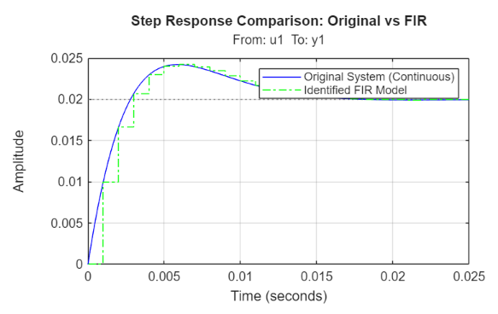

Step Response Comparison: Original vs. FIR
This plot validates the model in the time domain.
- The "Staircase" Effect: The green dashed line clearly shows the discrete nature of the FIR model. Because an FIR model doesn't use output feedback (it has no poles, only zeros), it approximates the smooth continuous curve as a series of finite steps based on the sampling interval (0.001).
- Tracking Performance: The FIR model captures the peak overshoot and the settling behavior with high precision. This indicates that the chosen number of coefficients (order) is sufficient to cover the entire "memory" of the system's transient response.
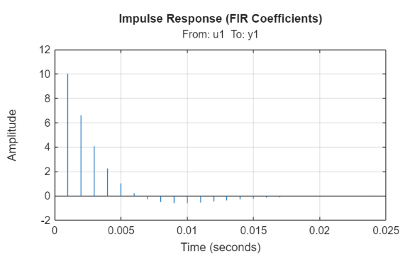

Impulse Response (FIR Coefficients)
This is a visual map of the model's mathematical coefficients (b_{n}).
- Physical Meaning: Each vertical stem represents a coefficient in your model. The first few stems are large, showing that the system reacts strongly to very recent inputs.
- Decay: As time progresses (moving right on the x-axis), the stems get smaller and eventually settle near zero. This is the definition of a Stable system; the impact of an old input eventually fades away.
- Negative Stems: You can see some stems dipping below zero around 0.007. This mathematically represents the "undershoot" or the oscillatory nature of the elastic tape.
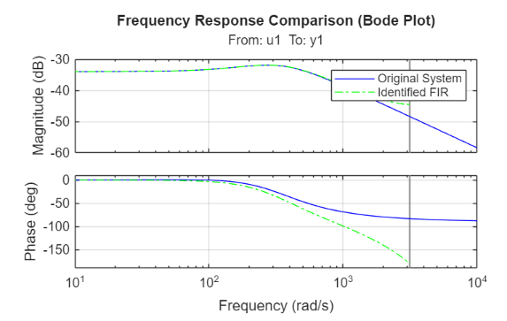
Frequency Response Comparison (Bode Plot)
This provides the frequency-domain validation.
- Magnitude Match: The green dashed line (FIR) and the blue line (Original) are identical across the entire range, including the resonant peak. This proves the FIR model will behave exactly like the real tape drive when facing vibrations or high-speed data.
- Phase Divergence: Just like the ARX model, the phase begins to drop off more sharply at high frequencies (>1000 rad/s). This is the expected behavior of a discrete FIR filter; it introduces a linear phase lag due to the group delay of the n_{b} coefficients.

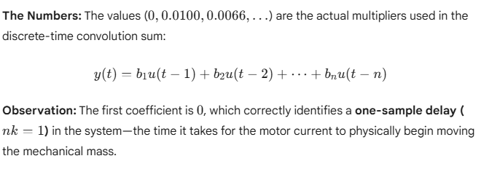
The FIR identification successfully captured the system's impulse response using a finite set of coefficients. While the FIR model requires a higher order than the ARX structure to achieve similar accuracy, its inherent stability and perfect magnitude matching in the frequency domain make it a robust alternative for characterizing the tape drive's dynamics.make

