% ConfigMap & Secret — Lab
Session 6 · CKA Level
•OH
ConfigMap & Secret — Lab
Env Vars · Volume Mounts · Combined Pattern

⏱ 50 minutes Д 100 points 📋 7 tasks ® CKA Level

Lab Rules
- Use kubectl and YAML files only
- Default namespace unless stated otherwise
- Apply the ConfigMap and Secret BEFORE creating any Pod
  - Verify every task with kubectl exec or kubectl logs

% ConfigMap & Secret — Lab
Session 6 · CKA Level
🗂️ Part 1 — ConfigMap
50 pts

1 | Create a ConfigMap — Imperative | Easy ⭐

Create a ConfigMap named app-config using the imperative method — no YAML file needed.

Field | Value
ConfigMap Name | app-config
Key 1 | APP_ENV = production
Key 2 | APP_PORT = 8080
Key 3 | APP_COLOR = blue
Key 4 | MAX_CONNECTIONS = 100
💡 Hint:
kubectl create configmap <name> --from-literal=KEY=value --from-literal=KEY2=value2 You can chain multiple --from-literal flags in one command.

Requirements:

a | Create the ConfigMap using --from-literal for all 4 keys

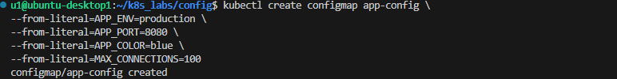

b | Run kubectl describe configmap app-config and confirm all 4 keys appear

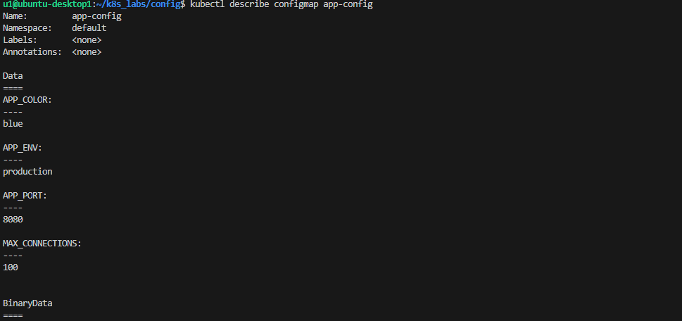

c | Run kubectl get configmap app-config -o yaml — what does the output look like?

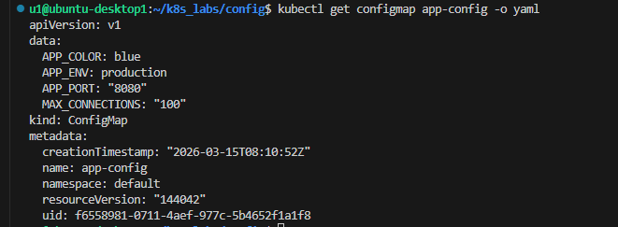

d | What is the difference between a ConfigMap and a regular variable you hardcode in a Pod?
✅ Verify with:
kubectl get configmap
kubectl describe configmap app-config kubectl get configmap app-config -o yaml
✍️ConfigMap allows separating configuration from the application code or Pod specification.
Instead of hardcoding values inside the Pod YAML, we reused by multiple Pods store them in a ConfigMap so they can be updated independently and

2 | Inject ConfigMap as Environment Variables | Easy ⭐

Create a Pod that injects all keys from the ConfigMap as environment variables using envFrom.

Field | Value

% ConfigMap & Secret — Lab
Session 6 · CKA Level

File to apply | 02-configmap-as-envvars.yaml
Pod Name | env-pod
Image | busybox
Injection method | envFrom → configMapRef: app-config
Command | env && sleep 3600

Requirements:

a | Apply 02-configmap-as-envvars.yaml

b | Run kubectl logs env-pod and find the 4 ConfigMap keys in the output
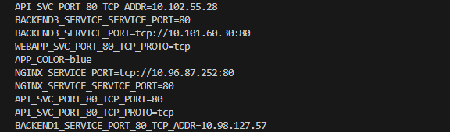

c | Run kubectl exec -it env-pod -- env | grep APP — what do you see?

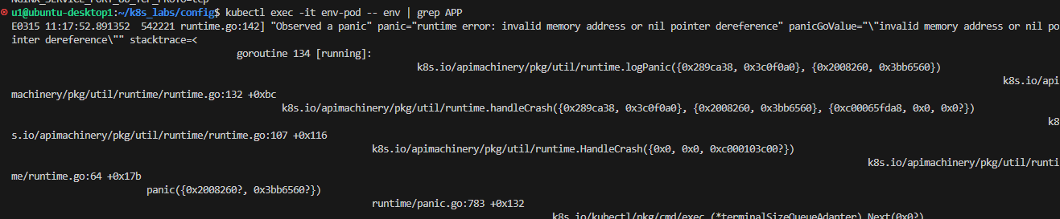

d | Explain: what does envFrom do differently than writing each env: key manually?
✍️ What did you see from grep APP?
The APP variables from the ConfigMap appeared as environment variables inside the containe
Difference between envFrom and individual env: keys:
envFrom imports all keys from a ConfigMap as environment variables automatically, while env requires defining each variable individually
✅ Verify with:
kubectl logs env-pod
kubectl exec -it env-pod -- env | grep APP
kubectl exec -it env-pod -- env | grep MAX

3 | Inject Specific Keys with Custom Names | Medium ⭐⭐

Create a Pod that injects specific keys from the ConfigMap with custom variable names inside the container.

Field | Value
File to apply | 03-configmap-selective-env.yaml
Pod Name | selective-pod
Image | busybox
Env var name | COLOR ← from APP_COLOR
Env var name | PORT ← from APP_PORT
📌 Note: The variable name inside the container can be different from the ConfigMap key name.

Requirements:

% ConfigMap & Secret — Lab
Session 6 · CKA Level
a | Apply 03-configmap-selective-env.yaml

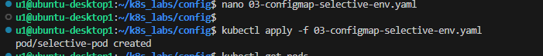

b | Check logs — the pod prints Color=blue and Port=8080

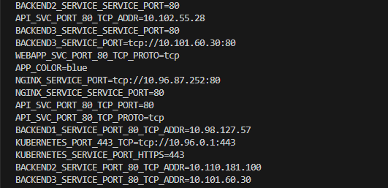

c | Run kubectl exec -it selective-pod -- env — is MAX_CONNECTIONS visible? Why not?
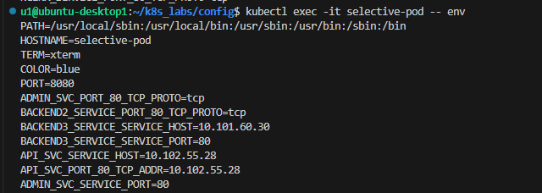
No, because only the specific keys defined in the env section are injected into the container

d | When would you use selective injection instead of envFrom?
Selective injection is used when the container needs only specific configuration values instead of importing the entire ConfigMap
✅ Verify with:
kubectl logs selective-pod
kubectl exec -it selective-pod -- env
✍️ Is MAX_CONNECTIONS visible? Why not? When to use selective injection instead of envFrom:

% ConfigMap & Secret — Lab
Session 6 · CKA Level
🔐 Part 2 — Secret
30 pts

4 | Create a Secret and Inspect It | Easy ⭐

Create a Secret named db-secret to store database credentials.

Field | Value
Secret Name | db-secret
Type | Opaque (generic)
Key 1 | DB_USER = admin
Key 2 | DB_PASSWORD = p@ssw0rd123
Key 3 | DB_NAME = myapp
💡 Hint:
Use the imperative method — kubectl handles base64 encoding for you: kubectl create secret generic <name> --from-literal=KEY=value

If using YAML (05-secret-basic.yaml), values must be pre-encoded: echo -n "admin" | base64 → YWRtaW4=

Requirements:

a | Create the Secret using the imperative method

b | Run kubectl describe secret db-secret — are the values visible?

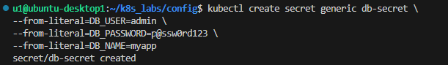

c | Run kubectl get secret db-secret -o yaml — how are the values stored?

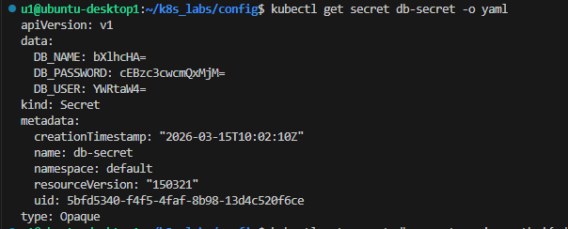

d | Decode DB_USER: kubectl get secret db-secret -o jsonpath='{.data.DB_USER}' | base64 -d

e | Explain: why is base64 NOT the same as encryption?
✅ Verify with:
kubectl get secret
kubectl describe secret db-secret kubectl get secret db-secret -o yaml
kubectl get secret db-secret -o jsonpath='{.data.DB_USER}' | base64 -d
✍️ How are values stored in the Secret YAML? Why
is base64 NOT encryption?

- Values are stored in base64 encoded format inside the data field

- Base64 is only encoding, not encryption. Anyone can easily decode it back to the original value

Session 6 · CKA Level
% ConfigMap & Secret — Lab

5 | Inject Secret as Environment Variables | Medium ⭐⭐

Create a Pod that injects the db-secret values as environment variables and verify they are decoded automatically.

Field | Value
File to apply | 06-secret-as-envvars.yaml
Pod Name | db-pod
Image | busybox
Injection method | envFrom → secretRef: db-secret
Command | echo User=$DB_USER && echo DB=$DB_NAME && sleep 3600

Requirements:

a | Apply 06-secret-as-envvars.yaml

b | Run kubectl logs db-pod — are the values decoded?

c | Run kubectl describe pod db-pod — can you see the Secret values there?
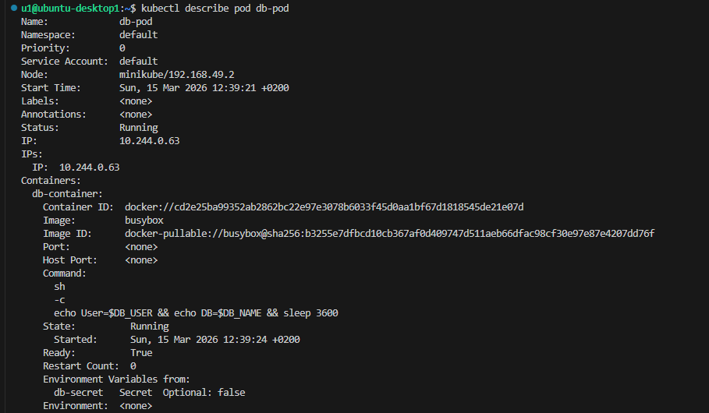
✅ Verify with:
kubectl logs db-pod
kubectl exec -it db-pod -- env | grep DB kubectl describe pod db-pod
✍️ Are values decoded in logs? What did you see?
Are values visible in kubectl describe pod?

1-Yes. The Secret values appear decoded inside the container logs.

2- No. The Secret values are not visible; Kubernetes only shows that the values come from a Secret.

% ConfigMap & Secret — Lab
Session 6 · CKA Level
Part 3 — Combined Pattern
20 pts

6 | Inject ConfigMap + Secret Together | Medium ⭐⭐

Create a Pod that uses both app-config (ConfigMap) and db-secret (Secret) — injecting both into the same container.

Field | Value
File to apply | 08-combined-cm-and-secret.yaml
Pod Name | fullapp-pod
Image | busybox
ConfigMap inject | envFrom → configMapRef: app-config
Secret inject | envFrom → secretRef: db-secret

Requirements:

a | Apply 08-combined-cm-and-secret.yaml

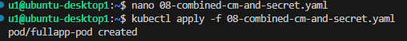

b | Run kubectl logs fullapp-pod — verify both sections print correctly

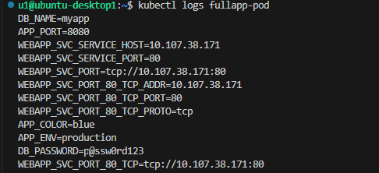

c | Run kubectl exec -it fullapp-pod -- env | sort — count how many env vars come from ConfigMap vs Secret
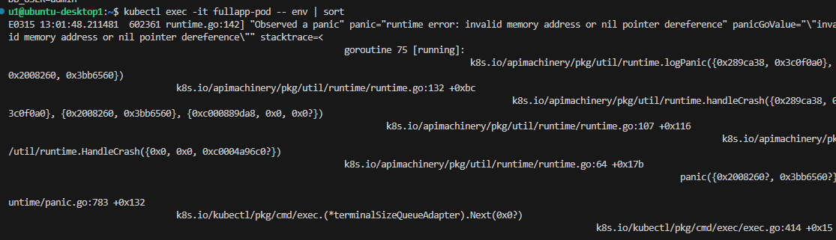

d | Explain: which vars should go in ConfigMap and which in Secret?
ConfigMap vars (non-sensitive)
APP_ENV
APP_PORT
APP_COLOR
MAX_CONNECTIONS

Secret vars (sensitive)

DB_USER
DB_PASSWORD
DB_NAME
7 Deployment with ConfigMap + Secret
Hard ⭐⭐⭐

Apply the Deployment that uses both ConfigMap and Secret. Verify that all 3 pods automatically get the same configuration.

% ConfigMap & Secret — Lab
Session 6 · CKA Level

Field | Value
File to apply | 09-deployment-with-config.yaml
Deployment Name | webapp-configured
Replicas | 3
ConfigMap key used | APP_ENV
Secret keys used | DB_USER, DB_PASSWORD

Requirements:

a | Apply 09-deployment-with-config.yaml

b | Confirm all 3 pods are Running: kubectl get pods -l app=webapp-configured

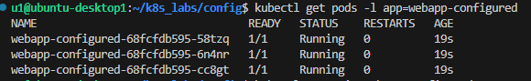

c | Pick any pod and verify it has the env vars: kubectl exec -it <pod> -- env | grep -E 'APP_ENV|DB_USER'

d | Pick a DIFFERENT pod and run the same check — do all pods have the same vars?

e | Explain: what is the advantage of using ConfigMap + Secret with a Deployment vs hardcoding values in the YAML?

Using ConfigMap and Secret allows separating configuration from the application. This makes it easier to update configuration without rebuilding the container image and allows multiple pods to share the same configuration securely.

