**Project Name: Company Network**

* **Abstract** : My project is a **Company Network** that contains the main headquarters.  
  the main headquarters has 4 departments.

# Topology

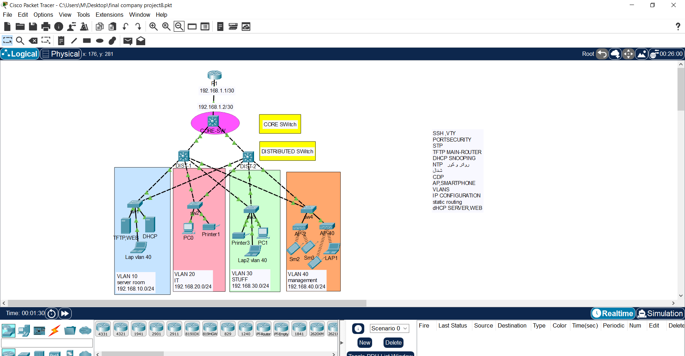

# Addressing Table

|  |  |  |
| --- | --- | --- |
| Device | Interface | IP Address |
| R1 | G0/0 | 192.168.1.1 |
| Core | G1/0/3 | 192.168.1.2 |
| Dist-1 | Connected to core switch |  |
| Dist-2 | Connected to core switch |  |
| SW1 | VLAN 10 ,40 | 192.168.10.0 |
| SW2 | VLAN 20,40 | 192.168.20.0 |
| SW3 | VLAN 30 ,40 | 192.168.30.0 |
| SW4 | VLAN 40 | 192.168.40.0 |
| DHCP Server | VLAN 10 | 192.168.10.5 |
| TFTP , WEBServer | VLAN 10 | 192.168.10.7 |
| Pc0 | Fa0/1 | 192.168.20.11 |
| Pc1 | Fa0/1 | 192.168.30.10 |

# Objectives

1- Configuring Basic configuration

2- Creating VLANs and assigning ports VLAN numbers

3- Subnetting and IP Addressing

4- Configuring Inter-VLAN Routing on the Multilayer switches

5- Configuring a Dedicated DHCP Server device to provide dynamic IP allocation

6- Configuring SSH

7- Configuring Static routing as the routing protocol

8- Configuring Port-Security on the switches

9- Configuring WLAN or wireless network

10- Configuring STP (portfast , Bpduguard)

11-Configuring disable CDP

13- TFTP Server, WEB Server

14- Configuring DHCP Snooping

15- Configuring NTP

**Our team :**

Shrouk Ahmed

Mariam Ashraf

Nada Hosny

Rana Emad

Dina Hany