Linux Commands Practical Report
Objective: To perform and document common Linux commands related to navigation, file management, permissions, and system administration.

Directory Navigation
Commands such as pwd and cd were used to navigate through the Linux file system and verify the current working directory.

File and Directory Management
mkdir, touch, rm, and rmdir were used to create and remove files and directories.

Viewing File Contents
cat and less commands were used to display and search file contents.

Permissions and Ownership
chmod and chown commands were used to modify permissions and ownership of files and directories.

Administrative Operations
sudo and root-level operations were explored to understand privilege management in Linux.
Screenshot 1
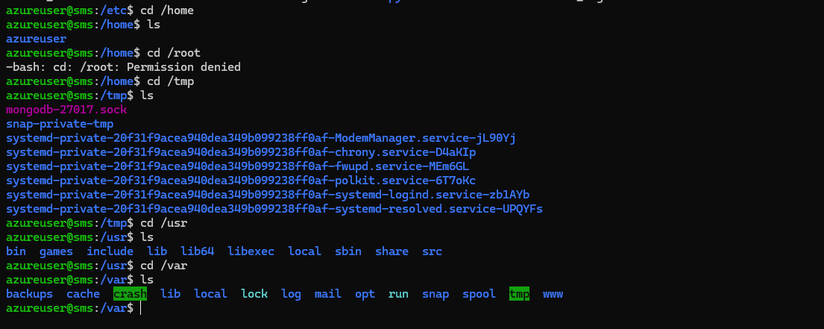
Screenshot 2
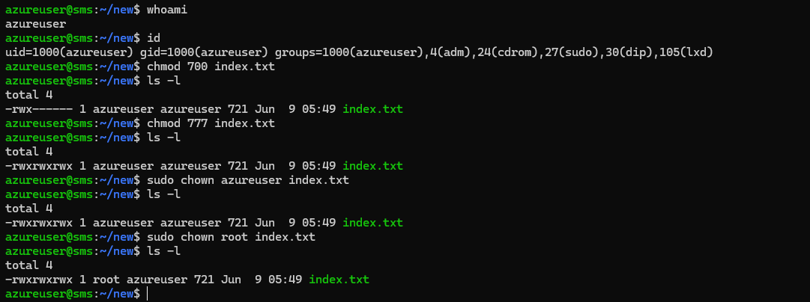
Screenshot 3
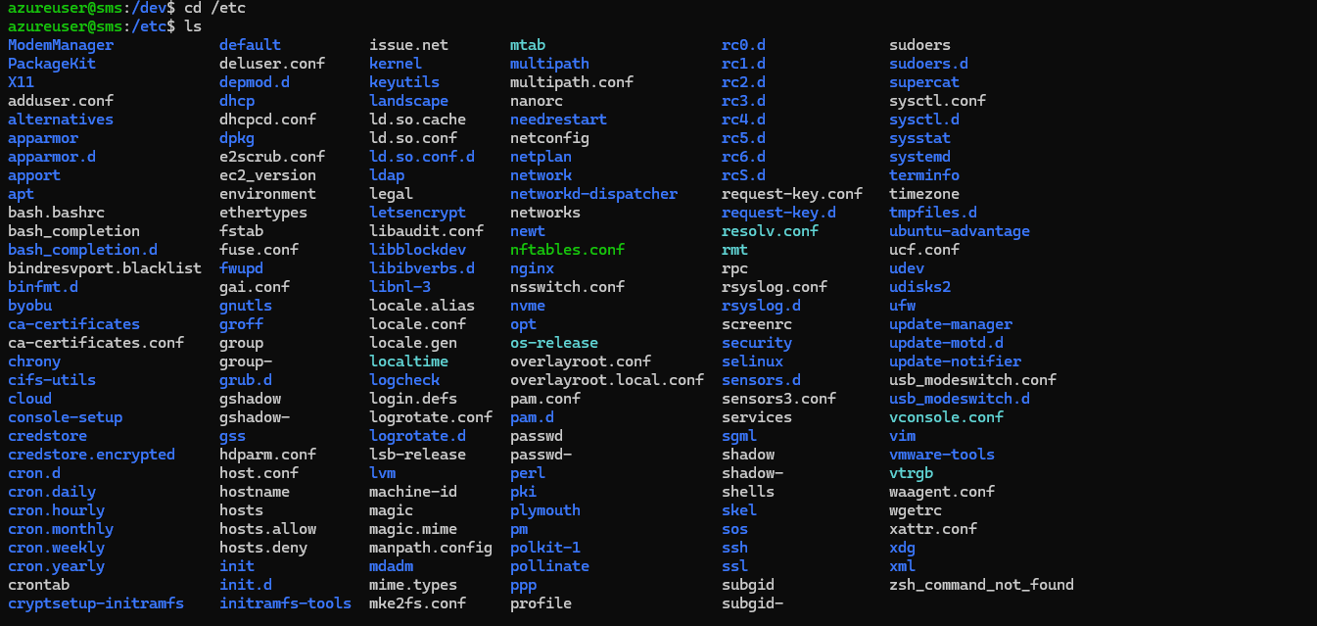
Screenshot 4
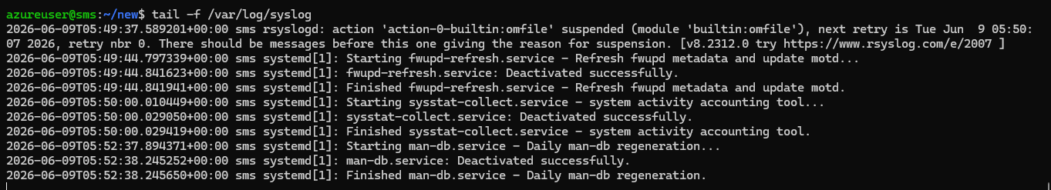
Screenshot 5
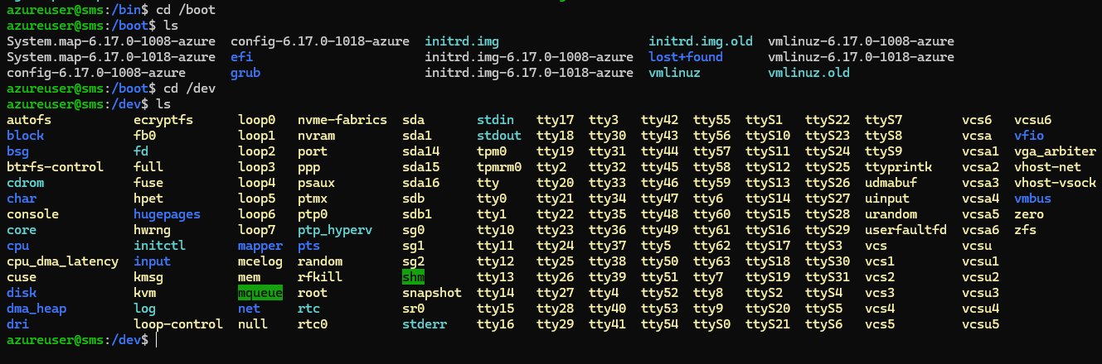
Screenshot 6
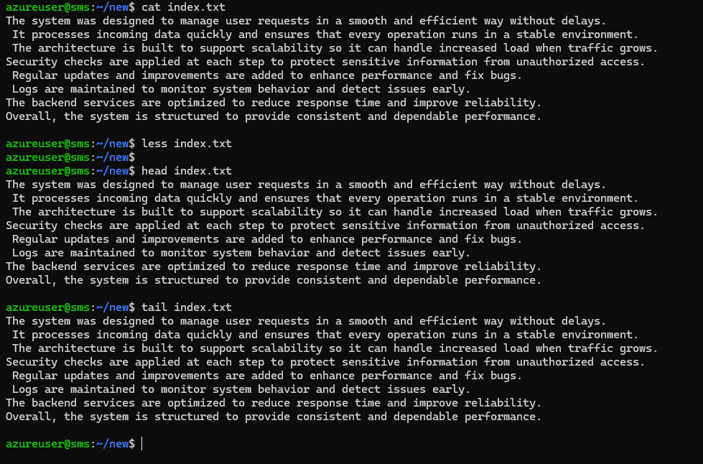
Screenshot 7
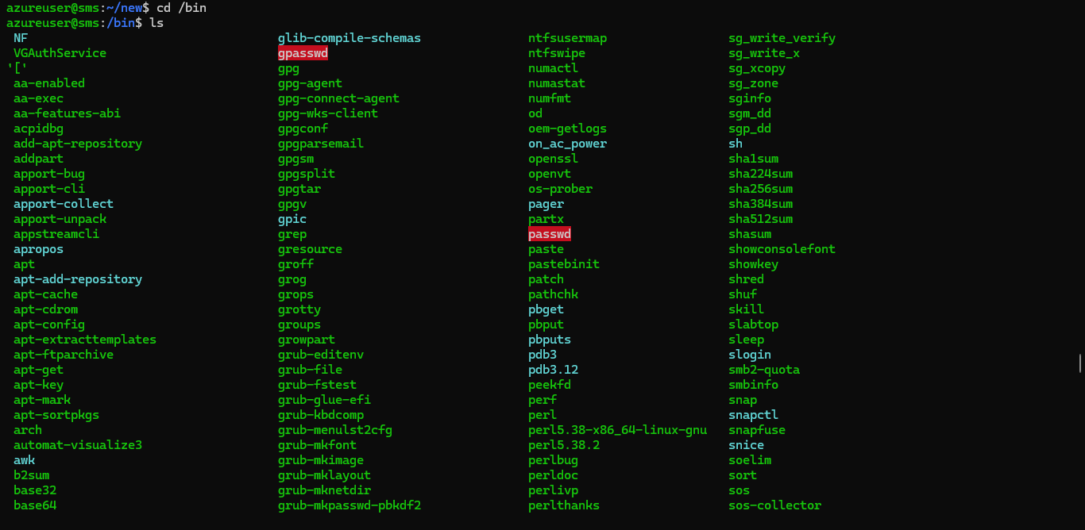
Screenshot 8
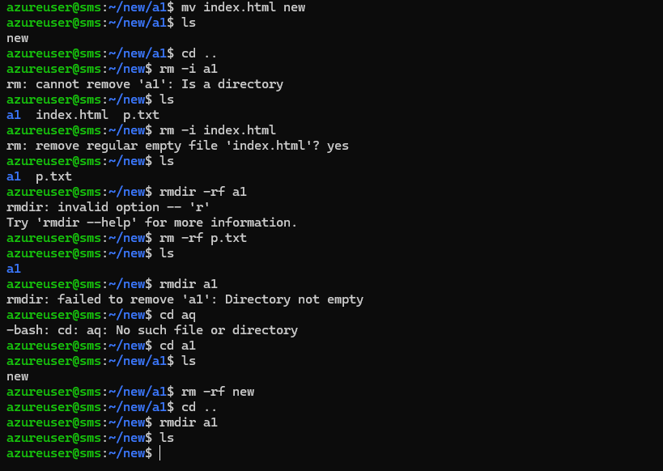
Screenshot 9
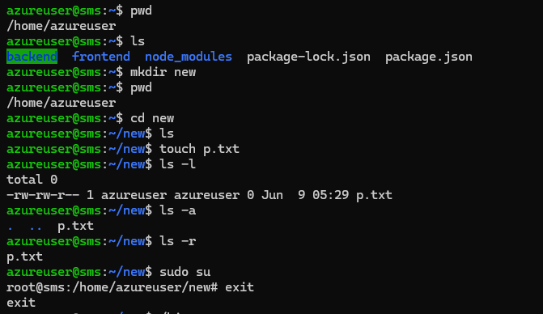
Screenshot 10
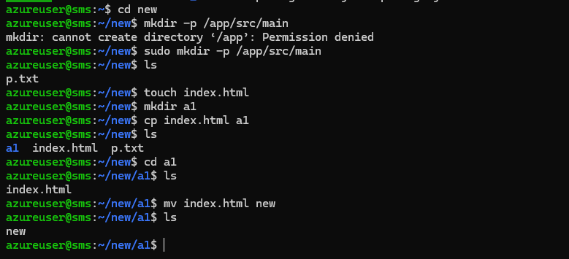

Conclusion
This practical exercise provided hands-on experience with essential Linux commands. The commands demonstrated file system navigation, file management, permissions handling, and basic system administration tasks that are commonly used in Linux environments.

