**Activity 1**

**Code:**

package com.mycompany.lab_05;

import java.util.Scanner;

public class Activity01

{

public static void main (String [] args)

{

int number1= (int) (Math.random()*10);

int number2= (int)(Math.random()*10);

Scanner input= new Scanner(System.in);

System.out.println("What is "+number1+" + "+number2+" ? : ");

int answer=input.nextInt();

while( answer != (number1+number2))

{

System.out.println("Wrong Answer Try again . \n"+"What is "+number1+" + "+number2+" ? : ");

answer=input.nextInt();

}

System.out.println("You got it !");

}

}

**Output:**

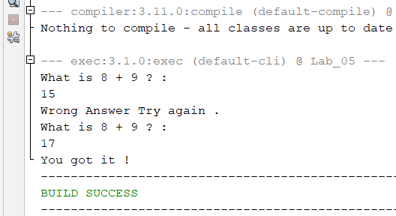

**Activity 2**

**Code:**

package com.mycompany.lab_05;

import java.util.Scanner;

public class Activity2

{

public static void main (String [] args)

{

Scanner input= new Scanner(System.in);

int limit;

int number;

int sum;

int counter;

System.out.print("Enter Number of Integers in list to get Average : ");

limit = input.nextInt();

sum=0;

counter=0;

System.out.print("Enter "+limit+" integers : ");

while(counter < limit)

{

number=input.nextInt();

sum=sum+number;

counter++;

}

if (counter !=0)

{

System.out.printf("The Sum of %d numbers is %d \n",limit,sum);

System.out.print("The Aerage is "+(sum/limit));

}

else

{

System.out.println("NO Input !");

}

}

}

**Output:**

**Activity 3**

**Code:**

package com.mycompany.lab_05;

import java.util.Scanner;

public class Activity3

{

static Scanner input= new Scanner (System.in);

static final int SENTINEL = -999;

public static void main (String [] args )

{

int number;

int sum=0;

int count=0;

System.out.println("Enter positive integers ending with "+SENTINEL);

number= input.nextInt();

while (number != SENTINEL)

{

sum=sum+number;

count++;

number=input.nextInt();

}

if(count !=0)

{

System.out.printf("The sum of %d numbers = %d \n",count,sum);

System.out.println("The average is "+(sum/count));

}

else

{

System.out.println("No Input !");

}

}

}

**Output:**

**Activity 4**

**Code:**

package com.mycompany.lab_05;

import java.util.Scanner;

public class Activity4

{

static Scanner input=new Scanner(System.in);

public static void main (String [] args)

{

int num;

int guess;

boolean done;

num = (int)(Math.random()*100);

done=false;

while (!done)

{

System.out.print("Enter an integer greater than or equall to 0 or less than 100 : ");

guess=input.nextInt();

if(guess==num)

{

System.out.println("You guessed the correct number .");

done= true;

}

else if (guess<num)

{

System.out.println("Your Guess is lower than number \nGuess again !");

}

else if(guess>num)

{

System.out.println("Your Guess is higer than number \nGuess agaun !");

}

}

}

}

**Output:**

**Activity 5**

**Code:**

package com.mycompany.lab_05;

import java.util.Scanner;

public class Activity5

{

public static void main (String [] args)

{

Scanner input= new Scanner (System.in);

int number, sum=0, count;

for(count =1; count<=5; count++)

{

System.out.println("Enter Numner "+count);

number=input.nextInt();

sum+=number;

}

System.out.println("The sum is "+sum);

}

}

**Output:**

**Activity 6**

**Code:**

package com.mycompany.lab_05;

import java.util.Scanner;

public class Activity6

{

public static void main (String [] args)

{

Scanner input= new Scanner (System.in);

int number,max;

System.out.println("Enter Numbers ");

number =input.nextInt();

max=number;

do

{

number=input.nextInt();

if(number>max)

{

max=number;

}

}while(number !=0);

System.out.printf("Max is %d and number is %d",max,number);

}

}

**Output:**

**Activity 7**

**Code:**

package com.mycompany.lab_05;

public class Activity7

{

public static void main (String [] args)

{

System.out.println(" Multiplication Table ");

System.out.println(" ");

for (int j=1 ; j<=9; j++)

{

System.out.print(" "+j);

}

System.out.println("\n_________________________________________");

for (int i=1 ;i<=9; i++)

{

System.out.print(i+"|");

for(int j=1; j<=9;j++)

{

System.out.printf("%4d",i*j);

}

System.out.println("");

}

}

}

**Output:**

**Activity 8**

**Code:**

package com.mycompany.lab_05;

public class Activity8

{

public static void main (String [] args)

{

int sum=0;

int number = 0;

while (number <20)

{

number ++;

sum+=number;

if(sum>=100)

{

break;

}

}

System.out.println("The Number is "+number);

System.out.println("The sum is "+sum);

}

}

**Output:**

**Activity 9**

**Code:**

package com.mycompany.lab_05;

public class Activity9

{

public static void main (String [] args)

{

int sum=0;

int number=0;

while(number<20)

{

number++;

if(number ==10 || number==11)

{

continue;

}

sum+=number;

}

System.out.println("The sum is "+sum);

}

}

**Output:**

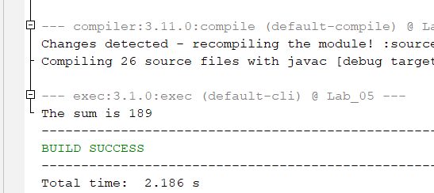

**Task 1(a)**

**Code**

package com.mycompany.lab_05;

import java.util.Scanner;

public class Task1_I

{

public static void main(String[] args)

{

Scanner input= new Scanner(System.in);

System.out.print("Enter Number 1 : ");

int num1=input.nextInt();

System.out.print("Enter Number 2 : ");

int num2=input.nextInt();

if (num1<=num2)

{

for(int i=num1;i<=num2;i++ )

{

System.out.print(i+" ");

}

}

else

{

System.out.println("Wrong Input You hav to Enter Like A<=B");

}

}

}

**Output**

**Task 1(b)**

**Code**

package com.mycompany.lab_05;

import java.util.Scanner;

public class Task1_II

{

public static void main(String[] args)

{

Scanner input= new Scanner(System.in);

System.out.print("Enter Number 1 : ");

int num1=input.nextInt();

System.out.print("Enter Number 2 : ");

int num2=input.nextInt();

if (num1<num2)

{

System.out.println("Ascending Order of Numbers is here");

for(int i=num1;i<=num2;i++ )

{

System.out.print(i+" ");

}

}

else

{

System.out.println("In Descending Order");

for(int i=num1;i>=num2;i--)

{

System.out.print(i+" ");

}

}

}

}

**Output**

**Task 1(c)**

**Code**

package com.mycompany.lab_05;

import java.util.Scanner;

public class Task1_III

{

public static void main(String[] args)

{

Scanner input= new Scanner(System.in);

System.out.print("How Much Number you want to sum ? : ");

int limit= input.nextInt();

int sum=0;

for(int i=1; i<=limit; i++)

{

System.out.println("Enter Number "+i);

int number=input.nextInt();

sum+=number;

}

System.out.println("Your Sum is "+sum);

}

}

**Output**

**Task 1(d)**

**Code**

package com.mycompany.lab_05;

import java.util.Scanner;

public class Task1_IV

{

public static void main(String[] args)

{

Scanner input= new Scanner(System.in);

System.out.println("Enter Number to get sum of cubes ");

int number=input.nextInt();

int sum=0;

for(int i=1; i<=number; i++)

{

int result= (i)*(i)*(i);

sum+=result;

}

System.out.println("Sum of cubes upto this number is "+sum);

}

}

**Output**

**Task 2**

**Code**

package com.mycompany.lab_05;

import java.util.Scanner;

public class Task2

{

public static void main(String[] args)

{

Scanner input = new Scanner(System.in);

System.out.print("Enter Number to get Factoral : ");

int number=input.nextInt();

int result=1;

for(int i=1; i<=number;i++)

{

result=result*i;

}

System.out.println("Your Factorial is "+result);

}

}

**Output**

**Task 3**

**Code**

package com.mycompany.lab_05;

import java.util.Scanner;

public class Task3

{

public static void main(String[] args)

{

Scanner input=new Scanner(System.in);

System.out.print("In how much numbers you want to find 0 numbers : ");

int limit=input.nextInt();

int count=0;

for(int i=1; i<=limit; i++)

{

System.out.print("Enter Number "+i+" : ");

int number=input.nextInt();

if (number==0)

{

count++;

}

}

System.out.println("\nTotal 0 numbers count is "+count);

}

}

**Output**

**Task 4**

**Code**

package com.mycompany.lab_05;

import java.util.Scanner;

public class Task4

{

public static void main(String[] args)

{

Scanner input= new Scanner(System.in);

System.out.print("Enter Length of Sequence : ");

int limit = input.nextInt();

int counter=0;

boolean checker=true;

for (int i=1; i<=limit; i++)

{

System.out.println("Enter Number "+i+" : ");

int number=input.nextInt();

if (number==0)

{

checker=false;

}

if (checker==true)

{

counter++;

}

}

System.out.print("Lngth of sequence where it ends with 0 is "+counter);

}

}

**Output**

**Task 5**

**Code**

package com.mycompany.lab_05;

import java.util.Scanner;

public class Task5

{

public static void main(String[] args)

{

Scanner input= new Scanner(System.in);

int max=0;

int number;

System.out.println("Enter Numbers to Find max number 0 to exit");

do

{

System.out.print("Enter Number : ");

number=input.nextInt();

if (number>max)

{

max=number;

}

}while(number !=0);

System.out.println("Max number is "+max);

}

}

**Output**

**Task 6**

**Code**

package com.mycompany.lab_05;

import java.util.Scanner;

public class Task6

{

public static void main(String[] args)

{

Scanner input= new Scanner(System.in);

int max=0, count=0,number,index=0;

System.out.println("Enter Numbers to find index of max number (0 to exit)");

while(true)

{

System.out.printf("Enter Nmber %d : ",(count+1));

number=input.nextInt();

if (count==0)

{

max=number;

index=1;

}

if (number==0)

{

break;

}

count++;

if (number>max)

{

max=number;

index=count;

}

}

System.out.println("Index of Max number is "+index);

}

}

**Output**

**Task 7**

**Code**

package com.mycompany.lab_05;

import java.util.Scanner;

public class Task7

{

public static void main(String[] args)

{

Scanner input= new Scanner(System.in);

System.out.println("Enter Numbers to Count Even Numbers (0 to exit)");

int count=0;

int num=1;

while (true)

{

System.out.printf("Enter Number %d : ",(num));

int number= input.nextInt();

if (number==0)

{

break;

}

else if (number%2==0)

{

count++;

}

num++;

}

System.out.println("Even Numbers is Sequence are "+count);

}

}

**Output**

**Task 8**

**Code**

package com.mycompany.lab_05;

import java.util.Scanner;

public class Task8

{

public static void main(String[] args)

{

Scanner input= new Scanner(System.in);

int count=1;

int max=0;

int result=0;

while (true)

{

System.out.printf("Enter Number %d : ",count);

int number=input.nextInt();

if (number==0)

{

break;

}

if (count==1)

{

max=number;

}

if (number>max)

{

max=number;

result++;

}

else

{

max=number;

}

count++;

}

System.out.printf("%d numbers are greater than their previous numbers ",result);

}

}

**Output**

**Task 9**

**Code**

package com.mycompany.lab_05;

import java.util.Scanner;

public class Task9

{

public static void main(String[] args)

{

Scanner input= new Scanner(System.in);

int count =0;

while (count<1)

{

System.out.println("Which Pattern Would you like to Print enter any of 1 , 2 , 3 , 4 , 5");

int command=input.nextInt();

System.out.println("Which Pattern Would you like to Prinnt ");

//1

if (command==1)

{

for (int i=1; i<=4;i++)

{

for (int j=1; j<=10; j++)

{

System.out.print("*");

}

System.out.println("");

}

}

//2

else if (command==2)

{

for(int i=1; i<=5; i++)

{

for(int j=1; j<=i;j++)

{

System.out.print("*");

}

System.out.println("");

}

}

//3

else if (command==3)

{

for (int i=1; i<=5; i++)

{ //printing spaces in line

for(int j=5; j>i; j--)

{

System.out.print(" ");

}

//printing stars

for(int k=1;k<=i;k++)

{

System.out.print("*");

}

//changing line

System.out.println("");

}

}

//4

else if (command==4)

{

for (int i=1; i<=5; i++)

{ //printing spaces

for(int j=5; j>i; j--)

{

System.out.print(" ");

}

//printing left triangle

for(int k=1;k<=i;k++)

{

System.out.print("*");

}

//Printing right triangle

for(int l=2; l<=i;l++)

{

System.out.print("*");

}

System.out.println("");

}

}

//5

else if (command==5)

{

for (int i=1; i<=5; i++)

{ //printing spaces

for(int j=5; j>i; j--)

{

System.out.print(" ");

}

//printing left triangle

for(int k=1;k<=i;k++)

{

System.out.print(i);

}

//Printing right triangle

for(int l=2; l<=i;l++)

{

System.out.print(i);

}

System.out.println("");

}

}

else

{

System.out.println("Wrong Command");

}

System.out.println("Would You Like to Print again ? \n1-Yes \n0-Exit");

int print=input.nextInt();

if (print==0)

{

count++;

System.out.println("Thanks");

}

else if (print !=1)

{

System.out.println("Wrong Command");

}

}

}

}

**Output**

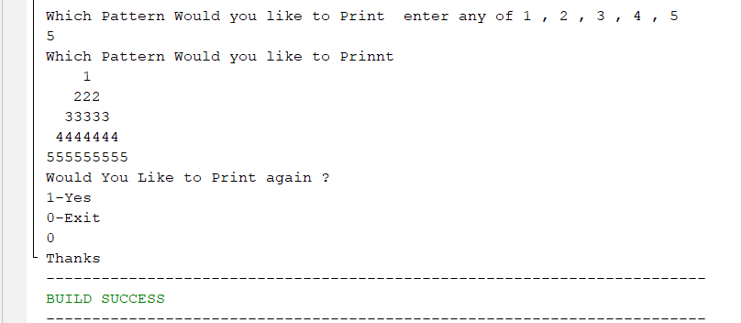

**Task 10**

**Code**

**Output**