

|  |  |
| --- | --- |
| **Name:** | **Ali Haider** |
| **Registration Number:** | **FA23-BSE-014** |
| **Lab** | **09** |
| **Date:** | **01,May,2024** |
| **Instructor:** | **Mr.Muzaffar Iqbal** |

**Lab_09**

**Task 01:**

**Code:**

/*

* Click nbfs://nbhost/SystemFileSystem/Templates/Licenses/license-default.txt to change this license

* Click nbfs://nbhost/SystemFileSystem/Templates/Classes/Class.java to edit this template

*/

package com.mycompany.mavenproject2;

import java.util.Scanner;

public class Task_01

{

public static void main(String[] args)

{

Scanner input=new Scanner(System.in);

int mark=0;

String name="";

while (true)

{

System.out.print("Enter Reg No : ");

int regNo=input.nextInt();

input.nextLine();

if (regNo==0)

{

System.out.println("Exit Done");

break;

}

System.out.print("Enter Name : ");

String new_name=input.nextLine();

System.out.print("Enter Marks : ");

int new_marks=input.nextInt();

input.nextLine();

if (new_marks>mark)

{

mark=new_marks;

name=new_name;

}

}

System.out.printf(" %s has maximum marks %d",name,mark);

}

}

**Output :**

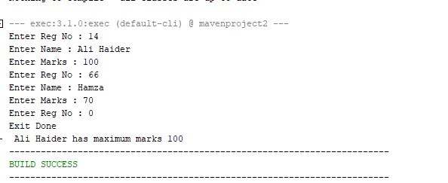

**Task 02:**

**Code:**

/*

* Click nbfs://nbhost/SystemFileSystem/Templates/Licenses/license-default.txt to change this license

* Click nbfs://nbhost/SystemFileSystem/Templates/Classes/Class.java to edit this template

*/

package com.mycompany.mavenproject2;

import java.util.Scanner;

public class Task_02

{

static String lengthLine="";

static int length=0;

static String asciLine="";

static String vowelsLine="";

static int vowels=0;

public static void main(String[] args)

{

Scanner input= new Scanner(System.in);

while (true)

{

System.out.print("Enter String or stop to exit: ");

String line=input.nextLine();

if (line.toLowerCase().equals("stop"))

{

break;

}

else

{

lengthLine=stringByLength(line);

asciLine=stringByAsci(line);

vowelsLine=stringByVowels(line);

}

}

System.out.println(lengthLine);

System.out.println(asciLine);

System.out.println(vowelsLine);

}

public static String stringByLength(String line)

{

int newLength=line.length();

if (newLength>length)

{

length=newLength;

return line;

}

else

{

return lengthLine;

}

}

public static String stringByAsci(String line)

{

if ((line.compareTo(asciLine)>0))

{

return line;

}

else

{

return asciLine;

}

}

public static String stringByVowels(String line)

{

int newLength=line.length();

int vowelsCount=0;

for(int i=0;i<newLength;i++)

{

if ("aeiouAEIOU".indexOf(line.charAt(i)) != -1)

{

vowelsCount++;

}

}

if (vowelsCount>vowels)

{

vowels=vowelsCount;

return line;

}

else

{

return vowelsLine;

}

}

}

**Output :**

**Task 03:**

**Code:**

/*

* Click nbfs://nbhost/SystemFileSystem/Templates/Licenses/license-default.txt to change this license

* Click nbfs://nbhost/SystemFileSystem/Templates/Classes/Class.java to edit this template

*/

package com.mycompany.mavenproject2;

import java.util.Scanner;

public class Task_03

{

static Scanner input= new Scanner(System.in);

public static void main(String[] args)

{

topThreeWeight();

}

public static void topThreeWeight()

{

int firstWeight=0;

int secondWeight=0;

int thirdWeight=0;

while (true)

{

System.out.print("Enter weight or 0 to exit : ");

int weight=input.nextInt();

input.nextLine();

if (weight==0)

{

break;

}

else

{

if (weight>firstWeight)

{

thirdWeight=secondWeight;

secondWeight=firstWeight;

firstWeight=weight;

}

else if (weight>secondWeight)

{

thirdWeight=secondWeight;

secondWeight=weight;

}

else if (weight>thirdWeight)

{

thirdWeight=weight;

}

}

}

System.out.printf("Highest weight is %d Second Highest weight is %d Third Highest weight is %d",firstWeight,secondWeight,thirdWeight);

}

}

**Output :**

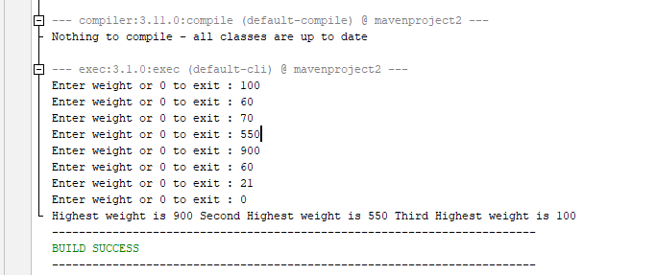

**Task 04:**

**Code:**

/*

* Click nbfs://nbhost/SystemFileSystem/Templates/Licenses/license-default.txt to change this license

* Click nbfs://nbhost/SystemFileSystem/Templates/Classes/Class.java to edit this template

*/

package com.mycompany.mavenproject2;

import java.util.Scanner;

public class Task_04

{

static Scanner input=new Scanner(System.in);

public static void main (String [] args)

{

System.out.print("Enter word 1 of length 5 : ");

String wordOne=input.next();

input.nextLine();

System.out.print("Enter word 2 of length 5 : ");

String wordTwo=input.next();

input.nextLine();

boolean status =anagramFinder(wordOne, wordTwo);

if (status==true)

{

System.out.println("Words are anagrams");

}

else

{

System.out.println("Words are not anagrams");

}

}

public static boolean anagramFinder(String wordOne,String wordTwo)

{

for (int i=0;i<=4;i++)

{

if (wordOne.indexOf(wordTwo.charAt(i))==-1)

{

return false;

}

if (wordTwo.indexOf(wordOne.charAt(i))==-1)

{

return false;

}

}

return true;

}

}

**Output :**

**Task 05:**

**Code:**

/*

* Click nbfs://nbhost/SystemFileSystem/Templates/Licenses/license-default.txt to change this license

* Click nbfs://nbhost/SystemFileSystem/Templates/Classes/Class.java to edit this template

*/

package com.mycompany.mavenproject2;

import java.util.Scanner;

public class Task_05

{

static Scanner input= new Scanner(System.in);

public static void main(String[] args)

{

areaCalculator();

}

public static void areaCalculator()

{

System.out.println("Enter 1 for Area of Circle : ");

System.out.println("Enter 2 for Area of Triangle : ");

System.out.println("Enter 3 for Area of Rectangle : ");

System.out.println("Enter 0 to exit: ");

int command=input.nextInt();

input.nextLine();

if (command==0)

{

}

else if (command==1)

{

System.out.println("Enter radius of circle");

double radius=input.nextInt();

input.nextLine();

System.out.println("Area is ");

System.out.println(area(radius));

System.out.println("Enter 0 for main menu -1 for exit ");

int decision=input.nextInt();

input.nextLine();

if (decision==0)

{

areaCalculator();

}

}

else if (command==2)

{

System.out.println("Enter Base of Triangle");

double base=input.nextDouble();

input.nextLine();

System.out.println("Enter Height of Triangle");

double height=input.nextDouble();

input.nextLine();

System.out.println("Area is ");

System.out.println(area(base,height));

System.out.println("Enter 0 for main menu -1 for exit ");

int decision=input.nextInt();

input.nextLine();

if (decision==0)

{

areaCalculator();

}

}

else if (command==3)

{

System.out.println("Enter Length : ");

int length=input.nextInt();

input.nextLine();

System.out.println("Enter Width : ");

int width=input.nextInt();

input.nextLine();

area(length, width);

}

}

public static double area(double radius)

{

double result = 2*(3.14)*((radius*radius));

return result;

}

public static double area(double base, double height)

{

double result=(0.5)*base*height;

return result;

}

public static void area(int length,int width)

{

int result= length*width;

System.out.println(result);

System.out.println("Enter 0 for main menu -1 for exit ");

int decision=input.nextInt();

input.nextLine();

if (decision==0)

{

areaCalculator();

}

}

}

**Output :**

