CARBON IQ
Carbon Investment Decision Support — complete project report
Research prototype for a hypothetical Saudi manufacturing facility · problem, benchmark, data, methods, implementation, results and validation
October 2026 · Version 1.3 (Phase A5 carbon and financial data strengthening, 26 October 2026)
Status. CARBON IQ is a research prototype, not a production-ready industrial decision system. The case facility, its activity data and all project costs are synthetic (illustrative) values anchored to cited public sources where possible; they do not describe any real Saudi company. Results demonstrate the method and must not be read as investment advice or a verified GHG inventory.
Deliverables. This report, CARBON_IQ_Data_Model.xlsx (live formulas), the Python package with automated tests, and a Streamlit interface. All three produce the same numbers; agreement is tested automatically.
Methods, not machine learning. CARBON IQ uses accounting, optimisation, simulation and decision analysis. It contains no trained or validated machine-learning model and is not described as AI-enabled.
Version 1.3 (A5). Inputs re-audited against Saudi and public sources: grid factor 0.573 tCO₂e/MWh derived from Saudi Arabia's 2025 UNFCCC transparency report and GASTAT (was 0.55, source never located); regulated methane price $2.15/MMBtu (was a $3 study anchor); rooftop PV cost SAR 2,500/kWp from a Riyadh market benchmark (was an unsourced SAR 3,750); PV degradation, compressed-air savings and an ongoing leak-management cost added. These evidence-based changes move the recommendation (Section 6.9); the v1.2 register is kept as a comparison profile.
Version 1.2. Version 1.1 corrected the Phase A1 audit issues. Version 1.2 applies two management decisions of 25 October 2026: the 90% carbon chance constraint counts reductions against the fixed reporting baseline (baseline and emission-factor uncertainty are tested as sensitivities), and a 90% budget chance constraint is added. Chance constraints are now tightened for sampling error and validated on an independent 200,000-scenario sample. No equation of the project models changed.

Contents
- Executive summary
- 1. Objectives and decision questions
- 2. The problem and its Saudi relevance
- 3. Competitor benchmark and defensible differentiation
- 4. Manufacturing case-study specification
- 5. Data foundation, assumptions and quality
- 6. Methods, implementation and results (6.1 carbon accounting · 6.2 project economics · 6.3 portfolio optimization · 6.4 uncertainty · 6.5 value of information · 6.6 sensitivity · 6.7 investment timing · 6.8 integrated recommendation)
- 7. Implementation architecture and validation
- 8. Limitations and future development
- References
- Appendix A. Assumption register
- Appendix B. Using the workbook, code and prototype interface

Executive summary
Problem. Saudi industrial organisations face growing pressure to measure and disclose emissions, but the energy, supplier, cost and emissions data needed to act are often held separately and are incomplete or uncertain. Measuring emissions does not by itself show which decarbonization investments to fund, how much to spend, when to act or how far to trust the answer.
What we built. A working prototype that links six established methods in one reproducible workflow: GHG Protocol carbon accounting with uncertainty propagation; project economics (NPV, payback, marginal abatement cost); portfolio optimization under a budget and a carbon target; Monte Carlo and chance-constrained selection; value-of-information analysis; sensitivity and robustness testing; and an investment-timing (real-options) analysis adapted from KAPSARC's 2026 offshore study.
Case. A hypothetical metal-fabrication plant near Riyadh emits 20,778 tCO₂e/yr (Scope 1 2,178, Scope 2 6,876, Scope 3 11,723); Scope 1+2 (9,054 t) is known to ±7.7% (95%). Management has SAR 5.00 million and a target of cutting Scope 1+2 by 15% (1,358 t/yr). Six projects are evaluated: rooftop solar, motors with variable-speed drives, compressed-air repairs, furnace heat recovery, forklift electrification and a lower-carbon steel supplier.
Key results (synthetic case)
Question | Answer from the prototype
Which projects pay? | Positive NPV at the 18-halala reference tariff: A (SAR 1.25M), B (SAR 0.31M), C (SAR 0.02M). Negative: D (−SAR 0.31M; MAC SAR 107/t), E (−SAR 0.24M; MAC SAR 830/t), F (−SAR 1.82M; MAC SAR 183/t). Forklift electrification abates little because the grid is carbon-intensive; the steel switch reduces Scope 3 only.
What should be funded under the budget? | Ranking projects one by one funds A+B+C (SAR 1.56M) and misses the target (1,755 t/yr). The optimizer chooses A+B+C: SAR 1.56M, 1,755 t/yr — the best NPV that meets the target.
Primary decision rule | Maximise expected NPV with ≥90% probability of meeting the carbon target (fixed reporting baseline) and ≥90% probability that actual capital cost stays within SAR 5M: A+B+C qualifies (SAR 2.56M; target 100.0%; within budget 98.9%). The smallest budget at which the rule is feasible is SAR 3,952,423 (A+C+D).
Carbon rule alone | With only the 90% carbon requirement the validated choice is A+B+C (SAR 2.56M; target 100.0%; within budget 98.9%). A+B meets the target in 93.69% of the 20,000 scenarios and 93.52% of the 200,000-scenario validation sample.
Comparison scenarios | Deterministic optimum A+B+C (NPV SAR 1.56M at base inputs); highest expected NPV A+B+C (SAR 2.56M; target 100.0%; within budget 98.9%).
What should we learn first? | Little: all uncertainty resolved is worth SAR 0.06M (EVPI) and a motor-system audit SAR 0.00M against an assumed SAR 80k cost, because the recommended portfolio is robust to the uncertain inputs. Supplier-specific steel data has no value for this decision.
When should we invest? | Heat recovery: decision tree says wait for the price decision (option value of waiting SAR 220k) at the regulated $2.15/MMBtu gas price.
Recommendation (illustrative). Under the decided risk rules the prototype recommends A+B+C at SAR 5M. This depends mainly on the Riyadh rooftop-PV cost benchmark (SAR 2,500/kWp): at the earlier SAR 3,750/kWp assumption the joint rule is infeasible (Section 6.9). Before committing: obtain formal PV quotations, confirm the 2027 tariff schedule, and treat compressed air (C) as marginal (NPV SAR 0.02M).
Validation. 127 automated tests: 127 passed, 0 failed, 0 skipped (Python 3.12.3); the integer program equals exhaustive enumeration; the Monte Carlo baseline uncertainty (±7.6%) confirms the analytic GHG Protocol propagation (±7.7%); 920 Excel formulas recalculate without errors and match Python; 28 of 28 deliberately injected faults were detected (tools/fault_injection.py).

1. Objectives and decision questions
CARBON IQ aims to convert incomplete operational, electricity, fuel, supplier and financial data into traceable emissions estimates and economically justified decarbonization investment recommendations. The prototype answers six questions:
- What are the facility's emissions and how reliable are the estimates? (Section 6.1)
- Which decarbonization investments are financially and environmentally attractive? (Section 6.2)
- Which combination should be funded under a limited budget? (Section 6.3)
- How do uncertainty and data gaps affect recommendations? (Sections 6.4 and 6.6)
- Which missing information is worth collecting before investing? (Section 6.5)
- When should management invest now versus wait? (Section 6.7)
Prototype vs production. The prototype demonstrates that the calculations work end to end and are internally consistent. A production system would additionally need real facility data pipelines, verified emission factors, formal quotations, user management and validation against real investment outcomes (Section 8).

2. The problem and its Saudi relevance
The problem paper (October 2026) reviewed four sources. Their evidence supports the data side of the problem; the decision side — that this limits investment decisions — is our interpretation, which this prototype is designed to address and future pilots must test.
Source (type) | What it documents | Relevance
KAPSARC, 2025 (Saudi policy commentary) | Saudi sustainability reporting "remains fragmented"; voluntary Saudi Exchange ESG guidelines (2018); small suppliers may lack resources to provide accurate Scope 3 data; need for robust data-collection systems. | Saudi context: the data foundation for decisions is still being built.
BDO Saudi Arabia, 2025 (advisory commentary, no survey data) | Energy spend, emissions and supplier data owned by different departments; reports compiled by spreadsheets and manual consolidation; Scope 3 hampered by inconsistent supplier data. | Describes the fragmentation hypothesis in the Saudi market.
Alorfi & Alsaadi, 2025 (peer-reviewed, Saudi manufacturing) | Data integration, infrastructure and cost barriers to data analytics; "costs and the lack of an ROI" most critical for manufacturing. | General analytics barriers, not carbon-specific: shows return on data-driven initiatives is hard to justify.
World Economic Forum, 2023 (international white paper) | Scope 3 ≈75% of company emissions on average (citing CDP); factors often industry averages; supplier data incomplete or inconsistent. | International evidence on supplier-data limits.
Problem statement. Many Saudi industrial organisations face growing pressure to measure and disclose emissions, yet the energy, supplier, cost and emissions data they need often sit in separate systems and are incomplete or uncertain. Reporting alone does not show which decarbonization investments to fund. Managers need a reliable way to compare options on carbon and financial terms while accounting for data gaps.

3. Competitor benchmark and defensible differentiation
The project team benchmarked five carbon-management platforms operating in or serving Saudi Arabia using their publicly advertised capabilities. The table below reproduces the team's benchmark; its entries were not independently re-verified for this report and carry no per-claim sources or access dates. Evidence-based re-benchmarking is scheduled for Phase A3; until then the table is the team's assessment, not verified evidence.
Capability | Saudi Carbon | SustainX | SGS + Sami | Schneider | URIMPACT | CARBON IQ (prototype)
Carbon accounting | ✓ | ✓ | ✓ | ✓ | ✓ | ✓ implemented
AI analytics | ✓ | ✓ | ✓ | ✓ | ✓ | ★ planned (no ML in prototype)
Emissions reduction planning | ✓ | ✓ | ✓ | ✓ | ✓ | ✓ implemented
Financial analysis | ✓ | ◇ | ✓ | ✓ | ◇ | ✓ implemented
Supplier data analysis | ✓ | ◇ | ✓ | ✓ | ✓ | ✓ basic (Scope 3 Cat 1, 4)
Investment optimization under constraints | ◇ | ◇ | ◇ | ◇ | ◇ | ★ prototype, not validated
Quantified decision uncertainty | ◇ | ◇ | ◇ | ◇ | ◇ | ★ prototype, not validated
Value-of-information analysis | ◇ | ◇ | ◇ | ◇ | ◇ | ★ prototype, not validated
Investment decision robustness | ◇ | ◇ | ◇ | ◇ | ◇ | ★ prototype, not validated
✓ = advertised (competitors) / implemented in the prototype (CARBON IQ); ◇ = not clearly established from the reviewed materials — it does NOT mean the competitor lacks the capability; ★ = CARBON IQ capability implemented on synthetic data but not validated on real decisions.
Correction to the team table. The original team table marked CARBON IQ with ✓ for AI analytics. The prototype contains no machine-learning component (its methods are optimization, simulation and decision analysis), so this report marks AI analytics as planned (★). Positioning. Carbon accounting, reduction planning and financial evaluation already exist in the market. CARBON IQ's potential advantage is narrower and testable: an integrated, uncertainty-aware investment decision engine that states what to fund, how much, how confident the recommendation is, and which data to collect first. We do not claim CARBON IQ is the first platform in Saudi Arabia to offer any feature.

4. Manufacturing case-study specification
Element | Specification (hypothetical)
Facility | Medium-sized metal-fabrication and assembly plant, Riyadh region; two shifts; 5,000 t/yr finished metal products
Boundary | Operational control. Scope 1 (natural gas for furnaces, diesel forklifts and generators); Scope 2 location-based grid electricity; Scope 3 Category 1 (purchased steel) and Category 4 (inbound road freight)
Activity (annual) | 12,000 MWh electricity · 35,000 GJ natural gas · 80,000 L diesel · 6,000 t steel · 2.0 million t-km freight
Budget and target | SAR 5.0 million capital; cut Scope 1+2 by ≥15% (1,358 t/yr); 90% required confidence under uncertainty; 6% real discount rate
Operational constraints | Roof area limits solar to 1,000 kWp; motor and compressed-air measures share compressor motors (overlap counted once); budget counts one-time capital; Scope 3 projects do not count toward the Scope 1+2 target
Candidate projects (inputs in the assumption register)
ID | Project | Main effect | Capex | Life
A | Rooftop solar PV (1,000 kWp) | 1,850 MWh in year 1, self-consumed; −0.5%/yr degradation | SAR 2,500,000 | 25 y
B | High-efficiency motors + variable-speed drives | 15% of non-compressor motor load + 3% of compressor load | SAR 1,200,000 | 15 y
C | Compressed-air leak repair & controls | 20% of compressed-air electricity (leaks ~20% → <10%, plus controls); leak programme SAR 15,000/yr | SAR 350,000 | 10 y
D | Furnace waste-heat recovery | 15% of furnace gas (5,250 GJ/yr) | SAR 600,000 | 15 y
E | Forklift electrification (12 units) | Removes 60,000 L diesel; adds 210 MWh electricity | SAR 900,000 | 10 y
F | Lower-carbon steel supplier (3,000 t/yr) | 3,000 t/yr from a DRI-EAF-type supplier (+SAR 80/t) | SAR 50,000 one-time | 10 y

5. Data foundation, assumptions and quality
All 61 inputs live in one register (carbon_iq/assumptions.py and the workbook) with value, unit, status, source or rationale and uncertainty distribution: 2 verified (cited public source, applicable here), 4 derived (computed from verified values), 13 transferred (cited source from another country, sector or study), 2 provisional (partial or secondary evidence, or a change announced; reported with scenarios) and 40 hypothetical (case assumptions). Version 1.0 labelled the transferred and provisional values "verified"; the A1 audit corrected this. Synthetic data are never presented as real company data. Since v1.3 each input also carries an evidence class — external 17, derived 4, hypothetical 40, measured 0 (the facility is synthetic, so nothing is a factory observation) — plus publication date, effective period and geographic applicability (Appendix A; workbook sheet Source Register).
Input | Value | Status | Source
Industrial electricity tariff | SAR 0.18/kWh (reference) | provisional | ECRA via Argaam, 13 Dec 2017: flat 0.18 from 1 Jan 2018; SEC schedule 2022. Adjustment from 1 Jan 2027 officially announced (SPA, 25 Oct 2026, rates in an attachment not retrieved); 0.23 reported by news sources — scenarios below
Diesel price | SAR 1.79/L | verified | Aramco price from 1 Jan 2026 (MEES); AGBI
Industrial gas (methane) price | USD 2.15/MMBtu | provisional | Al Jazira Capital, Jan 2025: Aramco methane $1.75 → $2.15 from 1 Jan 2025; 2026 rise reported but not quantified (scenarios G0–G2)
Discount rate | 6% real | transferred | KAPSARC DP49, Table D1 — utility-context WACC applied to the facility; 4–12% tested
Grid emission factor | 0.573 tCO₂e/MWh | derived | KSA BTR1 (UNFCCC, 2025) Table 6: 2021 electricity-generation emissions 205,579 Gg CO₂e ÷ GASTAT 2021 generation 358,640 GWh (Argaam)
Natural gas factor | 56.15 kgCO₂e/GJ | derived | IPCC 2006 Vol.2 Table 2.3 + AR5 GWPs
Diesel / freight factors | 2.66155 kg/L · 0.10163 kg/t-km | transferred | DESNZ 2025 (UK proxies)
Steel factors | 1.92 (avg) · 1.47 (DRI-EAF) · 0.69 (scrap-EAF) tCO₂/t | transferred | worldsteel 2025 report (global averages as supplier proxies)
PV yield | 1,850 kWh/kWp/yr (year 1) | derived | Alzahrani & Nahhas 2021: Riyadh fixed-tilt 2,008 kWh/kWp (PVsyst, PR 0.818) less ~8% for rooftop conditions (assumption)
PV installed cost | SAR 2,500/kWp | transferred | Knight Frank 2025: typical Riyadh fixed rooftop SAR 2.5/W from local providers (benchmark, not a quotation)
PV degradation | 0.5%/yr | transferred | Jordan & Kurtz 2013 median field rate
Compressed-air savings | 20% + leak programme SAR 15,000/yr | derived / hypothetical | Compressed Air Challenge 2026: leaks ~20% → <10% with quarterly surveys
Motor + VSD savings | 15% of non-compressor motor load | transferred | Fraunhofer ICT/CEMEP 2023: fans 29%, pumps 15% market potential; IEA 4E motor share
Heat-recovery savings | 15% of furnace gas | transferred | US DOE Process Heating Tip Sheet #1: 13–20% at 600°F air preheat
Project costs, savings shares, activity data | see register | hypothetical | Case assumptions with stated rationale and ranges
Quality limitations. (i) The grid factor is a 2021 national average derived from two official sources whose category boundaries are not reconciled; (ii) the 2027 tariff and 2026 gas price are not confirmed by primary documents; (iii) diesel and freight factors are UK proxies (diesel within 1% of IPCC defaults); (iv) supplier-specific steel factors are unknown and world averages are crude-steel, not product, intensities; (v) PV cost is a market benchmark and B–F costs are placeholders pending quotations; (vi) savings shares for B, C and D need audits; (vii) uncertainty distributions are judgement-based ranges.
Industrial electricity tariff: evidence (checked 25 October 2026)
Scenario | SAR/kWh | Effective | Evidence status | Source
T0 Reference: 18 halalas (in force 2018-2026) | 0.18 | 1 Jan 2018 - 31 Dec 2026 | verified for 2018-2026 | ECRA statement reported by Argaam, 13 Dec 2017: 'Prices for industrial use will be maintained at SAR 0.18 per KW/h'; SEC tariff schedule 2022 (ESMAP R…
T1 18 halalas + 2 halala non-qualifying surcharge | 0.20 | from 28 May 2025 | interpretation uncertain | SPARK utility notice, 27 Apr 2025: industrial facilities not qualifying for the intensive-consumption tariff 'will incur an additional charge of 2 (HH…
T2 Announced 2027 tariff: 23 halalas | 0.23 | from 1 Jan 2027 | reported (secondary sources); official schedule not obtained | Attaqa and Saudi Life Guide, 25 Oct 2026: industrial 23 halalas/kWh (transmission or distribution connection) from 1 Jan 2027; tariff rise confirmed w…
T3 Upper reform bound: 26 halalas | 0.26 | hypothetical | assumption (v1.0 range maximum) | Upper end of the v1.0 triangular range; no published source
The 18-halala flat industrial rate is documented for 2018–2026, which settles the v1.0 question about consumption bands (industrial use has no band). Three news reports published on 25 October 2026 state that the industrial rate becomes 23 halalas/kWh from 1 January 2027 (Attaqa, Saudi Life Guide; The National, citing SPA, confirms the rise without rates). Saudi Energy officially announced the adjustment on 25 October 2026 (SPA), but the rate table is in an attachment that could not be retrieved, so the official schedule and any industrial fixed fees were not obtained; a 2-halala surcharge for facilities that do not qualify for the intensive-consumption tariff (SPARK notice, Apr 2025) is ambiguous for SEC customers. The model therefore keeps 0.18 as the reference and reports every result under the four scenarios (Section 6.6) rather than asserting one rate for 2027 onwards.
Grid emission factor: evidence (replaced in v1.3)
Evidence | tCO₂/MWh | Access and use
Derived: KSA BTR1 (UNFCCC, Mar 2025) Table 6, 1.A.1.a.i electricity generation 2021 = 205,579 Gg CO2e / GASTAT 2021 generation 358,640 GWh | 0.57 | Both primary documents retrieved (BTR1 PDF; GASTAT 2021 Arabic PDF gives 359 TWh). Reference factor since v1.3 (scenario E2)
Saudi DNA, 'Development of the Kingdom's Updated Grid Emission Factor 2021' | 0.57 | Primary PDF not retrievable by the audit tools; value taken from KFUPM GHG inventories (Apr 2024; 2024 v2) which cite it. Factor type (operating/combined margin vs average) not confirmed. Scenario E1
IFI harmonised default grid factors v2.0 (Jul 2019), combined margin, firm energy | 0.48 | UNFCCC-hosted PDF. Context only: a marginal (crediting) factor, not a location-based inventory factor
IFI harmonised default grid factors v2.0 (Jul 2019), combined margin, intermittent energy | 0.65 | UNFCCC-hosted PDF. Context only: a marginal (crediting) factor, not a location-based inventory factor
Same emissions / GASTAT 2021 consumption 301,600 GWh | 0.68 | Derived; the 16% gap includes T&D losses and own use. Context: a consumption-based factor would add T&D losses, which GHG Protocol places in Scope 3 Cat 3
Saudi Arabia's First Biennial Transparency Report to the UNFCCC (BTR1, 2025, Table 6) reports 205,579 Gg CO₂e (AR5 GWPs) from electricity generation (IPCC category 1.A.1.a.i) in 2021; GASTAT reports 358,640 GWh generated that year (Argaam; GASTAT 2021: 359 TWh). Their ratio, 0.573 tCO₂e/MWh, is a defensible location-based grid average from primary Saudi sources and is close to the Saudi DNA 2021 factor (0.568, as cited by KFUPM). It replaces the v1.2 project factor (0.55), whose source table was never located; 0.55 and 0.568 remain as scenarios E0/E1. The ±10% range is kept for the 2021 vintage and unreconciled category boundaries. Dividing by consumption instead (301,600 GWh) gives 0.682, which includes transmission and distribution losses that the GHG Protocol places in Scope 3 Category 3 (not yet in the inventory boundary). The IFI harmonised factors (0.475 / 0.650) are marginal crediting factors and are listed for context only.

6. Methods, implementation and results
Each subsection states the method (with its source), what the prototype computes, the equation used and the result for the case. Where a method is our adaptation rather than the source's own application, this is stated.

6.1 Carbon accounting and emissions uncertainty
Method: GHG Protocol Corporate Standard, Scope 2 Guidance, Scope 3 Standard and uncertainty guidance. Emissions are activity × factor; first-order propagation combines ±% (95%) uncertainties under the guidance's assumptions (normal, unbiased, independent errors below 60%):
E_{i} = A_{i} × EF_{i} U_{i} = √(U_{A}² + U_{EF}²) U_{total} = √Σ(E_{i}·U_{i})² ⁄ ΣE_{i}
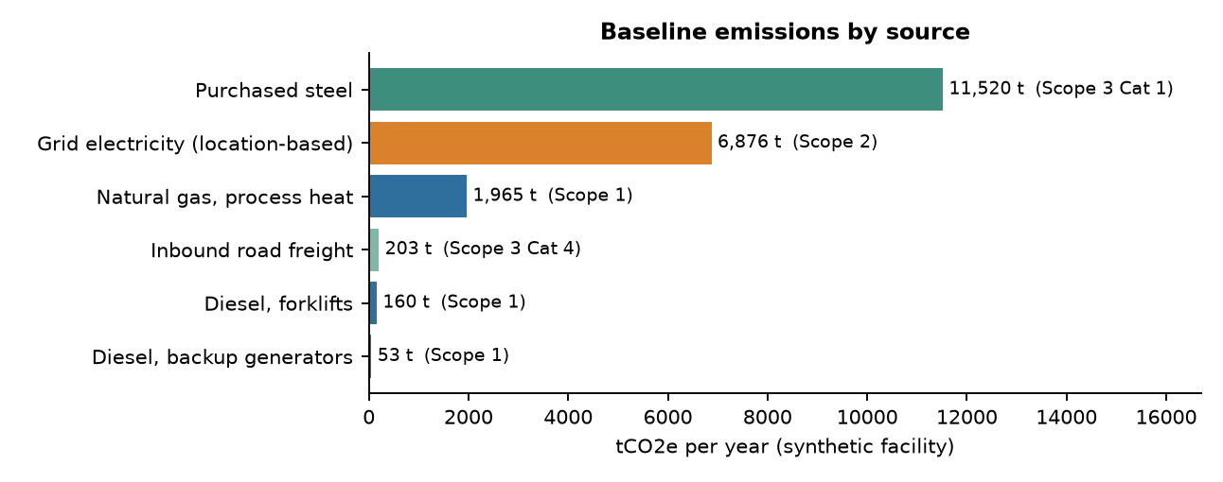
Figure 1. Baseline emissions by source (synthetic facility).
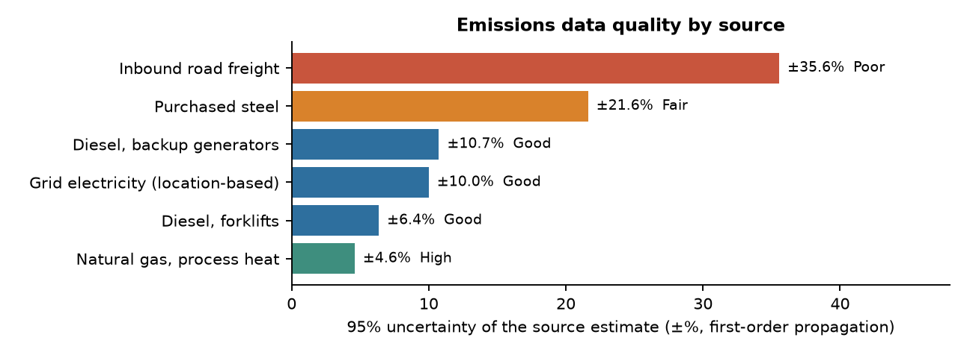
Figure 2. Uncertainty by source; labels use the guidance's High/Good/Fair/Poor scale.
Scope 1+2 is known to ±7.7% and the total to ±12.4%, dominated by Scope 3 steel (±21.6%) and freight (±35.6%). A Monte Carlo check of Scope 1+2 gives ±7.6%, confirming the analytic result. Since v1.1 both methods use the same activity-data uncertainties from the register (v1.0 hard-coded four of them in the analytic table only). Why first: reductions are measured against this baseline, and a decision cannot be more reliable than the data behind it.

6.2 Project economics
Each project's net present value and marginal abatement cost (MAC) use end-of-year real cash flows at 6%:
NPV_{i} = −C_{i} + CF_{i} × AF(r, T_{i}), AF = (1 − (1 + r)^{−T}) ⁄ r, MAC_{i} = −NPV_{i} ⁄ (AF × ΔE_{i})
For solar the year-1 output declines by d = 0.5% per year, so energy savings and tonnes use the degraded factor AF_{d} = (1 − ((1−d)/(1+r))^{T}) ⁄ (r + d) and O&M the ordinary annuity factor; MAC divides −NPV by discounted lifetime tonnes. Compressed air (C) carries an annual leak-management cost.
Project | Capex | Net cash flow/yr | NPV | Scope 1+2 t/yr | Scope 3 t/yr | MAC SAR/t | Payback
A Rooftop solar PV (1,000 kWp) | SAR 2,500,000 | SAR 308,000 | SAR 1,250,413 | 1,060.1 | -0.0 | -97 | 8.1 y
B High-efficiency motors + variable-speed drives | SAR 1,200,000 | SAR 155,520 | SAR 310,449 | 495.1 | -0.0 | -65 | 7.7 y
C Compressed-air leak repair & controls | SAR 350,000 | SAR 49,800 | SAR 16,532 | 206.3 | -0.0 | -11 | 7.0 y
D Furnace waste-heat recovery | SAR 600,000 | SAR 30,119 | −SAR 307,474 | 294.8 | -0.0 | 107 | 19.9 y
E Forklift electrification (12 units) | SAR 900,000 | SAR 89,600 | −SAR 240,536 | 39.4 | -0.0 | 830 | 10.0 y
F Lower-carbon steel supplier (3,000 t/yr) | SAR 50,000 | −SAR 240,000 | −SAR 1,816,421 | -0.0 | 1,350.0 | 183 | never
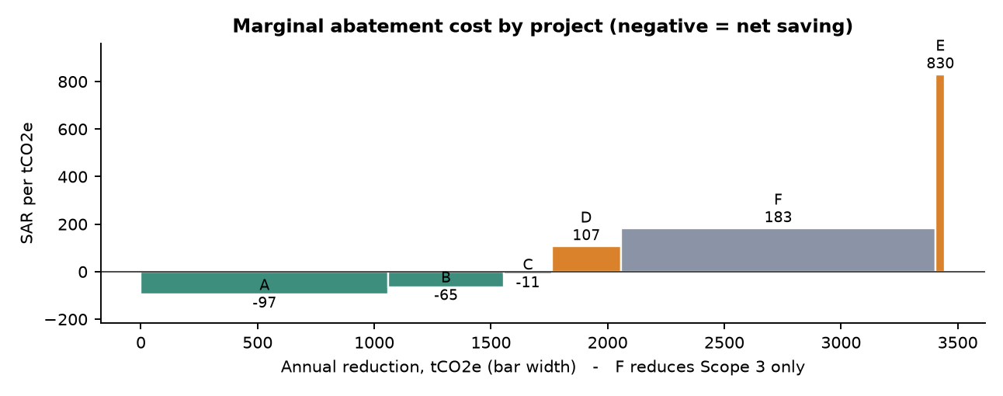
Figure 3. Marginal abatement cost curve (bar width = tonnes avoided per year).
Forklift electrification abates little (39.4 t/yr) because the Saudi grid factor (0.573 t/MWh) is high: the 210 MWh added offsets most of the diesel saved. The steel switch avoids the most tonnes (1,350 t/yr) but in Scope 3, which the Scope 1+2 target does not count. Solar's NPV (SAR 1.25M) rests on the Riyadh rooftop-cost benchmark; at the earlier SAR 3,750/kWp it would be SAR 0.00M (same other inputs). Compressed air is marginal (SAR 0.02M) once the leak-management cost is included.

6.3 Portfolio optimization
Method: binary integer programming, as reviewed for utility resource planning by Hobbs (1995) (full text not accessible to us; the manufacturing formulation is our adaptation). The overlap between B and C (compressor motors) is linearised so it is counted once:
max Σ x_{i}NPV_{i} − y_{BC}NPV_{BC} s.t. Σ x_{i}C_{i} ≤ B, Σ x_{i}ΔE_{i} − y_{BC}ΔE_{BC} ≥ T, y_{BC} ≥ x_{B}+x_{C}−1, x, y ∈ {0,1}
Solved with scipy's HiGHS mixed-integer solver and checked by enumerating all 64 portfolios (both give A+B+C); the workbook repeats the enumeration with live formulas.
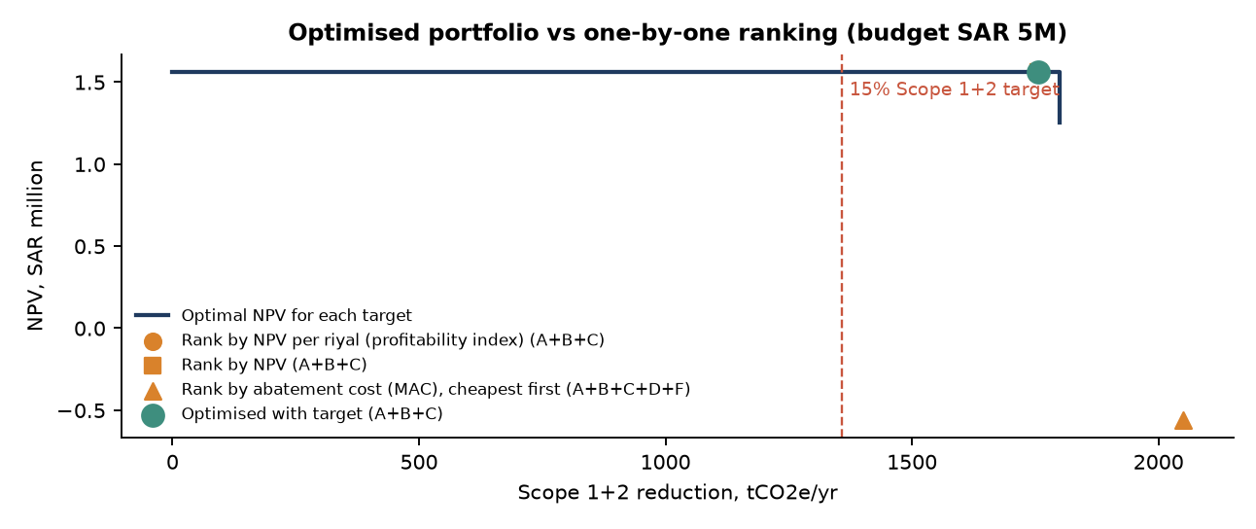
Figure 4. Best achievable NPV for each Scope 1+2 target, and what simple ranking rules choose.
Approach | Portfolio | Capex | NPV | Scope 1+2 t/yr | Meets target
Rank by NPV per riyal (profitability index) | A+B+C | SAR 4,050,000 | SAR 1,563,087 | 1,755.2 | yes
Rank by NPV | A+B+C | SAR 4,050,000 | SAR 1,563,087 | 1,755.2 | yes
Rank by abatement cost (MAC), cheapest first | A+B+C+D+F | SAR 4,700,000 | −SAR 560,808 | 2,050.0 | yes
Optimization (budget + target) | A+B+C | SAR 4,050,000 | SAR 1,563,087 | 1,755.2 | yes
Ranking rules choose A+B+C (Rank by NPV per riyal (profitability index); meets the target), A+B+C (Rank by NPV; meets the target), A+B+C+D+F (Rank by abatement cost (MAC), cheapest first; meets the target). The optimizer chooses A+B+C; meeting the target costs SAR 0k of NPV against the unconstrained optimum (A+B+C). Ledger check: for A+B+C the shared activity ledger gives 1,755.2 t/yr versus 1,761.4 t/yr if the overlap were double counted.

6.4 Uncertainty and stochastic optimization
Method: Monte Carlo evaluation and sample-average approximation of a chance-constrained program (Birge & Louveaux, 2011). Twenty thousand joint scenarios draw tariff, prices, savings shares, costs, PV yield and emission factors from the register's ranges (common random numbers for all portfolios). Evaluation reports the spread of a fixed portfolio; optimization chooses the portfolio across all scenarios:
max_{x} (1/S) Σ_{s} NPV(x, ξ_{s}) s.t. Pr[ΔE^{rep}(x, ξ) ≥ T] ≥ α, Pr[Σ_{i} x_{i}C_{i}(ξ) ≤ B] ≥ β, α = β = 0.90
ΔE^{rep} counts reductions with the fixed reporting factors against the fixed reporting baseline (management decision). Because the probabilities are estimated from S = 20,000 scenarios, each constraint is imposed in-sample at the tightened level α + 1.645·√(α(1−α)/S) = 0.9035, and the chosen portfolio is checked on an independent sample of 200,000 scenarios (Pagnoncelli, Ahmed & Shapiro, 2009; Birge & Louveaux, 2011).
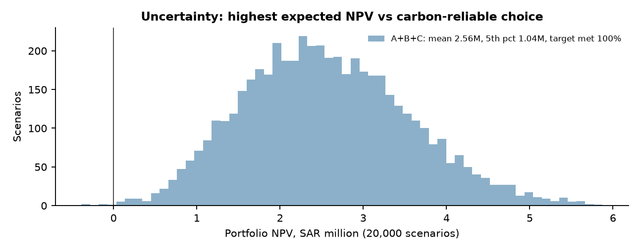
Figure 5. NPV distributions of the highest-expected-NPV portfolio and the validated carbon-reliable portfolio.
Portfolio | E[NPV] | 5th pct | P(NPV<0) | P(target) | P(target) validation | P(capex ≤ budget) | P(target) sampled factors
A+B | SAR 2,487,429 | SAR 1,034,883 | 0.1% | 93.7% | 93.5% | 100.0% | 90.6%
A+C+D | SAR 1,562,917 | SAR 461,012 | 0.8% | 98.7% | 98.6% | 100.0% | 96.2%
B+C | SAR 772,347 | −SAR 205,070 | 11.5% | 0.0% | 0.0% | 100.0% | 0.0%
A+C | SAR 1,870,677 | SAR 796,228 | 0.1% | 9.0% | 9.4% | 100.0% | 15.2%
Expected NPVs exceed the deterministic values because the tariff range is skewed upward (possible reform). A+B+C has the highest expected NPV; it meets the target in 100.0% of scenarios and stays within budget in 98.9%. The carbon rule chooses the same portfolio.
Decision rules: comparison, primary and sensitivity scenarios (same scenarios)
ID | Rule | Portfolio | E[NPV] | P(target) | P(target) validation | P(capex ≤ budget) | P(capex ≤ budget) validation | Status
D1 | Deterministic optimisation — comparison | A+B+C | SAR 2,557,033 | 100.0% | 100.0% | 98.9% | 98.8% | comparison
D2 | Maximum expected NPV — comparison | A+B+C | SAR 2,557,033 | 100.0% | 100.0% | 98.9% | 98.8% | comparison
D3a | Carbon chance constraint 90%, in-sample only (v1.1 method) — comparison | A+B+C | SAR 2,557,033 | 100.0% | 100.0% | 98.9% | 98.8% | meets target reliability on validation
D3 | Carbon chance constraint 90% (validated) — primary (carbon only) | A+B+C | SAR 2,557,033 | 100.0% | 100.0% | 98.9% | 98.8% | meets target reliability on validation
D4 | Carbon 90% + budget 90% chance constraints — PRIMARY RECOMMENDATION RULE | A+B+C | SAR 2,557,033 | 100.0% | 100.0% | 98.9% | 98.8% | feasible (validated)
S1 | Carbon chance constraint 90%, sampled emission factors — sensitivity (v1.1 primary) | A+B+C | SAR 2,557,033 | 100.0% | 100.0% | 98.9% | 98.8% | sensitivity (in-sample)
S2 | Carbon chance constraint 90%, uncertain baseline — sensitivity (baseline uncertainty) | A+B+C | SAR 2,557,033 | 100.0% | 100.0% | 98.9% | 98.8% | sensitivity (in-sample)
P(target) uses the primary basis (fixed reporting baseline) for every row so the rows are comparable; S1 and S2 apply their own basis when choosing (S1: sampled factors, P(target) 99.6%; S2: uncertain baseline, 100.0%). Validation: independent sample of 200,000 scenarios.
D1 and D2 both choose A+B+C. The deterministic NPV (SAR 1,563,087) is below the expected NPV (SAR 2,557,033) because the deterministic case uses most-likely values while the tariff range is skewed upwards (mode 0.18, mean 0.207 SAR/kWh); at mean inputs the deterministic optimum is A+B+C (NPV SAR 2,546,316).
With fixed reporting factors, A+B meets the target in 93.69% of the 20,000 scenarios and 93.52% on an independent validation sample of 200,000 (95% CI 93.41%-93.63%), above 90%. The validated carbon rule D3 chooses A+B+C, which has a higher expected NPV among the portfolios that pass.
These differences are correct and are not reconciled. D1 ignores uncertainty; D2 values outcomes by their average; D3 adds a reliability requirement on the carbon target; D4 adds the same requirement on the budget. The deterministic, expected-NPV and carbon-only results are kept as comparison scenarios.
Sampling check of the knife-edge portfolio
Sample | P(target) of A+B
Main sample (20,000 scenarios, seed 20261024) | 93.69% (s.e. 0.17%)
Validation sample (200,000 scenarios, seed 20261025) | 93.52% (95% CI 93.41%–93.63%)
Other 20,000-scenario samples, seed 1 | 93.06%
Other 20,000-scenario samples, seed 2 | 93.68%
Other 20,000-scenario samples, seed 3 | 93.72%
Other 20,000-scenario samples, seed 777 | 93.50%
Other 20,000-scenario samples, seed 2026 | 93.44%
In v1.2 this probability was 89.9% (within sampling error of 90%); with the v1.3 grid factor and PV inputs A+B meets the target in 93.52% of the validation sample, and the recommended A+B+C in 100.00%, so the tightened and validated rule no longer decides a knife-edge.
Budget chance constraint: infeasibility, minimum budget and alternative thresholds
Target-reliable portfolio | Budget needed for ≥90% compliance | E[NPV] | P(target) | P(target) validation
A+C+D | SAR 3,952,423 | SAR 1,562,917 | 98.7% | 98.6%
A+C+D+F | SAR 4,002,423 | −SAR 364,334 | 98.7% | 98.6%
A+B | SAR 4,244,808 | SAR 2,487,429 | 93.7% | 93.5%
A+B+F | SAR 4,294,808 | SAR 560,179 | 93.7% | 93.5%
P(target) ≥ | P(capex ≤ SAR 5M) ≥ 50% | P(capex ≤ SAR 5M) ≥ 60% | P(capex ≤ SAR 5M) ≥ 70% | P(capex ≤ SAR 5M) ≥ 75% | P(capex ≤ SAR 5M) ≥ 80% | P(capex ≤ SAR 5M) ≥ 90%
80% | A+B+C | A+B+C | A+B+C | A+B+C | A+B+C | A+B+C
85% | A+B+C | A+B+C | A+B+C | A+B+C | A+B+C | A+B+C
90% | A+B+C | A+B+C | A+B+C | A+B+C | A+B+C | A+B+C
95% | A+B+C | A+B+C | A+B+C | A+B+C | A+B+C | A+B+C
Choice at the SAR 5M budget for alternative reliability levels (tightened in-sample, validated out-of-sample).
With the decided 90%/90% levels the minimum budget for the joint rule is SAR 3,952,423 (A+C+D; -21.0% relative to the current budget), so the rule is feasible at SAR 5M and chooses A+B+C. The budget curve and the full threshold grid are in the workbook (sheet Decision Objectives) and outputs/budget_curve.csv.
Capital cost: quoted vs uncertain actual cost
Portfolio | Quoted capex | Mean actual capex | 90th pct | P(capex > budget) | P(target met) | P(target and budget)
A+B | SAR 3,700,000 | SAR 3,699,930 | SAR 4,237,195 | 0.0% | 93.7% | 93.7%
A+C | SAR 2,850,000 | SAR 2,849,512 | SAR 3,330,307 | 0.0% | 9.0% | 9.0%
A+C+D | SAR 3,450,000 | SAR 3,449,236 | SAR 3,945,713 | 0.0% | 98.7% | 98.7%
A+D | SAR 3,100,000 | SAR 3,099,337 | SAR 3,593,340 | 0.0% | 44.6% | 44.6%
B+C | SAR 1,550,000 | SAR 1,550,216 | SAR 1,787,665 | 0.0% | 0.0% | 0.0%

6.5 Value of information
Method: Howard (1966) information value theory, computed under the carbon decision rule D3 of Section 6.4 (maximise expected NPV subject to the tightened 90% target probability on the primary basis):
EVPI = E_{θ}[max_{d} V(d, θ)] − max_{d} E_{θ}[V(d, θ)] EVPPI_{X}: resolve input X only EVSI: imperfect measurement
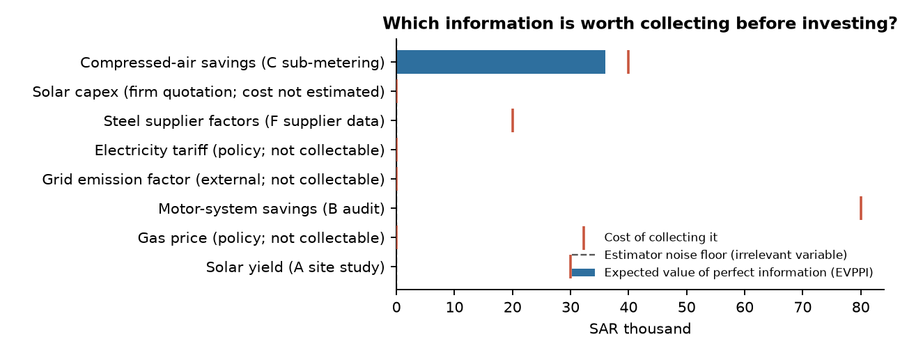
Figure 6. Expected value of resolving each uncertainty (bars) against the cost of collecting it (red marks).
Information | EVPPI | EVPPI − noise floor | Collection cost | EVPPI, v1.1 rule (comparison)
Compressed-air savings (C sub-metering) | SAR 35,954 | SAR 35,954 | SAR 40,000 | SAR 25,494
Solar capex (firm quotation; cost not estimated) | SAR 0 | SAR 0 | not collectable / not estimated | SAR 0
Steel supplier factors (F supplier data) | SAR 0 | −SAR 0 | SAR 20,000 | SAR 0
Electricity tariff (policy; not collectable) | SAR 0 | −SAR 0 | not collectable / not estimated | SAR 0
Grid emission factor (external; not collectable) | SAR 0 | −SAR 0 | not collectable / not estimated | SAR 0
Motor-system savings (B audit) | SAR 0 | −SAR 0 | SAR 80,000 | SAR 0
Gas price (policy; not collectable) | SAR 0 | −SAR 0 | not collectable / not estimated | SAR 0
Solar yield (A site study) | −SAR 0 | −SAR 0 | SAR 30,000 | −SAR 0
EVPI (all uncertainty resolved) is SAR 0.06M; a dummy irrelevant variable gives SAR 0 (noise floor). The highest single item is Compressed-air savings (C sub-metering) (EVPPI SAR 0.04M); the motor-system audit is worth SAR 0.00M (EVSI) against an assumed SAR 80k cost. In v1.2, when A+B sat on the 90% boundary, the audit was worth SAR 0.58M; with the v1.3 inputs the recommended portfolio is robust to B's savings, so information that cannot change the choice has little value. Value of information differs from data quality: steel supplier data is among the least certain inputs (±21.6%) yet has no value, because the Scope 3 project cannot change the Scope 1+2 decision.

6.6 Sensitivity analysis and decision robustness
Method: Saltelli et al. (2008). Uncertainty analysis measures the spread of outcomes (6.4); sensitivity analysis finds which inputs cause it (one-way tornado and first-order variance indices S_{i} = Var(E[Y|X_{i}]) ⁄ Var(Y), estimated by binning the Monte Carlo sample); robustness testing asks whether the recommendation changes (switch points).
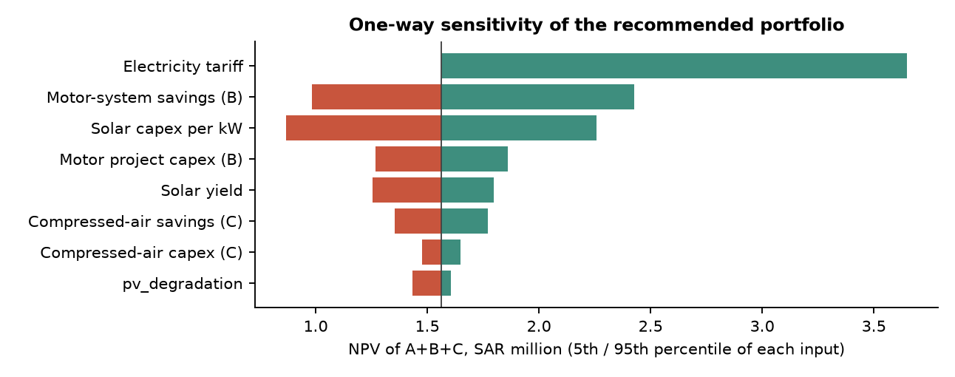
Figure 7. NPV of the deterministic optimum (A+B+C) with each input at its 5th and 95th percentile.
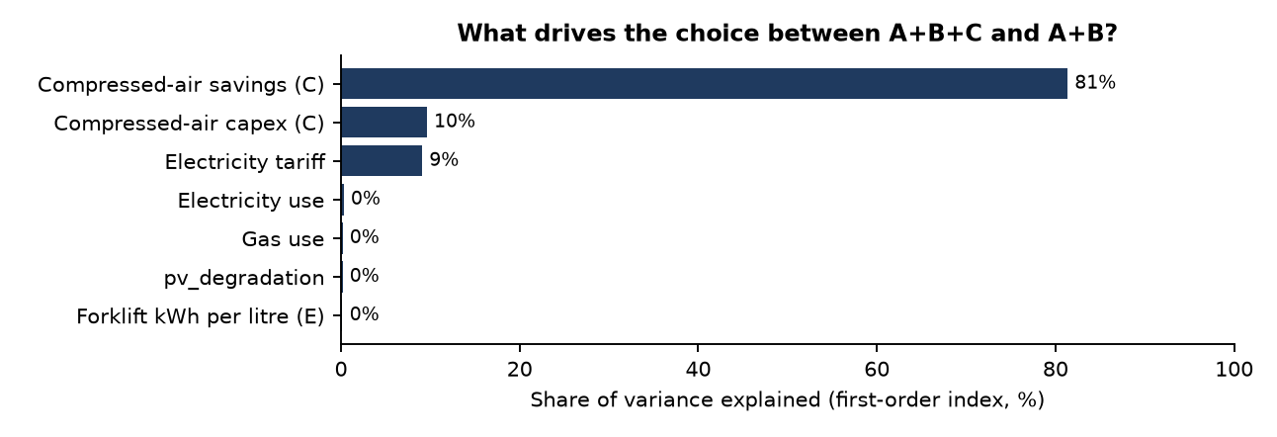
Figure 8. Inputs driving the choice between the two leading portfolios (first-order indices).
Input varied (others at base) | Effect on the deterministic optimum
tariff | robust over tested range
b_saving_frac | at 0.0885: A+C+D → A+B+C
pv_yield | robust over tested range
pv_capex_kw | robust over tested range
b_capex | robust over tested range
c_saving_frac | at 0.2: A+B → A+B+C
gas_price_usd | at 3.85: A+B+C → A+B+C+D
ef_grid | robust over tested range
c_capex | at 356,100: A+B+C → A+B
d_saving_frac | robust over tested range
Inputs whose variation within their ranges changes the deterministic optimum: b_saving_frac at 0.0885 (A+C+D → A+B+C); c_saving_frac at 0.2 (A+B → A+B+C); gas_price_usd at 3.85 (A+B+C → A+B+C+D); c_capex at 356,100 (A+B+C → A+B). Compressed-air savings switch the choice at the base value itself (C's NPV is close to zero), so the inclusion of C is marginal; solar cost no longer switches the choice within ±29% of the benchmark. Discount rate: 4% → A+B+C, 5% → A+B+C, 6% → A+B+C, 8% → A+B, 10% → A+B, 12% → A+B (with the target).
Tariff scenarios (full re-optimisation; in the Monte Carlo the tariff is fixed at the scenario value)
Scenario | SAR/kWh | D1 Deterministic | NPV | D2 Highest E[NPV] | E[NPV] | D3 Carbon | E[NPV] | D4 Carbon + budget
T0 Reference: 18 halalas (in force 2018-2026) | 0.18 | A+B+C | SAR 1,563,087 | A+B+C | SAR 1,642,843 | A+B+C | SAR 1,642,843 | A+B+C
T1 18 halalas + 2 halala non-qualifying surcharge | 0.20 | A+B+C | SAR 2,234,539 | A+B+C | SAR 2,323,133 | A+B+C | SAR 2,323,133 | A+B+C
T2 Announced 2027 tariff: 23 halalas | 0.23 | A+B+C | SAR 3,241,718 | A+B+C | SAR 3,343,568 | A+B+C | SAR 3,343,568 | A+B+C
T3 Upper reform bound: 26 halalas | 0.26 | A+B+C | SAR 4,248,896 | A+B+C | SAR 4,364,002 | A+B+C | SAR 4,364,002 | A+B+C
Choices across the four tariffs — D1: A+B+C; D3: A+B+C; D4: A+B+C (tariffs change savings, not capital cost or emissions). At the 2027 tariff reported in the press (0.23 SAR/kWh) the deterministic NPV of A+B+C rises from SAR 1.56M to SAR 3.24M. If the tariff stays at 0.18 for certain, the highest-expected-NPV portfolio is A+B+C and the carbon-rule A+B+C has E[NPV] SAR 1,642,843.
Grid-factor scenario
Scenario | tCO₂/MWh | Target t/yr | D1 | D2 (P target) | D3 carbon (P target) | D4 carbon + budget
v1.2 project factor 0.55 (source not located) | 0.55 | 1,317 | A+B+C | A+B+C (100.0%) | A+B+C (100.0%) | A+B+C
Saudi DNA 2021 GEF 0.568 (as cited) | 0.568 | 1,349 | A+B+C | A+B+C (100.0%) | A+B+C (100.0%) | A+B+C
BTR1 2021 / GASTAT 2021 derived 0.573 (reference since v1.3) | 0.573 | 1,358 | A+B+C | A+B+C (100.0%) | A+B+C (100.0%) | A+B+C
Across the three factors (0.55, 0.568, 0.573) the carbon rule chooses A+B+C / A+B+C / A+B+C and the joint rule A+B+C / A+B+C / A+B+C. In v1.2 (expensive PV) the factor mattered for the carbon rule; with the v1.3 inputs it does not change the choice.
Industrial gas price and rooftop PV cost scenarios (v1.3)
Scenario | Value | D1 | NPV | D3 Carbon | D4 Carbon + budget | Minimum budget for D4
G0 2025 regulated methane price (reference) | $2.15/MMBtu | A+B+C | SAR 1,563,087 | A+B+C | A+B+C | SAR 3,952,423
G1 2026 reported +10-20% (midpoint +15%) | $2.47/MMBtu | A+B+C | SAR 1,563,087 | A+B+C | A+B+C | SAR 3,952,423
G2 v1.2 anchor (KAPSARC DP49 modelling value) | $3.00/MMBtu | A+B+C | SAR 1,563,087 | A+B+C | A+B+C | SAR 3,952,423
P0 Riyadh rooftop benchmark SAR 2.5/W (reference) | SAR 2,500/kWp | A+B+C | SAR 1,563,087 | A+B+C | A+B+C | SAR 3,952,423
P1 v1.2 assumption SAR 3.75/W (no direct source) | SAR 3,750/kWp | A+B | SAR 151,070 | A+B+C | none feasible | SAR 5,436,295
The gas price affects only heat recovery (D), which is not in the recommended portfolio, so G0–G2 leave the choices unchanged. The PV cost is decisive: at the v1.2 assumption of SAR 3,750/kWp the joint rule becomes none feasible (minimum budget SAR 5,436,295). A formal PV quotation is therefore the most valuable piece of evidence for this decision.

6.7 Investment timing (real options)
Method: real-options analysis of irreversible investment (Dixit & Pindyck, 1994) as applied by KAPSARC DP49 (Albalawi & Sirin, 2026) to Saudi offshore decarbonization: the gas price follows a log-Ornstein–Uhlenbeck process (κ = 0.5, σ = 0.522; DP49's mean of $3/MMBtu is replaced since v1.3 by the current regulated price $2.15), the stopping problem is solved with least-squares Monte Carlo (Longstaff & Schwartz, 2001), and a GBM closed form gives a benchmark trigger. DP49's offshore results are not transferred to manufacturing; only the method and its calibration are reused, and the application to heat recovery D is our adaptation.
Invest now if NPV_{now} ≥ V_{wait}; GBM trigger G* = λ⁄(λ−1) × (C + O&M·A_{r}) ⁄ (A_{μ}·q) (DP49 Eq. C.7, C.13)
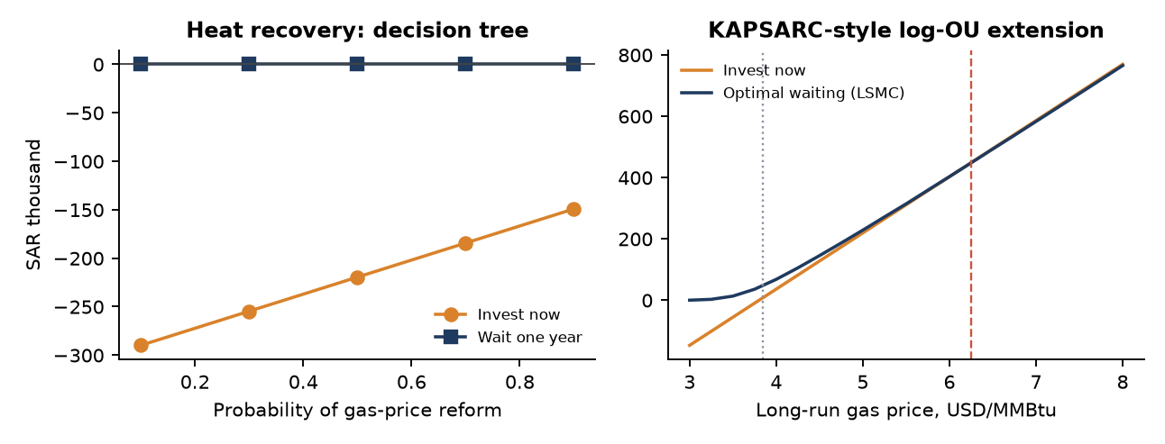
Figure 9. Left: reform decision tree (prototype method). Right: log-OU LSMC extension — value of investing now vs optimal waiting by long-run gas price.
Timing result for D (heat recovery) | Value
Static NPV at today's $2.15/MMBtu | −SAR 307,474
Static break-even gas price | $3.85/MMBtu
Decision tree: invest now (reform p = 0.5, to $3.225) | −SAR 219,524
Decision tree: wait one year for the decision | SAR 0
Option value of waiting → decision | SAR 220k → wait for the price decision
LSMC (log-OU, 5,000 + 5,000 paths): long-run price at which investing now beats waiting | ≈ $6.25/MMBtu (grid step $0.25)
GBM closed-form trigger (benchmark) | $17.27/MMBtu (multiplier 4.99)
Interpretation and limits. For an administered industrial gas price that changes by policy decision, the decision tree is the defensible prototype method: it shows that waiting for the price decision is worth SAR 220k and remains preferable even at reform probabilities (70–90%) where investing now already has a positive NPV — the classic real-options result that a positive NPV is not sufficient. The LSMC extension, using DP49's market-gas volatility, gives a trigger of about $6.25/MMBtu (κ 0.2–1.0 and σ 0.3–0.75 move it between $5 and $8); because an administered price does not fluctuate monthly with Henry Hub volatility, this figure illustrates the method rather than guiding the decision. The GBM benchmark overstates the trigger, as DP49 also notes. Timing is consistent with the portfolio: D is not in the recommended portfolio, so its timing does not affect the target. The deferral uncertainty (price policy, resolved by time) differs from the audit uncertainty (savings, resolved by measurement), so the option value and the information value are not double counted.

6.8 Integrated workflow and final recommendation
Stage | Input | Calculation | Output
1 Data | Bills, fuel cards, procurement, carrier data | Validation, status tagging, proxy estimates | Activity register
2 Carbon footprint | Activity, emission factors | E = A × EF by scope | Baseline by source and scope
3 Data quality | Error ranges | First-order propagation + Monte Carlo check | Baseline ± range
4 Project modelling | Costs, savings, prices | NPV, MAC, shared ledger | Project economics
5 Optimization | Budget, target, rules | Integer program / enumeration | Optimal portfolio
6 Uncertainty | Distributions | 20,000 scenarios, chance constraint | Robust portfolio
7 Information value | Collection costs | EVPI, EVPPI, EVSI | What to learn first
8 Sensitivity | All inputs | Tornado, variance indices, switch points | Key drivers
9 Timing | Deferrable projects | Decision tree; LSMC extension | Invest now / wait
10 Recommendation | Stages 2–9 | Rules + explanation | Management decision memo
The workflow is iterative: the audit recommended in stage 7 updates stages 4–6, after which the portfolio choice is re-run.
Recommendation to management (synthetic case). (1) Primary rule result: A+B+C meets both the 90% carbon (100.0%) and the 90% budget (98.9%) requirements at SAR 5M, with E[NPV] SAR 2.56M; the deterministic, expected-NPV and carbon rules agree. (2) The result depends on the Riyadh rooftop-PV cost benchmark: obtain formal PV quotations first — at SAR 3,750/kWp the joint rule is none feasible (Section 6.6). (3) Treat compressed air (C) as marginal (NPV SAR 0.02M): include it only with a committed leak-management programme. (4) The motor-system audit is not worth its assumed cost for this decision (EVSI SAR 0.00M). (5) Heat recovery: wait for the price decision at the regulated gas price. (6) Do not electrify forklifts for carbon reasons while the grid factor stays near 0.573 t/MWh. (7) Confirm the 2027 industrial tariff from the official Saudi Energy schedule before committing.

7. Implementation architecture and validation
Component | Role
carbon_iq/assumptions.py | Single register of all inputs: value, unit, status, source, distribution
engine.py | Baseline accounting, uncertainty propagation, finance primitives, project models, shared activity ledger
optimize.py | HiGHS integer program, exhaustive enumeration, ranking baselines, efficient frontier
uncertainty.py · voi.py · sensitivity.py · timing.py | Monte Carlo and chance constraints (incl. actual-capex risk and counting basis); EVPI/EVPPI/EVSI; tornado, variance indices, switch points; decision tree, LSMC, GBM trigger
decisions.py (v1.1) | Three decision objectives, counting-basis comparison, capital-cost risk, tariff and grid-factor scenarios
recalc.py (v1.1) | Portable LibreOffice recalculation of the workbook; status recorded in outputs/excel_recalc.json
tools/ (v1.1) | run_tests.py (suite + summary), fault_injection.py, crosscheck.py (Python vs Excel vs Word), compare_versions.py
pipeline.py · run_all.py | End-to-end run writing CSV/JSON/charts, the Excel model and a SHA-256 manifest
CARBON_IQ_Data_Model.xlsx | 19 sheets (including Source Register and A5 Changes); deterministic chain as live formulas (including the 64-portfolio optimum and the decision tree); simulation results as labelled values
app.py | Streamlit interface: budget, target, confidence, prices and discount rate recompute all results
tests/ | 127 automated tests (engine, decisions, timing, outputs, v1.1–v1.2 rules, A4 data quality, A5 inputs, A6 independent checks)
Validation evidence
Check | Result
Automated tests (python tools/run_tests.py) | 127 passed, 0 failed, 0 skipped (Python 3.12.3, NumPy 2.5.4, Streamlit 1.66.1)
Minimum versions and Colab | Suite also run with the minimum versions in requirements.txt (Python 3.11) and by executing the README Colab cell in IPython (see A1 completion report)
Hand calculations | Baseline factors, IPCC gas factor, project A/D/E/F cash flows and reductions, NPV/IRR/payback, decision tree, GBM λ
GHG Protocol worked example | 110 t ±4% + 90 t ±24% → ±11.0% reproduced
Analytic vs simulation uncertainty | Scope 1+2: ±7.7% first-order vs ±7.6% Monte Carlo
Optimization | MILP = model enumeration = independent enumeration (separate code) in all 3,267 budget/target/exclusivity cases (A6); 1,863 infeasible cases reported as infeasible
Independent recalculation (A6) | Emissions 9/9 and finance 170/170 checks agree with separately written code; independent spreadsheet 52 checks, all pass: true; independent Monte Carlo sampler gives the same D2/D3/D4 choices (see the A6 validation report)
No double counting | Ledger reduction equals portfolio reduction for all 64 portfolios; overlap removed only when B and C are both chosen
Value-of-information sanity | 0 ≤ EVPPI ≤ EVPI; irrelevant variable → 0; no uncertainty → EVPI = 0; EVSI ≤ EVPPI
Excel vs Python | 920 formulas, 0 errors (v1.0 reported 920 because LibreOffice stores 24 TRUE/FALSE constants as formulas); baseline, uncertainty, NPVs, Excel NPV() cash flows, optimum, objectives, tree and trigger equal Python
Reproducibility | Fixed seeds; identical results on repeated runs; SHA-256 manifest of all outputs
Fault injection (tools/fault_injection.py) | 28 of 28 deliberate errors detected: double counting, uncertainty rule, chance constraint, VOI baseline, log-OU drift, reporting basis (v1.1), capital-cost risk (v1.1), budget chance constraint (v1.2), sampling margin (v1.2), activity uncertainty (v1.1), missing as zero (A4), original overwritten (A4), estimation uncertainty (A4), gap-length refusal (A4), unit conversion (A4), change detection (A4.1), calibration factor (A4.1), uncertain target (A4.1), pre-posterior conditioning (A4.1), stability flag (A4.1), PV degradation (A5), leak-management cost (A5), profile restore (A5), MAC discounting (A5), finite-input guard (A6), IRR with degradation (A6), annuity edge (A6), ledger overlap (A6)
Changes from version 1.0 and their effect on results
Change (A1 issue) | Effect on results
Colab cell corrected; notebook added (A1-01) | None (execution only)
Minimum versions: NumPy ≥ 2.0, Streamlit ≥ 1.49 and others; lock file (A1-03) | None (v1.0 outputs were already identical across versions)
'AI-Enabled' removed from titles (A1-04) | None
Status labels: 12 'verified' values relabelled transferred (10) or provisional (2: tariff, grid factor) (A1-07, A1-13) | None (labels only)
Activity uncertainties (diesel ±5/±10%, steel ±2%, freight ±20%) moved into the register and sampled (A1-09) | Analytic uncertainty unchanged; Monte Carlo check ±7.50% → ±7.57%; EVPI SAR 651,351 → SAR 55,670; all decisions unchanged
v1.2: carbon chance constraint on the fixed reporting baseline (management decision; A1-02) | In v1.2 the carbon rule picked A+C+D after tightening (A+B in-sample at 90.3%). v1.3 sensitivities: sampled factors A+B+C, uncertain baseline A+B+C
v1.2: 90% budget chance constraint (management decision; A1-10) | Primary rule infeasible at SAR 5M in v1.2; minimum budget SAR 5,202,423 (A+C+D)
v1.2: chance constraints tightened for sampling error and validated on 200,000 scenarios | Carbon rule A+B → A+C+D in v1.2; VOI under the v1.2 rule had a noise floor of SAR 269,985 (v1.1: 0)
v1.3 (A5): grid factor, gas price, PV cost and degradation, compressed-air savings and leak cost re-sourced (Section 6.9) | Optimum A+B → A+B+C; primary rule none feasible → A+B+C; EVPI SAR 0.65M → SAR 0.06M
Tariff and grid-factor scenarios (A1-08, A1-07) | New scenario results; reference results unchanged
VOI collection costs linked to inputs; solar-capex row relabelled 'cost not estimated' (A1-18) | None
What is validated and what is illustrative
Validated (checked by tests, cross-checks or independent samples) | Illustrative (depends on synthetic or unconfirmed inputs)
Calculations: accounting, NPV, MAC, uncertainty propagation, optimisation (MILP = enumeration), ledger without double counting | All facility activity data, project costs and savings shares (synthetic case)
Internal consistency: Python = Excel (live formulas) = Word figures; reproducible outputs; injected faults detected | Distribution ranges (judgement-based), the 2027 tariff, the grid factor, the gas-price anchor and transferred factors
Chance-constraint feasibility of the reported choices on an independent 200,000-scenario sample | Every portfolio choice, NPV and probability as advice for a real plant
Statistical behaviour of the decision rules (sampling error, tightening) | Value-of-information magnitudes under the new rule (noise floor; method revision in A6)

8. Limitations and future development
- Synthetic case. Activity data and project costs are illustrative; results show how the method behaves, not what any facility should do.
- Data proxies. Grid factor derived from 2021 national statistics (category boundaries not reconciled); 2027 industrial tariff and 2026 gas price not confirmed by primary documents; PV cost is a market benchmark, other project costs are placeholders; UK diesel and freight factors; world-average crude-steel factors; savings shares unverified until audits.
- Decision framing. Management fixed the counting basis (fixed reporting baseline) and the 90% budget requirement on 25 October 2026. In v1.2 no portfolio was feasible at SAR 5M; with the v1.3 inputs the rule is feasible, but this rests on the PV cost benchmark.
- Inventory boundary. Refrigerant leakage (Scope 1), upstream fuel and grid-loss emissions (Scope 3 Category 3) and other purchased goods are outside the prototype boundary; Scope 2 is location-based only (no market-based instruments are modelled).
- Competitor benchmark. The table in Section 3 is the team's unsourced assessment; evidence-based benchmarking is Phase A3.
- Uncertainty model. Inputs are sampled independently from judgement-based ranges; correlations (e.g. between tariff and gas price reform) and model uncertainty are not represented. First-order variance indices omit interactions (total-effect indices are an extension).
- Optimization scope. Single period, one budget, binary projects; no partial sizing, phasing, financing, taxes or escalation. Enumeration is exact here; larger cases rely on the MILP.
- Timing. The decision tree assumes one reform event; the LSMC extension borrows a market-gas calibration that does not describe administered prices; DP49 results are not transferred.
- Value of information. Binning estimators (20 bins) carry small sampling error near a threshold; audit and data costs are assumptions.
- No machine learning. The prototype uses optimization, simulation and decision analysis; machine-learning features (e.g. gap filling, anomaly detection) are possible future work and are not claimed.
Future development
- Pilot on a real Saudi facility: connect metered data, procurement and quotations; validate recommendations against outcomes.
- Obtain the official 2027 tariff schedule, formal PV and equipment quotations, the plant's real gas supply and price; obtain supplier-specific steel and freight data; add refrigerants, Scope 3 Category 3 and market-based Scope 2.
- Model correlated uncertainties, multi-period budgets and phased investment (two-stage recourse), and total-effect sensitivity indices.
- Add documented machine-learning components only where they demonstrably improve estimates (e.g. missing-month imputation with uncertainty).
Changes from the earlier methodology paper. The methodology paper used illustrative project numbers (e.g. 2,700 MWh solar). This prototype replaces them with source-anchored inputs (1,000 kWp at 1,850 kWh/kWp, SEC tariff, KAPSARC 6% rate, IPCC/DESNZ/worldsteel factors), so case results differ; the methods and their integration are unchanged.

References
Albalawi, A. & El-Houjeiri, H. (2026). Decarbonization Pathways for Offshore Oil Power Systems: The Case of Saudi Arabia. KAPSARC. doi.org/10.30573/KS--2026-DP24
Albalawi, A. & Sirin, S.M. (2026). Decarbonization Investments Under Uncertainty: A Real-Option Analysis of Renewable Energy Investments for Offshore Oil Platforms in Saudi Arabia. KAPSARC Discussion Paper. doi.org/10.30573/KS--2026-DP49
Alorfi, A.S. & Alsaadi, N. (2025). Barriers to the adoption of big data analytics in Saudi Arabia's manufacturing sector. Systems 13(4), 250. doi.org/10.3390/systems13040250
BDO Saudi Arabia: Sharjeel, A.R. & Zaidi, S.M.A. (2025). Practical challenges in compiling a meaningful ESG report. bdoalamri.com
Birge, J.R. & Louveaux, F. (2011). Introduction to Stochastic Programming (2nd ed.). Springer. doi.org/10.1007/978-1-4614-0237-4
Dixit, A.K. & Pindyck, R.S. (1994). Investment under Uncertainty. Princeton University Press. press.princeton.edu
GHG Protocol (n.d.). Short Guidance for Calculating Measurement and Estimation Uncertainty for GHG Emissions. WRI/WBCSD. PDF
GHG Protocol: Corporate Accounting and Reporting Standard (rev. ed., 2004) link; Scope 2 Guidance (2015) link; Corporate Value Chain (Scope 3) Standard (2011) link
Hobbs, B.F. (1995). Optimization methods for electric utility resource planning. European Journal of Operational Research 83(1), 1–20. doi.org/10.1016/0377-2217(94)00190-N
Howard, R.A. (1966). Information value theory. IEEE Transactions on Systems Science and Cybernetics 2(1), 22–26. doi.org/10.1109/TSSC.1966.300074
IEA 4E EMSA (2025). Policy Brief #9: Electric motor systems. iea-4e.org
IPCC (2006). 2006 IPCC Guidelines for National GHG Inventories, Vol. 2, Ch. 2 Stationary Combustion. PDF
IRENA (2025). Renewable Power Generation Costs in 2024 (summary). PDF
KAPSARC: Yousef, F. et al. (2025). Navigating Global Sustainability Reporting and Taxonomies: Insights for Saudi Arabia. kapsarc.org
Longstaff, F.A. & Schwartz, E.S. (2001). Valuing American options by simulation. Review of Financial Studies 14(1), 113–147. doi.org/10.1093/rfs/14.1.113
Pagnoncelli, B.K., Ahmed, S. & Shapiro, A. (2009). Sample average approximation method for chance constrained programming: theory and applications. Journal of Optimization Theory and Applications 142(2), 399–416. doi.org/10.1007/s10957-009-9523-6
Saltelli, A. et al. (2008). Global Sensitivity Analysis: The Primer. Wiley. doi.org/10.1002/9780470725184
Saudi Electricity Company. Consumption tariffs (applied since 1 Jan 2018), via ESMAP RISE. PDF
UK DESNZ (2025). Greenhouse gas reporting: conversion factors 2025. gov.uk
US DOE (2000). Minimize Compressed Air Leaks, Compressed Air Tip Sheet #3. PDF
World Economic Forum (2023). Emissions Measurement in Supply Chains: Business Realities and Challenges. weforum.org
worldsteel (2025). Sustainability Indicators Report 2025. worldsteel.org
AGBI (Jan 2026). Saudi companies face cost increase as Aramco ups diesel price. agbi.com; NASA POWER irradiance for Riyadh via profilesolar.com
Argaam (13 Dec 2017). Saudi Arabia to hike electricity tariffs from January 1 (ECRA statement). argaam.com
Attaqa (25 Oct 2026). Saudi electricity prices raised for 2027 (in Arabic). attaqa.net; Saudi Life Guide (25 Oct 2026). Saudi Electricity Tariff 2027. saudilifeguide.com
The National (25 Oct 2026). Saudi Arabia announces support measures as electricity and water tariffs rise. thenationalnews.com
SPARK Utilities (27 Apr 2025). Intensive electricity consumption tariff notice. spark.sa
KFUPM (2025). Greenhouse Gas Emissions Inventory for 2024 (cites Saudi DNA, Development of the Kingdom's Updated Grid Emission Factor 2021). PDF
IFI Technical Working Group (Jul 2019). Harmonized IFI Default Grid Factors, v2.0. UNFCCC. PDF
Kingdom of Saudi Arabia (2025). First Biennial Transparency Report (UNFCCC). PDF; GASTAT (2022). Electric Energy Statistics 2021 (Arabic). PDF
Saudi Press Agency (25 Oct 2026). Saudi Energy announces electricity service tariff adjustment from January 1, 2027. spa.gov.sa
Al Jazira Capital (Jan 2025). The potential impacts of feedstock price hikes. PDF; MEES (2 Jan 2026). Saudi increases diesel prices. mees.com
Knight Frank (2025). Going Green: Rooftop solar potential in the GCC. PDF; Alzahrani, G.S. & Nahhas, A.M. (2021). Analytical study of power generation by PV system for Al-Riyadh and Al-Jubail. American Journal of Energy Research 9(1), 45–55. link
Jordan, D.C. & Kurtz, S.R. (2013). Photovoltaic degradation rates — an analytical review. Progress in Photovoltaics 21(1), 12–29. doi.org/10.1002/pip.1182
Schröder, A., Liebertseder, J. & Doppelbauer, M. (2023). Study on the energy-saving potential of electric motors with variable-speed drives in the EU. Fraunhofer ICT for CEMEP. PDF
Compressed Air Challenge (2026). Fact sheet 7: Compressed air system leaks. PDF; US DOE (2007). Process Heating Tip Sheet #1: Preheated combustion air. PDF

Appendix A. Assumption register
All 61 inputs as used in this report, the workbook and the code. Status: verified = cited public source, applicable here; derived = calculated from verified values; transferred = cited source from another context; provisional = partial or secondary evidence, or a change announced; hypothetical = case assumption. Distributions are the Monte Carlo ranges.
Key | Value | Unit | Status / evidence | Source / rationale | Range
tariff | 0.18 | SAR/kWh | provisional / external | Industrial tariff 18 halalas/kWh, flat (no consumption bands), in force 1 Jan 2018 - 31 Dec 2026 (ECRA statement reported by Argaam, 13 Dec 2017; SEC tariff schedule 2022). Reference case = last officially documented rate. A rise to 23 halalas/kWh from 1 Jan 2027 was reported on 25 Oct 2026; see TARIFF_SCENARIOS (published 13 Dec 2017 (ECRA via Argaam); 25 Oct 2026 (SPA)) | triangular 0.18, 0.18, 0.26
diesel_price | 1.79 | SAR/L | verified / external | Aramco diesel price SAR 1.79/L from 1 Jan 2026 (+7.8%; MEES 2 Jan 2026; AGBI Jan 2026); SAR 1.66/L in 2025 (Al Jazira Capital, Jan 2025) (published 2 Jan 2026) | triangular 1.79, 1.79, 2.3
gas_price_usd | 2.15 | USD/MMBtu | provisional / external | Aramco regulated methane (sales-gas) price USD 2.15/MMBtu from 1 Jan 2025, up from 1.75 (Al Jazira Capital, Jan 2025, summarising Aramco notices to listed companies). A further 10-20% rise from 1 Jan 2026 was reported by a secondary source without an official figure; see GAS_SCENARIOS. v1.2 used the KAPSARC DP49 modelling anchor of $3.0 (published Jan 2025) | lognormal σ 0.25
discount_rate | 0.06 | real, per year | transferred / external | 6% discount rate used by KAPSARC DP49 (Table D1; WACC from Albalawi & El-Houjeiri 2026) (published 2026) | fixed
budget | 5,000,000 | SAR | hypothetical / hypothetical | Management capital budget for decarbonization (case definition) | fixed
target_share | 0.15 | fraction of Scope 1+2 | hypothetical / hypothetical | Management target: cut Scope 1+2 emissions by at least 15% per year (case definition) | fixed
chance_level | 0.9 | probability | hypothetical / hypothetical | Required probability of meeting the target in the stochastic selection (management risk appetite) | fixed
budget_chance_level | 0.9 | probability | hypothetical / hypothetical | Required probability that the actual capital cost stays within the budget (management decision, 25 Oct 2026) | fixed
elec_mwh | 12,000 | MWh/yr | hypothetical / hypothetical | Synthetic metered grid electricity (12 monthly bills) | normal, s.d. × 0.01
gas_gj | 35,000 | GJ/yr (NCV) | hypothetical / hypothetical | Synthetic natural-gas use for furnaces and process heat | normal, s.d. × 0.015
diesel_forklift_l | 60,000 | L/yr | hypothetical / hypothetical | Synthetic diesel use, 12 forklifts (fuel cards) | normal, s.d. × 0.025510672645007768
diesel_genset_l | 20,000 | L/yr | hypothetical / hypothetical | Synthetic diesel use, backup generators (fuel logs) | normal, s.d. × 0.051021345290015535
steel_t | 6,000 | t/yr | hypothetical / hypothetical | Synthetic purchased steel (procurement records) | normal, s.d. × 0.010204269058003106
freight_tkm | 2,000,000 | t-km/yr | hypothetical / hypothetical | Synthetic inbound freight (carrier statements) | normal, s.d. × 0.10204269058003107
production_t | 5,000 | t/yr | hypothetical / hypothetical | Synthetic finished output (metal products) | fixed
motor_share | 0.45 | fraction of electricity | hypothetical / hypothetical | Non-compressor motor systems; plausible given motors' ~53% share of global electricity (4E/IEA 2025) | fixed
compressed_air_share | 0.15 | fraction of electricity | hypothetical / hypothetical | Compressed-air system share of plant electricity (assumption, to be sub-metered) | fixed
ef_grid | 0.573 | tCO2e/MWh | derived / derived | Saudi national grid average 2021 = emissions of electricity generation (IPCC 1.A.1.a.i, 205,579 Gg CO2e, AR5 GWP; KSA First Biennial Transparency Report, UNFCCC 2025, Table 6) / electricity generated (358,640 GWh; GASTAT via Argaam, 26 Dec 2022; GASTAT Electric Energy Statistics 2021: 359 TWh) = 0.573 tCO2e/MWh generated. Corroborated by the Saudi DNA 2021 grid factor 0.568 (as cited by KFUPM). Replaces the v1.2 project factor 0.55, whose source table was never located (published Mar 2025 (BTR1); Dec 2022 (GASTAT via Argaam)) | normal, s.d. × 0.05
ef_gas | 0.0561545 | tCO2e/GJ | derived / derived | IPCC 2006 Vol.2 Table 2.3 natural gas: CO2 56,100 + CH4 1 x 28 + N2O 0.1 x 265 kg/TJ (AR5 GWP) (published 2006 (IPCC); GWP AR5 2014) | normal, s.d. × 0.018
ef_diesel | 0.00266155 | tCO2e/L | transferred / external | DESNZ 2025 diesel (100% mineral), stationary combustion, 2.66155 kg CO2e/L (published Jun 2025) | normal, s.d. × 0.02
ef_freight | 0.00010163 | tCO2e/t-km | transferred / external | DESNZ 2025 HGV all diesel, average laden, 0.10163 kg CO2e/t-km (published Jun 2025) | normal, s.d. × 0.15
ef_steel_incumbent | 1.92 | tCO2/t steel | transferred / external | worldsteel 2025 report: global average 1.92 tCO2/t crude steel (2024); used as proxy for incumbent supplier (published 2025) | uniform 1.47, 2.34
ef_steel_alt | 1.47 | tCO2/t steel | transferred / external | worldsteel 2025 report: DRI-EAF route 1.47 tCO2/t (2024); proxy for alternative supplier offer (published 2025) | uniform 0.69, 1.47
pv_kwp | 1,000 | kWp | hypothetical / hypothetical | Rooftop PV size limited by usable roof area (~6,000 m2; case definition) | fixed
pv_yield | 1,850 | kWh/kWp/yr | derived / derived | Riyadh fixed-tilt PV simulated at 2,008 kWh/kWp/yr with performance ratio 0.818 (Alzahrani & Nahhas 2021, PVsyst + Global Solar Atlas, 200 MWp utility plant); rooftop value ~8% lower for flat-roof tilt, soiling and heat (assumption) = 1,850 (published 2021) | triangular 1650, 1850, 2010
pv_capex_kw | 2,500 | SAR/kWp | transferred / external | Typical fixed-mount rooftop installation cost SAR 2.5/W from Riyadh-based system providers (Knight Frank, 'Going Green: Rooftop solar potential in the GCC', 2025). Benchmark, not a quotation. v1.2 used SAR 3,750/kWp (assumed 1.45x IRENA utility-scale USD 691/kW; no direct source); kept as scenario PV-high (published 2025) | normal, s.d. × 0.15
pv_om_frac | 0.01 | of capex per yr | hypothetical / hypothetical | Fixed O&M 1% of capex per year (assumption) | fixed
pv_life | 25 | years | transferred / external | Renewables lifetime 25 years (KAPSARC DP49 Table D1; utility-scale context) (published 2026) | fixed
pv_degradation | 0.005 | per year | transferred / external | Median PV degradation 0.5%/yr (Jordan & Kurtz 2013, review of ~2,000 field rates); hot-desert sites tend to be higher (published 2013) | triangular 0.003, 0.005, 0.01
b_capex | 1,200,000 | SAR | hypothetical / hypothetical | IE4 motors + variable-speed drives on fans/pumps (budget quote placeholder) | normal, s.d. × 0.15
b_saving_frac | 0.15 | of non-compressor motor electricity | transferred / external | Consistent with the Fraunhofer ICT/CEMEP study (Dec 2023) of VSD saving potential: 29% of fan and 15% of pump electricity (ranges 17-39% and 8-17%); plant-specific savings unverified until an energy audit (key VOI variable) (published 15 Dec 2023) | uniform 0.08, 0.25
b_comp_frac | 0.03 | of compressor electricity | hypothetical / hypothetical | Premium-efficiency compressor motors (assumption; Fraunhofer/CEMEP 2023 market potential for compressors 4%, range 2-9%) | fixed
b_life | 15 | years | hypothetical / hypothetical | Equipment life (assumption) | fixed
c_capex | 350,000 | SAR | hypothetical / hypothetical | Leak survey/repair, controls, pressure reduction (placeholder) | normal, s.d. × 0.15
c_saving_frac | 0.2 | of compressed-air electricity | derived / derived | Leaks in a poorly maintained system ~20% of capacity (20-30%), well-maintained < 10% (Compressed Air Challenge fact sheet 7, 2026; US DOE tip sheet): repair recovers ~10-15 points; pressure reduction and controls add ~5 points (assumption) = 20%. v1.2 used 25% (the leak share itself, which overstates savings because leaks cannot be eliminated) (published May 2026) | uniform 0.1, 0.3
c_om | 15,000 | SAR/yr | hypothetical / hypothetical | Ongoing leak-management programme (quarterly leak surveys recommended by the Compressed Air Challenge) needed for savings to persist over the measure life (cost is an assumption, not a quotation; v1.2 had none) | fixed
c_life | 10 | years | hypothetical / hypothetical | Measure life (assumption; requires the leak-management programme) | fixed
d_capex | 600,000 | SAR | hypothetical / hypothetical | Furnace flue-gas heat recovery (placeholder quote) | normal, s.d. × 0.15
d_saving_frac | 0.15 | of natural gas | transferred / external | Combustion-air preheating saves 13-20% of natural gas at 1,000-2,000 F flue gas with 600 F air preheat (US DOE Process Heating Tip Sheet #1, 2007, table from IHEA Combustion Technology Manual); furnace temperatures of the case plant are assumed (published Nov 2007) | uniform 0.1, 0.2
d_om | 10,000 | SAR/yr | hypothetical / hypothetical | Maintenance (assumption) | fixed
d_life | 15 | years | hypothetical / hypothetical | Equipment life (assumption) | fixed
e_capex | 900,000 | SAR | hypothetical / hypothetical | Incremental cost of 12 electric forklifts + chargers (placeholder) | normal, s.d. × 0.15
e_kwh_per_l | 3.5 | kWh per litre displaced | hypothetical / hypothetical | Diesel ~10 kWh/L x ~25% engine efficiency / ~75% battery-to-wheel efficiency, rounded up (engineering assumption; no source found; status corrected from 'derived' to 'hypothetical' in v1.3 because the efficiencies are assumed) | uniform 3.0, 4.0
e_maint_saving | 20,000 | SAR/yr | hypothetical / hypothetical | Lower maintenance of electric fleet (assumption) | fixed
e_life | 10 | years | hypothetical / hypothetical | Fleet life (assumption) | fixed
f_steel_t | 3,000 | t/yr | hypothetical / hypothetical | Share of steel moved to a lower-carbon supplier (offer) | fixed
f_premium | 80 | SAR/t steel | hypothetical / hypothetical | Price premium of the lower-carbon offer (assumption) | uniform 50, 120
f_onboard | 50,000 | SAR | hypothetical / hypothetical | Supplier qualification and onboarding (one-time) | fixed
f_life | 10 | years | hypothetical / hypothetical | Contract horizon (assumption) | fixed
cost_motor_audit | 80,000 | SAR | hypothetical / hypothetical | Motor-system energy audit with logging (assumption) | fixed
audit_error_sd | 0.03 | absolute fraction (1 s.d.) | hypothetical / hypothetical | Audit measures B's savings fraction with normal error s.d. 3 percentage points (assumption) | fixed
cost_submeter | 40,000 | SAR | hypothetical / hypothetical | Compressed-air sub-metering for one quarter (assumption) | fixed
cost_supplier_data | 20,000 | SAR | hypothetical / hypothetical | Supplier-specific steel EPDs / mill certificates (assumption) | fixed
cost_pv_study | 30,000 | SAR | hypothetical / hypothetical | Site-specific PV yield study (assumption) | fixed
ro_kappa | 0.5 | 1/yr | transferred / external | Mean-reversion rate of ln G (KAPSARC DP49 maintained value) (published 2026) | fixed
ro_sigma | 0.522 | annualised | transferred / external | Instantaneous log-volatility of gas price, Henry Hub monthly (KAPSARC DP49) (published 2026) | fixed
ro_mu_gbm | 0.0125 | per yr | transferred / external | Long-run drift for GBM benchmark (KAPSARC DP49 Table D1) (published 2026) | fixed
ro_horizon | 10 | years | hypothetical / hypothetical | Window during which the facility may defer heat recovery (assumption) | fixed
ro_paths | 5,000 | paths | verified / external | Number of LSMC paths as in KAPSARC DP49 (published 2026) | fixed
tree_p_reform | 0.5 | probability | hypothetical / hypothetical | Probability that an industrial gas-price reform is announced within one year (scenario assumption) | fixed
tree_g_reform | 3.225 | USD/MMBtu | hypothetical / hypothetical | Industrial gas price after a reform (scenario assumption; +50% on the current $2.15 price; v1.2: +50% on $3 = 4.5) | fixed

Appendix B. Using the workbook, code and prototype interface
Excel data model (CARBON_IQ_Data_Model.xlsx)
Sheet | Contents
README · Dashboard | Guide, colour legend, data dictionary; management summary linked to the model
Facility Profile · Production & Operations · Electricity & Fuel · Suppliers & Logistics | Case definition and synthetic monthly/annual activity data with prices
Emission Factors · Baseline Emissions · Data Quality | Factors with sources; activity × factor; GHG Protocol propagation (formulas)
Investment Alternatives · Financials & Cash Flows | Project inputs, physical effects, NPV, MAC, payback; 25-year cash flows with Excel NPV() cross-check
Optimization | All 64 portfolios evaluated by formula; optimum by INDEX/MATCH; ranking baselines
Monte Carlo · Decision Objectives | Python results (purple) incl. actual-capex risk; three objectives with live NPV links, counting basis, budget risk, tariff and grid-factor scenarios
Value of Information · Sensitivity | Python results (purple); collection costs linked to inputs and net value of information as formulas
Investment Timing | Reform decision tree and GBM trigger as formulas; LSMC scan as Python values
Edit blue input cells only. Deterministic results update immediately; purple simulation results require re-running python run_all.py. Status cells use a drop-down (verified / derived / transferred / provisional / hypothetical) and numeric inputs are validated as non-negative.
Running the prototype
pip install -r requirements.txt → python run_all.py → python tools/run_tests.py → streamlit run app.py
In Google Colab use CARBON_IQ_Colab.ipynb or the README cell; `%cd /content/CARBON_IQ` must be on its own line. Installing LibreOffice (one apt-get line) enables the Excel-agreement tests; otherwise they are reported as skipped.
run_all.py writes outputs/ (CSV tables, results.json, charts, manifest.json) and regenerates the workbook in about 20 seconds. The Streamlit interface recomputes every result when the budget, target, confidence level, prices or discount rate change; it uses 5,000 scenarios by default, so its simulated figures differ slightly from the 20,000-scenario values in this report.
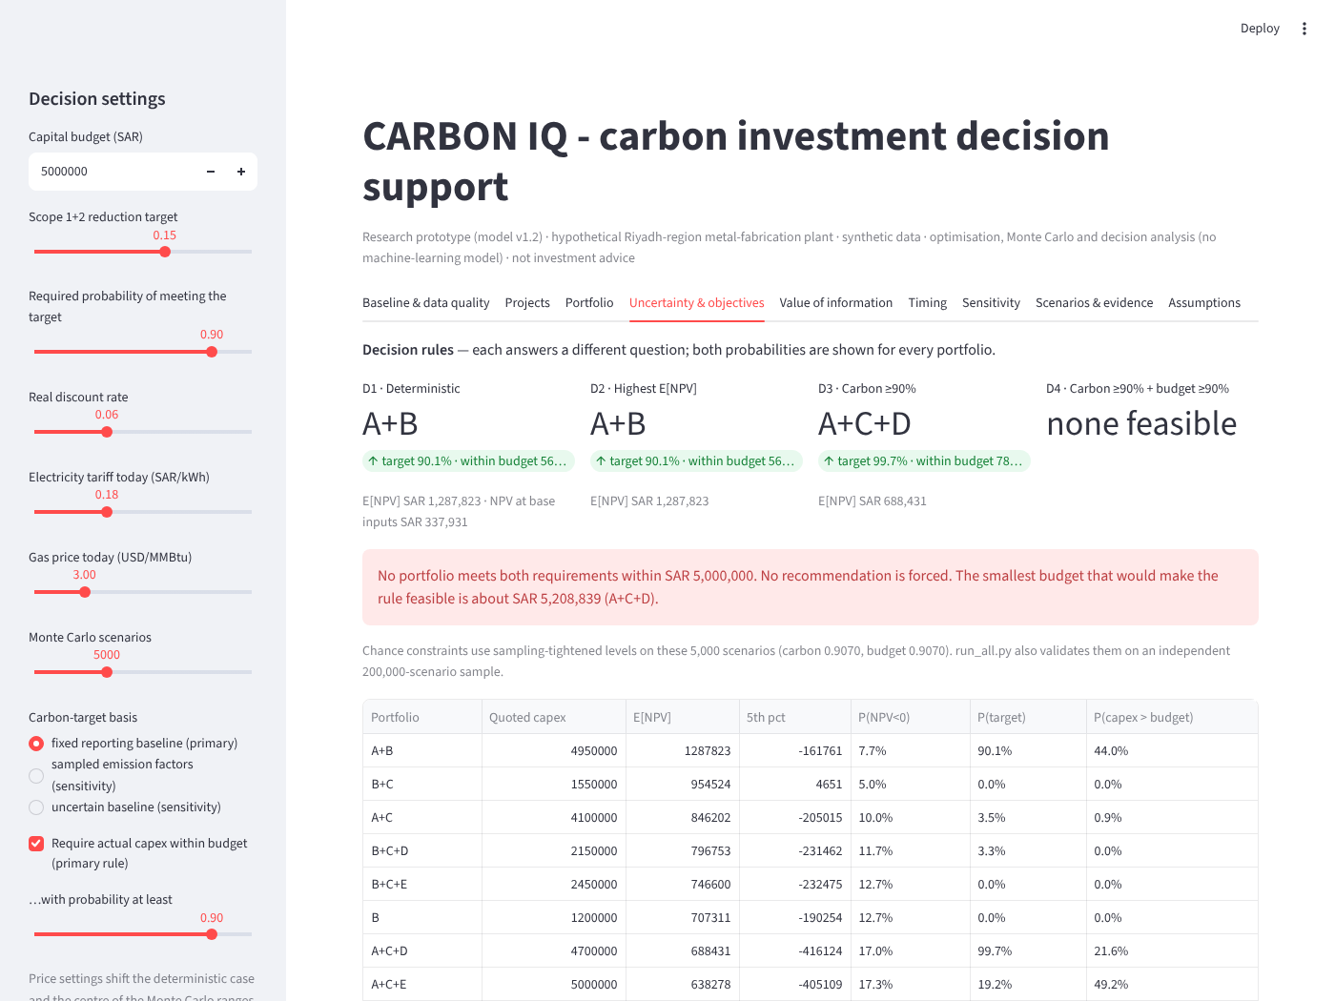
Figure 10. Prototype interface: decision rules tab (default settings, 5,000 scenarios; primary basis and 90% budget rule).

