PHASE 11 · IMPLEMENTATION REPORT · v1.0
Supplier Decision & Engagement
Carbon Decision-Support Assistant · fictional manufacturing facility, Riyadh Region · reporting year 2025 · synthetic data · integrated with Workstreams B and C
Objective. Evaluate freight suppliers using comparable carbon, financial, operational and data-quality evidence; identify supplier engagement priorities; and support transparent decisions to retain, improve, consider switching or request additional information.

Status: synthetic demonstration. Supplier names, costs, reliability, emission factors and evidence statuses are illustrative assumptions in the Phase 11 register, not real supplier records, quotations or verification certificates. Engagement-matrix scores, thresholds and weights and the scoring weights are project-designed assumptions, not official UN rules. The model never awards a contract or certifies a supplier as sustainable.

1. Summary
Phase 11 adds ten analytical modules, a 15-sheet assumptions register and a ninth dashboard tab, Supplier Decision & Engagement, to the integrated Workstream B + C application. The inventory is read, never rewritten: Scope 1 266.155, Scope 2 4,400.000 and known Scope 3 Category 4 193.097 tCO₂e (indicative total 4,859.252); Contractor A 121.956 and Contractor C 71.141 tCO₂e; Contractor B UNAVAILABLE; record completeness 48/60.
- Engagement. Carrier A: impact 70.5, maturity 39.3 → Q1, Priority 1 (Intensive engagement). Carrier C → Q4, Priority 4. Contractor B → Unclassified, insufficient evidence, with 5 default data requests.
- Switching appraisal (Carrier A → alternative D, lane L1). 120 → 80 tCO₂e/yr, 40 t avoided (33.33%), +SAR 20,000/yr, SAR 500/t annual, NPV −SAR 184,434.70, discounted lifetime cost SAR 597.13/t, break-even alternative cost SAR 296,114.86.
- Recommendations. L1 NO DEFENSIBLE RECOMMENDATION YET (R6: no willingness to pay set), L2 RETAIN EXISTING SUPPLIER, L3 IMPROVE EXISTING SUPPLIER, L4 REQUEST BETTER DATA. With a willingness to pay of SAR 600/t, L1 becomes CONSIDER SWITCHING (R7); with SAR 500/t, IMPROVE EXISTING SUPPLIER (R8).
- No double counting. On the shared activity ledger, freight efficiency (Workstream C) and switching on the inventory basis give 28.965 + 21.630 t separately but 47.350 t jointly (overlap 3.244 t removed).
- Validation. 170 passed in 14.39s: 35 Phase 4, 15 Workstream B, 25 Workstream C and 95 Phase 11 tests; 0 failed, 0 skipped. Five injected faults were all detected.

2. Architecture and data
Analytics are separated from the interface. The dashboard tab (phase11_tab.py) only displays engine results; every number in it comes from the modules below. Edits made in the dashboard are applied to a session copy, so the register and the inventory are never modified.
Table 1. Phase 11 modules
Module | Responsibility
supplier_models.py | Data classes; number parsing (blank / non-numeric / negative); emission-factor unit normalisation
supplier_data_loader.py | Loads and validates the register (duplicates, unknown references, modes, units, ranges); read-only inventory link; session edits
supplier_screening_engine.py | 14 checks (3–10 derived from data), eligibility, 7 data-quality dimensions, service equivalence
supplier_carbon_engine.py | Tonne-km comparison, partial substitution, shared activity ledger
supplier_financial_engine.py | Switching NPV, cost per tonne, break-evens (reuses the Phase 9 financial_engine.py)
supplier_engagement_engine.py | Impact, maturity, quadrant, priority, action plans
supplier_scoring_engine.py | Weight validation and normalisation, weighted scores, ranking status, weight sensitivity
supplier_uncertainty_engine.py | One-way tests, joint cases, break-evens, two-variable grid, ranking reversals
supplier_recommendation_engine.py | 7-step hierarchy, rules R1–R9, explanation fields, robustness
supplier_audit.py / run_phase11.py | Audit trail, scorecard, 20 CSV outputs and a SHA-256 manifest
The register (phase11/Phase11_Supplier_Decision_Assumptions_Register.xlsx) has 15 sheets: README, Supplier Profiles, Freight Activity, Emission Factors, Service Equivalence, Financial Inputs, Screening Evidence, Supplier Maturity, Engagement Matrix Rules, Scoring Weights, Uncertainty Assumptions, Engagement Action Plans, Monitoring Indicators, Source Register and Validation Cases. Every row has a data class and statuses use dropdowns. The Validation Cases sheet recomputes the demo with live Excel formulas, and the tests confirm the engine matches it.
Two emission bases. Lane L1 has a documented but unverified supplier-specific factor of 0.12 kgCO₂e/t-km, whereas the inventory uses the Phase 4 proxy of 0.10163. Supplier comparisons use the lane's own factor (decision basis); the inventory is unchanged. The 18.37 t gap is a methodology difference, not a reduction.

3. Screening and data quality
Fourteen checks are applied to each offer. Gate failures (identity, legal and safety) and capacity or route failures make an offer Ineligible. Missing material information makes it Insufficient evidence. A boundary mismatch, missing verification or enhancement gaps make it Conditionally eligible. Eligibility overrides any weighted score.
Table 2. Screening results
Offer | Supplier | Lane | Eligibility | Reasons / conditions
OF-A-L1 | SUP-CARR-A | L1 | Conditionally eligible | no third-party verification (confidence enhancement only)
OF-A-L3 | SUP-CARR-A | L3 | Conditionally eligible | no third-party verification (confidence enhancement only)
OF-C-L2 | SUP-CARR-C | L2 | Conditionally eligible | no third-party verification (confidence enhancement only)
OF-B-L4 | SUP-CARR-B | L4 | Insufficient evidence | check 3: Required transport capacity (offered or required capacity not stated); check 4: Comparable routes and freight specifications (not stated: destination, cargo); check 5: Freight mass and distance (freight mass and/or distan
OF-D-L1 | ALT-D | L1 | Conditionally eligible | no third-party verification (confidence enhancement only); check 13 Historical data completeness: Missing
OF-E-L1 | ALT-E | L1 | Ineligible | check 2 failed: Legal and transportation safety requirements (Transport operating licence not provided / expired (hypothetical)); no third-party verification (confidence enhancement only); check 13 Historical data completeness: Mi
Data quality is rated on seven dimensions (completeness, temporal, geographic, technological, methodological, evidence and provenance, verification) at High 100 / Medium 60 / Low 20 / Missing 0. An unverified but documented estimate remains usable with its uncertainty. Contractor B has no usable estimate: its emissions are UNAVAILABLE, never zero.

4. Engagement priority matrix
The UN Global Compact framework segments suppliers by impact and maturity into Priorities 1–4, but it does not prescribe scores. Phase 11 therefore uses project-designed, editable rules. Impact = 0.5 × share of known freight emissions + 0.3 × share of known tonne-km (both as 0–100) + 0.2 × materiality score. Maturity = mean of the assessed 0–4 indicators ÷ 4 × 100, requiring at least 5 of 7 indicators. Both thresholds default to 50.
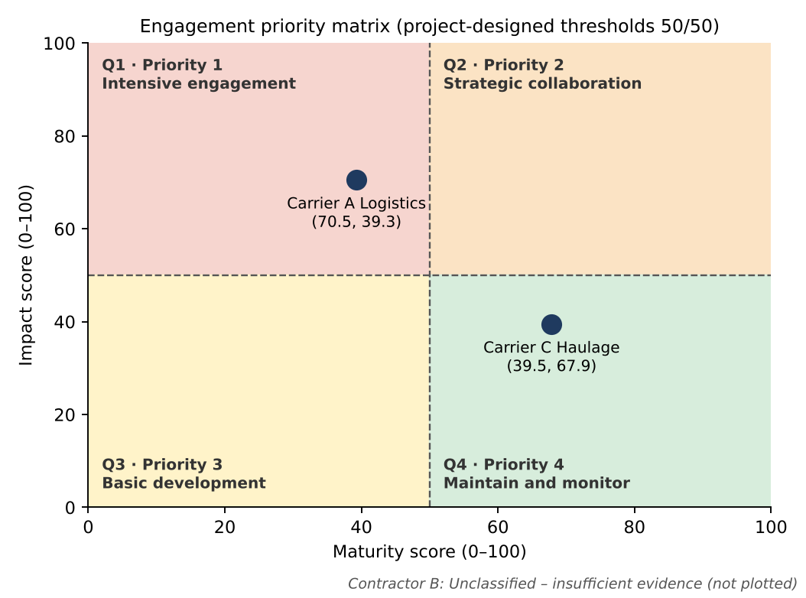
Figure 1. Engagement priority matrix (computed from the engines). Contractor B is not plotted because a position would require invented data.
Table 3. Engagement classification
Supplier | Impact | Maturity | Quadrant | Priority | Engagement | Actions
SUP-CARR-A | 70.5 | 39.3 | Q1 | 1 | Intensive engagement | 7
SUP-CARR-B | — | — | UNCLASSIFIED | Data engagement | Unclassified - insufficient evidence | 5
SUP-CARR-C | 39.5 | 67.9 | Q4 | 4 | Maintain and monitor | 5
The matrix sets engagement priority only; it never triggers replacement, and a test confirms that no threshold setting produces a switching recommendation. A labelled sensitivity can assign Contractor B a hypothetical 200 tCO₂e/yr (from the Phase 10 workbook). This changes only B's impact score, and B stays unclassified because just 3 of its 7 maturity indicators are assessed.

5. Alternatives, carbon and financial trade-off
The functional unit is the tonne-km of the same lane service. Offers on different lanes, with incompatible boundaries, units or periods, or with insufficient capacity are reported as limitations rather than compared.
emissions = tonne-km × EF ÷ 1,000; avoided = (EF current − EF alternative) × substituted tonne-km ÷ 1,000
NPV = −one-time costs + (current − alternative − recurring cost) × annuity factor(5%, 10 y)
discounted lifetime cost per tCO₂e = net present cost ÷ (avoided t/yr × annuity factor)
Table 4. Synthetic demonstration: Carrier A → alternative D on lane L1
Metric | Value | Metric | Value
Current emissions | 120.0 tCO₂e/yr | Annual cost difference | +SAR 20,000
Alternative emissions | 80.0 tCO₂e/yr | One-time switching cost | SAR 30,000
Avoided | 40.0 t (33.33%) | Annuity factor | 7.721735
Annual cost per tCO₂e | SAR 500 | Switching NPV | −SAR 184,434.70
Discounted lifetime cost / tCO₂e | SAR 597.13 | Break-even alternative cost | SAR 296,114.86/yr
The brief gave the NPV as "≈ −184,443". The exact closed-form value, which Excel's PV function in the register also returns, is −SAR 184,434.70, a SAR 8.30 difference. A negative NPV is not an automatic rejection: it is the price of the reduction and has to be weighed against a management willingness to pay, which the register deliberately leaves blank.

Weighted scoring (supporting evidence only)
Default weights are carbon 35, lifecycle cost 25, reliability 20, data quality 15 and improvement 5. These are illustrative project assumptions that the user can change; they are validated (numeric and non-negative) and normalised. A missing mandatory input gives no total and suppresses the ranking. The L1 ranking is DEFINITIVE.
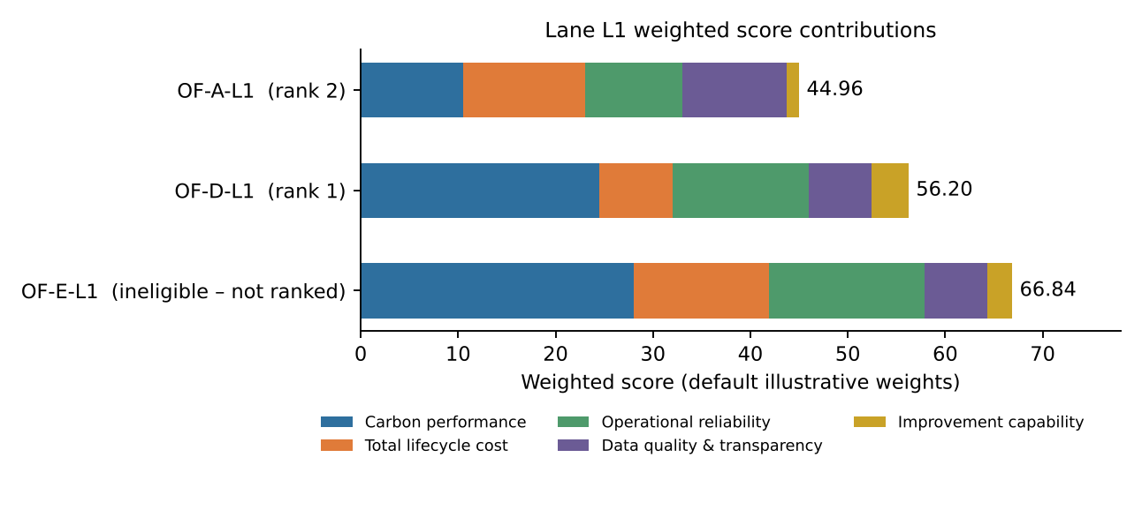
Figure 2. Lane L1 weighted score contributions. Alternative E has the highest score but failed the safety gate, so it is not ranked.
Ranking sensitivity: with a carbon weight below 10%, OF-A-L1 ranks first instead of OF-D-L1. A 60% cost weight also puts Carrier A first. Neither ±10 percentage-point weight changes nor the registered parameter ranges reverse the ranking.

6. Explainable recommendations
The project-designed hierarchy applies, in order: legal and safety → evidence sufficiency → service equivalence → comparable carbon and cost → operational risk → uncertainty → conditional recommendation. Each recommendation records its evidence, assumptions, carbon, financial and operational implications, data limitations, sensitivity, next steps and a human-approval flag.
Table 5. Rules
Rule | Condition | Action
R1 | Incumbent fails a mandatory gate | INELIGIBLE / ESCALATE
R2 | Incumbent evidence insufficient | REQUEST BETTER DATA
R3 / R4 | No viable alternative / no alternative with lower emissions | IMPROVE (Priority 1/3 or unclassified) or RETAIN
R5 | Lower emissions, NPV ≥ 0, carbon benefit robust across joint cases | CONSIDER SWITCHING
R6 | Lower emissions, NPV < 0, no willingness to pay set | NO DEFENSIBLE RECOMMENDATION YET
R7 | Lower emissions, lifetime cost per tonne ≤ willingness to pay, robust | CONSIDER SWITCHING
R8 | Lower emissions, cost per tonne > willingness to pay | IMPROVE / RETAIN
R5u / R7u / R9 | Carbon benefit not robust, or financial-only gain | NO DEFENSIBLE RECOMMENDATION YET
Table 6. Results with default inputs
Lane | Recommendation | Rule | Reason | Best alternative | Approval
L1 | NO DEFENSIBLE RECOMMENDATION YET | R6 | Lower emissions at a net financial cost and no management willingness-to-pay threshold set: the trade-off needs management judgement | OF-D-L1 | Yes
L2 | RETAIN EXISTING SUPPLIER | R3 | No eligible, equivalent and comparable alternative for this service | — | No
L3 | IMPROVE EXISTING SUPPLIER | R3 | No eligible, equivalent and comparable alternative for this service | — | No
L4 | REQUEST BETTER DATA | R2 | Incumbent evidence insufficient (missing material information); no comparison is defensible | — | No
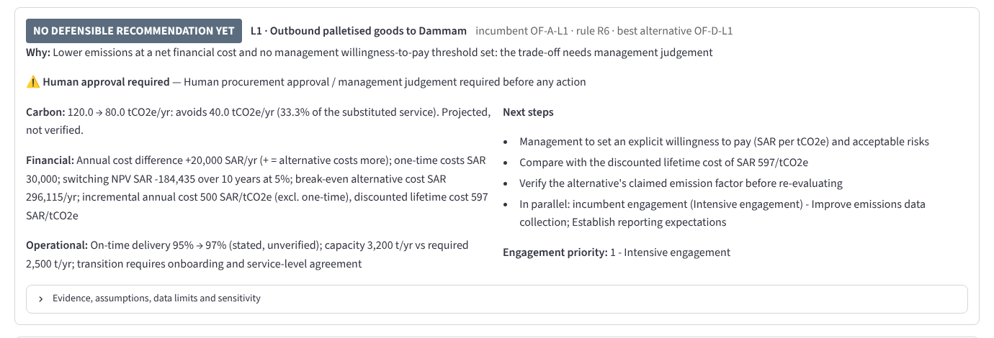
Figure 3. Recommendation card for lane L1 in the dashboard (section 6).

7. Uncertainty and double counting
Low, base and high values come from the register. They are stress tests, not probabilities.
Table 7. Joint cases for A → D on lane L1
Case | Avoided (t/yr) | NPV (SAR) | Lifetime cost per tCO₂e (SAR)
Unfavourable to switching | 10.00 | -523,304 | 6,777.03
Base | 40.00 | -184,435 | 597.13
Favourable to switching | 70.00 | 62,217 | -115.11
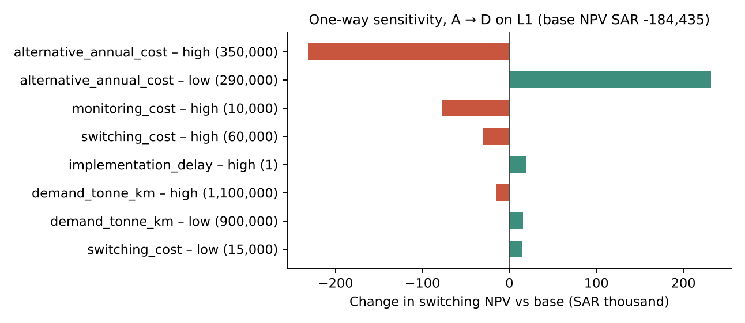
Figure 4. One-way sensitivity of the switching NPV. Emission-factor variables change tonnes avoided, not NPV, so they are omitted here.
The L1 recommendation is not robust: alternative_annual_cost low (290000) → CONSIDER SWITCHING. This is why management judgement and verified evidence are required before any switch.
Workstream C's freight optimisation and supplier switching act on the same tonne-km, so a single activity ledger applies both jointly: combined emissions = activity × (1 − efficiency) × [(1 − share) × current EF + share × alternative EF]. The baseline is never rewritten and Contractor B is never inserted.
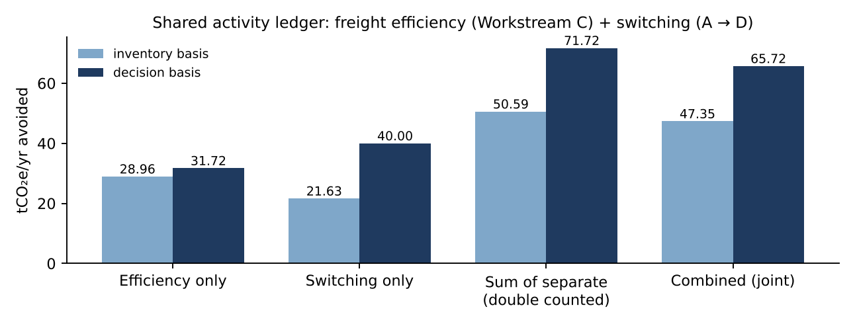
Figure 5. Shared activity ledger. On the inventory basis the efficiency figure (28.965 t) equals Workstream C's.

8. Action plans, monitoring and audit
- Action plans are generated from register templates by quadrant, verification gap, ineligibility or unclassified status. Each action has a responsible role, a deadline of 30, 60 or 90 days (an editable management assumption, not a UN requirement), required evidence, a success indicator, a status that can be edited in the session, a follow-up date and a verification method.
- The monitoring scorecard keeps projected and verified reductions separate. Verified reductions are 'none — no post-implementation data'; change indicators wait for a second reporting period.
- Each audit record holds the input version (register SHA-256), engine version, supplier and offer IDs, source, period, method, emission factor and its verification status exactly as recorded, assumptions, the rule triggered and the evidence status. No certificates or audit findings are invented.
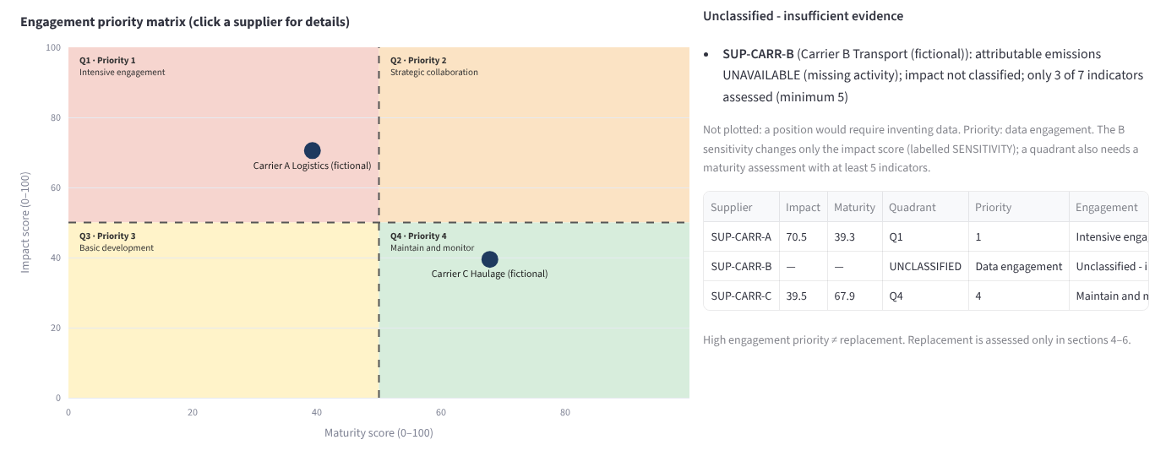
Figure 6. Engagement matrix in the dashboard (section 3), with editable thresholds and the unclassified panel.

9. Validation
Suite | Passed | Failed | Skipped
phase4/test_phase4.py | 35 | 0 | 0
test_workstream_b.py | 15 | 0 | 0
test_workstream_c.py | 25 | 0 | 0
test_phase11.py | 95 | 0 | 0
Total | 170 | 0 | 0
Command: python -m pytest -v. The only change to an existing test is the tab check in test_workstream_c.py, which now accepts the ninth tab after the unchanged eight. All Workstream B and C outputs are byte-identical to the uploaded package, and a fresh Workstream C run reproduces the committed manifest hashes. Full details are in Phase11_Validation_Report.md.

10. Limitations and next steps
- All supplier, cost, reliability, factor and evidence values are synthetic; the recommendations demonstrate the method only.
- Supplier factors are unverified (A documented, D claimed); the comparison would change if verification revised them.
- Contractor B has no activity, cost or service data, so it cannot be compared or classified until data is received.
- No willingness to pay is set, so lane L1 stays at NO DEFENSIBLE RECOMMENDATION YET by design.
- Dashboard edits and action statuses last for the session only (CSV/ZIP downloads are provided); persistent storage is not implemented.
- Clicking a point in the matrix uses Streamlit's selection events, which AppTest cannot simulate; the supplier selection box provides the same details.
- The Colab steps were written for Colab but could not be executed there from the build environment.

Next steps
- Collect 12 months of Contractor B activity and complete its maturity assessment.
- Obtain fuel-based evidence or third-party assurance for the Carrier A and alternative D factors.
- Have management set a willingness to pay and an acceptable-risk statement, then re-run the trade-off.
- Replace synthetic costs with formal quotations and contract terms before any procurement decision.

