WORKSTREAM B · PHASES 6–7 DELIVERABLE · v1.1
Emissions Calculation Engine, Hotspots and Data Confidence
AI-Enabled Carbon Decision-Support Platform · fictional facility, Riyadh Region · 2025 · synthetic activity data
Status: preliminary, demonstration-only results, not a verified 2025 corporate GHG inventory. Electricity now uses the Saudi Electricity Company (SEC) 2024 factor of 550 kg CO₂e/MWh, a provisional location-based Scope 2 proxy whose published value has not yet been confirmed; diesel and freight use UK proxy factors, and Contractor B's activity data is missing.

1. What Phases 6–7 deliver
Phase 6 finalises the calculation engine on the Phase 4 activity data, factor register and validator. Phase 7 adds a Streamlit/Plotly dashboard that ranks emission hotspots and shows how far each result can be trusted, using explicit criteria rather than statistical percentages. v1.1 aligns Workstream B with the updated Phase 3 and Phase 4: the engine reads the electricity factor FAC-ELEC-SEC-01 (550 kg CO₂e/MWh, SEC 2024, provisional_proxy) directly from the Phase 4 factor library, replacing the earlier 614.2 kg CO₂/MWh factor. Activity data and the diesel and freight factors are unchanged.
- Engine (calc_engine.py). Re-runs the 16 Phase 4 data-quality rules (0 BLOCK on clean data), calculates quantity × factor ÷ 1,000 per record, and aggregates by source, scope and month. A 40-field audit trail keeps each record's activity ID, factor ID and value, units, gas coverage, factor source, title, version, location, reference year, boundary, accounting scope and method and verification status, evidence reference, formula and validator flags.
- Reproducibility. Each run writes SHA-256 hashes of its inputs and outputs. Two independent runs on 21 Oct 2026 produced identical output hashes, and the Phase 4 input files are byte-identical to the updated Phase 4 package.
- Tests (executed). 50/50 passed on 21 Oct 2026: 15 Workstream B tests (12 hand-calculated cases matched, reproducibility, audit-trail recomputation, Contractor B unavailable, gas labels, completeness, label rules, dashboard smoke test, and four new checks: factor loaded from the Phase 4 library with its provenance, no superseded factor in outputs, total and shares reconcile, provisional factor not scored as verified) plus the 35 Phase 4 tests.

2. Emissions hotspots
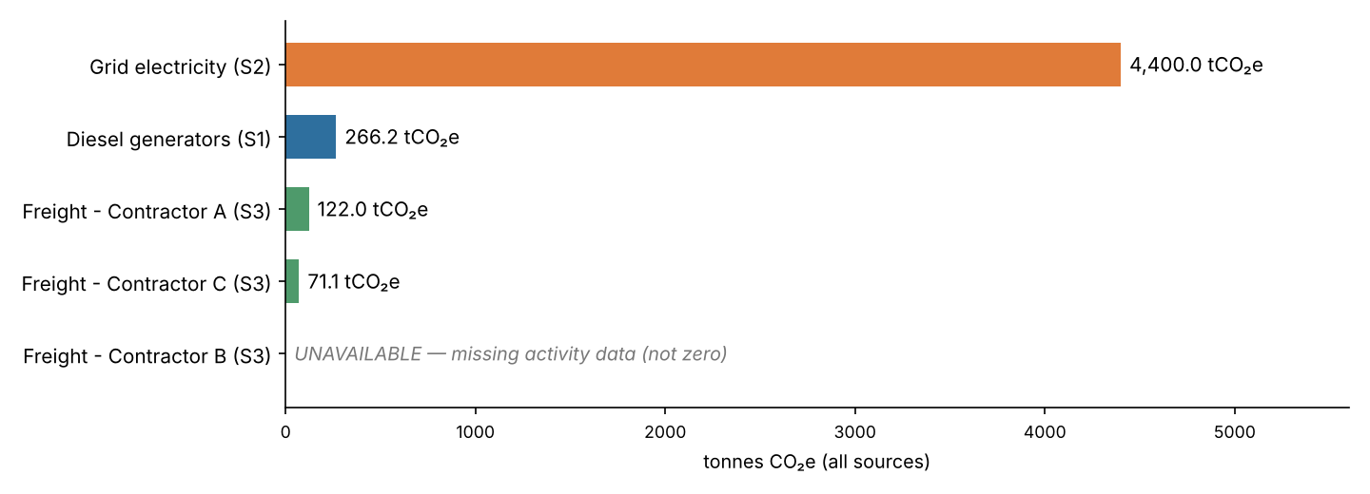
Figure 1. Annual emissions by source (dashboard Hotspots tab). Bar colour = scope.
Table 1. Results by source and indicative hotspot ranking
Rank | Source | Annual activity | Emissions | Share of quantified* | Status
1 | Grid electricity (Scope 2) | 8,000 MWh | 4,400.000 tCO₂e | 90.5% | Complete, provisional factor
2 | Diesel generators (Scope 1) | 100,000 L | 266.155 tCO₂e | 5.5% | Complete
3 | Freight, Contractor A (S3 Cat. 4) | 1,200,000 tonne-km | 121.956 tCO₂e | 2.5% | Complete
4 | Freight, Contractor C (S3 Cat. 4) | 700,000 tonne-km | 71.141 tCO₂e | 1.5% | Complete
– | Freight, Contractor B (S3 Cat. 4) | Missing (12 × NULL) | Unavailable | — | No data
 | Scope 3 Cat. 4 known-data subtotal | 1,900,000 tonne-km | 193.097 tCO₂e | 4.0% | Incomplete
* Share of the quantified total (4,859.3 tCO₂e). All sources are now CO₂e, but the total excludes Contractor B, so it is an indicative, incomplete total and not a corporate inventory.
Interpretation. Purchased grid electricity is the dominant hotspot, about 16.5 times Scope 1 and 90.5% of the quantified total. Its value now uses a CO₂e factor, but that factor is a provisional SEC 2024 proxy: the published figure, its MWh basis and its coverage of the whole Saudi grid are unconfirmed, and a 2024 value is applied to 2025. The change from 4,913.6 tCO₂ (v1.0) to 4,400.0 tCO₂e comes only from the factor change; it is not an emissions reduction, and the two figures are not like-for-like (CO₂ only versus CO₂e). Diesel is a distant second, with emissions concentrated in the summer months (June–September), following higher generator use. Known freight is the smallest quantified source, but it carries the greatest completeness risk: one of three carriers is unquantified, and its share cannot be bounded without activity data. Monthly electricity emissions peak in July–August (443 tCO₂e per month) against 292 tCO₂e in December, consistent with cooling demand.

3. Data confidence
Record completeness is not emissions coverage. 48 of 60 monthly records (80%) contain activity data, and the 12 missing records all belong to Contractor B. Emissions coverage is a different measure: 4 of 5 sources are quantified, Scopes 1 and 2 are fully quantified, and Scope 3 Category 4 is partial (2 of 3 carriers). The share of true total emissions covered is unknown. The missing 20% of records cannot be read as 20% of emissions, because no activity data exists to size Contractor B.
Table 2. Confidence criteria and labels (Met / Partial / Not met)
Source | C1 Completeness | C2 Factor age | C3 Geography | C4 Gas coverage | C5 Verification | C6 Boundary | Label
Diesel generators | Met | Met | Partial | Met | Partial | Met | MODERATE
Grid electricity | Met | Partial | Met | Met | Not met | Met | MODERATE
Freight, Contractor A | Met | Met | Partial | Met | Not met | Partial | LOW
Freight, Contractor C | Met | Met | Partial | Met | Not met | Partial | LOW
Freight, Contractor B | Not met | Met | Partial | Met | Not met | Partial | NOT QUANTIFIED
Criteria: C1, 12/12 months with data; C2, factor year equals 2025 (Not met if 3 or more years older); C3, Saudi-specific factor (Partial for a documented proxy); C4, CO₂e covering CO₂, CH₄ and N₂O (Not met if CO₂ only); C5, value checked against the published source (Partial if only a secondary copy was checked, Not met if unverified, including a provisional proxy not yet checked against its source); C6, boundary matches the Phase 3 expectation (Partial for an accepted proxy boundary). Rule: NOT QUANTIFIED if there is no activity data; LOW if 2 or more criteria are Not met, or 1 is Not met and 2 or more are Partial; HIGH if all are Met; otherwise MODERATE. Every label is additionally capped as demonstration only, because all activity data is synthetic.
No source reaches HIGH. Electricity, the largest hotspot, moves from LOW to MODERATE under the unchanged criteria: the SEC factor is Saudi-specific, CO₂e and matches the Phase 3 boundary, but it is one year older than the reporting year (C2 Partial) and its value is not yet verified against the primary report (C5 Not met). The label reflects the documented criteria, not the publisher, and the factor stays provisional. Confirming the SEC value, and the DESNZ diesel and freight values, would raise overall confidence more than any other single action.

4. Remaining limitations
- Not an inventory. Activity data is synthetic, and the quantified total (4,859.3 tCO₂e) excludes Contractor B, so it is indicative only.
- Factors. The electricity factor is the SEC 2024 intensity (550 kg CO₂e/MWh), used as a provisional location-based Scope 2 proxy: its published value, unit and reporting boundary have not been confirmed against the primary report, its representativeness of the entire Saudi grid is not established, and a 2024 value is applied to 2025. The UK diesel and freight factors are proxies, and the freight factor excludes well-to-tank emissions. The freight factor (0.10163) is still unverified, and the diesel factor is checked only against a secondary copy; both need a check against the primary DESNZ workbook.
- Contractor B. Scope 3 Category 4 cannot be completed until data is received, or until an estimate is made and labelled as estimated/imputed (rule DQ-12).
- No uncertainty ranges yet. The labels describe data quality; they are not quantified uncertainty.

5. Readiness for the next workstream
Ready for scenario modelling and investment evaluation: a validated, reproducible, auditable baseline by source and month (Scope 2 = 4,400.000 tCO₂e; indicative quantified total 4,859.252 tCO₂e, Contractor B excluded); gas-labelled scope totals; hotspot ranking; per-source confidence labels; and the electricity factor metadata (FAC-ELEC-SEC-01, SEC 2024, location-based, provisional_proxy) in the audit trail. The next workstream can model electricity, diesel and outsourced-freight interventions against the hypothetical SAR 1 million budget. It should test (i) the provisional SEC electricity factor against alternative Saudi grid factors once verified, (ii) alternative freight factors, and (iii) a clearly labelled range for Contractor B, so it can check whether data uncertainty changes the preferred investment. Run: pip install -r requirements.txt → python calc_engine.py → streamlit run app.py → python -m pytest.

