WORKSTREAM C · PHASES 8–10 · IMPLEMENTATION REPORT · v1.0
Reduction Scenarios, Financial Evaluation and Uncertainty-Aware Decision Analysis
Carbon Decision-Support Assistant · fictional manufacturing facility, Riyadh Region · reporting year 2025 · synthetic data · integrated with Workstream B
Status: illustrative, demonstration-only results. Activity data, reduction rates, costs and savings are synthetic. The electricity factor (550 kgCO₂e/MWh, SEC 2024) is a provisional location-based Scope 2 proxy, Contractor B's freight activity is missing, and no operational-feasibility check has been validated. Nothing in this report is a verified saving, a vendor quotation or an investment recommendation. The software is deterministic Python; it contains no AI or machine-learning component.

1. Summary
Workstream C adds three engines and three dashboard tabs to the existing Workstream B application. All assumptions are read from the uploaded Phase 8, Phase 9 and corrected Phase 10 workbooks; all emissions are recalculated from the Phase 4 activity records through the unchanged Workstream B engine. The baseline is unchanged: Scope 1 266.155, Scope 2 4,400.000 and known Scope 3 Category 4 freight 193.097 tCO₂e, an indicative quantified total of 4,859.252 tCO₂e with Contractor B unavailable.
- Phase 8. Default scenarios avoid 26.616 (diesel), 28.965 (known freight) and 440.000 tCO₂e/yr (electricity); applied together, 495.580 tCO₂e/yr (10.20% of the quantified total), with no double counting.
- Phase 9. Base-case financial NPVs are SAR 17,217, 96,209 and 619,652, identical to the Phase 9 workbook; all three have negative net cost per tonne (potential net savings) under the synthetic inputs.
- Phase 10. All three interventions have positive NPV in the base and high cases and negative NPV in the low case. The electricity–freight NPV tie occurs at electricity gross savings of SAR 92,211.74/yr, reproduced independently.
- Validation. 75 passed (35 Phase 4, 15 Workstream B, 25 Workstream C); 228/228 engine-versus-workbook reconciliation checks match; two clean runs reproduce identical SHA-256 output hashes.

Conditional findings (generated from the results)
- Electricity efficiency has the highest modelled financial NPV under the base assumptions (SAR 619,652), but its attractiveness depends on achieving the assumed operating savings: it would fall to the same NPV as known freight optimisation if its annual gross savings were SAR 92,212 instead of SAR 160,000, and to zero NPV at SAR 79,752. Results are illustrative and require engineering and financial validation.
- In the low case all three interventions have negative financial NPV; diesel efficiency is only the least negative (SAR -67,576) and is not recommended on financial grounds.
- Electricity efficiency gives the largest modelled annual abatement (440.0 tCO2e/yr on known data), which is a synthetic assumption, not a verified saving; its emission factor is a provisional SEC 2024 Scope 2 proxy.
- Known freight optimisation has the lowest net cost per tonne (SAR -332/tCO2e, a potential net saving) but the smallest absolute scale, and it covers known freight only (Contractor B missing).
- One-way ranking reversals within the tested 0.5x-1.5x range occur only for: electricity efficiency gross savings multiplier below 0.576x; electricity efficiency effectiveness multiplier (savings scale) below 0.576x. No reversal was found for CAPEX, OPEX, the shared discount rate (0-15%) or lead time (0-3 years) within the tested ranges.
- No option has validated operational feasibility; all checks in the Phase 9 feasibility register are unvalidated or provisional, so no intervention is recommended for procurement.

2. Data sources, source of truth and workbook findings
Each assumption has one source of truth; copies of the same number in other workbooks are checked, not used. Cells are located by their row labels, and every output cites the workbook cell it came from.
Table 1. Source of truth for each input
Input | Source of truth | Checked against
Baseline emissions per intervention | Workstream B engine (calc_engine.py) on phase4/data | Phase 8 F2:F4, Phase 9 B5:D5, Phase 10 B4:D4
Reduction rates 10% / 15% / 10% | Phase 8 'Scenario Register'!G2:G4 | Phase 9 B6:D6, Phase 10 B5:D5
CAPEX, gross savings, OPEX, lead time, life | Phase 9 'Assumptions'!B8:D12 | Phase 10 'Inputs'!B6:D10
Horizon 10 years, real discount rate 5% | Phase 9 'Assumptions'!B18:B19 | Phase 10 'Inputs'!B15:B16
Low/high multipliers, Contractor B inputs | Phase 10 (corrected) 'Inputs'!B17:B28 | —
Feasibility checklist | Phase 9 'Feasibility'!A4:E13 | —
Emission factors | phase4/data/emission_factors.csv (unchanged) | Workstream B tests
Cross-workbook consistency: 33 checks OK, 0 mismatches. The engines refuse to run if any mismatch appears. The workbooks are stored unchanged in workbooks/ and their SHA-256 hashes are tested.
Table 2. Findings from inspecting the workbooks
# | Finding | How the integration handles it
1 | Corrected Phase 10 'Cases' includes 200 tCO₂e/yr of hypothetical Contractor B in the base freight case (Cases!H8 = 58.96 tCO₂e/yr; Decision Summary C9). Phases 8–9 use 28.96 tCO₂e/yr (known data only). | Known-data abatement (28.96) is the primary figure; the hypothetical-B term is reported in a separate, labelled column. The workbook's combined figure is still reproduced exactly for reconciliation. NPV is unaffected (no costs or savings assigned to Contractor B).
2 | Phase 9 payback and cost per tonne formulas return 0 when net savings or lifetime tonnes are ≤ 0; Phase 10's NPV formula returns −CAPEX when the discount rate is 0%. | The engines return 'not reached / not defined' and compute 0% exactly. Results are identical at all workbook inputs; the difference matters only in sensitivity sweeps.
3 | Phase 10 'Inputs' row 11 ('Annual freight share eligible for Contractor B' = 0) is not referenced by any formula; applicability comes from Inputs!B28 = 1. | Applicability is read from B28, matching the workbook; row 11 is reported as unused.
4 | Phase 8 baseline activity cells D2:D3 are blank. | Activity is taken from the Phase 4 records (100,000 L; 1,900,000 tonne-km).
5 | In Phases 9–10 the column 'Freight B' means intervention B (Contractors A + C), not Contractor B. | Documented in code and outputs; Contractor B is always named explicitly.
6 | Phase 10 stress cases scale gross savings with effectiveness (savings × savings multiplier × effectiveness multiplier). | Reproduced as documented in Inputs!A33; the same convention is used in one-way effectiveness sensitivity.

3. Phase 8 — reduction scenario engine (scenario_engine.py)
Each scenario copies the 60 clean Phase 4 activity records in memory, scales the quantities of the target records and recalculates every record with the unchanged Workstream B engine (Phase 4 validator and calculator). Factor IDs, units, gas labels, validation flags and missing-data handling are therefore identical to the baseline, and the original files are never written.
Scenario quantity = baseline quantity × Π (1 − rᵢ) over interventions i acting on the record
Scenario emissions (tCO₂e) = scenario quantity × factor (kgCO₂e/unit) ÷ 1,000; avoided = baseline − scenario
Targets: A = diesel_stationary (SUP-FUEL-01); B = freight_road_outbound for Contractors A and C only; C = electricity_purchased (FAC-ELEC-SEC-01, 550 kgCO₂e/MWh). The multiplicative rule means two interventions on the same record could never double count (10% and 10% give 19%, not 20%); in the default set A, B and C act on different records, so the combined result equals their sum. Contractor B's 12 records keep a NULL quantity: they are not reduced, not zero and remain UNAVAILABLE.
Table 3. Scenario results (annual, tCO₂e)
ID | Scenario | Rates | Affected baseline | Avoided | % of affected | % of quantified | Scenario quantified total
A | Diesel generator efficiency | A=0.1 | 266.155 | 26.616 | 10.0% | 0.55% | 4,832.636
B | Known freight activity optimization | B=0.15 | 193.097 | 28.965 | 15.0% | 0.60% | 4,830.287
C | Electricity efficiency | C=0.1 | 4,400.000 | 440.000 | 10.0% | 9.05% | 4,419.252
ABC | Combined: Diesel generator efficiency + Known freight activity optimization + Electricity efficiency | A=0.1; B=0.15; C=0.1 | 4,859.252 | 495.580 | 10.2% | 10.20% | 4,363.672
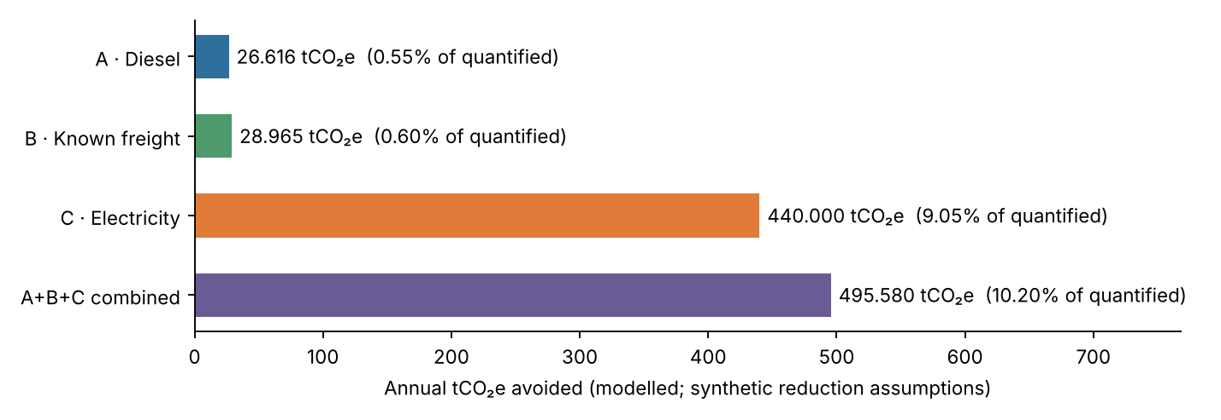
Figure 1. Annual tCO₂e avoided by scenario (from scenario_comparison.csv). Shares are of the incomplete quantified total.
The freight result differs from the workbook's 28.96455 by 0.000002 tCO₂e because the Phase 4 calculator rounds each monthly record to six decimals, whereas the workbook multiplies the annual total. Monthly results (scenario_monthly.csv) sum exactly to the annual figures. Rates can be changed interactively in the dashboard; the workbook defaults are restored on reload.

4. Phase 9 — financial and operational evaluation (financial_engine.py)
The engine reproduces the Phase 9 'Cash Flows' and 'Decision Summary' sheets: constant real SAR, CAPEX at year 0, end-of-year net savings while lead time < t ≤ min(technical life, horizon), no escalation, residual value, taxes or financing (company cash-flow perspective).
Financial NPV = −CAPEX + Σₜ (gross savings − OPEX) / (1 + r)ᵗ , r = 5% real, t = 1…10
Net present cost (NPC) = −NPV; Net cost per tonne = NPC ÷ (annual avoided tCO₂e × benefit years)
Cost per tonne: the numerator is discounted SAR and the denominator is undiscounted physical tonnes, exactly as in the workbook; money is never mixed between discounted and undiscounted values. A negative value indicates a potential net financial saving per tonne (negative net abatement cost), not a verified saving. A supplementary 'levelised' variant divides NPC by discounted tonnes and is reported separately. Simple payback = CAPEX ÷ annual net savings (workbook); discounted payback and IRR are added for information.
Table 4. Financial inputs and NPV (SAR)
Intervention | CAPEX | Gross savings/yr | OPEX/yr | Net savings/yr | NPV (engine) | NPV (workbook)
A · Diesel efficiency | 60,000 | 15,000 | 5,000 | 10,000 | 17,217 | 17,217
B · Known freight optimization | 120,000 | 40,000 | 12,000 | 28,000 | 96,209 | 96,209
C · Electricity efficiency | 500,000 | 160,000 | 15,000 | 145,000 | 619,652 | 619,652
Table 5. Payback, return and abatement cost
Intervention | Simple payback (y) | Discounted payback (y) | IRR | Avoided tCO₂e/yr | Lifetime tCO₂e | SAR/tCO₂e (workbook) | SAR/tCO₂e (levelised)
A · Diesel efficiency | 6.00 | 7.32 | 10.6% | 26.616 | 266.2 | -64.69 | -83.78
B · Known freight optimization | 4.29 | 4.94 | 19.4% | 28.965 | 289.6 | -332.16 | -430.16
C · Electricity efficiency | 3.45 | 3.88 | 26.2% | 440.000 | 4,400.0 | -140.83 | -182.38
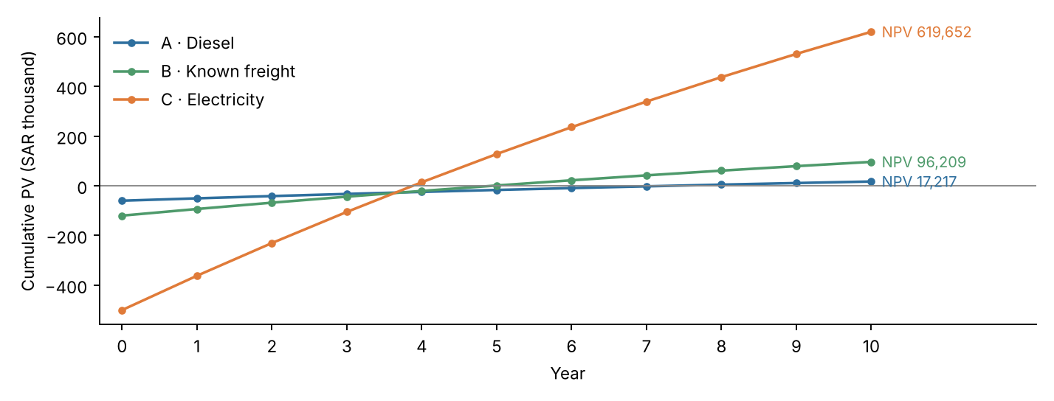
Figure 2. Cumulative discounted cash flow, years 0–10 (financial_cash_flows.csv).
A portfolio of all three (additive cash flows, assuming no interactions, which the workbook does not specify) needs SAR 680,000 CAPEX and gives NPV SAR 733,077 and 495.580 tCO₂e/yr.
Table 6. Operational feasibility checklist (Phase 9) — none validated
ID | Check | Evidence needed | Status | Implication
A | Generator reliability and duty cycle | Run-hour logs, backup-power requirements, maintenance records | Not validated | Do not reduce essential standby capacity
A | Efficiency mechanism | Measured loading, idle time, equipment audit | Not validated | 10% savings remains hypothetical
B | Carrier participation | Carrier contract, route plans, tonnes and distances | Not validated | Cannot assume contractors will cooperate
B | Service and delivery quality | Lead times, capacity, delivery frequency | Not validated | Avoid reductions achieved only by reduced output
B | Contractor B missing | 12 monthly activity records and freight factors | Unavailable | Scope 3 comparison is incomplete
C | Energy audit | Submetering, motor inventory, compressor and HVAC profiles | Not validated | Confirm achievable MWh savings
C | Operational downtime | Installation schedule, production loss assessment | Not validated | Downtime cost may change NPV
C | Emission-factor suitability | SEC factor primary source and accounting boundary | Provisional | Avoid presenting emissions as verified
A | Consistent output/service | Production volume, service-level targets | Not validated | Compare equal production/service levels
B | Consistent output/service | Production volume, service-level targets | Not validated | Compare equal production/service levels
C | Consistent output/service | Production volume, service-level targets | Not validated | Compare equal production/service levels
A | Financial input verification | Saudi tariffs, supplier quotes, cost year and taxes | Synthetic | Replace placeholder cash flows before recommendation
B | Financial input verification | Saudi tariffs, supplier quotes, cost year and taxes | Synthetic | Replace placeholder cash flows before recommendation
C | Financial input verification | Saudi tariffs, supplier quotes, cost year and taxes | Synthetic | Replace placeholder cash flows before recommendation

5. Phase 10 — uncertainty-aware decision analysis (uncertainty_engine.py)

5.1 Low, base and high cases
Joint stress cases from the corrected Phase 10 workbook: effectiveness ×0.7/×1.2, CAPEX ×1.3/×0.9, gross savings ×0.7/×1.2 (and scaled with effectiveness), OPEX ×1.2/×0.9. They are coherent stress tests, not statistical confidence intervals. Rank 1 is the highest NPV within each case, even when every NPV is negative.
Table 7. Cases (known-data abatement primary; hypothetical Contractor B separate)
Case | ID | Eff. | CAPEX | Savings/yr | OPEX/yr | NPV (SAR) | Rank | Avoided known t/yr | + hyp. B t/yr | SAR/t (known)
Low | A | 0.070 | 78,000 | 7,350 | 6,000 | -67,576 | 1 | 18.631 | — | 362.7
Low | B | 0.105 | 156,000 | 19,600 | 14,400 | -115,847 | 2 | 20.275 | 5.250 | 571.4
Low | C | 0.070 | 650,000 | 78,400 | 18,000 | -183,607 | 3 | 308.000 | — | 59.6
Base | A | 0.100 | 60,000 | 15,000 | 5,000 | 17,217 | 3 | 26.616 | — | -64.7
Base | B | 0.150 | 120,000 | 40,000 | 12,000 | 96,209 | 2 | 28.965 | 30.000 | -332.2
Base | C | 0.100 | 500,000 | 160,000 | 15,000 | 619,652 | 1 | 440.000 | — | -140.8
High | A | 0.120 | 54,000 | 21,600 | 4,500 | 78,042 | 3 | 31.939 | — | -244.3
High | B | 0.180 | 108,000 | 57,600 | 10,800 | 253,377 | 2 | 34.757 | 108.000 | -729.0
High | C | 0.120 | 450,000 | 230,400 | 13,500 | 1,224,844 | 1 | 528.000 | — | -232.0
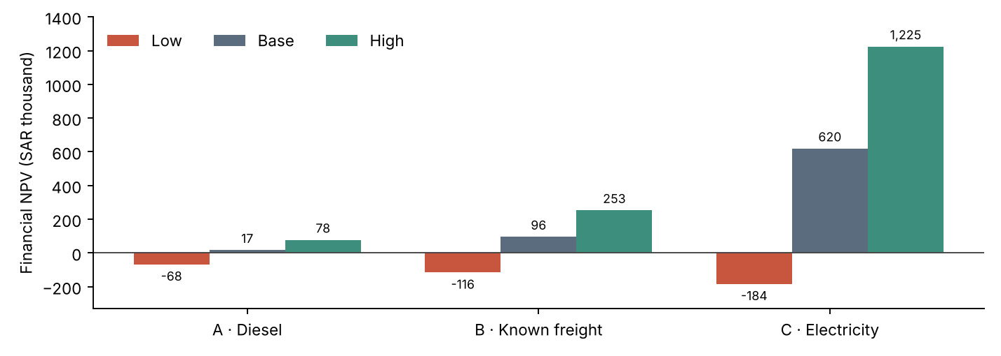
Figure 3. Financial NPV by case (uncertainty_cases.csv). All three options are negative in the low case.

5.2 One-way sensitivity
Each parameter is varied alone at the workbook's low/high multipliers (CAPEX, savings, OPEX, effectiveness), plus discount rates of 3% and 8% and lead times of 1 and 2 years (engine-selected test values, labelled as such in sensitivity_results.csv).
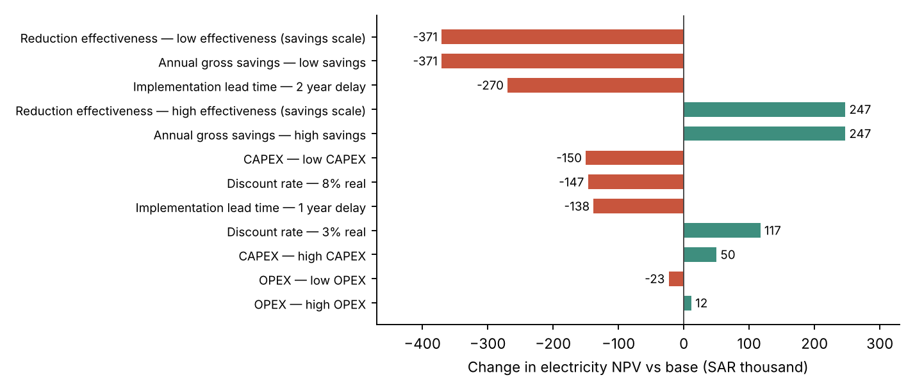
Figure 4. Electricity efficiency: change in NPV versus base for each one-way test (sensitivity_results.csv).

5.3 Financial switching values
Table 8. NPV break-even values (other inputs at base)
ID | NPV = 0 when … | Value
A | Gross annual savings at NPV = 0 | SAR 12,770/yr
A | Savings ratio at NPV = 0* | 85.1%
A | CAPEX at NPV = 0 | SAR 77,217
A | Annual OPEX at NPV = 0 | SAR 7,230/yr
A | Discount rate at NPV = 0 (IRR) | 10.6%
A | Longest whole-year lead time with NPV >= 0 | 1 year(s)
B | Gross annual savings at NPV = 0 | SAR 27,541/yr
B | Savings ratio at NPV = 0* | 68.9%
B | CAPEX at NPV = 0 | SAR 216,209
B | Annual OPEX at NPV = 0 | SAR 24,459/yr
B | Discount rate at NPV = 0 (IRR) | 19.4%
B | Longest whole-year lead time with NPV >= 0 | 3 year(s)
C | Gross annual savings at NPV = 0 | SAR 79,752/yr
C | Savings ratio at NPV = 0* | 49.8%
C | CAPEX at NPV = 0 | SAR 1,119,652
C | Annual OPEX at NPV = 0 | SAR 95,248/yr
C | Discount rate at NPV = 0 (IRR) | 26.2%
C | Longest whole-year lead time with NPV >= 0 | 4 year(s)
* Gross savings scale with effectiveness, so the savings ratio is also the effectiveness multiplier at NPV = 0.
Ranking ties are solved analytically: NPV_C(S) = −CAPEX_C + (S − OPEX_C) × AF equals the freight base NPV at S = SAR 92,211.74/yr, reproducing the corrected workbook (Ranking & Switching!B6). Electricity CAPEX would have to reach SAR 1,023,443, or freight gross savings SAR 107,788/yr, for freight to tie with electricity.
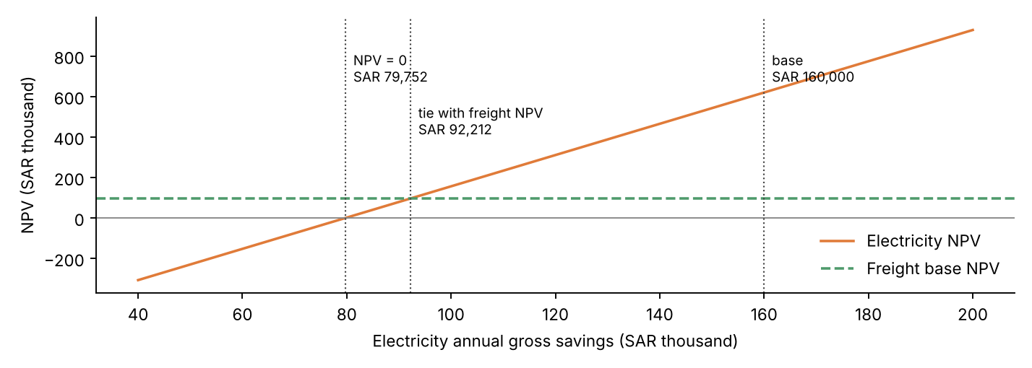
Figure 5. Electricity NPV against its annual gross savings, with the freight base NPV (one-way).

5.4 Ranking reversals
Varied | Parameter | Range | Reversal | Result
A | CAPEX multiplier | 0.5x-1.5x (step 0.05) | No | No ranking reversal within the tested range (no switch point at a positive multiplier)
A | Gross savings multiplier | 0.5x-1.5x (step 0.05) | No | No ranking reversal within the tested range (exact switch at 6.201x, outside the range)
A | OPEX multiplier | 0.5x-1.5x (step 0.05) | No | No ranking reversal within the tested range (no switch point at a positive multiplier)
A | Effectiveness multiplier (savings scale) | 0.5x-1.5x (step 0.05) | No | No ranking reversal within the tested range (exact switch at 6.201x, outside the range)
B | CAPEX multiplier | 0.5x-1.5x (step 0.05) | No | No ranking reversal within the tested range (no switch point at a positive multiplier)
B | Gross savings multiplier | 0.5x-1.5x (step 0.05) | No | No ranking reversal within the tested range (exact switch at 2.695x, outside the range)
B | OPEX multiplier | 0.5x-1.5x (step 0.05) | No | No ranking reversal within the tested range (no switch point at a positive multiplier)
B | Effectiveness multiplier (savings scale) | 0.5x-1.5x (step 0.05) | No | No ranking reversal within the tested range (exact switch at 2.695x, outside the range)
C | CAPEX multiplier | 0.5x-1.5x (step 0.05) | No | No ranking reversal within the tested range (exact switch at 2.047x, outside the range)
C | Gross savings multiplier | 0.5x-1.5x (step 0.05) | Yes | Ranking changes within tested range: top becomes B at 0.5x-0.55x (exact switch at 0.576x)
C | OPEX multiplier | 0.5x-1.5x (step 0.05) | No | No ranking reversal within the tested range (exact switch at 5.519x, outside the range)
C | Effectiveness multiplier (savings scale) | 0.5x-1.5x (step 0.05) | Yes | Ranking changes within tested range: top becomes B at 0.5x-0.55x (exact switch at 0.576x)
ALL | Shared real discount rate | 0.0%-15.0% (step 0.5 pp) | No | No ranking reversal within the tested range (top unchanged at every rate)
ALL | Shared implementation lead time | 0-3 years | No | No ranking reversal within the tested range
Within the tested ranges the base-case ranking (electricity first) reverses only if electricity savings or effectiveness fall below 0.576× their base values. No reversal occurs for CAPEX, OPEX, the shared discount rate (0–15%) or lead time (0–3 years).

5.5 Missing Contractor B sensitivity
Avoided freight = rate × (known eligible freight A + C + applicability × hypothetical Contractor B)
Applicability applies only to the hypothetical Contractor B term, never to the known freight. Hypothetical values (50 / 200 / 600 tCO₂e/yr) are sensitivity assumptions, not inventory values; the quantified baseline and Contractor B's UNAVAILABLE status are unchanged, and no financial savings are assigned to Contractor B.
Table 9. Contractor B sensitivity (tCO₂e/yr)
B case | Applicability | Hyp. B emissions | Known freight | Avoided known | Avoided hyp. B | Avoided total
Low | 0.00 | 50 | 193.097 | 28.965 | 0.000 | 28.965
Low | 0.50 | 50 | 193.097 | 28.965 | 3.750 | 32.715
Low | 1.00 | 50 | 193.097 | 28.965 | 7.500 | 36.465
Base | 0.00 | 200 | 193.097 | 28.965 | 0.000 | 28.965
Base | 0.50 | 200 | 193.097 | 28.965 | 15.000 | 43.965
Base | 1.00 | 200 | 193.097 | 28.965 | 30.000 | 58.965
High | 0.00 | 600 | 193.097 | 28.965 | 0.000 | 28.965
High | 0.50 | 600 | 193.097 | 28.965 | 45.000 | 73.965
High | 1.00 | 600 | 193.097 | 28.965 | 90.000 | 118.965
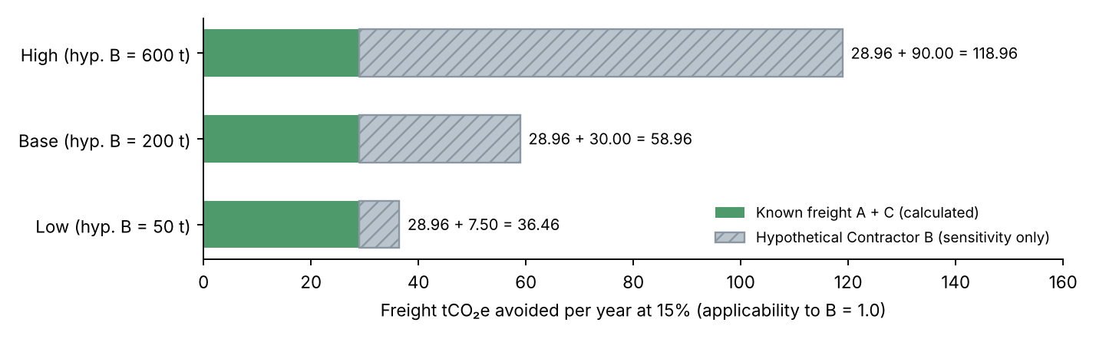
Figure 6. Known versus hypothetical Contractor B abatement at the workbook default applicability (1.0).

5.6 Decision robustness
Intervention | NPV low | NPV base | NPV high | Savings may fall | Financial robustness | Data confidence (Workstream B)
A · Diesel efficiency | -67,576 | 17,217 | 78,042 | 15% | Conditional: positive NPV in base and high, negative in low case | MODERATE
B · Known freight optimisation | -115,847 | 96,209 | 253,377 | 31% | Conditional: positive NPV in base and high, negative in low case | LOW (A), LOW (C); Contractor B NOT QUANTIFIED
C · Electricity efficiency | -183,607 | 619,652 | 1,224,844 | 50% | Conditional: positive NPV in base and high, negative in low case | MODERATE
Distinct criteria are kept separate: electricity has the highest relative NPV and the largest abatement; known freight has the lowest net cost per tonne; no option has validated feasibility; and data confidence is MODERATE for diesel and electricity and LOW for known freight (Contractor B NOT QUANTIFIED). No intervention is recommended for procurement.

6. Validation and test results
Table 10. Automated tests (executed with python -m pytest -v)
Suite | Passed | Failed
phase4/test_phase4.py (Phase 4 data, validator, 16 rules) | 35 | 0
test_workstream_b.py (Workstream B, unchanged) | 15 | 0
test_workstream_c.py (new) | 25 | 0
Total | 75 | 0
Table 11. Engine versus workbook reconciliation
Comparison | Matching | Tolerance
Phase 9 metrics and year-by-year cash flows, discount factors, PVs | 123/123 | 1e-6 (relative or absolute)
Phase 10 Cases (inputs, abatement, NPV, cost per tonne, rank) | 81/81 | 1e-5 tCO₂e / 1e-6 relative
Phase 10 switching values (Decision Summary B16:D18, Ranking & Switching B6, B8, B9) | 12/12 | 1e-9 relative
Phase 10 Missing Supplier sheet | 12/12 | 1e-5 tCO₂e
Total | 228/228
The largest financial difference is 2.3e-5 SAR/tCO₂e (freight cost per tonne), caused by the six-decimal record rounding described in section 3.
Reproducibility. run_workstream_c.py writes SHA-256 hashes of all inputs (three workbooks, four Phase 4 files) and outputs; two clean runs produced identical hashes, and the Workstream B outputs are byte-identical to the delivered Workstream B package. Fault injection. Three deliberate faults were each caught by the suite: additive instead of multiplicative combination (double counting), Contractor B treated as zero, and the old 614.2 factor value in the register.
The 25 Workstream C tests check: unchanged workbooks and baseline; cross-workbook consistency; default scenario reductions and their reconciliation with activity records; existing factor IDs and values; Contractor B never zero; no double counting (including a forced-overlap case); monthly–annual reconciliation; unmodified source records; independently coded NPV; reconciliation with the Phase 9 and corrected Phase 10 workbooks; discounting, timing and 0% edge cases; cost-per-tonne definition; switching values; reproducible sensitivity results; negative-NPV ranking; reversal detection; Contractor B separation; no superseded factor in any output; reproducible output hashes; all eight dashboard tabs; and dashboard values equal to direct engine calls after interactive changes.

7. Dashboard and software architecture
Module | Role
workstream_c_inputs.py | Reads the three workbooks by row label; returns values with cell references; consistency checks
scenario_engine.py | Phase 8: record-level scenarios via calc_engine.run (Workstream B engine, unchanged)
financial_engine.py | Phase 9: cash flows, NPV, NPC, payback, IRR, cost per tonne, feasibility, reconciliation
uncertainty_engine.py | Phase 10: cases, one-way sensitivity, switching, reversals, Contractor B, robustness, statements
run_workstream_c.py | Runs Phases 8–10, writes outputs/workstream_c/ and run_manifest_c.json
app.py + workstream_c_tabs.py | Streamlit dashboard: tabs 1–5 Workstream B (unchanged), tabs 6–8 Workstream C
Data flow: phase4/data → calc_engine (baseline) → scenario_engine (avoided tCO₂e) → financial_engine (NPV and cost per tonne) → uncertainty_engine (cases, sensitivity, decisions). The dashboard calls the same functions; a test changes a slider and a CAPEX input and checks that the displayed values equal direct engine calls.
- Tab 6 Reduction scenarios — sliders for each reduction rate; baseline vs scenario, avoided tCO₂e, % reduction, scope-level and monthly impacts, assumptions and Contractor B warning.
- Tab 7 Financial evaluation — session-only inputs (CAPEX, savings, OPEX, lead time, discount rate, horizon); NPV, payback, IRR, cost per tonne, 10-year cash-flow charts, feasibility indicators; flags when inputs differ from the workbook.
- Tab 8 Decision intelligence — conditional findings, low/base/high, tornado, switching values, reversal tests, Contractor B sensitivity, and a comparison of carbon impact, NPV, feasibility, uncertainty and data confidence.
The package runs locally or in Google Colab (README gives the exact cell-by-cell steps); no paid service or credential is required.

8. Limitations
- All activity data, reduction rates, CAPEX, OPEX and savings are synthetic; results demonstrate the method only.
- Electricity uses a provisional SEC 2024 Scope 2 proxy (550 kgCO₂e/MWh) not verified against the primary report; electricity dominates both baseline and abatement.
- Diesel and freight factors are UK proxies; the freight factor is unverified and excludes well-to-tank emissions.
- Contractor B is missing, so Scope 3 Category 4 and every total are incomplete; the hypothetical B values are sensitivity assumptions only.
- Interventions are assumed independent; the portfolio NPV ignores interactions, and avoided emissions assume linear activity-based factors and unchanged boundaries.
- Financial results exclude taxes, financing, escalation, residual value, downtime costs and carbon prices; 5% is an illustrative real rate, not a Saudi corporate hurdle rate.
- Low/base/high cases are stress tests, not probabilities; no Monte Carlo or correlated uncertainty is modelled.
- No operational-feasibility check is validated; synthetic scenarios do not demonstrate real-world feasibility.
- The Colab dashboard steps were written for Colab but could not be executed in Colab from the build environment.

9. Future improvements
- Replace synthetic inputs with metered electricity, generator run-hours, carrier tonne-km, Saudi tariffs and vendor quotations.
- Confirm the SEC factor (value, MWh basis, coverage) and the DESNZ diesel and freight factors against primary sources.
- Obtain 12 months of Contractor B activity data and recompute Scope 3 Category 4.
- Add probabilistic (Monte Carlo) analysis with correlated inputs, interaction effects between interventions and a budget constraint.
- Add downtime, escalation and residual value to the cash flows, and a market-based Scope 2 view once supplier data exist.

