**Screen shots of the working application**

1. Application home page

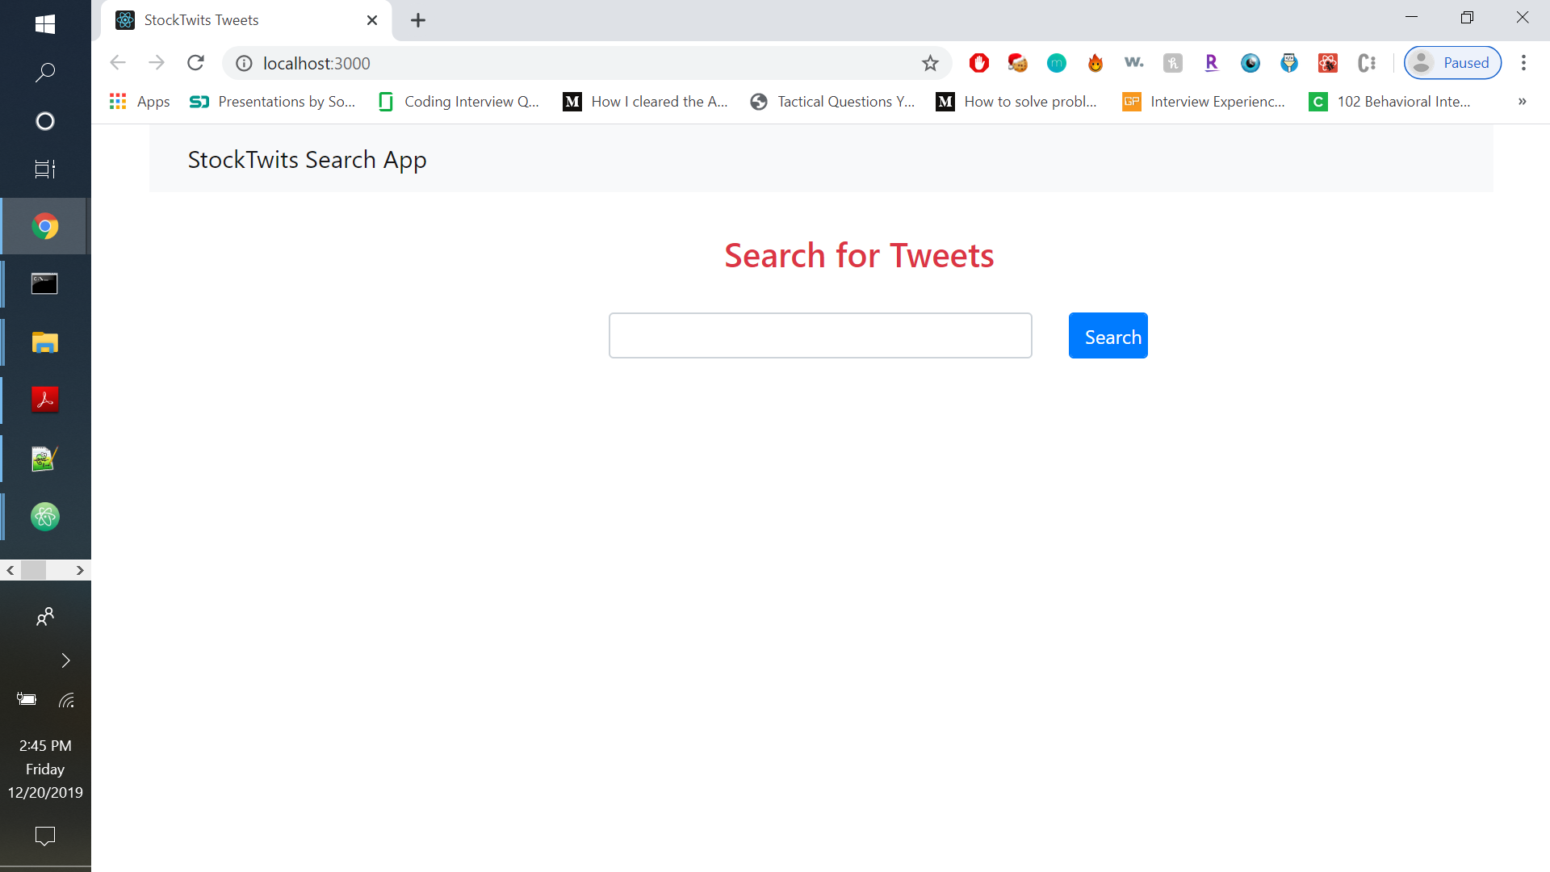

1. Tweets for the ticker symbol FB

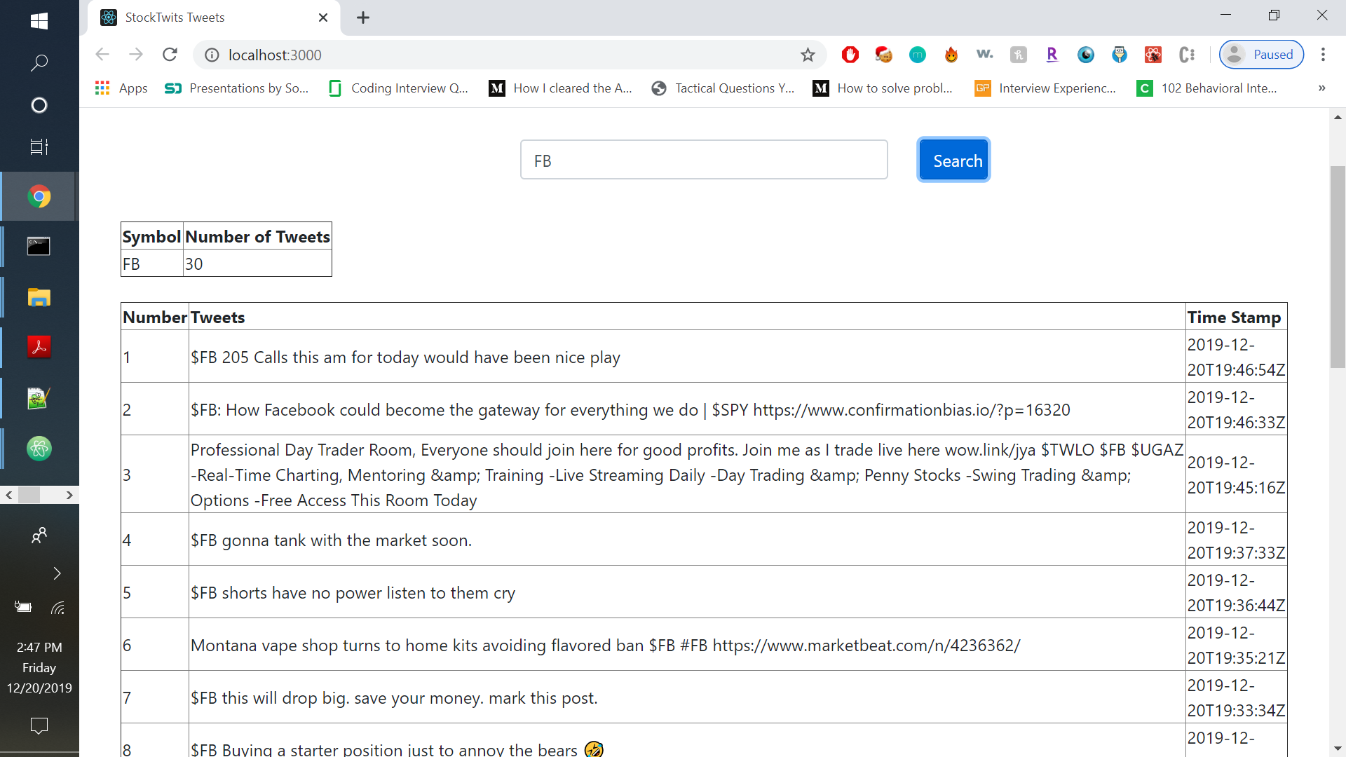

1. Latest Tweets with timestamp for multiple ticker symbols

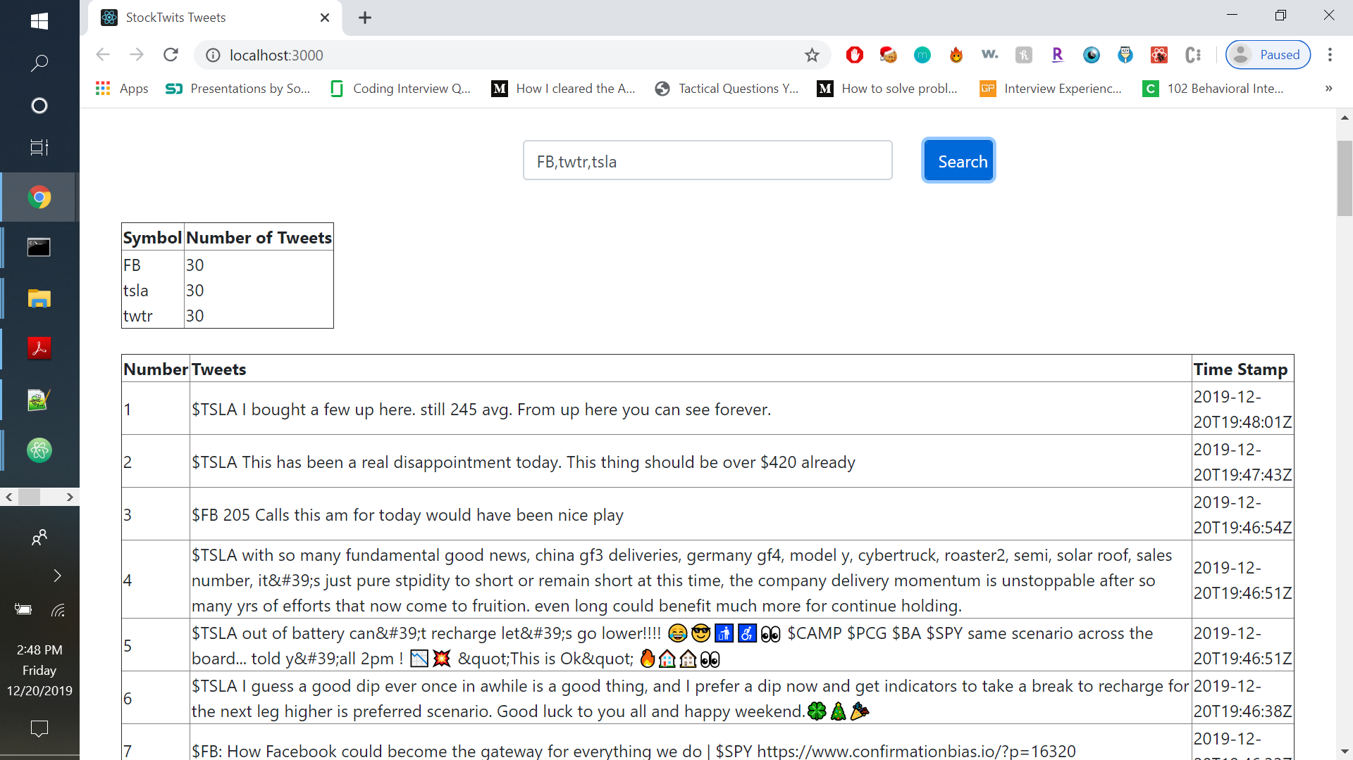

1. Latest tweets after deleting one ticker symbol

