

CSE470: Software Engineering  
Section: 5  
Group: 3  
**SPRINT 2**

| Sadat Mahmud | 22301301 |
| --- | --- |
| Rana Mustafa | 21101060 *(Scrum Master)* |
| Atoshi Samadder | 21301706 |
| Nabil Nashit | 21201060 |

**Software: VisiNexus –** Connecting insights through vision

**Requirements**

1. Real-time demos for computer vision applications such as object detection, emotion recognition, etc.
2. Interactive tools for learning and understanding computer vision applications
3. Documentation and tutorials
4. API access and integration guide
5. User Management
6. Virtual coins for purchasing accessibility

**Framework Setup**

| Frontend | React.js |
| --- | --- |
| Backend | Express.js |
| Computer Vision Models | OpenCV and TensorFlow |
| Database | MongoDB |
| Hosting | GoDaddy |

**Workload Distribution**

| Sadat Mahmud | Project Manager: Oversee environmental setup, and proper deployment |
| --- | --- |
| Rana Mustafa | Computer Vision Specialist: Optimize Computer Vision Models |
| Atoshi Samadder | Frontend Developer: Develop the user interface |
| Nabil Nashit | Backend Developer: Build the server-side logic and API endpoints |

### 

### 1. **Initial Setup of the MERN Stack**

* MongoDB: The database for storing your app's data, using the free cluster0 for our database.
* Express.js: The backend framework running on Node.js to handle HTTP requests and responses.
* React.js: The frontend JavaScript library for building the user interface we will use for our projects.
* Node.js: A JavaScript runtime environment used for running the server-side code.

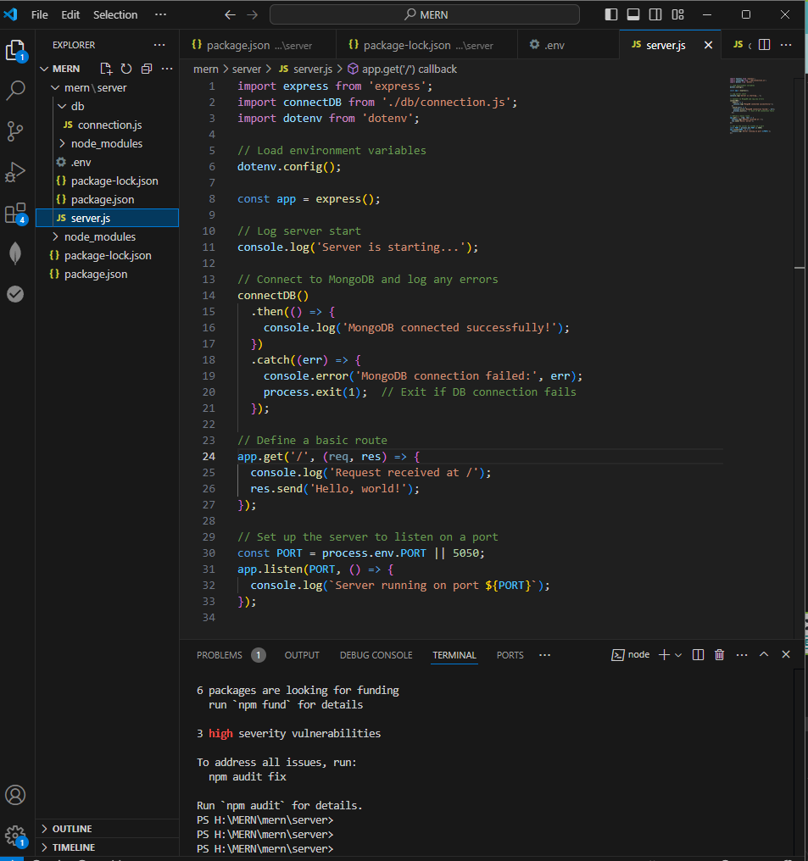

**2. Installing the Necessary Libraries**

**Using the terminal of VS Code I have installed the required libraries , giving the code below:**

| **npm init -y**  **npm install express mongoose dotenv**  **npm install --save-dev nodemon** |
| --- |

**3. Project Structure :**

**MERN(folder name that I have used for storing my setup)**

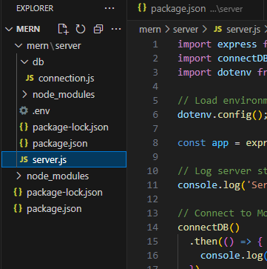

**4. MongoDB Setup:**

I am using the MongoDB ATLAS, using the free version cluster0 and then connecting to my VS code environment.

|  |
| --- |

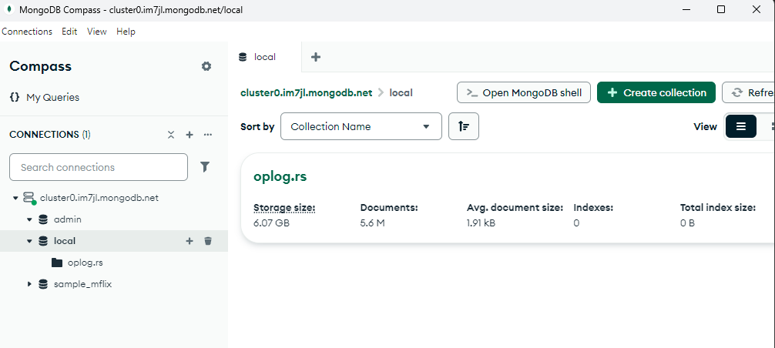

**5. Server setup :**

In the server .js mainly the import connectDB from './db/connection.js';

connects to the database.Using the “dotenv” for setting up the environment variables

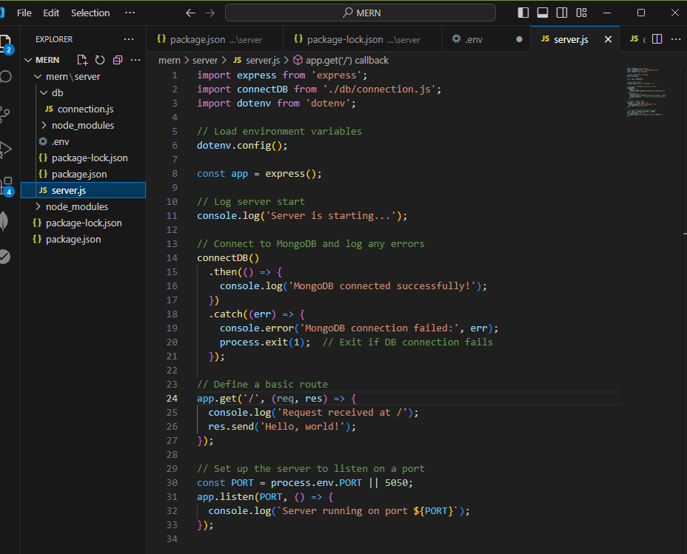

**Under the mern/server :**

| Directory: H:\MERN\mern\server  Mode LastWriteTime Length Name  ---- ------------- ------ ----  d----- 12/14/2024 10:04 PM .env  d----- 12/14/2024 9:13 PM node_modules  -a---- 12/14/2024 9:39 PM 35473 package-lock.json  -a---- 12/14/2024 9:13 PM 318 package.json  -a---- 12/14/2024 9:15 PM 0 server.js |
| --- |

**Running the server:**

Using the “ npm run dev “I have successfully load the web-paged and this runs “nodemon”which will watch for file changes and restart the server automatically.

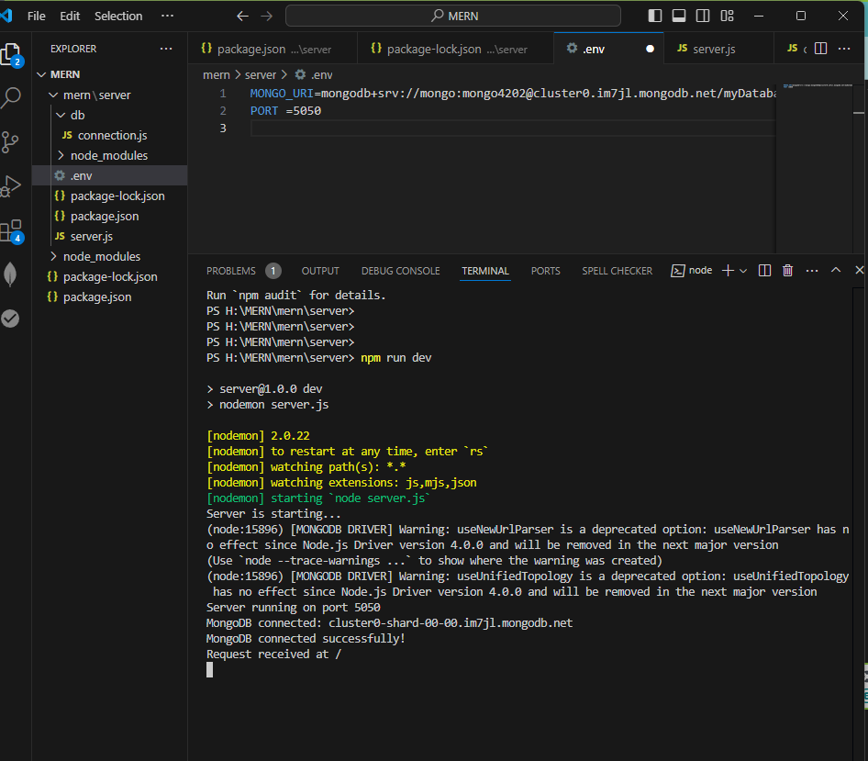

**web-page :** “http://localhost:5050/”

