**Computer Graphics, Lab Assignment 3**

Handed out: April 3rd, 2022

**Recommended due: 15:00,** April 3rd, 2022

**Hard due: 23:59,** April 9, 2023 **(NO SCORE for late submissions!)**

1. Write down a Python program to draw a transformed triangle in a 2D space.
   1. Set the window title to **[studentID]-[assignment#]-[prob#]** and the window size to (480,480).
   2. Draw a triangle using render() function below (DO NOT modify it!).

**def** render**(**T**):**

glClear**(**GL_COLOR_BUFFER_BIT**)**

glLoadIdentity**()**

# draw cooridnate

glBegin**(**GL_LINES**)**

glColor3ub**(**255**,** 0**,** 0**)**

glVertex2fv**(**np**.**array**([**0.**,**0.**]))**

glVertex2fv**(**np**.**array**([**1.**,**0.**]))**

glColor3ub**(**0**,** 255**,** 0**)**

glVertex2fv**(**np**.**array**([**0.**,**0.**]))**

glVertex2fv**(**np**.**array**([**0.**,**1.**]))**

glEnd**()**

# draw triangle

glBegin**(**GL_TRIANGLES**)**

glColor3ub**(**255**,** 255**,** 255**)**

glVertex2fv**( (**T @ np**.**array**([**.0**,**.5**,1.]))[:-1] )**

glVertex2fv**( (**T @ np**.**array**([**.0**,**.0**,1.]))[:-1] )**

glVertex2fv**( (**T @ np**.**array**([**.5**,**.0**,1.]))[:-1] )**

glEnd**()**

* 1. If you press or repeat a key, the triangle should be transformed as shown in the Table:

|  |  |
| --- | --- |
| **Key** | **Transformation** |
| Q | Translate by -0.1 in x direction **w.r.t global coordinate** |
| E | Translate by 0.1 in x direction **w.r.t global coordinate** |
| A | Rotate by 10 degrees counterclockwise **w.r.t local coordinate** |
| D | Rotate by 10 degrees clockwise **w.r.t local coordinate** |
| 1 | Reset the triangle with identity matrix |
| W | Scale by 0.9 times in x direction **w.r.t global coordinate** |
| S | Rotate by 10 degrees counterclockwise **w.r.t global coordinate** |

* 1. Transformations should be accumulated (composed with previous one) unless you press ‘1’.
     1. You’ll need a global variable to store current accumulated transformation.
     2. For example:

gComposedM = newM @ gComposedM; or gComposedM = gComposedM @ newM ;

* 1. Do not use OpenGL transformation functions.
  2. Submit a single .py file - **[studentID]-[assignment#]-[prob#].py**
  3. Expected result:

W*2 S*3

When starts

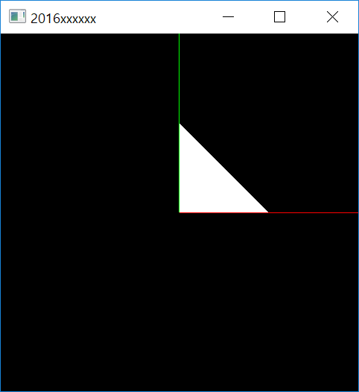

Q *2

A *3

E *5

D *2



1

