**Computer Graphics, Lab Assignment 5**

Handed out: May 08, 2023

**Recommended due: 11:00,** May 09, 2023

**Hard due: 23:59,** May 14, 2023 **(NO SCORE for late submissions!)**

*Submit your assignment through the LMS system and Hconnect(gitlab).*

1. Write down a Python program to draw following triangular pyramid (삼각뿔) by using indexed triangles representation and glDrawElements().
   1. 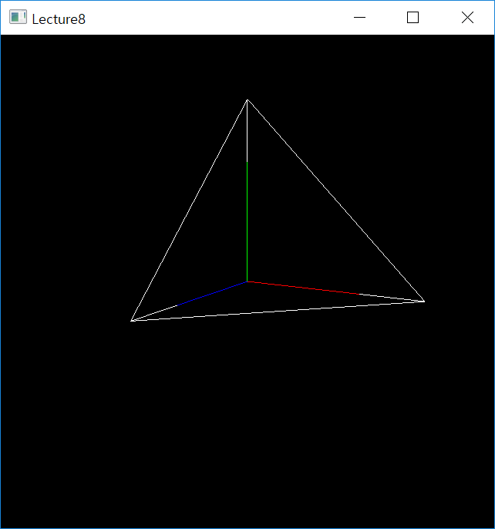



1.5

1.5

1.5

* 1. Start from the code in T5-Mesh slides. Make sure camera manipulation shortcuts ‘1’, ‘3’, ‘2’, ‘w’ work.
  2. Set the window title to **[studentID]-[assignment#]-[prob#]** and the window size to (480,480).
  3. Submit a single .py file - **[studentID]-[assignment#]-[prob#].py**