BNP Paribas – Liquid Alternatives
Consolidated Shared LLM Service
A single platform behind UC-021, UC-023 and UC-004

Overview
UC-021 (security callback scripts), UC-023 (KYC document processing) and UC-004 (invoice payment processing) were scored independently in the AI use case portfolio review, but all three rely on the same underlying capability: a large language model. Rather than each team building and operating its own integration, the three can be consolidated behind a single shared LLM service that is provider-agnostic – it can sit in front of any large language model vendor without the use cases themselves changing.
The service exposes two capabilities, not one. Generation takes a prompt and returns text – this is what UC-021 uses to draft security callback questions. Extraction takes a document and returns schema-validated structured data – this is what UC-023 and UC-004 use to pull fields out of KYC certificates and invoices. UC-021 does not touch the extraction pipeline at all: the consolidation is at the platform level, not the pipeline level, and that distinction is worth keeping explicit when this is presented.

Solution diagram
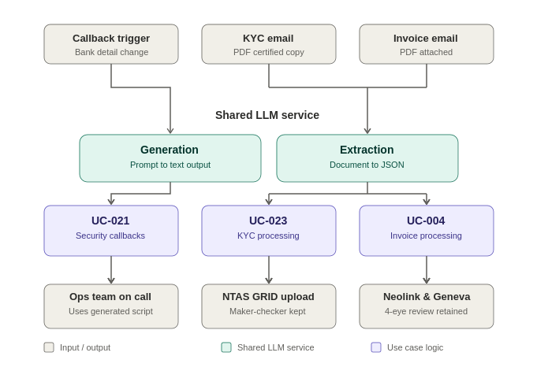
Figure 1: End-to-end data flow – inputs, shared capabilities, use case logic and downstream systems.

Capability breakdown
Capability | Input | Output | Used by
Generation | A prompt describing the scenario | Free text – no schema | UC-021 – security callback scripts
Extraction | A document (PDF / email attachment) | Structured JSON, schema-validated | UC-023 – KYC documents; UC-004 – invoices

Use case detail
Use case | Trigger | Capability used | Human control | System of record
UC-021 | Redemption bank-detail change requiring a callback | Generation | Ops staff use the script live on the call – nothing is auto-actioned | N/A – output is used, not stored
UC-023 | Certified KYC PDF received by email | Extraction | Maker-checker retained – maker verifies extracted fields | NTAS GRID loader file
UC-004 | Client invoice PDF received by email | Extraction | 4-eye review retained at each control point | Neolink, Geneva, NAV control pack

Why this shape
- Provider-agnostic – the service sits in front of the LLM vendor, not the use case; switching or multi-sourcing the model doesn't touch UC-021, UC-023 or UC-004.
- One service, two capabilities – generation and extraction are the only two things any of these use cases actually need from an LLM; a third use case can extend the platform without a third integration.
- Consolidation is at the platform level, not the pipeline level – UC-021 shares the service with UC-023 and UC-004, but not their document pipeline; be explicit about that distinction when presenting this to avoid overstating the overlap.
- Human control is preserved per use case – the shared service only ever perceives (generates or extracts); it never posts, uploads or decides. Each use case keeps its own control gate and system of record.
- Single place to govern – auth, rate limits, prompt versioning, logging and cost sit in one service rather than three independent integrations, simplifying model-risk and audit review.
AI Use Case Portfolio Review – Consolidated Shared LLM Service

