BNP Paribas – Liquid Alternatives
UC-022 – Client Trade File Processing
High-level solution diagram – data flow

Overview
Client trade files currently arrive via SFTP and are handled manually end to end: a team member checks the SFTP site for new files, selects the relevant trades against a set of criteria, formats the details with a macro, and uploads the result to Neolink. The proposed solution automates every step up to the final Neolink review and release, which stays with a human operator as the control gate.

Solution diagram
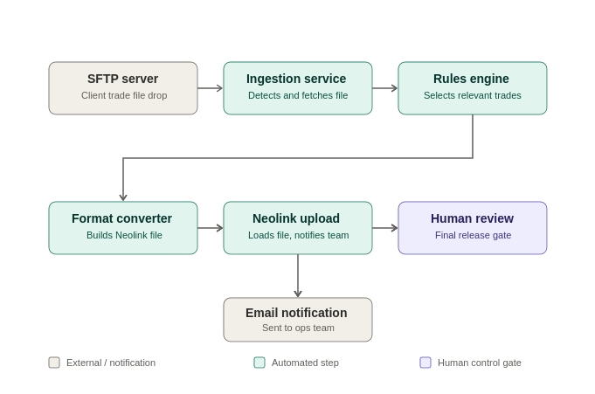
Figure 1: End-to-end data flow, from SFTP receipt to final human release.

Step-by-step data flow
STEP 1  SFTP server  Client trade file is dropped on the SFTP site. | STEP 2  Ingestion service  Automation detects and fetches the new file – no manual SFTP check. | STEP 3  Rules engine  Determines the relevant trade lines by rule, not by hand.
STEP 4  Format converter  Converts the selected lines to the Neolink upload format. | STEP 5  Neolink upload  Loads the file to Neolink and sends a notification email to the team. | STEP 6  Human review  Final review and release performed by a human operator – the retained control gate.

Why this shape
- Deterministic automation, not model risk – file detection, trade selection and format conversion are rule-based, not LLM-based.
- The only manual step retained is the final release in Neolink – the control that matters is preserved.
- Notification is a side-effect of the upload step, not a separate manual task – the team is told, not asked to check.
AI Use Case Portfolio Review – UC-022 solution diagram

