Enterprise AI Platform
Architecture Recommendations for RAG, KYC Document Processing, and Invoice Payment Processing

Objective
Evaluate whether a single shared AI/LLM service can support all three applications while improving reuse, governance, security and model lifecycle management.
Recommended Direction
Create a shared Enterprise AI Platform / AI Gateway. Centralize AI capabilities and controls, but keep application-specific workflow and deterministic business logic within each application.
Key Principle
Centralize AI capabilities, not business processes.

1. Executive Summary
Recommendation. Adopt a shared Enterprise AI Platform that exposes governed AI capabilities through standard APIs to all three applications. The platform should provide model access, document intelligence, RAG services, prompt/configuration management, guardrails, PII controls, evaluation, audit and observability.
Do not build a single monolithic application containing KYC, payment and RAG business logic. Each application should continue to own its workflow, system-of-record interactions, deterministic rules, file generation and downstream integrations.

2. Current Application Landscape
Application | Primary Function | Current AI / Automation | Downstream Output
RAG-based system | Answers user questions using enterprise data held in a relational database. | Retrieval + LLM response generation. | User response / application action.
KYC identity document pipeline | Processes identity documents and extracts required KYC data. | Intelligent Document Processing (IDP), with opportunity for AI normalization and semantic validation. | CSV file for downstream application.
Invoice payment processing | Extracts invoice data, validates it, and prepares payment instructions. | IDP followed by rule-based validation; AI can augment classification, anomaly detection and exception reasoning. | Payment file for payment processing application.

3. Recommended Architectural Principle
Centralize AI capabilities and governance; decentralize business workflow ownership.
- Applications invoke reusable AI capabilities through stable APIs rather than calling LLM providers directly.
- The AI platform owns model routing, prompt/version management, AI security controls, evaluation, logging and audit.
- KYC and payment applications retain their regulated process controls, deterministic validations, approvals, output-file generation and downstream integrations.
- The platform should remain stateless with respect to long-running business processes wherever possible; it provides AI decisions or enrichments, not business-process orchestration.

4. Target High-Level Architecture
RAG Application | ENTERPRISE AI PLATFORM | Relational DB
KYC Application | AI Gateway + Capability APIs | KYC workflow + CSV
Invoice Application | Model Gateway + AI Services | Payment workflow + files
 | Governance + Evaluation + Audit
Application-owned concerns | Approved LLMs / Document Models | Downstream business systems
Conceptually, each application calls the shared platform for AI capabilities. The applications remain responsible for their own transaction and workflow boundaries.
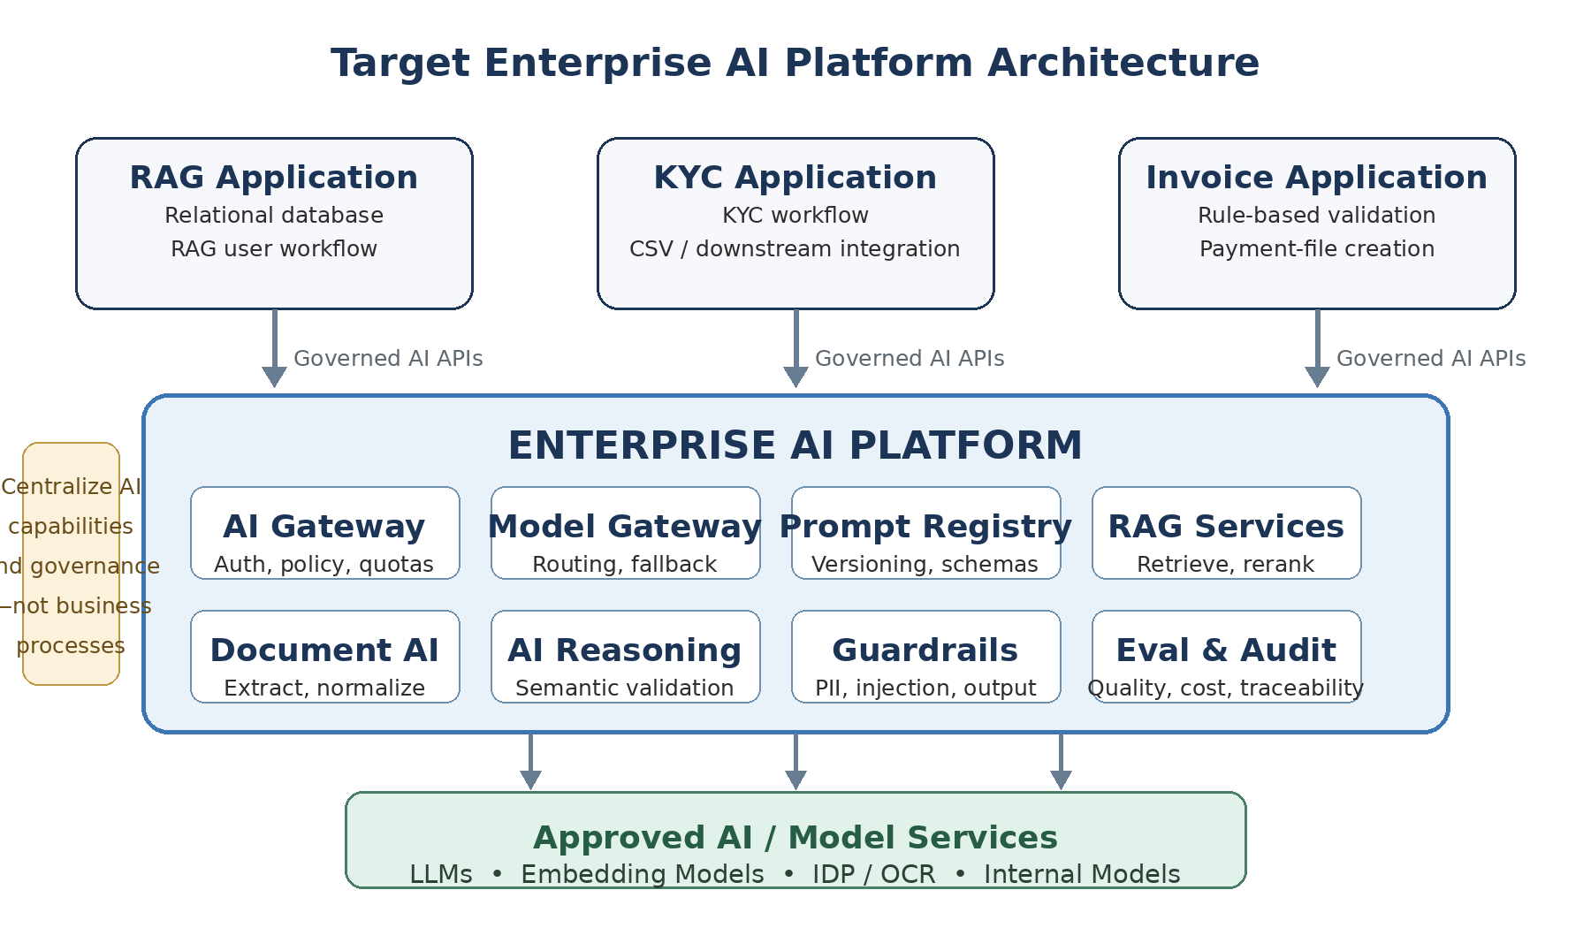
Figure 1. Recommended high-level architecture: three business applications consume centrally governed AI capabilities through shared APIs.

5. Capabilities to Centralize in the Enterprise AI Platform
AI Gateway / API Layer: Authentication, authorization, tenant/application identity, quotas, rate limits, request policy enforcement and standard API contracts.
Model Gateway: Abstract access to approved LLMs, embedding models, document models and internal models. Supports model routing, fallback, version control and provider portability.
Prompt & Configuration Registry: Versioned prompts, response schemas, model settings, ownership, approvals, test status and controlled promotion across environments.
RAG Services: Retrieval orchestration, query rewriting, embeddings, reranking, grounding, source metadata and access-aware retrieval patterns.
Document AI Services: Document classification, extraction, normalization, confidence scoring and optional orchestration of existing IDP/OCR services.
Semantic Validation & Reasoning: Cross-field consistency checks, exception categorization, natural-language explanations and contextual validations unsuitable for simple rules.
Guardrails & Data Protection: PII detection/redaction, prompt-injection controls, output validation, content controls, data-location policy and model allow-lists.
Evaluation & Observability: Quality metrics, extraction accuracy, hallucination/grounding measures, latency, token usage, cost, failure rates and business KPIs.
Audit & Traceability: Application, request ID, model/version, prompt version, policy decisions, response metadata, confidence and human-review outcomes where applicable.

6. Application-by-Application Responsibility Mapping
Application | Remain in Application | Move / Expose via Shared AI Platform
RAG | UI, user workflow, authorization context, relational DB ownership, application-specific business actions. | LLM access, embeddings, retrieval orchestration, reranking, prompt management, response guardrails, evaluation and model routing.
KYC | KYC case workflow, regulatory decisions, approvals, downstream CSV creation and destination-system integration. | Document classification/extraction, IDP orchestration, field normalization, confidence scoring, semantic validation, PII controls, audit metadata.
Invoice Payment | Invoice/payment workflow, deterministic accounting rules, approval controls, payment-file creation, posting and payment execution. | Document extraction, normalization, anomaly detection, semantic/cross-field validation, exception explanation and model-assisted review.

7. Preserve IDP; Use LLMs as an Augmentation Layer
The existing Intelligent Document Processor does not need to be replaced. A robust design is to retain IDP/OCR for document parsing and extraction, then use the shared AI platform for higher-level normalization, semantic checks and exception reasoning.
Document | IDP / OCR | Structured JSON | AI Validation / Normalization | Application Workflow
Design rule: use conventional software for deterministic rules; use AI for interpretation, extraction, classification, normalization and contextual reasoning.

KYC examples
- Normalize names/addresses across document formats.
- Check semantic consistency between document type, country, dates and extracted attributes.
- Route low-confidence or conflicting fields to human review.

Invoice examples
- Explain why an invoice triggered an exception.
- Detect unusual supplier/invoice patterns as a risk signal.
- Validate context that is difficult to express as a fixed rule.
- Keep arithmetic, threshold and accounting-policy checks deterministic where practical.

8. Define Capability APIs, Not Provider-Specific APIs
Applications should request a business-neutral AI capability rather than knowing which model, prompt or provider implements it. Example contracts:
- /ai/v1/generate
- /ai/v1/embed
- /ai/v1/knowledge/query
- /ai/v1/documents/identity/extract
- /ai/v1/documents/invoice/extract
- /ai/v1/validate
- /ai/v1/classify
This abstraction allows the platform team to change prompts, models, routing and providers without forcing every consuming application to be redesigned.

9. Central Governance Model
Model governance: Approved model catalogue; use restrictions by data classification; deployment/version approval; fallback policy.
Data governance: PII handling, masking/redaction, data retention, residency, encryption and provider data-use controls.
Prompt governance: Versioned prompts, named owners, testing, approval, change history and rollback.
Evaluation governance: Minimum quality thresholds; golden datasets; regression tests; grounding/extraction metrics; production monitoring.
Auditability: Trace request to application, user/service, model, model version, prompt version, policy result and relevant confidence values.
Cost governance: Usage by application, model and capability; budgets/quotas; model selection based on quality, latency and cost.
Human oversight: Clearly defined confidence thresholds and exception cases that require manual review, especially for KYC and payment-related decisions.

10. Key Design Risks and Mitigations
Risk | Impact | Mitigation
Central service becomes a monolith | Slow changes and tight coupling across applications. | Centralize reusable AI capabilities only; keep domain workflow in applications; use versioned APIs.
Platform becomes a single point of failure | Multiple applications affected by an AI outage. | High availability, circuit breakers, retries, graceful degradation and application-specific fallbacks.
LLM used for deterministic decisions | Unpredictable or non-repeatable outcomes. | Retain rules engines/code for deterministic calculations and policy controls.
Sensitive KYC/payment data exposed | Security, privacy or regulatory risk. | Data-classification-aware routing, approved providers/models, PII controls, encryption and audit.
Model or prompt changes degrade quality | Cross-application production risk. | Version pinning, test datasets, staged rollout, regression evaluation and rollback.
Unclear accountability | Governance gaps between platform and application teams. | Define a RACI: platform owns AI controls/capabilities; applications own business outcomes and process controls.

11. Suggested Implementation Approach
Phase 1 - Foundation - Create the AI Gateway, model abstraction, authentication/authorization, centralized logging, prompt/config registry and basic governance policies.
Phase 2 - RAG capability - Migrate the existing RAG application to consume shared generation, embedding, retrieval/reranking and evaluation services. This is typically the lowest-risk proving ground.
Phase 3 - Document capabilities - Expose reusable document extraction/normalization contracts while initially retaining existing IDP engines behind or alongside the platform.
Phase 4 - KYC integration - Move AI-specific KYC extraction/normalization/semantic validation into the shared platform while preserving KYC workflow and regulated decision controls.
Phase 5 - Invoice integration - Move document intelligence and non-deterministic reasoning into the platform; retain rules, approvals, payment-file creation and payment execution in the invoice application.
Phase 6 - Mature governance - Introduce formal evaluation gates, usage/cost dashboards, model lifecycle processes, automated regression testing, policy-as-code and cross-application AI risk reporting.

12. Recommended Ownership Boundary
Enterprise AI Platform Team | Application / Domain Teams
- AI Gateway and model access  - AI security and guardrails  - Prompt/model lifecycle tooling  - Common RAG and document capabilities  - AI observability, audit and cost controls  - Evaluation framework and shared standards | - Business workflows and SLAs  - Business/system-of-record authorization  - Deterministic business rules  - Case/payment approvals  - CSV/payment file creation  - Downstream system integration and business outcome ownership

13. Conclusion
A single shared AI platform is both feasible and recommended, provided it is implemented as a reusable AI capability and governance layer rather than a monolithic service containing all three applications.
The largest benefits are expected in centralized model governance, security, PII controls, auditability, prompt/model lifecycle management, observability, evaluation, provider flexibility and cost management. This architecture also permits each business application to retain the controls and deterministic logic required for its own operational and regulatory responsibilities.
Recommended next design artifact: define 8-12 concrete AI capability APIs and a responsibility matrix showing which component owns each function, data store, control and failure mode.

