AI AGENT-BASED INVOICE PROCESSING SYSTEM
Business Design Overview
Automated | Accurate | Auditable | Integrated
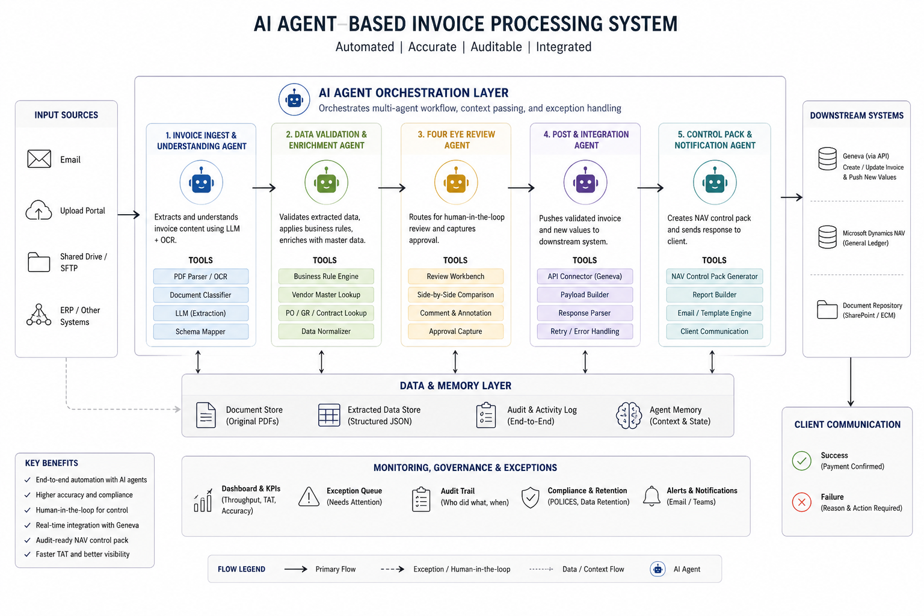
Purpose of this document
This overview explains the proposed AI-enabled invoice processing model in business terms: what changes, which controls remain, how exceptions are handled, and where business teams retain review and approval authority.

1. Executive Summary
The proposed design automates today's manual invoice processing workflow using an AI agent orchestration layer. Invoices can arrive by email, upload portal, shared drive/SFTP, or ERP/other systems. The AI agents extract invoice information, validate it against master data and business rules, route exceptions for human review, post approved values to Geneva, create the NAV control pack, and send a clear success or failure response to the client.
Business outcome | How the design supports it
Faster turnaround | Reduces manual handoffs and repeated data entry across invoice intake, review, downstream posting, and client communication.
Higher accuracy | Applies consistent extraction, validation, enrichment, and comparison checks before values are posted.
Audit-ready control | Maintains a complete activity log showing what was received, extracted, validated, approved, posted, and communicated.
Human control retained | Keeps four-eye review and exception queues for invoices that need judgement, approval, or correction.
Integrated operations | Connects invoice processing to Geneva, NAV control pack generation, document repositories, and client notifications.

Business view of the future process
- The system receives invoice documents and related messages through existing business channels.
- AI reads the invoice and extracts the relevant commercial and payment values.
- Business rules and reference data are applied before any downstream posting occurs.
- The system only escalates unclear or policy-sensitive cases to reviewers.
- Once approved, the system posts values, produces control evidence, and communicates the result back to the client.

2. Target Operating Model
The design is built around an orchestrated set of specialised agents. From a business perspective, these agents are digital process participants that perform repeatable work, record evidence, and request human input when needed.
Step | Agent / process area | Business responsibility | Input | Output
1 | Invoice ingest and understanding | Reads the invoice PDF, classifies the document, extracts key fields, and maps values to the required schema. | Email, portal, SFTP, ERP input | Structured invoice data + original document stored
2 | Data validation and enrichment | Checks extracted values against business rules, vendor master, purchase order / goods receipt / contract records, and normalises the data. | Extracted invoice values | Validated or exception-ready invoice package
3 | Four-eye review | Routes cases requiring human review to a side-by-side workbench, captures comments, and records approval decisions. | Validation outcome and invoice evidence | Approved invoice or rejection / clarification
4 | Post and integration | Builds the payload and posts approved invoice values to Geneva through an API. Retries and error handling are tracked. | Approved invoice package | Geneva posting result and response evidence
5 | Control pack and notification | Creates the NAV control pack, stores the evidence, and sends a success or failure response to the client. | Posting result and audit trail | Client confirmation and final processing status

Operating principle
Automation is not a replacement for business control. The design automates repeatable preparation, validation, evidence capture, and communication steps while preserving human review at approval and exception points.

3. Controls, Governance and Exception Handling
The model is designed to be auditable from intake to client response. Every major decision, data change, approval, posting attempt, and notification can be logged and linked back to the original invoice.
Control area | What business users can expect
Four-eye review | Invoices that require approval, correction, judgement, or policy review are presented to human reviewers before posting.
Exception queue | Items that fail validation or integration are clearly marked as needing attention, with reasons and next actions.
Audit trail | The system records who or what performed each action, when it happened, and what values were used.
Compliance and retention | Original PDFs, extracted data, audit logs, and control packs can be retained according to policy.
Monitoring and KPIs | Dashboards can show throughput, turnaround time, accuracy, exception rate, and processing status.
Alerts and notifications | Operational teams can be notified through email or collaboration tools when action is required.

Exception outcomes
- Success: values are posted to Geneva, the NAV control pack is generated, and the client receives payment confirmation.
- Failure: the invoice is not posted, the reason is captured, and the client or operations team receives the required action message.
- Needs review: the invoice is held in a workbench until an authorised person approves, rejects, or requests clarification.

4. Data and Integration View
The architecture separates business workflow from the data and memory layer so the organisation can trace every invoice and every decision. This creates a single evidence chain for operations, technology, risk, and audit teams.
Component | Role | Component | Role
Document store | Keeps the original invoice PDFs and supporting documents. | Extracted data store | Stores structured invoice values produced by the AI extraction step.
Audit and activity log | Captures the end-to-end process history, including system actions and human decisions. | Agent memory | Stores processing context and state so the workflow can resume and explain decisions.
Geneva integration | Receives approved invoice values through API integration. | Microsoft Dynamics NAV / General Ledger | Receives or supports the control pack and accounting evidence required for downstream controls.
Document repository | Stores final artefacts and supporting evidence such as control packs and audit reports. | Client communication | Sends success or failure responses based on the final processing outcome.

Integration safeguards
- Only approved and validated invoice data is eligible for downstream posting.
- API responses from Geneva are captured so operations teams can reconcile successful and failed postings.
- Retry and error handling prevent silent failures and create a visible operational queue.
- Final client communications are based on the confirmed posting/control outcome rather than assumptions.

5. Business Roles and Responsibilities
The proposed operating model clarifies who owns each decision and where automation supports the team. The AI agents perform routine processing; business users remain accountable for approval, exception resolution, and policy decisions.
Role | Primary responsibility in the automated model
Operations team | Monitors the queue, reviews exceptions, confirms unusual cases, and resolves operational issues.
Approver / reviewer | Performs four-eye review, approves or rejects invoices, and adds business comments where needed.
Finance / NAV control owner | Reviews control packs, confirms evidence completeness, and owns reconciliation expectations.
Technology / integration owner | Maintains connections to Geneva, email, repositories, and downstream systems.
Risk, compliance and audit | Reviews audit trails, retention, policy compliance, and evidence quality.
Client service team | Uses success and failure responses to keep clients informed and resolve payment questions.

What changes for business teams
- Less time spent manually reading, copying, and re-keying invoice values.
- More focus on exceptions, approvals, judgement-based decisions, and client service.
- Better visibility into invoice status, reasons for failure, and ageing work items.
- Consistent evidence for internal controls, audits, and downstream reconciliations.

6. Recommended Implementation Roadmap
A phased rollout will let the business prove value while reducing delivery risk. The roadmap below focuses on introducing automation progressively, with business sign-off at each control point.
Roadmap phase | Business focus
Phase 1: Discovery and baseline | Document the current manual workflow, invoice variants, required fields, review rules, exception reasons, and Geneva/NAV requirements.
Phase 2: Pilot extraction and validation | Run AI extraction and rule validation on a controlled set of invoices while keeping manual processing as the official process.
Phase 3: Human-in-the-loop review | Introduce the review workbench and approval capture, including side-by-side invoice and extracted data comparison.
Phase 4: Controlled Geneva posting | Enable API posting for approved pilot cases, capture responses, and reconcile outcomes with operations and finance.
Phase 5: Control pack and client response | Generate NAV control packs and automate client success/failure messages after confirmed outcomes.
Phase 6: Scale and optimise | Expand invoice coverage, tune exception handling, track KPIs, and continuously improve accuracy and turnaround time.

Success measures
- Reduction in invoice turnaround time from receipt to client response.
- Reduction in manual re-keying and repeated review effort.
- Improved extraction and validation accuracy over time.
- Clear visibility of exceptions, ageing items, and failure reasons.
- Evidence that approved invoices can be traced from original PDF to Geneva posting and NAV control pack.

