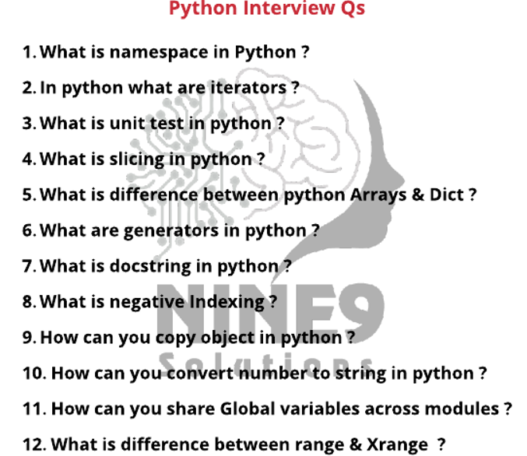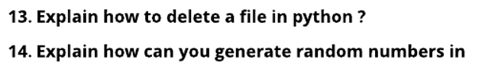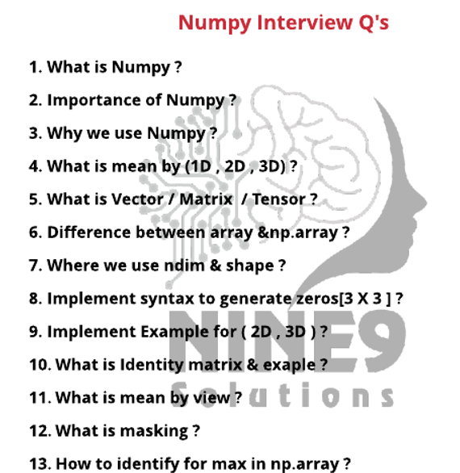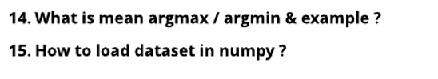

Pandas

### Define the Pandas/Python pandas?

### Define Series in Pandas?

### What are the significant features of the pandas Library?

### How will you create a series from dict in Pandas?

### How can we create a copy of the series in Pandas?

### How will you create an empty DataFrame in Pandas?

### How will you add a column to a pandas DataFrame?

### How to Rename the Index or Columns of a Pandas DataFrame?

### How to iterate over a Pandas DataFrame?

### What is Pandas NumPy array?

### Define GroupBy in Pandas?

### What is a pandas DataFrame?

### ****what can I import from NumPy?****

### How To Write a Pandas DataFrame to a File

Matplotlib

### What is the use of matplotlib and pyplot?

### What is the purpose of matplotlib?

### Which is better matplotlib or seaborn?

### Does seaborn need matplotlib?

### Is matplotlib part of numpy?

### What is import matplotlibPyplot as plt?

### Why do we need matplotlib inline?