1

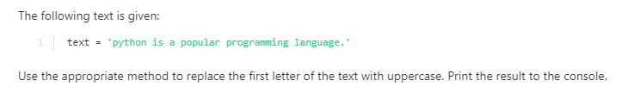

2

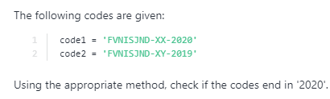

3

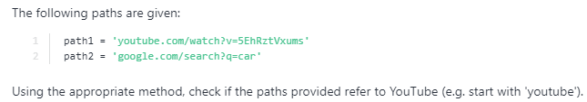

4

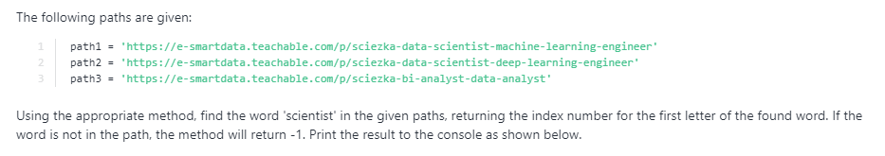

5

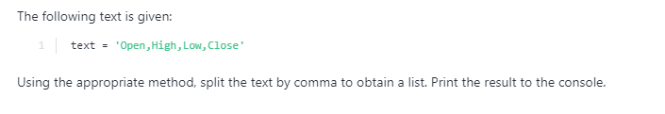

6

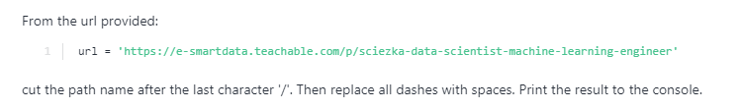url = 'https://e-smartdata.teachable.com/p/sciezka-data-scientist-machine-learning-engineer'

7

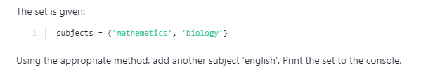

8

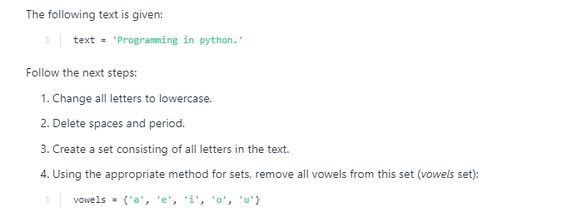



text = 'Programming in python.'

vowels = {'a', 'e', 'i', 'o', 'u'}

9

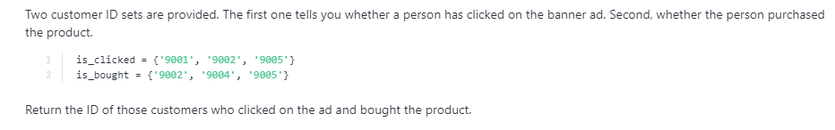

10

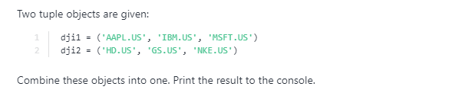

dji1 = ('AAPL.US', 'IBM.US', 'MSFT.US')

dji2 = ('HD.US', 'GS.US', 'NKE.US')

11

members = (('Kate', 23), ('Tom', 19)) 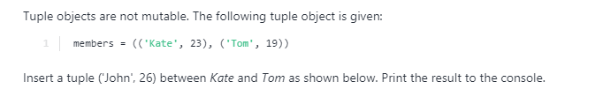

12

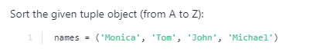

13

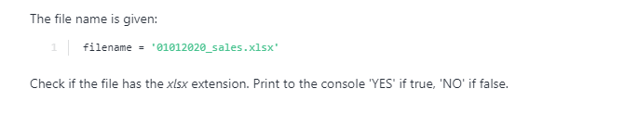

14

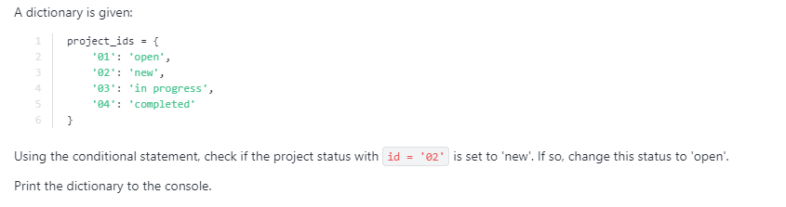

15



16

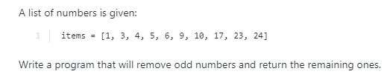

17

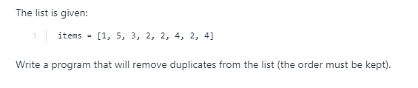

18

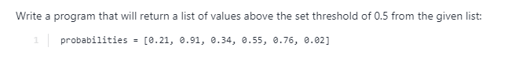

20

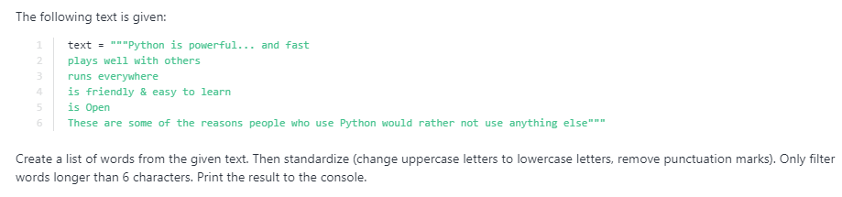text = """Python is powerful... and fast

plays well with others

runs everywhere

is friendly & easy to learn

is Open

These are some of the reasons people who use Python would rather not use anything else"""