Predicting Emission Energy in Quasi-2D Perovskite LEDs from Spacer Chemistry and Precursor Stoichiometry: When Machine Learning Works, and When It Does Not
From Intrinsic Chemistry to Extrinsic Efficiency: Mapping the Boundaries of Machine Learning in Quasi-2D Perovskite LEDs

Abstract
Quasi-two-dimensional (quasi-2D) halide perovskites remain difficult to design by intuition alone: the same nominal spacer and halide recipe can emit anywhere from the violet to the near-infrared depending on n-phase distribution, dielectric confinement, and processing history. We compiled 283 literature PeLED entries (photon energy 1.53–3.06 eV; peak wavelength 405–810 nm), converted organic spacer names to SMILES, and calculated 217 RDKit two-dimensional descriptors for each primary and secondary ligand after adding explicit hydrogens to the molecular graph. Together with precursor stoichiometry and solvent identity, this produced 462 input columns per record. Removing 173 near-duplicate descriptors (|r| > 0.90) and applying two feature-selection strategies on a stratified 80/20 split (226 training, 57 test) gave contrasting results. Recursive feature elimination with cross-validation (RFECV) kept 31 variables—the cross-validated optimum—whereas a random-forest importance filter (SelectFromModel, threshold = mean importance) retained only 13. Hyperparameter-tuned support vector regression on the smaller set performed best on the held-out literature data (R2 = 0.953, RMSE = 0.074 eV, MAE = 0.048 eV), clearly outperforming the 31-feature RFECV model (R2 = 0.920, RMSE = 0.097 eV) despite the latter’s lower cross-validation error. The retained descriptors are chemically recognizable: primary-spacer halide identity, spacer-to-lead ratio, lead halide and A-site fractions, DMF as solvent, and a small number of topological indices for primary and secondary spacers. SHAP analysis is consistent with confinement-dominated colour tuning. By contrast, models trained on 266 literature EQE values—including HTL, ETL, and additive labels—plateau near R2 ≈ 0.51–0.57, which we attribute to fabrication and measurement details that are not captured in compositional tables. Wavelength-based regressions are reported in the Supporting Information. The work separates what literature ML can reliably guide (emission colour from chemistry) from what still requires standardized device fabrication data (efficiency).
Keywords: quasi-2D perovskite, PeLED, photon energy, machine learning, Structured Query Language, Python, RDKit, feature selection, SHAP, EQE

1. Introduction
Metal halide perovskites have engrossed the field of optoelectronics through exceptional absorption coefficients, tunable bandgaps, high color purity, and solution processability, enabling rapid progress in solar cells, photodetectors, lasers, and light-emitting diodes (LEDs).[1-5] Among low-dimensional variants, layered quasi-two-dimensional (quasi-2D) metal-halide perovskites have emerged as a versatile material for perovskites LEDs (PeLEDs). Structurally, quasi-2D perovskite materials are formed by intercalating bulky organic spacer cations into the 3D framework, which truncates the inorganic octahedra into layers of thickness n. These quasi-2D perovskite are primarily categorized into Ruddlesden–Popper (RP) phases with the general formula L₂A_{n-1}Pb_{n}X_{3n+1} (A = small organic cation or inorganic cation, X = halide ion) where monovalent spacer cations (L) form van der Waals gaps between the inorganic layers and Dion–Jacobson (DJ) phases with general formula L′A_{n-1}Pb_{n}X_{3n+1} where divalent diammonium cations (L′) bond directly to adjacent inorganic sheets eliminating the van der Waals gap. By tuning their quantum and dielectric confinements, halide composition, and organic spacer chemistry we can cover a wide portion of the visible spectrum while retaining solution processability and improved environmental stability relative to their three-dimensional counterparts.[5, 6]
Since the parameter space is large in Quasi-2D perovskites unlike their 3D counterparts, and the outcome is not always predictable from main stoichiometry alone, research groups struggle to explore this space experimentally, one formulation at a time. Traditional materials development for perovskite optoelectronics has always depended on trial-and-error experimentation, density functional theory (DFT) and high-throughput screening. Now Machine Learning (ML), which rely on statical models, has emerged as a complementary fourth paradigm that can learn patterns from curated datasets, reduce experimental waste, and not limited by the theoretical rules/laws as physical models like DFT, which enlarge the scope for finding new relations and empirical laws. Therefore, ML models have been adopted in perovskite photovoltaics and, more recently, in LED work, to extract patterns from curated datasets.[7-9].
Materials forced ML workflows typically comprise data collection, data cleaning, feature engineering (molecular descriptor generation, correlation filtering, and feature selection), model training, and performance evaluation along with insights from interpretability tools such as SHAP (SHapley Additive exPlanations) to connect predictions with physicochemical drivers. In general data driven ML studies on perovskite optoelectronics focuses on active-layer optimization, transport-layer selection, interface engineering, and mechanism elucidation. Till date there are very few ML based reports available which are focused on quasi-2D perovskite’s emission and LEDs. Prior work on quasi-2D perovskites demonstrated that photon energy can be estimated from precursor composition and lipophilicity (XLogP3) of organic ligand leveraging random-forest model with root-mean-square errors on the order of ~0.05 eV. [10] Work on PeLED additives reached good accuracy only when the dataset was built from a single device architecture.[11] However, several gaps persist relative to the needs of quasi-2D LED researchers working across full visible-range color tuning. Our objective is to address the pain point where published ML studies confined to a narrow spectral window (for example green or blue Br/Cl systems) or a reduced feature set based solely on precursor ion ratios limited to single organic ligand systems, without explicitly encoding primary and secondary organic spacer structures through cheminformatics descriptors. In addition, we tried to answer if external quantum efficiency (EQE) can be predicted with comparable confidence with the literature data available under the same curation rules.
In this work we built the ML models addressing above mentioned gaps leveraging literature extracted dataset of quasi-2D perovskites for training and testing. Herein, we built three sets of ML models, two targeting emission energy (eV) and wavelength (nm) forecast which are material’s intrinsic properties and remaining one targeting EQE which is device based metrices. After the preparation of the dataset, we have done initial cleanup and formatting in the snowflake data warehouse (Enterprise data warehouse) using Structure Query Language (SQL), datasets are available in the github account to refer. Thereafter on top of the resulted dataset from snowflake, rest of the data engineering operation were performed in python (Jupiter Notebook) using pandas library with dataframes. Thereafter, Simplified Molecular Input Line Entry System (SMILES) strings were generated programmatically for each organic ligand based on IUPAC names by leveraging Chemical Identifier Resolver API hosted by the National Cancer Institute Computer-Aided Drug Design Group (nih.gov). Then 217 two-dimensional molecular descriptors per spacer (Primary and secondary) were generated using RDKit library structures (Chem.AddHs) using the SMILES. After the generation of molecular descriptors, high-dimensional feature extraction resulted in a dataset where the total number of features exceeded the number of observations, which led to curse of dimensionality. So, to handle the curse of dimensionality we applied couple of feature elimination techniques in a sequential order, 1) Correlation matrices and 2) SelectFromModel for one set of models and Recursive Feature Elimination using Cross Validation (RFECV) for another set of models. Finally, multiple ML models were built with the dataset considering selected fields post feature elimination. Among various models, SVR (Support Vector Regression) model outperformed rest of the models in forecasting emission energy with the dataset having 13 descriptors which were selected by SelectFromModel approach. It is worth mentioning that the models built on datasets went through recursive feature elimination also performed decently. All the codes for building different models and datasets are available in the github. Analyses without added hydrogens or without hyperparameter tuning are summarized in the Supporting Information.
2. Results and Discussion

2.1. ML models for forecasting emission energies
We created a curated dataset of 283 records for ML models training and testing, which is extracted from the available literature (dataset is available in github - SF_DATA_EMISSION_PEAK.xlsx, sheet SF_DATA_EMISSION_PEAK_NEW, column definitions and histograms are provided in SI Section S1). As the objective of the work is to build an efficient ML model which covers wide range emission forecasting in the visible region the data points collected have photon energies between 1.53 and 3.06 eV that is equivalent to peak wavelengths range 405–810 nm. The data distribution is uneven in a way that depicts the available literature till date. About ≈ 69% of 283 records fall between 480 nm and 550 nm (green–yellow), ≈ 12% lie in the violet/blue (400–480 nm), and ≈ 17% in deep red and near-infrared (650–900 nm), with fewer orange/red points in between (SI Table S1.1). A model trained only on typical green recipes would under represent the halide and confinement extremes that broadens the scope to cover entire visible spectrum.
Post two-dimensional molecular descriptors generation the dataset had 462 columns, which includes compositional and halide flags, one-hot encoded solvent columns, and Pri/Sec prefixed RDKit descriptors each SMILES (217 descriptors). To maintain the proper data distribution with respect to reports with mixed organic spacer and single organic spacer, where forty-six entries (~16%) are mixed primary and secondary spacers, we have done the 80/20 split by stratifying on IS_MIXED_SPACERS_SPACER, which splits 283 records into 226 training and 57 test records. It is worth mentioning that mixed spacer formulations are chemically important as the secondary ligand prominently impact interlayer spacing and can determine which n domains contributes more for the emission. After dataset splitting into training set and testing set, we started features elimination process to prevent curse of dimensionality using training dataset alone as we should avoid test data leakage. Initially, Pairwise Pearson correlation was applied on the training fold and omitted 173 redundant columns (|r| > 0.90), leaving 289 candidates for selection. Thereafter threshold-based SelectFromModel approach was used to further elimination of the features.

or recursive feature elimination with cross-validation (RFECV) were.

Figure 1 (to be inserted): Workflow from literature extraction to predicted Eph—SMILES conversion, AddHs descriptor calculation, correlation pruning, parallel RFECV (31 features) and SelectFromModel (13 features), tuned regressors, and SHAP readout.

2.2. Photon energy (Eph): feature selection and model performance

Hyperparameter tuning
All models discussed in this section were tuned with randomized search (15 trials, five-fold cross-validation) before evaluation on the 57-record test fold. We made this choice after observing that untuned models fit the training literature too tightly—particularly tree ensembles on high-dimensional descriptor blocks—while failing to generalize to held-out DOIs. For emission energy, where the chemistry signal is relatively strong, tuning mainly improves SVR and Gaussian process behaviour on the reduced 13-variable set (SI Table S7: untuned 31-feature GPR reaches only R2 = 0.877 on the test fold).

Thirty-one variables from RFECV versus thirteen from SelectFromModel
On the 289-variable training matrix, RFECV (five-fold stratified CV, random-forest selector with max_depth = 5, min_samples_leaf = 6) converges on 31 inputs. That number minimizes cross-validated RMSE on the training partition and is a reasonable stopping point if one trusts CV entirely.
A stricter filter fits a random forest once on all 289 survivors and keeps only descriptors whose importance exceeds the forest mean (SelectFromModel, threshold = 'mean'). That leaves 13 variables. The difference is not merely cosmetic: with 226 training points, the sample-to-feature ratio is 17.4 for the small set but only 7.3 for the RFECV set. On literature data that already mix synthesis routes, we find that the larger set picks up descriptor noise—BCUT partitions, extra EState surface areas—that helps CV but hurts prediction on the independent 57 records.
Test-set metrics for tuned models are summarized in Table 1. The best model is SVR (RBF kernel) on the 13-variable matrix.
Table 1. Held-out test performance for photon energy (eV), AddHs descriptors, hyperparameter-tuned models.
Feature selection | p | Model | R2 | RMSE (eV) | MAE (eV)
SelectFromModel | 13 | SVR (RBF) | 0.953 | 0.074 | 0.048
SelectFromModel | 13 | Gaussian process | 0.920 | 0.096 | 0.061
SelectFromModel | 13 | CatBoost | 0.875 | 0.121 | 0.063
RFECV | 31 | SVR (RBF) | 0.920 | 0.097 | 0.054
RFECV | 31 | Gaussian process | 0.877 | 0.120 | 0.073
RFECV | 31 | CatBoost | 0.862 | 0.127 | 0.066
The SVR test RMSE drops from 0.097 eV (31 features) to 0.074 eV (13 features)—roughly 0.23 eV in absolute terms, or ~24% relative improvement—while R2 increases from 0.920 to 0.953. For context, 0.07–0.10 eV is a useful screening window when comparing spacer modifications in the green spectral region (~2.2–2.4 eV). RFECV is still valuable: it defines a superset of chemically relevant variables and provides the curve in Figure 2 showing how CV error evolves as descriptors are stripped away. For publication-quality prediction on this corpus, however, the 13-variable model is preferable.
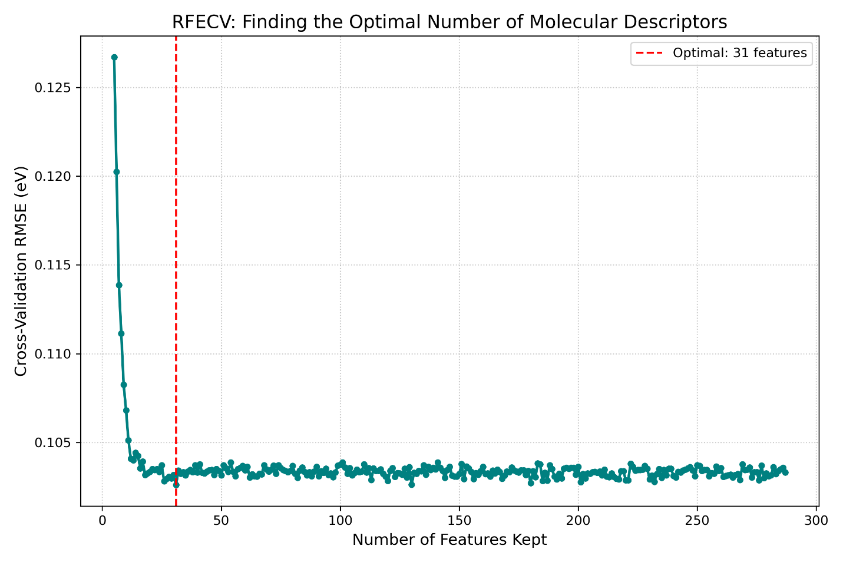
Figure 2 (to be inserted): RFECV cross-validation RMSE versus number of retained features; vertical marker at 31.
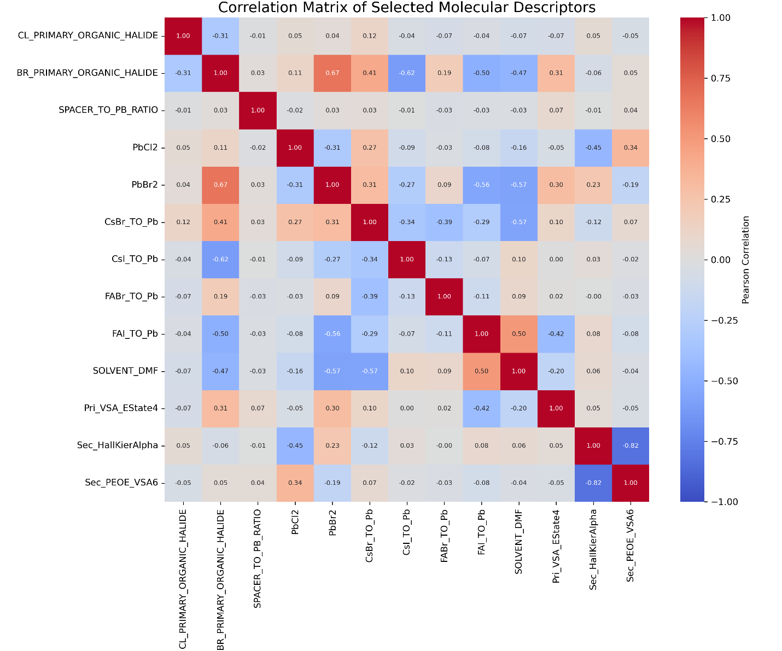Figure 3 (to be inserted): Correlation heatmap for the 13 retained training features.
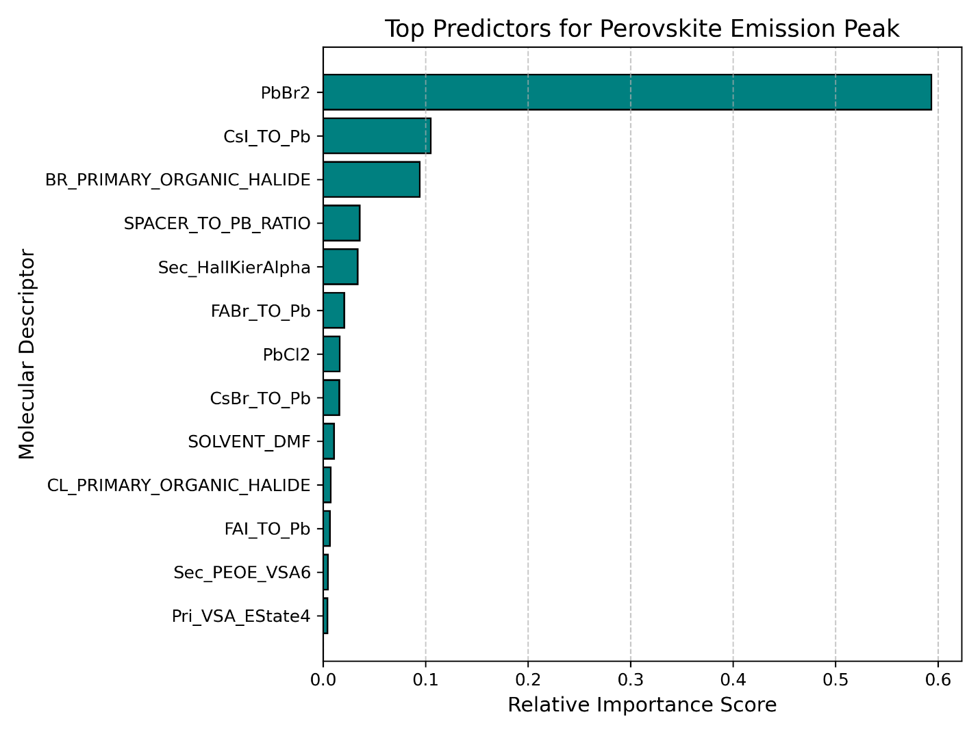Figure 4 (to be inserted): Random-forest importance ranking for the same 13 features.

What the thirteen descriptors mean chemically
The SelectFromModel list is short enough to discuss in physical terms:
CL_PRIMARY_ORGANIC_HALIDE, BR_PRIMARY_ORGANIC_HALIDE, SPACER_TO_PB_RATIO, PbCl2, PbBr2, CsBr_TO_Pb, CsI_TO_Pb, FABr_TO_Pb, FAI_TO_Pb, SOLVENT_DMF, Pri_VSA_EState4, Sec_HallKierAlpha, Sec_PEOE_VSA6
The halide flags and PbCl2/PbBr2 fractions set the inorganic framework’s band edge and the halide chemical potential in the precursor ink. Bromide on the primary spacer and bromide-rich lead sources generally push emission toward higher photon energy when low-n phases dominate, consistent with wider-gap wells.[5,9] SPACER_TO_PB_RATIO is the familiar lever for average n: more spacer relative to lead increases confinement and tends to blue-shift the peak until impurity phases or disorder pull it back.[1]
The cation-to-lead ratios (Cs, FA salts) reflect how much diversity is hidden in the “A-site” column of literature spreadsheets. Our model does not assume a single cation; it learns from the blended ratios actually reported. SOLVENT_DMF surviving selection is not surprising—DMF and DMSO are known to change Pb coordination and crystallization kinetics, which in turn changes n partitioning. That variable is a processing fingerprint as much as a chemical one.
Among molecular descriptors, Pri_VSA_EState4 captures how much of the primary spacer’s van der Waals surface sits in a particular electronic-state bin—related to heteroatom content and polarizability at the organic–inorganic interface. For mixed-spacer entries, Sec_HallKierAlpha (flexibility/topology of the secondary amine) and Sec_PEOE_VSA6 (partial-charge surface area on the secondary ligand) matter. When hydrogens are not added to the graph before descriptor calculation, the secondary-spacer term switches to Sec_EState_VSA8 instead (SI, Section S3); the primary halide and stoichiometry terms are unchanged.
The 31-variable RFECV set adds, among others, PRIMARY_SPACER_FRACTION, SOLVENT_DMSO, several Pri_BCUT2D_* partitions, Pri_qed, rotatable-bond counts, and additional PEOE/VSA terms (full list, SI Table S4). They refine the picture but do not improve test error given the available sample size.

SHAP readout
We used SHAP values to check whether the regression behaviour aligns with chemists’ expectations.[11] For SVR, a positive Shapley contribution from SPACER_TO_PB_RATIO on a given record means that stoichiometry pushes the predicted photon energy above the dataset average—interpretable as stronger confinement for that entry. Tree-model SHAP on CatBoost gives similar rankings, with halide and stoichiometry terms at the top. Figure 5 shows the beeswarm plot for tuned SVR (13 features). A parity plot for the 57 test points is recommended as Figure 6.

Wavelength models (briefly)
Because Eph and λ are related by E ≈ 1240/λ, one might expect wavelength regression to be interchangeable. In practice the literature mixes electroluminescence peaks with photoluminescence maxima, and the Stokes shift is not uniform across groups. We therefore treat wavelength as a secondary check. A tuned Gaussian process model on RFECV-selected features (28 variables, without AddHs; SI Section S2) reaches R2 = 0.958 with RMSE ≈ 21 nm on the same 57-record test fold. Full benchmarks and SHAP plots for λ are in the SI so the main discussion stays in energy units, which map more directly to confinement physics.

2.3. External quantum efficiency: a different problem
Once emission colour is treated satisfactorily at the materials level, one might hope EQE would follow from the same tables. It does not, at least not with the fields available in published PeLED summaries.
We assembled 266 EQE records with hole-transport material (HTL), electron-transport material (ETL), additive, and coarse processing variables (temperature, annealing time) in addition to the compositional columns used for emission. Even after recursive feature elimination to 20 descriptors and aggressive hyperparameter tuning, the best tree models reach only R2 ≈ 0.44–0.51 on the test fold (Table 2). Including HTL/ETL/additive explicitly in a CatBoost model with native categorical handling raises R2 to 0.57 (RMSE ≈ 4.4% EQE), which tells us stack chemistry carries some signal—but not enough to approach the emission models.
Table 2. Held-out test performance for literature EQE (%).
Model | R2 | RMSE (% EQE) | MAE (% EQE)
Tuned XGBoost (RFE, 20 features) | 0.512 | 5.01 | 3.77
Tuned random forest | 0.478 | 5.18 | 3.88
Tuned CatBoost | 0.443 | 5.35 | 3.75
CatBoost (architecture features) | 0.570 | 4.42 | 3.25
The gap between emission (R2 ≈ 0.95) and EQE (R2 ≈ 0.5–0.6) is not a failure of the algorithms. EQE couples radiative efficiency with charge injection balance and outcoupling. Pinhole-free morphology, interfacial trap passivation, and the exact measurement protocol (integrated sphere calibration, pixel area, sweep direction) move EQE by several percentage points without changing the precursor stoichiometry row in a spreadsheet. Different laboratories also anneal and antisolvent-quench under conditions that are described in prose but rarely digitized. Our view—shared by others who have tried to ML PeLED performance from literature alone[10]—is that EQE models trained on heterogeneous papers should be read as ranking tools, not as quantitative replacements for device fabrication.
Figure 7 (to be inserted): Schematic separating compositional controls of Eph from morphological and interfacial controls of EQE.
Figure 8 (to be inserted): SHAP summary for the CatBoost architecture EQE model.

3. Computational Methods
Literature records were taken from SF_DATA_EMISSION_PEAK.xlsx (emission sheet, 283 rows; EQE sheet, 266 rows). Primary and secondary spacer IUPAC names were converted to SMILES using an in-house lookup table and, when needed, the NIH CACTUS resolver. RDKit computed 217 two-dimensional descriptors for each unique SMILES after Chem.AddHs; descriptors were merged onto every record as Pri_ and Sec_ columns. Solvent was one-hot encoded. Reference DOIs were kept for traceability but not used as model inputs.
Train and test partitions (80/20, random_state = 42) were stratified on mixed-spacer identity for emission models. Highly correlated columns (|r| > 0.90, training fold only) were removed (173 columns). Feature selection then proceeded either by RFECV (31 features at the CV minimum) or by SelectFromModel with threshold 'mean' (13 features). No feature selection step used test-fold information.
Regressors—random forest, CatBoost, XGBoost, SVR, and Gaussian process—were evaluated on standardized inputs where required. Hyperparameters were chosen by randomized search (15 iterations, five-fold CV, negative mean squared error) implemented in scikit-learn and CatBoost’s built-in search for EQE runs. Metrics reported are coefficient of determination (R2), root-mean-square error (RMSE), and mean absolute error (MAE) on the 57-record test set.
SHAP values were computed with TreeExplainer for tree models and KernelExplainer (50 background samples from the training matrix) for SVR and GPR. Code, YAML configuration files, and notebook workflows are available in the project repository (ml_quasit package; configs under configs/emission_photon_energy/).

4. Conclusions
Literature ML can predict quasi-2D PeLED photon energy across a 405–810 nm compilation with useful accuracy if the descriptor set is kept chemically lean. In our hands, thirteen variables—halide identity, spacer-to-lead stoichiometry, key A-site and lead-halide fractions, DMF processing, and three spacer topology descriptors on hydrogen-complete structures—outperform a thirty-one-variable RFECV optimum on held-out data (R2 = 0.953 versus 0.920 for tuned SVR; RMSE 0.074 versus 0.097 eV). The result is consistent with a simple statistical fact: two hundred twenty-six training points cannot support three dozen free descriptor dimensions without overfitting, even when cross-validation suggests otherwise.
The selected features map cleanly onto confinement and composition arguments chemists already use to tune colour. SHAP analysis does not introduce contradictory rankings; halide and stoichiometry terms lead, with secondary-spacer indices appearing mainly where mixed ligands are present.
EQE, in contrast, is not predicted well from the same style of table (R2 roughly 0.5–0.6 at best). Transport-layer labels help modestly, but morphology and fabrication protocol dominate efficiency in ways literature columns do not capture. We would use the emission model to narrow spacer and ink choices before synthesis, and treat any EQE prediction as a weak prior until devices are built under a fixed stack and processing checklist.
Follow-up work in our group will hold out entire reference DOIs from training, link predictions to explicit n-phase indicators where XRD or optical data exist, and feed back in-house devices fabricated under constant HTL/ETL conditions to see whether EQE becomes learnable once the hidden variables are controlled.

Add this later:
Complementary ML studies have targeted organic-spacer libraries in two-dimensional perovskites, emphasizing that ligand choice is a first-class design variable alongside stoichiometry.[5] Separately, deep-learning classification of PeLED additives reached high accuracy only when the dataset was built from a single device architecture and supplemented with in-house experiments.[10] Those precedents matter for how we should read literature ML: models are most trustworthy when inputs and labels refer to the same experimental contract, and least trustworthy when they silently average over incompatible fabrication routes.
PeLED efficiency has risen sharply—external quantum efficiencies above 20% are now common for three-dimensional and optimized low-dimensional systems[11]—but efficiency is not predicted by the same variables that set emission colour. EQE depends on radiative yield, charge balance, and outcoupling, all of which are sensitive to film morphology and interface quality. Zhang et al. illustrated the data problem for device-targeted ML: even with careful molecular featurization, PeLED performance labels from literature are sparse and heterogeneous compared with the volume of data available in organic LED or photovoltaic ML campaigns.[10]

Author Contributions
[To be completed]

Conflicts of Interest
The authors declare no competing financial interest.

Data Availability
Analysis code and configuration files are available at [repository URL]. The curated workbook is available from the corresponding author on reasonable request.

Acknowledgments
[To be completed]

References
[1] Quan, L. N.; et al. Chem. Rev. 2019, 119, 7444–7477.
[2] Yuan, M.; et al. Nat. Nanotechnol. 2016, 11, 872–877.
[3] Smith, M. D.; et al. Chem. Rev. 2019, 119, 3104–3139.
[4] Straus, D. B.; Kagan, C. R. J. Phys. Chem. Lett. 2018, 9, 1434–1447.
[5] Li, Z.; et al. [Representative quasi-2D LED study].
[6] Lu, F.; et al. Adv. Photonics 2024, 6, 054001.
[7] Wang, S.; et al. ACS Nano 2025, 19, 29049–29072.
[8] Wang, Z.; Chen, C.; et al. J. Phys. Chem. C 2025, 129, 13542–13557.
[9] Wang, W.; et al. Nanoscale Adv. 2022, 4, 1632–1638.
[10] Zhang, L.; et al. Angew. Chem. Int. Ed. 2022, 61, e202209337.
[11] Lundberg, S. M.; Lee, S.-I. Adv. Neural Inf. Process. Syst. 2017, 30, 4765–4774.

Primary data: add_hydrogens_tuned_select_from_model.ipynb (13 features) and add_hydrogens_tuned_rfecv.ipynb (31 features). Supporting ablations: SUPPORTING_INFORMATION.md.

1. Hazra, V., A. Mandal, and S. Bhattacharyya, Optoelectronic insights of lead-free layered halide perovskites. Chemical Science, 2024. 15(20): p. 7374-7393.
2. Sumukam, R.R., et al., Halide Ions Distribution and Charge Dynamics in Mixed-Halide Perovskites. 2022. 16(5): p. 2100576.
3. Kumar, G.S., et al., Perovskite Nanowires for Next-Generation Optoelectronic Devices: Lab to Fab. ACS Applied Energy Materials, 2022. 5(2): p. 1342-1377.
4. Li, G., et al., Stabilizing high-efficiency perovskite solar cells via strategic interfacial contact engineering. Nature Photonics, 2026. 20(1): p. 55-62.
5. Karlsson, M., et al., Mixed halide perovskites for spectrally stable and high-efficiency blue light-emitting diodes. Nature Communications, 2021. 12(1): p. 361.
6. Tsai, H., et al., High-efficiency two-dimensional Ruddlesden-Popper perovskite solar cells. Nature, 2016. 536(7616): p. 312-6.
7. Wang, Z., et al., Data-Driven Design of Halide Perovskites for Efficient Green Light-Emitting Diodes via Machine Learning and DFT. The Journal of Physical Chemistry C, 2025. 129(30): p. 13542-13557.
8. Wang, S., et al., From Formability to Bandgap: Machine Learning Accelerates the Discovery and Application of Perovskite Materials. ACS Nano, 2025. 19(32): p. 29049-29072.
9. Lu, F., et al., Machine learning for perovskite optoelectronics: a review. 2024. 6 %J Advanced Photonics(5): p. 054001.
10. Wang, W., et al., Predicting the photon energy of quasi-2D lead halide perovskites from the precursor composition through machine learning. Nanoscale Advances, 2022. 4(6): p. 1632-1638.
11. Zhang, L., et al., Deep Learning for Additive Screening in Perovskite Light-Emitting Diodes. 2022. 61(37): p. e202209337.

