Supporting Information
ML Forecasting Emission and EQE Limits in Quasi-2D Perovskites
Ranadeep Raj Sumukam, Ramu Naidu Savu, Santhosh Rompivalasa and Banavoth Murali*
Solar Cells and Photonics Research Laboratory, School of Chemistry, University of Hyderabad, Prof. C R Rao Road, Hyderabad -500046, Telangana State, India.
*Email: murali.banavoth@uohyd.ac.in

Table S1. Dataset Statistics of file: data/SF_DATA_EMISSION_PEAK.xlsx, sheet SF_DATA_EMISSION_PEAK_NEW.
Statistic | Value
Records (N) | 283
Training | 226 (80%)
Testing | 57 (20%)
Stratification key | IS_MIXED_SPACERS_SPACER (> 0 vs. 0)
Eph (eV) | 1.53 – 3.06
λ (nm) | 405 – 810
Mixed-spacer count | 46 (16.3%)
Unique primary IUPAC | 22
Table S2. Wavelength bin distribution.
Wavelength Range | Label | Number of records | Fraction
400 – 480 | Violet/blue | 35 | 12.4%
480 – 550 | Green / yellow | 195 | 69.0%
550 – 650 | Orange / red | 6 | 2.1%
650 – 900 | Deep red / NIR | 47 | 16.6%
Table S3. Matrix dimensions.
Stage | Shape | Notebook output
Raw Excel | 283 × 37 | (283, 37)
After AddHs RDKit + OHE | 283 × 462 | (283, 462)
Unique SMILES processed | 30
After |r| > 0.90 | 283 × 289 | 173 columns dropped

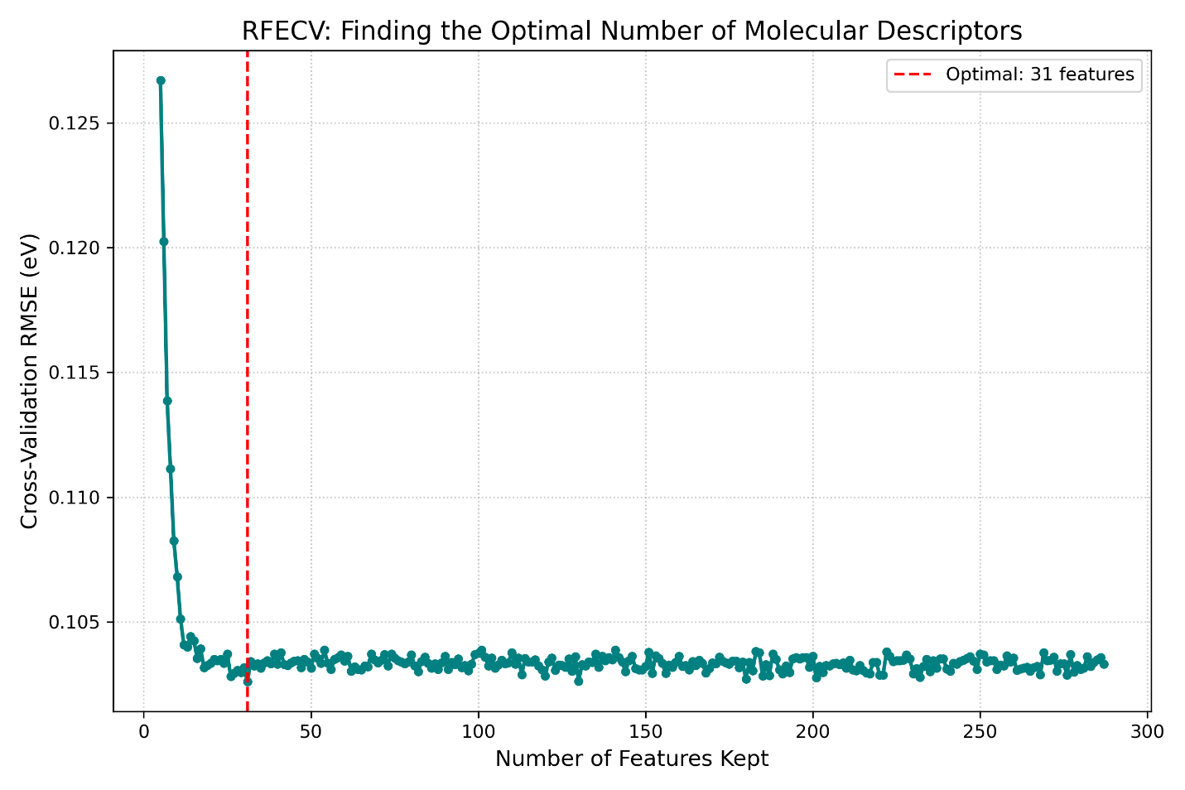
Figure S1. RFECV cross-validation RMSE versus number of retained features; vertical marker at 31.
Table S4. Sample-to-feature ratios.
Feature set | p | N_{train} | N/p
SelectFromModel (canonical) | 13 | 226 | 17.38
RFECV (canonical) | 31 | 226 | 7.29
RFECV no AddHs (ablation) | 39 | 226 | 5.79
Table S5. Thirteen features - select_from_model
S.No. | Feature Name
1 | CL_PRIMARY_ORGANIC_HALIDE
2 | BR_PRIMARY_ORGANIC_HALIDE
3 | SPACER_TO_PB_RATIO
4 | PbCl₂
5 | PbBr₂
6 | CsBr_TO_Pb
7 | CsI_TO_Pb
8 | FABr_TO_Pb
9 | FAI_TO_Pb
10 | SOLVENT_DMF
11 | Pri_VSA_EState4
12 | Sec_HallKierAlpha
13 | Sec_PEOE_VSA6
Training / testing shapes: (226, 13) and (57, 13).
Table S6. Thirty-one features - RFECV.
S. No. | Feature Name
1 | BR_PRIMARY_ORGANIC_HALIDE
2 | PRIMARY_SPACER_FRACTION
3 | SPACER_TO_PB_RATIO
4 | PbCl2
5 | PbBr2
6 | CsBr_TO_Pb
7 | CsI_TO_Pb
8 | FABr_TO_Pb
9 | FAI_TO_Pb
10 | SOLVENT_DMF
11 | SOLVENT_DMSO
12 | Pri_qed
13 | Pri_SPS
14 | Pri_BCUT2D_MWHI
15 | Pri_BCUT2D_MWLOW
16 | Pri_BCUT2D_LOGPLOW
17 | Pri_BCUT2D_MRHI
18 | Pri_Kappa3
19 | Pri_PEOE_VSA10
20 | Pri_PEOE_VSA7
21 | Pri_SMR_VSA1
22 | Pri_VSA_EState4
23 | Pri_VSA_EState7
24 | Pri_VSA_EState8
25 | Pri_NumHeteroatoms
26 | Pri_NumRotatableBonds
27 | Pri_Phi
28 | Sec_BCUT2D_MWHI
29 | Sec_HallKierAlpha
30 | Sec_Kappa3
31 | Sec_PEOE_VSA6
Training / testing shapes: (226, 31) and (57, 31).
Table S7. Emission Photon Energy —SelectFromModel (13 features)+ Hyperparameter-tuned model. Source: add_hydrogens_tuned_select_from_model.ipynb.
Rank | Model | R² | RMSE (eV) | MAE (eV)
1 | SVR (RBF) | 0.952715 | 0.074335 | 0.047942
2 | Gaussian Process | 0.920381 | 0.096459 | 0.060961
3 | CatBoost | 0.874856 | 0.120931 | 0.062522
4 | XGBoost | 0.756337 | 0.168744 | 0.070986
5 | Random Forest | 0.747938 | 0.171628 | 0.083796

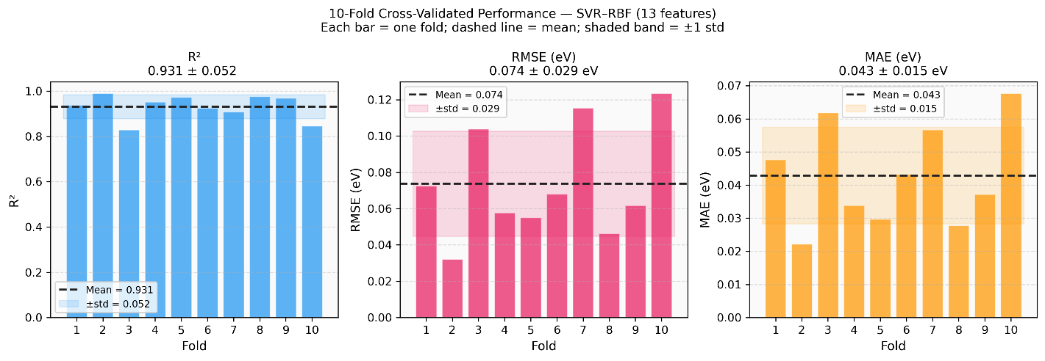
Figure S2. Ten-fold cross-validated R², RMSE, and MAE for the champion SVR-RBF model across all 283 samples. Each bar represents one fold. The dashed line indicates the mean and the shaded band represents ±1 standard deviation across folds.

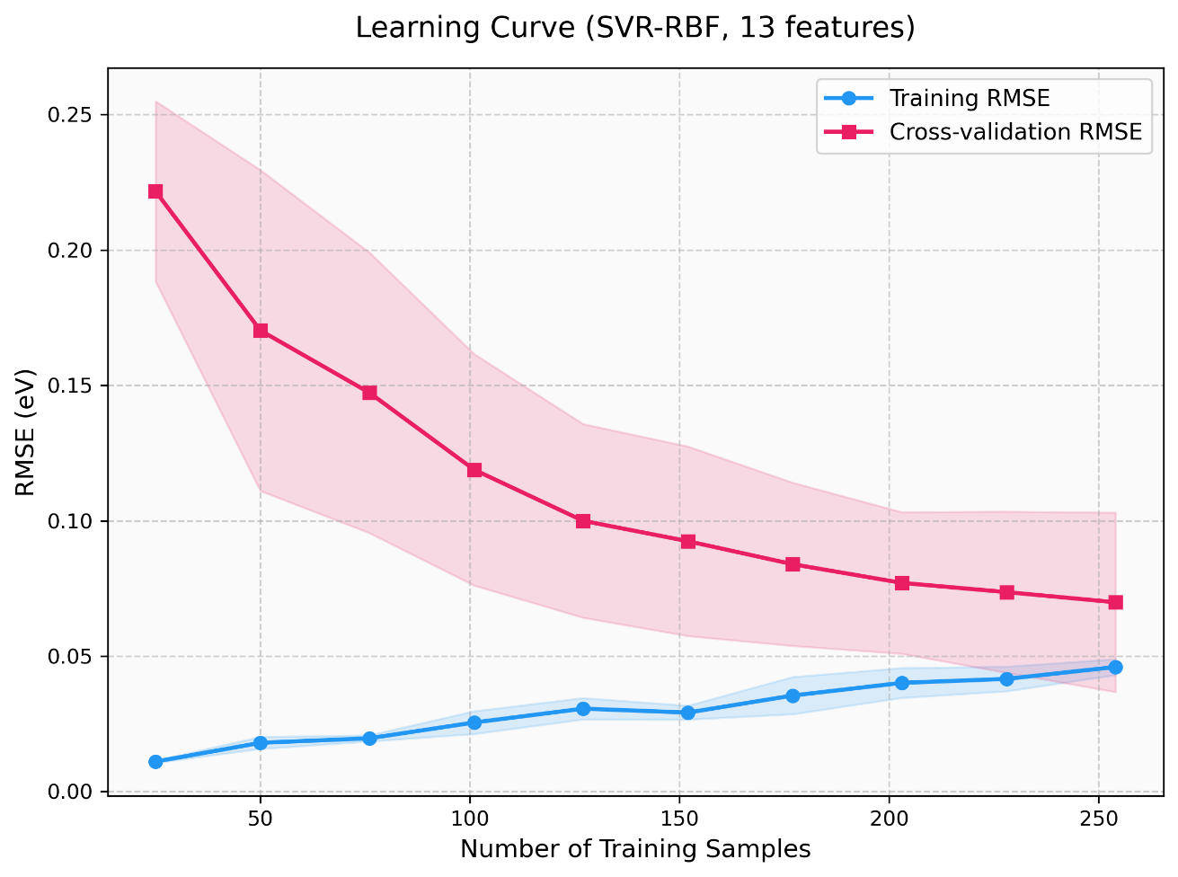
Figure S3. Learning curve for the champion SVR-RBF model evaluating the root-mean-square error (RMSE) as a function of training set size. The solid lines represent the mean RMSE across 10 cross-validation folds, and the shaded regions represent ±1 standard deviation. The convergence and flattening of the cross-validation error (red line) indicates that the model is well-fitted and the dataset size is sufficient for the model to learn the underlying patterns without requiring substantially more data.
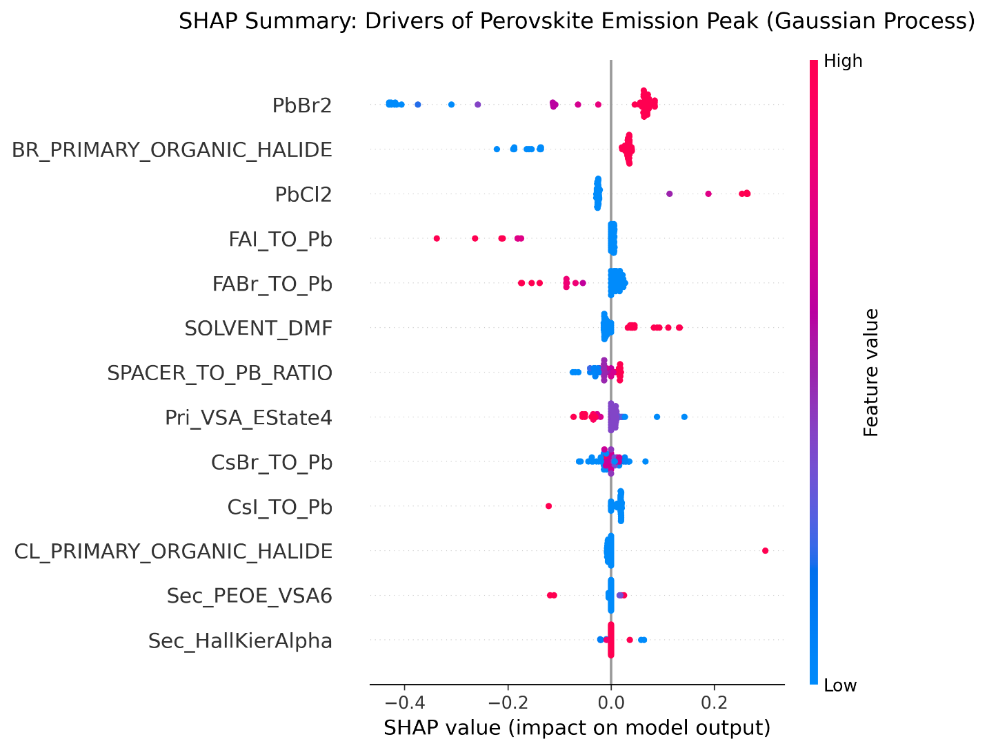
Figure S4: SHAP for the select_from_model + Gaussian Process model.
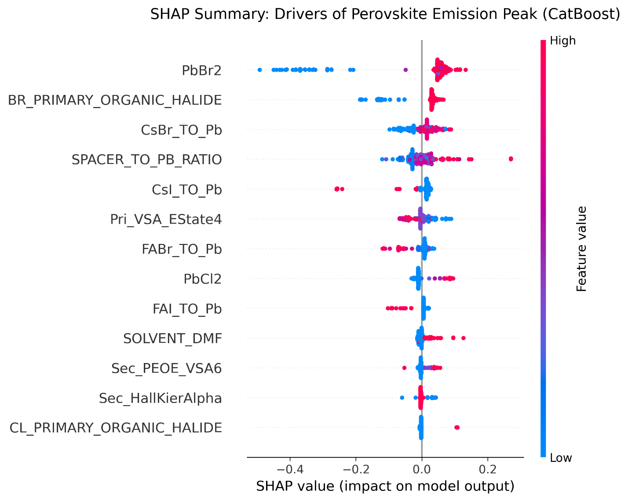
Figure S5: SHAP for the select_from_model + Catboost model.
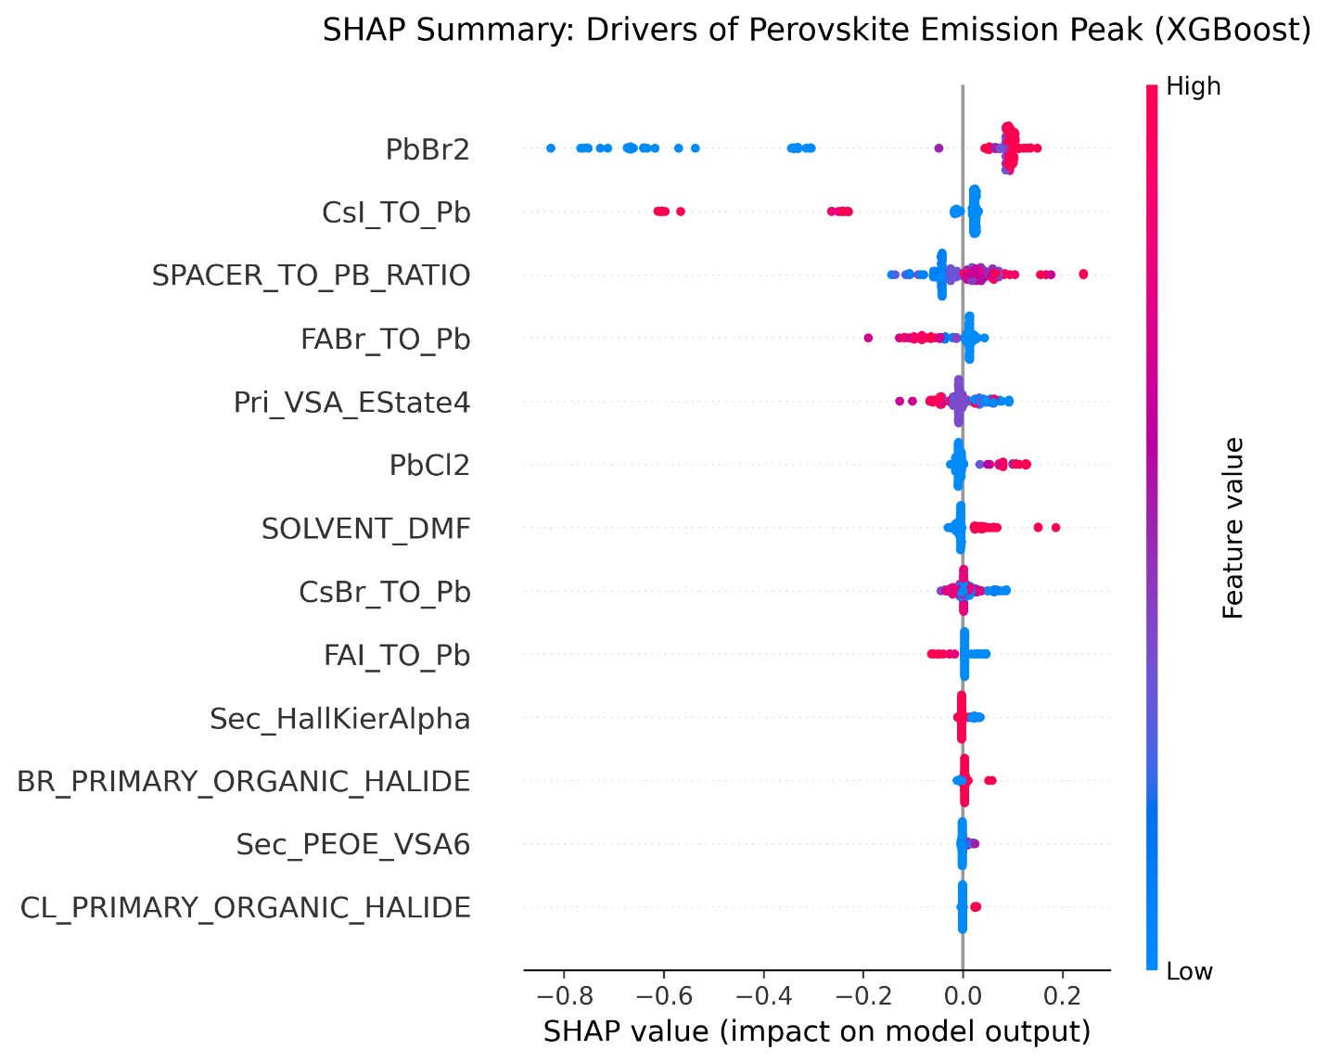
Figure S6: SHAP for the select_from_model + XGBoost model.

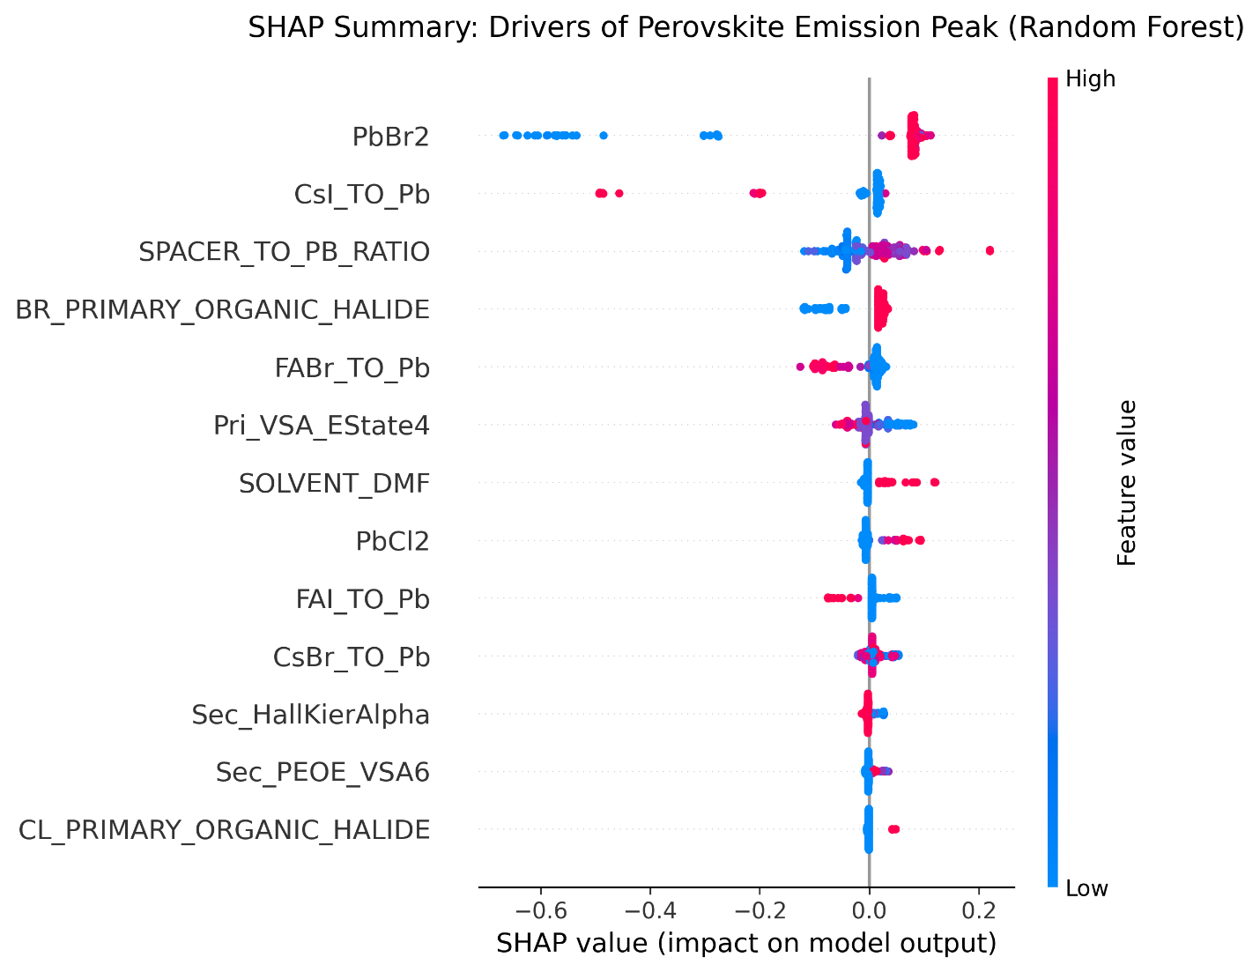
Figure S7: SHAP for the select_from_model + Random Forest model.
Table S8. Emission Photon Energy — RFECV (31 features)+ Hyperparameter-tuned model. Source: add_hydrogens_tuned_rfecv.ipynb.
Rank | Model | R² | RMSE (eV) | MAE (eV)
1 | SVR (RBF) | 0.919559 | 0.096955 | 0.053890
2 | Gaussian Process | 0.876814 | 0.119981 | 0.072528
3 | CatBoost | 0.861979 | 0.127001 | 0.066114
4 | XGBoost | 0.746257 | 0.172199 | 0.072514
5 | Random Forest | 0.690493 | 0.190182 | 0.086730

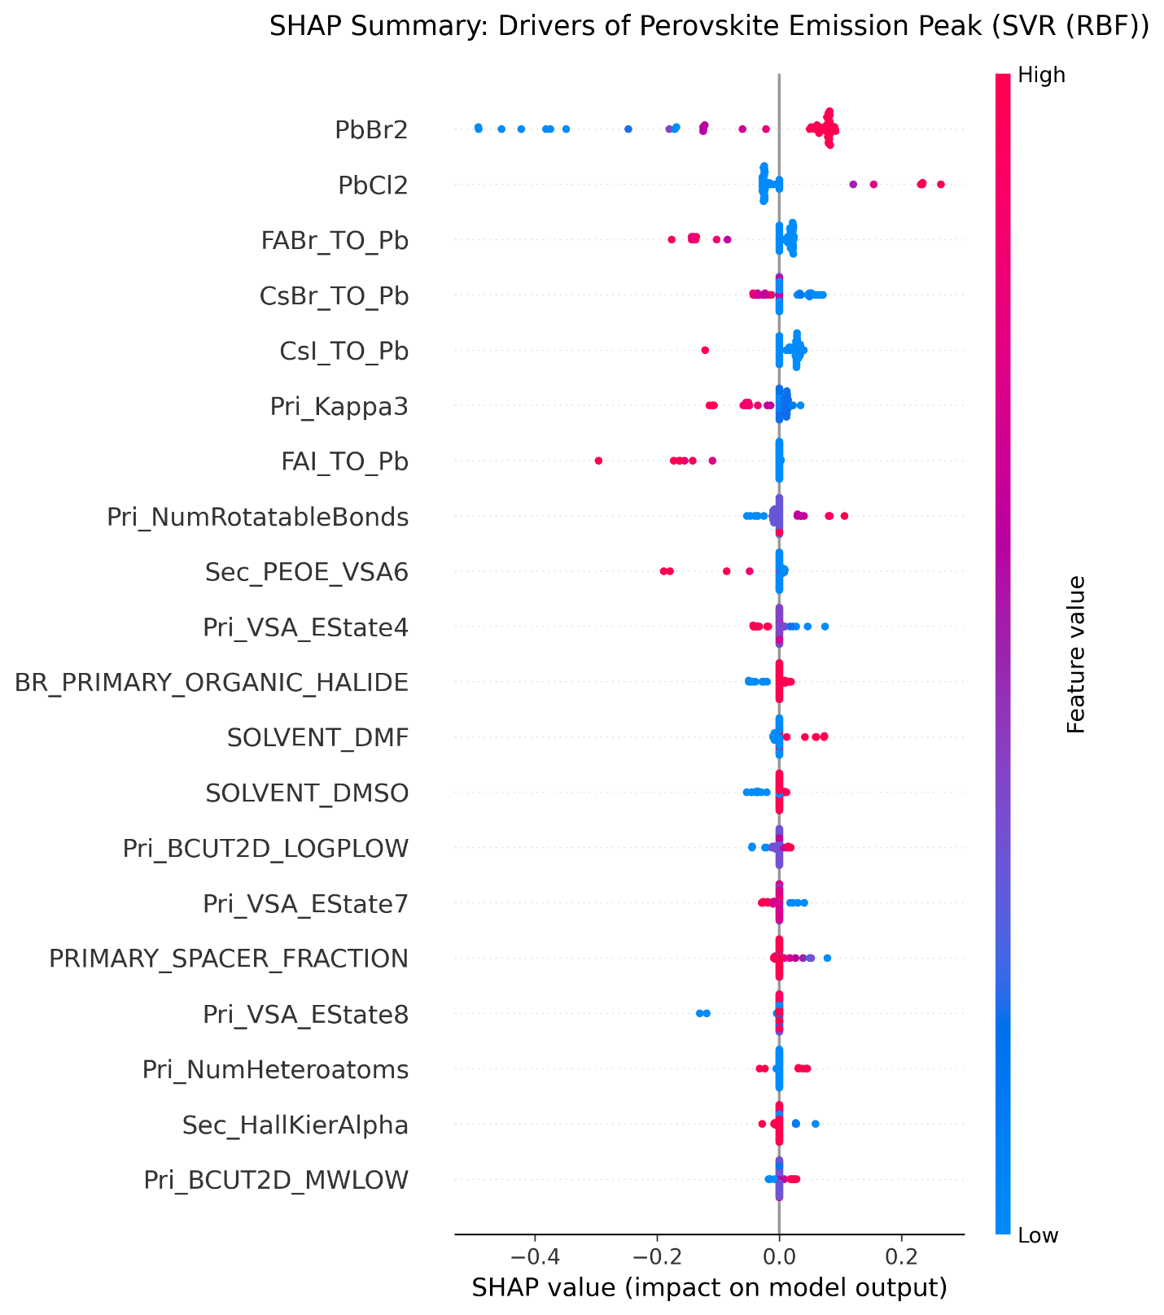
Figure S8: SHAP for the RFECV + SVR (RBF).

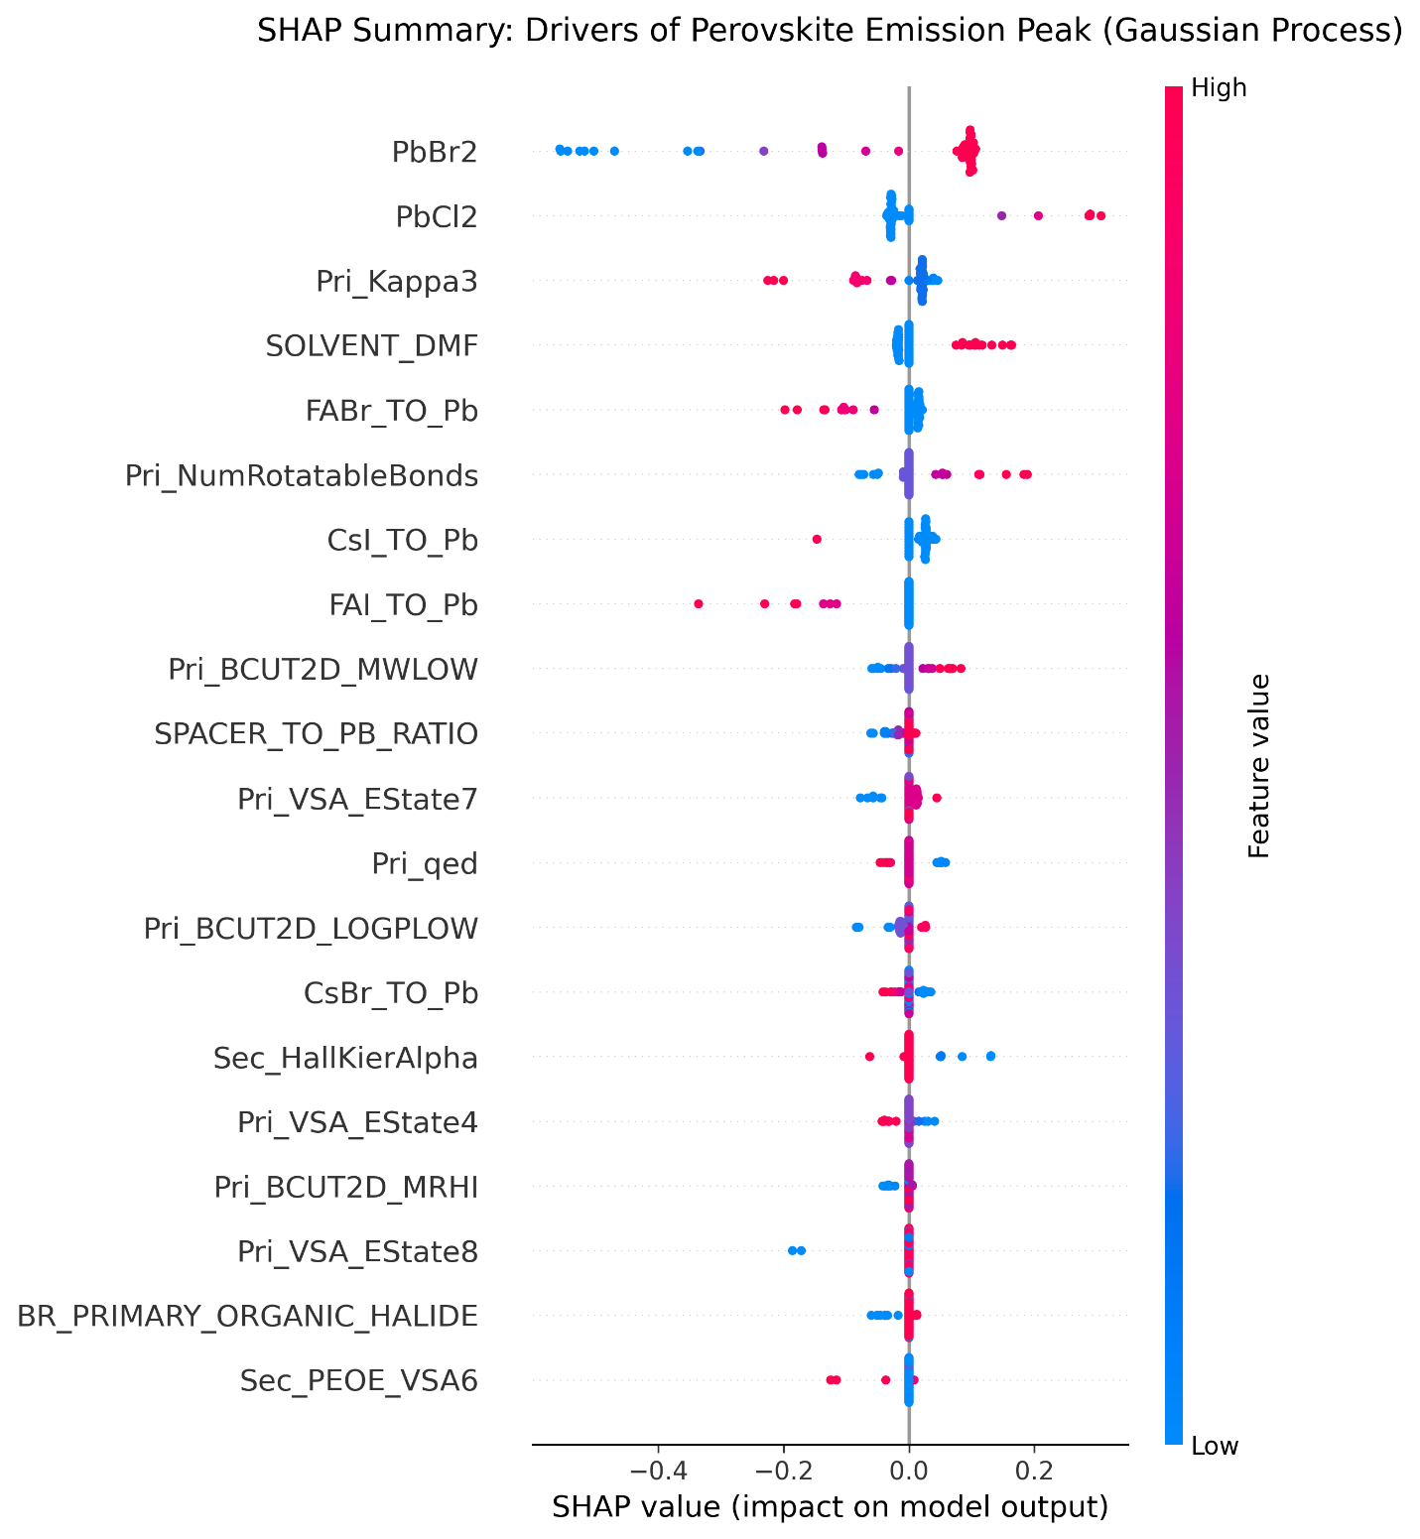
Figure S9: SHAP for the RFECV + Gaussian Process.

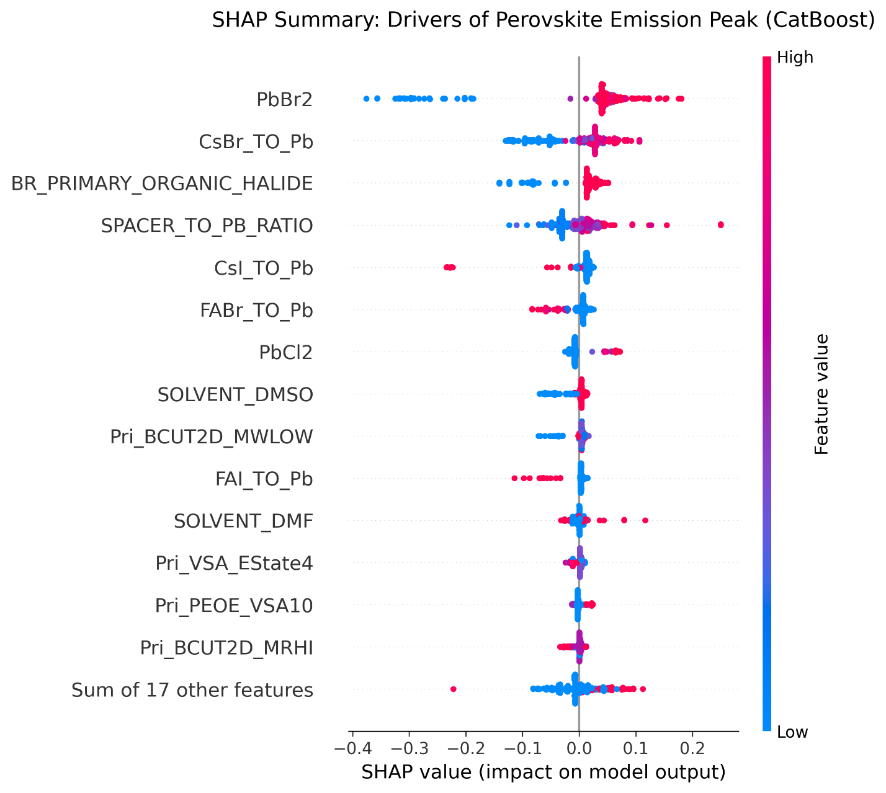
Figure S10: SHAP for the RFECV + CatBoost.

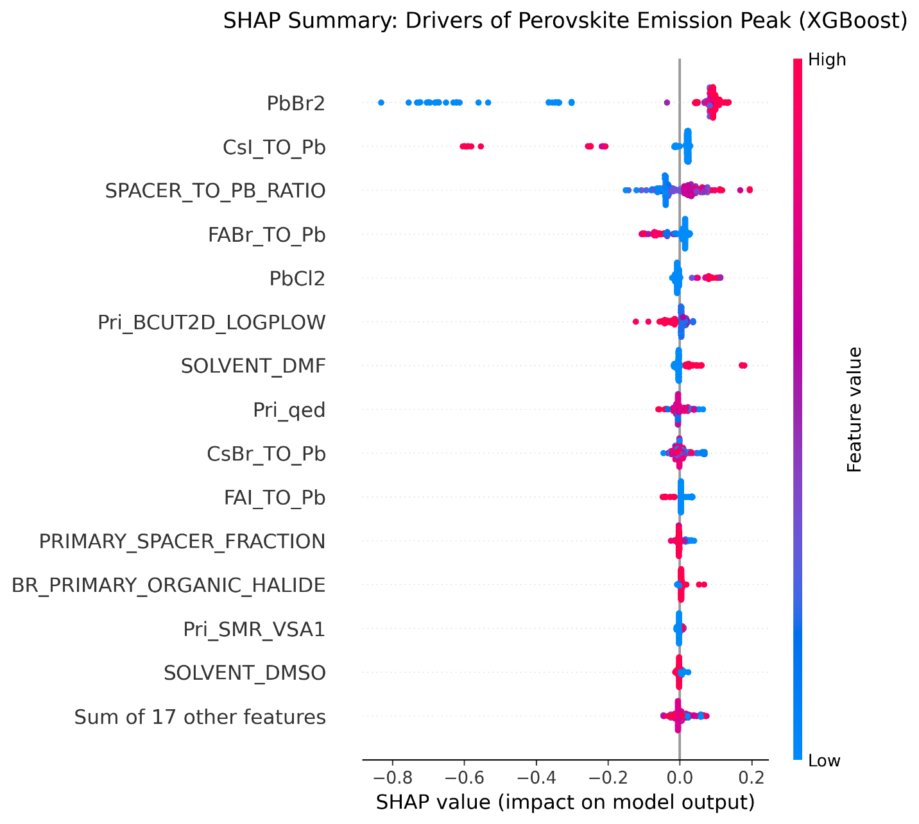
Figure S11: SHAP for the RFECV + XGBoost.

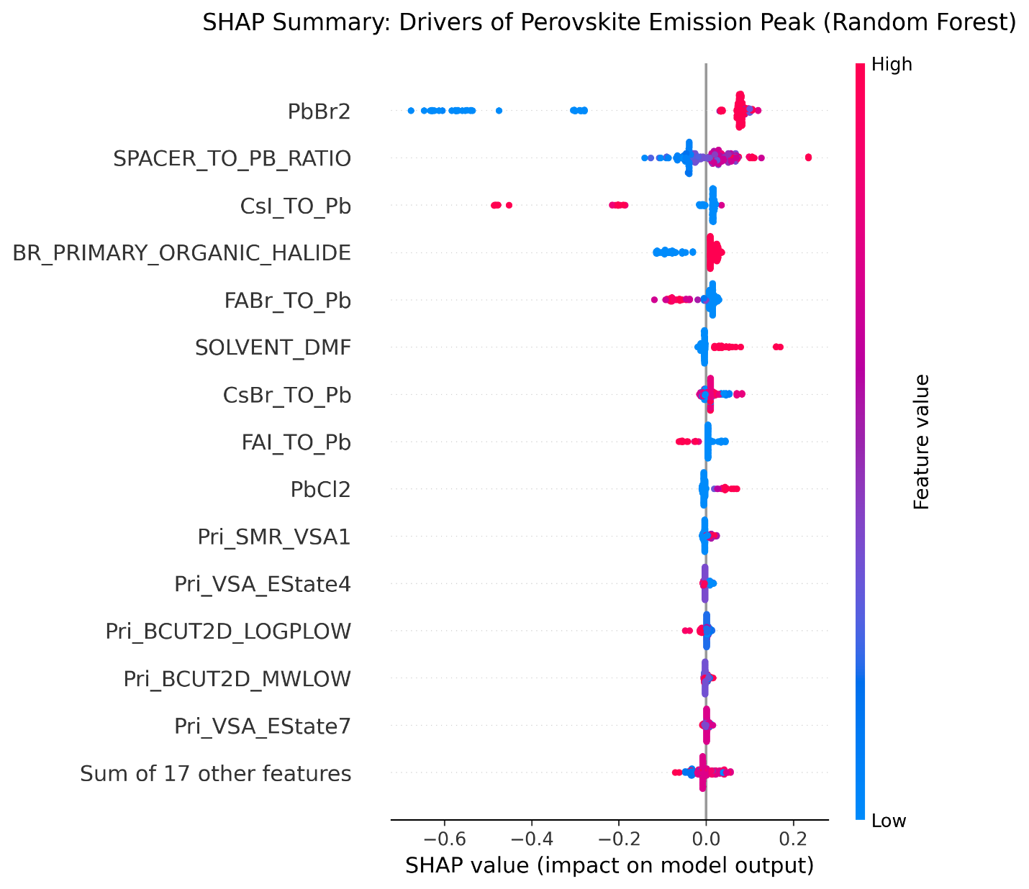
Figure S12: SHAP for the RFECV + Random Forest model.
Table S9. Emission Photon Energy — RFECV (31 features) + untuned model. Source: add_hydrogens_baseline_rfecv.ipynb.
Rank | Model | R² | RMSE (eV) | MAE (eV)
1 | Gaussian Process | 0.876814 | 0.119981 | 0.072528
2 | CatBoost | 0.857190 | 0.129185 | 0.069607
3 | SVR (RBF) | 0.819187 | 0.145361 | 0.073809
4 | XGBoost | 0.809737 | 0.149111 | 0.068635
5 | Random Forest | 0.699186 | 0.187492 | 0.085629

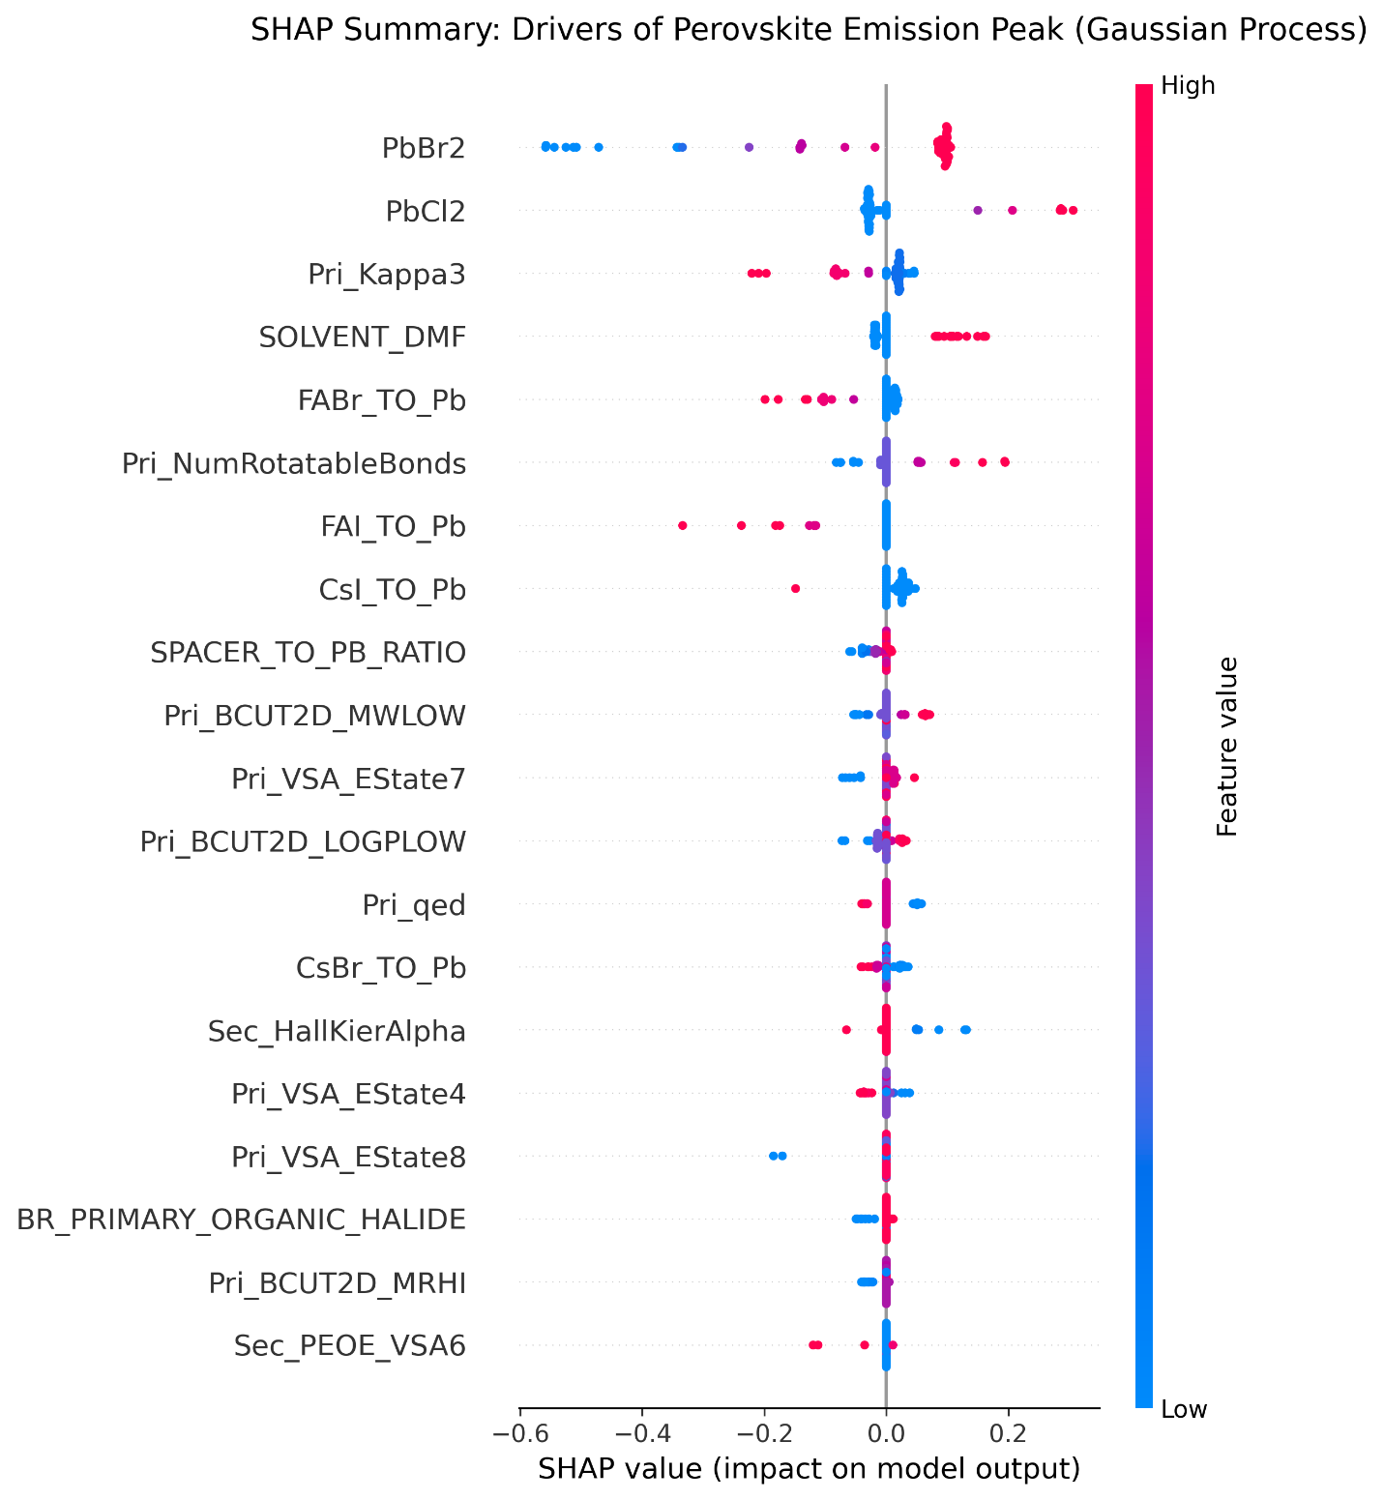
Figure S13: SHAP for the RFECV + Gaussian Process model without hyperparameter tuning.

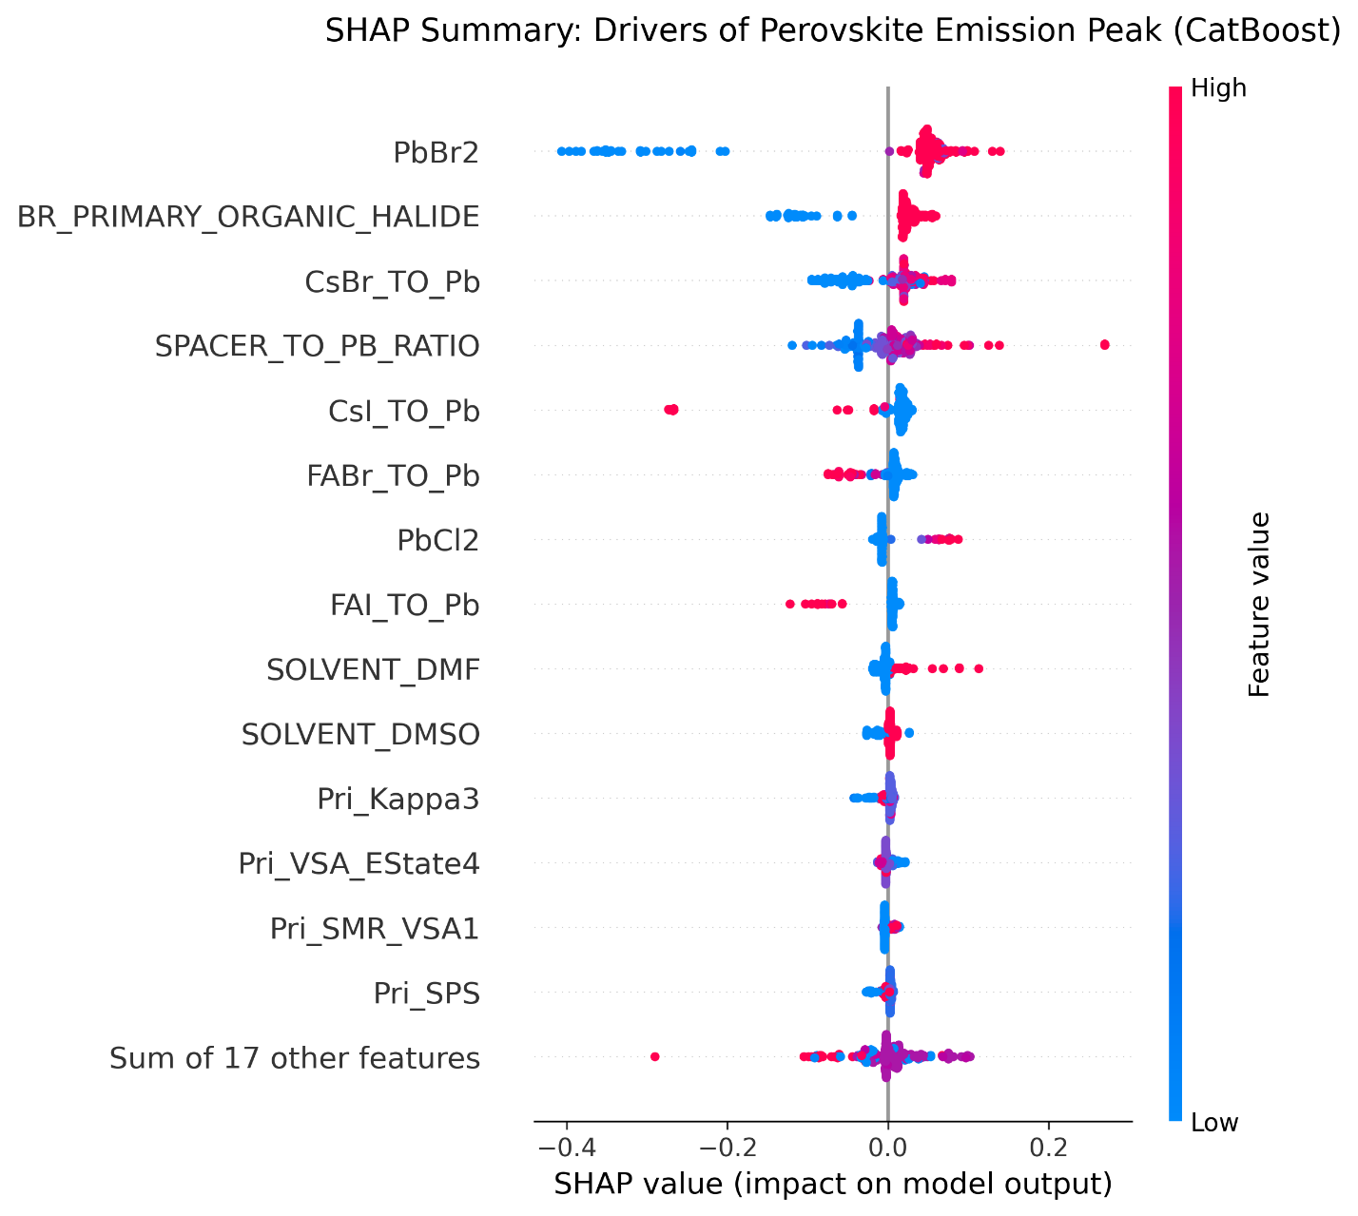
Figure S14: SHAP for the RFECV + CatBoost model without hyperparameter tuning.

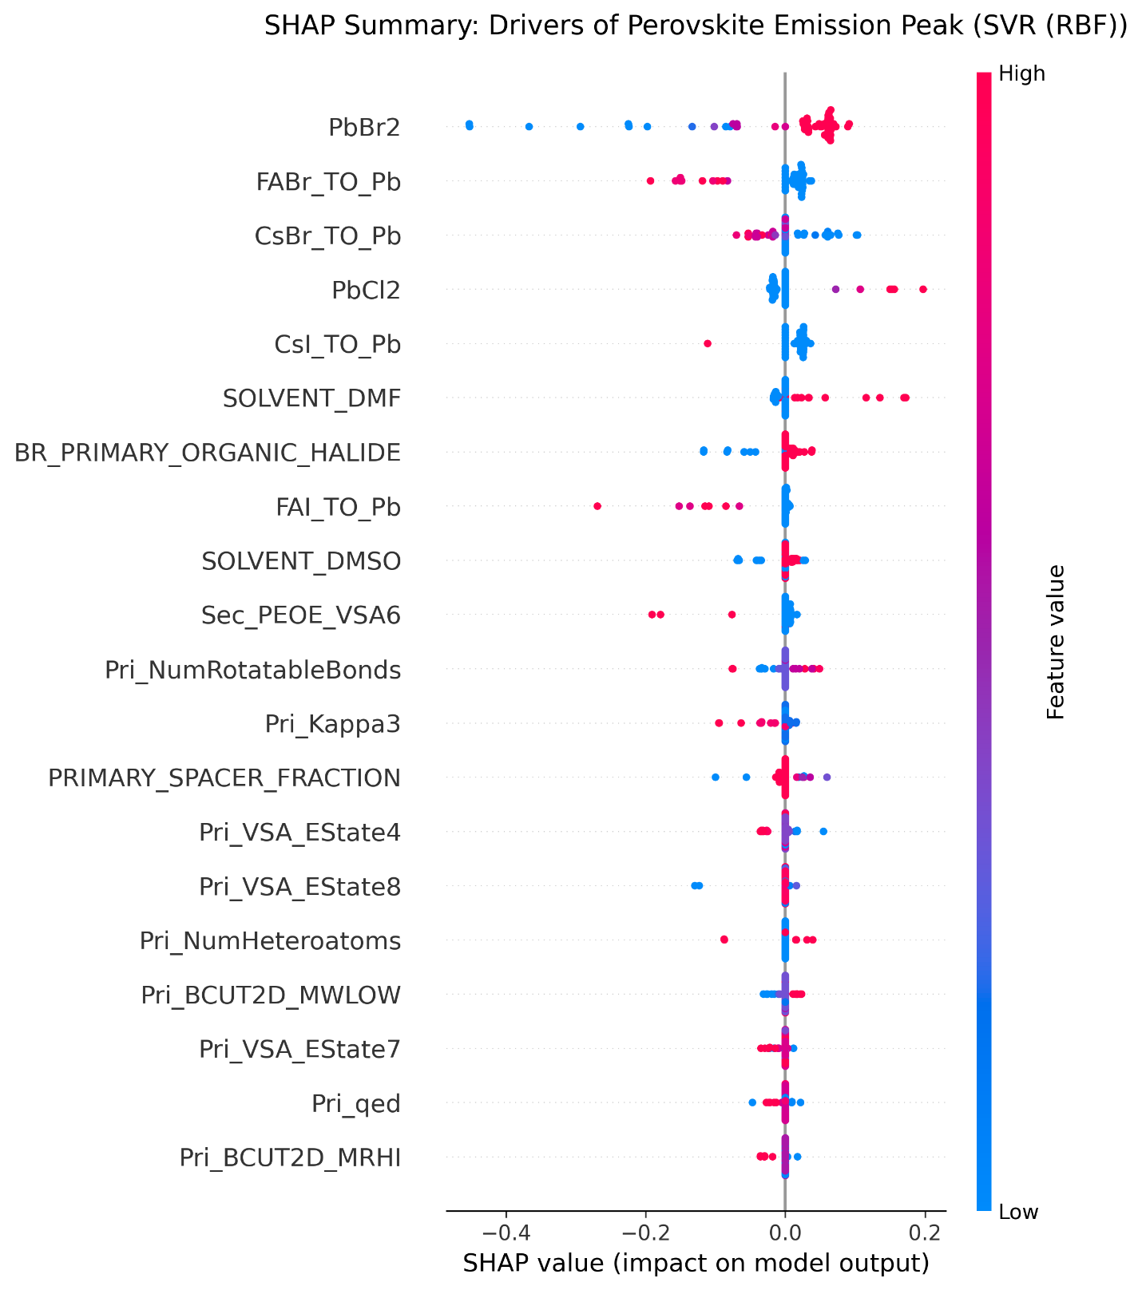
Figure S15: SHAP for the RFECV + SVR (RBF) without hyperparameter tuning.

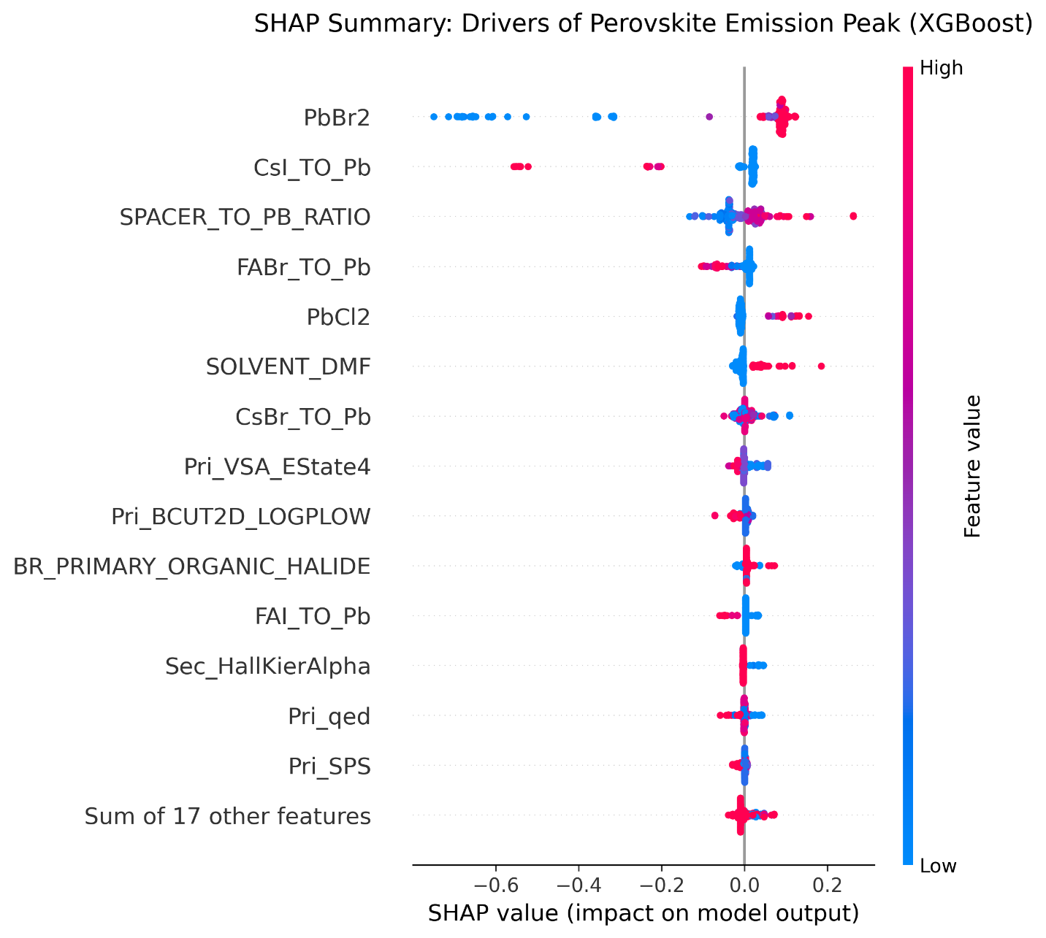
Figure S16: SHAP for the RFECV + XGBoost without hyperparameter tuning.

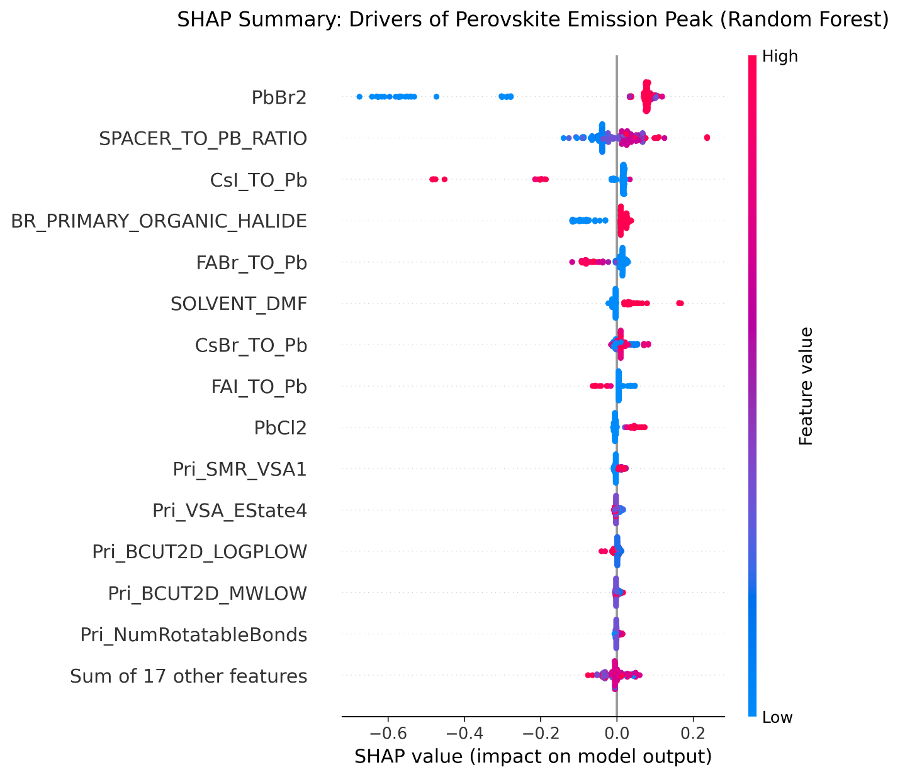
Figure S17: SHAP for the RFECV + Random Forest without hyperparameter tuning.
Table S10. Emission Photon Energy - comparison of best SVR models.
Notebook | Features | Hyperparameter Tuned | SVR R² | SVR RMSE (eV)
select_from_model + SVR | 13 | Yes | 0.953 | 0.074
RFECV + SVR | 31 | Yes | 0.920 | 0.097
RFECV + SVR | 31 | No | 0.819 | 0.145
Table S11. EQE Dataset summary.
Statistic | Value
Sheet | EQE_CLEANED
Records | 266
EQE range (%) | 0.002 – 30.84
Unique HTL | 34
Unique ETL | 13
Table S12. RFE-20 tuned models. Source: eqe_percent/rfe_20_features_tuned.ipynb.
Model | R² | RMSE (% EQE) | MAE (% EQE)
Tuned XGBoost | 0.512 | 5.01 | 3.77
Tuned Random Forest | 0.478 | 5.18 | 3.88
Tuned CatBoost | 0.443 | 5.35 | 3.75
Table S13. CatBoost model with ETL, HTL and additive categorical fields. Source: eqe_percent/catboost_only.ipynb.
Metric | Value
R² | 0.570
RMSE (% EQE) | 4.42
MAE (% EQE) | 3.25

