**Desktop Application:**

**Prerequisites:**

* The Database should be setup. It doesn’t matter if there is no data in the tables, they should simply be present.
* Install Visual Studio Code with Python extensions.
* Make sure that you have the Connector/Python for MySQL.

**Setup:**

* Install tkinter and ttkbootstrap by running the pip install <package name> command in the cmd.
* Open the project.
* Run the home.py file.

**Screenshots:**

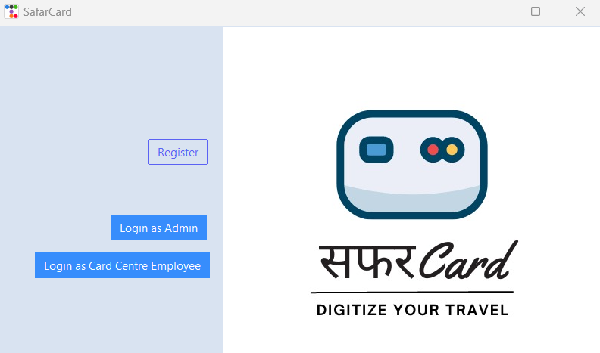

*Fig. Dashboard*

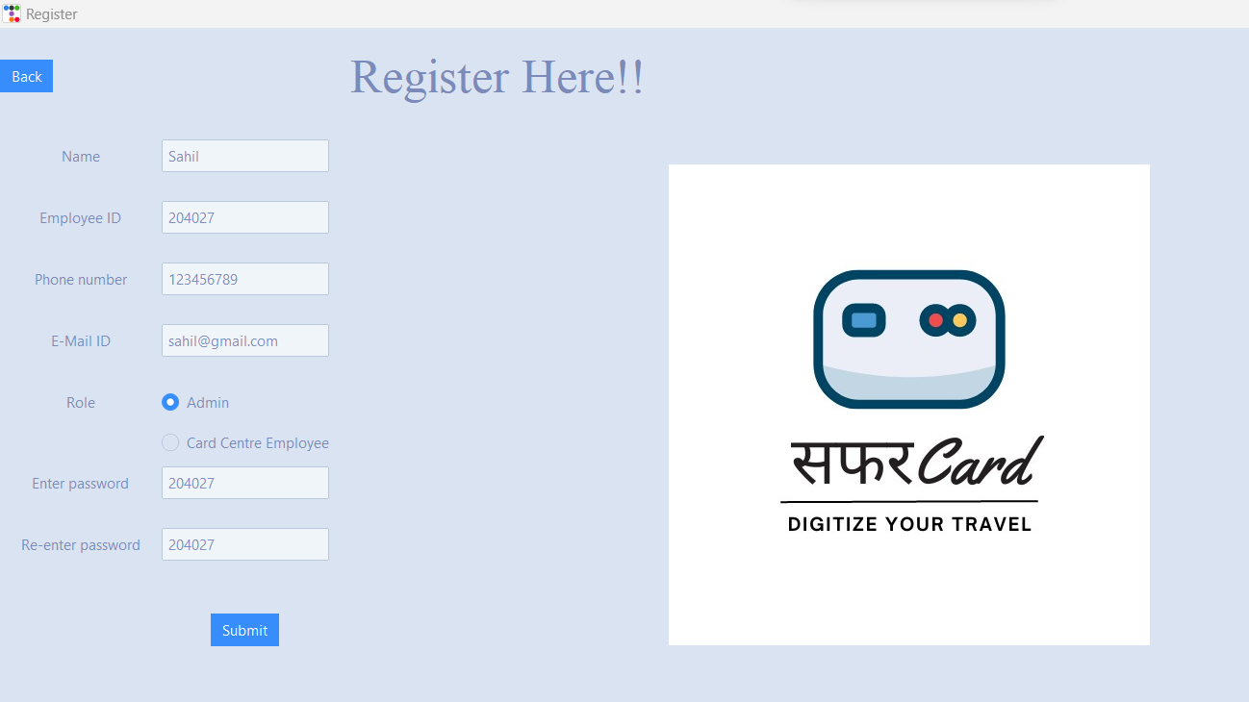

*Fig. Admin Registration Portal*

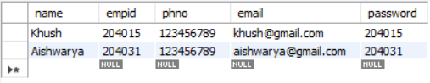

*Fig. Before*

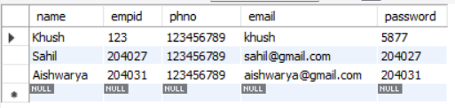

*Fig. After*

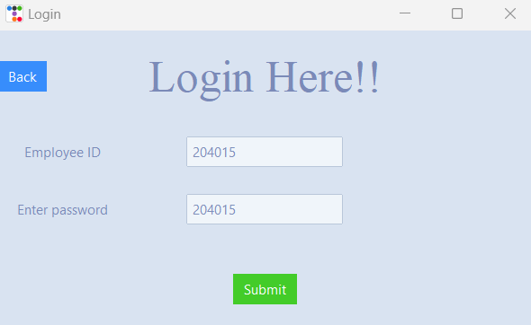

*Fig. Admin Login*

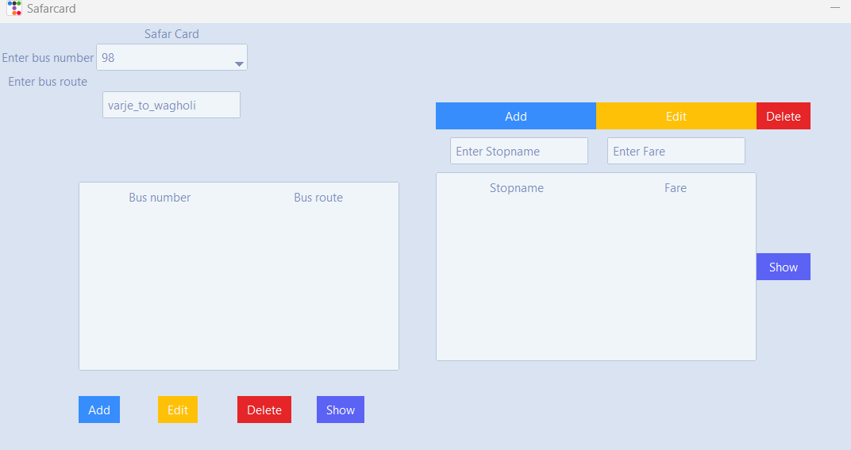

*Fig. Adding Bus Route*

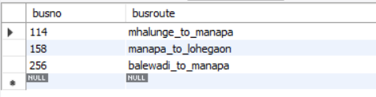

*Fig. Before*

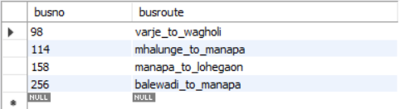

*Fig. After*

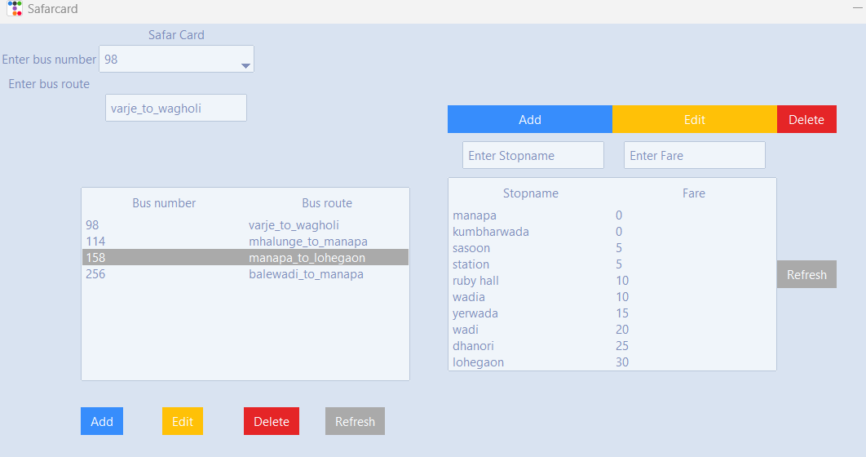

*Fig. Seeing Bus Routes and Stops*

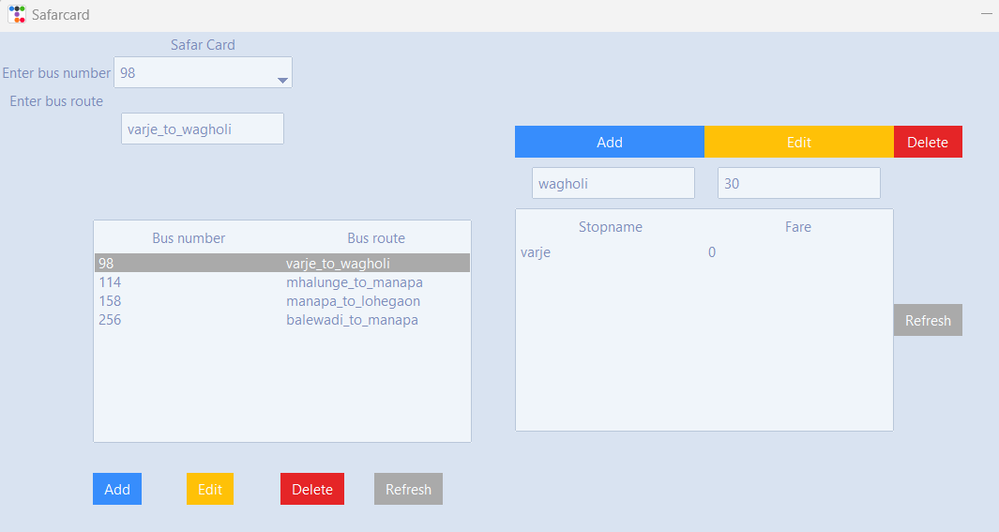

*Fig. Adding Stop*

**

*Fig. Before*

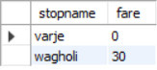

*Fig. After*

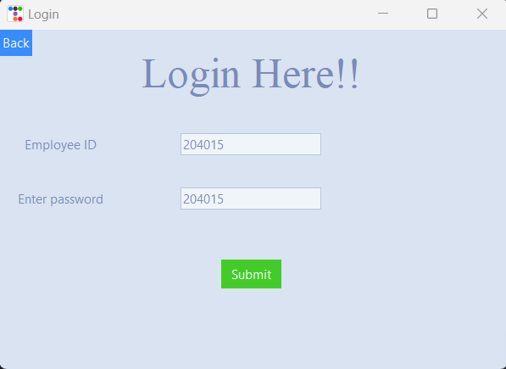

*Fig. Card Centre Employee Login*

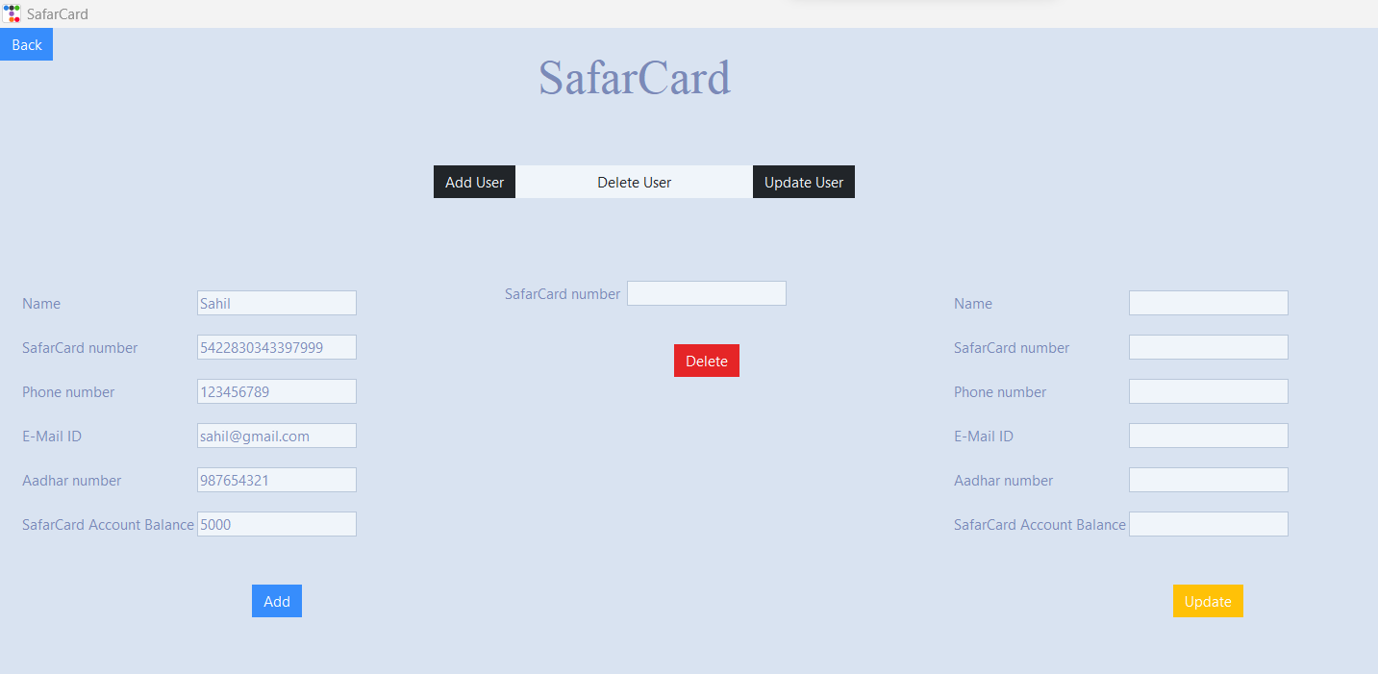

*Fig. Adding User*

**

*Fig. Before*

**

*Fig. After*

*Fig: Delete user*

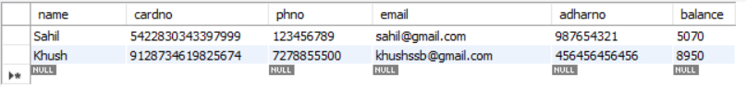

*Fig: Before*

**

*Fig: After*

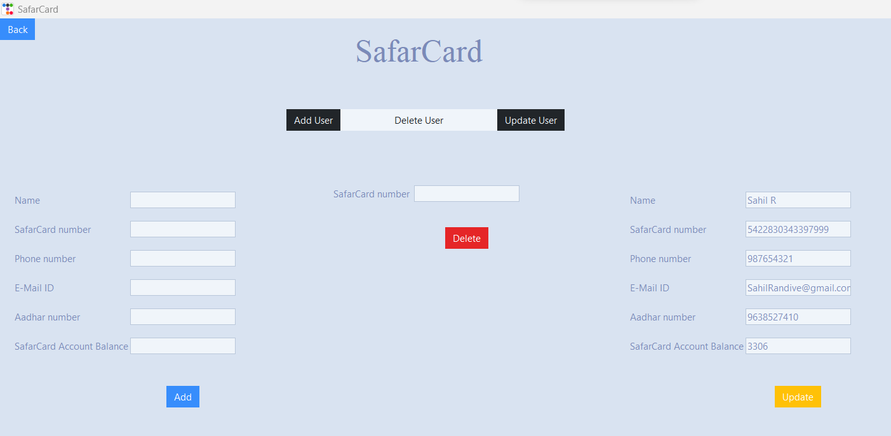

*Fig: Update existing user*

**

*Fig: Before*

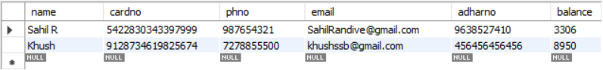

*Fig: After*